New address search

Changes to address search
Previously when adding an address, you had to search via postcode, then select the house number then accept the address.
This has now changed.
- Search via postcode and select the address from the dropdown menu
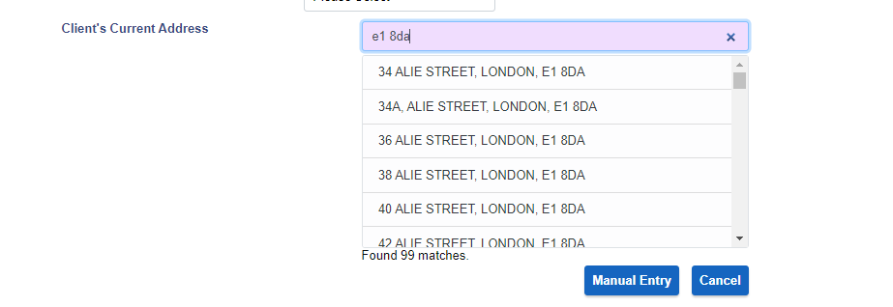
- Just start typing and then find the address from the dropdown menu
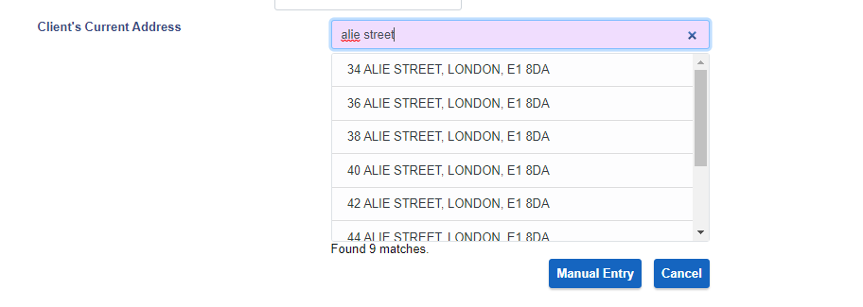

Don’t forget
When changing an address, remember to change the valid from date and to save to both the local and national record.
