New clinic layout

Following the upgrade to RiO 22, there will be a noticeable difference to the layout of the clinics page.

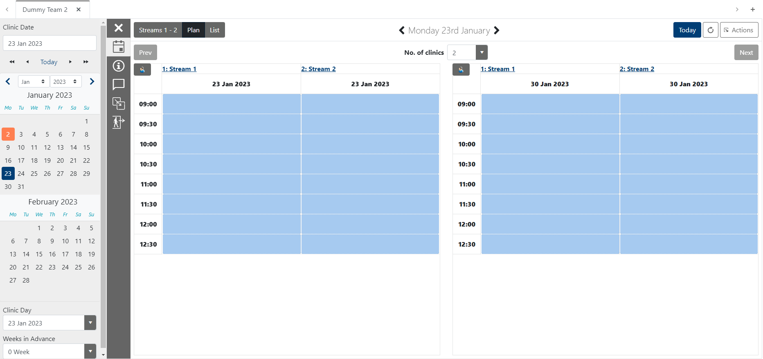
The new layout reflects the changes to the main diary page, so a lot of the functions work in a similar way.
To change the date of the clinic you can either click on the diary on the left-hand side (1) or you can select from the clinic date dropdown menu (2).
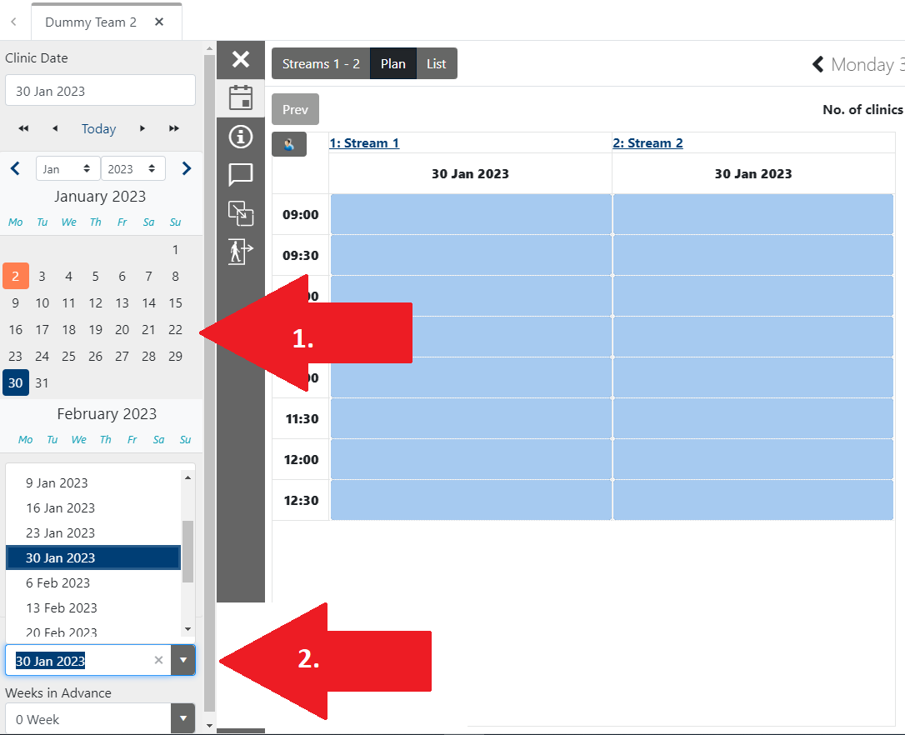
Alternatively, you can move the clinic date forward by a number of weeks by using the dropdown menu at the bottom of the screen,
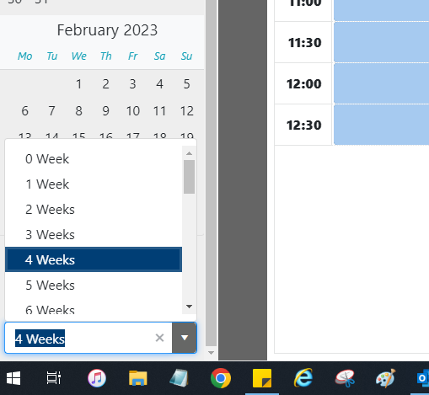

or click on the arrow next to the date in the centre of the screen
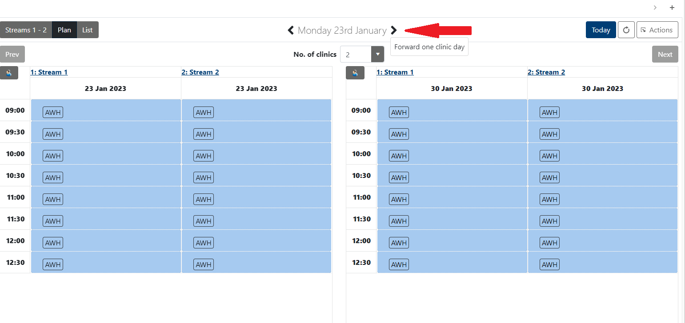

Selecting Filters
By clicking on the i logo in the grey bar you can set the filters for the clinic.
These include the visual indicators as well as the key for the different colours of the clinic slots, offering a quick visual check for available, booked or unavailable slots in the clinic streams.

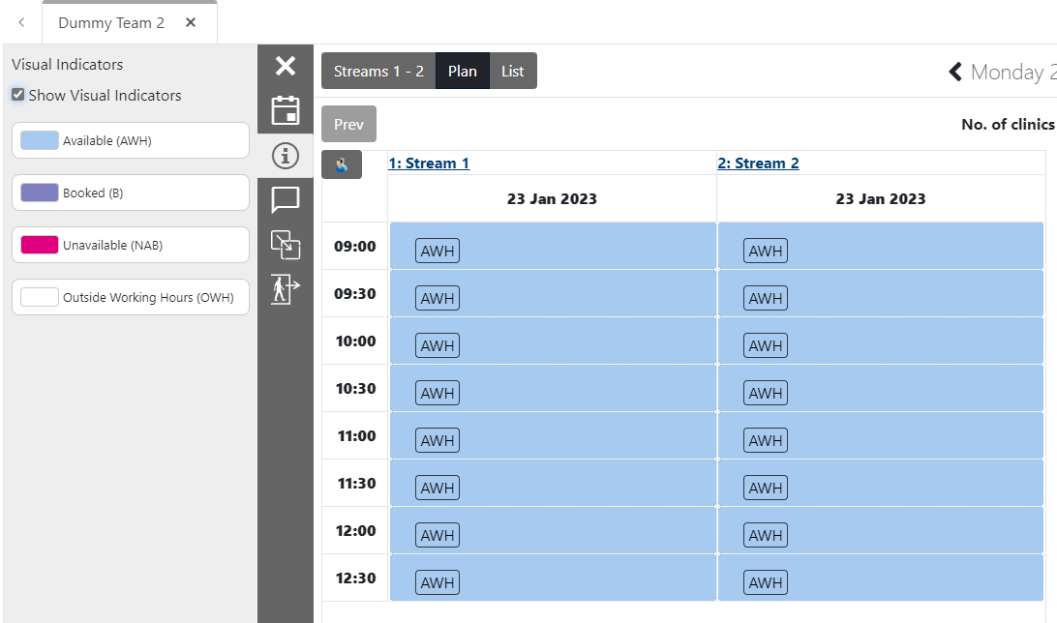

Other option on the grey bar includes the scratch pad and unscheduled appointments
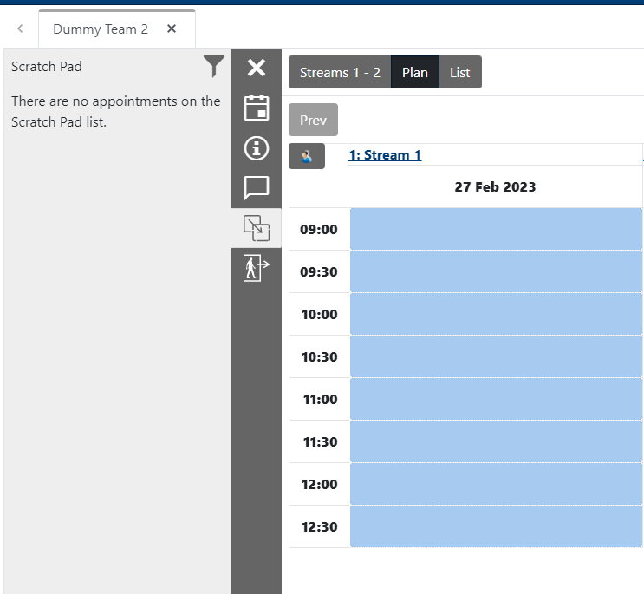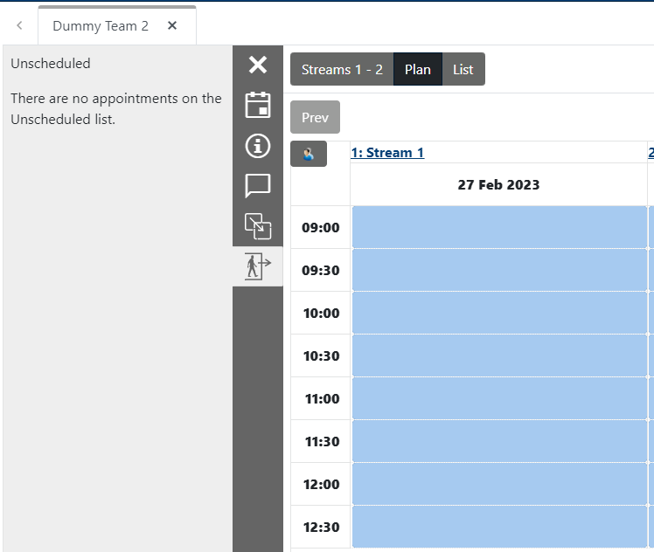
Adhoc clinics
The booking of adhoc clinic appointments has now moved as well. To book an adhoc clinic appointment you will need to select this appointment type from the 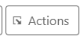button on the right-hand side of the screen
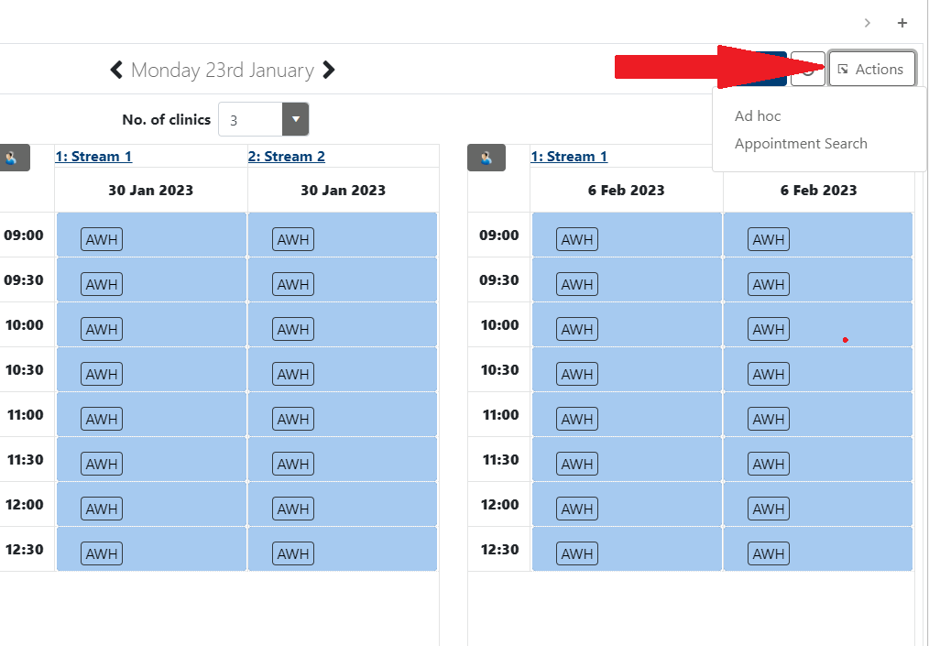

Seeing multiple clinic dates.
By clicking on the No. of clinics dropdown, you are able to select how many clinic days you can see on screen. However, the view will be affected by the number of streams in that clinic.
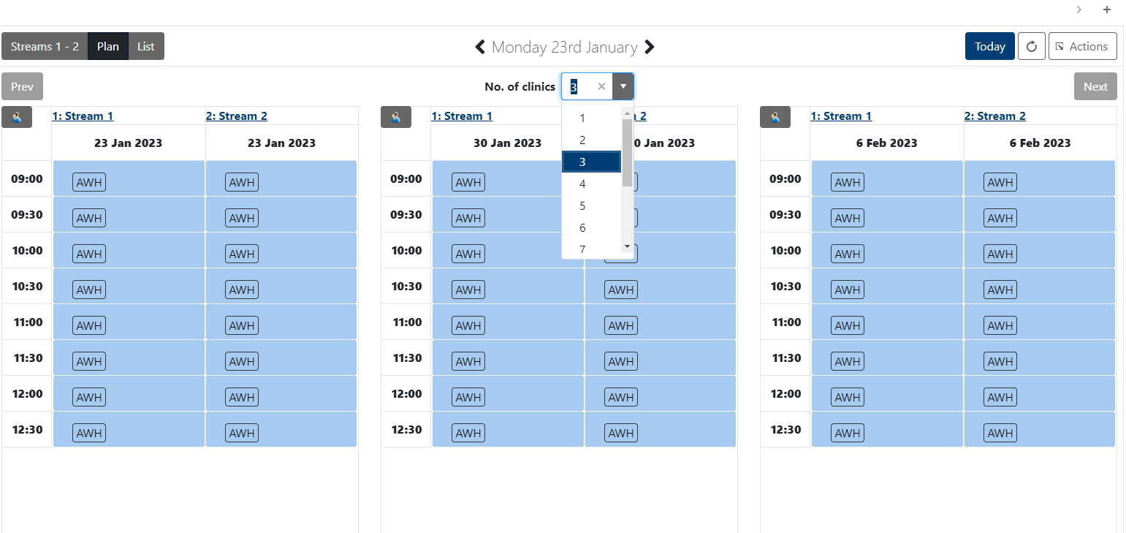
Booking an appointment
To book an appointment in the relevant slot, you now just click on the slot you want to book and select the appropriate option from the presenting menu.
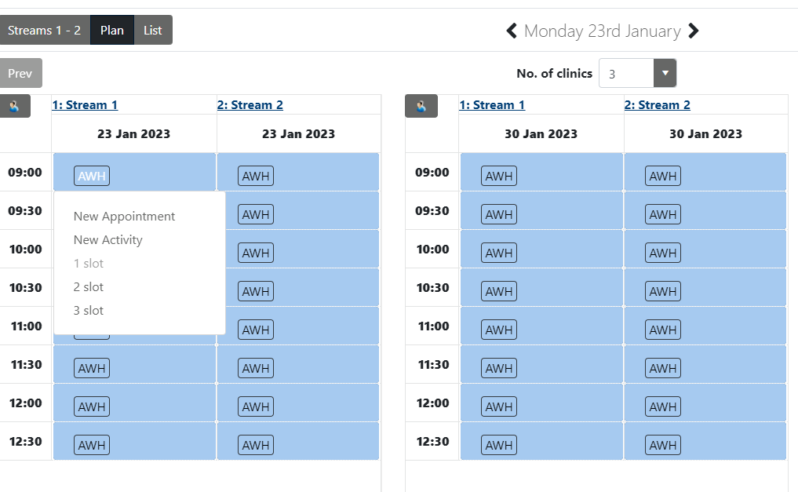
List View functions
If you select the clinic list option, all of the previous functionality associated with this view are now found at the bottom right of the screen.
