Rio 22 LOGIN SCREENS

First Login

When you access Rio for the first time you will be taken to the following screen that will ask you to confirm the authentication method.

- You will need to select Smartcard and then click Continue
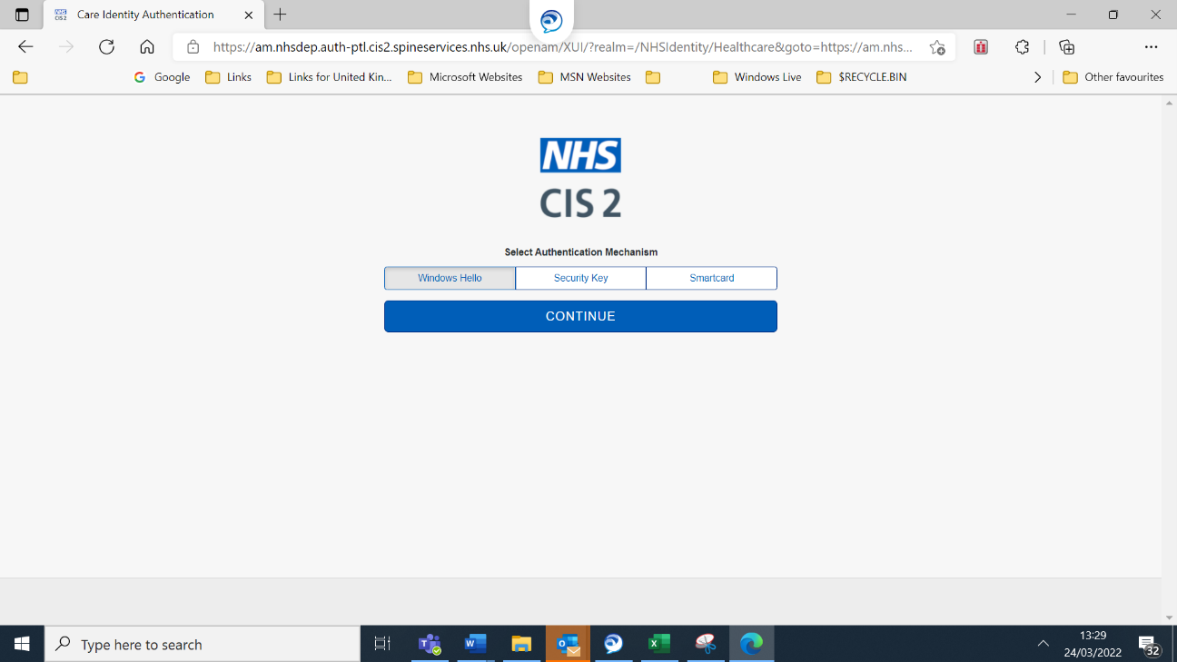

You will then be taken to the Select role screen (if you have more than one Smart Card role), or taken to your Rio homepage
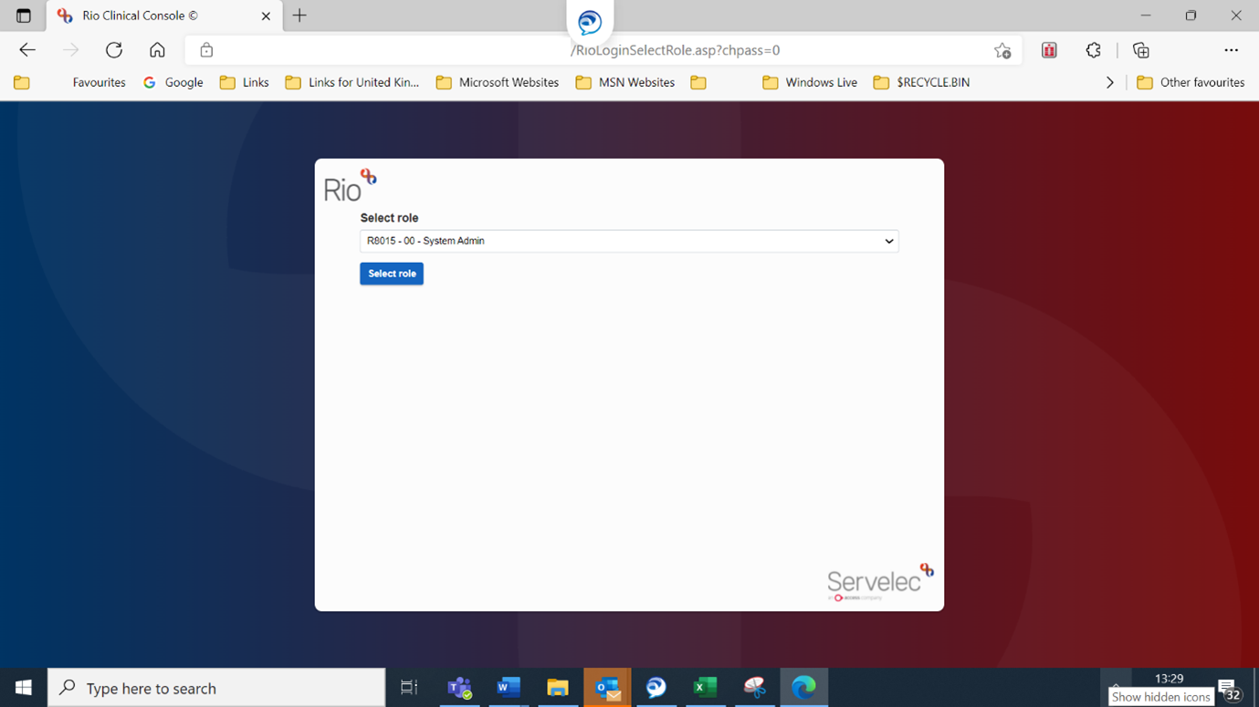

Once you choose a role and click Select role you will be taken to your Rio homepage.

Subsequent Logins

When you access Rio subsequently from the same device, you will not be asked to confirm the authentication method, although the below screen will display momentarily.

You will need to select Smartcard and then click Continue

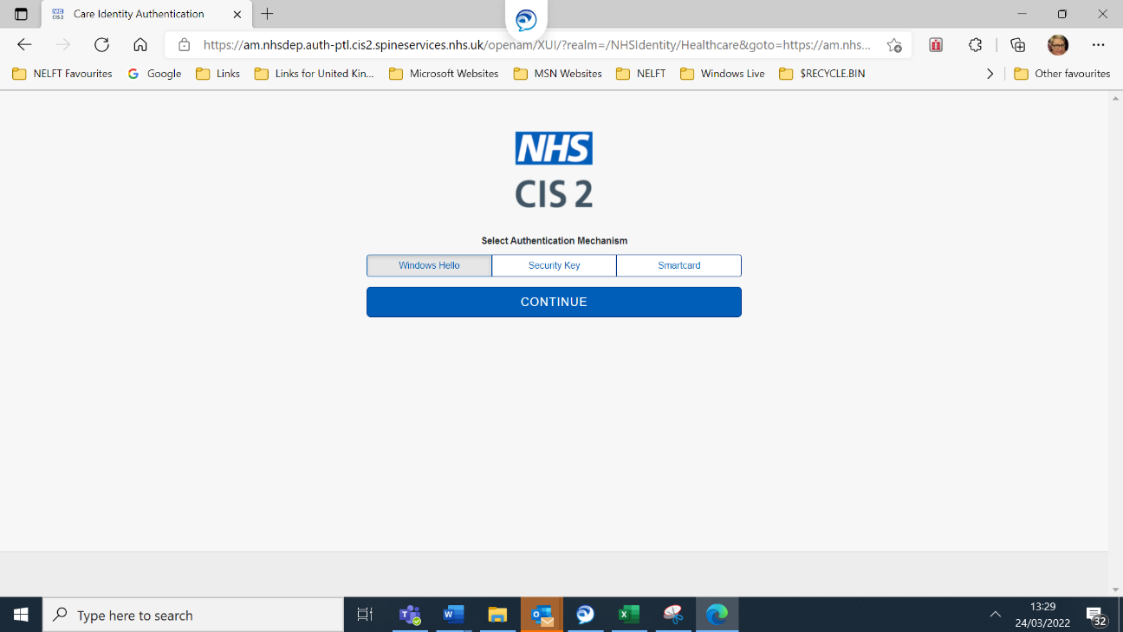
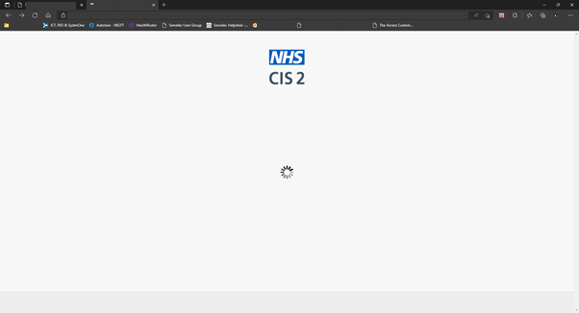

You will then be taken to the Select role screen (if you have more than one Smart Card role), or taken to your Rio homepage

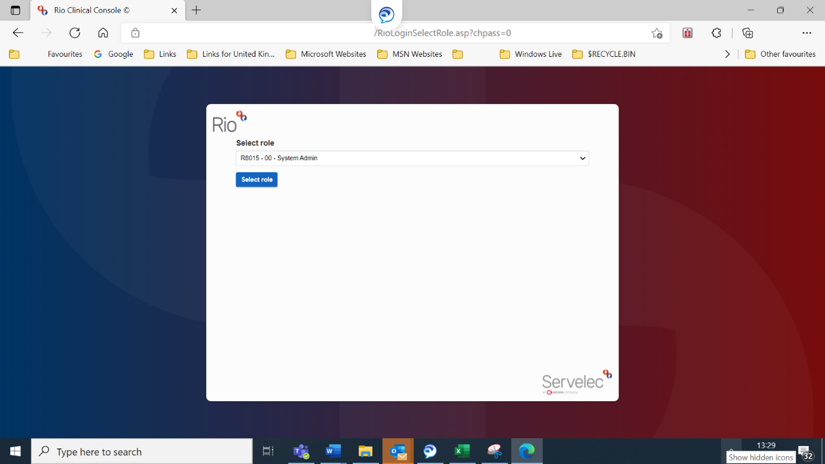

Once you choose a role and click Select role you will be taken to your Rio homepage.

If you select the wrong option at step 1, you will need to reset the browser cache and repeat the steps again.
You do this by
- Click on the ellipse in the top right corner
- Click on settings
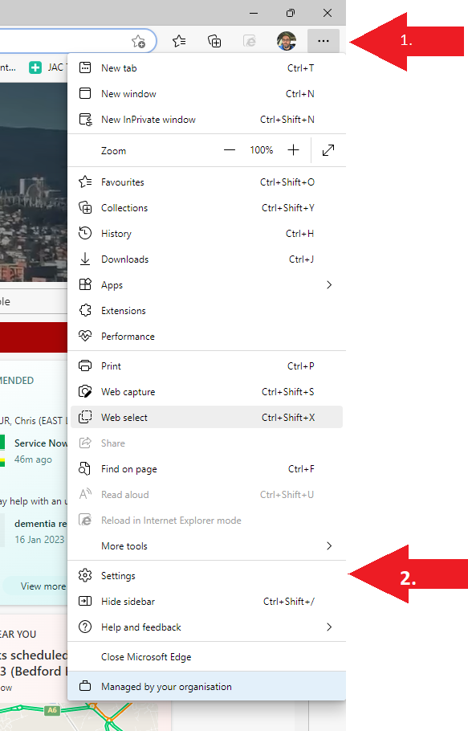

Next select
- Privacy, search and services option
- Under browsing data select Choose what to clear
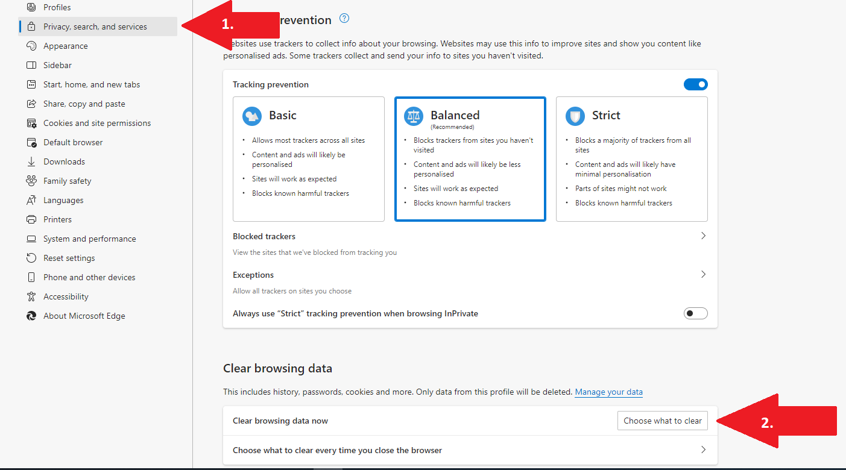

Finally make sure
- the box is ticked for cached images and files
- press the Clear now button

