Accessing patient information when clinical systems are down
What is SCR? SCR is a national system which provides access to information on allergies and prescribed medication held on GP systems. In some cases, more information may be shared dependent on how the GP surgery has set up their system.
You can access the summary care record by clicking on the NHS spine Portal logo on the desktop

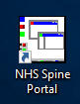

Once there you will need to select the launch summary care record (SCR) link
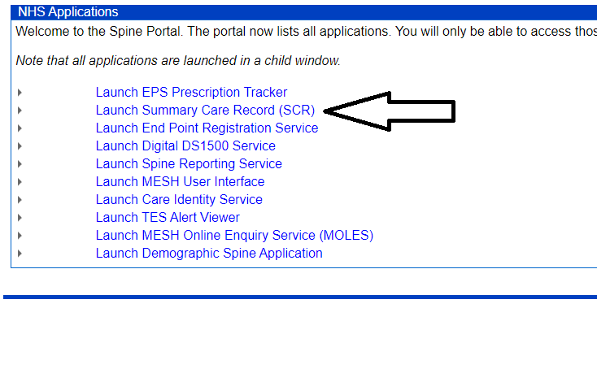

You will then be taken to the Find a patient page where you will need to enter the patients
- Gender
- Surname
- Date of birth

Or their NHS number
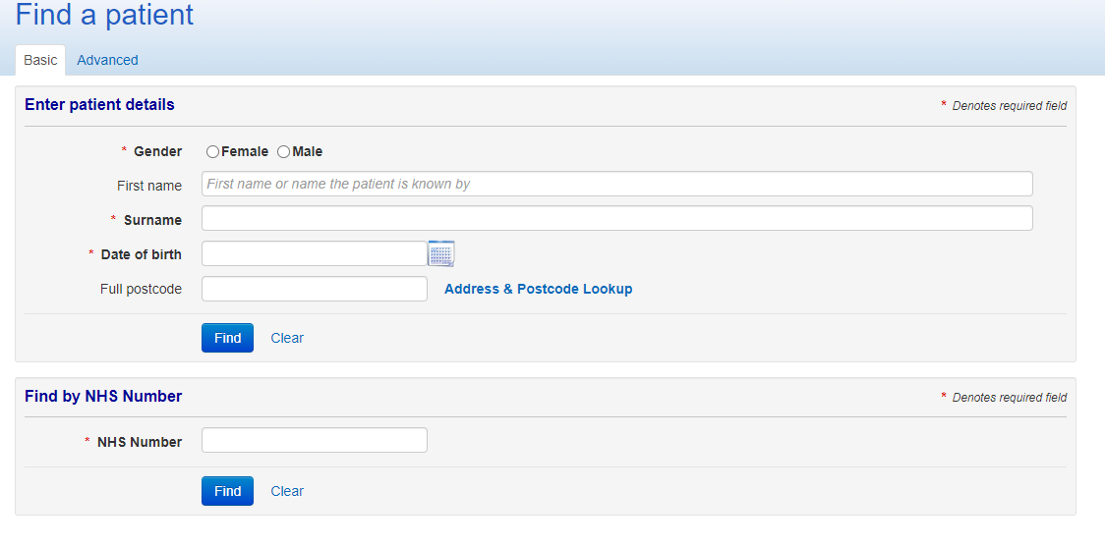

An alternative way of finding patient information is to use the trusts reporting services reports found by clicking on the report’s icon.
From here you will need to go to the patient clinical summary
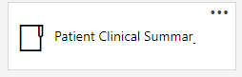
Then Mental Health
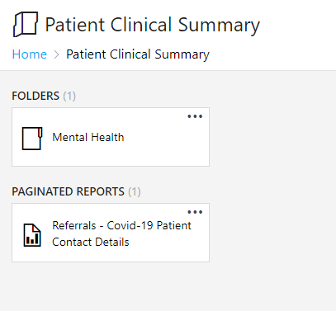
And then finally Patient clinical summary – patient search
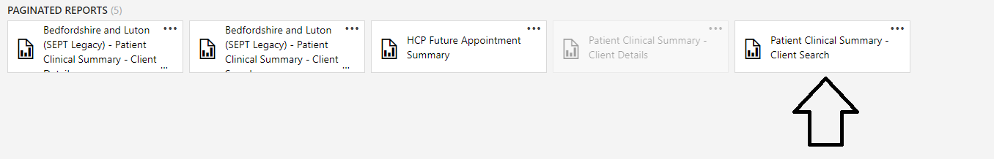

Once there you can search for your patient using their demographic information
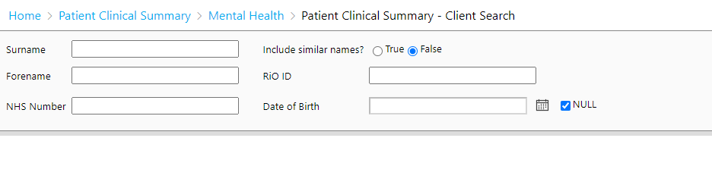
The link below will take you to the relevant page without launching the desktop app as long as you are on site or connected via AnyConnect.
http://svr-dwprd/reports/report/Patient%20Clinical%20Summary/Mental%20Health/Patient%20Clinical%20Summary%20-%20Client%20Search

