New diary page layout and functions

When you first log onto RiO you will notice the change to the page. The visual indicators have gone (this guide will show you how to get them back if you wish) and now there is only one column for booking appointments and activities.
The general functions remain the same, you can change view, you can select other people’s diaries, and you click on the link at the appropriate time to book and appointment or other activity.
The default page remains the daily diary
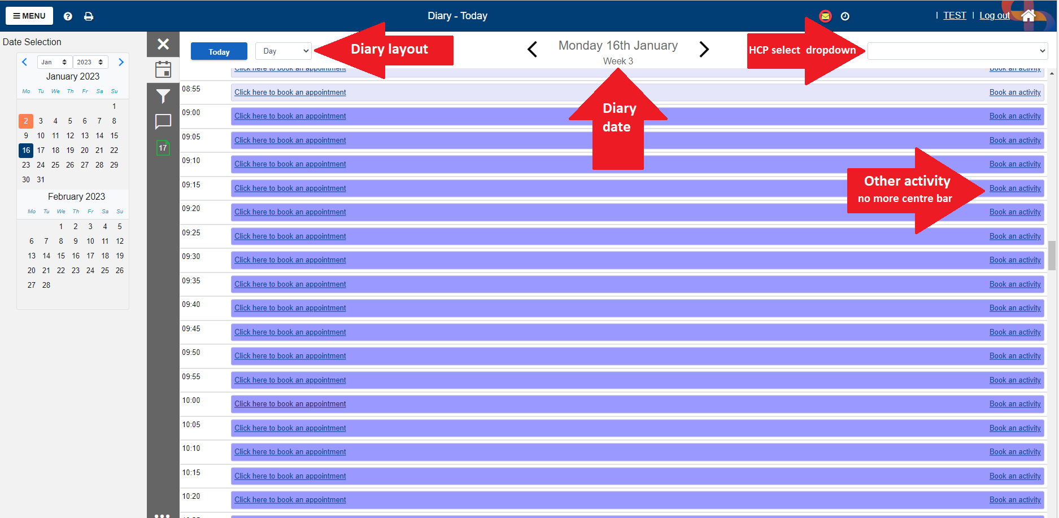

You can also select a weekly view that looks more like the Outlook diary and allows for a visual check of all upcoming appointments
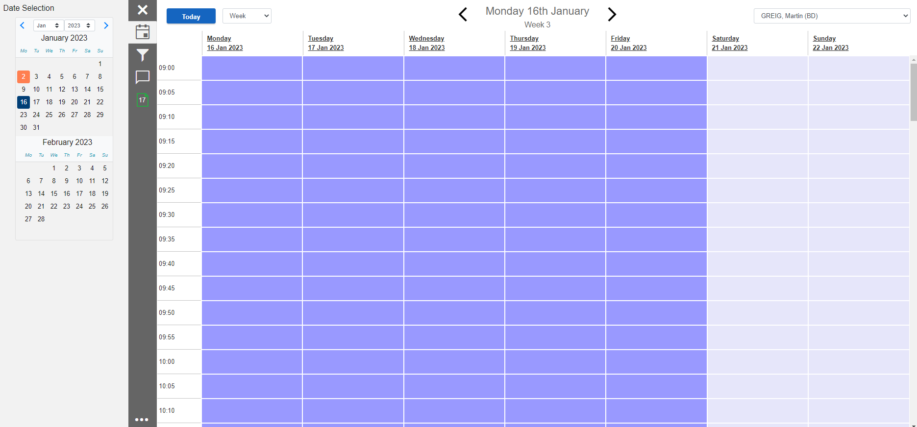
Whilst the month view has gone, you can now select the schedule view that will show all upcoming appointments in date order.
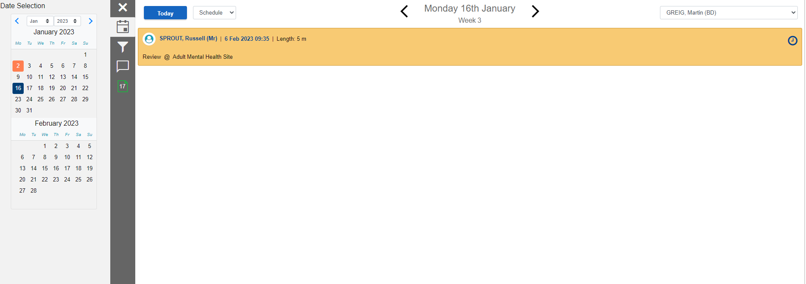

Date selection
The diary on the left had side can be used to select the date you want to go to. No need to select it and click go, just select the date and it will take you there. To get back to todays diary, just click on the blue button.
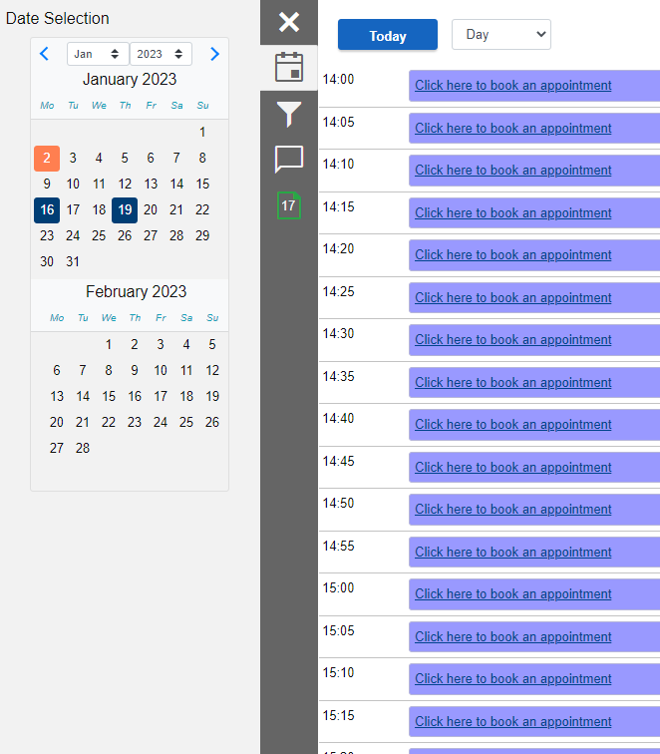
Scratch Pad
This is the bottom of the new menu items. It looks like a green pad and if you click on it then it replaces the diary (remember to select the date you want the appointment first). The previous drag and drop function works to book appointments this way.
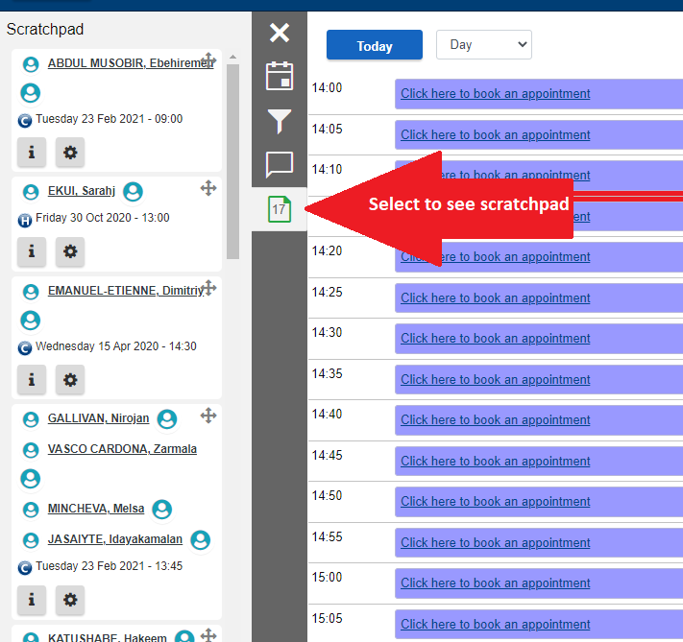

Filters and customisation
By selecting the filter option, you can then customise what you see in the diary. All options are colour coded as in previous versions of RiO. You can click on the “Show visual indicators” box to see them on the main diary page. You can also click on any of the appointment types to ONLY show them in the diary. To remove the filter, just click on the rest option above the key.
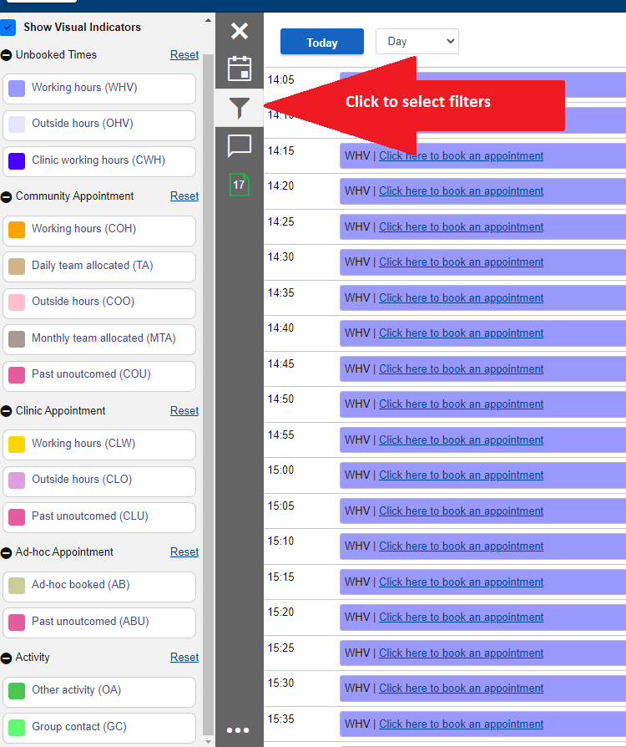

Quick access menu
The final change is the removal of the hyperlinks at the bottom of the page. This has been replaced by the 3dot ellipse. When clicked on it will pop up with 6 fast action menu items. Just click on them to be taken there
