Riverview changes

There has been a number of enhancements to the Riverview section of RiO.
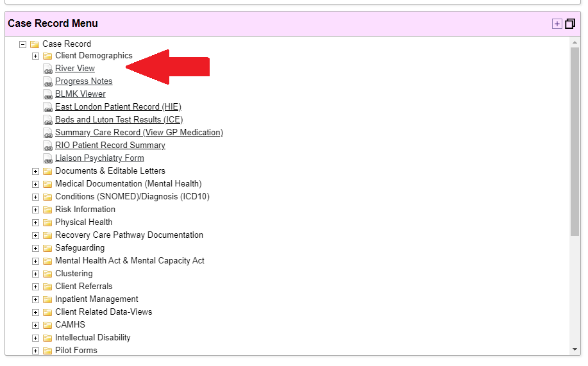
Found by the progress notes, it offers an overview of everything that happens to the patient record.
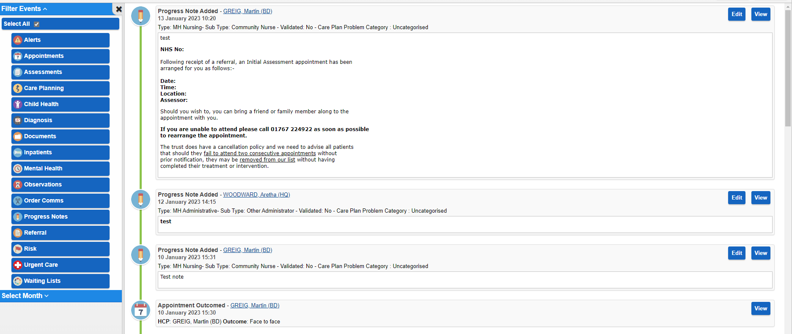

New enhancements
Riverview will now allow you to see the progress notes in the Riverview field. When you click on the edit option you will then be taken to the progress note and you can edit and save any changes.
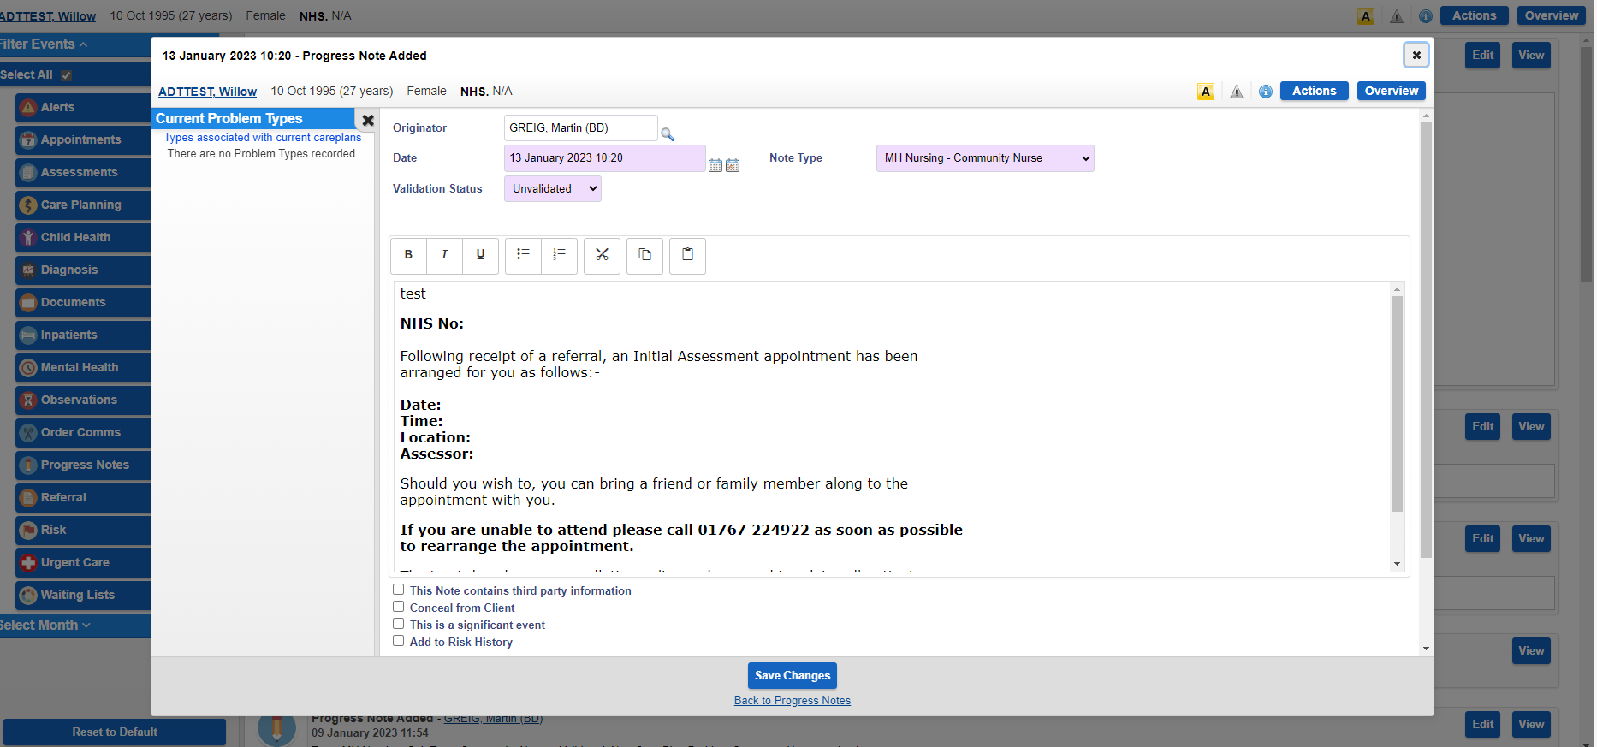

This will also work for any forms. Previously you had to click on the folder and then find the form from there.
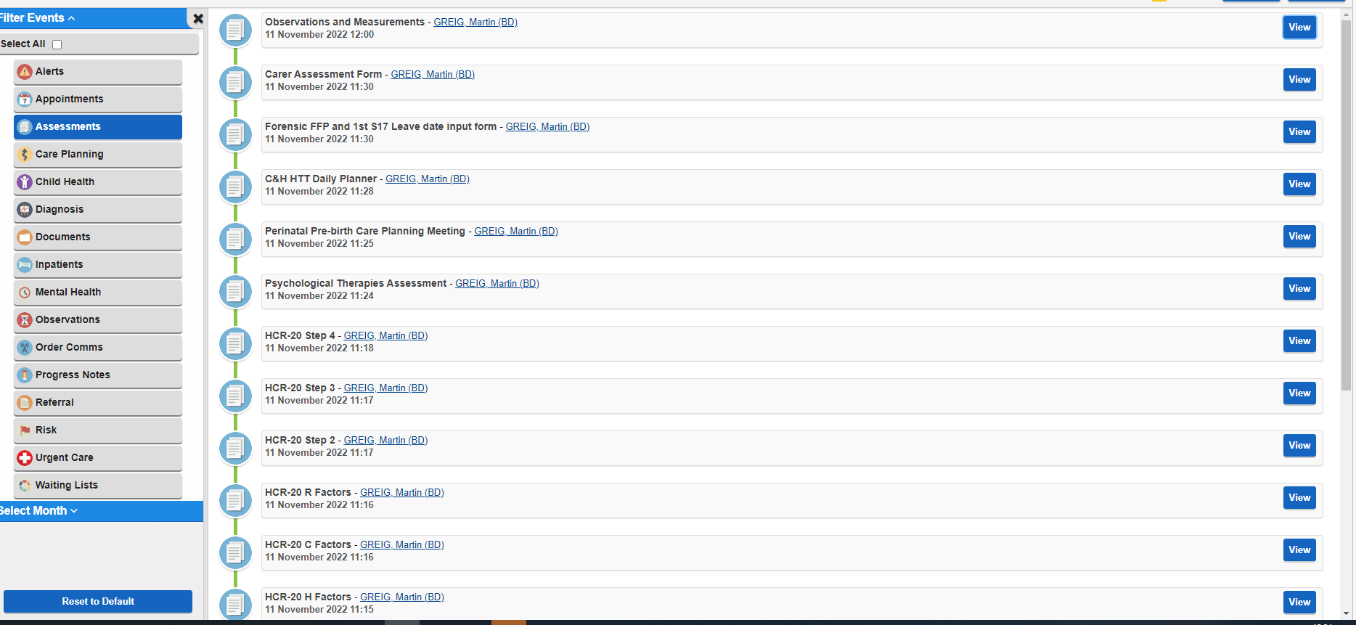

Now you can feel confident you have the correct form you are looking for just by clicking on the view button.
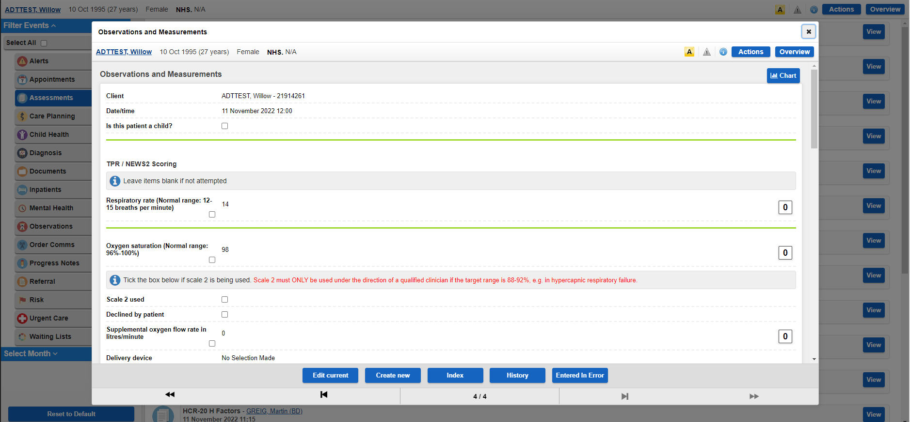

New areas in Riverview include
Waiting lists
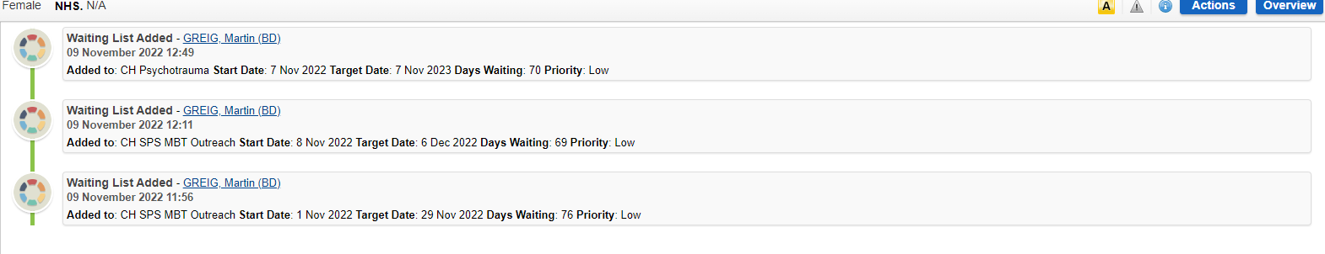

Documents list

