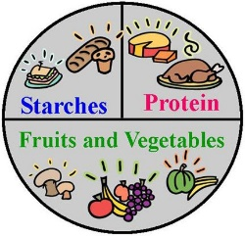
Food List
We have made this list of foods, as explained on our website to act as a guide for parents who have children that may be reluctant to eat a variety of foods. We hope that after using some of the strategies and advice on the website, that you can return to this list and see some progress.
BEFORE starting interventions at home please circle foods that your child will eat more than 2-3 bites of each time they are served that food. There is also space for foods for you to add. Please be specific as this will allow you to see progress within a food group e.g. your child may progress to eating a different variety of bread rather than just having bagels or they might progress with other types of crisps so it is important to list all of the crisps they do eat e.g. quavers, skips, wotsits, Pom Bears.
It is also important to consider the ENVIRONMENT that your child has these foods so e.g. if they do not accept a food (crackers) at home but they do in nursery/school, then discuss this with staff to find out how much they accept, and then add this to your list but make a note that this is in a particular environment. We would also encourage you to find out about what the mealtime environment in those places is like e.g. what is the noise level like? What is the lighting like? What table and chairs are used? What kind of plates/bowls/cutlery are used? Does your child sit with other children to eat?
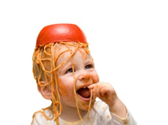
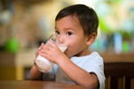
It is also good to think about HOW your child accepts this food.
Some things to think about:
- Does the food have to be presented on a certain plate? (Do they refuse if it is on something else?)
- Does the food have to be cut in a certain way? Or by a certain person?
- Do they only accept this food if it is a certain time of day?
- Is the brand important? If so, make a note of this.
Carbohydrates (breads and cereals) | Protein source | Fruits/Vegetables | Dairy | Comments about environment/way food is presented?
Bread slices (brown or white) | Eggs – what form? | Apples | Milk
Toasted bread | Chicken  What form does this take? (nuggets/sandwich slices) | Bananas | Milkshakes
Other forms of bread e.g. bagels, pitta bread/pizza/crumpets | Pork e.g. sausages, bacon | Avocado | Puddings e.g. custard, yogurts, mousse, semolina
Pasta  Any specifics? | Beef e.g. mincemeat | Oranges | Butters/spreads
Rice and cous cous | Fish | Broccoli
Crisps  Specific crisps?  Popcorn | Beans and pulses e.g. chickpeas | Cauliflower
Biscuits | Lentils | Carrots
Pastry e.g. sausage roll? | Nuts | Melon
Sweet pastries e.g. croissant | Cheese – what form e.g. cheese string? Babybels? Slices of cheese? | Berries
Cakes e.g. sponge, donuts, swiss rolls | Pepperoni | Strawberries
Potatoes – mash/roasted/chips/waffles/hash browns/wedges |  | Aubergine
Breakfast cereals |  | Tomatoes
Oats e.g. porridge |  | Peas
Cerelac and semolina |  | Sweetcorn
Jams |  | Fruit puree sachets

