Top tips -Messy Play with Food
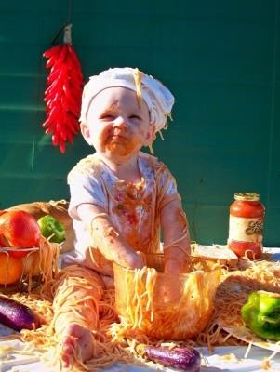
The goal of messy play with food is to introduce food as a fun and non-threatening activity. Playing with food through structured activities will help to begin to desensitise your child to food that they see, hear, smell or touch. Your child will become more confident when interacting with food and it is hoped that this will help prepare him for oral eating.

The plan is to introduce pretend play followed by play with dry foods, then wet foods and finally, foods of mixed textures.

Start at the level that your child will accept and enjoy! Once you are confident that they are having fun with that stage every time, then you can try to introduce some food from the next stage.

Things to Remember:

- Have fun!!
- This is a play activity (not meant for mealtimes)
- Encourage your child to play by showing them what to do – so you should be playing
along with your child!
- Don’t ask your child to eat the food or put in their mouth
- Praise him for looking, touching, holding, smelling, tasting, eating
- Show him you are enjoying yourself playing with the food
- Avoid wiping his hands or face until the end unless he is very upset
- Don’t worry about getting messy!
- Talk about what he/you are doing
- Be Patient – do not rush from one stage to the other.
- If you have introduced a new stage and your child gets upset, step back to the previous stage. Spend more time in the previous stage before trying to introduce the next stage again.
- Use a plastic sheet/shower curtain on surfaces to help clean up easily.
- Involve your child in the preparation and tidy up

Activity Ideas

Pretend Play | 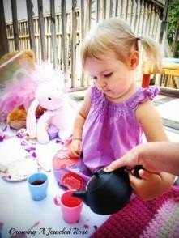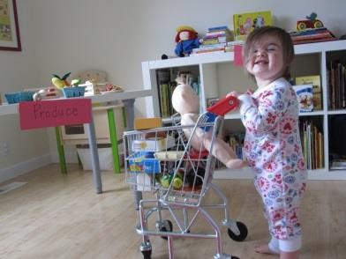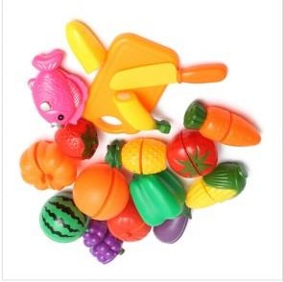
Feely Bag | Put a range of plastic food toys and/or plastic cutlery such as small cups into a bag and encourage the child to get each one out of the bag.
Going Shopping | You could play a ‘pretend’ game of shopping where you go round and put  plastic food into a bag.
Pretend Tea Party | Teddy bears’ picnic; doll’s party
Let’s Cook | Engage the child in making ‘pretend’ cups of tea or prepare food and  offering it to the dolls/teddies.

Drier Foods | 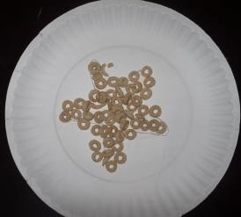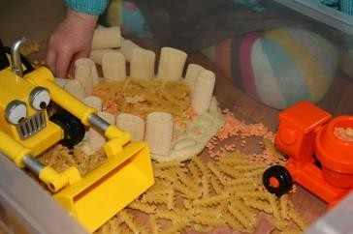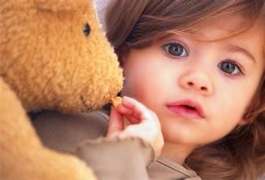
Pouring Games | For example, uncooked rice, pasta, cereals from one cup to another; into a  bowl; scooping them up from bowl to cup etc.
Feeding Games | Feeding Wotsits, Skips, Shreddies, and Cheerios to dolly, teddy, daddy,  mummy etc.
Decorating Games | Decorating a plate or piece of paper with e.g. dry pasta shells/twists,  Wotsits, 100s & 1000s, Shreddies etc. Try sticking them on with e.g. mashed potato or custard.
Play ‘find the ball’ in a bowl | E.g. Cheerios, Shreddies, cornflakes, Wotsits, etc.

Firmer Foods | 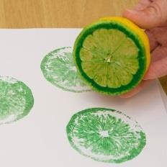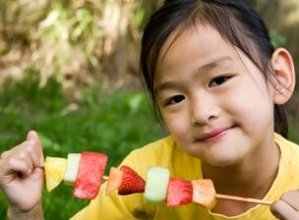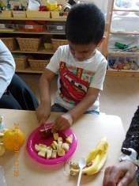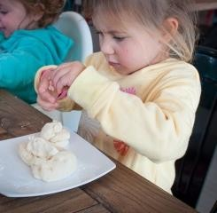
Fruit and Vegetables Prints | Cut a fruit or vegetable in half and sculpt out a shape, dip the shape in  food or paint and print on paper.
Food Faces | Cut out fruit or/and vegetablesinto shapes and place them on paper  plates to make happy faces. You could make the first one as a model for the child to copy.
Food Shapes | Cut out fruit or/and vegetablesinto shapes and place them on paper  plates to make different patterns. You could make the first one as a model for the child to copy.
Fruit/Vegetable Salad | As above, cut the fruit/vegetable into small pieces and let the child put  them in different bowls to make fruit/vegetable salad.
Fruit/Vegetable Kebabs | Cut the fruit/vegetable into small pieces and assemble them on a skewer.
Sorting | You can sort vegetables or fruit into separate bowls or get you child to  help you put the fruits and vegetables in the cupboard or fridge.
Let’s go Shopping | When you go shopping, try to engage your child in this by taking fruit and  vegetables from the shelf and put them in the trolley.
Pretend Play | Similarly, you could play pretend shopping games at home!
Dough | You can engage the child when making pizzas, bread or scones.

Wetter Foods | 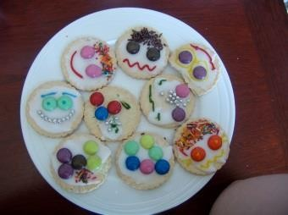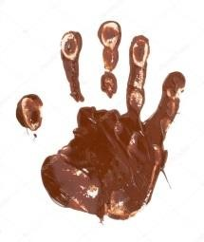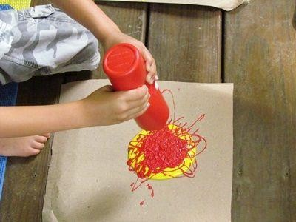
Decorating Biscuits | Decorate biscuits with icing, sweats, hundreds and thousands etc.
Mirror Drawing | Draw on a mirror/table/paper with custard, mayonnaise, gravy, sauce etc.  Stick things to it (Cheerios, chocolate buttons etc.)
Finger Painting | You could make different colours by mixing ketchup and mayonnaise to  make pink or add food colouring to the mayonnaise for finger painting or for making hand prints on the mirror.  Finger painting with chocolate spread, smooth peanut butter (if the child does not have a nut allergy), treacle etc. on a paper plate, card or mirror.
Mixing | Play with a cornflour & water mixture – watch it drip from the spoon, feed dolly, hold it in your hands, add food colouring etc.  Finger painting using the above cornflour with water mix; add food colouring or essences as preferred
Hand Prints | Make hand prints on a mirror or piece of paper – after dipping your hands in mashed potato, custard, and chocolate spread etc.
Jelly Joy | Scooping jelly in and out of containers; cutting out jelly shapes; pouring  jelly into different moulds and putting them in the fridge for later
Pretend Play | Create a jungle background using for example treacle or mashed potatoes  as a swamp, cornflour and water paste as a river etc. Using plastic animals, engage in play such as the animals getting stuck in the swamp or swimming in the river.
Splatter Art | Apply the food to a brush and then splatter on a page

Mixed Wet and Dry  Foods | 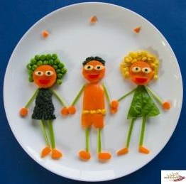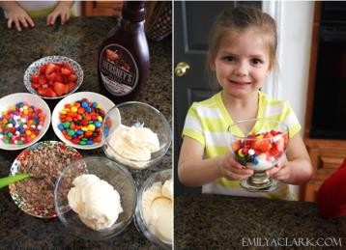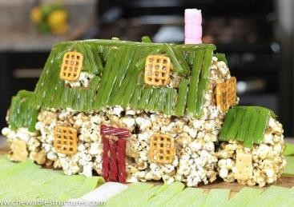
Ice cream sundae | Make different types of ice cream sundaes using various flavours of ice  cream and different toppings including chocolate sauce, chocolate chips, hundreds-and-thousands etc.
Making Faces | Make a face on a piece of cardboard paper, a paper plate or a plastic plate using a variety of food materials. For example, you can use custard,  yoghurt, rice pudding or mashed potato for skin, pasta, spaghetti or desiccated coconut for hair, Smarties, jelly beans or other sweets for features etc.
Creating a jungle, zoo or sea  background | Using mashed potato, chocolate spread, treacle, maple syrup, Golden  syrup, smooth peanut butter (make sure your child does not have a nut allergy), Fu fu, maize, boiled rice, cooked porridge and/or coloured desiccated coconut create different areas of your background. For  example, a ‘swamp’ or sticky area can be created using treacle, maple syrup or Golden syrup and sandy areas can be formed using maize or desiccated coconut. You can then play a game where the plastic animals move through the different areas and get stuck in the muddy areas or jump into the sandy areas.
Building Houses | Create different houses using some of the wet textures such as smooth  peanut butter, custard or mashed potato as a base and stick different types of biscuits as bricks to make a wall, windows, doors and a roof.
Pizza Toppings | When cooking, your child can help put different textured materials as a  topping such as tomato sauce, thin slices of mushrooms, thin slices of meat etc.
Decorating | You can decorate Krispie buns, fairy cakes or digestive biscuits using a  combination of vanilla/chocolate frosting, butter icing, smooth peanut butter or chocolate spread. Use a combination of chocolate buttons, jelly beans, marshmallows, Smarties, hundreds-and-thousands etc. tocreate patterns
Mirror Play | Use a sticky material like treacle, chocolate spread, custard or mashed  potato to make patterns or draw a picture on a mirror. Stick dry food such as cereal and/or firm food such as carrot sticks or pieces of cucumber on the drawing

