First-line Healthy Eating Advice
Preventing Overweight and Obesity

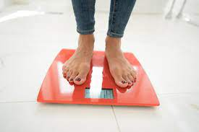 | Overweight and obesity can be related to mood changes, antipsychotic prescription, high calorie menu options, sugary drinks, limited opportunities to prepare meals independently, and self-neglect.
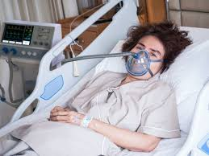 | Being overweight and obese can have serious negative impacts, causing respiratory compromise, diabetes risk, high blood pressure and premature death in extreme cases.
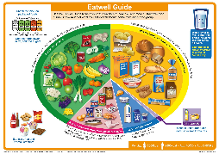 | A balanced diet which limits energy-dense options can reduce the risk of obesity, and in some instances, reverse the effects of metabolic disease.

Healthy Eating Tips

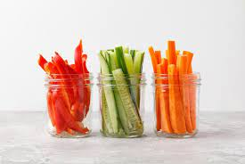 | Choose 100kcal snacks  Low calorie snacks are based on 1 piece of fruit, handfuls of vegetables. Try to cut out snacks where possible, and avoid sugary confectionary
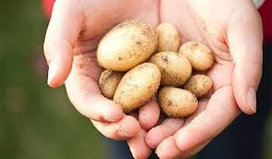 | Reduce portion size  Try to only have 1 fistful of carbohydrate per meal (eg 1 jacket potato, 1 ladle of rice/pasta), and avoid second helpings
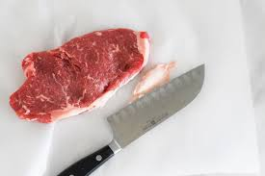 | Remove fat from meat and fish  Choose lean cuts of meat, remove fat from meat (the white part), remove skin from chicken and fish
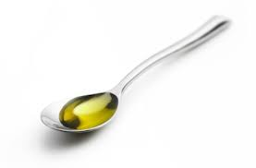 | Avoid fried and fatty food  Cook with 1 tsp oil, spread thinly with butter, remove batter from fish, drain oil with a paper towel
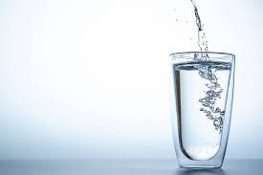 | Cut out fizzy drinks  Replace with flavoured water or no-added-sugar squash
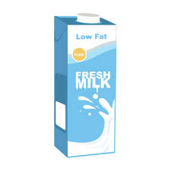 | Choose low-fat dairy options  Check the label, try alternative milks which are fortified with calcium, choose red-top milk, 0% yoghurt, soft spreadable cheese rather than hard cheese, avoid milky drinks with added sugar or syrup
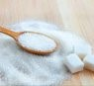 | Avoid added sugar and condiments  Choose sweetener, avoid salad dressing, avoid mayonnaise and ketchup

Healthy Eating Environment

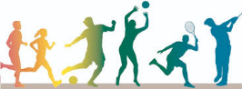 | Keep Physical  Aim for 30 minutes of exercise every day such as walking and record achievements.
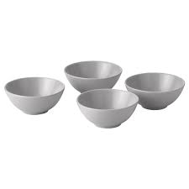 | Use small bowls or plates  For main meals, use a small bowl so that the portion looks bigger, don’t overfill the bowl
ELFT Nutrition Screening Tool.docx | Regular monitoring  Record food charts daily, and weight weekly
Drink lots of water with meals

It can help to fill-up on water rather and reduce portion sizes
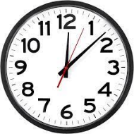 | Protected Mealtimes  Ensure that there is guaranteed time to eat meals without interruption, and really enjoy it. Avoid having snacks outside of mealtimes.

If you have queries about nutrition, please contact an ELFT dietitian

