Medical Devices Policy

Version number : | 5.0
Consultation Groups | Lead Nurses, CHS Policy Alignment Group
Approved by (Sponsor Group) | Medical Devices Committee
Ratified by: | Quality Committee
Date ratified: | 15th March 2023
Name of originator/author: | Medical Device Lead, Deputy Director for Infection Control and Lead for Physical Health, Senior Business Manager
Executive Director lead : | Chief Nurse
Implementation Date : | March 2023
Last Review Date | November 2022
Next Review date: | November 2025

Services | Applicable
Trustwide | X
Mental Health and LD
Community Health Services

Version Control Summary

Version | Date | Author | Status | Comment
01 | March 2008 | DG | Final | Newham PCT Policy
02 | July 2013 | CS | Draft | Trust wide Medical Devices Policy
03 | November 2014 | CS | Draft | Inclusion of software as a medical device. Recognition of the trust wide provider of medical solutions.
04 | July 2019 | BK | Final | Update to include community services and reformatted.
05 | November 2022 | BK  ED  DH | Draft | Update to include key messages, who should read this document, general rule overview, and medical devices SOPS, processes and forms.

Table of Contents

 |  | Page Number
1 | Introduction | 5
2 | Medical Devices Definition  2.1 Introduction  2.2 Single Use Medical Devices  2.3 Key Messages | 6
3 | Purpose | 7
4 | Who Should Read This Document | 7
5 | Scope | 7
6 | General Rules | 8
7 | Implementation and Monitoring | 11
8 | Sale or Donation Reuse | 12
9 | Systems and Management | 12
10 | Duties  10.1 All Staff  10.2 Matrons, Ward Managers and Team Leaders | 13
11 | Training | 14
12 | Prescribers of Medical Devices  11.1 Introduction  11.2 Dispensing Prescribers  11.3 Trust Medical Devices Leads | 15
13 | Decontamination and Cleaning | 16
14 | Replacement of Medical Devices | 17
15 | Operational Managers | 17
16 | Finance Department | 17
17 | Local Log of Medical Devices | 17
18 | Medical Device Maintenance and Repair | 18
19 | Medical Equipment Asset Register | 18
20 | Electronics Software | 19
21 | Tele Health and Tele Care  20.1 Tele Health  20.2 Home Tele Health Systems with Connected Monitoring Devices | 20
22 | Instructions/Guidance | 21
23 | Acquisition of Medical Devices | 21
24 | Equipment Hire | 22
25 | New Reusable Equipment that Arrives into an Area | 22
26 | Maintenance, Repair and Calibration  23.1 Introduction  23.2 User Servicing  23.3 Scheduled Servicing  26.4 Equipment Faults | 23
27 | Decommissioning and Disposal | 24
28 | Risk Assessment | 25
29 | Reporting Adverse Incidents and Disseminating ‘Medical Device Alerts’ | 25
30 | References | 28
31 | Acronyms | 29
32 | Appendices  See page 4 for full list | 30

List of Appendices

 |  | Page Number
1 | Managing your Clinical Equipment | 30
2 | Summary of Medical Devices Management | 31
3 | Medical Device Flow Chart for Reporting on Datix & Contacting Avensys | 32
4 | Local dissemination process for Field Safety Notices for Inpatients | 33
5 | Local dissemination process for Field Safety Notices for CHS | 34
6 | Medical Devices & Equipment Replacement Application Form | 35
7 | Disposal of Medical Devices Standard Operating Procedure | 39
8 | Decontamination of Medical Devices | 41
9 | Medical Device Decontamination Cycle | 42
10 | Medical Devices Process Life Cycle | 50

Introduction

ELFT attaches the greatest importance to the safety and care of its patients and considers it essential to provide effective and safe use of Medical Devices/equipment for patient care. We are also committed to ensuring safe systems of working, safe use of devices, and the provision of training and supervision to this purpose. Healthcare staff play a vital role in ensuring that medical devices are procured safely and used safely and effectively. They are vital for diagnosis, monitoring, rehabilitation and care. Effective management of this important resource is necessary to provide safe and high-quality patient care, clinical and financial governance, including minimising risks relating to adverse incidents.
The Medical Devices Policy is the overarching framework for the East London Foundation Trust (ELFT), which aims to provide clear guidance to staff on the acquisition, use and disposal of all reusable Medical Devices.
The growth of digital health, including artificial intelligence, software, and apps; combined with the implementation of the Medical Device Regulation (MDR), and the UK tech vision to build the most advanced health and care system in the world, all mean that it is an exciting time within the world of medical devices.
However, it must be recognised that failure, design flaws or incorrect use of such systems have the potential to cause patient harm. New digital tools and processes can also introduce new risks to clinical workflows. To help mitigate these risks, NHS Digital’s Clinical Safety Team has developed clinical risk management standards to support the safe design, build, deployment and maintenance of health IT systems. These standards are mandated under section 250 of the Health and Social Care Act 2012 and should be considered and must be met by suppliers and health organisations when commissioning and deploying any new health IT system. They now align with the new medical device regulations for standalone software and thus apply to all health IT systems, including those regulated by the medical device regulations.

Consultation and Ratification

The design and process of review and revision of this policy will comply with The Development and Management of Formal Documents.

The review period for this document is set as default of five years from the date it was last ratified, or earlier if developments within or external to the Trust indicate the need for a significant revision to the procedures described. This document will be reviewed by the Medical Devices Strategy Group and ratified by the Nursing and Medical Director.

Non-significant amendments to this document may be made, under delegated authority from the Medical Director, by the nominated owner. These must be ratified by the Nursing and Medical Director.

Significant reviews and revisions to this document will include a consultation with named groups, or grades across the Trust. For non-significant amendments, informal consultation will be restricted to named groups, or grades who are directly affected by the proposed changes.

Medical Devices Definition

  - Introduction
The Medicines in Healthcare Regulatory Agency (MHRA) 2015 defines a Medical Device as any instrument, apparatus, appliance, material software or other article that may be used on a patient for the purposes of:
- Diagnosis, prevention, monitoring, treatment or alleviation of disease
- Diagnosis, monitoring, treatment, alleviation of, or compensation for, an injury.
- Investigation, replacement or modification of the anatomy or of a physiological process
- Control of conception and which does not achieve its principal intended action in or on the human body by pharmacological, immunological, or metabolic means, but which may be assisted in its function by such means.

Function | Examples
Diagnosis or treatment of disease | - Diagnostic laboratory device  - X-ray machines  - Magnetic resonance imaging (MRI) scanners  - Vascular Catheters  - Dressings  - Surgical Instruments  - Syringes  - Hip replacement implants  - Standalone software for diagnosis
Monitoring of patients | - ECG  - Pulse oximeter  - Apps on mobile device
Critical Care | - Infant incubators  - Blood-gas analysers  - Defibrillators  - Ventilators  - Vascular stents
Improve function and independence of people with physical impairments | - Hoists  - Orthotic and Prosthetic appliances  - Pressure care devices  - Walking aids  - Wheelchairs  - Dressings  - Domiciliary oxygen therapy systems

  - Single Use Medical Devices
Medical devices designated for single use are not to be re-used under any circumstances. MDA 2000 (04) draws attention to the hazards and risks associated with re-processing and re-using single use items.

Single use – means that the manufacturer:
- Intends the item to be used once and then disposed of.
- Considers the item unsuitable for use on more than one occasion.
- Has insufficient evidence to confirm that re-use would be safe.

Single use Medical Devices should not be re-used as this affects the safety, performance and effectiveness of the device, and exposes staff and patients to harm.

  - Key messages
- New medical devices should only be introduced to the Trust through the correct approval and procurement process
- All staff are responsible for ensuring that they are adequately trained and assessed as competent to use any medical device that they are asked to use
- Clinical managers are responsible for ensuring that all staff within their responsibility are suitably and adequately trained in the use of each medical device that they are asked to use
- All medical devices should be kept adequately maintained through a programme of planned maintenance and though prompt identification and repair of faulty devices

Purpose

This policy describes the systems to manage and mitigate the risks associated with the acquisition, deployment, planned preventative maintenance, repair and disposal of medical devices within the organisation. It also gives guidance on user training and competence. Amongst others, this policy is based on the recommendations of the MHRA document Managing Medical Devices – Guidance for healthcare and social services organisations (April 2015). To enable clinical delivery of quality healthcare and compliance with clinical and financial governance, and to minimize risks of adverse events, this important resource requires effective and diligent management. Unless Medical Devices are managed proactively, reoccurrence of adverse incidents may happen. Safe and effective management will enhance the patient experience and reduce the risk of harm.

Who Should Read This

All clinical staff, including senior clinicians and senior managers, because they need to be aware of their responsibilities in respect of delivering the safe use of medical devices
All other staff, who might be required to assist in the use of medical devices, because the same responsibilities and competency requirements apply. Agency, students, visiting staff and apprentice staff also need to read this.
Relevant staff in the Human Resources & Organisational Development Directorate, because they need to be aware of their role in overseeing the provision of training in medical devices.

5. Scope

This policy applies to all Medical Devices purchased by ELFT for use with inpatients and within the community services. It does not apply to Medical Devices purchased by individual patients for their own use. The policy applies to all ELFT staff, in particular those who use Medical Devices and are responsible for the procurement, deployment, maintenance and repair of such devices. The policy acts as a guide to good practice in the management of Medical Devices. It provides information on the “lifecycle” aspects of Medical Devices, from purchasing, deployment, maintenance and repair through to their final disposal.

This policy sets out standards to ensure compliance with Medicines and Healthcare Regulatory Authority (MHRA) Legislation and Care Quality Commission (CQC) and Regulation 15.2 for Medical Devices. Managing Medical Devices (MHRA, April 2015) Managing Medical Devices outlines a systematic approach to the acquisition, deployment, maintenance (preventive maintenance and performance assurance), repair and disposal of medical devices. It is intended primarily for people in hospital and community based organisations that are responsible for the management of reusable medical devices, to help them set up and develop systems that promote the use of the medical devices for safe and effective health care.
CQC Fundamental Standards - Regulation 12 The intention of this regulation is to prevent service users from receiving unsafe care and treatment, in order to prevent any avoidable harm or risk of harm. CQC understands that there may be inherent risks in carrying out care and treatment, and will not consider it to be unsafe if providers can demonstrate that they have taken all reasonable steps to ensure the health and safety of service users, and to manage any risks that may arise during care and treatment. To meet the requirement of this regulation, the provider must take appropriate steps to assure itself that the care and treatment it delivers is safe for all service users. A provider would not be able to meet any of the requirements of this regulation if it did not have access to the necessary equipment or medicines, or did not use equipment safely.
CQC Fundamental Standards - Regulation 15 To meet the requirements of this regulation, providers must ensure that equipment is used for its intended purposes and in accordance with the manufacturer’s instructions. Where the equipment required to deliver care and treatment is owned by the service user, or is supplied by a third party (for example, a different service or an independent supplier) the provider must make every effort to ensure the equipment is suitable for use. If the equipment is unsuitable or not clean, the provider may decide not to provide care and treatment until it is clean (which may mean the provider needs to clean it, if appropriate) and/or suitable, or when replacement(s) are available. CQC would expect the provider to have taken all reasonable steps to ensure that it addressed the issue in a timely manner, and that it made appropriate support or alternative arrangements for the service user to receive their care and treatment.

6. General Rules
All medical device purchases shall be made in accordance with the Standing Orders and Standing Financial Instructions (SFIs) of ELFT.
It is considered to be best practice, as far as practicable, to reduce the variety of makes and models of devices that perform the same clinical task to a reasonable minimum. This allows potential economies of scale for equipment purchases and for associated consumable items. This approach:
- reduces the cost of holding spares
- improves flexibility in management of the Trust’s medical devices, including transferability of devices and trained staff between teams and departments
- reduces training costs
- reduces the risk to the patient and organisation arising from variation in the application of clinical procedures and the associated difficulties in maintaining competence and skills

Decisions regarding the selection and procurement of medical devices are determined through the interaction of 3 disciplines fulfilling the essential functions for this process, Medical Devices Team, Procurement and the Clinical Users. Decisions are reported to the MDSG. Specific duties include:

Medical Device Team
is responsible for:
- operating the Trust’s Capital Bids Replacement Programme (CBRP) and producing regular progress reports for MDSG
- ensuring that all devices purchased are CE (conformée européenne) marked.
- assessing the maintenance requirements of potential new medical devices to help in decision making. This process includes assessment of Pre-Purchase Questionnaires
- seeking advice from the Trust’s Infection Control function and Decontamination Lead prior to the procurement of medical devices

Medical Device Group (MDG)
is responsible for:
- providing assurance to the Quality Committee that an effective and robust system exists across the Trust for the safe use of ‘Medical Devices’ and ‘Patient Safety Alerts’ to protect staff and patients
- enabling a strategic overview of Medical Devices, developing systems and reviewing evidence in monitoring the Medical Devices Policy
- monitoring contracted services
- reviewing significant and complex patient safety and medical device alerts specifically to:
  - agree action plans and where necessary identify a named lead / executive lead to individual alerts.
  - monitor action plans against progress to ensure that action underway dates and deadline dates are met.
  - agree circulation and actions for internal alerts and coordinate communication plans.
  - agree Capital BID Projects in line with the trust replacement programme.
- reviewing and agreeing the process for managing safety alert
- reviewing all serious incidents relating to Medical Devices and where necessary escalate to the internal alert process; support improvements to Medical Device incident reporting

Ward and Department Managers, EPCT Staff
are responsible for:
- identifying and prioritising the need for additional medical devices. Clinical users are requested to contact Medical Devices Team for selection advice, ahead of raising requisitions. Good practice is to define the clinical need, draw up a specification and draw up a shortlist of possible suitable equipment
- ensuring that existing and future budgets are sufficient to fund the lifetime of the proposed additional medical devices
- preparing bids for investment and submitting them to MDSG
- (Within their delegated authority) ordering and procuring medical devices.

Procurement
Reporting to the Director of Finance, Procurement and Performance, the Procurement Team, is responsible for:
- purchasing approved medical devices in compliance with the Trust’s SFls and policies and national guidelines
- supporting Medical Devices Team and MDSG in providing initial cost, running cost and contract information of potential new medical devices to help decision making
- safeguarding the financial and clinical impact to the Trust and recording indemnity records.
- Clinical users are requested to contact Procurement for quotation advice, ahead of raising requisitions.

Medical Devices Rented or Leased by the Trust
Medical devices may be rented to the Trust by an external supplier to fulfil a short term requirement for that device or leased to the Trust as an alternative to direct purchase. The requirement for the device may be identified by Medical Devices Team, Procurement or the clinical users. Liaison of all these parties is important to achieve the most cost effective and clinically appropriate solution to fulfil the device requirement
This includes the following duties:

Medical Devices Team
Is responsible for:
- Advising on appropriate medical devices for rental and assisting with the rental process where required
- carrying out full commissioning checks on leased medical devices
- keeping records of medical devices being leased to the Trust
- Quality Assurance team cascade safety notices and support Medical Devices Team to collate evidence
Procurement
Is responsible for:
- Achieving the most cost effective rental or leasing of medical devices for the Trust
- Processing the rental or leasing requisition and order for medical devices rented or leased by the Trust

Ward and Department Managers, Services managers and EPCT Staff
Are responsible for:
- checking that leased equipment has been correctly accepted and commissioned before use
- notifying Medical Devices Team and Procurement when rental period has finished
- Assisting with the identification of appropriate medical devices for rent or lease

Nurses and individual staff

- Registered practitioners - are professionally accountable for ensuring that they keep their knowledge and skills up to date, taking part in appropriate, regular learning and professional development activities that aim to maintain and develop competence to improve performance (NMC Code 2015)
- Support workers, apprentice and visiting staff - are responsible for maintaining and updating their personal competence under the guidance of their line manager. Working within competencies clearly identified in the Area Specific Training and Competence Logbook and their appraisal, which provides clarity on organisational expectations and delivers a robust structure and process which will enable competence to be assessed, maintained and recorded. Support Workers must strive to improve the quality of healthcare, care and support through continued professional development. (Skills for Care & Skills for Health Code of Conduct for Healthcare Support Workers and Adult Social Care Workers in England 2013)
- Nurses, apprentices, visiting staff, agency and Administrators - must be given adequate support and opportunity to develop competence under supervision prior to undertaking formal assessment of competence against the relevant competency document(s). Assessment can take place during work based induction, as part of the acquisition of new skills, or as a result of the introduction of new medical equipment. Competence should be maintained through practice and reviewed by the individual and their manager during annual appraisal.
Medical Devices loaned to or trialled by the Trust

Medical devices may be loaned to the Trust by an external supplier either to fulfil a short term requirement for that device or to trial the equipment as part of a selection procedure leading to purchase. The need to carry out clinical or user trials of medical equipment in the Trust may be identified by Medical Devices Team, Procurement or the clinical users. However all of these parties must liaise in order that the trial fully achieves its objectives. This includes the following duties:

Medical Devices Team
Is responsible for:
- carrying out pre-use checks on loaned medical devices
- keeping records of medical devices being trialled in the Trust
- ensuring indemnity is in place before equipment use

Procurement
Is responsible for:
- recording indemnity agreement information relating to medical equipment on trial in the Trust

Ward and Department Managers, services
Are responsible for
- notifying Medical Devices Team and Procurement when trial or loan period has finished
- checking that equipment has been checked and indemnified before use

Trust Staff agreeing to the loan or trial of devices may find themselves personally liable for losses if they do not follow the above policy 6 | Duties in Relation to the Medical Devices Asset Register

7. Implementation and Monitoring
The policy is posted on the Intranet with promotion via the Communications team to inform of the implementation of the policy with a request to managers to disseminate as appropriate in their areas. As this is a review of a policy, no specific training will be arranged.
All staff should be aware of their responsibilities/accountabilities with regards to Medical Devices which should be discussed both at local inductions and annual appraisals thereafter.
The local quality groups will monitor the implementation of this policy and report on the performance of medical equipment management via the Quality committee.
The Directorate Quality group will produce an end of year report for the Trust Virtual Medical Devices Group and specific to compliance as defined by the steps outlined in this policy.
8. Sale or Donation for Reuse
Medical Devices regulations only apply to medical devices being sold for the first time. There is no legislation which specifically covers the resale or reuse of medical devices or equipment.

However used medical devices are still required to be safe under other national provisions including:

- Consumer Protection Act
- Sale & Supply of Goods Act
- Health & Safety at Work etc Act
- Trade Descriptions Act
- The Electrical Equipment (Safety) Regulations
- Unfair Contract Terms Act

Before any sale or transfer of equipment takes place, both parties should be clear about their legal liabilities (this must include the MDM):

- The purchaser may inherit the liability for previous incidents or unpaid hire purchase costs if appropriate contracts are not used.
- A vendor may request the purchaser to sign a disclaimer, to the effect that the vendor has no future responsibility for the equipment.
- Product may be sold “as seen” or “buyer beware” (caveat emptor) in which case liability is usually transferred to the purchaser.
- The vendor may retain contributory negligence.
- In general, the more comprehensive the information supplied by the vendor, the lower will be the inherited liability. The Medical Devices Regulations require manufacturers to provide all the information needed to verify whether the medical device can operate correctly and safely, plus details of the nature and frequency of the maintenance and calibration needed to ensure that the device operates properly and safely at all times.
- It is considered good practice to extend this principle to the sale or donation for reuse of equipment, as such the following information should be supplied to the new owner of any equipment resold, donated, or otherwise transferred to new owners: A clear statement that the equipment is being resold/ donated
- A certificate of decontamination
- All user manuals and training requirements
- Full details of maintenance and servicing requirements
- Service history and manual
- Usage history
- Quality assurance test details
- Safety updates, including any MHRA and manufacturer documents, that have been released since the medical device was first supplied
- The Medical Devices Manager to keep all other records for the period 10 years

NOTE: If any of the above information is not available, it may not be appropriate to pass the equipment on to a new user

9. Systems and Management

The Trust board is responsible for ensuring there are effective systems in place within the organisation.
The Chief Nurse is the executive responsible for Medical Devices; this responsibility is delegated to the Lead nurse on Physical Health.
The Operational Directors through their service managers are to ensure that those services directly managed by the Trust adhere to the standards set out in this policy.
Directors and Operational Managers are to ensure that all professionals are appropriately trained and competent in the use of the medical device and that training is formally recorded, reviewed and updated regularly.
The Associate Medical Director of IT & Systems will ensure that all new software applications that ELFT uses are reviewed in line with MEDEV 2.1/6 in order to assess whether or not it is likely to constitute a Medical Device
The Quality Committee oversees Medical Devices including adverse incident reporting and actions required on MHRA’s Medical Devices alerts and manufacturers field safety notices. The Quality Committee oversee the development and implementation of the Medical Devices policy.
The Medical Devices Team oversees that the Trust adheres to and is compliant with MHRA regulations and to ensure that the requirements of Regulation 16 of the Health and Social Care Act 2008 (Regulated Activities) Regulations 2010 are being met “to ensure the safety, availability and suitability of equipment to protect service users and others who may be at risk from the use of unsafe equipment by ensuring that equipment is provided for the purposes of carrying on of a regulated activity”.

10. Duties

  - 10.1 All Staff
Medical devices and equipment are used every day by most healthcare professionals to support the care and treatment of patients. All relevant staff have a role in ensuring that all equipment is used safely and for the purpose that it was intended for. It is the responsibility of all users of Medical Devices to ensure:
- It is suitable for its intended purpose.
- Its use is properly understood by the professional user.
- That staff are trained and competent in operating and decontaminating the device safely.
- That it is regularly maintained and safe for use.
- That it is procured following safe processes.
- That it is properly decontaminated.
- That staff ensure that patients who are issued Medical Devices understand how to use the equipment safely.
- The selection of the correct device for the intended use whilst ensuring that the device is appropriate the patient’s condition.
- That the storage of all devices is practically safe to avoid unnecessary damage.
- That any battery-operated device is charged up where required.
- That any disposables are appropriate and safe to use.
- The agreed procedures and protocols are followed at all times.
- That the knowledge of how to respond a device and in the event of a problem and in order to reduce any risk to the patient.
- That all safety related incidents and potentially harmful products are reported, via Datix.
10.2 Matrons, Ward Managers, EPCT Staff and Team Leaders
- Will only purchase equipment have approved by the Medical Devices Team and through the Trust E-Procurement Department processes.
- Will ensure Medical Devices that meet the requirements of the care users are available and as a minimum they are to ensure the availability of mandatory Medical Devices
- Will highlight any deficit in equipment availability to their line manager and Service Director.
- Will ensure that all new equipment is reported to the Avensys department for acceptance testing and inclusion onto the audit and Medical Devices asset register.
- Will ensure decommissioned equipment is reported to the Avensys department for removal from the asset register.
- Will ensure that there is a logbook in each area that contains accurate records for each piece of equipment.
- Will ensure that contractual warrantees on specific items of equipment are kept safe.
- Will ensure that all new equipment is installed correctly and all the appropriate documentation logged into a logbook that is available to present as evidence for audits or inspection by both internal and external inspectors.
- Will ensure that there is provision of alternative facilities in the event of equipment failure.
- Will ensure that all staff are made aware of the Medical Devices Policy requirements and their responsibilities in this respect.
- Will ensure that staff know how to report faulty equipment.
- Will be competent to assess the competence of clinical and non-clinical staff in the use of Medical Devices.
- Will ensure that Medical Devices (including resuscitation equipment) is checked and records are available as evidence for audit or inspection from both internal and external inspectors.
- Will have systems and processes in their environments to ensure that Medical Devices are clean; all Medical Devices will have a cleaning schedule that is available as evidence for audit or inspection from both internal and external inspectors.
- Will ensure that equipment is replaced, when it is: worn out beyond economic repair, damaged beyond economic repair, clinically or technically obsolete, requiring repair but spare parts are no longer available.

11. Training

Ward managers and service leads are responsible for identifying training needs within their areas of responsibility and are responsible for organising appropriate training.
Ensuring that users of equipment have completed training and verifications of competency.
The purchaser will ensure there is a process of training in place to train staff in the use of new equipment.
Medical devices must only be used or operated by a member of staff who has been suitably trained and who feels confident and is competent to do so.

The Trust recognises that it has a role to play in ensuring that members of staff are able to use the available reusable medical devices and equipment for the benefit of themselves and the patients in their care.
The training and update requirements for the use of reusable medical devices and equipment apply to all staff. This applies to permanent members of staff and temporary staff e.g. bank, agency or locum staff. No member of staff may operate any reusable medical device or equipment unless they and their immediate supervisor are confident that they are completely competent in its use.
Staff competency will be evaluated by a senior member of the ward or department team, or other competent person delegated to do so by the ward or department manager.
All staff must attend any training courses that the Trust requires before they use any reusable medical devices and equipment. Until they have successfully completed the identified training, and have been assessed as competent, they may only operate the reusable medical devices and equipment under supervision.
Staff must be trained in the decontamination processes required for the equipment to the appropriate level required for the individual equipment.
All staff are required to comply with the Health and Safety at Work Act 1974 (HSWA 1974) and the Provision and Use of Work Equipment Regulations and Lifting Operations and Lifting Equipment Regulations 1998 (PUWER-LOLER), which place a statutory requirement on employers and employees to ensure that they are trained to use any work based equipment. The importance of medical equipment training is also identified by the MHRA, NHSLA and the CQC. Reusable medical devices and equipment are work based equipment and are included in the Trust’s mandatory training matrix.

12. Prescribers of Medical Devices

  - 12.1 Introduction
As Medical Devices become more sophisticated and frequently used, there are risk implications for the healthcare professionals and patients who use them. Prescription of a Medical Device is the process that ensures only the most appropriate item of equipment is given to a patient or carer as part of an overall treatment plan. Clinical risk is reduced by permitting only appropriately trained healthcare professionals to prescribe a Medical Device for use by patients.
The person prescribing will need to have the knowledge and skills to ensure that:
- An appropriate device has been selected.
- The device has been appropriately maintained and decontaminated.
- It has been adjusted (if necessary) for the individual patient.
- The patient or carer is educated and supported in its use.
- Appropriate documentation has been completed. Competency in the correct use of Medical Devices will ultimately result in a reduction in clinical risk and the delivery of high-quality care.

  - 12.2 Dispensing Prescribers
Prescribers who also dispense are responsible for maintaining a database that includes:
- Manufacturers details.
- Serial number.
- Warranty details.
- Date of distribution.
- End of life.

Prescribers are also responsible for:
- Registering the equipment with the appropriate provider company.
- Informing the GP.
- Ensuring the patient is trained.

  - 12.3 Trust Medical Device Leads
- Monitor Medical Devices and other related contracts.
- Provide reports to relevant subcommittees as appropriate.
- Work with the Corporate Central Alert System Risk Manager on relevant alerts.
- Escalate to Trust board and MHRA as necessary.
- Agree processes for appropriate decommissioning and disposal of items not currently under agreed contracts.
- Liaise with Directorates on rolling programme of equipment replacement. Planned replacement of major items should be incorporated into business plans.
- Will run a quarterly report on all Medical Device Datix to identify themes and lessons learnt and create and annual review of key themes to inform future work plans.

13. Decontamination and Cleaning

Medical devices may serve as vehicles for the transmission of infection to susceptible hosts. Decontamination is the combination of processes (including cleaning, disinfection and sterilization) used to make a re-usable Medical Device safe for further use on patients and handling by staff. The effective decontamination of re-usable Medical Devices is essential in reducing the risk of transmission of infectious agents.
- All staff will clean/decontaminate any Medical Device after use in accordance with the manufacturer instructions.
- Staff will ensure that all disposable items for single use are disposed of after single use in the appropriate manner.
- Staff will ensure that all Medical Devices have a cleaning schedule and that is available as evidence for audit or inspection from both internal and external inspectors.
- Appropriate arrangements must be in place for the decontamination of all Medical Devices in service within the Trust. This includes contaminants from the normal use of the equipment, and from any other related activity that might affect it.
- Details of the arrangements and processes relevant to the decontamination of Medical Devices can be found in the Trust’s Infection Prevention and Control Policy.

For support and advice about decontamination, contact the Infection Prevention and Control Team. Elft.infectioncontrol@nhs.net

14. Replacement of Medical Devices

All devices have a set working life based on the technology and continuity in availability of spares/support from manufacturer. When a new device is accepted on inventory, seven years of life expectancy is recorded unless specified by the manufacturer or supplier based on the guaranteed availability of spares and services. Therefore, the database should highlight all the devices due for replacement based on the set parameters.

15. Operational Managers

Operational managers of healthcare services delivered on wards and departments within the Trust are the designated “owners” of a wide range of medical equipment and devices. They are responsible for ALL devices in use on their areas at all times. Therefore, as owners of this equipment, it is their responsibility to ensure that all their equipment is maintained adequately to the manufacturer’s recommendations and timeframe. Advice on equipment maintenance issues can be sought from the Medical Device Lead.
Ward Managers and Service Leads must ensure an inventory of all medical equipment/devices owned or managed by their Department is maintained. This information will be centrally coordinated by the Medical Equipment Servicing contractor in order to enable the organisation to take appropriate action following manufacturer’s recall or the issue of hazard warning notices. The inventory will ensure that Medical Devices are examined annually for electrical safety, calibrated and/or serviced as necessary and that scheduled maintenance takes place.

16. Finance Department
The Finance Department will ensure that Medical Devices are procured in line with Trust Standard Financial Instructions.

They will also monitor and report on spending to the Board as follows: -
- New equipment.
- Replacement equipment.
- Repairs to equipment
- Consumables.
- Contract maintenance.
- Contracting and service level agreements with external stakeholders.
- Will ensure that contracts specify adherence to MHRA regulations

17. Local Log of Medical Devices
All clinical areas will have a logbook that details the lifespan of all equipment within the clinical area. This will include:
- Documentation on receipt of an item.
- Certificates of calibration.
- Warranties.
- Servicing history.
- Repairs history.
- Decontamination certificates if the item has been returned for repair outside the organization.
- Cleaning and checking schedules.
- Certificate of disposal.

18. Medical Device Maintenance and Repair

The majority of medical equipment maintenance in the Trust is provided by contracted company Avensys. Clinical departments will maintain a local inventory of all equipment serviced and maintained via external service contracts. It is their responsibility to ensure that all equipment is maintained to the manufacturer’s recommendations and timescales.
The planned preventative maintenance system utilises a computerised register of medical equipment, which highlights equipment that is due for maintenance, the servicing that is required and also the timescale for completion of the work. All maintenance and calibration are as per manufacturer’s guidance and timescales. It is therefore important for users, subject to their immediate clinical needs, to make their equipment available upon request for routine maintenance at any given time.
The contracted company has a duty to inform the local Operational Manager and the Medical Device Lead if there are any issues with servicing and equipment maintenance. Random audit will be carried out by the Medical Device Lead to ensure the contracted companies are compliant with contract terms and conditions and specifications. In the event of a fault occurring with an item of medical equipment, the user must remove the equipment from use and inform the appropriate maintenance provider.
Under no circumstances must users attempt to repair the equipment themselves. It is important for users to be mindful of the fact that items of re-usable medical equipment intended for repair and used in the treatment of patients may become contaminated with hazardous substances during use.

19. Medical Equipment Asset Register

All service areas should maintain accurate local registers of devices which are able to demonstrate their maintenance/service history from acquisition through to disposal. The maintenance contractors will maintain an external database (accessible by ELFT staff) of all ELFT Devices and agree on an annual program of planned Preventative Maintenance to ensure devices are safe and accurate. All medical equipment will be entered onto the equipment management database by the Contractor Avensys detailing the following:
- Unique identifier for service organization.
- A full history, including date of purchase and where appropriate, when it was put into use, deployed or installed.
- Service schedule (if applicable, and to include calibration).
- Maintenance schedule.
- Supplier and manufacturer.
- Serial number.
- Purchase date and warranty period.
- Any specific legal requirements.

20. Electronics Software

The Medical Device lead with support from the Lead for Physical health will co-ordinate and evaluating prospective physical medical devices that contain any software element, including internet of things (IoT) devices. They will co-ordinate with relevant IT and clinical experts to evaluate the safety of these devices and that they comply with relevant medical device regulations. In addition, they will ensure that appropriate cyber security requirements are met in collaboration with IT and the information governance lead. The directorate proposing a project will prepare a report outlining benefits and risks together with any mitigations in place and deployment plan for submission to the Digital Strategy Board for approval.
The Director of IT & Systems will ensure that all new software applications that are ELFT uses are reviewed in order to assess whether or not it is likely to constitute a Medical Devices.
All products that may be considered Medical Devices, including clinical information systems that are potentially subject to the Medical Device Regulations, shall undergo a process of review prior to deployment by the Trust.
An initial assessment will be made as to whether the device has no software element, includes software or is solely software.
In the case of products that are or include software liaise with Medical Device Team to check whether a software application is or is not likely to constitute a Medical Device. Medical software that will be reviewed as to whether compliance is necessary includes Clinical Information systems, Decision Support Software, Information Systems, Communication Systems, Web Monitoring Systems and in Vitro Diagnostic Systems. If compliance appears to be necessary, the Trust will seek appropriate documentation from the manufacturer and in cases of doubt will rely on the opinion of the Medical and Healthcare Products Regulatory Agency (MHRA) as to the applicability of the regulation.
Where the certified medical device consists solely of software (within for example the electronic health record, or a web application), the use of the certification of this device will be incorporated within the Clinical Safety Case for that digital solution and will fall under the remit of the IT clinical safety programme. Please contact IT Clinical safety office/intranet: https://www.elft.nhs.uk/intranet/digital/our-staff-and-digital/how-do-i-start-digital-project
A responsible individual will review the supplier safety documentation, review the device with respect to potential risks and offer remedial consideration for the mitigation of risk, consider user and staff documentation, consider training requirements and produce a proposed deployment plan covering these matters.
Before deployment of these systems the Medical Devices group will in conjunction with IT and information governance evaluate the safety of these systems, provide guidance on mitigating risk and ensure that cybersecurity vulnerabilities that might compromise patient safety are addressed.

Digital First
We know that technology and data is transforming the way we live our lives; from mobile phones and laptops, to the apps and online services we use daily. That’s why our aspiration - to improve the quality of life for all we serve - can be achieved through becoming a ‘Digital First’ organisation.
As a frontrunner in the digitisation of the NHS, ELFT is transforming the way it works. ‘Digital First’ at ELFT means:
- Engaging and empowering service users in their own wellbeing
- Using technology to solve problems, free up staff time and improve experience of care
- Joining up patient data safely, so the Trust can go paperless
Our Staff and Digital
Meet the team and our Digital Champions. Find information and links to training as well as resources on cybersecurity, digital project management, setting up a new starter, printing and mail services, remote network connection, video meetings and webinars.
Our Clinical Staff and Digital
Find information and resources on electronic patient records, shared care records, Thalamos Digital Mental Health Act, digital dictation, e-prescribing and virtual consultations.
Our Service Users and Digital
Find out more about the People Participation Digital Community, the patient-facing portal, Patients Know Best and Ali, ELFT's virtual agent. Find out how you can bring a digital tool to service users.
Suspicious of an email? Think it could be phishing or spam? Report it to elft.cyber@nhs.net.
How do I start a Digital project?
Have an idea for a digital project? Came up with an app, device or system that could improve experience of care, or reduce workload? Are you launching a new service, or moving buildings? ELFT’s Digital Programme Management Office is at your service!
If your service has an idea for a digital solution which you want to set up, or a new system you would like to buy, the first step would be get in touch with the Digital PMO at: elft.digitalpmo@nhs.net. The Digital PMO will be in touch with next steps and documentation that needs to be completed to support your request. You will be supported during this process and a dedicated Digital Project Manager will be assigned to you.
You can get help with:
- Engaging suppliers
- Assessing data protection and compliancy
- Reviewing the cyber security of your project
- Finance and budget assessments
- Procurement
- Directing you to the PPDC, to work with service users & carers
- Connecting you with the Digital Communications Lead
NB: if you are looking to get a new mobile phone/laptop, set up a new starter, or any other team requests please continue to log requests through the IT Service Desk Portal.
Contact us at elft.digitalpmo@nhs.net

21. Tele Health and Tele Care

  - 21.1 Tele Health
Tele health is the delivery of health services or information using telecommunications technologies. It uses devices to monitor people’s health in their own home including monitoring vital signs (blood pressure, heart rate, blood oxygen levels, and weight). The monitoring includes blood glucose as well. The data can then be transmitted to a healthcare professional who can observe health status without the patient leaving home. Increasingly, this latter function could be placed on a server and software could be used to interpret the patient data. This could be considered a Medical Device.
Software used for Tele health purposes may or may not be classified as a Medical Device, under MEDEV 2.1/6 (f.4) Home care monitoring, wired or mobile. Standalone software intended for archiving patient results or for transferring results from the home environment to the healthcare provider is not an IVD device. The results are available, readable and understandable by the user without the intervention of the software, also (d.1.3) Home care monitoring, wired or mobile. The telecommunication system (mobile, wireless, wire, etc.…) is not, as such, a Medical Device. Tele health systems that manipulate and act on data transferred can be regarded as Medical Devices.
In the case of Tele health services offered by the Trust, the Florence simple Tele health system is not classified as a medical device. And the Medical and Healthcare Products Regulatory Agency (MHRA) advises that they found Flo most likely NOT to be a Medical Device, as it is effectively a transport and storage medium for raw data and most importantly does not de-skill the work of a clinician, by e.g. embellishing data or performing clinical algorithm calculations. The MHRA’s advice is not definitive as to whether a device is or is not a Medical Device as this is something that can be tested in a court of law; nevertheless, as it is the regulatory authority, it is the best source of advice currently available

  - 21.2 Home Telehealth Systems with Connected Monitoring Devices
MHRA requires individual devices to be CE marked as Medical Devices but does not require a system to be CE marked as a Medical Device unless it is placed on the market as a single product. Items such as the hub and possibly the motion detector (depending on the claims of the manufacturer) are not likely to be CE marked Medical Devices as they do not have a medical purpose. However, the software that runs on the server and interprets or interpolates the patient data is likely to be a Medical Device and would be regulated as such.

22. Instructions/Guidance

All users, end users and technical staff must have access to manufacturers’ instructions.
It is the responsibility of each Directorate to ensure user manuals are current for the device(s) in use in their area and that revised user manuals are requested when devices receive software upgrades after repair or service.
Each device will have a risk log with appropriate mitigations in the use of the device available as part of the deployment of the solution.

23. Acquisition of Medical Devices

The selection process takes into account care objectives and priorities of the healthcare organisation and the needs of the patients. The process should consider whole life costs and follow the national acquisition policy and recommendations, including any regional or national aggregation of procurement where this results in best value for money.
The acquisition process should take the needs and reasonable preferences of all interested parties, including those involved in the use, commissioning, decontamination, maintenance and decommissioning of all Medical Devices.
The procurement department should ensure consumables are cost effective for the life of the device if applicable. This would include the cost of the device and its maintenance and the lifetime costs of consumables.
The procurement process should take account of the Trusts standardisation procedures, furthermore; Safety, quality and performance considerations are to be included in all acquisition decisions.
The recommendations of the MHRA and other appropriate bodies are to be considered before selection and acquisition.
Procurement should ensure that all acquisitions meet local regulations.
Procurement must comply with ‘Information Asset Privacy by Design Procedure’ policy and ensure that cybersecurity vulnerabilities are addressed.
Where new equipment is to be sourced and a shortlist has been reached, equipment may be demonstrated or given a trial period of use and the opinion of all intended users considered.
Before equipment is used for demonstration or trial, the Medical Devices department will be consulted to ensure there is an indemnity procedure in place.

24. Equipment Hire

Hire agreements must be checked to ensure that arrangements for insurance, maintenance, liability and the processes to be followed in the event of a fault are adequately covered.
Devices on loan from manufacturers or other organisations, including NHS organisations, should be subject to a written agreement which defines the device management requirements and responsibilities and liabilities.
Delivery receipt and pre-use procedures for hired and loan equipment should be the same as those for purchased equipment, unless otherwise specified in a written agreement.
An Asset register should be kept locally for these devices including any servicing logs.

25. New Reusable Equipment that Arrives in an Area

All reusable Medical Devices must be acceptance checked by the EBME department on arrival to an area for:
- Relevant documents,
- Instructions, compliance and calibration certificates, warranty details,
- Damage, appropriate CE markings, serial numbers for inventory requirements,
- Functional ability of the device,
- Electrical basic safety check prior to use,
- Device calibration prior to use,
- Installation requirements.
Equipment that has never before been used in an area, e.g. that staff are unfamiliar with, will require the senior nurse for that team to liaise with manufactures regarding a training programme for all relevant staff.

26. Maintenance, Repair and Calibration

  - 26.1 Introduction
All Medical Devices require routine maintenance and/or calibration at a frequency recommended by the manufacturer whether it be checks by the user, maintenance by contracted company or maintenance by the manufacturer.
Maintenance The daily responsibility for the regular maintenance of Medical Devices is with staff.
Medical Devices will have one or more schedules for maintenance, servicing and calibration.
These are covered below.
  - 26.2 User Servicing
User servicing is the responsibility of the user (staff or patient/client). This may involve daily checks e.g. syringe drivers, glucose monitoring machines, DEFIBs, regular cleaning, record of checks and any findings. Users must have the appropriate training before carrying out these checks.
  - 26.3 Scheduled Servicing
Scheduled servicing is planned and will be carried out by Avensys on behalf of the Trust. Avensy has a database of all equipment used within the Trust that requires servicing and calibration. Newly purchased items are added to the database by Avensys. It is the responsibility of the manager to ensure that this information has been passed to Avensys.
Avensys is responsible for servicing, maintaining and calibrating all Medical Devices within the agreed schedule. This is monitored via a contract group held between the Trust and Avensys every two months. The lead for this on behalf of the Trust is the Physical Health Lead Nurse. Problems or issues with this contract will be reported to the physical health lead.
  - 26.4 Equipment Faults
Medical Devices and equipment that becomes faulty must be removed from service and isolated as soon as practicably possible. Faulty items must be labelled as such and tagged or marked to ensure they are not inadvertently put back into service and they must also be cleaned in accordance with the Decontamination Policy and have attached a Declaration of contamination status form. The fault should be reported to Avensys 01562 745858
Avensys will arrange for an engineer to investigate the fault and report back to the manager for appropriate action.
If the equipment has become faulty and caused injury (or could have done) to a member of staff or a patient/client this must be reported through the completion of an incident report and maybe subject to a report to the MHRA – see Incident reporting and management procedure.
It is the responsibility of each individual to ensure the equipment they use is in a serviceable state prior to clinical use. Serviceable state would mean there is no visible damage to the equipment, the equipment passes pre-use checks, the equipment hasn’t been reported as faulty and that the service due date hasn’t expired. All maintenance procedures must be in line with the manufacturer’s recommendations.
The expected life cycle of a device/piece of equipment should be held in the database and regularly reviewed against the usage, maintenance and repair record to see if the end date needs to be adjusted. Heavy use or irregular maintenance may reduce the life cycle; limited use may extend it. Manufacturers recall of a device will take precedence over other considerations.
Factors to consider include:
- Whether the device is damaged or worn out beyond economic repair.
- Its reliability (check service history).
- Clinical or technical obsolescence.
- Changes in local policies for device use.
- Absence of manufacturer/supplier support.
- Non-availability of correct replacement parts.
- Non-availability of specialist repair knowledge.
- Users’ opinions.
- Possible benefits of new model (features, usability, more clinically effective, lower running costs).
- Lifecycle of the Medical Device.

27. Decommissioning and Disposal

Decommissioning aims to make equipment safe and unusable, while minimising damage to the environment. Equipment deemed unfit for use should be decommissioned. This should include decontamination, making safe and unusable. This is to ensure that inappropriate persons do not use the equipment and expose themselves or others to hazards. Users should consult the Medical Devices Team or the Estates department for advice before decommissioning commences. Disposal of electrical/electronic equipment should comply with the Waste Electrical and Electronic Regulations 2013. Consult the Medical Devices Team or the Estates Department in the first instance. Some waste products need specialised disposal.
Examples include:
- Wastes containing certain metals (e.g. Mercury above 3% and some batteries)
- Oil wastes.
- Wastes from coolants.
- Radioactive waste.
- Healthcare waste from human or animal origin.
- Human waste from care, diagnosis, treatment or prevention of disease. Where applicable, equipment should be decontaminated before disposal or transfer to a third party and supplied with a certificate of decontamination. When returning Medical Devices to the manufacturer at end of life, or when transporting devices, ensure that they are appropriately packaged and secured. Issues that should be addressed include: strength of packaging materials, protecting sharp edges and ensuring that the device cannot get damaged during transit. Legislation applies to the transport of goods by road and rail.
- The carriage of dangerous goods and use of transportable pressure equipment (amendment) regulations 2011
- Chemicals (hazard information and packing for supply) regulations 2009
- The radioactive material (road transport) regulations 2002
- If a device stores patient identifiable data, this should be securely erased or hard drives removed and sent to IT for destruction when the device is decommissioned. Data on any device should be forensically unrecoverable.

28. Risk Assessment

Risk assessments are to be conducted or reviewed as appropriate, prior to new devices being accepted into Trust service and prior to being allocated to a service user in the community for individual use. These risk assessments should be implemented.
- post incident review
- change of model or function
- as advised by the Trust or legislation
Risk assessments are to be logged – a copy retained within the service and are to be brought to the attention of “users” at the earliest opportunity.
Medical Devices are to be risk assessed, by a competent person delegated by Service Lead and documented to ensure that any hazards and risks identified are appropriately recorded and mitigating actions taken in relation to such as: usage (including assembly and disassembly & accessories), training, maintenance, servicing, decontamination and disposal associated with a particular device.

29. Reporting Adverse Incidents and Dissemination Medical Device Alerts

For all incidents involving Medical Devices that occur within the Trust. In the first instance the Staff are to ensure that any patient and/or staff wellbeing or safety is not compromised, then immediately remove the item from use. The department manager must then be informed as soon as possible after the incident. Staff must complete a Datix Incident form and retain the device should an investigation be required. There is also a requirement to report incidents involving Medical Devices to various external agencies where it is implicated in a serious incident. Once equipment involved in an incident has been removed from use, users must do the following:
- Quarantine the suspect device, together with any associated consumables.
- Inform Medical Device Lead as soon as possible after the event.
- The equipment should clearly label ‘FAULTY EQUIPMENT – DO NOT USE’.
- The department manager should then liaise with the Medical Device Lead and the Physical Health Lead who will determine if the equipment is safe to use.
Anyone can report concerns about a medicine or medical device to it via its Yellow Card scheme.
The National Patient Safety Alerting Committee (NaPSAC,) set up 2018 is developing common standards will also have a role in ensuring alerts are received and takes identified actions. These standards and thresholds agreed by NaPSAC will underpin CQC’s inspection of National Patient Safety Alerts and any regulatory response to non-compliance.
The role of NaPSAC
- Developing common standards and thresholds for National Patient Safety Alerts
- Developing a single recognizable consistent format for National Patient Safety Alerts
- Overseeing the development of a process to ensure all alert issuers reach these common standards and thresholds.
Anyone can report concerns about a medicine or medical device to it via its Yellow Card scheme.
Central Alert System (CAS) from the Medical and Healthcare Product Regulatory Agency (MHRA) and National Patient Safety Agency (NPSA).
The Trust generates and also receives medical device safety alerts from external agencies such as the Medicines and Healthcare Products Regulatory Agency (MHRA), the National Patient Safety Agency (NPSA) and others through the Central Reporting System. Corporate Central Alert System Risk Manager distributes to the relevant leads, ensuring they are disseminated throughout the organisation and followed up on the implementation of actions required by information received from alert notices and recorded on ‘Datix Alerts Module’. The Risk manager provides a report to the Trust Medical Devices group and Quality Committee of all alerts received via CAS for compliance/governance purposes. This includes monitoring responses within the given deadlines and transmits all responses to the Medical Devices Agency (DH) and provides monitoring data to Clinical Commissioners. All staff are responsible for ensuring they read and act upon any safety alerts that are distributed to them.
ELFT’S response to these alerts is monitored by both the CQC and Commissioners who can impose financial penalties on the organisation if these alerts are not actioned within the deadlines stated in the alert. The policy for the Alerts system outlines the procedures and process for providing assurance to the trust that alerts have been actioned as documented a recorded the ‘Datix Alerts System’.
Managing Medical Devices, (April 2014) a Crown Publication, which includes the following:
“Acceptance” Testing – When a new medical equipment is delivered to the Trust an “acceptance” test is to be carried out to ensure that the equipment is correct and complete on delivery, the test will identify any fault with the equipment and any damaged caused during transit Manufacturer’s Instructions – The “User” should have access to the manufacturer’s operating instructions and DME&P&P to the manufacturer’s service / maintenance instructions.
Handling / Storage – Information will be made available to “Users” on the appropriate methods for handling / storing Medical Equipment & accessories. There will also be guidance on how internal batteries should be charged

Contractors have the delegated responsibility for maintaining medical equipment/ devices within ELFT will report any actions taken using a unique device identifier, the identifier will allow the device to cross referenced with contractor databases by their asset numbers for fault repair, audit and Planned Preventative Maintenance (PPM)
- Maintain a trust-wide Medical Devices asset register for tracking purposes.
- Respond to requests for repairs of faulty equipment.
- Carry out ‘acceptance testing’ on all new devices/equipment prior to use
Planned Preventative Maintenance (PPM) – The PPM always follows the manufacturer’s guidance with the identified service organisation documented within the equipment database, which will also point to the level of maintenance support required.
The User is responsible for routine maintenance on the equipment i.e. regular cleaning, preparation for use and performing User checks.
Damaged / malfunctioning medical devices – must be removed from service immediately, clearly labelled and reported to the DME&P&P help desk, who will organise the necessary action. Decontamination – All Medical Devices requiring PPM, repair, removal, loaned, disposal etc. must be decontaminated. The decontamination procedure will follow the manufactures / supplier’s instructions or the Trust Decontamination Policy before release by the “User” or clinical service.
Equipment Disposal – The manufacturer will provide details for the best methods for waste disposal, the process will be carried out in compliance with the Trusts: Standing Financial Instruction, the Waste Management Policy and the Waste Electrical and Electronic Equipment (WEEE) Regulations 2006.

30. References

Associated Documents and Supporting References
- Post-Brexit UK domestic legislation https://www.legislation.gov.uk/eu-legislation-and-uk-law
- Controlled Assurance Medical Devices Management Standard (Decontamination section) DH, social services and public safety https://www.health-ni.gov.uk/publications/reporting-compliance-controls-assurance-standards
- CQC Essential Standards of Quality and Safety – regulation 15: Premises and Equipment https://www.cqc.org.uk/guidance-providers/regulations-enforcement/regulation-15-premises-equipment
- Department of Health, Medicines and Healthcare products Regulatory Authority – Managing Medical Devices – Guidance for healthcare & social services organisations January 2021 https://assets.publishing.service.gov.uk/government/uploads/system/uploads/attachment_data/file/982127/Managing_medical_devices.pdf
- Health and Safety at Work Act 1974 http://www.hse.gov.uk/work-equipment-machinery/purchaser.htm
- Regulations Sl2008 http://www.mhra.gov.uk/home/groups/esera/documents/regul atorvnews/con049176.pdf
https://www.legislation.gov.uk/ukdsi/2012/9780111522752
- Medicines and Medical Devices Regulations – What you need to know https://www.gov.uk/government/publications/report-a-non-compliant-medical-device-enforcement-process/how-mhra-ensures-the-safety-and-quality-of-medical-devices
- Medical Devices Regulations 2002 – Regulation 16 of the Health and Social Care Act 2008 https://www.cqc.org.uk/guidance-providers/regulations-enforcement/regulation-16-receiving-acting-complaints
- (Regulated Activities) Regulations 2012 http://www.legislation.gov.uk/ukdsi/2012/9780111522752 https://www.gov.uk/government/publications/report-a-non-compliant-medical-device-enforcementprocess/how-mhra-ensures-the-safety-and-quality-of-medical-devices
- MHRA2006 – Directive 2007/47/EC. Transposed into UK law by the Medical Devices Amendment
- Regulations Sl2008
- Code of Conduct for Healthcare Support Workers and Adult Social Care Workers in England https://www.skillsforcare.org.uk/Documents/Standards-legislation/Code-of-Conduct/Code-of-Conduct.pdf

31. Acronyms

- CAS Central Alert System
- DCB Data Coordination Board
- DPIA Data Protection Impact Assessment
- DPO Data Protection Officer
- ICP Infection Prevention and Control
- IFU Instructions for Use
- IGSG Information Governance Steering Group
- MDM Medical Devices Manager
- MDG Medical Device Group
- MDT Medical Device Team
- MHRA Medicines and Healthcare products Regulatory Agency
- MIA Master Indemnity Agreement
- OGC Office of Government Commerce
- QOB Quality Operations Board
- Cleaning Physical removal of organic matter and infectious agents.
- Disinfection Reduction in viable infectious agents.
- Sterilization Render an object free from all viable infectious agents.
- Decontamination A combination of processes which removes or destroys contamination so that infectious agents or other contaminants cannot reach a susceptible site in sufficient quantities to initiate infection or other harmful response.

Appendix 1 – Managing Your Clinical Equipment

Has your equipment been serviced? Is it fit for use?

For All Patient, Clinical or Medical Equipment Please call Avensys
01562 745858
“Who do I call when medical equipment breaks?”
AVENSYS- 01562 745858
For further queries about your equipment email: Medical Devices INBOX (elft.medicaldevices@nhs.net)

“Who do I call for Hoists, Hoist slings?”
Call Avensys 01562 745858
When reporting a fault please give:
- a brief description of the problem
- the asset number, make, model and serial number of the item – check the Asset Tag for this and your name, location and telephone number
- Let them know if the problem is urgent or not urgent. This allows them to schedule their attendance appropriately.

Appendix 2 – Summary of Medical Devices Management
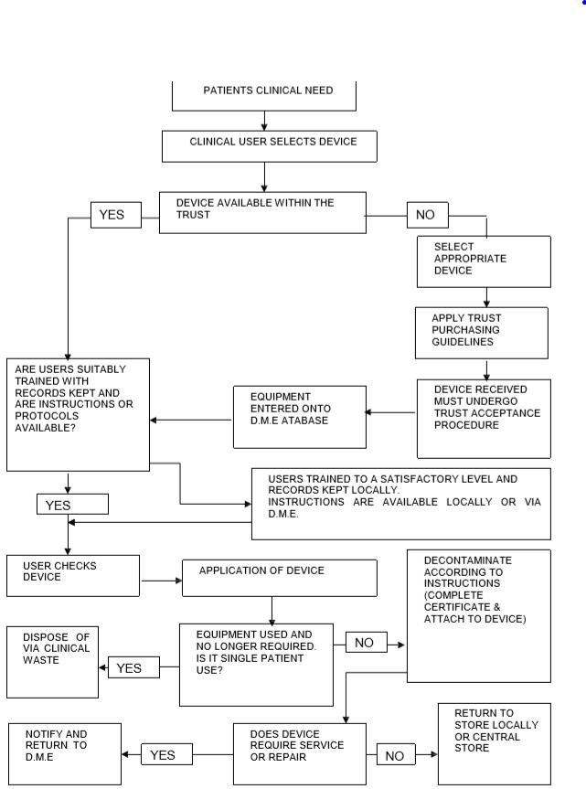

Appendix 3 – Medical Device Flow Chart for Reporting on Datix & Contacting Avensys
Type: Care & Treatment
Category: Medical Device/ Equipment
Subcategory: Medical Device or equipment failure
Outcome: Make appropriate selection

Complete ‘Incident Classification Section’ as:
Complete ‘Patient safety information’ section
Complete ‘Reporter details’ section
Log in to Datix
Once Datix is complete, notify your manager and elft.medicaldevices:nhs.net
Incident manager will be your line manager / Local manager
Complete the remainder of the Datix form

Call Avensys 01562 745858

A brief description of the problem
the asset number, make, model, serial number your name,
location and telephone number,
State if problem is urgent or not urgent. This allows them to schedule their attendance appropriately

Appendix 4 – Local dissemination process for Field Safety Notices for Inpatients

Medical Device Team to email Alert and Feedback Form with relevant action points to *Matrons and Lead Nurses.

For information only
For action
Matrons and Lead nurses to distribute to Physical health nurses:
Physical Health Nurses, to collect evidence

If a service does not response an incident report will be completed by the Central Team
This alert will remain open until all actions have been completed
Physical Health Nurses to update safety alert tracker and send all feedback forms to Medical Devices Lead copying Medical Devices Inbox mail
Team managers to take required action and complete feedback form and email to relevant Physical Health Nurse
Physical Health leads to share alert with team managers via email
Physical Health Nurses to extract safety tracker data send to relevant **Trust Lead
Team managers to cascade to staff and discuss at team meetings
Physical Health Nurses to share alert with team managers via email (evidenced through read receipts) and update safety tracker

Appendix 5 – Local dissemination process for Field Safety Notices for Community Health Services

Medical Device Team to email Alert and Feedback Form with relevant action points to *CAS Champions.

CAS champions to share alert with team managers via email
For information only
For action
CAS champions: CHN: HE/SHE THCHS: HE/SHE
CHN & THCHS: HE/SHE
BCH : HE/SHE
This alert will remain open until all actions have been completed
If a service does not response an incident report will be completed by the Central Team
CAS champions to update safety alert tracker and send all feedback forms to relevant **Trust Lead
Team managers to take required action and complete feedback form and email to relevant CAS champion
Team managers to cascade to staff and discuss at team meetings
CAS champions to extract safety tracker data send to relevant **Trust Lead
CAS champions to share alert with team managers via email (evidenced through read receipts) and update safety tracker
Appendix 6 – Medical Devices & Equipment Replacement Application Form

Complete this form to request consideration for purchase of medical equipment replacement needs only. This form does not apply to requests for purchase of equipment required for expansion of existing services or the provision of new clinical services.

Existing Equipment Description: | Asset Number(s):
Directorate/Department:
Name of Head of Department | Contact No:  Email Address:
Outline the reason for request:
Is the device a replacement? | □YES □NO

If yes give medical devices product name and details below  What is the estimated purchase price including VAT?  Will there be an additional installation required and what cost? If yes give details below  If replacing an existing piece of equipment, will the old equipment be decommissioned?  If not, give the reason: | □YES □NO  YES □NO
a) Clinical Requirements:
- What impact does this device have on existing clinical practices?

- List the general profession of key users (e.g. nurses, doctors, physiotherapists, etc.)
Will there be any change to the number of clinical procedures carried out (e.g. increased patient through-put) if this piece of equipment is not replaced?  Give details of any significant changes below | □YES □NO
b) Installation:
Does the device require additional services (e.g.  water, power, ventilation etc..)? | □YES □NO
Does the device require any IT interface to the IT  network? | □YES □NO

Does the device require storage space on the IT  network/server? | □YES □NO
Are further safety measures required? | □YES □NO
If you have answered yes, to any of the questions in b) above please provide details.
c) Consumables:
Does the device require consumables of a type  not currently purchased by Procurement? | □YES □NO
Are generic consumables available or must consumables be purchased from the equipment  supplier? | □YES □NO
What is the total expected annual consumable  Cost (incl. of VAT)? | £
d) Maintenance/Licensing:
Are there any additional operating costs (e.g. Preventative Maintenance Checks/Calibration as per manufacturers’ recommendations)? | □YES □NO
Will this equipment require a service contract? | □YES □NO
Is there an annual validation requirement? | □YES □NO
Is there a recurring software license fee? | □YES □NO
If you have answered yes, to any of the questions in d) above please provide details.

e) Cleaning and Decontamination:
Who will be responsible for cleaning the equipment?
Will any equipment components require decontamination – if so state decontamination requirements?
Is there sufficient capacity and skill within current services to carry out the decontamination? If not, please provide details of your proposal to decontaminate the equipment.
Has funding been sought/received from other sources?  If yes, give details: | □YES □NO

Cost Assessment | Amount (£)
Cost of equipment incl. VAT
Warranty period | Years
Estimated cost of annual maintenance contract

Estimated change in consumable costs from
current
Estimated change in cost of annual validation, if
applicable?
If additional facilities required (test equipment, water, power, ventilation etc.) – state estimated
cost
Total Estimated Cost | (£)

For Clinical Services, this form must be signed by the Head of Department and Clinical Services Manager.
Name:
Signed:_________________________________ Date:

Name:
Signed:_________________________________ Date:

Reviewed by Medical Devices Group
□ Yes □ No □ Not Applicable
Chair Name:
Signed:_________________________________ Date:

Approval No. (if applicable): _______________ Date: _

Comments:
Signature:

Note: Approval is valid for 12 months.
PRE-PURCHASE QUESTIONNAIRE (PPQ Form)
The purpose of this questionnaire is to support the pre-acquisition assessment and approval of proposals to procure Devices and accessories under purchase, exchange, rental, lease, loan, donation or other agreements. Please ensure that all relevant sections have been completed and that all supplementary information requested has been provided.
(Note: The term ‘Devices’, as used here, includes equipment and systems; in the case of systems the requirements below apply both to the individual constituent Devices and to the configured system as a whole.)

Product Description:

Type: | Make:
 | Model:
Manufacturer:
Supplier: |  | PRODUCT DETAILS: (*Manufacturer, Supplier, or other)

1 | a) | When was this Model first placed upon the market?
 | b) | Is this Model still in production? | YES |  |  | If not, when did production cease? |  |  | NO
 | c) | Any outstanding Field Safety Corrective Actions / Field Safety Notices? | YES |  |  | If YES, details attached? |  |  | NO
 | d) | Has a product brochure and specification been attached to this return?
 | e) | Does this return cover a range of Model variants and / or Accessories? | YES |  |  | If YES, all item details attached? |  |  | NO

Appendix 7 – Disposal of Medical Devices Standard Operating Procedure

Purpose

This SOP has been produced for all those who are responsible for the management of single-use and reusable medical devices when the devices are no longer required This is to ensure all medical devices are replaced as/when required and used devices are disposed of in line with waste regulations. Disposal must comply with relevant Health and Safety legislation, local directives and WEEE legislation. Medical devices must always be decontaminated before reuse, relocation, sale, donation or disposal.

Who does the procedure apply to?
- Authorised Staff of diagnostic and therapeutic equipment
- Ward/Department Managers
When should the procedure be applied?
- When a medical device requires replacing: it has passed its life expectancy or spare parts are unavailable
- When a medical device is condemned
- When a medical device needs to be disposed of
How to carry out this procedure:
Notification
When a medical device has passed its life expectancy or unavailability of spare parts but is still usable, the contracted engineer will issue the user with a Notification Form.
This is to inform the user that the device will need replacement and if the contracted company is able to replace this device they shall replace it, where the contracted company is not able to replace the devices, this shall be raised with the Medical Device Lead.
This device can still be used until the stated date.
Condemnation
When a medical device is permanently removed from use, servicing engineer will issue the user with a Condemnation Certificate and the user shall forward the certificate to the Medical Device Lead who will arrange for removal. The Condemnation Certificate will be signed by the condemning engineer and countersigned by service manager or Clinical Lead for that service when the device has been physically removed from service. A Condemnation Certificate will be issued for one of the following criteria:
- worn out beyond economic repair
- damaged beyond economic repair
- unreliable through service history
- clinically or technically obsolete
- spare parts no longer available when a repair is required
- unable to be cleaned effectively prior to disinfection and/or sterilisation
- a device identified in accordance with MPCE local procedure

Once a Condemnation Certificate has been issued under no circumstances must the device be brought back into service?
Disposal
Disposal of medical devices can be arranged through Hilditch Group in line with the guidance of MHRA Managing Medical Devices 2014. The service shall email the medical device lead and inform them about devices to be disposed. They should include the condemnation certificate. Medical device lead shall arrange for the disposal of the condemned devices. For medical devices with patient identifiable information managers should ensure that all patient identifiable data is securely and correctly removed/deleted from the equipment prior to disposal. The Trust has a duty to maintain the security and confidentiality of patient information.
Devices will be either transferred to a Trust approved auctioneer or waste disposal agent in compliance with all national and legal requirements (WEEE regulations) for safe environmental disposal of the device(s).
Condemned devices should be disinfected and packed per infection control protocol
Staff should remove all Trust identifiable labels attached to the medical devices before they are removed from Trust premises for disposal or sale through an approved auctioneer.

What do these terms mean?
WEEE – Waste Electrical and Electronic Equipment regulations apply to the disposal of medical devices to ensure:
- Waste arising from these products is minimised and their re-use is promoted
- The waste products are treated and meet recovery and recycling targets for the waste materials
Medical device management includes a wide range of activities:
- Advice and assistance with equipment evaluation prior to purchase
- Help with Deciding on the model that most fits the user department needs
- Preparation ready for implementation of the device which includes commissioning the equipment and training the staff how to use it
- Technical and clinical support of the equipment and staff during its lifetime
- Planned end of life replacement correct disposal of the old equipment

MHRA – Medicines and Healthcare products Regulatory Agency is a government body, which was set up in 2003 to bring together the functions of Medicines Control Agency (MCA) and Medical Devices Agency (MDA). These include the regulation of medicines and medical devices and equipment used in healthcare and the investigation of harmful incidents.

Appendix 8 – Decontamination of Medical Devices

Routine decontamination of reusable non-invasive care equipment must be done according to manufacturers’ instructions and using suitable cleaning products that are in line with local policy. It should be undertaken:

- Between each use

- After blood and/or body fluid or other visible contamination

- At regular predefined intervals as part of an equipment cleaning protocol

- Before inspection, servicing or repair (Health Protection Scotland, 2015)

The level of decontamination required depends on the level of risk associated with the item.

Effective decontamination of medical devices is essential in reducing the risk of cross infection. To ensure that this responsibility is exercised in a responsible and effective way the whole process of decontamination must be considered before purchasing and acquisition of health care equipment, decontamination, transport, storage, disposal. This requires effective management systems covering a range of disciplines and locations across the Trust. It is essential to establish methods of decontamination at the earliest stage of acquisition.
Appendix 9 – Medical Device Decontamination Cycle
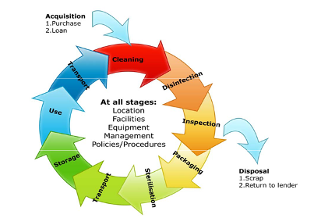

Appendix 9 – Medical Device Process Life Cycle

The effective management of medical devices throughout the medical device life cycle is a crucial process that provides value for the manufacturer and the end user. As medical devices transition through each stage of their life cycle, they are subject to new types of processes, testing and regulatory requirements.
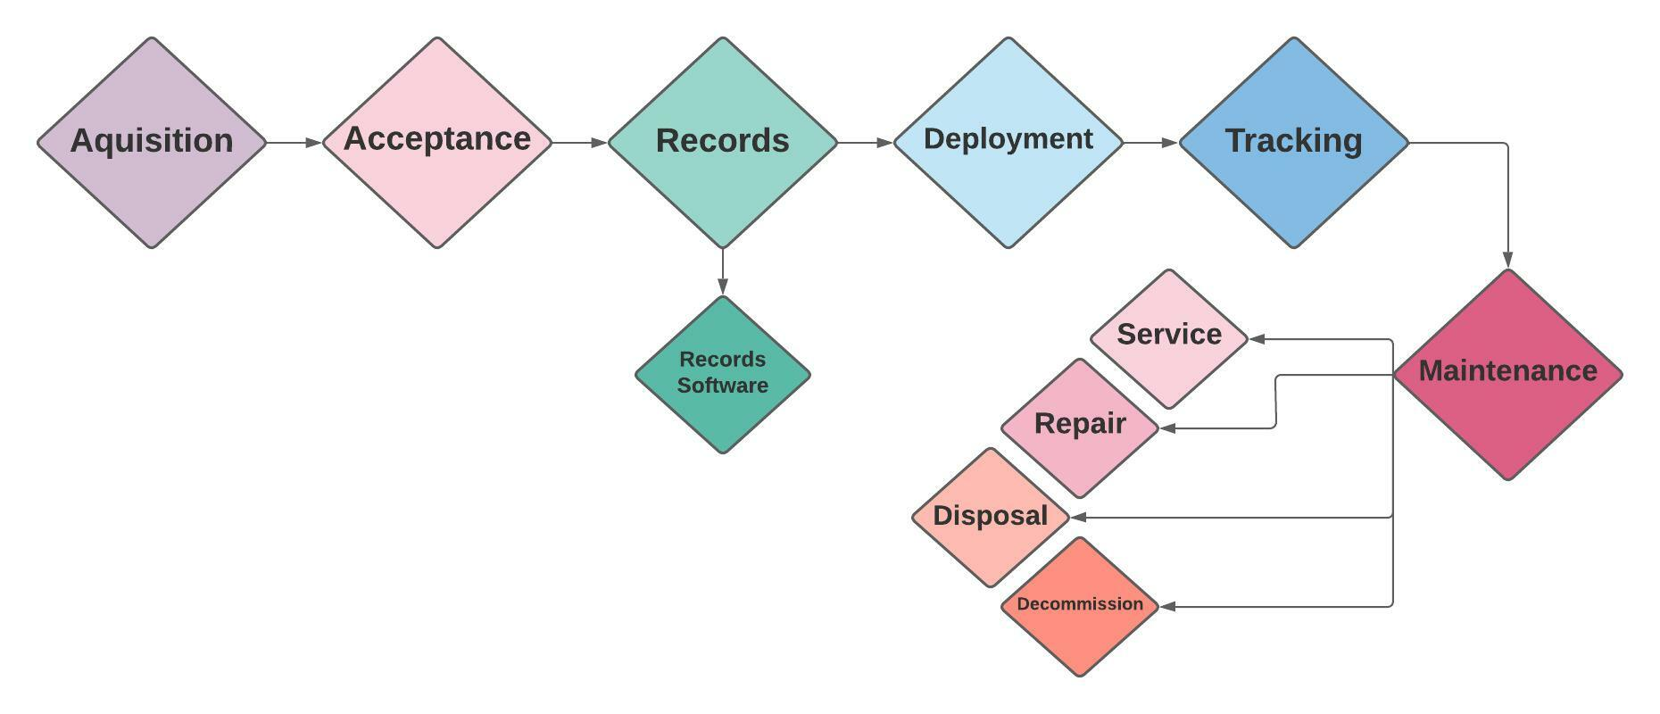
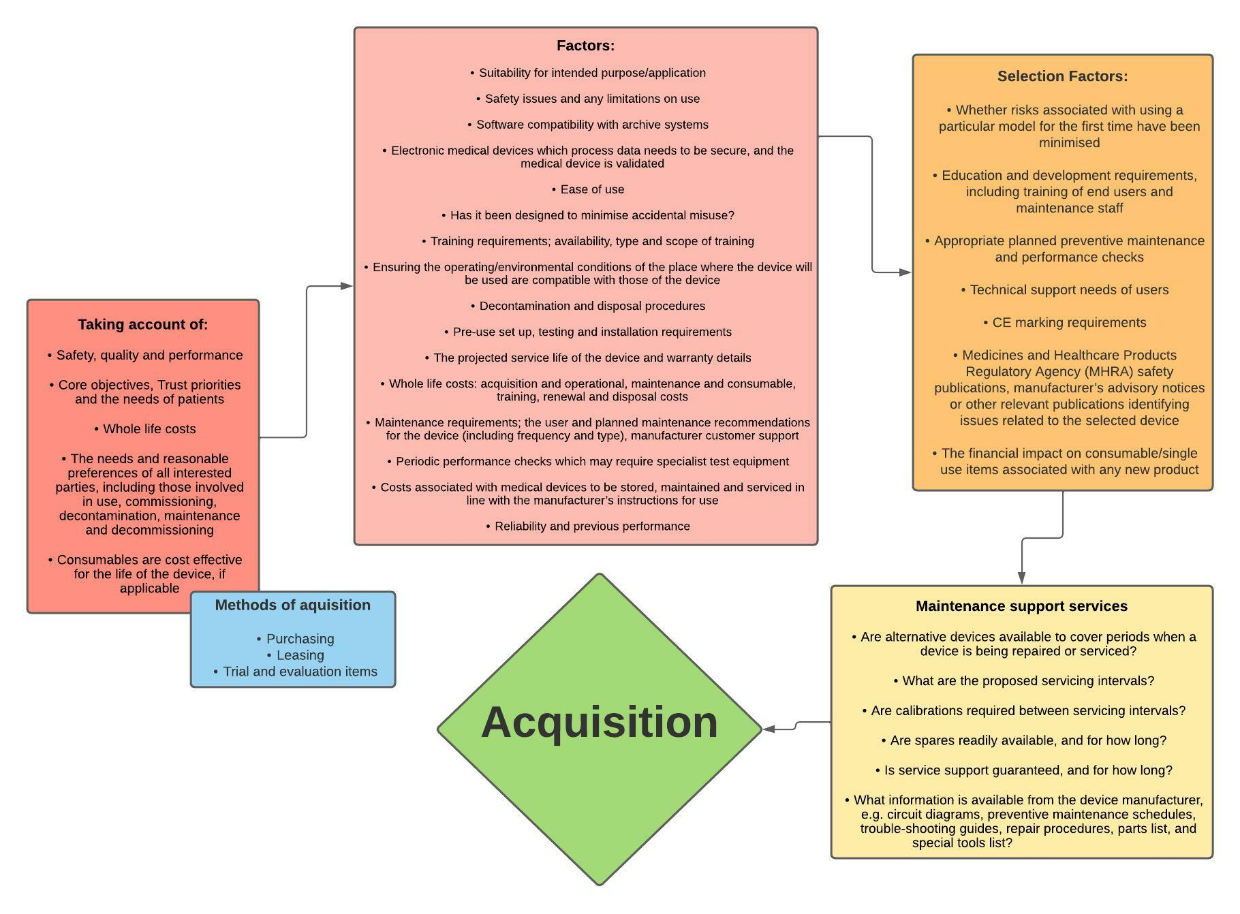
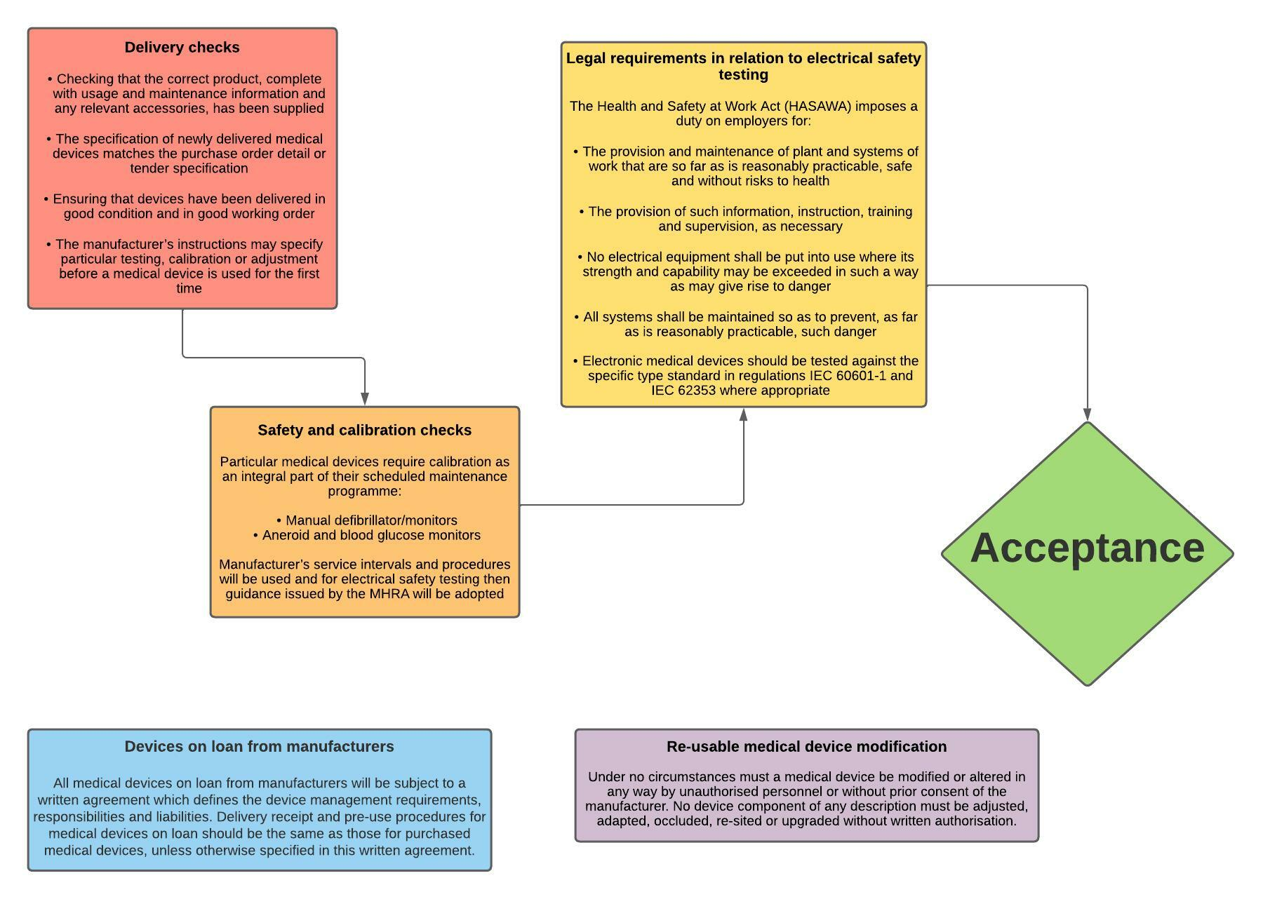
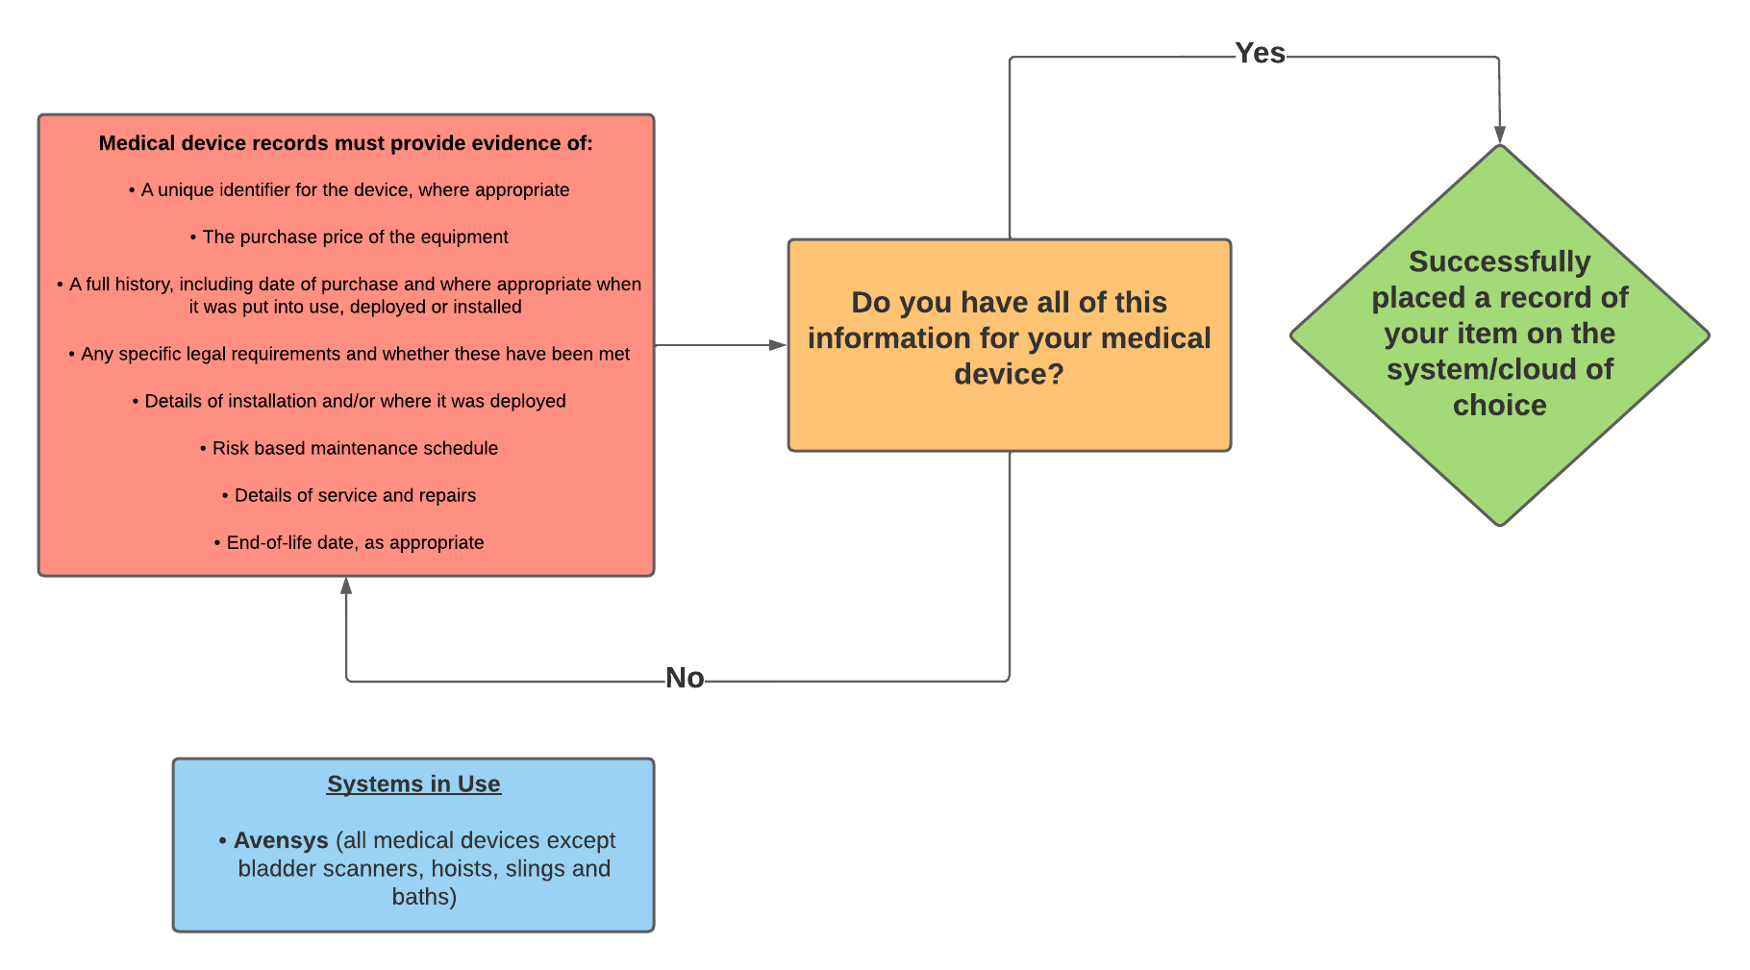

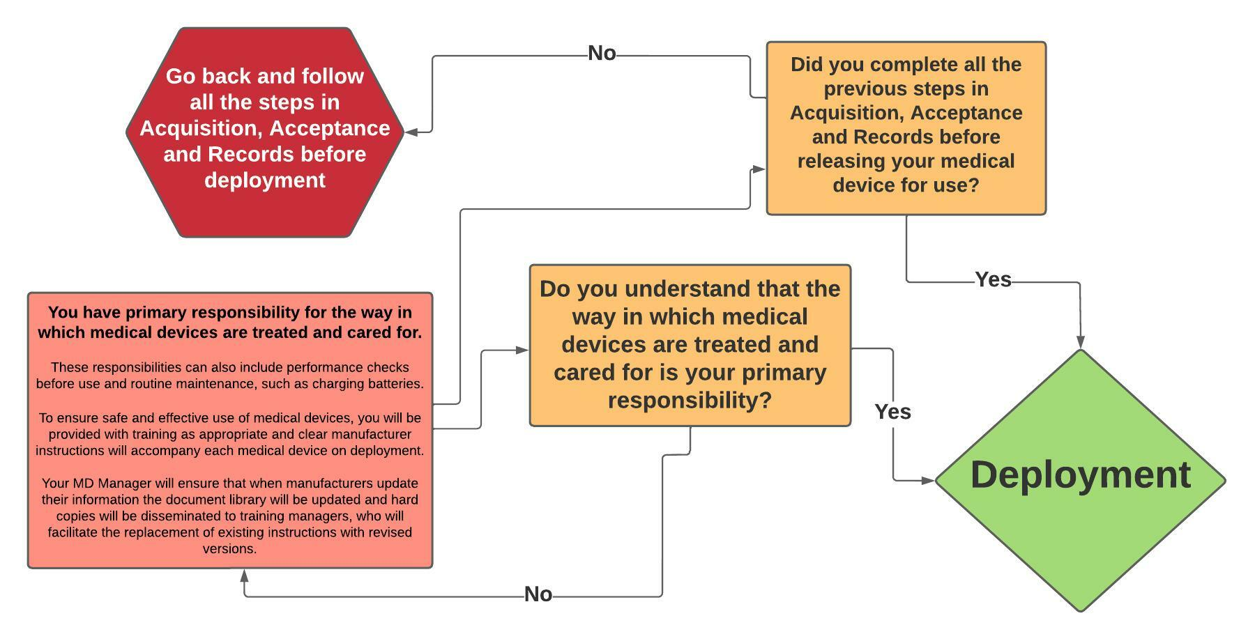

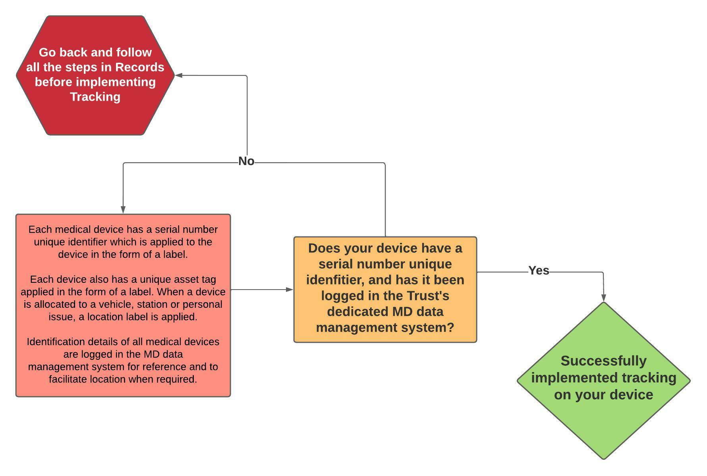

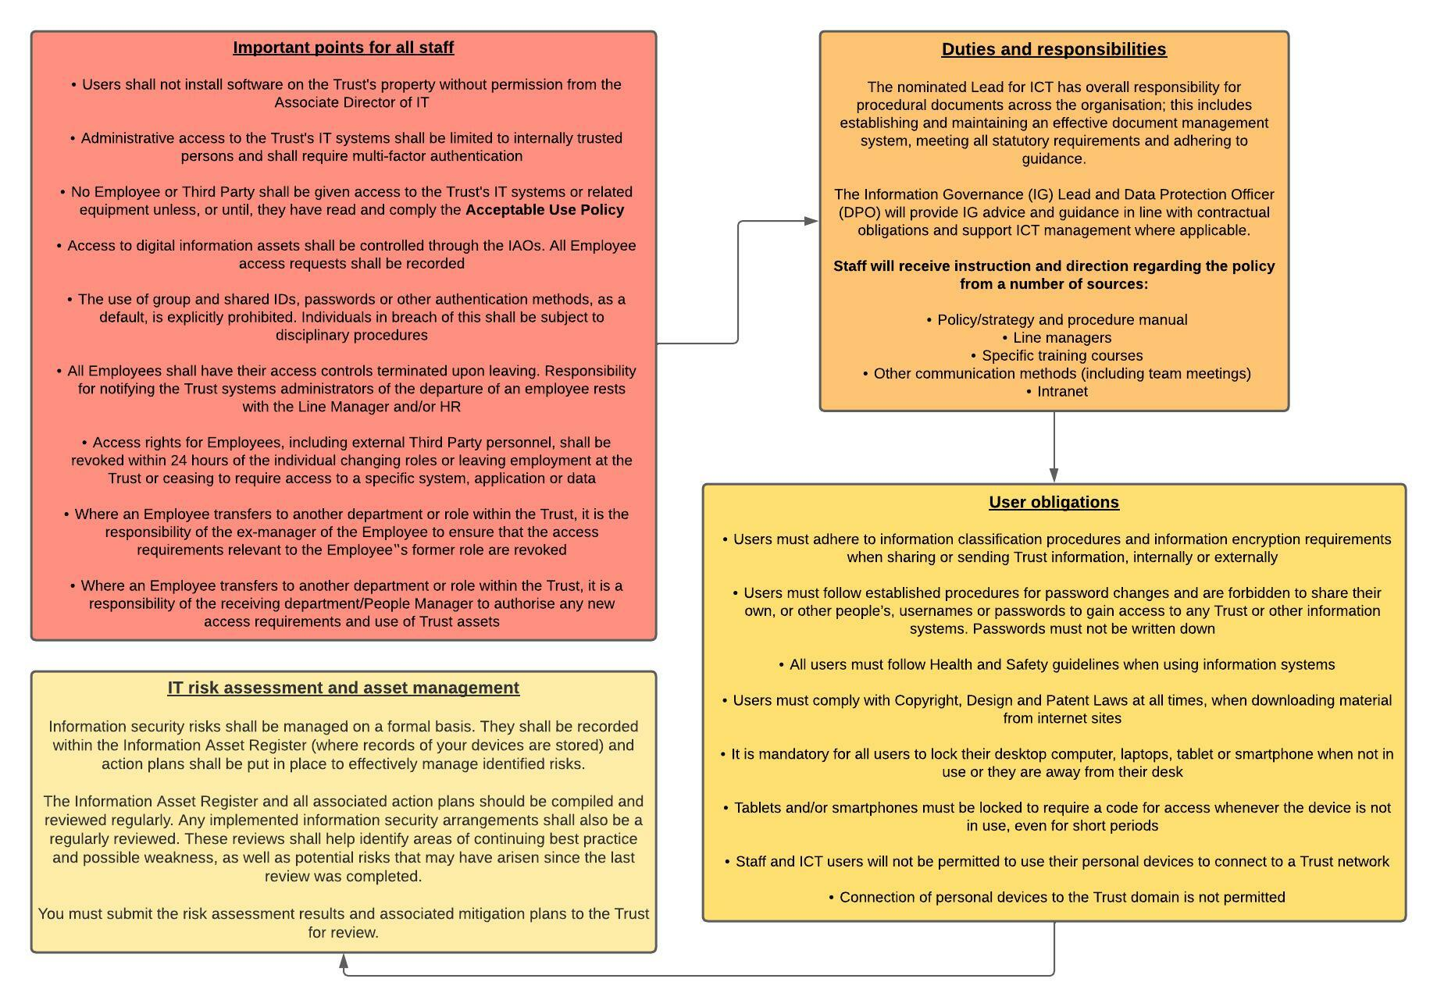
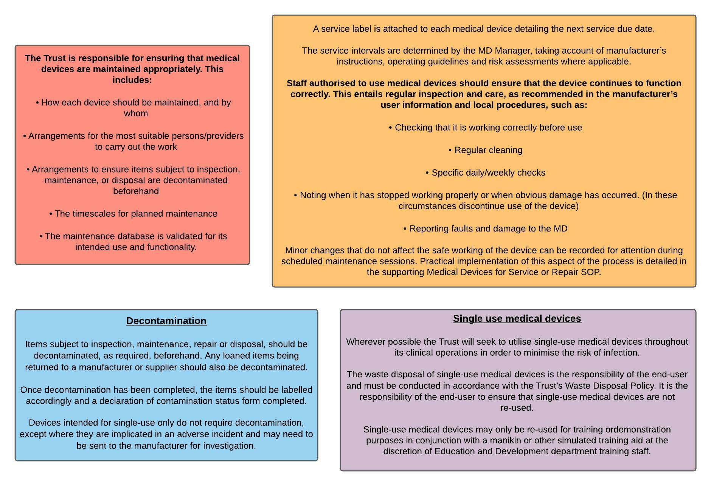

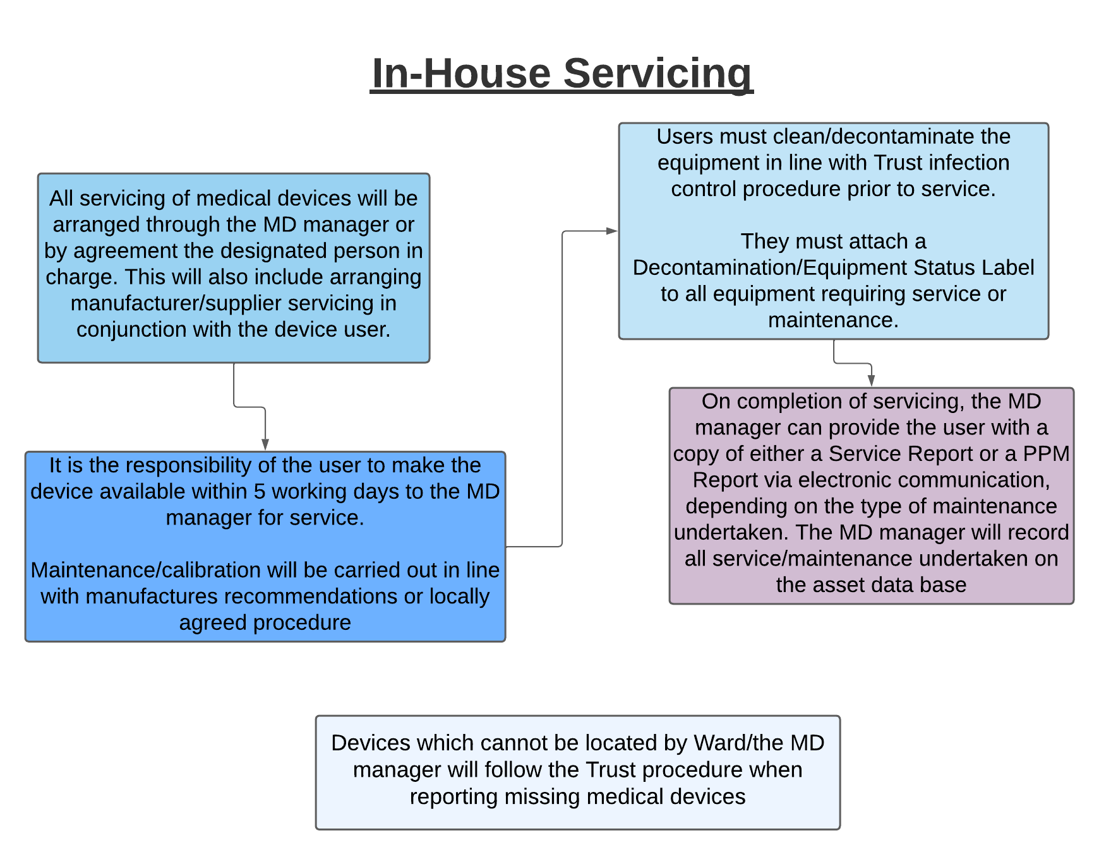
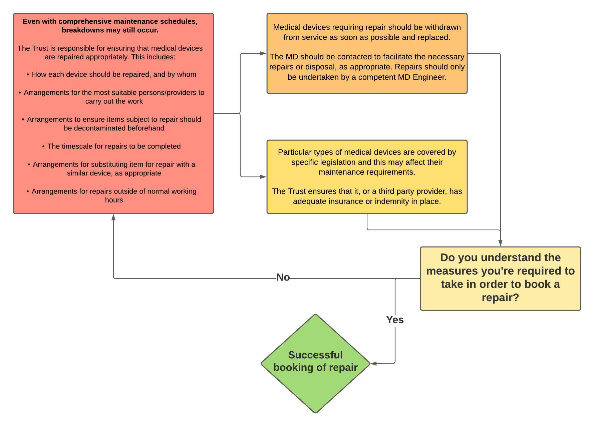
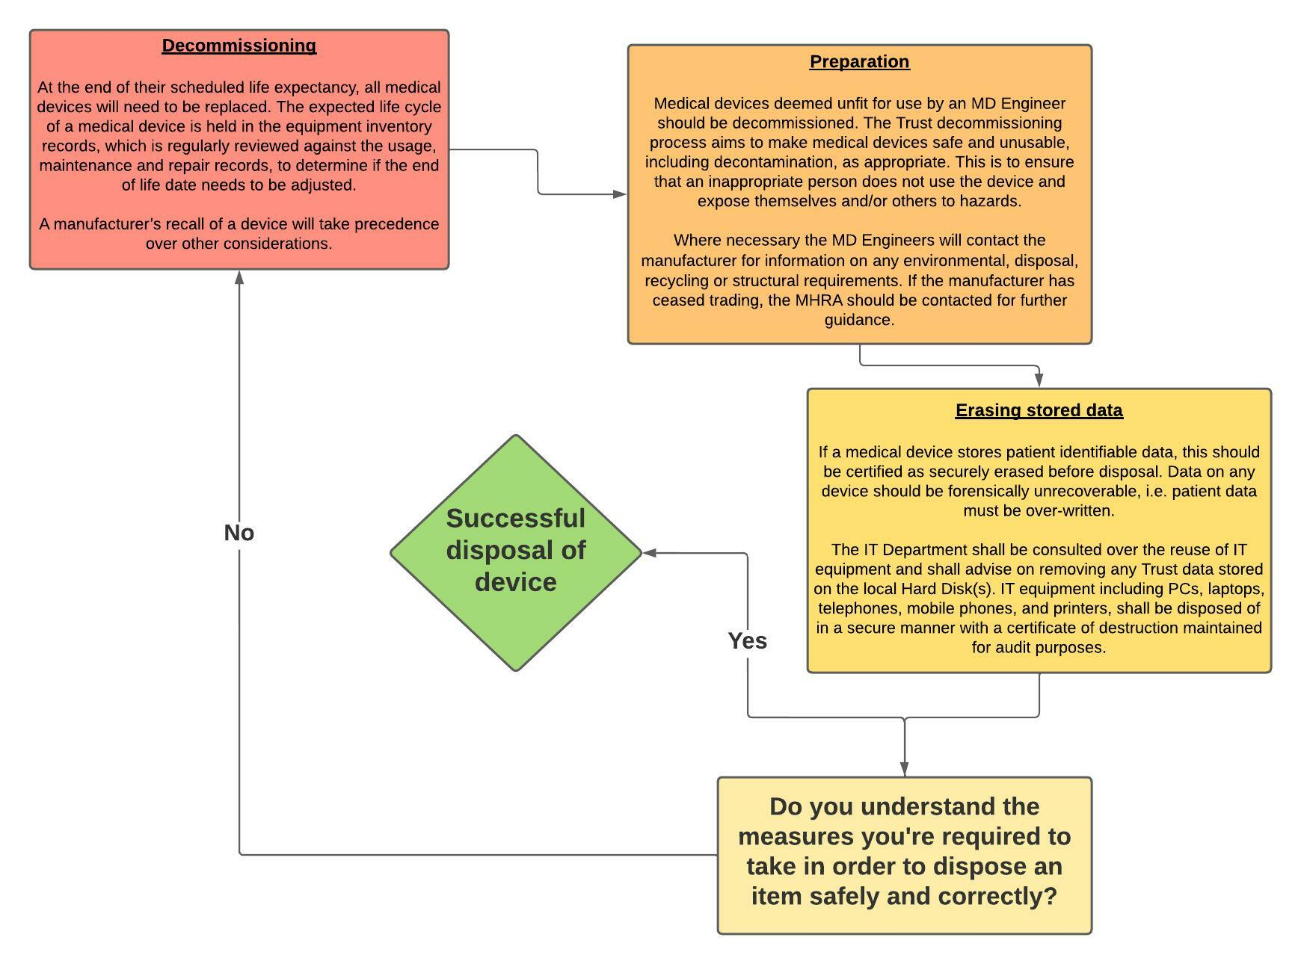
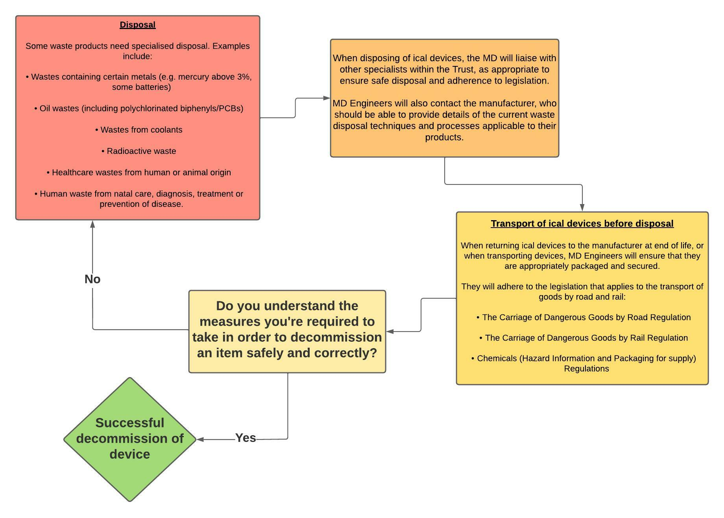

END

