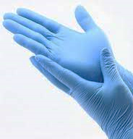
Glove or no Glove?
Use this checklist to make sure you’re
only using disposable gloves or aprons
when it’s clinically necessary.

- Taking a patients observations
- Washing a patient
- Dressing a patient
- Feeding a patient
- Transporting a patient
- Completing paper or electronic notes
- Handling used linen unless soiled
- Preparing and administer IV medications
- Giving oral medications
- Mobilising i.e. Physiotherapy
- Assessing a patient
- Touching blood or any bodily fluid
- Taking a blood sample
- In contact with broken skin
- Handling hazardous chemicals
- Handling contaminated waste with blood and bodily fluids
- Handling sharp instruments contaminated with blood and bodily fluids
- In contact with an Infectious patient
- Dressing wounds
Wear gloves when: Don’t wear gloves when:

For more information search ‘glove use’ on ELFT Intranet

