**Taking Care of My Sensory System: What is Regulation?**

*They’re hyper’ ‘They’re all over the place’ ‘They’re acting up’*

Often we might hear or say things like this, when we see a child having trouble with an activity or routine that happens every day. As occupational therapists, we use the word ‘regulation’ to describe this.

Regulation is a foundational building block skill of every activity that people do, every day.

 But what does it mean to be regulated or dysregulated?

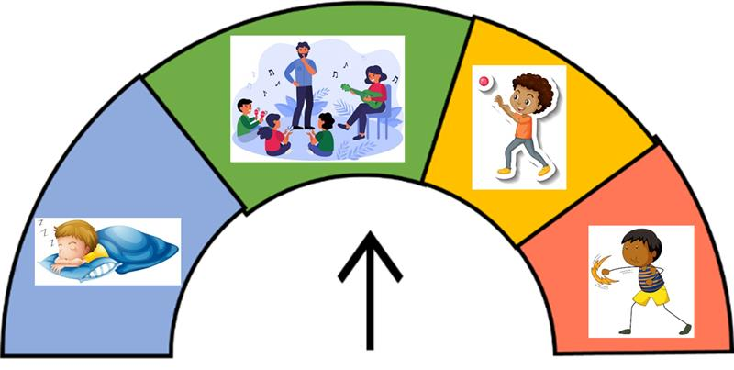

 Being ‘regulated’ means having the right amount of energy in the body, to match the activity you’re trying to do. For example being slow and tired at bedtime, focused in class, and energetic at playtime. And even being ‘dangerous’ if we’re facing a danger situation, like escaping a fire or a real attack.

 Regulation involves:

 - Taking information in from the world and from the body and mind.

- Processing that information to understand what it means.

- Making an action or response, what we do next.

|  |  |
| --- | --- |
| C:\Users\BeggH\AppData\Local\Microsoft\Windows\INetCache\Content.MSO\9F796580.tmphttps://lh4.googleusercontent.com/EZiQvZ1CtVt-PWWXSaHOPN6zEvX6UVAiEEefVa39soyRTXyoSd8Rfe0tQ4nf7P9WBxJ_JmERVPI-fc9h4iopI4d-WYxwMxsVKiTKUUII9sUMFKiL04Vdn23eJKsHLd-AbXfunN2iwL4jMtoEwuxQ4g=s2048 | |
| **What activities make your child’s regulation go ‘fast’ or up into the red level of energy?** | **Which of the 8 senses do you think those activities send signals through?** |
|  |  |
| C:\Users\BeggH\AppData\Local\Microsoft\Windows\INetCache\Content.MSO\9F796580.tmphttps://lh4.googleusercontent.com/EZiQvZ1CtVt-PWWXSaHOPN6zEvX6UVAiEEefVa39soyRTXyoSd8Rfe0tQ4nf7P9WBxJ_JmERVPI-fc9h4iopI4d-WYxwMxsVKiTKUUII9sUMFKiL04Vdn23eJKsHLd-AbXfunN2iwL4jMtoEwuxQ4g=s2048 | |
| **What activities make your child’s regulation slow down, or go down into blue energy?** | **Which of the 8 senses do you think those activities send signals through?** |
|  |  |