**Helping My Child’s Sensory Needs: What is Regulation?**

*‘They’re hyper’ ‘They’re all over the place’ ‘They’re acting up’ ‘They’re naughty’*

Often we might hear or say things like this, when we see a child having trouble with an activity or routine that happens every day. As occupational therapists, we use the word ‘regulation’ to describe this.

Regulation is a foundational building block skill of every activity that people do, every day.

 But what does it mean to be regulated or dysregulated?

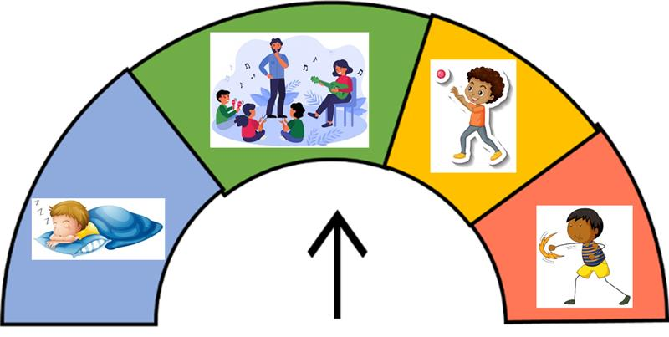

  Being ‘regulated’ means having the right amount of energy in the body, to match the activity you’re trying to do. For example being slow and tired at bedtime, focused in class, and energetic at playtime. And even being ‘dangerous’ if we’re facing a danger situation, like escaping a fire or a real attack.

 Regulation involves:

 - Taking information in from the world and from the body and mind.

- Processing that information to understand what it means.

- Making an action or response, what we do next.

Some children *‘***over-react’** to a situation, because it really feels ‘that scary’ or ‘bad’ or overwhelming for them. They might ‘have a tantrum’ because they are:

* Scared or overwhelmed
* 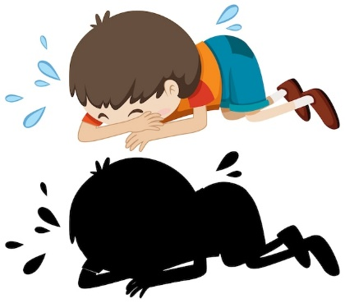Trying to communicate but they can’t explain why
* Feeling sensory ‘overload’- the sensory feelings are uncomfortable and bad

|  |  |
| --- | --- |
| https://lh4.googleusercontent.com/EZiQvZ1CtVt-PWWXSaHOPN6zEvX6UVAiEEefVa39soyRTXyoSd8Rfe0tQ4nf7P9WBxJ_JmERVPI-fc9h4iopI4d-WYxwMxsVKiTKUUII9sUMFKiL04Vdn23eJKsHLd-AbXfunN2iwL4jMtoEwuxQ4g=s2048Free vector sticker template with a girl cartoon character isolated  C:\Users\BeggH\AppData\Local\Microsoft\Windows\INetCache\Content.MSO\9F796580.tmp | |
| **What activities make your child feel overwhelmed?**  For example: visiting the shops. | **Which senses do those activities use?** For example, the shops are loud (for the hearing) and crowded (for touch sense getting bumped by strangers). |
|  |  |
| Free vector little cute boy cartoon character on white backgroundhttps://lh4.googleusercontent.com/EZiQvZ1CtVt-PWWXSaHOPN6zEvX6UVAiEEefVa39soyRTXyoSd8Rfe0tQ4nf7P9WBxJ_JmERVPI-fc9h4iopI4d-WYxwMxsVKiTKUUII9sUMFKiL04Vdn23eJKsHLd-AbXfunN2iwL4jMtoEwuxQ4g=s2048  C:\Users\BeggH\AppData\Local\Microsoft\Windows\INetCache\Content.MSO\9F796580.tmp | |
| **What activities make your child calm?**  For example, water play. | **Which senses do these activities use?**  For example, something shiny to watch (eyes), to hear (ears), to touch or squeeze (hands). |
|  |  |