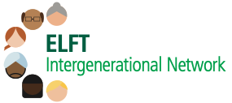
Role Title: Intergenerational Network Lead Role
Band: Existing banding on substantive role
Hours: One day per week (offered as secondment alongside the existing role)
Tenure: 2 years
Reporting To: Executive Sponsor and Trust Equality Lead
Accountable To: Trust Equality Executive / Chief Quality Officer
Main contacts: Staff, managers and leaders, other network leads, People and Culture Team, Communication Team, Staff Side, external networks and other partner organisations

Intergenerational Network Lead
If you are Ambitious, Brave and Passionate in ensuring staff of all ages work well together there has never been a more exciting time to join our team!
We are looking to recruit one Network Lead for our Intergenerational Staff Network. The candidate needs to be passionate about equality, diversity and inclusion, and excited to support the Trust in its journey of shaping and implementing the equalities agenda. This network supports to facilitate career progression for younger members of staff and help retain employment for older members of staff, by challenging age related stereotypes.

This is a fantastic opportunity to develop and apply your skills and knowledge to support and shape a range of initiatives aimed at improving working conditions for all our staff, and to develop and maintain a representative workforce and inclusive leadership. Previous post holders have commented on the personal growth in confidence, organisational networking – both inside and outside the Trust, and the supportive culture within all of the different Network Leads and Sponsors groups, making the role really rewarding.

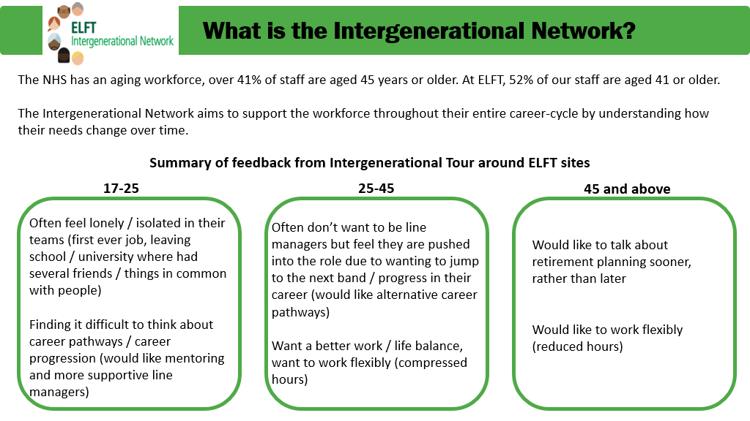

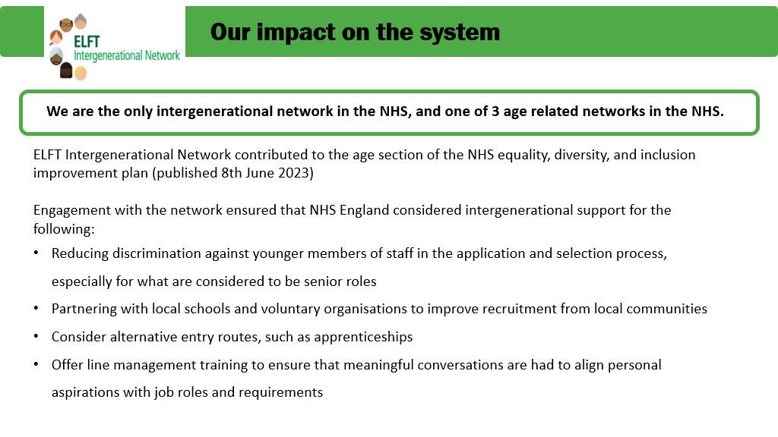

ELFT Equality Networks
There are six Staff Equality Networks at ELFT
- Women’s Network
- Men’s Network
- RaCE Network
- ELFT Ability Network
- LGBTQIA+ Network
- Intergenerational Network

Each network fulfils various functions including providing opportunities for social interaction, peer support, and personal development. Staff Equalities Networks can also contribute to the development of Trust policies and practices and have a pivotal role in channelling staff voices, building actions plans for organisation development, and improving working conditions of our workforce.

How it Works
The role is for one day a week for two years, as protected time from your existing position, and in addition to your current role within the Trust. For example, if you work 5 days per week, then the 5th working day will be dedicated to this Network Lead position and you will continue your employment in your substantive role for the other 4 days per week.

Your banding will remain the same as your main substantive role. Your specific Network responsibilities will be discussed and agreed with your Network’s Executive Sponsor.

The role will be re-advertised following two years tenure.

Please note: you must discuss the practicalities around the one day per week commitment with your line manager and receive approval from them in order to apply for the role.

Want to find out more?
For an initial discussion, please contact Amar Shah (amarshah@nhs.net) for an appointment to discuss.

Expression of Interest
A short document to include:
- ‘Three reasons to shortlist me’
- A summary of ‘What I would like to achieve with the Network over the next two years’.
Please submit your expression of interest to Amar Shah via amarshah@nhs.net
Closing date: 5pm on Friday 22nd Septemver 2023

Intergenerational Network Lead Role Description
Working closely with the Executive Network Sponsor, Amar Shah, this role will enable you to apply your communication and engagement skills to build, coordinate, and deliver plans that will support our Trust’s equality, diversity, and human rights agenda. You will play a key role in channelling staff voices and coordinating equalities activities within the Intergenerational Network. Now, perhaps more than ever, equity and age-related issues need a forum where they can keep up to speed with the legislative, political, and impactful changes related to the employee lifecycle..

Key Duties and Responsibilities
Report to and agree annual work plan with the Network’s Executive Sponsor in collaboration with network members
Liaise with Trust Equality Lead, Director of People and Culture and People and Culture Manager in order to plan the work of the network
Maintain a list of network contacts via NHS Mail Distribution List
Draft communications material for the network and assist in the design and production of relevant documentation (e.g. posters, flyers, Intranet Page updates, etc.)
Promote involvement in the network through internal communications and face-to-face engagement events (e.g. Corporate Induction, promotional stalls at various Trust sites, etc.)
Organise meetings, conferences, workshops, and focus groups of the network
Plan the agenda for network meetings in collaboration with network members and Executive Sponsor
Provide regular updates and reports on network activity
Take minutes at network meetings and capture all relevant actions
Ensure that actions arising from network activity are followed up
Lead projects or project streams for the network
Produce annual network plan and track its progress
Contribute to annual data submissions as well as annual celebration events
Facilitate promotional events and send communications in order to raise awareness and profile of networks
Raise invoices for venue hire, speakers, and any other expenses related to the network
Answer any general queries regarding the network
Provide advice and support to network members
Lead network’s social media accounts and communications
Commission internal and external facilitators for network workshops and events
Liaise with external stakeholders and national bodies
Liaise with counterpart Leads in other Trusts and organisations to share best practice
Work in line with the Trust’s policies and procedures
Complete any other relevant administrative duties as needed

