The Coborn Centre for Adolescent Mental Health
Thematic Review
Covers Galaxy Ward (PICU), General Ward and
Day service.
Authors

Abiola Ajayi-Obe – Associate Director for Risk and Governance
Louise Turner Serious Incident Reviewer, Risk and Governance
With contributions from:

Tim Bull –Associate Director for Safeguarding Children
Kamel Cheradi – Acting Service Manager The Coborn
Lyndsey Hobson – Associate Director for CAMHS
Zara Keane – Business Manager, The Coborn
Cathy Lavelle – Consultant Child and Adolescent Psychiatrist and Clinical Director, ELFT Children’s Services, Clinical Director, CAMHS New Models of Care, North Central and North East London
Claire McKenna – Director of Nursing, ELFT.
Ravi Patel Consultant Child and Adolescent Psychiatrist and Associate Clinical Director The Coborn
Rafik Refaat Consultant Child & Adolescent Psychiatrist, Deputy Clinical Director ELFT In-Patient CAMHS, Lead Consultant CAMHS New Models of Care, North Central & North East London

Contents
1.0 Introduction: 4
1.1 Initial themes which led to initiation of a Thematic Review 4
1.2 Terms of Reference 4
1.3 Scope 5
2.0 Methodology 6
3.0 Background: 6
3.3 2020 onwards 8
3.3.1 New Model of Care: 8
4.0 Service Composition 2019 11
4.1 Teams / Staffing 13
4.1.1 Staffing Establishment 13
4.1.2 Vacancies and Staff Mix 18
4.1.3 Coborn unit staffing vacancies 22
5.0 External Reviews 25
5.1 Care Quality Commission (CQC) reports 25
5.2 Coborn unit Quality Network for Inpatient Child and Adolescent Mental Health Service reports (QNIC) 26
5.3 Complaints/ Concerns and Incidents and SIs inclusive of reporting incidents 27
6.0 Governance issues during Covid-19 27
7.0 Safeguarding Provisions 28
7.1 Safeguarding training 30
7.2 Allegations against staff members 31
7.3 Key policies relating to safeguarding 32
7.4 Mandatory training for all staff employed by ELFT including the trust training needs analysis (TNA) 34
8.0 Young People Profiles 40
9.0 Covid -19 44
9.1 Covid-19 and the impact 44
9.2 First wave of Covid-19 March 2020 onwards 44
9.5 Covid-19 and staff training 45
9.6 Covid-19 and staff retention and shielding 46
9.7 The Coborn - Covid-19 positive patients 46
9.8 The Coborn - Covid-19 staff sickness 47
9.9 The Coborn - Covid-19 staff shielding – wave one and wave two 47
10.0 Findings and Analysis 49
10.2 Findings and Conclusion 50
11.0 Recommendations 51
12.0 Appendices 53
13.0 Glossary 55
14.0 References 56
References 56

List of Tables
Table 1: 2016 Bed Establishment 7
Table 2: 2018 Bed Establishment 7

Table 1: 2016 Bed Establishment 8
Table 2: 2018 Bed Establishment 8
Table 3 Service Composition 2019 12
Table 4.1.1 Staffing Establishment 14
Table 5.1 Care Quality Commission (CQC) reports 26
Table 6 showing extenuating circumstances (including police call out incidents during incidents and post incidents) 36
Table 7 Number of absent without leave (AWOL) incidents 37
Table 8 41
Table 9.7 The Coborn - Covid-19 positive patients 47

List of Charts
Chart 1 10
Chart 2: ACUTE – ACTUAL STAFFING (april 2020 to March 2021
Chart 3: PICU – acute and minimum staffing comparison (april 2020 – march 2021) 16
Chart 4: galaxy – acutal staffing in comparison to minimum staffing (april 2020 – march 2021) 17
Chart 5: coburn administration vacancies (June 2019 – December 2020) Chart 6: coborn medical vacancies (june 2019 – december 2020) 20
Chart 7: coburn nursing vacancies (june 2019 to december 2020) 21
Chart 8: level 3 safeguarding trained staff as of february 2021 31
Chart 9: Number of lado referrals made from coborn 32
Chart 10: extenuating circumstances 35
Chart 11: number of awol incidents 36
Chart 12: Number of incidents by type 37
Chart 13: Types of restraints and incidents 38
Chart 14: Absconsions including from escorted leave and failure to return from leave 39
Chart 15: The Coborn Covid-19 staff related illness 48

1.0 Introduction:

1.1 Initial themes which led to initiation of a Thematic Review
Thematic reviews into services are conducted whenever themes from individual incidents reported onto the Trust’s Incident Management Database (DATIX) indicates that there are unusual changes to behaviours of service users or staff in a service.

Themes | DATIX Reference Number
SU Alleged Attack on Staff | 139025  138927  139020  138204
Staff Alleged Attack on SUs | 135757  137865  131299
Ligature Incidents | 138546  138569  138588
AWOL | 138017

The DATIX incidents listed above were the initial incidents, which gave rise to concerns about the number of incidents taking place within The Coborn Unit relating to both Service User (SU) attacks on staff and Staff alleged attacks on SUs. An email escalating these issues was sent to the Director of Specialist Services alerting the service. (See appendix 1).

1.2 Terms of Reference

The review team met on the 12th January 2021 to agree the Term of Reference for this Review. The following terms of reference were agreed to include; Those Coborn Incidents which meet the harm threshold of moderate or severe (definitions were provided for each harm threshold / type). (See appendix 2).

The factors listed below were considered throughout this review:

- Theming of common Young People (YP) personal characteristics -
  - Young People from the Transforming Care Cohort i.e. With Neuro-development difficulties (Rio)
  - Safeguarding Characteristics / Looked After Children etc. (Rio)
  - History of Trauma informed ways of thinking (Rio)
  - A review of the young people who have been the subject of the highest amount of DATIX reports/ Top 10 – to determine processes for escalation and assurances regarding their management and to consider whether The Coborn / Galaxy Ward is the right placement for them.

- The factors behind any Delayed Discharges
- Availability of MAPA/PMVA trained staff (From the Unit and elsewhere) and established MAPA/PMVA presence.
- Bed pressures – including the availability of PICU step down to general adolescent unit beds.
- Review ligature incidents of moderate / severe harm in patients in the care of the Unit from 01.01.2018 to 31.01.2021 / against how care plan has evolved to manage their harm.
- Review of safeguarding concerns including;
  - Safeguarding training
  - Allegations against staff
  - Complexity of patients – children in need, LAC children.
- Review of all incidents of violence and aggression categorised at moderate or severe harm levels
  - Property Damage
  - Against other individuals
  - Review receipt of Violence and Aggression training at Induction
- Identification of common service gaps
  - Commissioning objectives
  - Environmental/ consideration of the appropriateness of de-escalation space provided

- Identification of common care gaps -
- Patient Knowledge

1.3 Scope

To take into account the establishment of the Galaxy Ward CAMHs unit in 2017 this review was scoped to include the 3-year period from -
- 1st December 2017 to 31st December 2018, and then annually to include the period;
- 1st January 2019 to 31st December 2019
- 1st January 2020 to 31st January 2021.

The review was benchmarked against – The CAMHs Unit at South London and Maudsley (SLAM) another PICU unit from the London CAMHS area who kindly shared their experiences to help with this thematic review.

The review includes commentary to identify the service compositions as detailed in section 4.0 below. Please note only service compositions from December 2019 and March 2021 have been included due to the unavailability of this information for the other years within the scoped period of the review.

2.0 Methodology

We conducted this review by speaking to The Coborn Unit Leadership Team including - The Ward Manager, Medical Leads, Clinical and Nursing Leads and Safeguarding Leads. The terms of reference and scope for this review was co-produced as a collaborative effort with section leads agreed, for provision of the content for individual sections. Literature including previous CQC reports, nursing reviews of the service together with staffing reviews a January 2021 Board Report on the use of Restrictive Practices and NHSE guidance were reviewed and findings explained, where necessary, by various co-reviewers.

A separate meeting was held on the 4th May 2021 between the review’s Authors and a Coborn Consultant Psychiatrist / Clinical Lead and SLAM Adolescent Services team’s members to establish the SLAM service offering, especially during the first and second Covid-19 Pandemic waves.

The Fishbone diagram derived to inform the review was shared electronically with the review’s co -reviewers and contributors. The fishbone findings were discussed and the findings accepted at a feedback meeting held on 09.07.2021. The recommendations included in this review were also identified at this meeting.

An SIR report SI 137865 which was commenced during the scoped period of this review was also consulted to inform this review.

Due to Covid-19 restrictions and the acuity of the young people on the Unit, the review did not interview any patients on the Unit.

3.0 Background:

In March 2006, The Coborn Centre for Adolescent Mental Health **was established with the contributions of Dr Rafik Refaat, Lead Consultant and Associate Clinical Director, Dr Navina Evans, Consultant Psychiatrist and Clinical Director for child and adolescent mental health services (CAMHS) and Andy Cruickshank, Service Manager, together with others. Initially the unit comprised of four psychiatric intensive care unit (PICU) beds for the most acutely unwell, an additional six-day service beds, and twelve general ward beds totalling twenty-two beds.

“The Coborn Centre is a purpose built children and adolescent mental health service (CAMHS) for inpatients and day patients that is bright, modern and clean. There was evidence of anti-ligature fixtures in bedrooms and bathrooms. The acute area has en-suite bathroom facilities but these are shared on the PICU. There is gender segregation on the acute area with three lounges; male, female and mixed. The PICU is smaller and has a mix of genders at times although on the day of our visit all PICU patients were female. There is a central lounge area and bedrooms are located off the main area.” (Commission, 2017). The Unit “is an inpatient service for young people between 12 and 18 years of age, both male and female, with complex and severe mental health difficulties. The Centre itself contains a 12-bed acute ward and up to six full-time and nine part-time day-service places, as well as a four bed PICU. Galaxy Ward [which] adds a further 12 PICU beds to the Centre’s provision.” (Care Quality Commission, 2020)
The Unit, as reported in the CQC Inspection Report (Care Quality Commission, 2020) accepts referrals from ELFT, NELFT and CNWL. The average length of stay for inpatient admissions is 43 days.

Table 1: 2016 Bed Establishment

Bed Type | Number
Day Service | 6
General | 12
PICU | 4
Total for The Coborn | 22
**The Coborn Centre for Adolescent Mental Health is referred to as The Coborn/Unit throughout this review.
3.1 2018 onwards
In February 2018, the new Galaxy ward PICU was established with ten beds. Later the Coborn was re-established as a regional unit. The PICU then had the total number of beds increased from ten to sixteen and commenced delivering a service that covered the whole of the London area.

Six months after this increase in bed capacity, South London and Maudsley (SLAM) opened another Adolescent Unit with eight PICU beds, which covered the south London area. The Coborn was now a nationally commissioned service that could admit unwell adolescents from anywhere within the country.
Table 2: 2018 Bed Establishment
Bed Type | Number | Comments
Galaxy Ward (PICU) | 10 | As @ February 2018
Galaxy Ward ( PICU) | 16 | Beds increased from 10 to 16  Funded as a regional, nationally commissioned PICU. Consisting of 4 beds on PICU and 12 beds on Galaxy.
General Ward | 12
Day Service | 6
Total for the Coborn | 34

3.2 2020 onwards

3.2.1 New Model of Care:

An NHS Lead Provider Collaborative commissioned by NHS England (NHSE) in October 2020 commenced a New Care Model with the following aims:-

- To provide young people using specialist mental health services and with learning disabilities and autism, with care closer to home.
- Enable joined up care with local teams and support networks
- To support home care provision as soon as is possible
- Improve patient experience and care outcomes
- Give local populations a greater voice in specialist mental health service provision

See: (NHS England, 2020) NHSE New care models - https://www.england.nhs.uk/new-care-models/
Notably, the introduction of this New Care Model in October 2020 took place during the second Wave of the Covid-19 Pandemic. As a result, new methods of working including bed management systems (Care Quality Commission, 2020) were introduced during a time of emergency revisions – necessitated by Covid-19 protocols - to care (provision) for Coborn young people, during what was altogether a very challenging time for The Coborn staff and patients.

The Provider collaborative assumed the commissioning role from NHSE In October 2020. Previously, referrals into The Coborn had come directly from referrers. The new arrangement introduced a patient flow team who managed referrals for all young people in the NCEL area and interfaced with the 4 NHS units in the patch, including the Coborn. The aim of the collaborative was to ensure that Young people are admitted as close to home as possible, and in the early days worked to repatriate some young people back into area. The Coborn team have had to establish relationships with the Patient flow team regarding admissions, rather than liaising directly with referrers, or with NHSE when there are difficulties in finding a bed.
Covid-19 created unforeseen ripple effects where patients, for discharge, were not able to complete Section 17 home visits, prior to discharge, with the aim of readjusting themselves back into family life before finally returning home. This fact often resulted in delayed discharges and further pressures on staff on The Coborn.
Covid 19 also led to an increase in mental health problems for Young people with an increase in crisis presentations, a significant increase in eating disorder presentations and an increase in acuity.
Reportedly, there was an expectation that The Coborn would operate as usual with a capacity of twelve general beds. Notably, pre Covid-19, full capacity at twelve was rarely reached with the average operating number of beds fluctuating between nine-ten. However, the high acuity of the patients admitted to the Unit, the decreased staffing numbers, as a result of Covid-19 shielding, and other absences, resulted in greater pressures on the existing staff to deliver services. This proved challenging when there was an increase in demand for admissions for eating disordered young people requiring high levels of care in line with national presentation levels.
3.3.2 The Coborn New Model Commissioning Intentions vs SLAM provisions:

This review identified that the original commissioning intentions for The Coborn indicated that the unit would be the Lead Provider of paediatric/adolescent PICU mental health services for the entire London area. However, the catchment area for The Coborn was later revised to only provide adolescent mental health care services for the North, East and West of London area. This arrangement acknowledged the PICU Adolescent Unit at (SLAM) providing services to South London (and region) children and adolescents.

Since October 2020, ELFT has been the lead provider for the NCEL CAMHS provider collaborative. BEH, Whittington, NELFT and Tavistock are partners in the collaborative. This means that ELFT provides services at the Coborn and that it commissions the adolescent in-patient services at Brookside, Beacon and Simmons House. The Coborn provision (as at April 2021) provides support to 96% of patients who are from the London area with two patients (4%) from the Luton and Bedfordshire area as a result of the lack of PICU CAMHS provision within this area.

The SLAM CAHMS PICU inpatient offering is much smaller at eight beds compared to the ELFT Inpatient provision of sixteen PICU beds. Both SLAM and ELFT have a similar number of beds on the general Adolescent Unit at twelve beds respectively. Notably, Snowfields ward at SLAM, their 11 bed open adolescent unit, was closed during Covid-19. Additionally ELFT has six additional day service beds to support reintegration back into the community and for those young people who need daytime support who can then go home in the evening.

Members of the review team met with SLAM on 04.05.2021. SLAM reported that due to the low numbers of young people on their Unit during first and second Pandemic waves they were able to continue to deliver a much more paced service, where both patients and staff were able to bubble up and work, in the main, successfully. SLAM are also lead providers for the South London Partners New Care Model Collaborative, which was launched earlier than the NCEL collaborative.

The following chart shows the occupancy levels at The Coborn January 2020-June 2021.

Chart 1
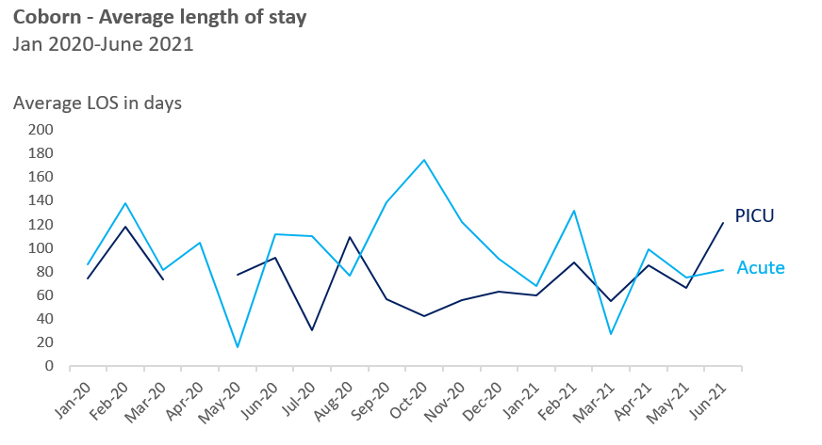
Table 3 Service Composition 2019
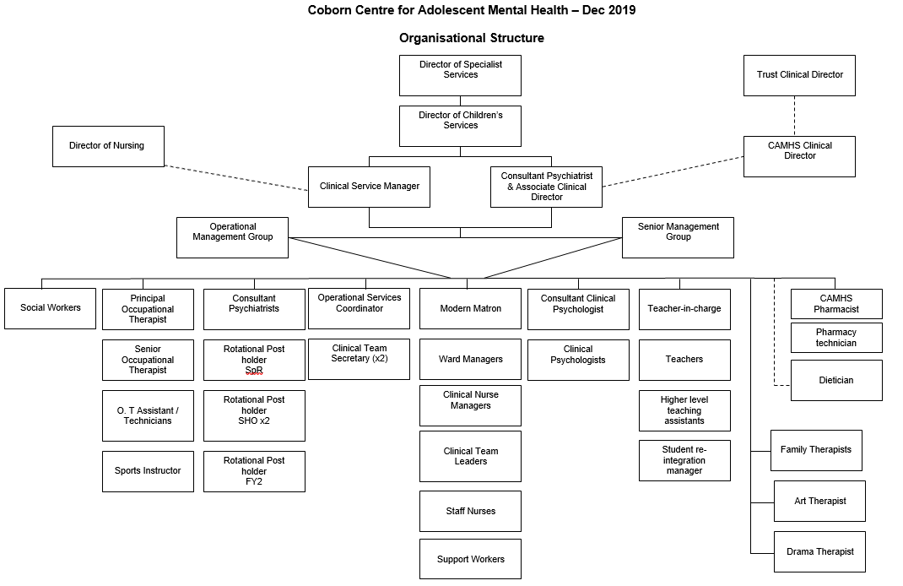
Service Composition 2021
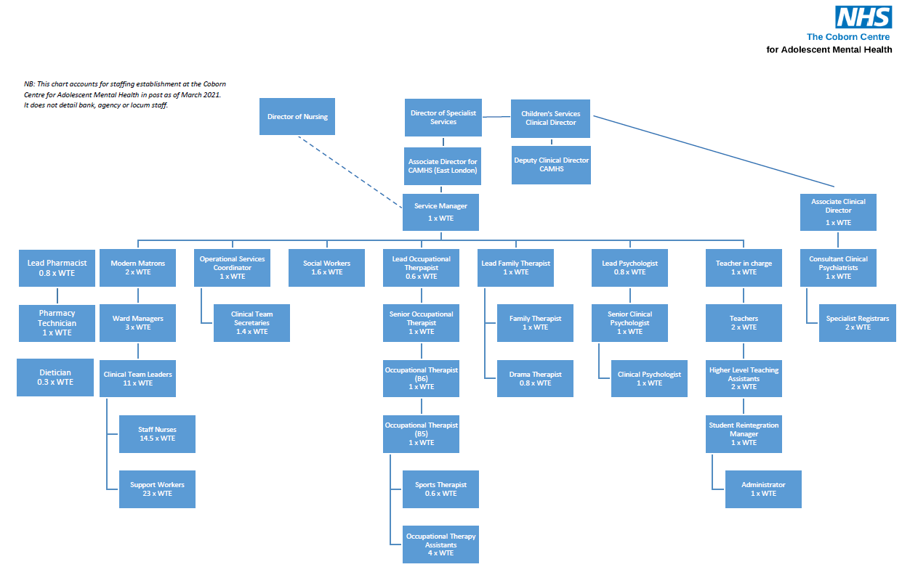

4.1 Teams / Staffing

Table 4.1.1 Staffing Establishment

There is a Service Manager and an Associate Clinical Director (ACD) responsible for leading the Coborn. There are 3 Consultants, Head of Psychology, Head of Therapy, Senior Pharmacist, Nurse consultant, x2 Modern Matrons and a Senior Social Worker. There are Band 8A Psychologists, Family Therapists and three Ward Managers (one from each PICU, general ward and day care units).
The following table shows The Coborn minimum unit staffing as at April 2021.

Ward | Registered Mental Health nurse minimum staffing per day (sum: early, late, night shift) | Support worker minimum staffing per day (sum: early, late, night staff)
Acute | 6 | 6
PICU | 6 | 6
Galaxy | 8 | 11

The graph below shows the actual level of staffing on the acute ward in comparison to the minimum staffing requirement. Staffing below zero indicates understaffing and staffing above zero indicates overstaffing (period April 2020-March 2021).
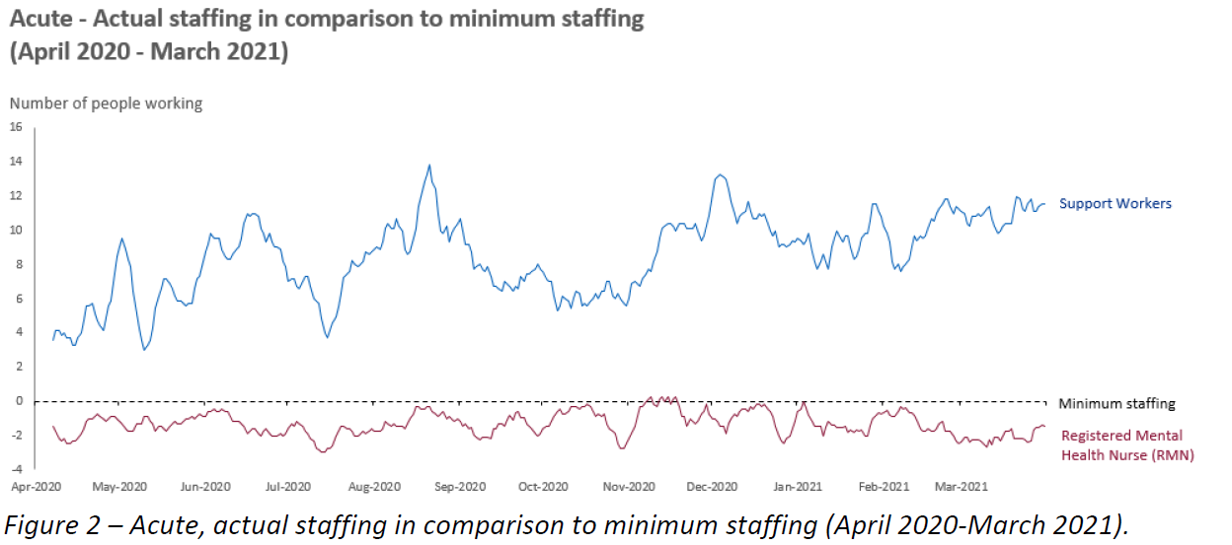
Chart 2: ACUTE – ACTUAL STAFFING (april 2020 to March 2021

The graph below shows the actual level of staffing on the PICU ward in comparison to the minimum staffing requirement. Staffing below zero indicates understaffing and staffing above zero indicates overstaffing (period April 2020-March 2021).
Chart 3: PICU – acute and minimum staffing comparison (April 2020 – march 2021)
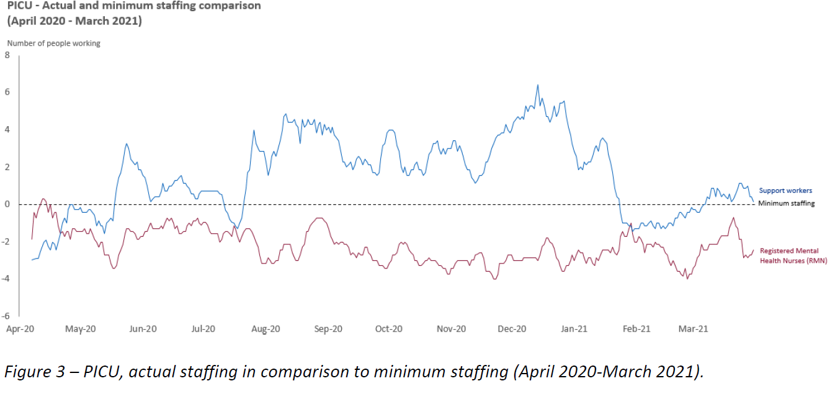

The graph below shows the actual level of staffing on Galaxy ward in comparison to the minimum staffing requirement. Staffing below zero indicates understaffing and staffing above zero indicates overstaffing (period April 2020-March 2021).
Chart 4: galaxy – actual staffing in comparison to minimum staffing (April 2020 – march 2021)
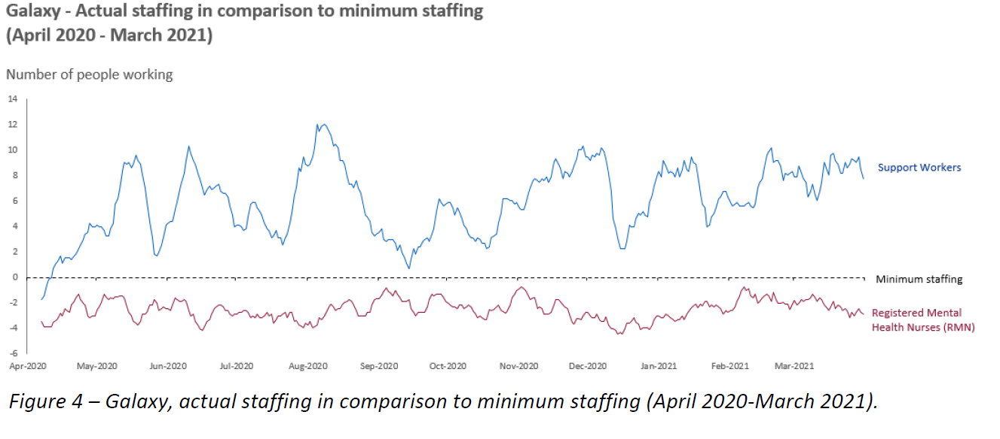

Table 4.1.2 Vacancies and Staff Mix
A recent Coborn staffing paper undertaken over the period June 2019- December 2020 has identified the following staffing establishment and current role occupancy and vacancy rates with staff in post as of January 2021. Coborn – staffing and vacancies review June 2019-December 2020 can be found in appendix 4.

Staff Role | Establishment in WTE | Actual (Current) | Band / Grade
Admin and Clerical
Admin and Clerical | 2.4 | 1.4 | 4
Operation Manager | 1.0 | 1.0 | 6
Bank Administrator | 0 | 0 | 4 – Reduction of 1 WTE band 4 administrator for Galaxy ward to 0.6 WTE in September 2020 to create a band 5 post for the MDT.  Band 5 role not recruited to - so subsequent vacancy.
Bank Administrator | Nil | 1.0 | 3
Medical
Medical Locum Consultant | Nil | 0.8 | Locum Consultant from Dec 2020
FY2 | ? | 0 | Junior doctors
Associate Clinical Director | 1.0 | 1.0 | Medical grading
Consultant | 1.3 | 1.3 | Medical grading
SPR | 2.0 | 2.0 (only filled in March 2021) | Medical grading
Nursing
RMN Band 5 | 14 | 14 (permanent staff) + 1.8 (band 5 agency) | 5
RMN Band 6 | 6 | 6 (permanent staff) +1.0 (band 6 agency) | 6
Ward managers | 3.0 | 3.0 (as at Jan 2021) | 7
Matron | 2.0 | 2.0 (as at Jan 2021) | 8A
Service Manager | 1.0 | 1.0 | 8A
Support Worker | 27.5 | 27.5 | 3
Occupational Therapy
Occupational Therapy Technician | 4.0 | 4 | 3
Sports Therapist | 0.6 | 0.6 | 4
Occupational Therapist | 1.0 | 1.0 | 5
Occupational Therapist | 1.0 | 1.0 | 6
Occupational Therapist | 1.0 | 1.0 | 7
Occupational Therapist | 0.6 | 0.6 | 8A
Psychotherapy
Art Therapy | 0.8 | 0.8 | 7
Family therapy | 1.0 | 1.0 | 7
Lead family therapist and psychotherapy team manager | 1.0 | 1.0 | 8A
Pharmacy
Pharmacy Technician | 1.0 | 1.0 | 5
Lead CAMHS Pharmacist | 0.8 | 0.8 | 8A
Psychology
Clinical Psychologist | 1 | 1 | 7
Senior Psychologist | 1 | 1 | 8A
Lead Psychologist | 0.8 | 0.8 | 8B
Social Worker
Social Worker |  | 1.6 | 8A
Teaching Team
Administrator | 1.0 | 1.0 | N/A
Student Reintegration Manager | 1.0 | 1.0 | N/A
Higher Level Teaching Assistants | 2.0 | 2.0 | N/A
Teachers | 2.0 | 2.0 | N/A
Teacher in Charge | 1.0 | 1.0 | N/A

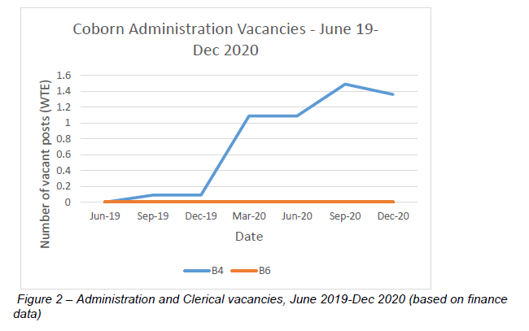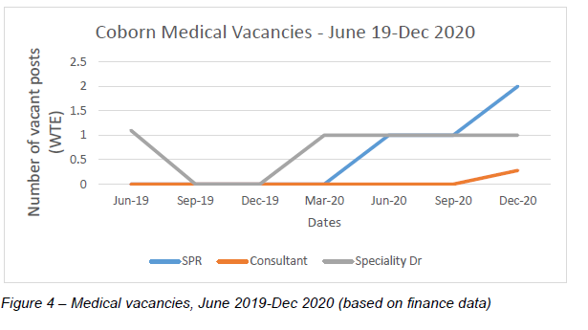

Chart 5: The coborn administration vacancies (June 2019 – December 2020) Chart 6: The coborn medical vacancies (june 2019 – December 2020)

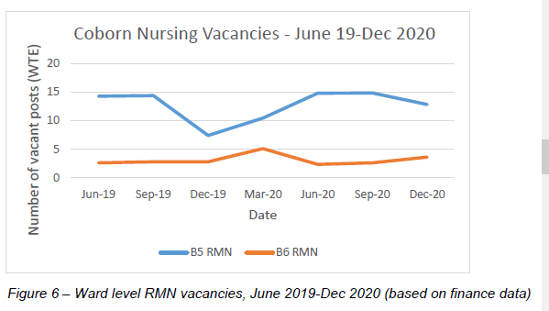
Chart 7: coborn nursing vacancies (june 2019 to December 2020)

Table 4.1.3 Coborn Unit staffing vacancies

Changes in Leadership in 2020

In 2020, there were significant changes within the leadership structure at The Coborn. The lead Consultant/Associate Clinical Director left the service, and the roles of the Associate Clinical Director passed to another consultant. A locum was appointed to fill the vacant clinical sessions. There were also major shifts in the nursing management. Throughout 2020, staff left the service due to promotion, a matron became the Acting Service Manager and there were in house promotions from band 6-band7-band8. This created some gaps within the nursing management structure but also with the effects of COVID-19 had at times a detrimental effect on the service (as seen in section 6 governance section).

Medical Cover:
Notably there were no Consultant vacancies on the unit until December 2020 when 0.5WTE of a Consultant post became available. There was a 1.0 WTE Speciality doctor role vacant throughout the period June 2019 to December 2020. Only dropping to no vacancies in this staff group for the 3rd Quarter of 2019/20. Sadly, the Unit only has SPR cover at 1.0 WTE in March 2020 with the second SPR post recruited into in September 2020.

Medical cover on The Coborn
1 x Foundation Year Doctor (LTFT)
2 x Core Trainee (LTFT)
3 x Higher Trainee (LTFT)
3 x Consultant (LTFT + Associate Clinical Director)
Duty doctor covering the Coborn as part of the Newham Centre for Mental Health out of hours.
On-call cover from Higher Trainees to support the duty doctor out of hours
On-call cover from CAMHS Consultant out of hours”.

Registered Mental Health Nurses:
Of some concern is the fluctuating number of registered (qualified) mental health nurses available over the period June 2019 to December 2020. As at June 2019 here were 14 Band 5 RMNs, this number had reduced to 7 by December 2019, slowly rising again to 14 over June to September 2020 and then commenced falling to 12 as at December 2020. The picture for Band 6 qualified RMNs in the Unit shows a less fluctuating picture. With three Band 6 RMNs on the Unit as at June 2019, which rose to 6 as at March 2020 reducing to between 3 and 4 by December 2020. The lack of qualified nurse leaders on the Unit is also demonstrated in The Coborn Staffing Review data (see appendix 3). As at June 2019, there was only 1 x 0.1WTE Matron at Band 8a on the Unit, and then from March to October 2020 there were no Band 8a matrons in post on the Unit. In October 2020, the acting matrons and ward managers started in post as the previous ward matron stepped into the new role of Interim Service Manager. This created an acting up opportunity for x2 band 8 matrons and x2 service managers who started in October 2020.

Happily, as at January 2021 both Band 8a matron roles were successfully recruited into. The Unit was fully established with x3 Band 7 Ward Manager’s until December 2019 when the Ward Manager presence was reduced by 0.8WTE until June 2020, when it appears that the full 3.0WTE was re-established. The decreased number of band 5’s and 6’ and the lack of a matron during the change to the new model of care supports the staffing pressures the unit experienced.

Support Workers:
Overwhelmingly, the highest established staff group is that of 27.5 WTE Support Workers at Band 3. The Unit has rarely had the full establishment of Support Workers in post due to the fluctuating number of vacant positions at any point in time during the period of the staffing review where this data was interrogated. As at June 2019 there were 5.5 WTE vacancies rising to 6.5 WTE in December 2019 and then falling to 0.5 WTE in September 2020, slowly rising to 2.5 WTE as at December 2020. Consequently, the Unit has routinely worked at reduced staffing establishment figures ranging from 30%, at its worst to 2% at its best.

Occupational Therapists
The Band 3 roles were successfully recruited into in September 2019 with the incumbents remaining in post since then. The Staffing Review data shows that it seems difficult to retain a Band 4 Sports Therapist in role, as the role only seems to have been filled for a short period in September 2019. The effects of this should be considered further as this review is of the view that this role could be very important to the successful recovery of young people via a sports /activities focus.

Psychology Staff:
Due to the absence of historic data on the vacancy rates of psychology staff. No updates on this issue are included in this review.

Social Worker:
Due to part time worker accommodations, Social Work provision was down by 0.4WTE against establishment needs.

Teaching Team:
Teaching provision to the Unit is provided via a SLA with Tunmarsh School, which commenced in April 2018. As this provision is via an SLA, the review did not see vacancy rates for Teachers and Teaching Team provision to the Unit.

Nurse Training and Retention:

A review of “Nursing Leavers 2019/20 - 2020/21” - Completed by Claire McKenna Director of Nursing (see appendix 3) on 11 March 2021 indicated that for the two year period there were no stark indications, common across all the exit interviews undertaken, to indicate a trend into why nurses left. However, unqualified Support workers did overwhelmingly report across both years that they were leaving to “take up further studies”.

Student Bursaries’ to support trainee nurses education is no longer available. (The Health Foundation, The Kings Fund, Nuffield Trust, 2019) The removal of nursing bursaries and the attrition rate of, particularly, mature students from nursing education due to financial straits has created further shortages to the pool of qualified nurses, which will affect the number of qualified nurses who can be recruited into the unit over the long term.
The Director of Nursing advised, in response to the removal of the nursing bursary question that it did not directly affect staffing on the Coborn unit. Moreover, that the main period of people leaving was in September due to people starting university courses to undertake their training with on average people staying on the unit for approximately 2-3 years prior to commencement of their studies. Overall, the timing of support workers leaving The Coborn is indicative of the start of the University academic year in September and many of these support workers commencing their nurse training.
Within the changes for staffing there were three changes in one year of service manager and acting positions of band6-band7, band 7-8A and band 8A-band 8B.
A review of unqualified and qualified nursing staff was undertaken for the period 2019-2020 and can be found in appendix 3.

Notably, the data included in the review of Nursing Leavers 2019/20 -2020/21 was >0.05 and therefore statistically insignificant. A deep dive analysis of this paper has shed light on some of the wider national and local issues surrounding nursing staffing. Essentially, there is a national and a London wide issue around pay and accommodation for nurses. The new pay system has not helped to positively address retention matters with respect to nurses. This is related to the extended gap between increment points on nurse’s agenda for change pay scales. Newly qualified band 5s, in particular, are easily attracted to band 6 or community roles outside of London/SE. This also affects other bands as their lifestyles change.
As an organisation, ELFT is an attractive proposition and the CAMHs service is often seen as a key area to work in. Additional challenges around the provision of accommodation for nurses introduces another dimension, which adversely affects the overall retention of nurses.

5.0 External Reviews

Table 5.1 Care Quality Commission (CQC) reports

An unannounced inspection was undertaken on the 6th November 2017 visit reference 38260 (see appendix 5).

2017 and 2020 CQC Visit Findings

CQC Findings and Domains | 2017  (06.11.2017) | 2020  (16.01.2020)
Visit Type | Unannounced | Unannounced
Unit Overview | 12 Bedded Acute Ward  4 Bedded PICU | 12 Bedded Acute Ward  6-9 Day Service Places  16 Bedded PICU
PICU Bed Numbers | 4 | 16
Patients on Unit at time of visit | 15 including;  (8 Detained across acute and PICU Ward x4 on S.2 and x4 S.3) | 11 including (9 detained @ X5 on S.3 and X4 on S.2)
Staffing  Nurses  Medics  Other | X 4 RMNs  X 3 Consultant Psychiatrists, , X 1SPR, X 3 Core Trainee Jnr Doctors  X 4 Support Workers/ OTs/OT assistants, Psychologists and Social Workers are in MDT  Art and Drama Therapists | At time of visit there were x3 RMN vacancies and X 4 non registered RMN vacancies  X3 Consultant Psychiatrists, X4 SPRs and X3 junior doctors  Teams included OTs, Psychologists and Social Workers. X2 Family Therapists, X1 dietician, X1 Drama Therapist, X1 Art Therapists  Therapy provision was available 7 days per week
Independent MH Advocate (IMHA) | Available and active  IMHA visits ward and facilitates patients council meeting | No Mention Made
Patients’ Council | Present | No Mention Made
Education Provision | Available for All | No Mention Made
Overview of Patient Interviews | Overall Patients engaged and positive about the Unit | Overall Patients engaged and positive about the Unit
CQC Past Actions Compliance | Compliant | Compliant. However new areas were identified for action
Other | PICU to be expanded from X4 to X16 beds with the addition of X12 additional beds | Provision to admit young people with Learning Disabilities, Challenging Behaviours and Eating Disorders who would have individualised Care Plans, extra staff support and specialist staff who could conduct nasogastric feeding.
Table:

5.2 Coborn unit Quality Network for Inpatient Child and Adolescent Mental Health Service reports (QNIC)

Coborn Unit QNIC Certificate 2015-2018

For the period 14.07.2015-14.07.2018, the Coborn Unit was accredited as excellent by the Royal College of Psychiatrists (see appendix 6).

For the period 04.09.2018-03.09.2021, the Coborn Unit was accredited by the Royal College of Psychiatrists (see appendix 6).

5.3 Complaints/ Concerns and Incidents and SIs inclusive of reporting incidents

Formal complaints about The Coborn were minimal with two complaints received in 2019, which were subsequently closed. A further two complaints were received in 2021 that are currently being investigated.

6.0 Governance issues during Covid-19

The review noted that with staff shielding and the reduction in staff through Covid-19 related absences that this also resulted in a reduction in PMVA/MAPA trained staff. This altogether proved to be a very challenging time for the unit. Recruitment was onerous alongside changes in leadership and management that appeared to all happen at once.
Additionally, following a restructure of staff within The Coborn, there were gaps in some management cover and the governance structure was altered. Consequently, The Coborn senior management had to work face to face with patients on the wards to cover for this deficit.
During Covid-19, nursing supervision suffered as a result of shortage of staff as well as the amount of incidents that required the team to be constantly on the floor to manage young persons in crisis.
The nursing team continued to have weekly reflections, supported by senior family therapists, but they could hardly leave the floor to attend academic sessions even when it was offered virtually.
Staff connections was fractured due to the lack of a full MDT. The Acting Service Manager was constantly interviewing to try to fill staff vacancies
In contrast, SLAM had no changes in their governance structure throughout Covid-19 with only a change to their meetings going online to accommodate a reduction in face-to-face meetings due to Covid-19 face-to-face restrictions.

During Covid-19 it was recognised the need to change meeting structures on The Coborn. These included-
- There was a Covid-19 MDT meeting where discussions took place regarding staffing morale, sickness, the environment and infection control.
- Management were attending Infection control meetings on a daily basis to get the latest news on Covid-19 and the strategy.
- The Service Manage attended the Silver Covid -19 meeting with the directorate and feeding any news to the wider team.
- An agreed infection control protocol for The Coborn was initiated including ordering PPE and swabs on a weekly basis.
- The launch of a track and trace log book that was based at the reception and at the entrance of Galaxy ward.
- Patients across the whole unit were rag rated enabling services to close the day service. This then led to the launch of a virtual ward to keep in touch with patients who still needed the support of the unit.
- Closure of the small 4 bedded PICU due to a Covid-19 outbreak.
- Gradually as infection rates improved, this was re-opened and the day service was reopened.
- There are now weekly Covid-19 huddles where management touch base with the latest news, staffing welfare, shielding, PPE and the Government guidelines.

7.0 Safeguarding Provisions

All clinical staff at The Coborn are offered three monthly safeguarding children supervision, which takes place in a group setting. The need for effective staff safeguarding supervision has been a feature of many serious case reviews and the importance of safeguarding supervision is referred to in many key reports and enquiries. This training should provide opportunities for peer learning and discussion, provide protected time to think, explain and understand safeguarding concerns, help practitioners cope with the emotional demands of the job and help workers identify unknown issues or offer a new angle on complex issues.

The minimum requirements for safeguarding supervision is set out in the safeguarding supervision policy. This takes place with The Coborn staff every three months in the form of group supervision. Q3's supervision took place in October 2020 and was attended by thirteen members of staff. There was difficulty arranging a date for Q4 due to staffing pressures but a date has been set in March. This staffing pressure was around the same time as the second wave of Covid-19.
Staff attendance at safeguarding supervision should monitored at staff one to one line management supervision and any safeguarding children issues should be routinely discussed.

The safeguarding team can be contacted for unplanned one to one safeguarding advice and support via telephone or e-mail, and the team run a duty system to ensure someone is available in cases of annual leave and sickness cover. Staff are advised not to wait until safeguarding supervision if they have a concern, but to contact the safeguarding team or speak with their manager. Children's social services can always be contacted for help and advice 24 hours a day throughout the year.

The option is available for senior clinical staff at The Coborn to facilitate safeguarding supervision themselves to overcome the difficulty of shift work etc., though they would have to undertake a training course in safeguarding supervision. This was discussed with The Coborn staff in February 2020 prior to the Director of Safeguarding entering the post and prices and course details were distributed.
Since February 2021, the named professional for safeguarding children covering Newham meets with senior The Coborn staff to discuss issues arising from incidents reported that week.

7.1 Safeguarding training

All The Coborn clinical staff should receive level 3 safeguarding children training amounting to 12 hours every three years which is in line with the intercollegiate document “Safeguarding Children and Young People: Roles and Competencies for healthcare Staff. Fourth Edition: January 2019”.

Level 3 training is provided for all clinical staff who:
- Work with children and young people and / or
- Their parents / carers and / or
- Any adult who could pose a risk to children; and
- Who could potentially contribute to assessing, planning, intervening and / or evaluating the needs of a child or young person and / or parenting capacity (regardless of previous safeguarding concerns have been identified or not).
Up until March 2020, this took place as face to face training and since September 2020 has been covered by completing an online learning package and an online 2-hour interactive session with the safeguarding team.

Level three safeguarding training figures in February 2021 for the Coborn are provided below.
Level three safeguarding training figures compared to the expected level
ELFT trust target is >90 %
Table:
Department within Coborn | Percentage of level 3 training completed
Galaxy ward | 35.29%
PICU | 50%
Coborn adolescent services | 65.85%

Chart 8: level 3 safeguarding trained staff as of February 2021

7.2 Allegations against staff members

The Allegations Against Staff Policy covers staff responsibility with respect to this area. This is a legal duty and follows statutory guidance. Any allegation made against a member of staff needs to be reported to a dedicated post at social services, the Designated Officer (commonly referred to as the LADO). It has to be reported to the Associate Director for Safeguarding Children, is fed back to the Director of Safeguarding and the Executive Lead for Safeguarding (Chief Nurse), and forms one of the key performance indicators that are fed back to the clinical commissioning group (CCG) via the safeguarding children dataset.
Referrals should be made or advice sought from the LADO at the earliest opportunity. Gaps in this process were identified in November 2020. A local process around allegations has since been agreed with The Coborn, HR and the LADO and a training day was undertaken on the 13.04.2021 and was attended by ward managers, matrons and the social worker.

The below graph details referrals made from the Coborn unit to the LADO regarding allegations against ELFT staff for the 2020-21 reporting period. There were no referrals received by the safeguarding team within Q1 and Q2. However, it is possible that referrals were being made during this period without the safeguarding team being notified.
Chart 9: Number of lado referrals made from The coborn

The serious incident reported in November 2020, in which a young person was assaulted by a member of staff, highlighted concerns in the reporting process prompting the need for further support in this area. There were seven referrals to the LADO in that period, two of which were made by the same young person on two separate occasions (against different staff members), who also made another allegation in Q4. The referral rate has stabilised since.

7.3 Key policies relating to safeguarding

- Safeguarding children supervision policy
- Safeguarding children policy
- Allegation against staff policy
Anecdotally it was established during investigation of a ligature incident that a member of staff had no knowledge of the ligature policy. This was reported back to the Associate Director for safeguarding Children by the named professional for safeguarding children although there are no further details.

7.4 Mandatory training for all staff employed by ELFT including the trust training needs analysis (TNA)

Staff training – training needs analysis (TNA) (see Appendix 7).
Information received from the ELFT learning and development adviser confirms that there is one training needs analysis (TNA) for the Trust and these are not individualised to each ward. The notes and staff group columns within appendix 7 provide granularity.

Staff Safety
There have been recent reports via staff interviews and DATIX incident report numbers 148729 and 148882 that the availability of reduced numbers of personal alarms. Staff members noted staff leaving and taking personal alarms home thus creating a reduced amount of alarms. This creates its own safety issues amongst staff.
Table 6 showing extenuating circumstances (including police call out incidents during incidents and post incidents)

Dates | No of incidents where police were called | No of incidents where a 999 call was made for emergency police attendance | No of incidents where police are recorded as attending the site | No of incidents where police are recorded as refusing to attend the site | No of 999 call incidents later reported to the police
01.12.2017-31.12.2018 | 75 | 21 | 0 | 1 | 46
01.01.2019-31.12.2019 | 78 | 37 | 0 | 1 | 35
01.01.2020-31.12.2020 | 57 | 17 | 0 | 1 | 35
01.01.2021-31.01.2021 | 2 | 1 | 0 | 0 | 1

Chart 10: extenuating circumstances

Table 7 Number of absent without leave (AWOL) incidents
Table:Dates | Number of AWOL incidents
01.12.2017-31.12.2018 | 21
01.01.2019-31.12.2019 | 29
01.01.2020-31.12.2020 | 19
01.01.2021-31.01.2021 | 3

Chart 11: number of awol incidents

Chart 12: Number of incidents by type
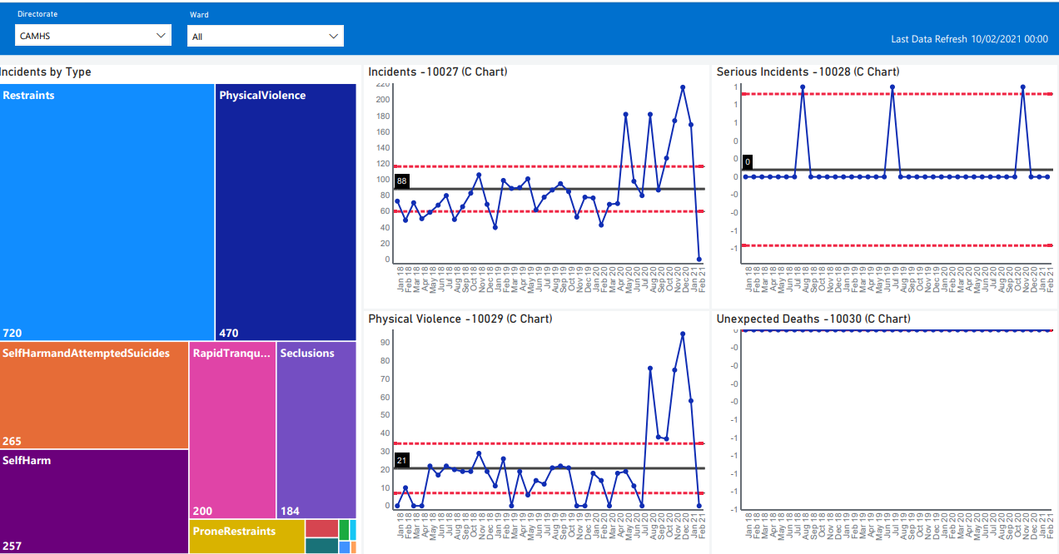

Chart 13: Types of restraints and incidents
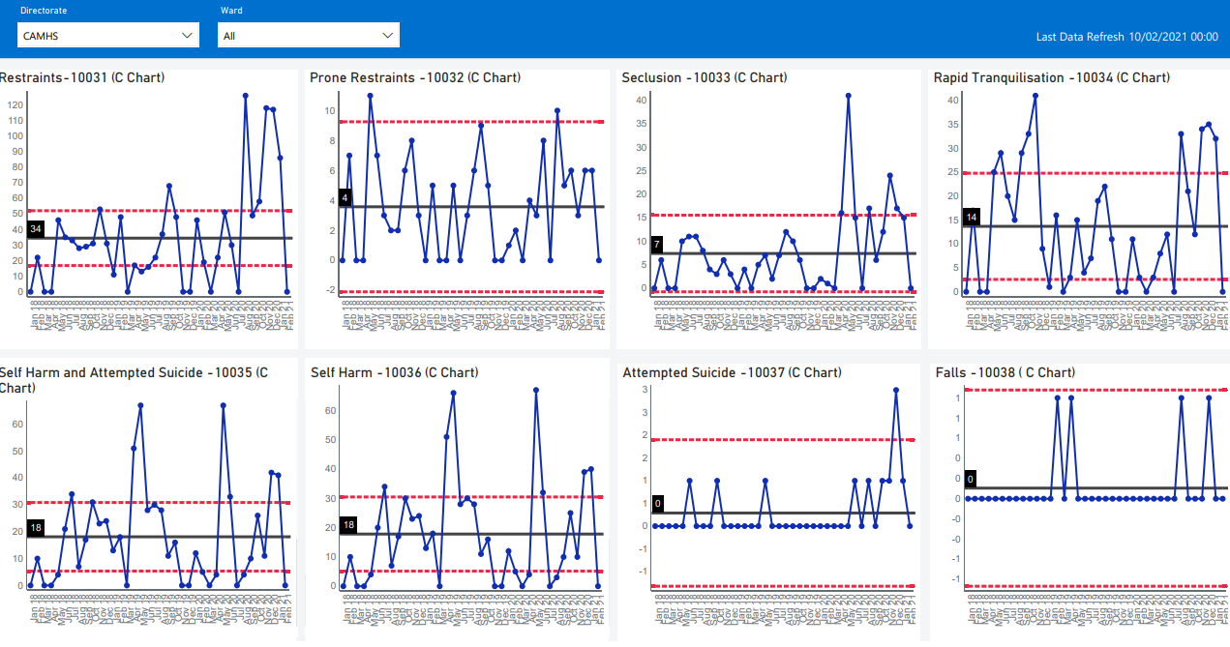

Chart 14: Absconsions including from escorted leave and failure to return from leave
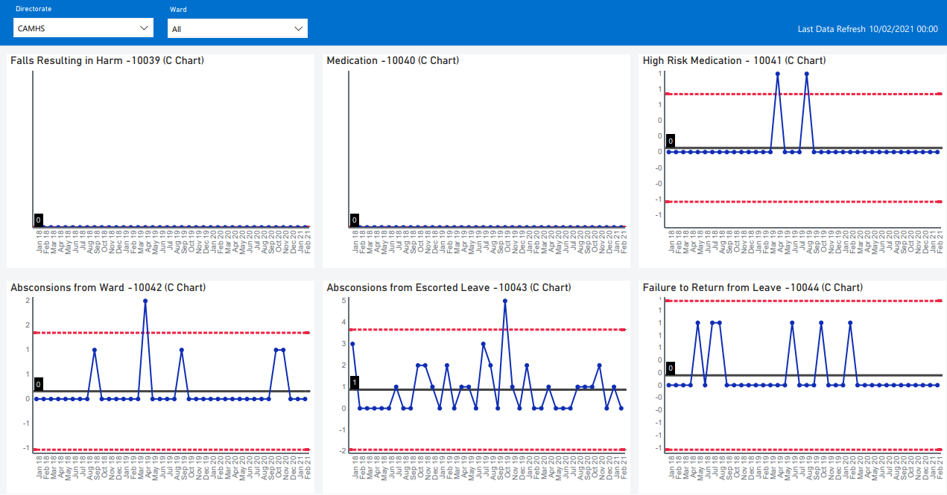

8.0 Young People Profiles
The following table identified incidents from 1st December 2017-1st January 2021 that required a serious incident review or concise review. Only 14 are indicated in the table below as these were the incidents identified as moderate harm and above and which therefore triggered a Serious Incident Review.
Within this timeframe, a total of 53 incidents generated a 48-hour report. All other incidents were of low harm.
Table 8
Year | Age of patient | Gender | Diagnosis | Incident type/s | MHA 1983 (2007) section number
2018 | 16 | Female  LC  DATIX 88936, 86382, 94010 | PTSD, depressive disorder, anorexia nervosa and emerging EUPD. | Making weapons from cutlery, head banging,  Ingestion of batteries  Ingestion of bleach  Verbal aggression  Overdose of Paracetamol | Section 3
 | 16 | Female  RD  DATIX | Extensive history of self-harm and increasing self-harm behaviours. | Self-harming behaviour  Removal of sutures from lacerations from self-harm  Suicidality | Section 2 initially then Section 3
 | 15 | Male  KA  DATIX 78803 and 82119 | Emotional dysregulation and history of aggression to others and property | Thoughts of harming others with weapons and abuse to animals.  Fashioning weapons | Section 2
 | 16 | Female  SAF  DATIX  80906, 80924, 81558 | Emotional dysregulation, emotionally unstable personality disorder and history of deliberate self-harm | Tying ligatures | Section 3
 | 15 | Female  DC  DATIX 75354, 75365 | Deliberate self-harm behaviour, violence towards others, difficulty regulating emotions. | Fashioning weapons  Overdose of medication | Section 2
 | 16 | Female  SM  DATIX 87680, 87855 | Emotional dysregulation and autistic spectrum disorder | Self-harming behaviour  Suicidal ideation | Section 3
 | 17 | Female  ML  DATIX 79084 | ADHD  Tourette’s and conduct disorder | Violence and aggression | Section 2
2019 | 17 | Male  OA  DATIX 100631 | Intellectual disabilities, attachment disorder, challenging behaviour including violence towards others and property. | Violence and aggression involving the police after absconscion. Member of staff involved and sustained soft tissue injury to shoulder and leg | Section 2 initially then Section 3
 | 15 | Female  SD | Overdoses, low mood, emotional dysregulation and tying ligatures. | Self-harm by putting a carrier bag over her head.
 | 15 | Male  HE  DATIX 115507, | Low mood and self-harm related to diabetes neglect. | Purposeful ingestion of sugary drinks and not administering insulin.
2020 | 15 | Female  AG  DATIX 137865 | ADHD, LD, ASD | Repeated episodes of violence and aggression towards staff | Section 2
2021 | 14 | Transgender  AA  DATIX 149081 | Emotional dysregulation, self-harm behaviours, food and fluid restriction and aggressive behaviour towards others. | Self-harm – head banging, ligatures, swallowing foreign bodies e.g. pens, batteries, | Section 3
 | 15 | Female  AG | ADHD, LD, ASD | Repeated episodes of violence and aggression towards staff
 | 16 | Male  HE  DATIX 142234 | Low mood and self-harm related to diabetes neglect. | Purposeful ingestion of sugary drinks and not administering insulin.

It should be noted that altogether there were 41 DATIX incidents reported including these same patients that did not meet the threshold for moderate harm.

The spike in incidents resulting in the restraints, as shown on page 33, have been described as ‘post lockdown effects on some of the young people admitted’ to the Unit. (Andy Cruikshank, 2021). Cruikshank describes how due to a combination of factors including; changes to the profile of emergency admissions of young people admitted to the unit lead to marked increases in aggression. Notably these young people are often found to be ‘on the edge of care of are fully cared for by their local authority. They have long histories of difficulties in relationships – often (because) of trauma, abuse, and the corresponding issues of regulating emotions and behaviours. Aggression in this context can often be considered as a means of testing safety and gaining control in situations where safe autonomy is considered by carers to be beyond the capabilities of a young person at that time. (Andy Cruikshank, 2021)

An additional complexity to this is that a number of young people have a degree of learning disability – which is an important factor in framing behavioural disturbance and corresponding care and treatment.” (Andy Cruikshank, 2021). The increase in admissions of young persons into the Unit during the Pandemic is therefore directly correlated with the number of violence and aggression incidents recorded during this period.

9.0 Covid -19 impact

9.1 Covid-19 and the impact

Covid-19 management continues to be a dynamic and evolving one, which has changed rapidly - almost daily over the course of the year. At the start of the pandemic, it was necessary to isolate children and young people for 10-12 days. Now it is only necessary to conduct an overnight Covid-19 test with results received back much quicker and many more nudge testing machines within ELFT available.

9.2 First wave of Covid-19 March 2020 onwards

In March 2020 during the first wave of Covid-19, the impact on the ward and patients was staff having to shield, increased sickness absence and patients coming onto the Unit having to be put into isolation. In March 2020 alone, 36 members of ELFT Coborn Unit staff were shielding which was 50% of the unit’s workforce.
Covid-19 management of individual young persons was based on how the individuals presented alongside their individual ability to co-operate whilst also considering infection control measures that were in place. During the first wave shielding resulted in patients having to take a Covid-19 test and then to self-isolate for a period of 10-14 days. Shielding created its own problems with the children and adolescents not wanting or understanding why they had to shield which resulted in 1:1 observations being instigated because young people did not want to obey the required boundaries. This increased the pressure in an already pressurised environment due to the staffing constraints that 1:1 observations created.
Lack of family visits contributed to the heightened unrest and pressure, as families were not able to come in and visit young persons. Home visits and overnight stays as part of discharge planning did not take place, which also delayed discharges but also created increased amounts of pressure on the young people and their families. During Covid-19, some of the digital strategy IPADS were working and then not working with inconsistencies with internet access, which created barriers in terms of connecting with families. Understandably, this did not help to settle patients down and contributed to “a perfect storm” of; unsettled young people and increased staff absences directly due to pandemic measures and its effects.
9.3 Second wave of Covid-19 October 2020 onwards
During the second wave from October 2020 onwards, the duration of time required to shield had significantly dropped with patients having Covid-19 tests and results being returned within a shorter time span and therefore, patients were spending less time in seclusion.
Acuity and demand in the Community CAMHS services had risen and been sustained from the first wave of the pandemic. This reached a critical point in November 2020 in the form of a number of factors, which included-
- Delayed discharges within Tier 4 due to long timescales to source and offer appropriate social care provision
- High acuity in the community with numbers of Children and Young People (CYP) presenting in crisis to A&E, without being previously known to community services, increasing.
- Increased numbers of young persons with initial physical and mental health needs in acute beds, requiring ongoing/further mental health support which needed to be moved on to a setting like Coborn (even if they were just waiting for a social care placement).
- Intervention in Community CAMHS included a daily crisis call with stakeholders across ELFT patch to prevent admissions into Tier 4. This measure led to diversion with intensive packages of care for many young people meaning those admitted into the Coborn were of a particularly high level of acuity and risk, increasing the chance of potential violence and aggression, enhanced observations (which drew heavily on the workforce) leading to extraordinary packages of care and consideration of segregation.

Despite these challenges, The Coborn as part of the North Central and East London (NCEL) collaborative have remained a responsive part of the support system for the children and young persons in North East London, supporting where possible with the acuity and pressures described above.
9.4 SLAM first wave of Covid-19 March 2020 onwards
SLAM reported that during Covid-19 first wave, they experienced similar issues with placements that could not meet young person’s needs but they could not make any direct correlation with this occurring as a result of Covid. Discharges of general adolescent unit patients proved challenging due to not being able to facilitate leave as a result of Covid-19 restrictions, SLAM also reported the same issues, as the Coborn, with the digital strategy creating barriers in terms of connecting with families.

9.5 Covid-19 and staff training
As of March 2020, all face-to-face training was placed on hold. This included safeguarding level 3 training required by qualified nurses and PMVA training also known as MAPA training. PMVA is a 5-day face-to-face training course that enables the skills to deal with violence and aggression. The result of this left The Coborn with a reduced number of PMVA trained staff to help manage the violence and aggression.
Similarly, SLAM experienced the same impact from Covid-19 on staff training as they had employed NHS Professionals staff on the unit that were not PMVA trained. Non-substantive staff members were given the option to stay working on the unit for weeklong periods, thus reducing their exposure to other areas and reducing possible transmission of Covid-19, to other areas. This arrangement enabled staff continued presence with their young persons. SLAM stated that although the PMVA training was not being offered face to face, there was an option for staff to receive safeguarding level 3 training online. Additionally, they had a trained social worker on every ward. This gave staff the option of talking to them for any kind of safeguarding concerns they had, if they needed advice.
9.6 Covid-19 and staff retention and shielding
During the first wave from March 2020 onwards, The Coborn reported 36 members of staff who had to self-isolate (50% of the workforce), whereas SLAM reported 11 members of staff who had to self-isolate (Unknown percentage of the staff). The Coborn utilised bank members of staff to cover shifts. The exact numbers are not known.
SLAM used NHS professionals as their recruitment agency with their own regular staff doing NHS professional shifts (NHSP). SLAM reported a reduction in the number of NHSP personnel due to NHSP staff being required to only stay and work regularly on that ward and not move around, to prevent possible further transmission of Covid-19. SLAM stated that they did not feel that they had lost more staff over the period during the Covid-19 waves due to shielding or other Covid-19 related absences.
Covid-19 clearly had an effect on staff retention. However, this was not a challenge exclusive to CAMHS inpatient services and was an issue across the whole of ELFT. However, lockdown had a disproportionate impact on the Unit due to the existing staff deficits and a small staffing pool available to support an acute unit. Additionally, the lockdown was directly correlated with an increase in referral patterns into the unit from care homes and placement breakdowns, which resulted in bed pressures and a reduction in the available pool of general admission beds. Together with an increase in the levels of acuity of young people admitted to the unit.

Table 9.7 The Coborn - Covid-19 positive patients
Date | Number of Covid-19 positive patients
31.03.2020-31.01.2021 | 9
Table 9.8 The Coborn - Covid-19 staff sickness
Date | Number of staff with Covid-19 related sickness
 | First wave
03.2020 | 36 (50%) of The Coborn work force
04.2020 | 1
05.2020 | 0
06.2020 | 0
07.2020 | 0
08.2020 | 0
09.2020 | 0
 | Second wave
10.2020 | 0
11.2020 | 0
12.2020 | 1
01.2021 | 19 (20%) of The Coborn work force
02.2021 | 0
03.2021 | 0

Table 9.9 The Coborn - Covid-19 staff shielding – first wave and second wave

Covid-19 wave | Total number of staff shielding
Wave 1 commencing 03.2020 | 9
Wave 2 commencing 10.2020 | 10

Chart 15: The Coborn Covid-19 staff related illness

March 2020 First wave
October 2020 Second wave
10.0 Findings and Analysis
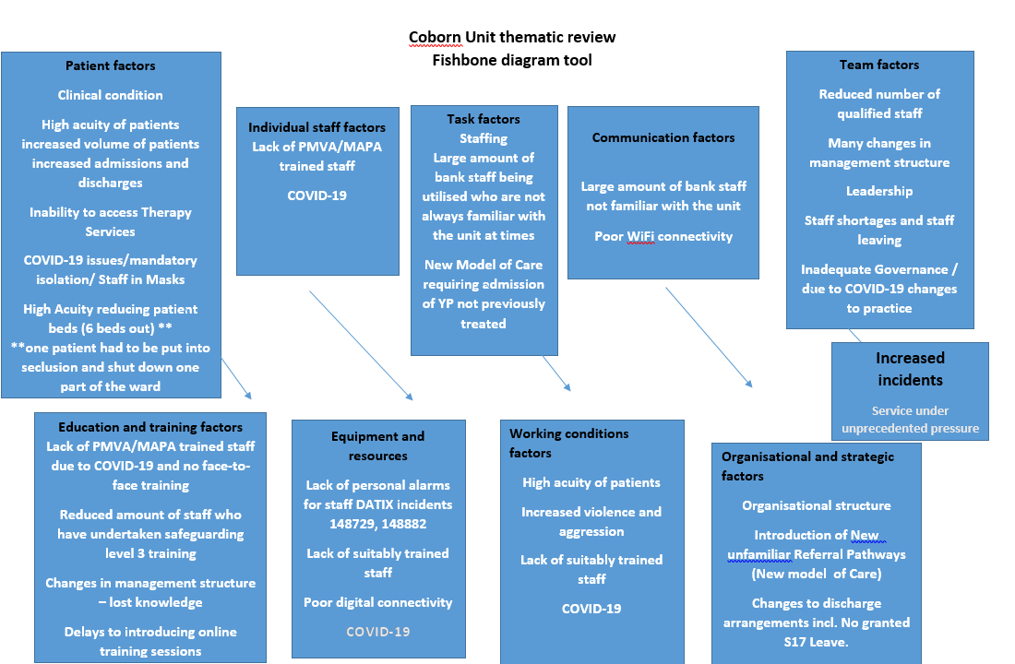

10.1 Findings and Conclusion

The regularity in occurrence of the incidents, which gave rise to this review, were indicative of a finely tuned system under pressure. The Coborn Unit when optimally working requires all the necessary cogs (staff) and wheels (processes) to be in (near) perfect alignment i.e. the availability and working knowledge of staff, for the unit to work at its best. Sadly, this working environment had become disrupted due to the effects of Covid-19. The introduction of the Provider collaborative in October 20 also led to a new system for receiving referrals, although referral criteria to the unit did not change. There was an increase in acuity in the young people referred to the ward. The Coborn have longstanding experience in managing young people with ASD, LD and Eating disorders, ,including in tube feeding, but there was an increase in presentations of these difficulties in the referred population, whilst the staff themselves were coming to terms with new ways of working due to the Pandemic.

The review has shown that overall, pre 2020, the Unit had mostly full staff complements with a stable leadership team. Indicative of low attrition rates and systems knowledge of the staff in post. At the onset of the Pandemic in March 2020, these staffing levels changed with key members of staff leaving the unit and others not being available due to shielding issues etc. This resulted in the employment of staff from the Trust bank, who did not always have a working knowledge of the Unit and how things ‘worked around here’. Many of the Bank staff also did not have the requisite MAPA training / education to enable them to effectively handle some of the more challenging behaviours of children and young people on the Unit. SI 137865, revealed how a staff member who allegedly assaulted a young person had not received MAPA training when the incident occurred, despite having worked on the unit for a number of years. Additionally, the Coborn structure is not set up, as is the case for the SLAM PICU, with social worker presence on a daily basis to provide safeguarding advice and support to staff. There is a senior social worker present and working across the Coborn provision, although not based solely in Galaxy.

In October 2020, a highly anticipated and exciting new initiative to change the commissioning of adolescent in-patient services was commenced. Commissioning switched from NHSE to the NCEL provider collaborative, with ELFT as lead provider. The collaborative set up a patient flow team (bed management service) as the point of referral and to manage referrals across the system. The aim of the collaborative was to facilitate young people being cared for as close to home as possible and to reduce lengths of stay where indicated. This included liaising with all units within the collaborative about how to facilitate admissions when necessary. The Coborn team had to adjust to a clinical interface with the PFT regarding management of referrals and had to establish working relationships with the leads for the collaborative and the patient flow team. The launch of the Provider collaborative and the introduction of the patient flow team coincided with a period of unprecedented low staffing levels and in a period when Unit staff were just coming to terms with the new working arrangements necessitated by Covid-19.
The pressures on Unit staff became even greater because of the exacerbated presentations of children and young people whose routines has been stopped or disrupted due to the pandemic, leading to their behaviours becoming more challenging. Altogether, the Coborn as a finely tuned system, which relies on a great deal of co-ordinated working, appears to have received several quite significant disruptions all at once including:
- Pandemic Management change to working processes necessitating the need to isolate children and young people on arrival into the Unit.
- The cessation of some therapeutic inputs- due to isolation and loss of groups etc.
- The cessation of Section 17 Leave
- The cessation of Consultants Breakfasts to name a few.
The New Care Model requiring;
- Staff adjusting to receiving higher numbers of referrals due to surge in demand and having to establish a relationship with the Collaborative patient flow team
- Increasing presentation of children and young people with eating disorders and autism
- Working with unprecedented bed capacity levels.
- Also the closure of the day unit due to infection control restrictions, meaning that it was more difficult to step young people down prior to discharge.
Collectively these issues hugely contributing to the pressures experienced by Coborn Unit staff and the disorientation of the children and young people who were admitted to the unit.
In summary, the combination of; a complex working environment, acutely unwell children and young people being managed by pressured staff and some inadequately trained staff - in the midst of a Pandemic – (the likes of which had not been seen for a century) created a perfect storm. Culminating in increased incidents of young people, on the unit, attacking each other and staff, destroying unit property and in three cases of staff (allegedly) assaulting young people.

11.0 Recommendations
Bed Management
- Consider reducing number of PICU beds from 16 to 11 to enable more efficient and successful management of young people.
Or
- Reconfigure PICU provision on Unit with a reduction from 12 on Galaxy – exact number to be agreed with NHS England/ NCEL Collaborative and ELFT directors
Estates
- Review Coborn Unit estate to assess and reconfigure for optimal professionals joint working with young persons.
Financial
- NHSE Provider Collaborative to review financial envelopes for each provider included in the collaborative with a view to ensuring income parity, to deliver equitable care, across the collaborative.
Recruitment
- Ensure long-term planning systems/mechanisms are in place to recruit appropriate staff groups to support necessary staffing mix.
- Identify alternative recruitment channels into the Unit.
Staff Retention
- Develop alternative / flexible staffing plans also including the ‘type’ of staff required to manage staffing disparities and to focus on ‘care around’ the child/young person.
- Identify alternative staffing incentives, outside of financial incentives, to encourage staff retention including health and wellbeing and specialist training and development packages.

Training
- Identification and provision of alternative channels to provide emergency MAPA training for unit staff as required. Particularly, when pandemic emergency management measures are introduced.
- Induction and Training programmes for new staff to be maintained during times of pandemic measures / other emergent measures in place.
- Ensure the regular provision and updating of Safeguarding Training – and its maintenance during pandemic revisions to service provision.
- Commence aspiring training with regards to Autistic Spectrum Disorder and Learning Disabilities clients to develop staff knowledge and skills

Patient Centred Care
- Develop ‘around the child’ staffing skill mixing to better support young people
- Review the efficacy of treatment provided to young people on the 16-bedded Unit.
- Introduce ‘Spot Briefing’ sessions at the start of each shift to understand staff knowledge of young persons on the Unit and to update them with current updates.
- Use Just Culture initiatives to create a safe environment for staff to say ‘ I don’t know’ and seek help and support as needed.
- Create Welcome Packs for young persons to include; details of Seclusion and Restraints practices on the Unit and information as to when these will be used. Pack should also include ‘Advanced Directives’ of how young person would like to be de-escalated when in a crisis.

12.0 Appendices

Appendix 1 Increase in number of incidents

Appendix 2 Coborn agreed Terms of Reference

Appendix 3 The Coborn review of nursing leavers

Appendix 4 Coborn staffing paper – review of staffing changes and vacancies (June 2019-December 2020).

Appendix 5 CQC reports 2017 and 2020

Appendix 6 QNIC certificates for the period 2015-2018 and 2018-2021
Appendix 7 ELFT Training Needs analysis

Appendix 8 ELFT Restrictive Practices Board Report Jan 2021

13.0 Glossary

ACD - Associate Clinical Director
CNWL – Central and North West London
CQC – Care Quality Commission
ELFT – East London Foundation Trust
HEE – Health Education England
IMHA – Independent Mental Health Advocate
MAPA – Management of Actual or Potential Aggression
NELFT – North East London Foundation Trust
NHS – National Health Service
NHSE – National Health Service England
PICU – psychiatric intensive care unit
PMVA – Prevention and Management of Violence and Aggression
QNIC – Quality Network for Inpatient Child
RMN – Registered Mental Health Nurse
SLAM – South London and Maudsley NHS Foundation Trust
SW – Support worker
The Coborn – The Coborn centre for adolescent mental health
TNA – Training Needs Analysis

14.0 References

- Care Quality Commission. (2020). CAMHS Coborn - CQC Mental Health Act 1938 Monitoring Visit. Care Quality Commission.

- Commission, C. Q. (2017). Coburn Centre Mental Health Act 1983 Monitoring Visit. CQC.

- NHS England. (2020). NHS-Led Provider Collaboratives: specialised mental health, learning disability and autism services. Retrieved from https://www.england.nhs.uk/mental-health/nhs-led-provider-collaboratives/: https://www.england.nhs.uk/mental-health/nhs-led-provider-collaboratives/

- The Health Foundation, The Kings Fund, Nuffield Trust. (2019). Closing the Gap. London.
- (The Health Foundation, The Kings Fund, Nuffield Trust, 2019)

- National Association of Primary Care - https://napc.co.uk/primary-care-home/ last accessed 10.03.2021

- NHSE New care models - https://www.england.nhs.uk/new-care-models/ last accessed 10.03.2021
- NHSE NHS-Led Provider Collaborative https://www.england.nhs.uk/mental-health/nhs-led-provider-collaboratives/

- Closing the Gap.

The Coborn thematic review action plan
Serious Incident Reviewers To Complete |  |  |  | Managers To Complete |  |  | Directorate to Complete
Issue Identified  (Reference to Contributory Factors and Root Causes) | Action Learning Themes (as recorded on Datix  http://mh126-hq-datix/Datix/Live/index.php?action=home&module=ACT | Recommendation | Level of Recommendation  Individual  Team  Directorate  Organisation | Actions To Be Taken | By Whom | By When | Outcome | Completion  Sign-off
 |  | Feedback of the review and report to be provided to the Coborn senior management staff | Team |  | Lead Reviewers  Abiola Ajayi-Obe  Louise Turner | Oct 2021
Safe staffing levels and reduction in bed capacity |  | The Coborn unit to consider a reduction in the number of allocated beds across the two PICU wards | Organisation | Consider reducing number of PICU beds from 16 to enable safe management of young people.  Reconfigure PICU provision on Unit from 12 beds on Galaxy Ward as a result of reviewing impact on population, contractual and service operation. Number of beds to be decided and agreed at NCEL collaborative level with ELFT . | Lindsay Hobson  Cathy Lavelle/Rafik Rafaat  Dorian Cole  Mohit Venkataram | March 2022
Improve configuration of staff physically to improve communication and the delivery of patient care |  | Create an MDT room on Galaxy and recreate the de-escalation room to enable MDT presence on the ward and provide support to nursing staff | Organisation | Create these rooms by Oct 202, review the impact in December 2021 | Steffney Kamara / James Atkinson | Oct 2021
Staffing issues within the Coborn |  | Ensure long-term planning systems/mechanisms are in place to recruit appropriate staff groups to support necessary staffing mix.  Identify alternative recruitment channels into the Unit. | Directorate and Organisation | Assurance group with attendance from AD/Service manager, Director for Nursing/Deputy Clinical Director meeting regularly to review developed plan.  High level items completed already include live comprehensive system to track recruitment, outreach to universities, work with People and Culture to make adverts more attractive, target Newham population, virtual recruitment days, review turnover information to consider a sustainable establishment, rolling adverts etc  Work will continue | Kamel Cheradi /Steffney Kamara/  Lindsay Hobson | Review Oct 2021, Review Jan 2022
Improve staff retention |  | Develop alternative / flexible staffing plans also including the ‘type’ of staff required to manage staffing disparities and to focus on ‘care around’ the child/young person.  Identify alternative staffing incentives, outside of financial incentives, to encourage staff retention including health and wellbeing and specialist training and development packages. | Directorate and Organisation | Review of establishment and piloting the impact on roles such as additional OT and Social Workers, experienced RMNs, OTAs, Life Skills/Recovery worker. Ongoing review of both impact for young people, staff workload and budget requirements for this  QI project – enjoyment in work ongoing  Training – considering transparency, equality of Coborns development of staff also in place and being further developed/established | Steffney/Kamel/Lindsay Hobson | Ongoing
Staff training issues identified |  | Identification and provision of alternative channels to provide emergency MAPA training for unit staff as required. Particularly, when pandemic emergency management measures are introduced.  Induction and Training programmes for new staff to be maintained during times of pandemic measures / other emergent measures in place.  Ensure the develop training meets the needs of a specialist unit operating at PICU complexity  Ensure the regular provision and updating of Safeguarding Training – and its maintenance during pandemic revisions to service provision.  Further implement training with regards to Autistic Spectrum Disorder and Learning Disabilities and Eating Disorder young people to further develop staff knowledge and skills within the staff | Directorate and Organisation | Escalation of the continued issues around availability Trust wide of these issues and a sustainable way forward which prioritises Units such as the Coborn with level of risk that prevents admissions and challenges the maintaining of safety on the unit  Nurse Consultant and Service Manager have developed and are iteratively improving following feedback  Structured plan in place to recover rate of and monitor progress to better compliance of supervision, provision of groups. Ongoing and monitored  Participation in NHS E training regarding this, identified training and key individuals. Ongoing analysis of CYP presentation trends to further ensure appropriate training and knowledge within Coborn to manage demand and improve further the delivery of care to CYP | Claire/Lorraine/Andy  Kamel Cheradi and Steffney Kamara  Newham Safeguarding Children Lead / Steff Kamara/ Nina Stovold | October 2021 with review in Dec 2021 and March 2022
Ensuring patient centred care |  | Develop ‘around the child’ staffing skill mixing to better support young people  Review the efficacy of treatment provided to young people on the 16-bedded Unit.  Introduce ‘Spot Briefing’ sessions at the start of each shift to understand staff knowledge of young persons on the Unit and to update them with current updates.  Support the Respect Value for the Trust create a safe environment for staff to say ‘ I don’t know’ and seek help and support as needed.  Create Welcome Packs for young persons to include; details of Seclusion and Restraints practices on the Unit and information as to when these will be used. Pack should also include ‘Advanced Directives’ of how young person would like to be de-escalated when in a crisis. | Directorate and Organisation | Recruitment completed regarding Art therapist/Drama Therapist and additional OT (alongside Nurse Consultant post). Additional Modern Matron also being non recurrently funded  MDT base established throughout the unit and group activities re-established as Covid restrictions lifted  Review of handover processes to ensure the right information is shared to support safety on the unit with each change of shift  QI project initiative about culture, way of delivering feedback and creation of safe, learning environment for staff, supported interventions as occasions arise with ACD and Service Manager  Completed the update of the Welcome pack and ongoing delivery of training regarding seclusion, restraint etc | Claire Mckenna/ Steffney Kamara  Steffney Kamara/ James Atkinson  Kamel Cheradi/ Modern Matrons  Ravi Patel/ Steffney Kamara  Laura Fisher and Kamel Cheradi | Oct 2021  Sept 21  Oct and Dec 2021  March 2022 with monthly review and ongoing  Sept 2021
Ongoing relationship dynamics between NCEL Collaborative and Coborn Unit |  | Coborn and NCEL collaborative to review current governance structures and working relationship |  | Review of governance, working relationships and review each quarter successes and challenges in completed work to improve wherever possible future working | Lindsay Hobson/Ravi Patel/ Rafik Rafaat/ Dorian Cole | Dec 2021 with review March 2022

