Date: 27th July 2023

How to
Authenticate
Via Authenticator App

Step 1
Navigate to https://portal.nhs.net .

Step 2
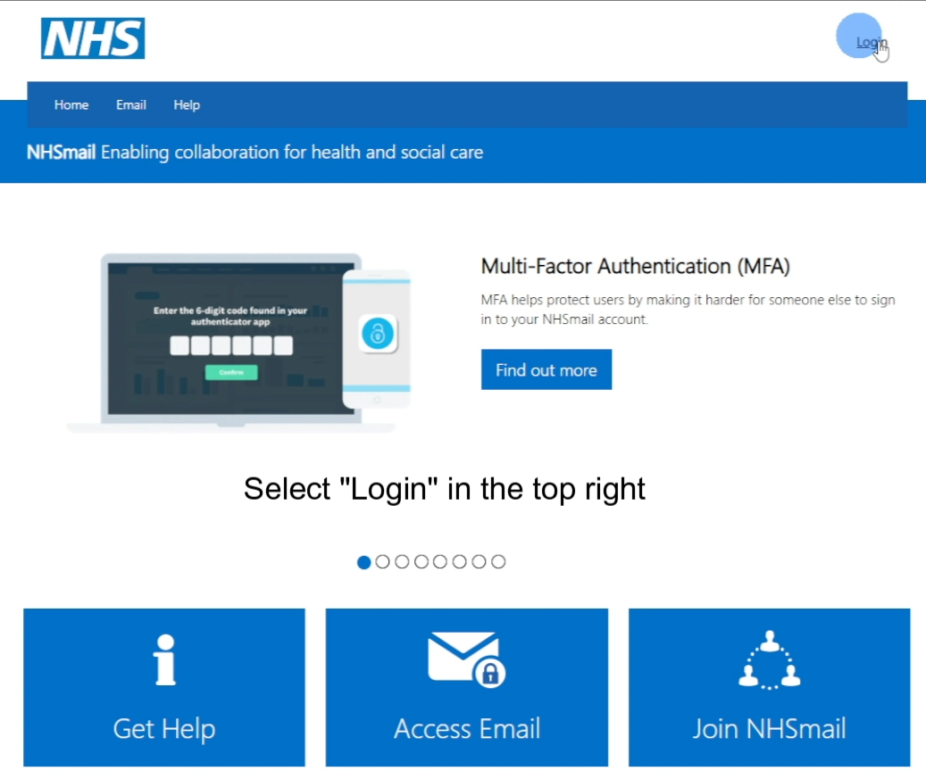
Sign in via the “Login” button in the top right of the page.

Step 3
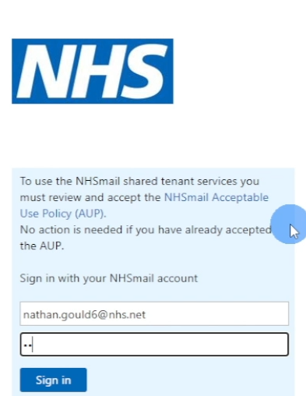
Sign in with your NHS mail credentials.

Step 4
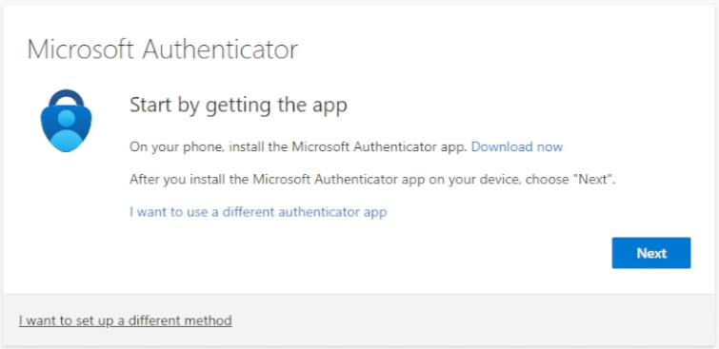
Click the “Download now” button.

Step 5
Using your phones camera, scan the appropriate QR code for your device.
You will be taken you your App/Play Store to download the Authenticator app.
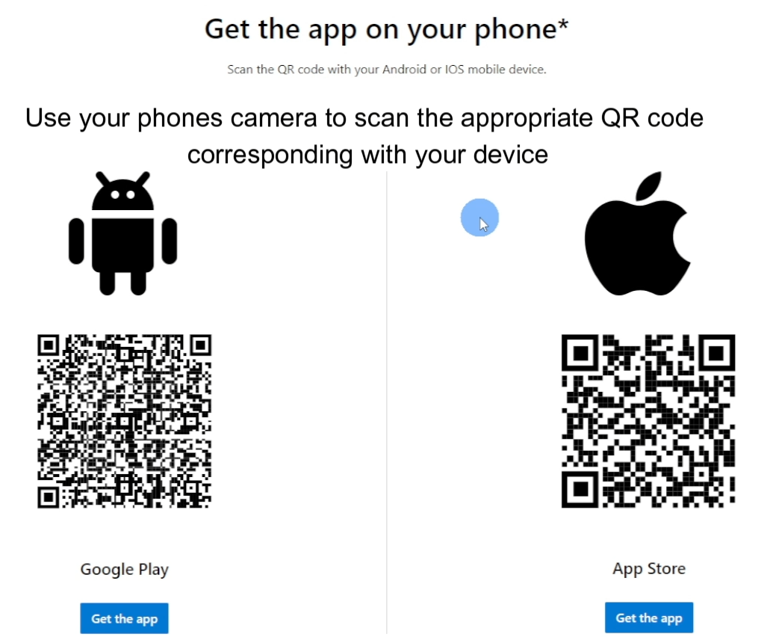

Step 6
After installing the app, click the “next button in your browser.

Step 7
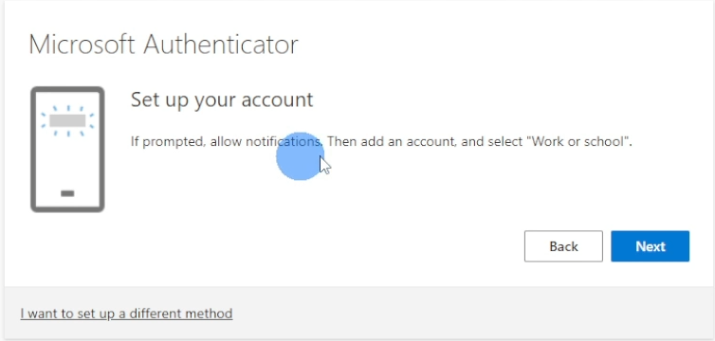
Click “Next” again.

Step 8
Once the QR page below loads, keep it open & head back into your Authenticator app.

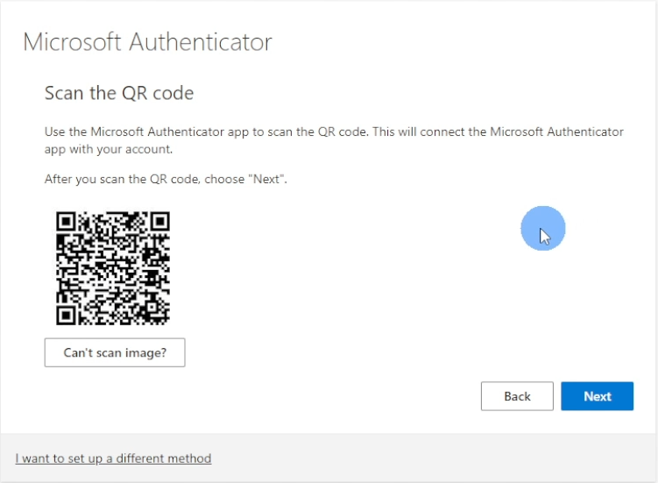

Step 9
Click “Add account”
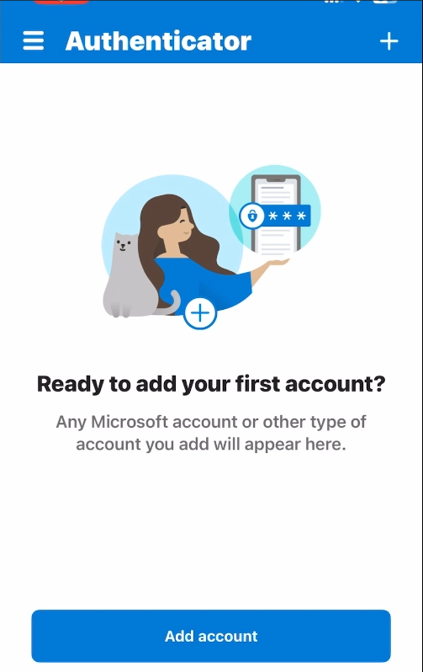
Then choose Work or School Account”.
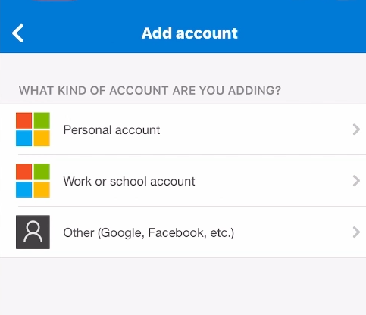

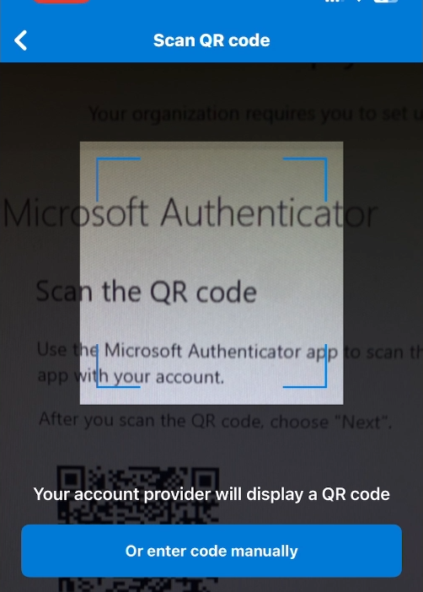
You will be prompted to scan the QR code you received in Step 8.

Once the QR code has been scanned, wait for your NHS account to populate.

Step 10
Head back to the QR page in your browser and click “Next”.

Step 11
You’ll be given a 2 digit code to put into your Authenticator app.

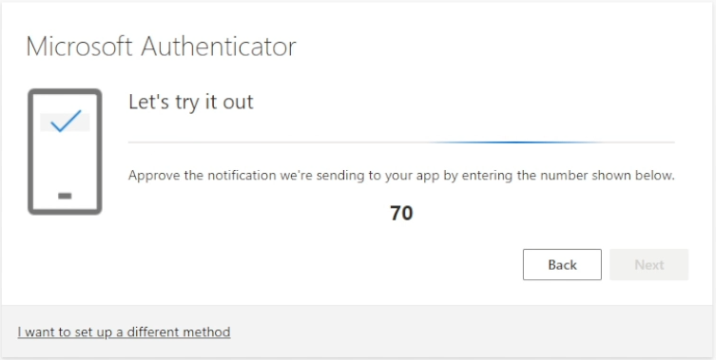

Step 12
Enter the code into your app and click “Yes”.
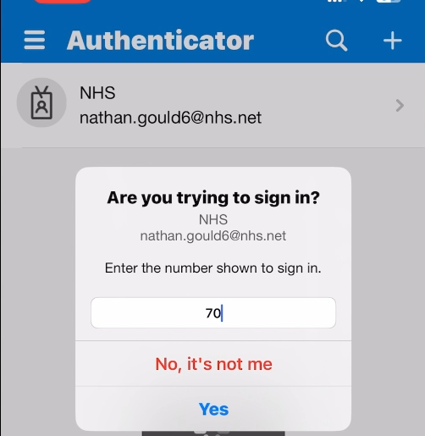
After clicking yes, you will get an “Approved” banner. Once you do, head back to your browser.
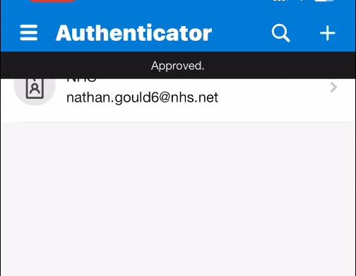
Step 13
You’ve now completed the MFA process.
Click “Done” and you will be redirected to your NHS emails.
