Respiratory Infections Policy

Version number : | 4.0
Consultation Groups | Infection Prevention & Control Committee  Quality Committee
Approved by (Sponsor Group) | Infection Prevention & Control Committee/Infection Prevention & Control Team
Ratified by: | Quality Committee
Date ratified: | 6th September 2023
Name of originator/author: | Infection Prevention & Control Team
Executive Director lead : | Director of Nursing
Implementation Date : | September 2023
Last Review Date | September 2023
Next Review date: | June 2024/ When national guidance changes

Services | Applicable
Trustwide | X
Mental Health and LD
Community Health Services

Version Control Summary

Version | Date | Author | Status | Comment
01 | 03-08-2022 | Rana  Begum | Final | Policy development in line with national guidance to management all respiratory infections:  - Influenza  - Avian influenza  - Parainfluenza  - Respiratory Syncytial Virus  - Adenovirus  - Human Metapneumovirus  - Rhinovirus  - MERS coronavirus  - COVID-19
02 | 7th October 2022 | Rana  Begum | Final | Updates in line with national guidance updated - paused on asymptomatic patient & Staff testing
03 | 2nd November 2022 | Rana  Begum | Final | Updates in line with national guidance updated- paused on asymptomatic patient & Staff testing. Appendices updated.
04 | 30th June 2023 | Harriet Ddungu,  Rana Begum, Monsur Gabr & TB Services | Final | Updated in line with national guidance.
 |  | Siobhan Fensom | Final | Updated Fit-testing guidance.

Table of Contents
 |  | Page Number
 | Policy | 6
 | Executive Summary | 6
 | Scope/Purpose | 6
 | Roles & Responsibilities | 6
 | Introduction | 7
 | Respiratory Virus Transmission | 7
 | Influenza | 8
 | Pandemic Influenza | 8
 | Avian Influenza | 8
 | Parainfluenza (HPIV) | 9
 | Respiratory Syncytial Virus (RSV) | 9
 | Adenovirus | 10
 | Human Metapneumovirus | 10
 | Rhinovirus | 10
 | Coronaviruses | 11
 | Middle East Respiratory Syndrome Coronavirus (MERS-CO) | 11
 | SARS Coronavirus  17.1 SARS-CoV-2 (Coronavirus 2019 or COVID-19) | 11  12
 | Management of Coronavirus 2019 (COVID-19) Infections | 13
 | Transmission of COVID-19 | 13
 | Infectious Period of COVID-19 | 14
 | Symptoms of COVID-19 | 14
 | Management Pathway for Patients with COVID-19 Infection in Inpatient Ward Settings. | 15
 | Management Pathway for Patients with COVID-19 Infection in Community/ Domestic Settings | 15
 | Management Pathway for Healthcare Staff Members with COVID-19 Infection | 15
 | Management Pathway for Service-User Who Is a Contact of Positive COVID-19 Case | 15
 | Management of Individuals Who Are at Higher-Risk (Clinically Vulnerable) of Severe Illness from COVID-19 | 15
 | Stepping Down Care in Isolation for Extremely Clinical Vulnerable Patients | 15
 | Documentation of Lateral Flow Test / PCR Results | 15
 | Management of COVID-19 Outbreaks | 15
 | Admitting to Wards with Active COVID-19/ Influenza Outbreaks | 15
 | Root Cause Analysis Investigations of Hospital-onset of COVID-19 Infections | 15
 | Patient/ Service User Information for COVID-19 | 15
 | COVID-19 Vaccination | 15
 | COVID-19 Treatment | 16
 | Management of Respiratory Infections  35.1 Diagnosis of Respiratory Virus Infections  35.2 Care in Isolation Respiratory Illness  35.3 Ending Care in Isolation | 17  17  17  18
 | Standard Infection Prevention Control Precautions (SICPs) | 18
 | Patient Placement in In-patient Setting | 18
 | Hand Hygiene  38.1 Hand Hygiene Etiquette for Service-Users | 18  19
 | Respiratory Hygiene/Cough Etiquette | 19
 | Personal Protective Equipment (PPE)  40.1 Donning and Doffing of PPE  40.2 Respiratory Protective Equipment (RPE)  40.3 FFP3 Respirator or Powered Respirator Hood | 19  20  20  20
 | Aerosol Generating Procedures  41.1 Guidance for High-risk Aerosol Generating Procedures on Patients with  Suspected/Confirmed Respiratory Virus | 21  21
 | Safe Management of the Care Environment | 22
 | Safe Management of Care Equipment | 22
 | Safe Management of Healthcare Linen | 22
 | Safe Management of Blood and Body Fluids | 22
 | Safe Disposal of Waste (Including Sharps) | 22
 | Occupational Safety: Prevention and Exposure Management | 22
 | Environmental Cleaning | 22
 | Use of Portable Fans/ Recirculating Air Conditioning Units | 22
 | Crockery & Cutlery | 23
 | Outbreak Management of Respiratory Infections | 23
 | Management of Tuberculosis Infections  52.1 Introduction  52.2 Infectious TB  52.3 Risk Factors for Developing MDR-TB  52.3.1 Additional Risk Factors for Mental Health Patients  52.4 Care in Isolation For Suspected/Confirmed TB cases  52.5 Risk Management Flowchart  52.6 Community Cases  52.7 Contact Tracing  52.8 Patients Who Are Non-compliant with Treatment for Infectious TB | 24  24  24  25  25  25  26  26  26  27
 | References | 28
 | Appendices  See page 5 for full list | 29
55 | Document Control  55.1 Procedure Checklist  55.2 Equality Analysis  55.3 References | 82  83  85  92

List of Appendices
 |  | Page Number
 | Part I: COVID-19 Patient Testing Pathway  Part II: COVID-19 Documentation of Results | 30  31
 | Management Pathway for Service User with Covid-19 Infection | 32
 | Management Pathway for Patient with COVID-19 Infection in Community/Domestic Settings | 33
 | Staff Testing Flowcharts | 34
 | Staff Identified as Contact of a Person with Covid-19 Infection | 35
 | Management Pathway for Service User/ Patient Contacts of COVID-19 | 36
 | COVID-19 Testing Pathway for Clinically Vulnerable Patients | 37
 | Management of Individuals Who Are at Higher-risk (Clinically Vulnerable) of Severe Illness from COVID-19 | 38
 | Stepping-down of Care in Isolation Precautions for Severely Immunosuppressed Patients | 42
 | Management of Outbreaks | 43
 | Contact Tracing Form for Occupational Health-Team | 44
 | Reporting to the UK Health Security Agency | 45
 | Admitting to Wards with Active COVID-19/Influenza Outbreaks | 46
 | Root Cause Analysis Investigations of Hospital-onset COVID-19 Infections Flowchart | 48
 | Root Cause Analysis (RCA) Form for Reviewing Hospital-onset COVID-19 Cases | 49
 | Virology Diagnostic Testing | 60
 | PPE Requirements When Caring for Suspected/Confirmed Respiratory Infections | 62
 | Donning and Doffing of PPE | 63
 | Factsheet and Guidance on the Use of Filtering Face Piece Mask (FFP3 Mask) | 71
 | PPE Risk Assessment for Respiratory Infections | 74
 | Environmental Cleaning | 75
 | Patient Information Leaflet on COVID-19 | 79
 | Quick Reference Guide to IPC Measures for Confirmed/ Suspected TB Cases | 81

Abbreviations

Human Metapneumovirus | HMpV
Respiratory Syncytial Virus | RSV
Human Parainfluenza Virus | HPIV
Coronavirus 2019 | COVID-19
Middle East Respiratory Syndrome coronavirus | MERS-CO
Severe Acute Respiratory Virus | SARS
Aerosol Generating Procedures | AGPs
Respiratory tract infection | RTI
Upper Respiratory tract infection | URTI
Lower Respiratory tract infection | LRTI
Personal Protective Equipment | PPE
Filtering Face Piece respirator masks | FFP3
Infection Prevention & Control Team | IPCT

Policy

- Executive Summary

This policy sets out standards for the assessment and management of patients with proven or suspected respiratory virus infections on Influenza, Avian influenza, Parainfluenza Respiratory Syncytial Virus, Adenovirus, Human Metapneumovirus, Rhinovirus, Middle East respiratory syndrome coronavirus (MERS-CoV) & Coronavirus 2019 (COVID-19).

- Scope/Purpose
The purpose of this document is to provide information on how to manage patients with respiratory infections, in order to minimise the risk of transmission within the healthcare setting. This policy applies in all Trust settings for the care of patients (all ages) presenting with acute febrile respiratory tract illness which is suspected or proven to be due to a respiratory virus.

It should be used in conjunction with up-to date guidance from UK Health Security Agency (UKSHA) and the National Health Service England (NHSE); national guidance is regularly updated in accordance with circulating strains of Influenza/ Variants of COVID-19 prevalent in UK and the global status of respiratory virus outbreaks as identified by the World Health Organisation (WHO).
The policy covers infection prevention and control measures for common respiratory viral infections. Various infections e.g. varicella, measles etc. may be transmitted via the airborne route; however these will not be covered by this policy. Please refer to the Infection Prevention & Control Policy Manual for further information.

- Roles & Responsibilities
Table 1: Roles & Responsibilities

Person/Department | Key Responsibilities
Chief Executive Officer (CEO) | - Has overall accountability for the Trust policies
The Director of Infection Prevention and Control (IPC) | - To provide assurance to the board that IPC systems are in place that IPC risks are managed effectively for staff, patients and visitors across the Trust  - To ensure that any shortfalls in policy implementation are addressed
IPC Doctor/ Microbiologist | - To provide advice on management & diagnosis of respiratory virus infections
Infection Prevention & Control Team (IPCT) | - Act as role model for best IPC practice  - Update this policy as required and immediately following any update on national guidance  - Provide IPC training for all relevant staff where required  - Act as an expert resource and support for all staff
Borough Lead Nurses/Service Leads/ Modern Matrons/Team/Ward Managers | - Act as a role model  - To ensure the implementation of this policy  - Act upon IPC advice and disseminate information accordingly to teams  - Ensure that staff are fit tested and aware of fit testing compliance figures within their departments
Infection Prevention & Control Link Practitioners | - Act as role model for best IPC practice  - Support the IPCT to deliver the IPC agenda  - Assist in creating an environment that is IPC safe for the patient, staff & visitors
Fit testing Team | - Provide training on fit testing / FFP3 respirator masks  - Testing staff for use of FFP3 respirator masks  - Maintain accurate staff records on fit testing compliance
Occupational Health department | - Providing advice for staff affected by respiratory viral infection including return to work assessment  - Providing advice to staff who have had contact with patients with respiratory viral infection regarding their own health, including staff with underlying risk factors  - Follow up for staff contacts of patients with emerging severe respiratory virus infections
All staff (including bank, agency or contracted staff) | - All Healthcare staff has a responsibility to comply with Trust policies for prevention and control of infection; those who provide direct patient care must ensure they are up to date with PPE usage procedures  - Healthcare staff who may perform aerosol-generating procedures or care for patients with severe emerging respiratory viruses (e.g. avian influenza, MERS, COVID-19) must ensure they are trained in and fit tested for use of FFP3 respirator masks

- Introduction

A respiratory tract infection (RTI) is an infectious process affecting any part of the upper and/or lower airways. Common viral causes of RTIs include: rhinoviruses, coronavirus, influenza, parainfluenza and Respiratory Syncytial Virus (RSV).

- Respiratory Virus Transmission
The pathogens that cause respiratory tract infections are spread through one or more of four main routes:
- Large Droplet Transmission: Virus containing droplets greater than 5 microns in size may be generated from the respiratory tract during coughing, sneezing or talking. If droplets from an infected person come into contact with the mucous membranes (mouth or nose) or surface of the eye of a recipient, they can cause infection. These droplets remain in the air for a short period and travel about one metre, so closeness is required for transmission.

- Direct Contact Transmission: Infectious agents are passed directly from an infected person to a recipient who then transfers the organism into their mouth, nose or eyes.

- Indirect Contact Transmission: A recipient has contact with a contaminated object (fomite) e.g. furniture or equipment. The recipient then transfers the organism from the object to their mouth, eyes or nose.

- Airborne transmission during and after Aerosol Generating Procedures (AGPs) can produce droplets <5 microns in size. These small droplets can remain in the air, travel more than one metre from the source and still be infectious, either by mucous membrane contact or inhalation.

- Influenza

Influenza or 'flu' is a respiratory illness caused by infection by influenza virus. It affects mainly the nose, throat, bronchi and, occasionally, lungs. Infection usually lasts for about a week, and is characterized by sudden onset of high fever, aching muscles, headache and severe malaise, non-productive cough, sore throat and rhinitis.

Influenza occurs most often in winter and usually peaks between December and March in the northern hemisphere. Illnesses resembling influenza that occur in the summer are usually due to other viruses.

There are two main types that cause infection: influenza A and influenza B. Influenza A and influenza B must not be nursed together in the same immediate environment.

Influenza A usually causes a more severe illness than influenza B. The influenza virus is unstable and new strains and variants are constantly emerging, which is one of the reasons why the flu vaccine should be given each year.

The typical incubation period for influenza can be up to 7 days, with an average of 2-5 days. Individuals infected with Influenza are regarded as being infectious for one day before the onset of symptoms and up to 7 days after the onset of the symptoms. Severely immunocompromised persons can shed virus for weeks or months.

Most infected people recover within one to two weeks without requiring medical treatment. However, in the very young, the elderly, and those with other serious medical conditions, infection can lead to severe complications of the underlying condition, pneumonia and death.

- Pandemic Influenza

Pandemics arise when a new influenza virus emerges which is capable of spreading in the worldwide population. Pandemic influenza may occur when a new influenza A virus subtype emerges which is markedly different from recently circulating strains and is able to infect humans and spread efficiently from person to person and cause significant clinical illness in a high proportion of those infected. This was the situation during the influenza pandemic of 1918-19, when a completely new influenza virus subtype emerged and quickly spread around the globe.

The H1N1 (2009) 'swine flu' pandemic virus emerged in Mexico in 2009 and spread around the world causing mild/asymptomatic disease in the majority of cases but severe illness and death in a small proportion of cases, particularly in more vulnerable groups. In August 2010 the WHO officially declared the H1N1 (2009) pandemic over, although the strain still causes a minority of Influenza A infections (as of 2017).

- Avian Influenza

Avian influenza (bird flu) is a disease of birds caused by Influenza A viruses closely related to human influenza viruses. It naturally circulates in wild waterfowl such as ducks and geese; other bird species are susceptible and it may cause severe disease in birds with high mortality.

Avian influenza A(H7N9) emerged in 2013 in China where, as of May 2017 it has resulted in 1,486 laboratory-confirmed human infections, including at least 571 deaths.

Avian influenza A (H5N1) has been reported to have caused 859 confirmed human cases and 453 deaths between 2003 and May 2017. Outbreaks with avian influenza A (H5N1) have occurred amongst poultry in a number of countries during 2016/17 including in West Africa
(Nigeria, Niger, Libya, Cameroon, Cote d’Ivoire) the Middle East (Iran) and Asia (Vietnam, Nepal, India, Bangladesh, Cambodia, Nepal), however since 2015 the only human cases reported were in Egypt.
Avian influenza A (H5N6) has been responsible for widespread outbreaks in birds across China, Japan and South East Asia, and in 2017 significant outbreaks have been reported from Mainland China, Japan, Taiwan, Hong Kong, Myanmar and Vietnam. 17 human cases of avian influenza A (H5N6) have been reported in China since 2014 with at least 10 deaths
Avian influenza A (H5N8) is an emergent, highly pathogenic avian influenza virus that affects birds and was first reported in January 2014 and has since been detected in many countries including the UK, although human infections have not been identified as of June 2017.
Avian influenza viruses do not currently infect humans easily and most cases occur after close contact with poultry or birds. There have been no reports to date of sustained human-to-human transmission, although the associated mortality has been high. However, the potential for transformation of avian influenza into a form that both causes severe disease in humans and spreads easily from person to person leading to an avian influenza pandemic is a great concern for world health.
Additional precautions are indicated if epidemiology suggests possible exposure to avian influenza (including returning travellers).

- Parainfluenza (HPIV)
There are four types of Human parainfluenza Virus (Types 1 to 4) and two subtypes (4A and 4B). They are generally considered community acquired respiratory pathogens. HPIV1-4 infection is one of the common causes of upper and lower respiratory tract disease, especially in young children. The incubation period is from 1-7 days, initiation of infection occurs when contact is made between the virus and nasal mucosa.
HPIV types 1-4 can cause a full spectrum of respiratory illness, including the common cold, croup, and severe lower respiratory tract illness (particularly in the elderly and immunocompromised), such as bronchitis, bronchiolitis and pneumonia. Treatment is generally supportive, requiring maintenance of airway and hydration. Steroids can be beneficial in treatment of croup. No vaccinations have yet proved successful.

- Respiratory Syncytial Virus (RSV)
The incubation period ranges from 2 - 8 days. The communicability ranges from 2 days prior to onset of symptoms to 10 days after their resolution. However in young infants viral shedding may continue for as long as 3-4 weeks.
For most people, RSV infection causes a respiratory illness that is generally mild. For a small number of people who are at risk of more severe respiratory disease, RSV infection might cause pneumonia or even death. Those most at risk of developing severe illness due to RSV are the very young, aged 1 year and under and the elderly. RSV is best known for causing bronchiolitis in infants.
The virus is transmitted by large droplets and secretions from the respiratory tract of infected individuals. Studies have demonstrated that most cross infection is due to direct contact or indirect contact or through fomites rather than airborne spread.
There are no vaccines against RSV although children at high risk from infection may be offered passive immunity with monoclonal antibody preparation (Palivizumab) in line with Department of Health and Joint Committee on Vaccination and Immunisation (JCVI) Guidelines:
http://webarchive.nationalarchives.gov.uk/20130107105354/http://www.dh.gov.uk/prod_consum_dh/groups/dh_digitalassets/@dh/@ab/documents/digitalasset/dh_120395.pdf

- Adenovirus
The incubation period is generally 4 to 10 days and uncomplicated infection usually resolves within 1 week. Adenoviruses can cause a wide range of presentations. Symptoms of adenovirus infection can be similar to the common cold, influenza or even pneumonia, croup, and bronchitis. Conjunctivitis, pharyngoconjunctival fever and gastroenteritis can also be caused by adenoviruses
Respiratory adenovirus infection is spread via droplet, direct contact or indirect via a contaminated surface or object. The virus is relatively resistant to physical and chemical agents, facilitating transmission by direct contact, water, contaminated objects, respiratory droplets and fomites. Their stability at low pH, such as gastric secretions allows faecal-oral spread. Virus enters via the mucosal surfaces of the eye, nose or mouth. Standard respiratory infection control procedures must be implemented for suspected or actual infection.

- Human Metapneumovirus
Human metapneumovirus is a respiratory pathogen closely related to RSV. It is associated with a range of illnesses from mild infection to severe bronchiolitis and pneumonia.
HMpV is a common but under diagnosed cause of community-acquired respiratory illness in infants, children and adults. After an estimated incubation period of 5-6 days it causes upper and lower respiratory tract infections (URTI, LRTI), with symptoms ranging from subclinical to severe pneumonitis.
In infants/ children under 2 years, HMpV is an important cause of bronchiolitis and pneumonia. An individual patient with HMpV is clinically indistinguishable from one with RSV and so clinical diagnosis is unreliable.
Spread of HMpV is presumed to be airborne and by fomites. There is no vaccine and respiratory precautions and hand washing should be used to prevent spread.

- Rhinovirus
Transmission of rhinoviruses is via direct contact, although infections have been documented by both large and small particle aerosols. Initiation of infection occurs when contact is made between the virus and nasal mucosa. Viral shedding persists after the resolution of symptoms and has been cultured from 10-20% of patients 2-3 weeks after the infection.
The symptoms of a rhinovirus infection are: discharging or blocked nasal passages often accompanied by sneezes, and perhaps a sore throat. A "runny nose" (rhinorrhoea) may be accompanied by a general malaise, cough, sore throat etc. The characteristic symptoms occur from one to four days after infection at which time extremely high titres of the rhinovirus are found in the nasal secretions (there can be as many as 1000 infectious virus particles per ml).
Rhinoviruses do not usually cause lower respiratory tract infection. They are sometimes detected in patients with severe respiratory tract infection but this may be an incidental finding.
Their contribution to disease in the immunosuppressed however has not been fully elucidated. Unless there are very immunosuppressed patients present, care in isolation is not routinely advised.

- Coronaviruses
Human coronaviruses were first identified in the mid-1960s and are named after the crown-like projections that can be seen on the surface of the virus. These viruses cause respiratory infections of varying severity in humans and animals. Although many strains of coronavirus produce mild upper respiratory tract infection, the SARS (Severe Acute Respiratory Syndrome) coronavirus and MERS (Middle East Respiratory Syndrome) viruses are both coronaviruses which can cause severe respiratory disease. Additional precautions are indicated if epidemiology suggests possible exposure to these severe diseases (usually returning travellers).

- Middle East Respiratory Syndrome Coronavirus (MERS-CO)
This coronavirus emerged in Saudi Arabia in 2012. Since then 2,029 laboratory-confirmed cases have been reported (as of June 2017), including at least 704 related deaths. Most of these cases have occurred in the Middle East, although there was also a large outbreak in South Korea in 2015. Four cases were detected in the UK in 2013 (none since February 2013) and although the global risk of widespread transmission of MERS-CoV remains low, ongoing vigilance is necessary.
The clinical presentation of MERS ranges from asymptomatic to very severe pneumonia with acute respiratory distress syndrome, septic shock and multi-organ failure resulting in death. The clinical course is more severe in immunocompromised patients and persons with underlying chronic comorbidities.
There is growing evidence that the dromedary camel is a host species for the virus and that camels play an important role as a source of human infection. Although it is likely that zoonotic transmission is the starting point of most clusters, human-to-human transmission is the most common mode of transmission for MERS-CoV. Many of the cases have occurred in the context of healthcare associated outbreaks where infection control precautions have not been appropriately implemented, highlighting the importance of the implementation of standard precautions and ongoing vigilance.

- SARS Coronavirus
SARS is a severe respiratory disease caused by SARS coronavirus (SARS CoV). It was first recognised in Guangdong Province in China in November 2002, and spread worldwide before being contained by 5 July 2003. Between July 2003 and May 2004, four small and rapidly contained outbreaks of SARS were reported; three of which appear to have been linked to laboratory releases of SARS-CoV. No cases have been reported since 2004 (as of June 2017).
On 31 December 2019, the World Health Organization (WHO) was informed of a cluster of cases of pneumonia of unknown cause detected in Wuhan City, Hubei Province, China.
On 9 January 2020, it was announced that a novel coronavirus had been identified in samples obtained from these cases and initial analysis of virus genetic sequences suggested that this was the cause of the outbreak.

17.1 SARS-CoV-2 (Coronavirus 2019 or COVID-19)
In February 2020 this new virus was formally named as SARS-CoV-2, and the disease caused by it was named Coronavirus 2019 (COVID-19), in line with best practice guidance.
On 11 March 2020 WHO declared the COVID-19 outbreak a global pandemic due to the rapid spread and severity of cases around the world.
Scientific consensus is that SARS-CoV-2 is zoonotic in origin, however the source of the original outbreak is yet to be determined.

18. Management of Coronavirus 2019 (COVID-19) Infections

On the 13th January 2023; WHO published the Clinical management of Covid-19: living guidance. Providing guidance that is comprehensive and holistic for the optimal care of COVID-19 patients throughout their entire illness is important.
The latest version (6th) contains important updates and recommendations which relate to discontinuation some of the transmission-based precautions and release from COVID-19 care pathway.
On the 22nd May 2022 published guidance which was updated on the 31st March 2023; United Kingdom Health Security Agency (UKHSA) published guidance: Covid-19 information and advice on coronavirus (COVID-19) for health and care professionals.
People at higher risk include:
- Older people
- Pregnant
- Unvaccinated
- Immunocompromised

19. Transmission of COVID-19
SARS-CoV-2 is primarily transmitted between people through these infectious respiratory particles (droplet and aerosol) when they are inhaled, or come into contact with the eyes, nose or mouth.
Transmission risk is highest in close proximity to an infectious person (particularly within 2 meters). The number of infectious respiratory particles is greatest close to the nose and mouth. Being in poorly ventilated indoor spaces, particularly for an extended period of time, also increases the risk of becoming infected.
Indirect transmission can occur through contact with surfaces contaminated with the virus (fomite transmission).
The risk of transmission in a specific setting depends on factors including:
- contact patterns, such as the proximity, number of contacts, and duration of contact with other people
- individual infectiousness and susceptibility, including viral load and immune status
- activities taking place in the setting, for example singing or exercising, which increase the volume and propulsion of respiratory particles
The virus can also spread in poorly ventilated and/or crowded indoor settings, where people tend to spend longer periods of time. This is because aerosols can remain suspended in the air or travel farther than conversational distance (this is often called long-range aerosol or long-range airborne transmission).
After 10 days from symptom onset or a positive test result, the likelihood of infectiousness is low in individuals who are not immunocompromised. Fragments of inactive virus may however be detected by PCR in respiratory tract samples following infection for prolonged periods (frequently up to 90 days, sometimes beyond) when the individual is no longer infectious.
SARS-CoV-2 has been detected in blood, faeces, conjunctival secretions and urine of confirmed cases. As always, body fluids should be regarded as potentially infectious when handling.
It is possible for humans to transmit SARS-CoV-2 to other mammals including dogs, cats, and farmed mink. The risk of transmission from mammals to humans is likely to be low, however this varies by species.
Aerosol generating procedures (AGPs) can result in the release of aerosols from the respiratory tract when these are performed in health and care settings. During AGPs, there is an increased risk of aerosol spread of SARS-CoV-2 irrespective of the mode of transmission (contact, droplet), therefore, airborne precautions must be implemented when performing AGP on a suspected or confirmed case of COVID-19 /respiratory infections.

20. Infectious Period of COVID-19

Transmission of SARS-CoV-2 occurs from 9 days before symptom onset to 15 days after symptom onset, with most transmission occurring 3 days before symptom onset to 5 days after symptom onset.

Severely immunocompromised patients can remain infectious for a much longer period.
There is some evidence that children may be less infectious, and are infectious for a shorter period of time, compared with adults.
Positive lateral flow device (LFD) tests have been shown to be associated with high viral load in infectious cases. People who have high viral loads are more infectious to other people.

21. Symptoms of COVID-19
The incubation period for SARS-CoV-2 varies according to the circulating variant.
COVID-19 presents with a range of symptoms with varying severity. It is estimated that 1 in 3 people have COVID-19 without displaying any symptoms.
The main symptoms include:
- fever,
- a new and continuous cough,
- anosmia (loss of smell)
- ageusia (loss of taste).
- shortness of breath,
- fatigue,
- loss of appetite,
- myalgia (muscle ache),
- sore throat,
- headache,
- nasal congestion (stuffy nose),
- runny nose,
- diarrhoea,
- Nausea and vomiting.
- Older people may present with less common symptoms.

In some individuals cough or a loss of, or change in, normal sense of smell or taste may persist for several weeks. This is not considered an indication of ongoing infection when other symptoms have resolved.
Individuals who are infected with SARS-CoV-2 and who are asymptomatic can still transmit virus to others.
- Management Pathway for Patients with COVID-19 Infection in Inpatient Ward Settings
Please refer to Appendix 2.

- Management Pathway for Patients with COVID-19 Infection in Community/ Domestic Settings
Please refer to Appendix 3.

- Management Pathway for Healthcare Staff Members with COVID-19 Infection
Please refer to Appendix 4.

- Management Pathway for Service-User Who Is a Contact of Positive COVID-19 Case
Please refer to Appendix 6.

- Management of Individuals Who Are at Higher-Risk (Clinically Vulnerable) of Severe Illness from COVID-19
Please refer to Appendix 8.

- Stepping Down Care in Isolation for Severely Immunosuppressed Patients
Please refer to Appendix 9.

- Documentation of Lateral Flow Test / PCR Results
Please refer to Appendix 1 (Part II).

- Management of COVID-19 Outbreaks
Please refer to Appendix 10.

- Admitting to Wards with Active COVID-19/ Influenza Outbreaks
Please refer to Appendix 13.

- Root Cause Analysis Investigations of Hospital onset of COVID-19 Infections
Please refer to Appendices 14 & 15.

- Patient/ Service User Information for COVID-19
Please refer to Appendix 22.

- COVID-19 Vaccination
The first vaccine for COVID-19 was approved for use by the Medicines and Healthcare products Regulatory Agency (MHRA) in the UK on 2 December 2020.

Vaccination remains a primary protection measure against both COVID-19 and flu, helping to reduce the risk of serious illness, hospitalisation and death.
The Joint Committee on Vaccination and Immunisation (JCVI) has provided final advice to government advising that an extra COVID-19 booster dose in spring 2023 should be offered to:
- adults aged 75 years and over
- residents in a care home for older adults
- individuals aged 5 years and over who are immunosuppressed (as defined in tables 3 or 4 of the Green Book)
From 30 June 2023, the primary vaccination offer will become more targeted, for those at higher risk of severe outcomes from COVID-19. Whereas, Flu vaccination reduces the risk of co-infection with COVID-19 and flu, and is therefore an important defence against severe outcomes.
- COVID-19 Treatment
Iindividuals who are at higher risk of severe outcomes from COVID-19 may be eligible for treatment eligible if they become unwell.
Revised eligibility for COVID-19 treatments include:
- Aged 12 and over
- Highest risk of getting seriously ill from Covid-19
- Symptomatic
- Tested positive for Covid-19
Patients’ positive with COVID-19 should be referred to the designated COVID 19 Medicines Delivery Unit (CMDU) for eligibility assessment and the treatment which is most appropriate.
Most eligible individuals should have received a ‘pre-notification’ letter or email (specified in their GP record) to alert them that they have a condition, or are on treatment, that may make them eligible for treatment.
Early treatment is more effective, provided within 5 days of symptom onset, so timely reporting of test results is essential to identify and assess potentially eligible people within the treatment window.
If the individual is not contacted by a CMDU clinician within 24 hours of receiving their positive result, the service should contact their GP or call 111 who will refer them to a CMDU if they are potentially eligible.
Individuals who test positive may be asked to take a PCR test by the NHS team arranging treatment.

35. Management of Respiratory Infections

Table 2: Infection control precautions to prevent transmission of respiratory viruses

Routes of transmission | Measures to prevent transmission
Direct: Person to person by large droplet transmission  From direct close contact with an infected person during the period of infectivity. | Droplet Precautions  Standard and contact precautions (as below) and:  Wear fluid resistant surgical mask when in side room or within 1m of infected person  Segregation of the coughing and sneezing patient; ask patient to wear FRSM
Indirect: contact with items contaminated by large droplets  Large droplets (from respiratory tract of an infected person) may contaminate the environment for short periods; virus can be transmitted by indirect contact from contaminated surfaces onto hands. | Standard Infection Control precautions  Hand hygiene after each and every contact (alcohol gel or soap/water)  Environmental cleaning – as standard policy  Equipment decontamination - as standard policy  Contact precautions  Gloves and aprons for contact with patient or their immediate environment.
Airborne: fine droplet transmission in some activities where risk of aerosol is high | Additional PPE for staff performing aerosol generating procedures  Standard precautions and  FFP3 respirator mask, eye protection and disposable long sleeved gown when performing aerosol-generating procedures

35.1 Diagnosis of Respiratory Virus Infections
For patients admitted to hospital with suspected influenza or respiratory virus infection, viral swabs should be taken. These are sent to a reference laboratory where they will undergo molecular PCR (polymerase chain reaction) testing for a panel of respiratory viruses including influenza A & influenza B and RSV.
Please refer to Appendix 16 for further information.

35.2 Care in Isolation Respiratory Illness
The patient must be nursed in a single room or cohort bay with the doors closed. Continue care in isolation after the onset of clinical symptoms or until the patient is asymptomatic. Advice will be provided by the IPCT on length of care in isolation depending on transmission spread of microorganism.
Staff contact should be kept to a reasonable minimum without compromising patient care.

35.3 Ending Care in Isolation
Care in isolation of the patient may be discontinued after 7-10 days depending on illness and onset of clinical illness providing symptoms are no longer present. Please discuss with IPCT before discontinuing care in isolation measures. Email elft.infectioncontrol@nhs.net
N.B. Immunocompromised patients (and children) may excrete viruses for a longer period.

- Standard Infection Prevention Control Precautions (SICPs)
SICPs are the basic IPC measures necessary to reduce the risk of transmitting infectious agents from both recognised and unrecognised sources of infection and are required across with ALL suspected /confirmed respiratory infections.
The elements of SICPs are:
- Patient placement and assessment for infection risk (screening/triaging) before and during admission;
- Hand hygiene;
- Respiratory etiquette;
- Personal protective equipment;
- Maintaining social/physical distancing
- Safe management of the care environment;
- Safe management of care equipment;
- Safe management of healthcare linen;
- Safe management of blood and body fluids;
- Safe disposal of waste (including sharps);
- Occupational safety: prevention and exposure management;

- Patient Placement in In-patient Setting
On admission assess patients for symptoms;
Local arrangements for identified vulnerable patients i.e. weekly LFD testing can be agreed;
Observe patients regularly for respiratory symptoms throughout their stay.
The Nurse in charge on shift should inform IPCT team (email elft.infectioncontrol@nhs.net ) that patient has suspected respiratory viral infection.
Within ward setting where possible, patients should be allocated a single room with en-suite facilities.
The transfer of patients outside their room should be limited to medically necessary activities where possible and the patients should be encouraged to wear a mask.
If a single room is not available, cohort patients with confirmed respiratory infection should be advised.

- Hand Hygiene
Staff must undertake hand hygiene as per the World Health Organisation (WHO) ‘5 moments of hand hygiene’, using either soap and water or an alcohol-based hand rub.
Refer to IPC Policy Manual Hand hygiene section for further information.

38.1 Hand Hygiene Etiquette for Service-Users
Service users should be instructed and encouraged to wash their hands or use alcohol gel hand rubs at entry points to the facility where hand-washing signage should be in place.
Service users who are unable to wash their hands should be provided with wipes so they are able to decontaminate their hands prior to eating and drinking, after toileting and attending to hygiene needs as required. Clinell hand wipes can be ordered for this purpose.

- Respiratory Hygiene/Cough Etiquette
Actively encourage patients to cover their nose and mouth with disposable tissues when coughing, sneezing, wiping or blowing their nose and dispose of the tissue in a disposal bag on the bedside prior to be disposed of as clinical waste.
For patients with COVID-19 encourage the wearing of a fluid resistant surgical mask (FRSM) where possible to prevent spreading and contamination of the environment.
Encourage/assist the patient to clean their hands after coughing, sneezing, wiping or blowing their nose.
Restrict patient movement unless clinically indicated, if they need to travel to other areas within the hospital they should wear a surgical mask (if tolerated) at all times.

- Personal Protective Equipment (PPE)
Health care workers delivering direct patient care must wear personal protective equipment (PPE):
- Universal masking with surgical face masks (Type II or IIR) to prevent the transmission of respiratory infectious agents in health care settings, as a source of control measure
- PPE must be available at point of use and stored in a clean dry area
- An integral combined visor and mask, FRSM plus visor or goggles must be worn to protect from the risk of contamination by splashes, aerosols and droplets
- A disposable apron must be worn whenever there is a risk of contamination by a patient’s blood or bodily fluids and during activities that involve close patient contact
- Long sleeved fluid repellent gowns must be worn if there is risk of excessive soiling or contamination from aerosol generating procedures (AGP’s)
- Disposable gloves must be worn when in direct contact with blood and body fluids including mucus
- Wear a Fluid resistant surgical mask for all patient care activities when in the side room/cohort bay or when in close proximity with an infectious patient (within 2 metres)
- Use additional eye protection (based on risk assessment) if risk of splashing
- Wear appropriate PPE e.g. gloves and plastic apron for activities that involve direct contact with the patient and their immediate environment
- FFP3 respirator masks to be worn when undertaking aerosol-generating procedures
Regardless of whether staff have had, and recovered from a specific respiratory pathogen or have received vaccine for that organism, they should continue to follow the infection control precautions including PPE.
All PPE is single patient use apart from the surgical mask which can be worn for up to 4 hours. However FRSM should be replaced if damp.
Please refer to Appendix 17 & Appendix 20 for PPE requirements when caring for suspected/confirmed respiratory infection.
Note: The distinction between droplet and aerosol transmission is not always clearly defined. A clinical risk assessment should be performed using the hierarchy of controls to inform the assessment and should include evaluation of the ventilation in the area, operational capacity, and prevalence of infection in the local area. Staff should be provided with training on the correct use of RPE. Current guidance is that an FFP3 respirator must be worn by staff when caring for patients with a suspected or confirmed infection spread by the airborne route, when performing AGPs on a patient with a suspected or confirmed infection spread by the droplet or airborne route, and when deemed necessary after risk assessment.

40.1 Donning and Doffing of PPE

All staff using personal protective equipment must be trained on how to safely don and doff their PPE including the correct order to avoid cross contamination.
See Appendix 18 further details on donning and doffing of PPE.

40.2 Respiratory Protective Equipment (RPE)
Filtering face piece (FFP) mask must be considered when a patient is admitted with a suspected/ confirmed infection that spreads by the airborne route and when carrying out aerosol generating procedures (AGPs).
The decision to wear an FFP3 respirator/hood should be based on clinical risk assessment e.g. task being undertaken, the presenting symptoms, the infectious state of the patient, risk of acquisition and the availability of treatment.

40.3 FFP3 Respirator or Powered Respirator Hood
- powered respirator hoods are an alternative to tight-fitting FFP3 respirators for example when fit testing cannot be achieved
- powered hoods can be single use (disposable) or reusable (with a decontamination schedule, see note) and must be fluid resistant; the filter must be enclosed with the exterior and the belt able to withstand disinfection with 10,000ppm av.cl.
- All tight fitting RPE i.e., FFP3 respirators must be:
- single-use (disposable) or reusable, and preferably and fluid-resistant (if not a full face visor should be worn)
- fit tested on all healthcare staff who may be required to wear a respirator to ensure an adequate seal/fit according to the manufacturers’ guidance
- fit checked (according to the manufacturers’ guidance) every time a respirator is donned to ensure an adequate seal has been achieved
- Compatible with other facial protection used i.e. protective eyewear so that this does not interfere with the seal of the respiratory protection.
For further information on FFP3 mask please refer to Appendices 19 & 20.

- Aerosol Generating Procedures
Aerosol generating procedures (AGPs) are medical procedures that can result in the release of aerosols from the respiratory tract. The criteria for an AGP are a high risk of aerosol generation and increased risk of transmission (from patients with a known or suspected respiratory infection).
The list of medical procedures that are considered to be aerosol generating and associated with an increased risk of respiratory transmission include:
- cardiopulmonary resuscitation (CPR)- ELFT Local policy
- awake* bronchoscopy (including awake tracheal intubation)
- awake* ear, nose, and throat (ENT) airway procedures that involve respiratory suctioning
- awake* upper gastro-intestinal endoscopy
- dental procedures (using high speed or high frequency devices, for
- example ultrasonic scalers/high speed drills)
- induction of sputum
- respiratory tract suctioning**
- surgery or post-mortem procedures (like high speed cutting / drilling)
- likely to produce aerosol from the respiratory tract (upper or lower) or sinuses.
- tracheostomy procedures (insertion or removal).
- Awake including ‘conscious’ sedation (excluding anaesthetised patients with secured airway)
- ** The available evidence relating to respiratory tract suctioning is associated with ventilation. In line with a precautionary approach, open suctioning of the respiratory
tract regardless of association with ventilation has been incorporated into the current AGP list. It is the consensus view of the UK IPC cell that only open suctioning beyond the oro-pharynx is currently considered an AGP that is oral/pharyngeal suctioning is not an AGP.

41.1 Guidance for High-risk Aerosol Generating Procedures on Patients with Suspected/Confirmed Respiratory Virus
- The performance of aerosol-generating procedures should be minimised as far as is feasible without compromising patient care.
- Activity to be performed in a side room/single room (wherever practicable) and with the door closed.
- Limit personnel in the room to the minimum number necessary to perform the procedure.
- Staff involved in the aerosol generating procedure to wear: FFP3 respirator mask, eye protection, disposable long sleeved gown and gloves.
- Staff to have been correctly fit tested and trained in correct use of FFP3 masks and PPE.
- Healthcare staff who may perform aerosol-generating procedures should be medically cleared, trained and fit-tested for FFP3 respirator use. Responsibility lies with the staff member to make sure they are fit tested. Please see Appendices 19 & 20 for further information regarding fit testing for FFP3 respirators, with training of organisational trainers being supported by the infection control and occupational health teams.
- Ensure adequate ventilation of room either by natural/ mechanical ventilation (window opening / non re-circulating air conditioning unit).

- Safe Management of the Care Environment
Physical distancing is recommended to remain at 2 metres when caring for patients with suspected/ confirmed respiratory infection.
Inpatient bedded services can utilise the COVID-19 safety bundle on a daily basis to support safe management of the environment.
Work place risk assessment should be undertaken & reviewed every 3-6 months to assess the immediate work environment or earlier if they are significant changes to the working environment.

- Safe Management of Care Equipment
Re-usable medical equipment must be cleaned and disinfected with two -step disinfection wipe. Please refer to IPC Policy Manual decontamination section.

- Safe Management of Healthcare Linen
Linen should be managed as infectious linen in red canvas bags. Please refer to Linen Policy for further information.

45. Safe Management of Blood and Body Fluids
Management of blood and body fluids should be managed as per IPC Policy Manual - Handling of Blood & Body Fluids. Please refer to IPC Policy Manual.

46. Safe Disposal of Waste (Including Sharps)
Management of clinical waste should be managed as per IPC Policy Manual - Management of Clinical Waste. Please refer to IPC Policy Manual.

47. Occupational Safety: Prevention and Exposure Management
For staff management of respiratory infections at work please liaise with Occupational Health and refer to IPC Policy Manual.

48. Environmental Cleaning
Enhanced cleaning should be requested via the Help desk during an outbreak.
All floors and flat surfaces must be cleaned twice daily with the recommended disinfectant. Communal clinical equipment must be cleaned after each use with 2- step clean and disinfectant wipe.
A care in isolation door notice must be displayed at all times. The door to the isolation room must remain closed at all times.
Please see Appendix 21 for cleaning definitions and terminology.

49. Use of Portable Fans/ Recirculating Air Conditioning Units
Avoid the use of fans that re-circulate air. Please refer to IPC Policy Manual for further information.

50. Crockery & Cutlery
There is no need to use disposable plates or cutlery. Crockery and cutlery can be washed in a dishwasher. If there is no access to dishwashing processing, disposable cutlery should be used.
51. Outbreak Management of Respiratory Infections
Management of outbreaks of 2 or more cases in the same time and place will be risk assessed and outbreak management protocols will be implemented as per IPC Policy Manual. Please refer to IPC Policy - Management Outbreak subsection.

52. Management of Tuberculosis Infections

  - 52.1 Introduction
Tuberculosis (TB) is an infectious disease caused by the Mycobacterium Tubercle Bacilli. It usually presents as a respiratory disease affecting lungs, larynx, pleura or Mediastinal lymph nodes. It can also affect bones and joints, organs, the gastrointestinal and renal tracts, central nervous system or disseminated through the blood stream. Cases of pulmonary TB with sputum smear positive for acid-fast bacilli are considered infectious to others. TB is a major public health problem in London, accounting for 45% of all cases reported in England.
All patients on admission to East London NHS Foundation Trust should have a physical health check which includes assessment of risk factors for infection. If TB is suspected, the patient should be referred urgently to the local TB team and appropriate infection prevention and control precautions should be put in place.
Patients for whom TB is being suspected should be isolated in a single room with en-suite toilet to minimise contact with others, the door should remained closed for the duration of infectivity in mental health units, provided that there are no immunocompromised patients (e.g. HIV positive) in the area.
Resistance to TB drug treatment can develop, and in some cases multi-drug resistance (MDR TB) develops if patients are not compliant with medication. All patients with TB should have risk assessments for drug resistance and for HIV. There is some evidence that patients with mental health problems are at greater risk of developing MDR TB (Story et al 2007). Refer to points 52.3 and 52.3.1 for a list of risk factors for MDR TB.
Suspected or confirmed MDR TB cases will need to be transferred to a specialist centre with negative pressure facilities for management.
TB is a notifiable disease and the clinician in charge of the patient is responsible for notification to the local Health Protection Unit (HPU) under The Health Protection (Notifications) Regulations 2010. Suspected or confirmed TB cases, as mentioned above need to be referred urgently to the TB team and the infection prevention and control team needs to be informed.
If patients are later found to be negative, the TB team will de-notify them. Risk assessment regarding significant exposures and possible contact tracing will be done by Public Health England local Health Protection Team in conjunction with the TB team and the Infection Prevention and Control team. Contact tracing will be carried out by the TB Nurse Specialist following outcome of the risk assessment. Staff cases should be referred to Occupational Health.
People who have active infectious (open) pulmonary or laryngeal TB expel small respiratory droplets when coughing and sneezing. These small droplet nuclei are carried by air currents and can be inhaled by susceptible people.

  - 52.2 Infectious TB
TB symptoms include:
- Malaise, weight loss, fevers and night sweats
- A persistent cough (>3 weeks) which could be initially dry and non-productive, but later can become productive
- Haemoptysis (blood-stained sputum)
- Breathlessness occurs when a substantial part of the lung is affected
- Pain and haemorrhage are less common
  - 52.3 Risk Factors for Developing MDR-TB
- HIV positive people
- Previous TB treatment especially if prolonged, incomplete or non-compliant. Treatment failure (patient remains smear positive and symptomatic after 4 months of compliant treatment)
- Contact with a known case of drug-resistant TB
- Birth in a foreign country where there is a high incidence of TB
- Age profile, with highest rates between 25-44 years and male gender

  - 52.3.1 Additional Risk Factors for Mental Health Patients
- Homeless people or living in hostels
- Substance misuse
- Contact with prison

A link between mental health patients with additional risk factors above have been identified in an outbreak of drug resistant TB in London in a large study which highlighted there is a high prevalence of drug resistant infectious disease, non-compliance with treatment and follow-up in this sub-group
Although drug resistance can prolong the period of infectiousness to others as well as compromising the effectiveness of treatment, MDR TB is not more infectious than drug sensitive TB.

  - 52.4 Care in Isolation for Suspected/Confirmed TB Cases
On identification of any TB case a decision will be made about appropriate placement based on a risk assessment. If a patient is suspected or confirmed to be AFB sputum smear- positive (not MDR TB) from 1 or more of 3 samples, the patient must be isolated in a single room with en-suite facilities (e.g. toilet) and with the door closed on the ward provided that there are no patients who are immunosuppressed in the area. If these groups cannot be relocated then the infectious patient should be referred to a specialist centre with negative pressure isolation facilities. If the patient is suspected to have MDR TB they will need to be transferred to an acute hospital with negative pressure isolation facilities. Please see Appendix 23 for a quick reference guide to IPC measures for confirmed/suspected TB cases.
52.5 Risk Management Flowchart
TB culture positive but sputum smear negative for AFB, asymptomatic patient, fully compliant with TB treatment (if unsure seek advice from the HPU)

Notify all suspected or confirmed cases to:
The HPU, and refer them to: Local Chest Clinic (TB team) &
Inform the Infection Prevention & Control Tea,
TB culture positive but sputum smear negative for AFB, asymptomatic patient, fully compliant with TB treatment (if unsure seek advice from the HPU)

TB culture positive but sputum smear negative for AFB, asymptomatic patient, fully compliant with TB treatment (if unsure seek advice from the PHE)

TB culture positive but sputum smear negative for AFB, asymptomatic patient, fully compliant with TB treatment (if unsure seek advice from the HPU)

Sputum TB smear positive with risk factors for MDR TB, or confirmed MDR TB
Suspected or confirmed smear positive respiratory TB from one or more of 3 samples, no risk for MDR TB.

  - 52.6 Community Cases
Infectious cases should be advised to stay at home until they have received 2 weeks of continuous compliant anti TB drugs. They should be educated about the risks of spreading infection and advised about disposal of tissues and to cover the mouth when coughing and turn away from contacts. Patients should not make any new contacts until they are non-infectious to others. Advice and follow up will be provided by the local TB team caring for the patients.

  - 52.7 Contact Tracing
The TB team and the local Public Health England Health Protection team will assist the local team in performing the risk assessment to identify individuals who might have had significant exposure.
Details of all patient contacts will be sent to the TB nurse at the local chest clinic as soon as notification is made.
For community cases a list of friends and work colleagues may need to be checked as well as family and staff contacts.
A separate list of staff contacts will be sent to Occupational Health teams who will follow up all staff contacts.
Patients who have been in contact with an infectious TB case will need to be informed and an entry made in their notes by the doctor and the patient’s GP informed. Patients who have been identified as at risk will be informed and screened by the TB Nurse Specialist.
For management of non-compliant patients, advice is required from Public Health England.

52.8 Patients who are Non-Compliant with Treatment for Infectious TB
Patients who are non-compliant with treatment for infectious TB are likely to fall into one of the following 3 categories:
Patients who have capacity to consent to treatment (as defined by the Mental Health Capacity Act, Section 3) but who refuse to comply with treatment for whatever reason may need to have compulsory admission and detention to hospital to ensure that they are closely monitored under sections 37 and 38 of the Public Health Act. Compulsory medical examination can also be required under section 35 of that Act. Compulsory treatment is not allowed under the Public Health Act.
Patients who do not have capacity to consent to treatment as defined by the Mental Health Capacity Act, Section 3, can usually be treated, if necessary by admission to hospital under the common law doctrine of necessity e.g. that they lack capacity to consent and that it is in their best interests that treatment should be given. Any such treatment must be in conformity with the principles of the Mental Health Capacity Act and take account of the safeguards provided by that Act, such as the need to refer to an independent Mental Health Capacity Advocate in certain circumstances, or to consult with a Lasting Power of Attorney with health and welfare powers if one has been appointed.
Patients who refuse treatment for infectious TB due to mental disorder may in some cases be detained under the Mental Health Act 1983 though any such detention must be because the patient meets the criteria for detention under that Act and is being detained either for assessment under Section 3. The Mental Health Act does not provide a power for compulsory treatment of a physical condition. If the patient is incapable of consent to treatment for TB due to their mental disorder treatment can be provided according to above.

53. References
1. COVID-19 supplement to the infection prevention and control resource for adult social care
Updated 8 June 2023.

https://www.who.int/publications/i/item/WHO-2019-nCoV-clinical-2023.1

https://www.who.int/publications/i/item/WHO-2019-nCoV-therapeutics-2023.1

https://www.who.int/publications/i/item/WHO-2019-nCoV-prophylaxes-2023.1

https://www.gov.uk/guidance/covid-19-information-and-advice-for-health-and-care-professionals

https://www.gov.uk/government/publications/covid-19-guidance-for-people-whose-immune-system-means-they-are-at-higher-risk

https://www.gov.uk/government/publications/wuhan-novel-coronavirus-background-information/wuhan-novel-coronavirus-epidemiology-virology-and-clinical-features

https://www.nice.org.uk/guidance/ng188/resources/covid19-rapid-guideline-managing-the-longterm-effects-of-covid19-pdf-51035515742

https://www.gov.uk/government/collections/wuhan-novel-coronavirus

https://www.england.nhs.uk/national-infection-prevention-and-control-manual-nipcm-for-england/

Loveday, H et al (2014) epic3: National evidence-based guidelines for preventing healthcare-associated infections in NHS hospitals in England. Journal of Hospital Infection; 86S1: S1-S70. http://www.his.org.uk/files/3113/8693/4808/epic3_National_Evidence-Based_Guidelines_for_Preventing_HCAI_in_NHSE.pdf (accessed 29.10.2015)

Public Health England (2019) PHE guidance on the use of antiviral agents for the treatment and prophylaxis of seasonal influenza https://assets.publishing.service.gov.uk/government/uploads/system/uploads/attachment_data/file/1062335/MERS-CoV-algorithm.pdf
Public Health England (2020) UK Pandemic preparedness.
https://www.gov.uk/government/publications/uk-pandemic-preparedness

2. Public Health England. Avian Influenza Guidance and Algorithms. Available at: https://www.gov.uk/government/collections/avian-influenza-guidance-data-and-analysis#diagnosis-and-management

3. Joint Committee on Vaccination and Immunisation Statement on immunisation for Respiratory Syncytial Virus. Department of Health 2010. Available at: http://webarchive.nationalarchives.gov.uk/20130107105354/http://www.dh.gov.uk/prod_consum_dh/groups/dh_digitalassets/@dh/@ab/documents/digitalasset/dh_120395.pdf

J.E. Coia et al (2013) Guidance on the use of respiratory and facial protection equipment. Journal of Hospital Infection. 85; 170-182
Health & Safety Executive. 2013. Respiratory protective equipment (RPE)

54. Appendices

Appendix 1 (Part I) – COVID-19 Patient Testing Pathway
Patient has symptoms of COVID-19?
- Fever
- A new and continuous cough
- Loss of smell
- Loss of taste
- Shortness of breath
- Fatigue
- Loss of appetite

No further actions required.
NO
There is no longer a requirement for routine weekly PCR-swabbing of clinically vulnerable patients.

De-isolate patient. No further actions are required. Email elft.infectioncontrol@nhs.net
PCR Negative

Continue care in isolation & management of patient as COVID-19 positive.
PCR positive
LFD Negative

Continue care in isolation & management of patient as COVID-19 positive.
LFD Positive
Conduct Lateral Flow Device (LFD) & care in isolation & contact elft.infectioncontrol@nhs.net

YES
- Myalgia (muscle ache)
- Sore throat
- Headache
- Nasal congestion (stuffy nose/ runny nose)
- Diarrhoea
- Nausea and vomiting

Conduct PCR test. (As PCR is highly sensitive to viral load). Continue care in isolation until PCR result is available.

Appendix 1 (Part II) COVID-19 Documentation of Results
All LFD / PCR swabs taken & the accompanying results are to be recorded on RiO in-line with Quality Care and for national reporting.

Recording of swabs and swab results on Rio

All swabs taken and their results (as per current guidance) must be documented on RiO records in line with quality care and assurance

Pulling Ward and Directorate Reports

Individual lead nurses & ward managers should access the IPC Power BI dashboard to monitor recording of swabs taken & results for their directorates and wards.

Access to the dashboard can be requested from the IT portal as & when necessary

Appendix 2 – Management Pathway for Service User with COVID-19 Infection

Service users who develop COVID-19 symptoms or test positive on lateral flow devices (LFD) OR polymerase chain reaction (PCR) test must be isolated. They can end their care in isolation early on day 7, provided that they have 2 consecutive negative LFD results taken on day 6 and day 7, 24 hours apart.

Ending care in isolation early (on day 7) using LFD test Tests

Care in Isolation days are counted from the day after the swab was taken or initial symptoms.

Service users should isolate ideally in single rooms with en-suite facilities

To end isolation service user must be asymptomatic &
undertake LFD Testing

Day 6 LFD Test is positive
Day 6 LFD Test is negative

Continue isolation & take another LFD Test on Day 7.
The service user must isolate for 10 days.
Day 7 LFD Test is negative

The service user can end isolation if the LFD is negative & the service user is asymptomatic. Please also notify elft.infectioncontrol@nhs.net

All patients on a ward with a positive case or outbreak must have physical health assessment to identify those who are clinically vulnerable to infection if not already known. Manage patients as per the guidance for identification and management of clinically vulnerable patients.

Appendix 3 – Management Pathway for Patient with COVID-19 Infection in Community/Domestic Settings
Pre Home Visit Checklist

Phone call to the patient and ask the following:
- Has the Patient had a diagnosis of COVID-19?
- Do they have a new continuous cough?
- Do they have a high temperature?
- Do they have a loss of, or change in, your normal sense of taste or smell (anosmia)?
- Does anyone in the household have the above?
- Has the patient been discharged from an inpatient unit in the last 7 days?
Ensure that all COVID-19 related care plans are implemented onto the patients’ records on RIO/EMIS/S1
Remember to document on RIO/EMIS/S1 reminders that the patient is either ‘suspected’ or ‘confirmed positive’ so all staff are aware.
Complete Datix for confirmed COVID-19 Infection.
Yes
Consider: Clinical assessment can the visit be safely re-scheduled? If No, follow below.
Document visit as required on RIO/EMIS/S1
- Visit to be completed by 1 nurse
- PPE to be worn
- Waste disposed of as per waste management policy pre
COVID--19.
- DO NOT REUSE Gloves and Aprons. Change at each visit.
No
- Complete visit with 1 nurse, 2 if the patient is a ‘double-up’ visit.

- PPE to be worn – Gloves/aprons/face mask with visor or goggles depending on risk assessment. Goggles need to be thoroughly cleaned after each use with Green Clinell wipes, and allow to dry thoroughly before use.

- Waste must be double-bagged, then transported back to base and disposed of as clinical waste or left for 72 Hours and patient disposes of in household waste stream.

- DO NOT REUSE Gloves and Aprons. Change at each visit.

Appendix 4 – Staff Testing Flowcharts

Staff member has symptoms of COVID-19?

- Fever
- a new and continuous cough
- loss of smell
- loss of taste
- shortness of breath
- fatigue
- loss of appetite
- myalgia (muscle ache)
- sore throat
- headache
- nasal congestion (stuffy nose/ runny nose)
- Diarrhoea
- Nausea and vomiting

Staff members who develop symptoms, at any point, must inform management & follow stay-at-home guidance.

Days 1-5 – Staff member to isolate at home.

Day 6 – Staff member can return to work if symptoms have resolved. Line managers should undertake a risk assessment before patient-facing healthcare staff return to work in line with normal return to work processes.

Risk assessment – If working in patient-facing OR with immune-comprised patients consider:
- asking staff member to wear a surgical face mask up to day 10 after symptom onset
OR
- negative results on LFD test prior to returning to work

Appendix 5 – Staff Identified as Contact of a Person with COVID-19 Infection
Has the staff member been identified themselves or notified as a contact of COVID-19 infection in the same household or overnight stay?

NO
YES

Staff who are identified as a household or overnight contact of someone who has had a positive COVID-19 test result should discuss ways to minimise risk of onwards transmission with their line manager.

This may include considering:
- Redeployment to lower risk areas for patient-facing healthcare staff, especially if the member of staff works with patients who are immune-comprised and they are at higher risk of serious illness despite vaccination.
- Working from home for non-patient-facing healthcare staff limiting close contact with other people especially in crowded, enclosed or poorly ventilated spaces
- Whilst they are attending work, staff must continue to comply rigorously with all relevant infection control precautions.

If staff develop any symptoms during these 10 days, they should follow the advice for staff with symptoms of a COVID-19/ respiratory infection.

Contacts outside of the household do not need to take further action.

Appendix 6 – Management Pathway for Service User/ Patient Contacts of COVID-19
Service User / Patient identified as a contact due to exposure

Inpatient/service-user exposure

Contact IPC department elft.infectioncontrol@nhs.net for support with risk assessment

Inter-ward transfer of contacts are to be discouraged

Is patient symptomatic?

No

Yes

Monitor patient for 10 days. If they become symptomatic complete an LFD test.

Also contact the IPCT elft.infectioncontrol@nhs.net

Document results of the LFD test on RIO clinical record.

Symptomatic patients are to be encouraged to isolate & to take an LFD test for COVID-19.
Manage as though positive until the result of the test.
Any clinically vulnerable patients on the ward are to be protected from ongoing exposure and managed as per clinically vulnerable guidance.

Contacts can be discharged home & to other health & social care facilities

Patients can be discharged home if well enough. They may receive visitors if necessary
Can be allowed leaves and visitors

Appendix 7 – COVID-19 Testing Pathway for Clinically Vulnerable Patients
Local arrangements can be agreed.

Appendix 8 – Management of Individuals Who Are at Higher-risk (Clinically Vulnerable) of Severe Illness from COVID-19
The UKSHA guidance on measures to combat respiratory infections including COVID-19 continue to evolve as more evidence on the virus emerge and vaccine program has proven to be a success in offering people protection. However, there remains a smaller number of people whose immune system means they are at higher risk of serious illness from COVID-19, despite vaccination.
What-This document is intended to provide guidance and increase awareness for clinicians and anyone involved in the assessment and placement of patients to help in early identification and protection of patients with immunosuppression and other physical health conditions that put them at higher risk of infection.
Who-Immunosuppression means a person has a weakened immune system due to a particular health condition or because they are on medication or treatment that is suppressing their immune system. People who are immunosuppressed, or have specific other medical conditions that weaken their immune system, may have a reduced ability to fight infections and other diseases, including COVID-19.
In addition, there may be other physical health conditions or a combination of comorbidities that may make a person more susceptible to infection.
The Current UKSHA list of people with condition that put them at higher risk of infections includes:
- Down’s Syndrome
- certain types of cancer or have received treatment for certain types of cancer
- sickle cell disease
- certain conditions affecting their blood
- chronic kidney disease (CKD) stage 4 or 5
- severe liver disease
- an organ transplant
- certain autoimmune or inflammatory conditions (such as rheumatoid arthritis or inflammatory bowel disease)
- HIV or AIDS who have a weakened immune system
- inherited or acquired conditions affecting their immune system
- rare neurological conditions: multiple sclerosis, motor neurone disease, Huntington’s disease or myasthenia gravis
Why-Early identification of vulnerable patients on the Government list is vital in ensuring that while patients are under your care in ELFT they are:
- Protected from exposure to infection, especially respiratory infections including COVID-19.
- Encouraged to take a third primary dose of the COVID-19 vaccine or spring booster (for those eligible)
- Referred for new antiviral treatments for COVID-19 if they do test positive.

Other patients who may be clinically vulnerable to infection
In addition to the above list, when assessing patients on admission or those already in-patients, the following patients are to be considered:
- those on clozapine medication with abnormal neutrophil counts,
- morbidly obese,
- uncontrolled diabetes,
- pregnancy,
- frail and elderly,
- Chronic respiratory diseases.

These conditions should be pointers during a good physical health assessment as can increase the risk of severe illness from respiratory infection including COVID-19. Though these conditions do not guarantee anti-viral treatments should the patients test positive for COVID-19, the purpose of identifying these patients early is to ensure a protection plan is included in their care plan and they can also be encouraged to have their vaccines if they are not yet up to date.
How to assess- Clinicians are encouraged to continue using their clinical judgement during physical health assessment to identify patients with conditions that put them at higher risk of infection.
Most people with immunosuppression listed on the government list will be under the care of a hospital specialist and will usually have been identified and issued a letter to that effect. Ask your patients and their relatives if they have any such letter identifying them as ‘at higher risk of serious illness if they become infected with COVID-19’.
To identify those in the ‘other vulnerable group’, clinicians are to ask patients if they have ever been previously identified under the shielding plan as clinically vulnerable at the beginning of the COVID-19 pandemic. This information can be used in addition to findings from their current assessment to determine clinical vulnerability.
It is vital that all reasonable measures are taken in identify these patients as early as possible. This will enable the drawing of a tailored care plan and other necessary actions required to protect them from infection.
Documentation
It is important that the Trust have a system and process in place to identify and capture the information on vulnerable patients for assurance purposes. Patients identified as clinically vulnerable per the above lists, must have an alert placed on their Rio to help with easy identification. A new alert category has been added to Rio for this purpose.

How to add the alert:
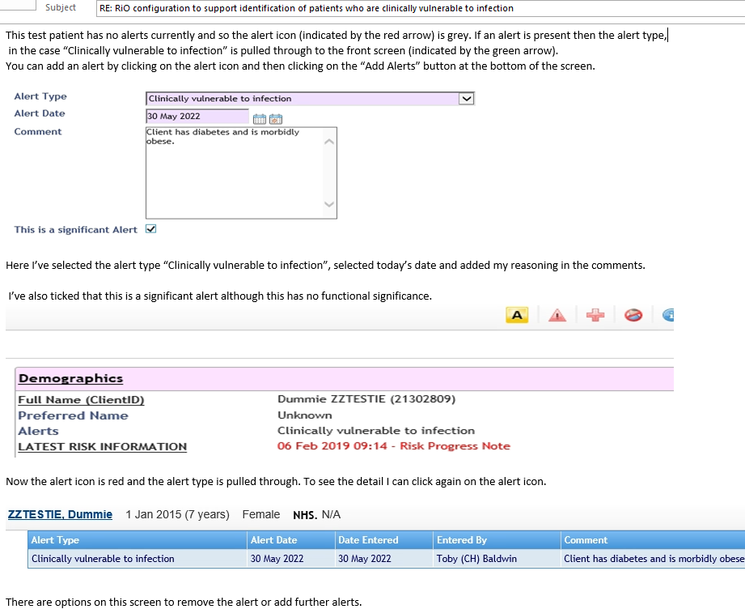
Protective measures
The following measures should be taken to minimise transmission risk to all clinically vulnerable patients:
- En-suite bedroom placement especially if in a ward that has an incident of infection.
- separate toilet facilities if en-suite room is not possible
- Encourage 2m distancing from others as much as possible.
- Signage of protective care in isolation on patients bedroom door
- Continued use of face masks except when alone in their own room.
- Encourage vaccination if not yet fully vaccinated.

Further information can be found here:
https://www.gov.uk/government/publications/covid-19-guidance-for-people-whose-immune-system-means-they-are-at-higher-risk/covid-19-guidance-for-people-whose-immune-system-means-they-are-at-higher-risk#vaccines
https://www.gov.uk/guidance/covid-19-information-and-advice-for-health-and-care-professionals
London IPC management of respiratory infections (including SARS-CoV-2) for Spring 2022- by the London IPC Reference Group Approved by London CEG 13.04.22 Version1.0

Appendix 9 – Stepping-down of Care in Isolation Precautions for Severely Immunosuppressed Patients
Severe immunosuppression includes people who had or may recently have had:
- a blood cancer (such as leukaemia or lymphoma)
- a weakened immune system due to a treatment such as steroid medicine, biological therapy (sometimes called immunotherapy), chemotherapy or radiotherapy
- an organ or bone marrow transplant
- a condition that means you have a very high risk of getting infections
- a condition or treatment your specialist advises makes you eligible for a third dose of COVID-19 vaccine.

Not all clinically vulnerable patients are severely immunosuppressed. If in doubt discuss with the patient’s clinician/s and a member of the IPC team.

Is the patient severely immunosuppressed?

Yes
No

Please follow the flowchart for Management Pathway for Service
User with COVID-19 Infection
(Appendix 2)
Patients must be assessed on a case-by-case basis to determine severe immunosuppression. Stepping down of care in isolation precautions will need to be discussed with clinical medical teams & the IPC Team/Infection Control doctor.

Appendix 10 – Management of Outbreaks

2 or more positive cases in the same time and place

Contact IPC department elft.infectioncontrol@nhs.net for support with risk assessment. For Out of hours Contact Director on-call

IPCT to conduct risk assessment:
- Confirmed cases and detail
- Extent of secondary exposure.
- Location of incident
- Whereabouts of employees involved
- Manager/team contact details

Healthcare staff outbreaks
For patient outbreaks

Management attend outbreak management meeting organised by IPC team.

Management attend outbreak management meeting organised by IPC team.

The manager is to notify Occupational Health immediately.
Manager to start completing Contact Tracing to identify any risks to colleagues and patients.
If patient/s are at risk, complete Patient Contact Tracing Form and send to IPCT elft.infectioncontrol@nhs.net
Complete Staff Contact Tracing Form and send to Occupational Health tpukl.elftteamprevent@nhs.net Managers should inform IPCT upon completion of this action.

Outbreak management meetings to be held as and when required depending on the scale of outbreak

Team manager takes appropriate action re resourcing in light of staff self-isolating etc.

Occupational Health provides intervention/signposting for staff as necessary and appropriate.
Staff member notifies line manager of LFD results

Appendix 11 – Contact Tracing Form for Occupational Health-Team
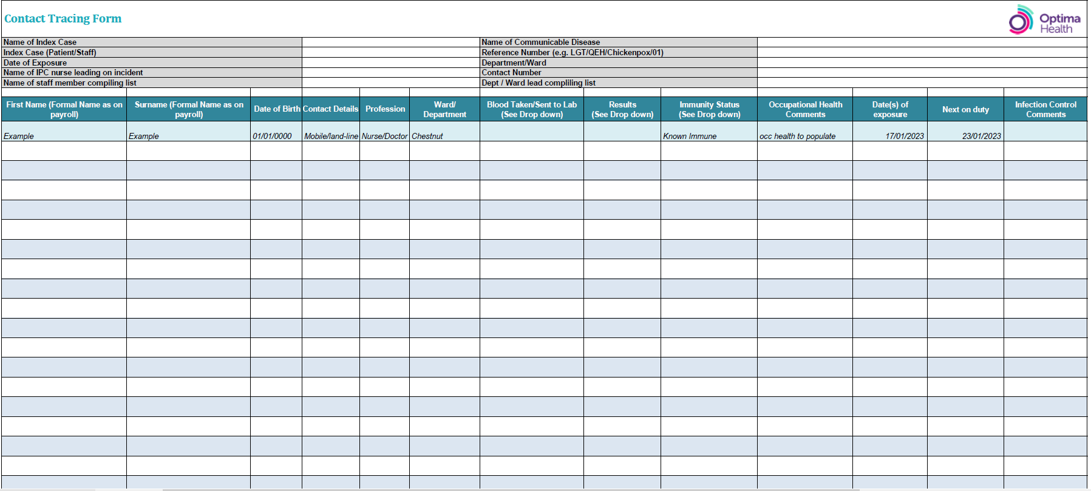

Appendix 12 – Reporting to the UK Health Security Agency

During outbreaks, the local health protection team should be informed of confirmed infectious
cases. For Covid-19 outbreaks, local clinicians/Borough Lead Nurses/IPC nurses must call or
email their local coronavirus response cell once an outbreak is declared. A reference number will
be provided – please ensure this is shared with the Infection Protection & Control Team.

Contact Details for Notification of COVID-19
Area | Contact Details
East London | Outbreaks reported to NEL ICB  nelondonicb.ipc@nhs.net
Luton & Bedfordshire | Outbreaks reported to East of England HPT  phe.eoehpt@nhs.net

Notifiable Disease – Reporting to UK Health Security Agency (UK HSA)

COVID-19 is a notifiable disease and must be reported to UK HSA – local Health Protection
Team (HPT).

Registered Medical Practitioners (RMPs) have a statutory duty to notify the ‘proper officer’
at their local HPT of suspected cases of certain infectious diseases.

Appendix 13 – Admitting to Wards with Active COVID-19 / Influenza Outbreaks
Guidance for admitting new patients to Wards with active COVID-19/Influenza cases/outbreaks.
Before considering admission or transfer to a Ward with infections please clarify (via the DSN) if there are any available beds on Wards without COVID-19/Influenza cases in an ELFT borough.
Criteria to consider when admitting patients to these areas:
1) The clinical risk is such that delaying admission would be likely to cause avoidable harm whether the patient is in the community, ED or acute hospital bed.
2) This is a clinical decision and must be made by the admitting consultant/Doctor, balancing the risks and benefits for the patient, and if the balance of risks needs further discussion, in consultation with the service’s Clinical Director and Borough Lead Nurse or nominated deputies as required (Out-of-hours on-call consultant and DSN). IPC advice is available 9am to 5pm Monday-Friday, outside of these times the Director on-call should be utilised as required through the on-call system. Each Borough Lead Nurse will need to keep record of each patient admitted using the SOP which is on the daily DSN report.
Please e-mail elft.infectioncontrol@nhs.net for all patients admitted using the SOP. This email should be sent by the Borough Lead Nurse, Duty Senior Nurse and/or Ward Manager.
Prior to admission the following requirements must be met and clearly recorded in the patient’s RiO notes:
- Open and transparent discussion about the risks with the patient and family
- The patient and relatives/carer must be informed of the ward status regarding the positive case or outbreak prior to admission, and must agree to the admission.
- This discussion must take place at the point of assessment/decision to admit, and must be recorded in the patient’s RiO notes.
- If not possible to achieve this discussion and agreement with the patient and family, then best interest principles must be applied by the clinical decision maker (out-of-hours this is the on-call consultant) and the outcome recorded in the patient’s RiO notes.

Risk assessment
- Patient must be assessed on an individual case-by-case basis.
- The vaccination status of the patient being admitted should also be taken into consideration. Whilst this may be considered in the risk assessment, it is important to note that under the current NHS advice, there is a chance people might still get or spread COVID-19/Influenza even if they have had different doses of the vaccine due to the different variants rising/individual immune responses to vaccines. All IPC precautions must still be followed regardless. Patient with no COVID-19/Influenza vaccination (or no previous infection) must not be admitted to a Ward with an on-going outbreak.
- Risk assessment must consider any underlying health conditions and comorbidities (chronic and acute) of the patient being admitted to ensure they are not clinically extremely vulnerable (Refer to UKSHA definition)
- The health status of patients on admitting Wards i.e. acuity, number of confirmed cases, and their cooperation with care in isolation (if needed)
- Environmental limitations (e.g. availability of en-suite facilities, equipment etc.)
- Risks of delaying the admission
- If risk assessment determines that admission to the outbreak Ward is not recommended and not in the patient’s best interest, but they still require a bed then use the formal escalation procedure via the on-call manager.

Admission agreed
If the outcome of the risk assessment determines that admission to the outbreak/affected Ward is in the patient’s best interest and outweighs the risk of exposure to infection, the following must be considered to help minimise the risk:
- The new patient should be admitted to en-suite bedrooms where possible (please note Hackney do not have en-suite rooms but may have beds – please discuss this with the DSN and local Senior Nurses).
2a) Admission LFD swabs should only be taken if the patient is symptomatic for COVID-19
2b) PCR swabs should only be taken for patient/s who are suspected to have Influenza
- If symptomatic, should the patient need to leave their room, encourage them to wear surgical face masks and perform hand hygiene before leaving and returning to their rooms.

Once a decision to admit has occurred then a message confirming the decision needs to go to the IPC email address elft.infectioncontrol@nhs.net with the patient’s name, RiO number and the admission ward.

Appendix 14 – Root Cause Analysis Investigations of Hospital onset COVID-19 Infections Flowchart
COVID-19 positive case is identified on a ward (check date of admission and specimen date to determine if HOCI definition is met as below)

IPC nurse to send a notification email to department (ward manger, matron and borough lead nurse) and request a date for RCA meeting. Attach the RCA template to this email. RCA to be completed within 2 weeks of notification

Ward to report all HOCI cases on Datix and Datix No.to be added to the RCA form

IPC Admin will support the wards by sending a diary invite for the RCA meeting, either as part of an outbreak meeting (if outbreak) or as a separate meeting, whichever works best

Ward complete a draft RCA form with as much information from the patient’s case note and any relevant documents (aim to cover 72 hours prior to the date of positive swab). Also include information of audits carried out around this time as evidence and for assurance purposes.

Ward to send the completed RCA draft form to IPC at least 2 days prior to the meeting date

All to review and update the draft RCA form during the meeting and identify root course and contributing factors etc.

Based on the issues identified and lessons learned, formulate a SMART action plan

Agree on how and where the lessons will be shared

Appendix 15 – Root Cause Analysis (RCA) Form for Reviewing Hospital-onset COVID-19 Cases

Draft completed by: |  | Date

Patient Details (Use index case when reviewing a cluster or outbreak)
Full name |  | NHS Number
ELFT/Rio No |  | Date of Birth
Admission date to ELFT facility |  | Ethnicity
Current ward |  | Bedroom number, En-suite?
Date of admission to this ward |  | Patient’s Consultant
Admitted From |  | Previous wards in ELFT
Admission Diagnosis |  | Ward/Department where positive sample was taken:
Ward where Infection is thought be acquired |  | Directorate where acquired
Date positive sample collected |  | Date positive result received
Date/s of previous negative swabs (if any) |  | Compliant with isolation?
Symptomatic? |  | Symptom onset date
Is the patient on clozapine therapy? (State yes or no ) |  | If yes, was medication reviewed on detection of COVID-19?
COVID-19 vaccination status |  | Admitted to Hospital due to symptoms?

A brief case summary. Clinical Details & Physical Health / Clinical Summary: (i.e. Physical Health)

Timeline with Dates | Activity- (case note review 72 hours prior to positive result/symptoms) | Source of information/ Comment
 |  | e.g. Rio note, outbreak meeting, emails, others

Details of contacts with external care providers 72 Hours prior to positive test
(Including hospital appointments/Care reviews and admissions with dates)
e.g. OPA-Cardiac Clinic Luton & Dunstable | 1st April 21
Details of contacts with Internal care providers 72 Hours prior to positive test (Including current ward)
e.g. Positive staff member XYZ |  | 3rd April

Did the patient have multiple moves within and or out of the Hospital?

Date transferred | Ward | Reason
Risk factors of contacts from above e.g. Care of elderly wards, respiratory wards, contact with known COVID-19, contact with immunosuppressed patients.
Are there any reported and recorded staff absences in previous 72 Hours?
Comment with dates:
Lateral Flow testing among staff taking place?
Comment:

Has any member of the patients’ household or visitors reported to have COVID-19?
Yes/No | Comment:
Was Covid testing for the patients compliant with the national and Trust guidance?
Yes/No | Comment:
Did this patient have a prolonged admission?
Yes/No | Comment:
During this patient’s journey did the Trust have high numbers of outbreaks/nosocomial cases?
Yes/No | Comment:
Have there been any other confirmed COVID positive patients on this ward in the past 7 days?
Yes/No | Comment:
Does the patient have multiple co-morbidities? E.g. patient on immuno-suppressants, extremely clinically vulnerable/clinically vulnerable group, from BAME background?
Please State:

Has the patient been on any overnight leave, absconded or left the ward within 72 hours prior?
Yes/No | Comment:

Any other factors not already listed above:

Environmental factors
Was the ward nursing team aware of cleaning requirements and their responsibilities?
Yes/No | Comment:
Was the ward domestic staff aware of cleaning requirements and their responsibilities?
Yes/No | Comment:
Was additional touchpoint cleaning in place in the ward / departments during the patients care?
Yes/No | Comment:
The ward the patient has been admitted to does it have a ventilation system review as part of work place risk assessment and deemed adequate? (if there are air condition units please check with estate and facility that they are the types that brings in fresh air and not recirculating the air)
Yes/No | Comment:

Give the latest Cleaning audit score by contract monitors- contractor |  | Date of Audit:
Cleaning comments/List any issues from this audit:
Give the latest infection control (IPCN) Environmental audit score |  | Date of Audit:
Comments/List any issues from this IPCN environmental audit:

Staff factors;
Give the latest IPC Stat & Man training (L1 & L2) compliant score for the ward – All staff |  | Provided by & Date:
Training related comments/List any issues identified in IPC training:
Any latest COVID-19 training updates received.

Any identified shortfalls in staffing numbers throughout the incident? (High sickness, high agency/bank staff usage, staff working across wards during shifts)
Yes/No |  |  | Comment:

Any other ward/staffing Comments / avoidable contributory factors not mentioned above:

PPE and Hand Hygiene Facilities:
Give the latest Hand hygiene validation audit score (if older adult ward) |  | Date of Audit:
Hand hygiene comments/List any issues from this audit:

Hand Hygiene Facilities- Have there been any barriers to compliance with hand hygiene 72 hours prior to incident? (E.g. lack of paper towels, soap, alcohol based hand rub, accessible hand wash basin etc.)
Yes/No | Comment:

Has staff been trained in the use of PPE (Donning and doffing?
Yes/No |  | Comment:
Are staff wearing the appropriate PPE in line with current guidance?
Yes/No |  | Comment:
Ward PPE Audit & Hand Hygiene and comments (combined tool):
Completion rate: | Compliance Rate: | Comment:

Cleaning monitoring by ward management;
Have any recent environmental audits/ spot checks been completed by ward management?
Yes/No | Comment:
Management Cleaning comments: List any issues identified on spot check;

Summary of learning from all the risks above- Root course/Risk factors
 | YES | NO
No Risk from compliance with PPE?
No Risk Identified from confirmed positive COVID-19 cases in Staff?
No Risk identified from confirmed positive COVID-19 cases in patients?
No risk identified from any contact with other healthcare facilities/service providers?
No risk identified from any contact with family/visitors?
Contact Tracing completed for all contacts and they are monitored?

No risk noted from non-compliance with isolation of positive patients?

No risk noted from Isolation/ cohorting of contacts? (e.g., non-compliant and lack of isolation facility)

No environmental risks noted i.e. lack of availability of facilities and cleaning?

No risk noted from non-compliance with Hand Hygiene?
No risk noted due to gaps in staff knowledge? (Staff training & update)

No risk noted from shortfalls in staffing?
No risk noted from acuity of ward? (I.e. number of 1:1 eyesight observations)
No risk noted from patient’s co-morbidity?
Any other risks noted?

Action log for completion;
Lessons and Actions agreed | Responsible person | Complete by Date | Date completed/ Status/comment

Sharing the lessons:
Name of meeting/Medium where lessons will be shared | By Whom | Date

HOCI categories;
Please tick which category this case falls into, definitions below:

Hospital-onset indeterminate healthcare-associated – first positive specimen date 3-7 days after admission to trust
Hospital-onset probable healthcare-associated – first positive specimen date 8-14 days after admission to trust
Hospital-onset definite healthcare-associated – first positive specimen date 15 or more days after admission to Trust
Other – please state :
Levels of Harm-Please tick (see definition in appendix A on page 9)
No harm
low harm
Medium harm
High harm

Conclusion:

Date of RCA meeting:
Members of the RCA meeting Name: | Title:

Appendix A - Definition of level of harm for Hospital-Onset Probable and Definite Healthcare Associated COVID-19 infection
Level of Harm | Definition
No Harm | Asymptomatic. Mild symptoms but does not require intervention.
Low Harm | Symptomatic but does not meet the definition for moderate harm below.  Requires Low level support – such as oxygen therapy.
Moderate Harm | Moderate harm’ includes harm that requires a moderate increase in treatment. There is no easy rule for defining what is considered a ‘moderate’ increase in treatment but applying previous guidance in the context of COVID-19 suggest moderate could include: a move to specialty care (such as ICU), a prolonged hospital stay arising from the treatment needs of the nosocomial infection, or need for higher levels of oxygen therapy for more than a short period.*  NB: Transfer to another area for the purpose of infection control alone (that is, transfer to a COVID-19 ward when no other harm is identified) would be considered low harm. Note that prolonged hospital stays for infection control reasons alone (e.g. need to be clear of infection before return to a care home) would not automatically count as a moderate increase in treatment  Where a patient suffers permanent or long-term harm, including permanent physical impairment, chronic (>12 weeks) pain, and/or other long-term impacts such as psychological harm or impairment to normal working or personal life. Harm should also be considered severe if there was a need to undertake lifesaving intervention such as CPR.*  NB: This definition can be difficult to apply in the context of COVID-19 as long-term disability from COVID-19 infection may be unrelated to the initial disease severity and may not be apparent until months later. Organisations must use their judgement in assessing the severity of harm.
High Harm Serious incident (COVID-19 deaths) | All hospital onset healthcare associated COVID-19 cases (both HOPA and HODA) where COVID-19 is cited on either part 1 or part 2 of the death certificate (i.e., the death resulted from a COVID-19 clinically compatible illness with no period of complete recovery between the illness and death) and have been medically determined to have been caused or contributed to by COVID-19. *  NB: Placing COVID-19 in part 2 of the death certificate does not indicate the patient ‘died with’ COVID-19. It means that COVID-19 was known or suspected to have contributed to the death.  Where there is clear evidence that the death of a patient within 28 days of a COVID-19 positive swab being taken has been caused by something other than COVID-19, this does not meet the definition of a nosocomial COVID-19 serious incident.

*Always seek the views of the patient’s clinician/clinical team when defining these level of harm. Also note that some harm may not be obvious immediately, start with the level of harm at diagnosis. This can be changed later if patient’s condition change

Appendix 16 – Virology Diagnostic Testing

To test for influenza or other respiratory viruses in adults a green viral swab must be taken from the throat (for influenza) or nose (for COVID-19). Staff must wear appropriate PPE including gloves, apron, face and eye protection when obtaining a swab.
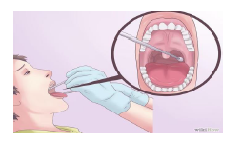Take the swab. Take green virology swab and gently rub it against the back of the throat on the area near the tonsils. This ensures that a proper sample in the area is captured well onto the swab
In children to test for respiratory viruses a nasopharyngeal swab or aspirate is taken (commonly for respiratory syncytial virus RSV). The viral medium is in a green swab.
Nasopharyngeal Aspirate Specimen Collection:
• Insert tubing attached to syringe (or compressed bulb for infants) through nose and direct toward nasopharynx.
• Pull back on syringe (or decompress bulb for infants) to withdraw secretions
• Expel secretions into viral transport media
• This process also used for nasopharyngeal swabs for COVID-19 detection, swabbing the throat first and proceeding to the nostrils.

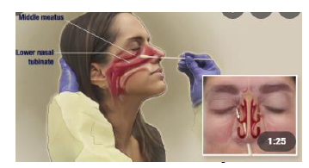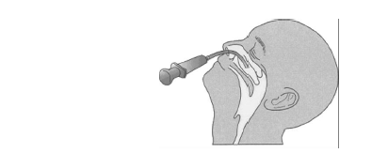
Nose swab.
Take a nose swab using a dry swab and insert into both nostrils. Wear PPE – Apron, gloves, face mask and eye protection. Do not exert too much force.

Sending samples to the testing laboratory

- label each sample with ID, date of birth and type of sample
- use the specific microbiology, one form for each sample
- do not place paperwork (request forms) in the primary container for Category B transport
- request form must include a contact phone number for sharing of results
- samples without appropriate paperwork will not be tested or testing will be delayed

Equipment for Specimens Collection

Items for taking viral specimen
Virology swabs | 1 | 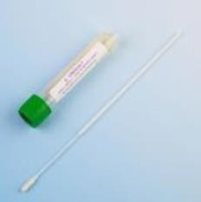
Pathology Bio Hazard plastic sample bag (Double bag specimen) | 2 | 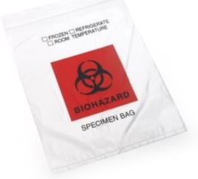

Appendix 17 – PPE Requirements When Caring for Suspected/Confirmed Respiratory Infections

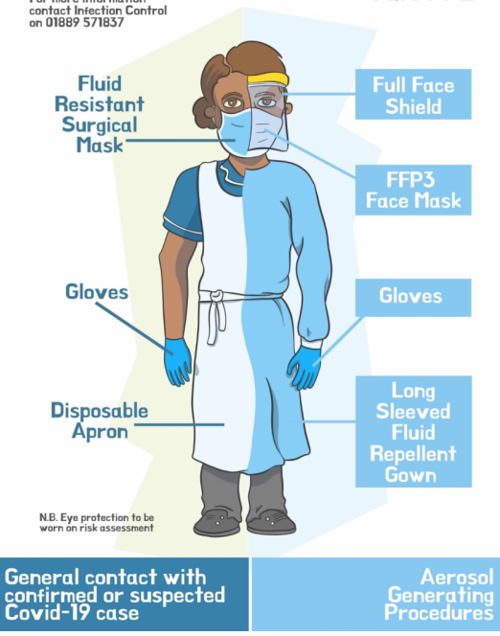
GPPE for standard precautions
PPE for Suspected/Confirmed respiratory infections including COVID-19 & AGPs

Appendix 18 – Donning and Doffing of PPE
- Video of donning can be found here: https://www.youtube.com/watch?v=kKz_vNGsNhc
- Video of doffing can be found here: https://www.youtube.com/watch?v=oUo5O1JmLH0
- Video for donning/doffing coveralls can be found here: https://www.youtube.com/watch?v=ufmH3vIqfE0

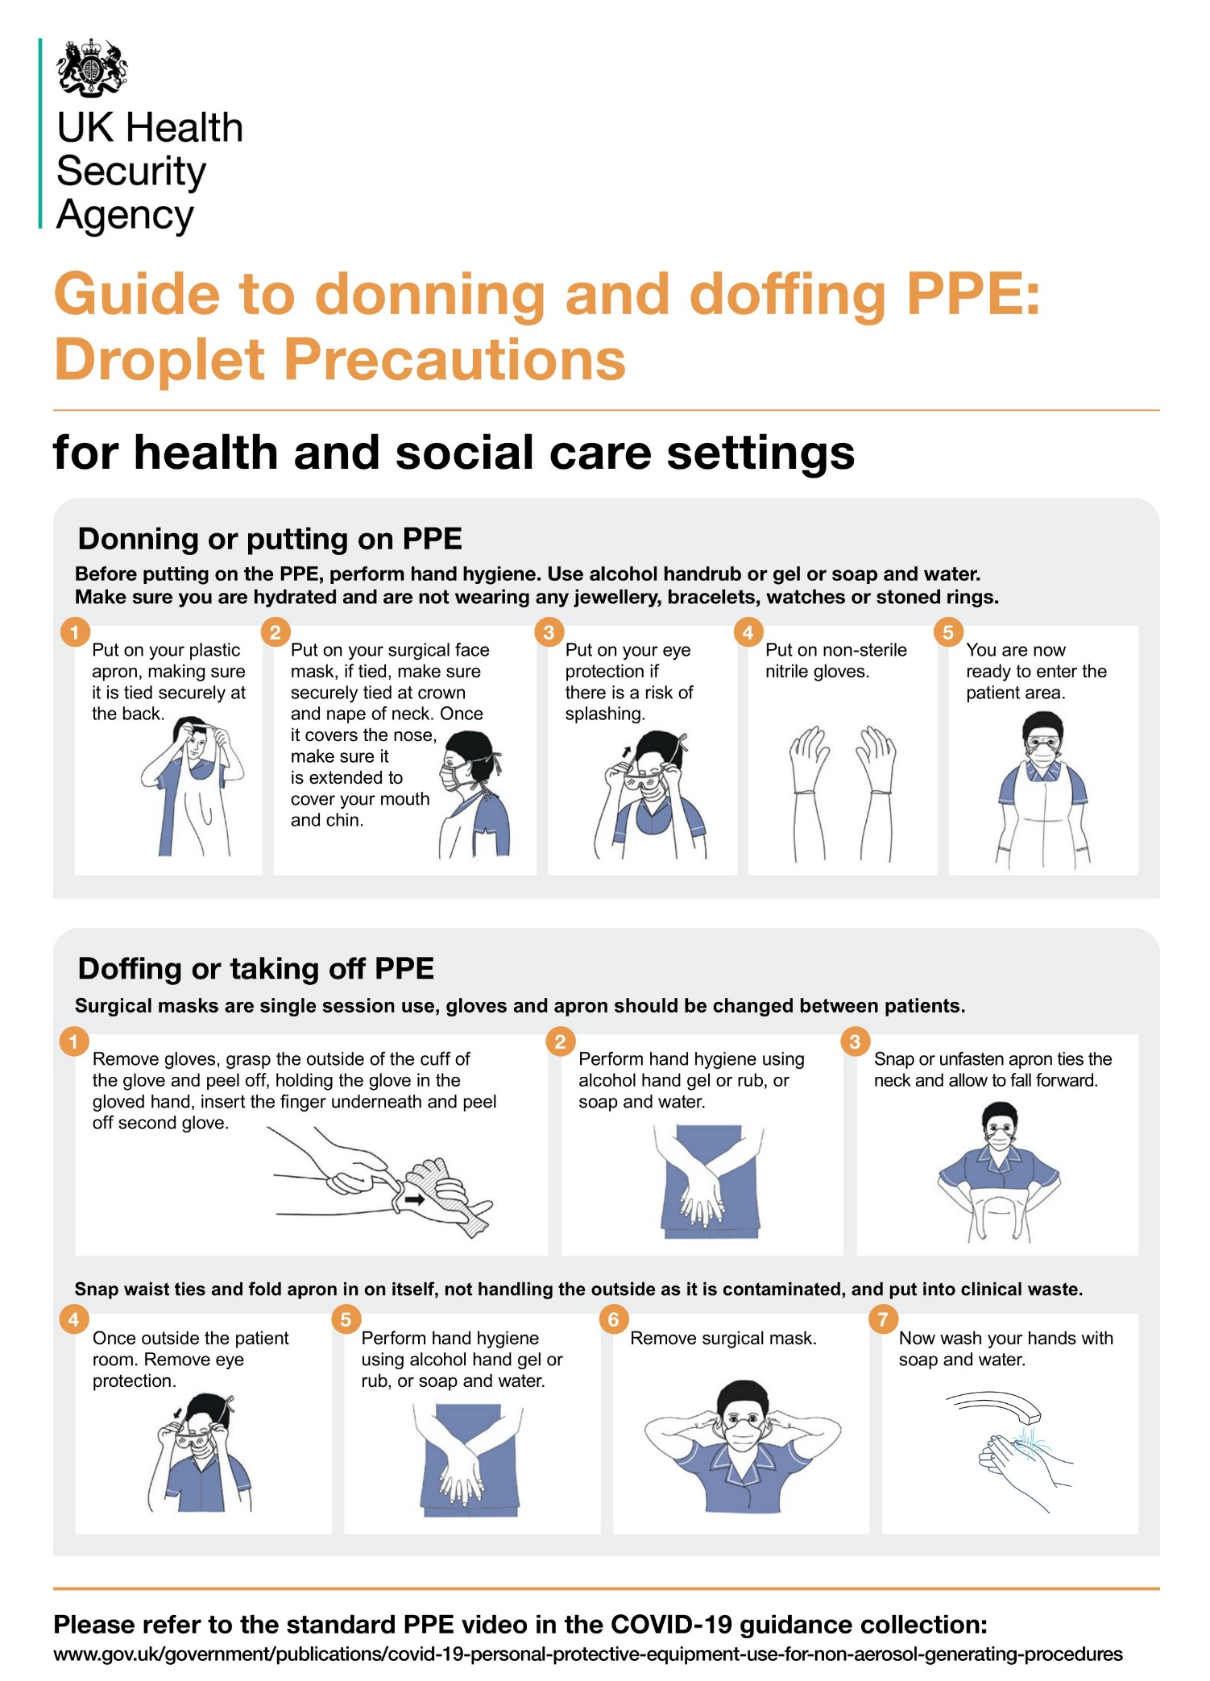

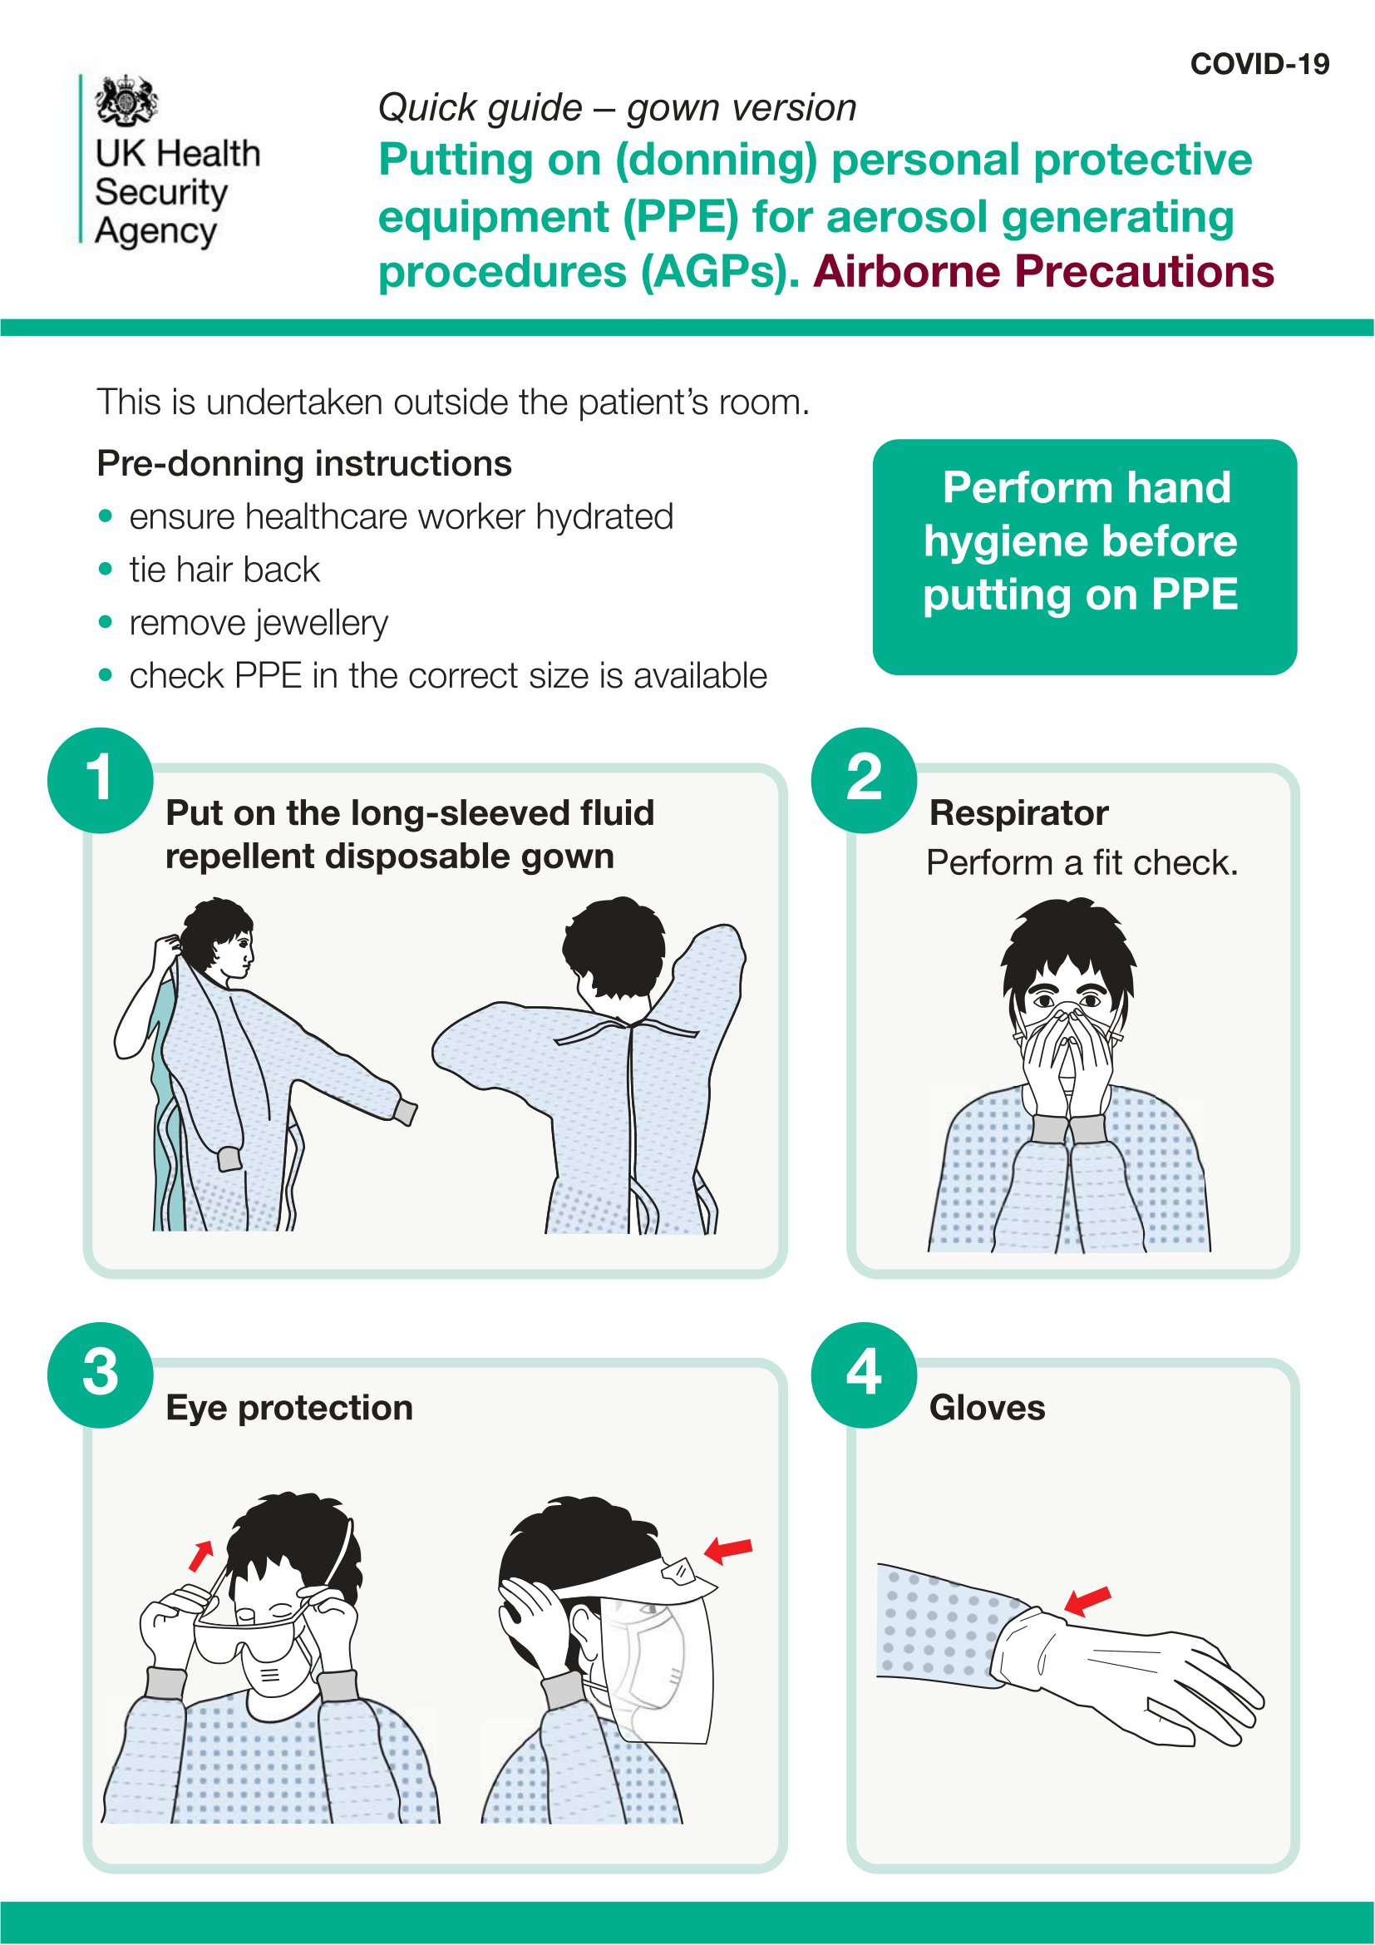

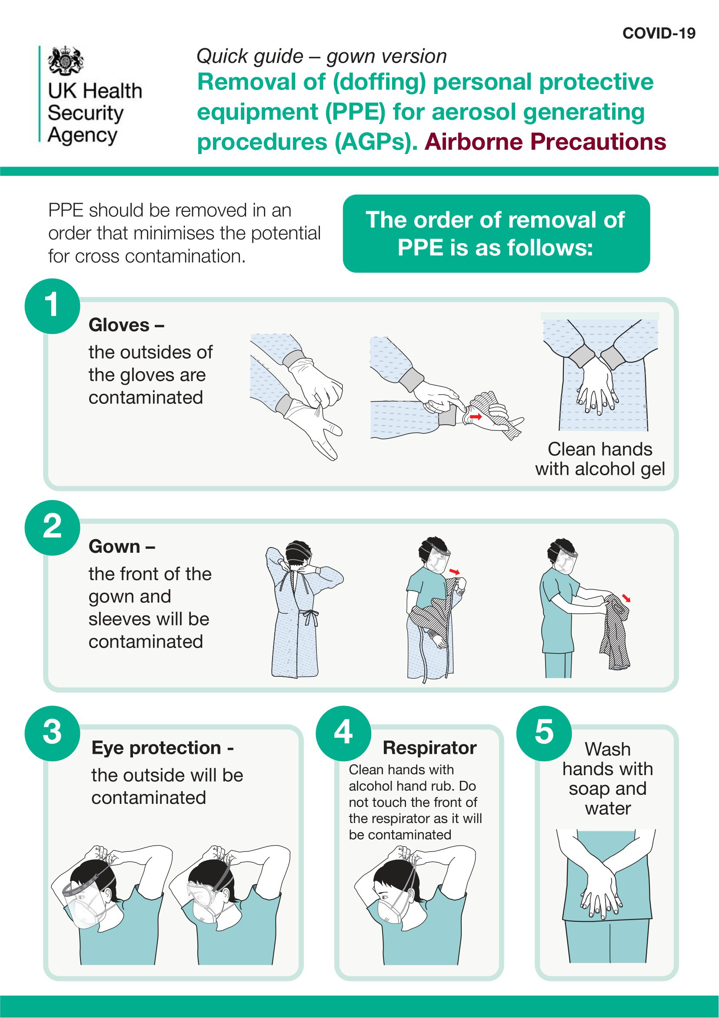

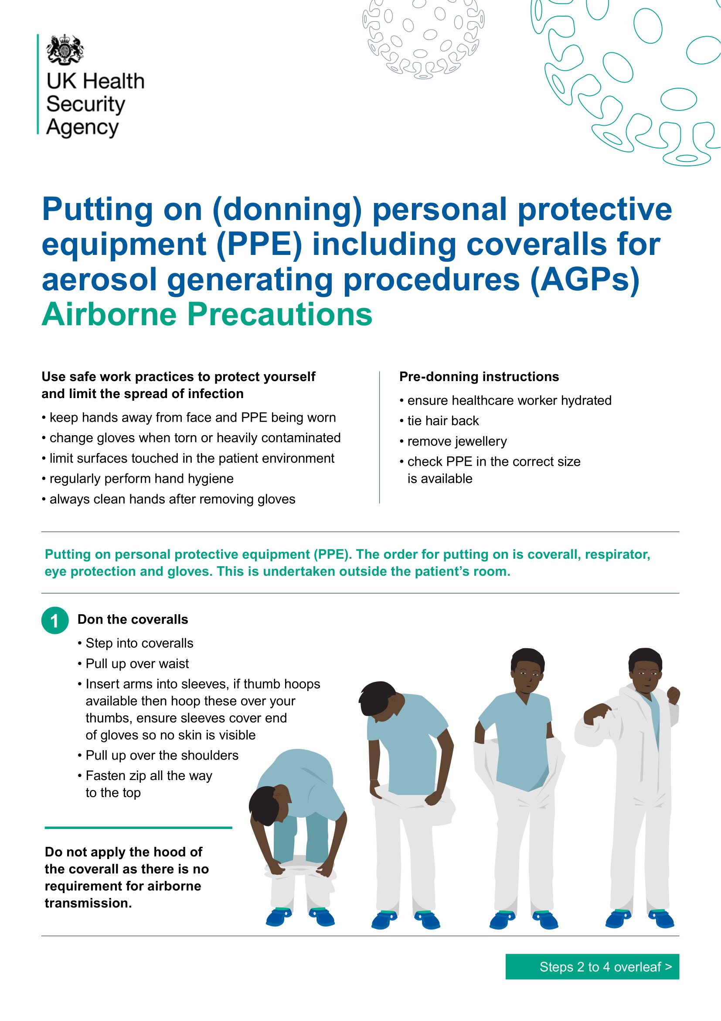

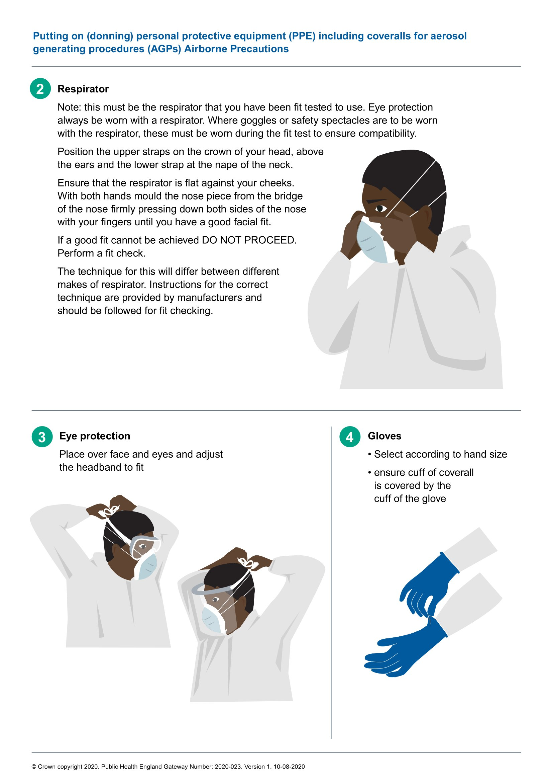

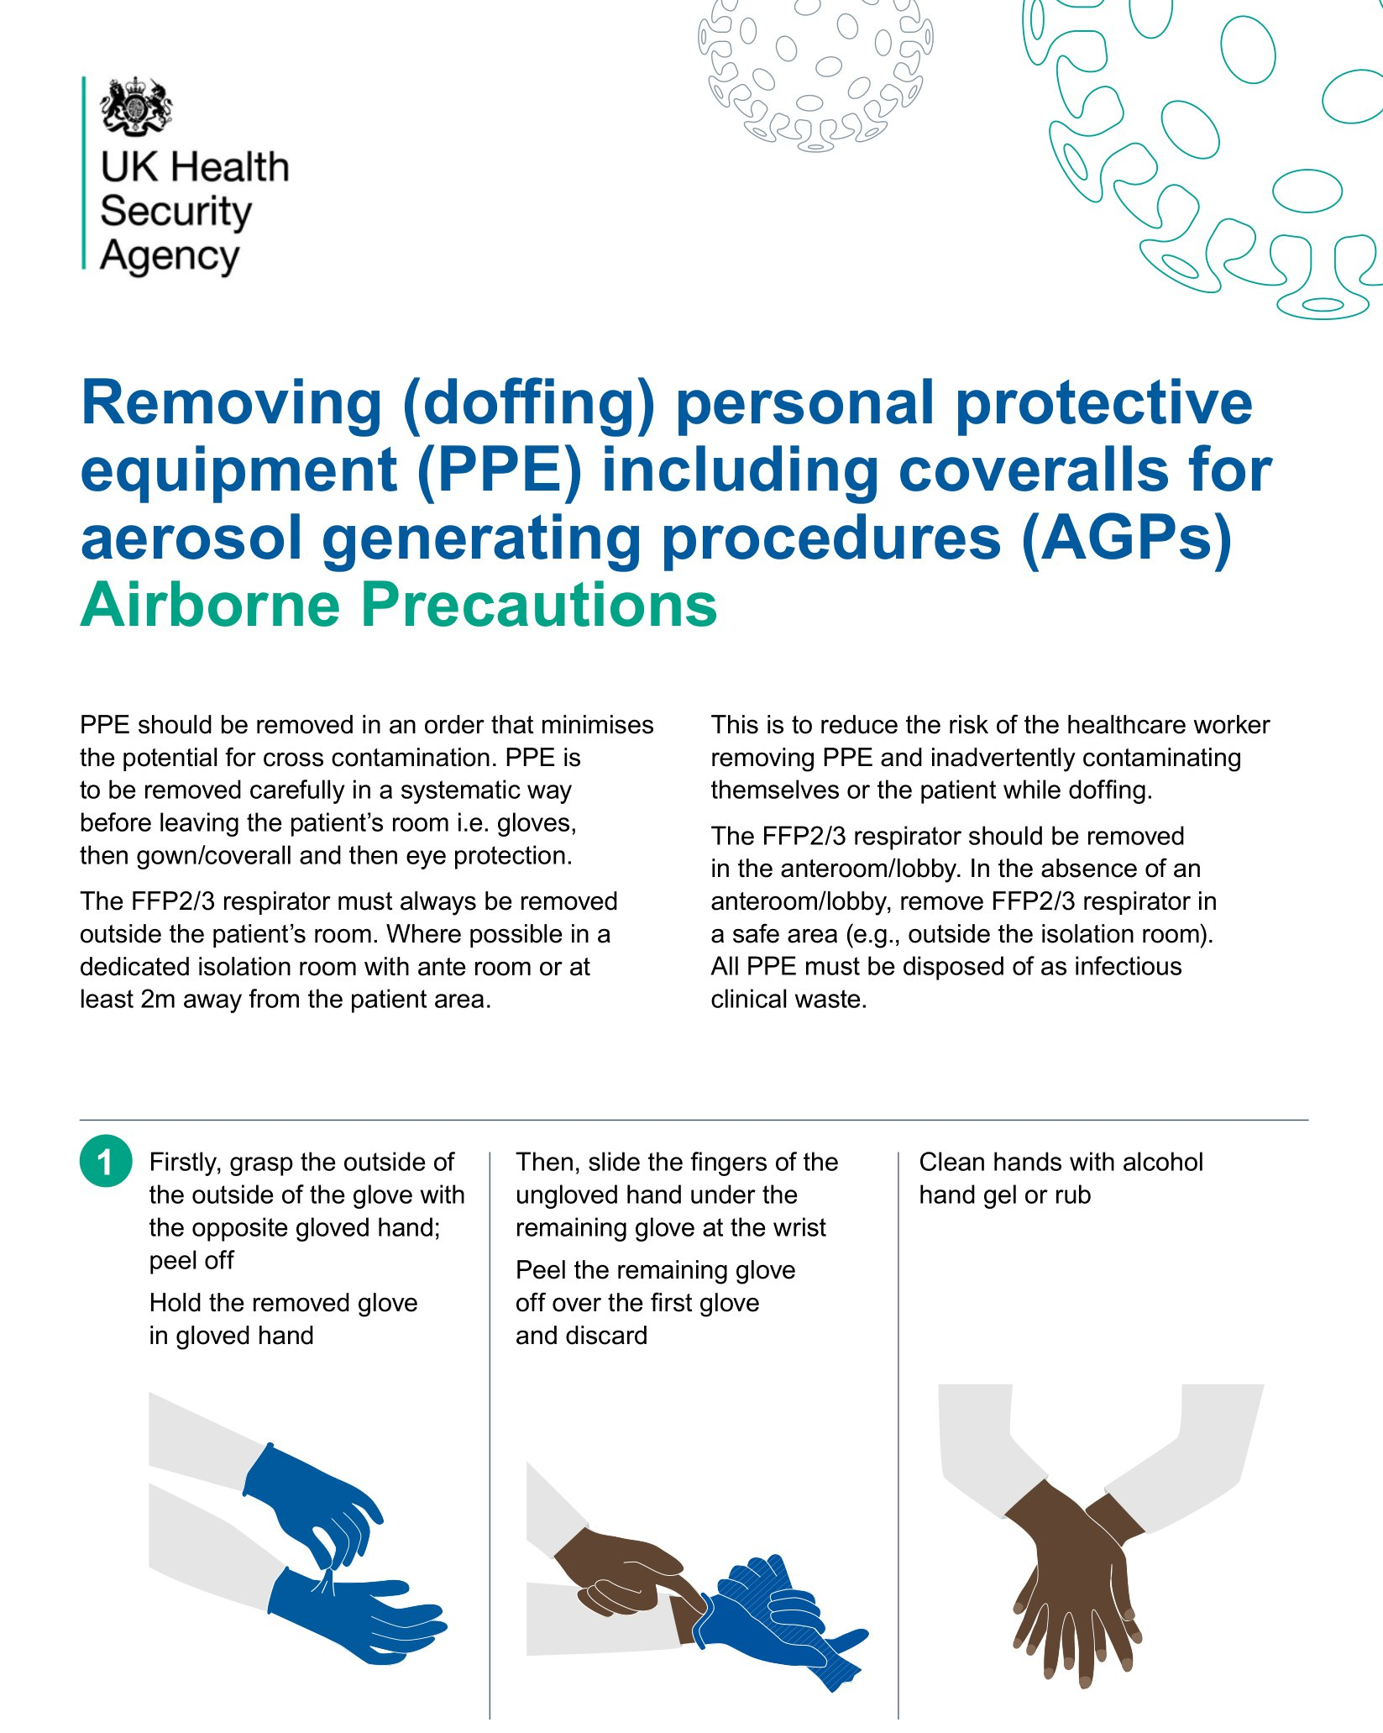

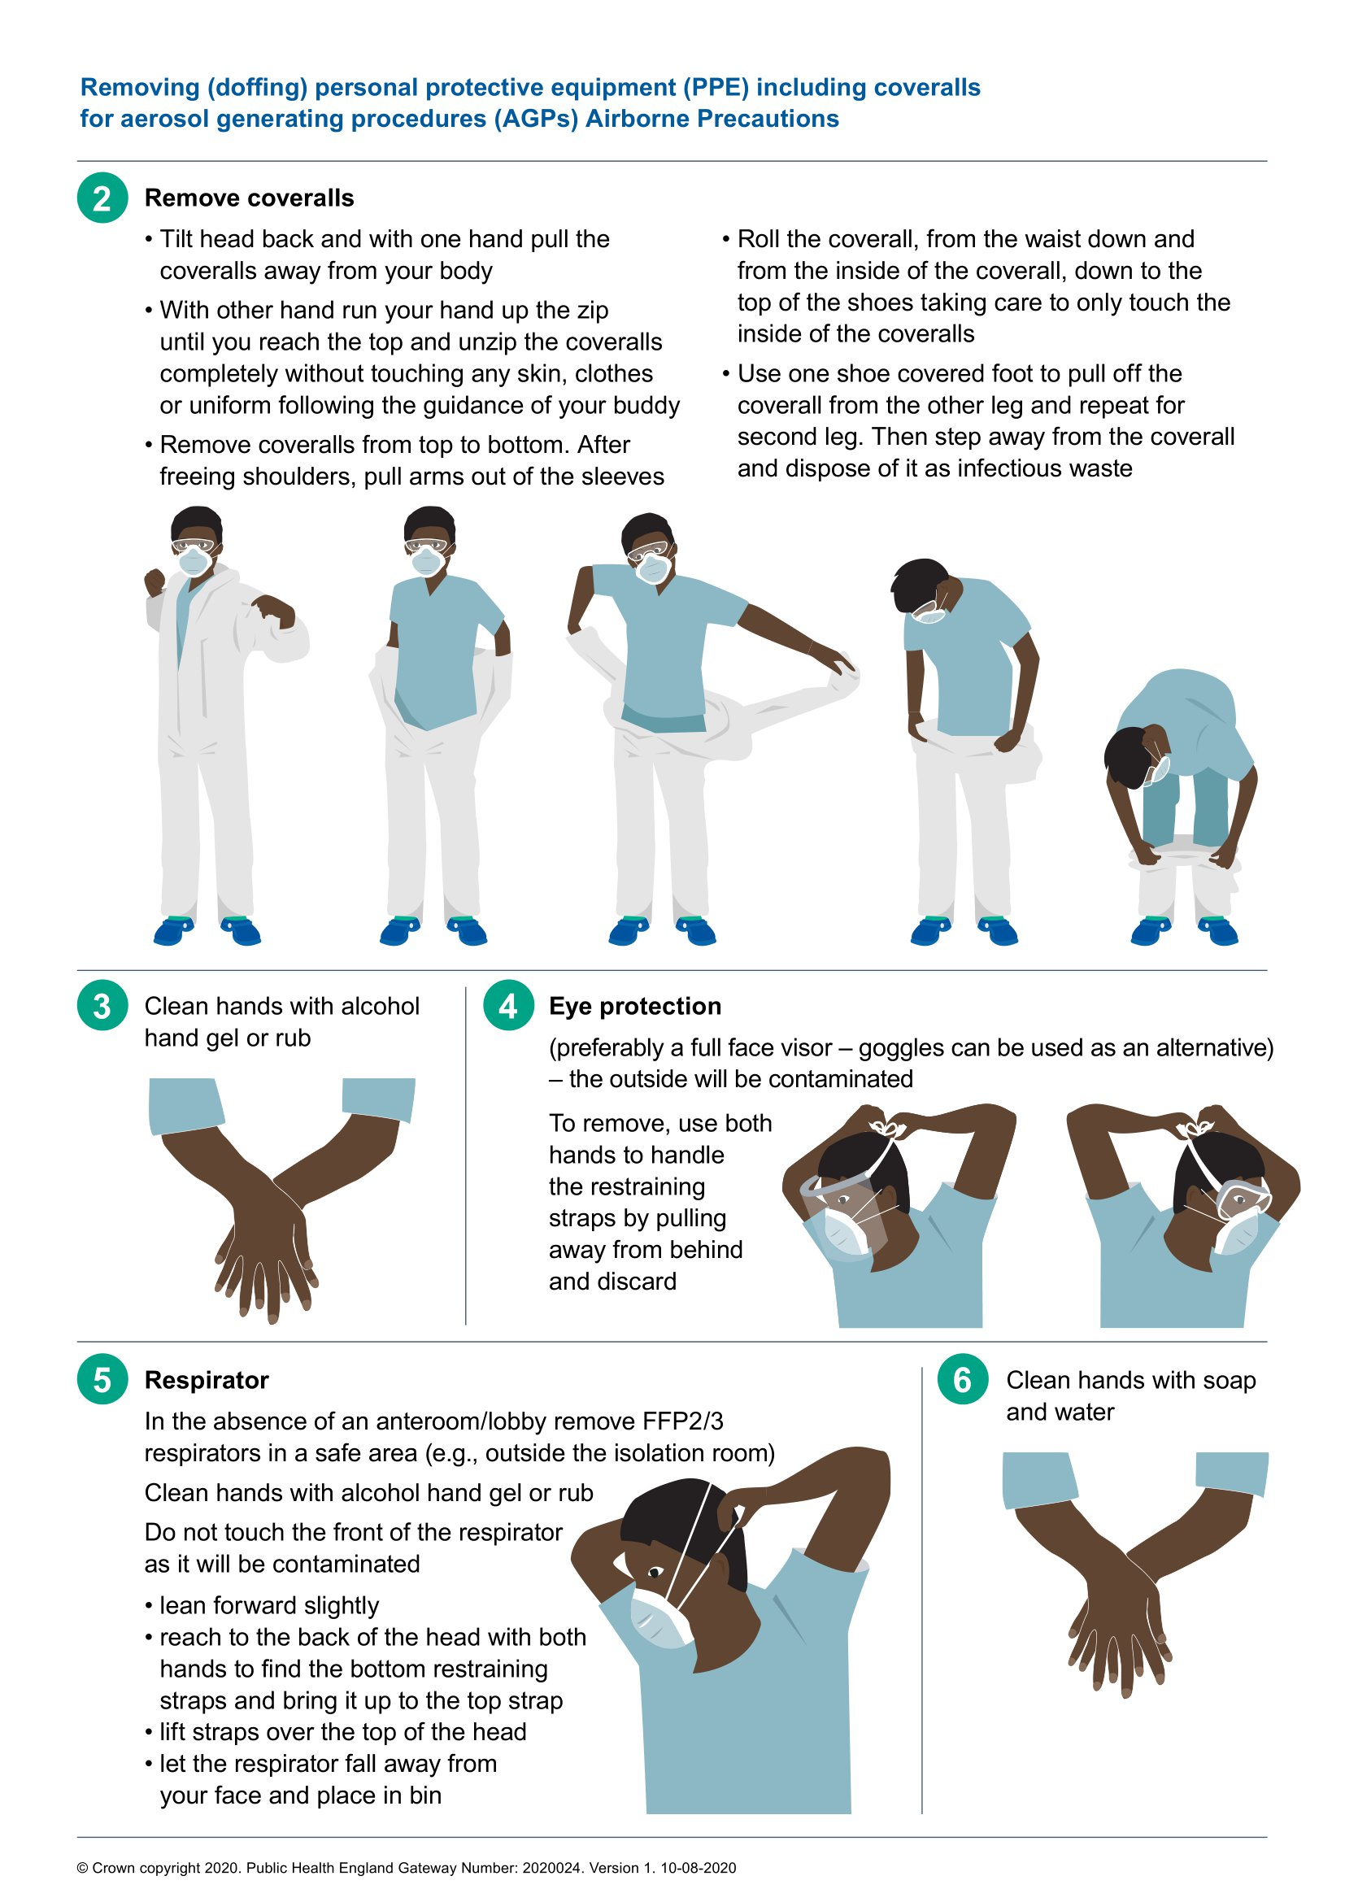

Appendix 19 – Factsheet and Guidance on the Use of Filtering Face Piece Mask (FFP3 Mask)

1. What is filtering face piece mask (FFP3 Mask)?

A filtering face piece is a type of respiratory protection that is worn over the nose and mouth designed to protect the wearer from inhaling hazardous substances, including airborne particles (aerosols). There are 2 types of respiratory protection that can be used, tight-fitting disposable FFP respirators and loose-fitting powered respirator hoods. There are 3 categories of FFP respirator: FFP1, FFP2 and FFP3. FFP3 mask and loose-fitting powered respirator hoods provide the highest level of protection and are recommended when caring for patients in areas of high risk.

2. What do I need to consider before I wear FFP3 Mask?

Before wearing an FFP3 mask there are a few things to consider. Under Health and Safety law it is a legal requirement all staff using this type of equipment are face fit tested.

3. What is face fit testing?

A face fit test should be carried out before wearing FFP3 masks for the first time. Inadequate fit can reduce the protection provided and lead to immediate or long-term ill health or can even put the wearer's life in danger.

A fit test should be repeated whenever there is a change to the FFP3 mask type, size, model or material, or whenever there is a change to the circumstances of the wearer that could alter the fit of the FFP3 mask, for example:

- weight loss or gain

- substantial dental work

- any facial changes (scars, moles, effects of ageing etc.) around the face seal area facial piercings

- introduction or change in other head-worn personal protective equipment (PPE)

Retesting is advised every 2 years.

- How do I wear FFP3 mask?

Training can be provided by the Trust fit testing team. Please contact them on elft.fittesting@nhs.net

- Can visitors and patients wear FFP3 mask?

FFP3 mask are recommended only for use by healthcare personnel who need protection from both airborne and fluid hazards (e.g., splashes sprays). These respirators are not used or needed outside of healthcare settings. Patients should not be routinely given FFP3 mask

however, in cases of suspected TB infection (based on risk assessment) this may be used. However please seek advice from infection control department in the first instance on elft.infectioncontorl@nhs.net

6. When should I wear an FFP3 Mask?

ELFT guidance is that an FFP3 mask is worn in the case of any resuscitation event.

- Should I wear and FFP3 mask with Valve or Non-valve?

The Infection Prevention and Control department recommends wearing FFP3 mask without a value. An FFP3 mask with a valve is not fluid resistant and doesn’t not provide the wearer adequate protection to airborne particles.

- Can I re-use the FFP3 mask after I have worn it?

FFP3 masks should be discarded after each patient encounter and after aerosol generating procedures. It should also be discarded when:
- it becomes damaged or deformed;

- no longer forms an effective seal to the face;
- becomes wet or visibly dirty;

- breathing becomes difficult;

- or if it becomes contaminated with blood,

- Respiratory or nasal secretions, or other bodily fluids from patients.

- What is an Aerosol generating procedure (AGPs)?

AGPs are procedures that create a higher risk of respiratory infection transmission and are defined as any procedure that can result in the release of airborne particles <5um in size from the respiratory tract of an individual. These can remain suspended in the air, may travel over a distance and may cause infection if they are inhaled when treating someone who is suffering from an infectious disease, transmitted wholly or partly by the airborne or droplet route.

FFP3 respirator masks will be required when undertaking an AGP on a patient COVID-19 pathway or when an unacceptable risk of transmission remains following rigorous application of the hierarchy of controls.

The list of medical procedures that are considered to be aerosol generating and associated with an increased risk of respiratory transmission is:

- Cardiopulmonary resuscitation (*Local policy for ELFT);

- awake bronchoscopy (including awake tracheal intubation)
- awake ear, nose, and throat (ENT) airway procedures that involve respiratory suctioning
- awake upper gastro-intestinal endoscopy
- dental procedures (using high speed or high frequency devices, for example ultrasonic scalers/high speed drills)
- induction of sputum
- respiratory tract suctioning
- surgery or post-mortem procedures (like high speed cutting / drilling) likely to produce aerosol from the respiratory tract (upper or lower) or sinuses.
- tracheostomy procedures (insertion or removal). *Awake including ‘conscious’ sedation (excluding anaesthetised patients with secured airway.

- Additional Infection control measures:

When using FFP3 mask the following infection prevention and control measures should also be utilised:

- Wearing PPE including gowns/aprons/ gloves, face visor/eye protection- please conduct risk assessment of clinical activity and PPE required.

- Hand hygiene using soap & water or alcohol

- COVID-19 staff risk assessment

- COVID-19 vaccination

- COVID-19 work place risk assessment

- Opening of windows for ventilation. Mechanical ventilation which does not recirculate the air.

- References

https://www.england.nhs.uk/wp-content/uploads/2022/04/C1636-national-ipc-manual-for-england-v2.pdf

https://www.hse.gov.uk/pubns/indg479.pdf

https://www.hse.gov.uk/coronavirus/ppe-face-masks/face-mask-ppe-rpe.htm

https://www.hse.gov.uk/coronavirus/ppe-face-masks/face-mask-ppe-rpe.htm

Appendix 20 – PPE Risk Assessment for Respiratory Infections
Staff in environments where patients have suspected/confirmed respiratory infections should wear masks (Fluid Resistant Surgical Masks). If fit-tested, staff should wear Face Filtering Particle (FFP3) masks. If in doubt, please contact the Infection Control team at elft.infectioncontrol@nhs.net.

Are you:
- Working on ward with suspected or confirmed COVID-19/respiratory illness? E.g. Influenza, TB etc.
- Are you looking are COVID-19 positive case in the community?
- Undertaking aerosol generating procedures (AGPs) including resuscitation? (For other AGPs, please see NHS Manual)
- Working in poorly ventilated environments?

Consider wearing Fluid Resistant Surgical Mask. Including the following IPC measures:
- PPE – Aprons, gloves, face visors/eye protection based on risk assessment of clinical activity
- Hand hygiene-soap and water or alcohol gel
- COVID-19 Workplace risk assessment
- Opening of windows for ventilation
Consider wearing FFP3 Mask. Including the following IPC measures:
- PPE – Aprons, gloves, face visors/eye protection based on risk assessment of clinical activity.
- Hand hygiene-soap and water or alcohol gel
- COVID-19 Workplace risk assessment
- Opening of windows for ventilation

No
Have you been fit tested?
Yes
Appendix 21 – Environmental Cleaning
On wards with COVID-19 outbreaks, enhanced cleaning must be booked via the helpdesk.

Cleaning products/solutions
Decontamination of equipment and the care environment must be performed using a combined detergent/disinfectant solution at a dilution of 1,000 parts per million (ppm) of chlorine.

Only cleaning (detergent) and disinfectant products supplied, are to be used. Products must be prepared and used according to the manufacturers’ instructions and recommended product ‘contact times’ must be followed. If alternative cleaning agents/disinfectants are to be used, they should only on the advice of the IPC Team and conform to EN standard 14476 for virucidal activity. The person responsible for undertaking the cleaning with detergent and disinfectant should be trained in the process.

Cleaning the room/ward/environment:

    - Before cleaning the environment, domestic staff to liaise with Ward nursing staff and exchange information on cleaning and any potential risk;
    - Domestic staffs to collect PPE form ward nursing staff;
    - Before entering the room, perform hand hygiene;
    - Don PPE as donning guidance (gloves, apron, Fluid resistant surgical mask, visor/googles- if risk of splashing);
    - Collect all cleaning equipment (should be single use where possible) and healthcare waste bags before entering the room;
    - The following staff will undertake cleaning duties shown in table 1 with a chlorine-based disinfectant at a minimum strength of 1,000ppm;
    - Equipment to be discard if not sent off to laundry;
    - Patient care equipment should be cleaned with disinfectant wipes;
    - Dedicated disposable equipment (such as mop heads, cloths) must be used for environmental cleaning and disposed as clinical waste;
    - Communal cleaning trollies should not enter the room;
    - Doff PPE as doffing guidance;
    - Wash hands including up to elbows with soap and water;
    - Cream hands.

Patient isolation rooms must be cleaned:
- Twice a day;
- During discharge;
- Transfer;
- After an AGP (this includes removal and laundering of all curtains).
Domestic/cleaning staff performing environmental decontamination should:
- Ideally be allocated to specific area(s) and not be moved between COVID-19 positive wards and non-COVID-19 care areas
- Be trained in which personal protective equipment (PPE) to use and the correct methods of wearing, removing and disposing of PPE.
The care environment should be kept clean and clutter free. In COVID-19 positive wards all non-essential items including toys, books, and games should be removed from reception, waiting areas, day rooms and lounges. When made available, these items should not be shared. All toys must be cleanable and should be cleaned regularly by nursing staff in line with the Trust Infection Prevention & Control Policy Manual.

Table 1: Cleaning duties of all staff disciplines
Clinical staff | Frequency | Domestic staff | Frequency
All hard surfaces in COVID-19 positive rooms | Twice | Corridors | Twice
Beds | Daily | Bathrooms | Twice
High touch surfaces- keyboard, phones, light switches, Fobs ,Keys | Daily- A minimum of 3 times a day with disinfectant wipe | High touch surfaces  Door Handles, rails | Daily- A minimum of 3 times.
Bed linen. Do not shake linen and avoid all necessary agitation | Daily | Toilets | Twice
Toilets – where soiling | Ad-hoc | Floors | Twice
Mattress | Daily | Staff toilets/ changing rooms | Daily
Cupboard  Tables Chairs | Twice | Showers | Twice
All re-usable medical equipment (BP cuffs, dynamaps, blood glucose machines, oxygen cylinders | Before /after patients use/In between patients with disinfectant wipe | Communal areas- dining room/ lounge | Twice
Toys, books, and games/ I-pads | Before /after patients use/In between patients with disinfectant wipe | Bedrooms | Twice
 |  | Collection of clinical waste  – as per local arrangements | Daily

Situation | Local Terminology |  | Clean required or to be requested
 | Luton & Beds | London
Regular cleaning on wards/community bases | General Clean  Touch surface cleaning | Scheduled Daily Clean  Touch point cleaning | During COVID-19 as a preventative we have changed all cleaning products to have enhanced cleaning via Chlor tab liquid clean. While the units are all being maintained with Chlor cleaning there is no need for any enhanced cleaning alongside the regular discharge/admission cleans as the unit are getting the protective surfaces maintained at all times. Cleaning will be in line with cleaning schedules for your area.  All area that are in constant contact ‘touch’ by others, hand rails, doors, furniture etc. – Currently carried out using Chlor clean as the deterrent and preventative measure as bleach based. In all bases staff are required to use antibacterial wipes to clean desks & office equipment in between users.

Situation | Local Terminology |  | Clean required or to be requested
 | Luton & Beds | London
Situation specific cleans | Discharge/admission clean  Acute clean  Additional clean | Discharge/admission clean  Infectious Discharge/admission clean  Enhanced Clean  Additional clean | Room stripped by clinical staff, room then cleared (includes mattress/bed base/curtains/all high & low surfaces/internal of wardrobe/chest drawers and all touch surfaces, floor scrubbed and mopped  As above but with Chlorclean following the discharge or transfer of a patient with known infection.  As above but using all Chlor cleaning as a preventative measure to control cross contamination – PPE complete change when leaving room (donning/doffing). Using this current method during COVID as our standard cleaning process along with constant touch surface cleaning by Domestics & Staff on average every 2 hours during the day. (inpatient areas)

Situation | Local Terminology |  | Clean required or to be requested
 | Luton & Beds | London
Special situation cleans | N/a  2nd clean | Spillage clean (communal areas – contractual)  Spillage clean (clinical areas) | All bodily fluid spillage cleans are undertaken by the service provider in communal areas (lift/lobbies, corridors, reception areas etc.  Following a 1st clean undertaken by Clinical staff due to bodily fluid of some description. Not usually a help desk but managed on the unit with staff working on shift. If out of hours this would be via help desk.
COVID positive area cleans |  |  | Staff on the Inpatient Units or community bases SHOULD NOT REQUEST A DEEP CLEAN – These cleans are part of a programme of work that is scheduled under a PPM.  Even if a patient has been in isolation and they are now free to wander the area they leave (bedroom will only require a further clean using the current system already in place) – please do not request a Deep Clean of the unit as best cleaning practise has been maintained at all times. The preventative clean is the same as a maintained clean while using Chlor Cold Water Cleaning. ALL DEEP CLEANS ARE MANAGED VIA THE CONTRACT

Appendix 22 – Patient Information Leaflet on COVID-19

- You have been identified as being a contact of a patient who has tested positive for COVID 19. What is COVID 19?

Coronavirus (COVID-19) is the illness caused by a new strain of coronavirus first identified in Wuhan City, China, it can cause a cough and or a fever/high temperature.

Coronavirus can cause more severe symptoms in people with weakened immune systems, older people and those with long term conditions like diabetes, cancer and chronic lung disease.

- What are the symptoms of COVID 19?
    - fever,
    - a new and continuous cough,
    - anosmia (loss of smell)
    - ageusia (loss of taste).
    - shortness of breath,
    - fatigue,
    - loss of appetite,
    - myalgia (muscle ache),
    - sore throat,
    - headache,
    - nasal congestion (stuffy nose),
    - runny nose,
    - diarrhoea,
    - nausea and vomiting.
    - older people may present with less common symptoms.

- How does it spread?

COVID-19 is spread by droplets in coughs and sneezes. It can be also spread via airborne route in areas with poor ventilation.

- How can I prevent other people from getting COVID-19?

You can reduce spreading the infection by:

- Avoiding direct hand contact with your eyes, nose and mouth;
- Maintaining good hand washing;
- Avoiding direct contact with other patients or sharing personal items such as mobile phones;
- Covering your nose and mouth when coughing or sneezing with disposable tissues and disposing of them in the nearest waste bin after use.
- Getting COVID-19 vaccine

- Wash your hands regularly
Wash your hands with soap and water/ disinfectant wipe before eating and drinking, and after coughing, sneezing and going to the toilet.

- How is it treated?

Monoclonal antibodies can be used to treat mild to moderate COVID-19 infection in people who are more likely to get very sick.

- What happens if you are a contact of a patient diagnosed with COVID 19 while in hospital?

You will be monitored for any symptoms of COVID-19 for 7 days. The nursing and medical team will liaise with the Infection Prevention & Control department on how best to support in provided care that maintains safety and prevents further harm.

- What happens if I am discharged before the 7 days are over?
You need to continue to monitor for symptoms (see symptoms section above) until the 7 days are up. You should be told when that will be by the ward staff on your discharge.
.
- What about visitors? Are friends and family at risk?
It is recommended that any family members who may be at risk due to underlying health conditions minimise visits, particularly when there is active COVID-19 cases on the ward you are being cared for.

Appendix 23 – Quick Reference Guide to IPC Measures for Confirmed/Suspected TB Cases

The following summarises the infection prevention and control measures for each of the categories of TB.

 |  | MDR-TB  Confirmed  or Suspected | Pulmonary TB  Not MDR-TB  Confirmed  or Suspected | Smear Positive TB | Smear Negative TB | Non Pulmonary TB
Isolation  Requirements | Negative pressure isolation room | Call IPC
 | Standard isolation room |  |  |  | Call IPC
Masks | Mask = FFP3  All staff entering room & wear until leaving room
Mask = FFP3
Staff performing aerosolising procedures*
Mask = FFP3
All visitors
Visitors | Visitors  Restricted to close contacts
Waste | Infection site waste managed as infectious (e.g. sputum, wound etc.)
Specimens | Handle as category 3, Human pathogen hazard group^

IPC Discuss options with Infection Prevention and Control Team

55. Document Control

55.1 Procedure Checklist

To be completed and attached to any document which guides practice when submitted to the appropriate committee for consideration and approval.
 | Title of document being reviewed: | YES / NO / UNSURE | Comments
1 | Title
 | Is the title clear and unambiguous? | Yes
2 | Purpose
 | Are reasons for development of the document stated? | Yes
3 | Development Process
 | Are people involved in the development identified? | Yes
 | Do you feel a reasonable attempt has been made to ensure relevant expertise has been used? | Yes
 | Is there evidence of consultation with stakeholders and users? | Yes
4 | Style/Format
 | Is the document in the correct structure/format? | Yes
 | Is the document clear and concise? | Yes
 | Are key terms defined? | Yes
5 | Content
 | Is the objective of the document clear? | Yes
 | Is the target population clear and unambiguous? | Yes
 | Are the intended outcomes described? | Yes
 | Are the statements clear and unambiguous? | Yes
6 | Evidence Base
 | Is the type of evidence to support the document identified explicitly? | Yes
 | Are key reference cited? | Yes
 | Are the reference cited in full? | Yes
 | Are supporting documents referenced? | Yes
7 | Approval
 | Does the document identify which committee/group will approve it | Yes | Infection Prevention & Control Committee and Quality Committee
 | If appropriate have the Joint Human Resources/Staff side committee (or equivalent) reviewed the document? | N/A
8 | Implementation Plan
 | Is there an implementation Plan? | Yes
 | Does the plan clearly state how the procedure will be disseminated? | Yes
 | Does the plan include the necessary training/support to ensure compliance? | Yes
9 | Document Control
 | Does the document identify where it will be held? | Yes
 | Have archiving arrangements for superseded documents been addressed? | Yes
10 | Impact Assessment
 | Is the impact assessment completed? | Yes
11 | Review Date
 | Is the review date identified? | Yes
 | Is the frequency of review identified? If so is it acceptable? | Yes
12 | Overall Responsibility for the Document
 | Is it clear who will be responsible for co-ordinating the dissemination, implementation and review of the document? | Yes | Deputy Director of Infection Prevention & Control.  Infection Prevention & Control Team.

Individual Approval
If you are happy to approve this document, please sign and date it and forward to the chair of the committee/group where it will receive final approval.
Name | Bernadette Kinsella – Deputy Director of Infection Prevention & Control. | Date | 7th September 2023
Signature

Committee Approval
If the committee is happy to approve this document, please sign and date it and forward copies to the person with responsibility for dissemination and implementing the document and the person who is responsible for maintaining the organisation’s database of approved documents.
Name | Lorraine Sunduza – Chief Nurse/Director of Infection Control | Date | 17th August 2023
Signature

55.2. Equality Analysis

A template for undertaking equality analysis of new and existing policies, function, service redesign, internal reorganisations or restructuring processes.

Contents
 | Page
Part 1: Equality Analysis Details | 198
Part 2: Proposal Details | 199
Part 3: Equality Analysis of Staff | 200
Part 4: Equality Analysis of Service Users/Patients | 201
Part 5: Findings from the Equality Analysis | 202
Part 6: Equality Analysis Action Plan | 203
What Happens Next? | 203
References | 204

Part 1: Equality Analysis Details

Title of ‘Proposal’ | Policy review
Name of Directorate | Corporate services
Name of Manager Undertaking the Equality Analysis | Rana Begum – Trust-wide Lead Infection Prevention and Control Nurse
Consultation Date/s with Staff | N/A
Consultation Date/s with Service Users | N/A
Date Equality Analysis Completed | 7th September 2023
Review Date  (Review at least once every 3 years) | 7th September 2023

Part 2: Proposal Details

1) What are the aims of the proposal? Indicate if this is a new proposal or the review of an existing one?
(The term ‘proposal’ covers activities such as policy development, policy review, service redesign and internal reorganisation or restructuring processes)

This policy incorporates the NHS England National Infection Control Manual on the guidance of COVID-19 / respiratory infections as per national guidance recommendations.

2) Provide a summary of the current activity to which the proposal relates e/g/ policy or service structure and provision and the reasons for the changes being proposed? (State if the proposal involves relocating a service to another site; extended service hours; puts staff at risk or involves significant change)

This policy incorporates the COVID-19 infection control policy as well as the management of respiratory infections into one policy as per national guidance recommendation

Part 3: Equality Analysis of Staff

Protected Groups  Identify the impact or potential impact on each of the following protected groups, with due regard to the three aims of the PSED (Public sector equality duty) | Impact Positive or Negative?  Or No Impact? | Please describe the process of your analysis with reference to the following:  - Results of consultation  - Data or research on the protected groups that you have considered  - Implications for the protected groups
Age: | No impact
Disability: (Consider a range of impairments, including – sensory, mental, physical and learning disability) | Impact | Care in isolation measures can impact patients’ mental health. Within ELFT we should operate within a framework of least restrictive practice when caring for patients in isolation. Collective responsibility between IPC, Physical health and clinical team to provide a framework for isolation to be reviewed and ensure inbuilt daily reviews for patients being isolated.
Sex: | No impact
Religion or Belief: (including no belief) | No impact
Sexual Orientation: | No impact
Race: (Including ethnicity and nationality) | No impact
Gender Reassignment: | No impact
Pregnancy and Maternity: | No impact
Marriage and Civil Partnership: | No impact

Part 4: Equality Analysis of Service Users / Patients

Protected Groups  Identify the impact or potential impact on each of the following protected groups, with due regard to the three aims of the PSED (Public sector equality duty) | Impact Positive or Negative?  Or No Impact? | Please describe the process of your analysis with reference to the following:  - Results of consultation  - Data or research on the protected groups that you have considered  - Implications for the protected groups
Age: | No impact
Disability: (Consider a range of impairments, including – sensory, mental, physical and learning disability) | Impact | Care in isolation measures can impact patients’ mental health. Within ELFT we should operate within a framework of least restrictive practice when caring for patients in isolation. Collective responsibility between IPC, Physical health and clinical team to provide a framework for isolation to be reviewed and ensure inbuilt daily reviews for patients being isolated.
Sex: | No impact
Religion or Belief: (including no belief) | No impact
Sexual Orientation: | No impact
Race: (Including ethnicity and nationality) | No impact
Gender Reassignment: | No impact
Pregnancy and Maternity: | No impact
Marriage and Civil Partnership: | No impact

Part 5: Findings from the Equality Analysis

Use this space provided below to elaborate on your decision based on the findings of the equality analysis
1. Accept the Proposal – No evidence of discrimination and appropriate opportunities have been taken to advance equality and foster good relations.

Accept the proposal as there is no equality impact

2. Adjust the Proposal – Take steps to remove barriers to advance equality. It may involve introducing actions to mitigate the potential effect or to look at how to deliver the proposal in a different way. It is lawful under Equality Law to treat people differently in some circumstances, for instance developing single sex provision where required.

N/A

3. Continue the Proposal – Despite adverse effect or taking opportunities to advance equality provided the proposals do not unlawfully discriminate and can be objectively justified. (To identify whether a proposal may unlawfully discriminate due regard should be given to discrimination on the basis of the protected characteristics)

N/A

4. Stop the Proposal – The policy shows unlawful discrimination and adverse effects that cannot be mitigated

N/A

Part 6: Equality Analysis Action Plan

Adverse Impact - Staff
No adverse impact on staff

Adverse Impact – Service Users
No adverse impact on service users

What Happens Next?
Once a plan has been put in place to mitigate against adverse impacts, the Equality Analysis should then be signed off by the Director/Head of the Service. Following this, the proposal can then be implemented. It is important to remember that Equality Analysis is not a once off process. It is important therefore, to be alert to emergent equality impacts throughout implementation.

This Analysis has been checked and approved by:
Name: Rana Begum
Title: Trust-wide Lead Infection Prevention & Control Nurse
Date: 7th September 2023

Once completed, the document should be sent to the Trust’s Risk & Datix Manager to support the policy development and review process: j.sims3@nhs.net
55.3 References
http://www.eastlondon.nhs.uk/about_us/equality_and_diversity.asp Equality Information including examples of Equality Analysis, East London Foundation Trust

www.equalityhumanrights.com Equality and Human Rights Commission

www.stonewall.og.uk Lesbian, Gay & Bisexual Information and Research, Stonewall

www.ndti.org.uk; Achieving Age Equality in Local Mental Health Services, National Mental Health Development Unit

