Buccolam Protocol for BCHS

Version number : | 1
Consultation Groups | Bedfordshire Hospital NHS Trust, Bedfordshire GP, Bedfordshire Community Services, BCHS Quality Assurance Group and East London Foundation Trust.
Approved by: | Medicines Committee
Ratified by: | Medicines Committee
Date ratified: | 8th Nov 2023
Name of originator/author: | Version adapted from Bedfordshire Hospital NHS Trust.  Shelley Obeng-Frimpong  Prudence Mbwanda
Lead Pharmacist | Saema Arain
Lead Nurse for Specialist Nurses | Leander Webb
Implementation Date : | 8th Nov 2023
*Last Review Date | N/A
Next Review date: | 8th Nov 2026

* All procedures must be reviewed every three years. A director may decide to set a shorter review period, if appropriate/required. There may also be a need to review a procedure in advance of a planned review date, i.e. due to changes in national policy or legislation, changes in service provision, recommendation from internal or external review, change in local and national reporting requirement or targets.
Services Applicable
Bedfordshire Community Health services
ELFT

Version Control Summary

Version | Date | Author | Status | Comment

Contents
Content |  | Page
1 | Clinical Procedural Documents | 3
2 | Introduction | 3
3 | Scope and Limitations | 3
4 | Indication | 3-4
5 | Monograph of Prescribing and Administration of Buccal Midazolam | 5
6 | Characteristics of staff authorised to prescribe | 5
7 | Recommended Characteristics of staff authorised to train administrators | 5
8 | Recommended Characteristics of administrators | 5-6
9 | Clinical Condition | 6
10 | Criteria for Inclusion | 6
11 | Criteria for Exclusion | 6
12 | Criteria for Caution | 6-7
13 | Description of Treatment | 8
14 | Overdose | 9
15 | Advice to GP | 9
16 | Advice to Patient/Parent/Carer | 10
17 | Audit and Monitoring | 11
18 | Reference List | 12
19 | Appendix 1 – Core Components of Epilepsy Awareness and Buccal Midazolam Training Course (ESNA June 2019) | 13
20 | Appendix 2 – Risk Assessment for Administration of Buccal Midazolam by Carer | 14-15
21 | Appendix 3 – Emergency Care Plan for Prolonged and/or Cluster of Seizures – community | 16-21
22 | Appendix 4– Administration of Buccal Midazolam | 22-23
23 | Appendix 5 – Luton and Dunstable Buccolam protocol | 24

Protocol for the Prescribing and Training of Administrators of Buccal Midazolam for Prolonged and/or Cluster of Seizures in Adults

Introduction

This document provides guidance on the prescribing and training of administrators of buccal Midazolam.

The Epilepsies: Diagnosis and Management Guideline (CG137) from the National Institute for Health and Care Excellence (NICE) instructs administering immediate emergency care and treatment to children, young people and adults who have prolonged and/or recurrent convulsive seizures. The said guideline recommends buccal Midazolam as the first-line of treatment in adults with prolonged or recurrent seizures in the community. Rectal Diazepam can be given if preferred or if buccal Midazolam is not available.

The prescribing of Buccal Midazolam (Buccolam®; Epistatus®) must be kept in line with their respective SmPC.(Epistatus is non formulary and can only be restricted for use in case of severe stock shortages for Buccolam in an emergency)

Scope and Limitations

For the purpose of this clinical guideline, buccal Midazolam will be the drug of choice for prolonged or recurrent seizures in the community. Additionally, the focus will only be with the management of adults. The words buccal and oromucosal are interchangeable in this document.

.

Indication

Buccal Midazolam is indicated for the management of febrile convulsions and status epilepticus. It is normally given through the buccal route in the occurrence of prolonged and/or repeated convulsive seizures. Prompt administration will significantly reduce the number of hospital admissions.

Buccal Midazolam is not licensed for use in adults over eighteen years. It is a Schedule 3 controlled drug (Misuse of Drugs Act 1971; and its regulations 2001).Although only licensed in children, MHRA guidance states that a licensed product used off label is preferable to an unlicensed product, therefore it is recommended that Buccolam is used in adults.

This policy should be read in conjunction with the following Trust policies:

- Medicines Policy ELFT
https://www.elft.nhs.uk/sites/default/files/2022-01/medicines_policy_14.0.pdf
- Patient’s Own Drug Policy ELFT
https://www.elft.nhs.uk/sites/default/files/2022-01/patients_own_drugs_policy_3.0.pdf
- Procedural guidelines for the administration of medicines with Community Health Services.
https://www.elft.nhs.uk/sites/default/files/202203/Policy%20for%20the%20administration%20of%20Medicines%20in%20CHS%20final%20%281%29.pdf
- Unlicensed and off label medicines Policy
https://www.elft.nhs.uk/sites/default/files/202201/unlicensed_and_off_label_medicines_policy_4.0.pdf
- Consent to the treatment
https://www.elft.nhs.uk/sites/default/files/202203/Consent%20To%20Treatment%20policy%205.6.pdf

NICE Guidance https://www.nice.org.uk/guidance/cg137/chapter/1-Guidance#prolonged-or- repeated-seizures-and-convulsive-status-epilepticus-2 Treating prolonged or repeated seizures and status epilepticus, Published 11 January 2012, Last Updated 12 May 2021

Summary Product Characteristics (SmPC)
  - https://www.medicines.org.uk/emc/product/7460/smpc, Accessed January 2022
  - https://www.medicines.org.uk/emc/product/2679/smpc, Accessed January 2022

Monograph for Prescribing and Training of Administrators of Buccal
Midazolam
Characteristics of staff authorised to prescribe | - Consultant Neurologist  - Epilepsy Specialist Nurse – Independent Non-Medical Prescriber  - General Practitioner  https://www.bedsformulary.nhs.uk/chaptersSubDetails.asp?FormularySectionID=4&SubSectionRef=04.08.02&SubSectionID=A100&drugmatch=3662#3662  Through the document the terminology of ‘prescriber’ will be used to cover those able to prescribe.  It is the responsibility of the prescriber to ensure they remain up to date with the research and developments in this area of treatment.
Recommended | - Have a nursing or medical qualification and a minimum of two years’ experience working with people with epilepsy  - Have a minimum of one year’s experience in delivering training/facilitation courses and can provide evidence of a relevant teaching and assessment qualification  - Can provide evidence of Continuous Practice Development (CPD) and that their knowledge and experience of epilepsy is kept up to date by attending and contributing to local and national epilepsy peer groups  - Have vicarious liability insurance in place or ensure, if working via an NHS organisation, third sector provider or other organisation, that there is indemnity insurance as part of the organisation cover  - To provide regular dates for epilepsy awareness and Buccolam training throughout the course of the year.  - Be able to complete mental capacity assessments and best interest assessments for those lacking capacity when deciding to prescribe Buccolam.
Characteristics of
staff authorised to
train administrators
(Trainer)

(Not provided by ELFT, to be completed upon initial prescribing of Buccolam)
Recommended Characteristics of Administrators (Parent/ Carer/ Paid Carer)  (Not provided by ELFT, to be completed upon initial prescribing of Buccolam) | - It is recommended that all potential administrators should receive training in epilepsy awareness and the administration of buccal Midazolam as rescue medication covering the core components of epilepsy awareness and buccal Midazolam training course (Appendix 1)  - A risk assessment must be completed by the trainer, who will take responsibility for delegation of the task, before a decision is made to allow the administration of medicines by a parent/carer/paid carer (Appendix 2)  - Initial training being broken down ie initial training should comprise of epilepsy awareness training (2-3 hours) and Buccolam training ( 1-2 hours). Refresher training for Buccolam should be renewed yearly (1-2 hours), epilepsy awareness training should be renewed every 2 years ( 1-2 hours).  - Professional carers with the responsibility to administer buccal
 | Midazolam should receive biennial training updates for
 | epilepsy awareness and administration of buccal Midazolam.
 | - Employers of staff who administer buccal Midazolam should
 | ensure that they receive training updates as above.
 | - Patients, families and carers of people with epilepsy should
 | have the opportunity to be involved, as far as is practical, in the
 | development of their emergency care plan ( Appendix 3)
 | - The care plans must be reviewed annually, or when
 | circumstances for administering the drug change. Care plan to be reviewed by the prescriber.
 | - The care plan must be signed or countersigned by the prescriber.
Clinical Condition | Buccal Midazolam is indicated for the treatment of prolonged, acute, convulsive seizures in children and adolescents aged 10 to less than 18 years. It should be recognised that, although  Midazolam is a licensed drug, the use of buccal Midazolam for the  treatment of prolonged and/or continuous seizures in adults over the age of 18 years is still unlicensed in the United Kingdom.
Criteria for inclusion | Only prescribe buccal Midazolam for use in the community for adults who have had a previous episode of prolonged and/or cluster seizures.  Treatment should be administered by trained administrator as indicated by an agreed emergency care plan devised and signed by the prescriber.
Criteria for exclusion | - Hypersensitivity to the active substance, benzodiazepines or to any of the excipients as per respective SmPC (Buccolam®; Epistatus®).  - Myasthenia Gravis  - Severe respiratory insufficiency  - Compromised airway  - Sleep apnoea syndrome  - Severe hepatic impairment  - CNS Depression
Criteria for caution (refer to SmPC for more detailed information) | - Midazolam should be used with caution in patients with chronic respiratory insufficiency because it can further depress respiration. The patients should be followed closely for signs and symptoms of respiratory depression and sedation. It is recommended to inform patients and their caregivers to monitor for these symptoms.  - Midazolam should be used with caution in patients with chronic renal failure, impaired hepatic or cardiac function due to possible accumulation and decrease in clearance respectively.  - Concomitant use of Midazolam and opioids may result in sedation, respiratory depression, coma and death. Therefore, the decision to prescribe Midazolam with opioids should be done if alternative options are not possible. The lowest effective dose and the shortest possible duration of opioid should be used.  - Debilitated patients are more prone to the central nervous system (CNS) side effects of benzodiazepines therefore, lower doses may be required.  - Midazolam should be avoided in patients with a medical history of alcohol or drug abuse.  - Midazolam can cause anterograde amnesia.  - The administration of high dose of Midazolam in the last trimester of pregnancy or during labour has been reported to produce maternal or foetal adverse reactions.  - Midazolam is excreted in low quantities (0.6%) in human milk.  As a result, it may not be necessary to stop breastfeeding following a single dose of Midazolam.

Description of Treatment
Name of Medicine | Midazolam Oromucosal solution  - as Midazolam hydrochloride (Buccolam®)  - as Midazolam maleate (Epistatus®)
Medicinal Form and Strength (For Adults) | Brand Preparation Dose Pack Size  Buccolam® (10mg/2ml) oromucosal solution Pre-filled syringe 10mg/2ml 2 or 4 pre-filled syringes per pack  Epistatus® (10mg/ml) oromucosal solution This is non formulary and only to be used in severe stock shortages for Buccolam , in an emergency. Pre-filled syringe 10mg/ml 1 pre-filled syringe per pack
POM/P/GSL | POM
Dose/Frequency | - The standard dose for buccal Midazolam is 10mg for adults. As stated above, Buccolam® is 10mg in 2ml while Epistatus® is 10mg in 1ml. Unless otherwise specified on the emergency care plan provided by an epilepsy specialist/prescriber, carers should only administer a single dose of buccal Midazolam (10mg).  - The prescriber should supply at least two pre-filled syringes but not more than two packs of the recommended buccal Midazolam.  - Buccal Midazolam, both brands, is designed to be administered to the area between the lower gums and inner cheek of either side of the mouth (Appendix 4).  - If buccal Midazolam is to be given by the carer for the first time, emergency medical assistance should be sought prior to administration because of the risk of respiratory depression.  - If the seizure does not stop shortly after administration of the buccal Midazolam, the paramedics should be called, taking into account the detailed instructions from the epilepsy specialist/prescriber written on the emergency care plan.  - Patients should be kept under close supervision by a carer who remains with them.  - A second or repeat dose of buccal Midazolam, if previously advised as per the devised care plan, should not be given without prior emergency medical assistance.  Maximum dose of Midazolam to be administered within a 24-hour period is 20mg or lower if specified by epilepsy specialist/consultant neurologist as indicated in the individualized emergency care plan provided.
Adverse Effects / Relevant warnings | - The most common adverse effect noted is severe drowsiness however, agitation, restlessness, and disorientation have been reported, although these are rare.  - Respiratory depression occurs at a rate of up to 5%, although this is a known complication of convulsive seizures as well as being related to Midazolam use.  - There have been reports of falls and fractures in benzodiazepine users. This risk of such is increased in those taking concomitant sedatives (including alcoholic beverages) and in the elderly.  - Other Adverse Effects: Please consult the SmPC for a detailed listing of all adverse events.  - Healthcare professionals are asked to report any suspected adverse reactions through the Yellow Card Scheme,  www.mhra.gov.uk/yellowcard.

Overdose | - Overdose is highly unlikely with the single recommended dosage however, Midazolam overdose can present as a threat to life if the patient has pre-existing respiratory or cardiac insufficiency, or when combined with other CNS depressants (including alcohol).  - It is usually manifested by degrees of CNS depression from drowsiness to coma. In mild cases, symptoms include drowsiness, mental confusion and lethargy. In more serious cases, symptoms may include ataxia, hypotonia, hypotension and respiratory depression. It rarely results to coma and very rarely to death.  - Following overdose to buccal Midazolam, vomiting should be induced within one hour if the person is conscious or gastric lavage undertaken with the airway protected if the patient is unconscious. If there is no advantage in emptying the stomach, activated charcoal should be given to reduce absorption. Special attention should be paid to respiratory and cardiovascular functions in intensive care.  - Intravenous Flumazenil, to be given as STAT or adjusted according to response, may be useful as an antidote.
Advice to GP | - BLMK prescribing guidelines: https://medicines.bedfordshirelutonandmiltonkeynes.icb.nhs.uk/wpcontent/uploads/2022/07/BLMK-Buccal-midazolam-prescribing-guidance.pdf  - Prescribe buccal Midazolam, at least two pre-filled syringes but not more than two packs, after communication with the epilepsy specialist/consultant neurologist about the need for treatment.  - Refer promptly to the epilepsy specialist/consultant neurologist if frequency of administration increases, if there is lack of clinical efficacy, or if there are any concerns.  - Report adverse events to epilepsy specialist/consultant neurologist and to the Committee on the Safety of Medicines (CSM).  - Seek advice from epilepsy specialist nurse/consultant neurologist on any aspect of patient care that is of concern and may affect treatment.  - Alter or stop the treatment on advice of the epilepsy specialist/consultant neurologist.  - If the GP is prescribing the Buccolam without the support of the epilepsy specialist nurse/consultant the responsibility for the care plan and ensuring that the risk assessment and training is completed remains with the GP.  - GP practice to monitor the frequency of repeat requests, and to review where and when appropriate.  - For patients who are not under the care/ discharged by the consultant neurologist the care will be provided by the GP. Therefore Buccolam care plan and risk assessment to be completed/transcribed/reviewed by the GP.  - Bedfordshire Community Health Service (BCHS) Pharmacy team are available for any pharmaceutical queries.
Advice to patient/parent/ carer | - Patients, parents, and unpaid carers should attend training on epilepsy awareness, to be provided by the Epilepsy Specialist Nursing Service.  - Patients, parents and unpaid carers to source external Buccolam training, prior to Buccolam being prescribed.  - Paid staff members are only permitted to administer buccal Midazolam if they have epilepsy awareness training, which needs to be updated once every two years. They should have been trained to administer buccal Midazolam in accordance with the NICE Guidance. It is the responsibility of the care provider to ensure that all staff are up to date with their training.  - Actively participate in developing individualised emergency care plan with the prescriber.  - Adhere to the emergency care plan in administering buccal Midazolam.  - Patients, parents, and carers need to keep a record of when the buccal Midazolam has been administered together with a seizure diary noting the description, duration and possible triggers of seizures.  Report to the prescriber if they do not have clear understanding of the treatment and emergency care plan.  - Attend scheduled appointments with the GP and epilepsy specialist/consultant neurologist as appropriate.  - Ensure that they have a prescribed buccal Midazolam supply that is in date readily available in case the patient requires it as per the emergency care plan provided.  - Seek immediate help if suspecting adverse effects, overdose, or of worsening condition.  - Assume responsibility in observing special precautions for  storage as directed by the trainer and must ensure that the supply on hand is checked for expiration date.
Special precautions for storage | - Keep the oral syringe in the protective plastic tube/original package.  - Do not refrigerate or freeze.  - Do not store above 25°C.
Special precautions for  disposal and handling | - Buccal Midazolam is not for intravenous use.  Any unused product or waste material should be disposed of in accordance with local requirements.
Follow up | - Evaluation of therapeutic response should be made annually or as indicated by the prescriber. If no positive effect or if there has been no need, this needs to be reviewed by epilepsy specialist/consultant neurologist/GP and possibly consider stopping the treatment.
Records | - Emergency Care Plan for Prolonged Seizures and/or Cluster of Seizures should be up to date, reviewed annually, and uploaded to the hospital and community systems, with a copy given to the patient/parent/carer and to the GP.
Audit and Monitoring | - The prescription and administration of Buccal Midazolam for prolonged and/or cluster of seizures in adults in the community setting will be audited two years after initiation by the Adult Epilepsy Specialist Nursing Service or GP to assess the efficacy and productivity of this emergency medication.This will be facilitated through record keeping and routine appointments.  - For the patients who do not meet the community Epilepsy Specialist Nursing service criteria the auditing will remain the responsibility of the prescriber.  - Monitoring of therapeutic response and need will be conducted annually by the prescriber/consultant neurologist/ epilepsy nurse specialist.

REFERENCE LIST

Epilepsy Nurses Association (ESNA) 2019, Best practice guidelines for training professional carers in the administration of Buccal (Oromucosal) Midazolam for the treatment of prolonged and/or clusters of epileptic seizures in the community, accessed 18 January 2022,
<https://esna-online.org/>.

Joint Formulary Committee 2020, British National Formulary, 80th Ed, BMJ Group and Pharmaceutical Press, London.

National Institute for Health and Care Excellence 2021, Epilepsies: Diagnosis and Management Clinical Guideline (CG137), accessed 22 January 2022,
<https://www.nice.org.uk/guidance/cg137/chapter/1-Guidance#prolonged-or-repeated- seizures-and-convulsive-status-epilepticus-2>.

Neuraxpharm UK Ltd 2021, Buccolam 10mg oromucosal solution SmPC, Electronic Medicines Compendium, accessed 22 January 2022,
<https://www.medicines.org.uk/emc/product/7460/smpc>.

Veriton Pharma Limited 2021, Epistatus 10mg Oromucosal solution SmPC, Electronic Medicines Compendium, accessed 22 January 2022,
<https://www.medicines.org.uk/emc/product/2679/smpc>.

Appendix 1 – Core Components of Epilepsy Awareness and Buccal Midazolam Training Course
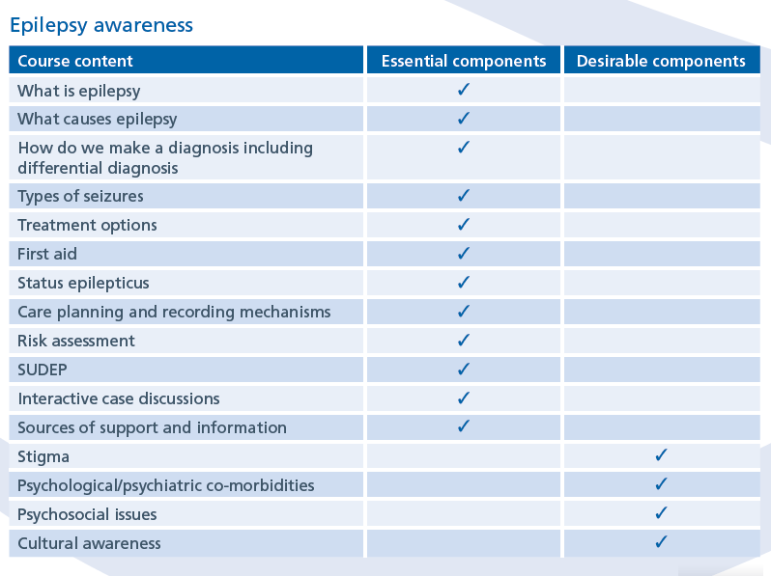
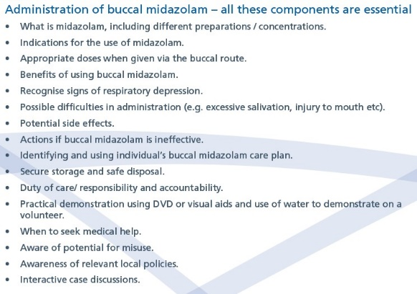

Epilepsy Nurses Association (ESNA) 2019, Best practice guidelines for training professional carers in the administration of Buccal (Oromucosal) Midazolam for the treatment of prolonged and/or clusters of epileptic seizures in the community, accessed 18 January 2022, <https://esna- online.org/>

Appendix 2 – Risk Assessment for Administration of Buccal Midazolam by Parent/Carer
Date:………………………………………..
Patient Name:…………………………………….. Accomplished by:……………………..
Date of Birth:……………………………………….
Hospital No.:……………………………………….
(Patient Addressograph)
Risk Assessment for Administration of Buccal Midazolam by Parent/Carer  (All must be answered ‘Yes’ to proceed with training.) | Yes/No
The patient of concern requires the Buccal Midazolam as prescribed by the Consultant
Neurologist.
An assessment and individualized emergency care plan for prolonged and/or cluster of seizures has been completed by the prescriber and copies made available to the relevant professionals involved (GP/ Consultant/ Epilepsy specialist nurse and the administrator).

The administrator of the Buccolam is aware that an ambulance must be called before administering the Buccolam. This is only for the first administration.
The patient of concern cannot self-administer the Buccal Midazolam.
There are no current safeguarding issues.
The patient agrees and provides consent for the parent/carer to administer the Buccal Midazolam and will comply with the provided emergency care plan. –
Next of kin/carer has been involved with the mental capacity assessment and best interest decision for the administration of Buccolam.
Next of kin/carer will comply with the provided emergency care plan.
The delegated administrator accepts responsibility to perform the task of giving the
Buccal Midazolam to the required standard following training.
The delegated administrator signs a confirmation that they have received, understood and will comply with the training provided.
The administration of the prescribed Buccal Midazolam is to the patient of concern only as per the provided emergency care plan.
There is sufficient supply and suitable storage for the prescribed Buccal Midazolam.
The use of Buccal Midazolam and the emergency care plan accompanying it will be reviewed annually by the Consultant Neurologist/Prescriber/Epilepsy Specialist Nurse.
Declaration of Training Compliance:

I, (Print Name), confirm that I attended the Buccal Midazolam training on (Date) conducted by
(Name and Designation.
I understand the requirements for the safe administration, storage, and disposal of Buccal Midazolam.
I will follow the individualized updated emergency care plan provided by the prescriber/Epilepsy Nurse.
I understand the necessity of good record keeping and I shall liaise with the prescriber regarding concerns with Buccal Midazolam administration.

Signature of Trainee: Date: Signature of Trainer: Date:

Appendix 3 – Emergency Care Plan for Prolonged and/or Cluster of Seizures Template – community services.

EMERGENCY CARE PLAN FOR BUCCAL MIDAZOLAM

*Please keep this with you at all times*

PERSONAL DETAILS

First Name: |  | INSERT PHOTO
Surname:

Date of Birth:

NHS Number:

Address:

Date Care Plan completed
Date Care Plan to be reviewed

CONTACT INFORMATION
First Name:
Surname:
Relationship:
Telephone numbers: | Mobile –
 | Home -
 | Work -

BUCCOLAM Oromucosal solution in a pre-filled oral syringe  Dose in Milligrams (mg) | 1st Dose | 2nd Dose

CONSULTANT/GP DETAILS
Print Name:
Signature:
Date:

Copies held by: Community records/ Consultant/Specialist Epilepsy Nurse/Other*
*Delete as applicable

BUCCAL MIDAZOLAM (pre-filled oral syringe BUCCOLAM)
PROCEDURE FOR ADMINISTRATION
*ONLY TO BE ADMINISTERED BY A PERSON WHO HAS BEEN TRAINED AND IS COMPETENT*

- Assess the situation and administer first aid

- Check the Buccolam has the correct name and is in date and that it is the correct dose.

- Take one plastic tube, break the tamper-proof seal and remove the syringe containing Buccolam

- Remove and discard the red syringe cap.

- Gently pull back the patient’s cheek just enough to put the end of the syringe into the side of the mouth between the gum and cheek. Angle the syringe to ensure that the end is well within the buccal cavity

- Slowly press the syringe plunger to release the full amount of Buccolam into the side of the mouth. It may be easier to give about half the Buccolam dose into one side of the mouth and the other half into the other side

- After giving Buccolam keep the empty syringe to give to the paramedic/parent so they know what dose has been given. Make a note of the time Buccolam was given, duration and type of seizure.

- As soon as possible, move the patient into the recovery position.

- Remain with person until recovered. Usual absorption time is 4-10 minutes.

- Observe breathing and colour. Buccolam can make breathing shallow.

- If difficulties giving Buccolam or concern following administration, follow care plan attached.

Seizure Type:

- ____________________________________________________________

Usual duration of seizure type 1:

- _____________________________________________________________

Usual duration of seizure type 2:

MIDAZOLAM TREATMENT PLAN
- WHEN SHOULD BUCCAL MIDAZOLAM BE ADMINISTERED? (Note should include whether it is after a certain length of time or number of seizures)
  - Note for the first time call 999 before giving Midazolam
  - If seizure (i) lasts longer than 5 minutes
  - NB Seizure (ii) doesn’t require Buccal Midazolam

- DOSE: HOW MUCH MIDAZOLAM IS TO BE GIVEN? (In milligrams)

- IF THERE ARE DIFFICULTIES IN THE ADMINISTRATION OF MIDAZOLAM e.g. DRIBBLING, MISSING THE MOUTH DUE TO SUDDEN JERK/CONVULSIONS. WHAT ACTION SHOULD BE TAKEN?
Abandon attempt and call 999 if Midazolam lost due to excess dribbling and seizure continues.
- CAN A SECOND DOSE OF MIDAZOLAM BE GIVEN?

- YES, HOW LONG AFTER THE 1ST DOSE CAN THE 2ND DOSE BE GIVEN IF THE SEIZURE CONTINUES?

- IF YES, HOW MUCH IS TO BE GIVEN?

- WHEN SHOULD 999 BE DIALLED FOR EMERGENCY HELP?
- If full prescribed dose fails to control the seizure within 5 minutes
- If injury has occurred
- If concerned about the breathing
- If concerned for any other reason

- WHO NEEDS TO BE INFORMED IF MIDAZOLAM IS GIVEN?

Health Care Plan Agreed by:

INDIVDUAL: | Signature | Date
CONSULTANT: | Signature | Date
HEALTHCARE PROFESSIONAL/OTHER | Signature | Date

RECORD OF USE OF BUCCAL MIDAZOLAM
DATE
RECORDED BY
TYPE OF SEIZURE
LENGTH AND/OR NUMBER OF SEIZURES
INITIAL DOSE AND TIME
OUTCOME
SECOND DOSAGE (IF ANY)/TIME
OUTCOME
OBSERVATIONS
PRESCRIBING DOCTOR INFORMED
OTHER INFORMATION
WITNESS
RE-ORDER OF BUCCAL MIDAZOLAM
NAME OF PERSON RE-ORDERING
DATE

Appendix 4 – Administration of Buccal Midazolam

  - (Buccolam®)
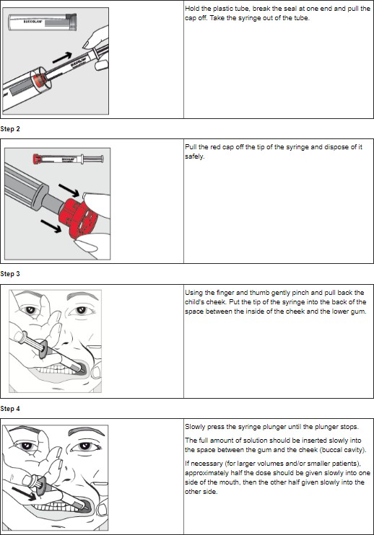

Summary Product Characteristics (SmPC), https://www.medicines.org.uk/emc/product/7460/smpc, Accessed January 2022

(Epistatus®)
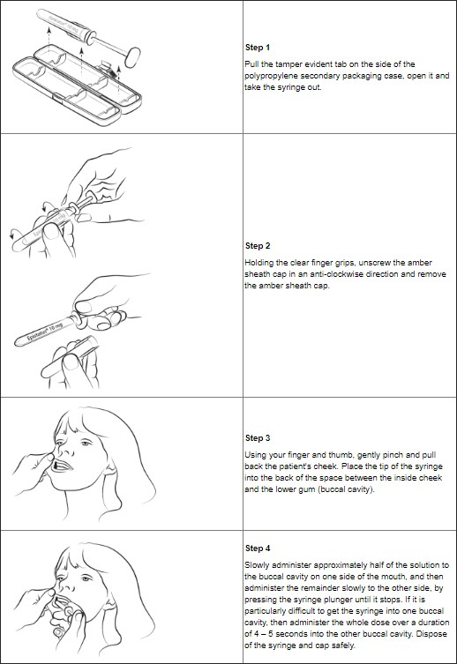

Summary Product Characteristics (SmPC), https://www.medicines.org.uk/emc/product/2679/smpc, Accessed January 2022

Appendix 5 – Luton and Dunstable Buccolam protocol

