

**PRIMARY CARE**

**DIRECTORATE HANDBOOK**

JAP V3

21.09.23

*Welcome to the Primary Care Directorate!*

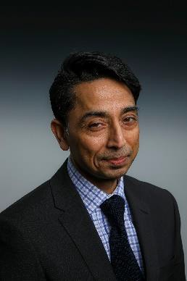

Dear all,

It gives me great pleasure to introduce the Primary care handbook. This is a living, breathing document, which will organically grow with each of us. The document aim is to provide a helpful referral source for all of us in the Primary Care directorate. Keeping the document live to ensure it continually reflects what we do to keep our registered patients safe is a responsibility of each of us. Please email updates to Farhana Azra, email: [Farhana.azra@nhs.net](mailto:Farhana.azra@nhs.net) to ensure this document is accurate.

The Primary Care services are going through incredible changes both nationally and locally with developments like Primary Care Networks, workforce transformation and changing expectations of Primary Care to deliver the system ask. We should be at the forefront of this transformation using QI tools to ensure our service users continue to receive the best care.

I am grateful to you all for the active participation from you all in the development of the Primary Care directorate. The development of the directorate is in response to the Trust strategy to deliver population health, and our population-based registers put us in a unique position to work with our Mental Health and Community Health colleagues and system partners to deliver the support networks that allow system solutions. While we will integrate and lead this march, can I also remind us all that our other strategy is about staff experience. Enjoying what we do and maintaining team morale and happiness for each of you with the respect and dignity we treat each other is really important for me. So let us use this handbook to ensure we provide population health and good outcomes for our residents with a smile on our face.

I would also like to take the opportunity to thank everyone who contributed for their leadership in the development and untiring effort in making this handbook a reality

#### Yours sincerely

**Dr Mohit Venkataram**

**Executive Director- Primary Care**

Our Services 4

Our Structure 8

Our supporting Corporate Team 10

Trust Board 11

Quality & Compliance 12

Complaints 13

Local Practice Clinical Governance Meetings 13

Risk Logs 13

Caldicott Guardian 13

Safeguarding 14

PRIMARY CARE DIRECTORATE GOVERNANCE STRUCTURE 16

Pharmacy and Controlled Drugs 17

Central Alert System (CAS) 17

Business Continuity, Disaster Recovery and Emergency Readiness 19

Working groups designed for peer networking, service transformation and support 19

ELFT Primary Care Directorate Nurse Forum 19

People Participation 20

Quality Assurance 22

Health, Safety and Security Team 26

Quality Improvement (QI) 27

Datix and Risk Management 28

Corporate Performance 32

IT and Digital 33

Communications and Engagement 35

Primary Care Skills Academy @ ELFT Purpose 36

Freedom to Speak Up Guardian 37

Contracts, Business Development and Procurement 38

Finance 38

People and Culture 40

Organisational Development 44

Accessibility 45

Translation Services 47

Equipment 47

Estates 48

Flu Vaccination Ordering 49

Primary Care Networks 49

Abbreviations sheet 53

# 

# Our Services

**Leighton Road Surgery** in Leighton Buzzard.

The practice has a list size of circa. 20,000 and is part of Leighton Buzzard PCN. The practice provides routine medical care to a mixed urban and rural population.

**Cauldwell Medical Centre** in Bedford.

The practice has a list size of circa. 9,000 and is part of East Bedford PCN. The practice provides routine medical care to a slightly younger population than normal and has a slightly higher than average caseload of patients with mental health problems.

**Bramingham Park Medical** **Centre** in Luton

The practice has a list size of circa. 7,000 and is part of Phoenix Sunrisers PCN. The practice provides routine medical care to a population with a higher than average number of patients under 19 years and between 30 to 35 years of age and a below average number of patients over 60 years of age..

**Kingsway Health Centre** in Luton

The practice has a list size of circa.11,000 and is part of Phoenix Sunrisers PCN. The practice provides routine medical care to a population with higher than average under 40-year age range and a lower than average over 50-year age range.

**Newham Transitional Practice** in Newham.

The practice has a list size of circa. 5,000 and works across two sites in Newham. The practice is commissioned to provide care to a transitional population of patients, some do not have access to an NHS number, some are homeless, some are from migrant populations etc.

**Health E1 Homeless Medical Centre** in Tower Hamlets.

Health E1 is a specialist health service for people who are homeless in Tower Hamlets, London. The practice has a list size of around 5000 patients, and registers people who are street homeless or those in temporary accommodation. Health E1 works closely with local services to provide holistic service for our patients.

**The Greenhouse Practice** in Hackney.

The practice provides care in a very similar way to HealthE1 and looks after a list of circa. 1,200 patients. The practice is also providing Primary Care outreach in City and Hackney, working with hotels that house asylum seekers and accommodation settings for those who are vulnerably housed or sleeping rough

**The Homeless Outreach and Vulnerable People Outreach Service -** This service was set up in April 2020 in response to the COVID-19 pandemic. It was initially commissioned to provide primary care services to people in hotel accommodation who had formerly been rough sleeping. The service has a team of GP’s and primary care nurses and operates across Newham and Tower Hamlets. The team works closely with the nurse led outreach service at Newham Transitional Practice. The service has developed during the COVID-19 pandemic and now aims to offer flexible care to any person who is homeless and needs care in any setting outside of one of our homeless practices.

**The Pathway Homeless Team @ RLH -** The Pathway service links to Health E1 and is based in Bart’s Hospital Trust. This small team works with clinical staff in the Bart’s Trust to ensure that robust discharge plans are in place for homeless people admitted to hospital, thus ensuring that these patients do not stay in the hospital longer than necessary and are not discharged to the street. To contact the Pathway Homeless Team at the Royal London Hospital please call 07730130221 (Mon-Fri 9-5) or email [elft.pathwayhomelessteam@nhs.net](mailto:elft.pathwayhomelessteam@nhs.net)

**Pathway Homeless Team at Homerton Healthcare NHS Foundation Trust -** The Pathway Service links to the Greenhouse Practice and Providence Row and is based in Homerton University Hospital. This is a multi-professional team of homeless health specialists including a GP, general nurse, occupational therapist, and a housing advisor. The team provides support and advice needed to improve the quality of health and social care for people experiencing homelessness attending our hospital. The team is also co-managing a six-bed step down service located in the London Borough of Hackney. To contact the team, please call 07385 399520 (weekdays, 09:00 to 17:00) or send an e-mail to:

[huh-tr.pathwayhomelesspersonsteam@nhs.net](mailto:huh-tr.pathwayhomelesspersonsteam@nhs.net).

**Cauldwell Medical Centre** Patient numbers: **9,264**

**Joined ELFT:** April 1, 2020

**CQC rating:** Good

**Practice type:** General practice

**Practice Manager:** Anita Green

**Clinical Lead:** Dr Margaret Kalilani-Themuka

**Lead ACP:** Christina Guevara

**Bypass number:** 01525858912 (option 1 for Cauldwell)

**Health E1 Homeless Medical Centre Patient numbers:** 90-1,200 at any one time

**Practice type:** Specialist general practice for homeless people

**Joined ELFT:** 2012

**CQC rating:** Good

**Practice manager:** Mohammed Al-Mahfuz

**Clinical lead**: Matthew Burridge

**Senior Clinician:** Laura Pisaneschi

Bypass number is 0207 247 1778 for emergencies only

Email: [thccg.healthe1@nhs.net](mailto:thccg.healthe1@nhs.net)

**Newham Transitional Practice Patient numbers:** Approx. 5,000

**Practice type:** Full GP care offer to any patients unable to register with a standard GP service.

**Joined ELFT:** 2011

**CQC Rating:** Good (Outstanding for care of the vulnerable)

**Practice manager:** Louise Wilson

**Deputy Practice Manager:** Vacant

**Clinical Lead:** Dr Duncan Trathen

**Lead Nurse:** Sihle Malapela

**Bypass number:** 0207 909 4982

**Leighton Road Surgery** Patient numbers: 19,935

**Practice type:** General practice Joined ELFT: Feb 2020

**CQC Rating:** Good

**Practice manager:** Sarah Needham

**Clinical Lead GP:** Dr Santiago Dargallo

**Deputy Clinical Lead**: Alex Guevara

**Lead Nurse:** Vacant

**Bypass number: 01525 858912 Option 2**

**Greenhouse Practice** Patient numbers: 1,092

**Practice type:** general practice for homeless people

**CQC rating:** outstanding

**Practice Manager:** RuthThacker

**Deputy Practice Manager:** Ali Khan

**Clinical lead:** DrPadma Wignesvaran

**Lead Nurse:** Marion John

**Bypass number:** 07596 559982

**Kingsway Health Centre**

**Practice type:**

**CQC rating: Good** (Responsive – requires Improvement)

**Practice Manager:**  SnehalGoswami

**Deputy Practice Manager:** Charmaine Perry

**Clinical lead:** Adil Ali Khan

**Lead Nurse:** Nadeem Moyden

**Bypass number:** 01582 568914

**Bramingham Park Medical Centre**

**Joined ELFT:** 2023

**Practice type:**

**CQC rating:** Good

**Practice Manager:** SnehalGoswami

**Clinical lead:** Dr Vivek Kazal

**Lead Nurse:** Louise McParland

**Bypass number:** 01582 563085

# Our Structure



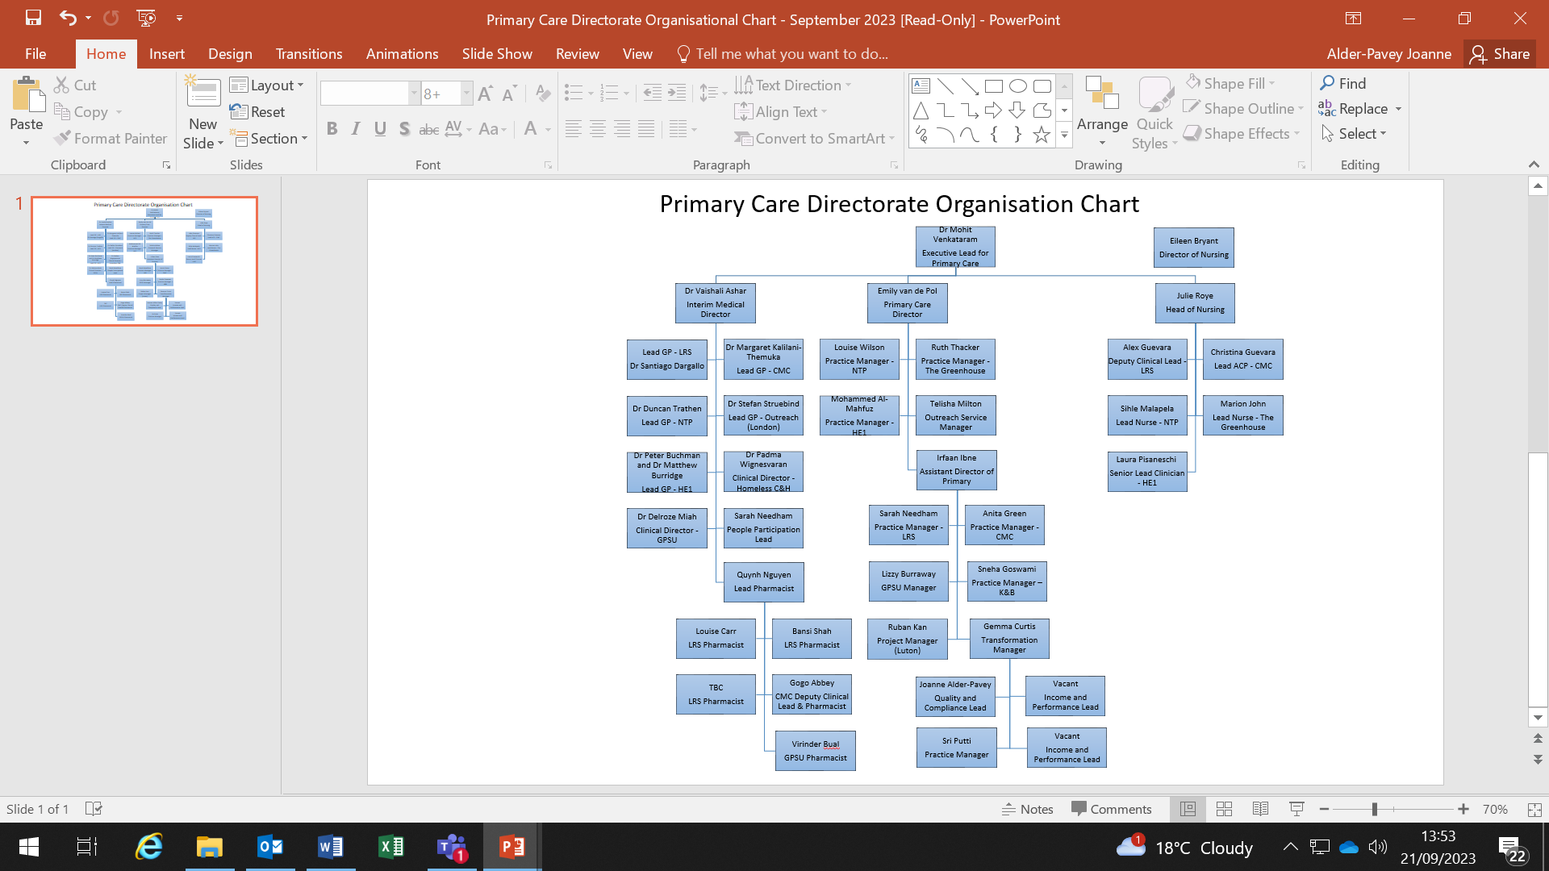

# Our supporting Corporate Team

|  |  |
| --- | --- |
| **Finance** | Naomi Scott  Suganthy Kandiah |
| **Quality Assurance** | Ella Webster |
| **Quality Improvement** | Carlos Santos |
| **Performance** | TBC |
| **People Relations** | Jacqueline Awidi  PBP Gemma Kendall |
| **Organisation Development** | Mairead Heslin |
| **Training & Development** | Princess Kabba |
| **Health & Safety** | Richard Harwin - Lead  Hafiza Rahman - Advisor |
| **Datix/Risk** | Joanne Sims |
| **Quality & Compliance** | Joanne Alder-Pavey |
| **Communications** | Sara Marsili |
| **Contracts** | Thomas Morgan |
| **Safeguarding** | **Beds**  **SGA** Suzanne Jenkinson  **SGC** Clarissa Wye  **London**  **SGA**  Cheneka Murray (*City & Hackney)*  Emma Crivellari (Newham)  James Thomas (Tower Hamlets)  **SGC**  Bev Heredge (City & Hackney)  Maura Hubbard (Newham)  Gurinder Lall (Tower Hamlets) |
| **Executive Assistant to Director and Medical Director** | Farhana Azra |
| **Transformation Manager** | Gemma Curtis |

# Trust Board

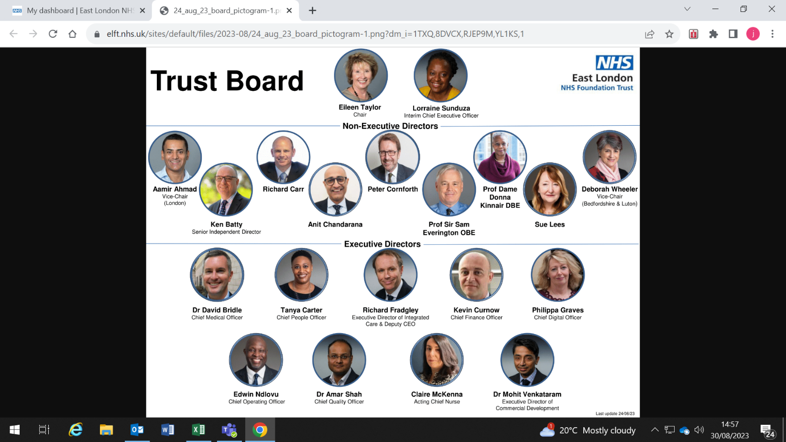

# Quality & Compliance

The PCD is be supported by a band 6 Quality and Compliance Lead. The Quality and Compliance Lead plays an important part in helping to ensure that Primary Care Services are able to deliver on the Trust's commitment to quality improvement and the provision of high quality services.

The role of the Quality and Compliance Lead is to ensure the delivery of a coherent and systematic approach to quality and assurance management, reporting and improvement. They will ensure that quality and compliance management and quality assurance systems are in place and fully functional across all services our practices.

The QCL will ensure our Directorate and services are supported in meeting statutory, regulatory and organisational requirements in relation to the quality of care that service users and their carers receive as well as ensuring that staff are performing in a safe environment. To do this they will work closely with clinical, administrative and management colleagues within Primary Care Services and also partner agencies to ensure that quality and assurance management and reporting illustrates services being safe, caring, responsive, effective and well led.

They will be a key support around

1. Complaints
2. SIs
3. Datix
4. QAG
5. Local practice clinical governance meetings
6. Action and improvement planning

Who can help you?

|  |  |  |  |
| --- | --- | --- | --- |
| **Name** | **Role** | **Telephone** | **Email** |
| Joanne Alder-Pavey | Quality & Compliance Lead | 07785695413 | [j.alder-pavey@nhs.net](mailto:j.alder-pavey@nhs.net) |



# Complaints

Local policies and processes are in place to manage Complaints within the Primary Care directorate to ensure concerns raised by patients are investigated and addressed and national requirements are met. Further information is also available on the GMC website, which clearly sets out GP practices responsibilities via the following link https:/[/www.b](http://www.bma.org.uk/advice-)m[a.org.uk/advice-](http://www.bma.org.uk/advice-) and-support/gp-practices/complaints-in-primary-care/complaints-in-primary- care.

Each practice will ensure that serious complaints and themes relating to complaints are escalated to the monthly DMT and Clinical Governance Committees and where necessary to the Trusts Complaints Team.

Helpful complaints information:



# Local Practice Clinical Governance Meetings

To ensure consistency, high quality and safety in all that we do in Primary Care we have developed a clinically lead, standardised approach to a practice based clinical governance meeting with a clear reporting structure. All practices are required to undertake an MDT practice based clinical governance meeting chaired by the practices Clinical Lead one per month working to the standard agenda contained below.

Practices are able to add to the agenda but all other items are mandatory, with underpinning improvement plans. Risks and issues scored above 8 should be escalated up to the DMT. The PBCGM reports into the Directorate QAG.

A standardised term of reference and agenda for the clinical governance is available, which every practice is required to work to, additional items can be added at your own localised need. The agenda and terms of reference are here:



# Risk Logs

All practices should have a risk register in place using the ELFT standardised risk register. Any risks above score 15 will be reported up to the DMT with mitigations. The Directorate has a risk log, which is owned at both QAG and DMT level and reviewed monthly.

# Caldicott Guardian

A Caldicott Guardian is a senior person responsible for protecting the confidentiality of a patient and service-user information and enabling appropriate information sharing. Organisations that access patient records are required to have a Caldicott Guardian, which is mandated for the NHS by the Health Service Circular: HSC 1999/012. The mandate includes acute trusts, ambulance trusts, mental health trusts, integrated care boards (ICBs), special health authorities, commissioning support units and area teams.

The Guardian plays a key role in ensuring that NHS, Councils with Social Services Responsibilities and partner organisations satisfy the highest practical standards for handling patient identifiable information. Acting as the 'conscience' of an organisation, the Guardian actively supports work to enable information sharing where it is appropriate to share, and advises on options for lawful and ethical processing of information. For more information visit: <http://systems.hscic.gov.uk/infogov/caldicott> . Dr David Bridle is the ELFT Caldicott Guardian [d.bridle@nhs.net](mailto:d.bridle@nhs.net)

# Safeguarding

Safeguarding Adults and Children remains everyone’s responsibility. As a health care provider, this forms part of the NHS Contract and statutory obligations under the Care Act 2014, The Counter-Terrorism and Security Act 2015, The Children Act 1989 and The Children Act 2004, and within statutory guidance including The Care and Statutory Guidance for Adults 2015, and Working Together to Safeguard Children 2018.

ELFT is rated by CQC as an outstanding trust and takes its safeguarding responsibility seriously. The trust believes that its entire staff should be aware of their role to identify signs and symptoms of harm, neglect or abuse and report and share it with the relevant partners in a timely manner. Safeguarding is about preventing abuse and neglect, as well as promoting good practice for responding to concerns on a multi-agency basis.

The trust strongly advocates the Think Family approach and considers the whole-family approach to address issues like domestic abuse, mental ill health, drug and alcohol issues etc. that affects the whole family.

Training plays a key part in educating, raising awareness and improving the skills of the staff members and the trust believes in delivering safeguarding training right at the start to ensure that their staffs are inclusive, respectful and caring when delivering their responsibilities towards service users.

If you need to raise a safeguarding concern, you will need to raise the concern both with your local ICB team and with the appropriate ELFT local safeguarding lead. As part of a primary care team and part of ELFT, both processes need to be completed to satisfy legal requirements and regulation.

Please also remember that if you see a child that you think is at imminent risk of FGM you must call the police immediately and inform safeguarding leads.

**SAFEGUARDING ADULTS TEAM**

Dinh Padicala - [dinh.padicala@nhs.net](mailto:dinh.padicala@nhs.net) - *Associate Director for Safeguarding Adults and Domestic Abuse: 02081215403*

James Thomas - [james.thomas44@nhs.net](mailto:james.thomas44@nhs.net) - *Named professional for safeguarding children (Tower Hamlets): 02081215358 / 07341789596*

Cheneka Murray – [Cheneka.murray@nhs.net](mailto:Cheneka.murray@nhs.net) - *Named professional for safeguarding children (City and Hackney): 07435733991*

Suzaan Jenkinson – [Suzaan.jenkinson@nhs.net](mailto:Suzaan.jenkinson@nhs.net) - *Named Professional for Safeguarding Adults (Bedford and Central Beds): 01234316716 / 07775 002926*

Dermott Flynn – [dermott.flynn@nhs.net](mailto:dermott.flynn@nhs.net) - *Named Professional for Safeguarding Adults (Luton): 01234316716 / 07775027164*

Emma Crivellari - [emma.crivellari@nhs.net](mailto:emma.crivellari@nhs.net) - *Named professional for Safeguarding Adults (Newham): 07789877158*

Tony Alston - [tony.alston@nhs.net](mailto:tony.alston@nhs.net) - *Named professional for Safeguarding Adults (Bedfordshire): 07920075744*

**SAFEGUARDING CHILDREN TEAM**

Victoria Winfield-Brown – [Victoria.winfield-brown@nhs.net](mailto:Victoria.winfield-brown@nhs.net) - : *Associate Director for Safeguarding Children: 07940001247*

Gurinder Lall – [gurinder.lall@nhs.net](mailto:gurinder.lall@nhs.net) -  *Named professional for Safeguarding Children (Tower Hamlets): 07908194436*

Catherine Jordan – [Catherine.jordan2@nhs.net](mailto:Catherine.jordan2@nhs.net) - *Named professional for Safeguarding Children (Luton): 07733124587*

Maura Hubbard – [maura.hubbard@nhs.net](mailto:maura.hubbard@nhs.net) - *Named professional for Safeguarding Children (Newham): 07867177225*

Bev Heredge – [bev.heredge@nhs.net](mailto:bev.heredge@nhs.net) - *Named professional for Safeguarding Children (City & Hackney): 07721237802*

Clarissa Wye – [c.wye@nhs.net](mailto:c.wye@nhs.net) - *Named professional for Safeguarding Children (Bedfordshire): 07891865051*

Karen Patchett – [Karen.patchett@nhs.net](mailto:Karen.patchett@nhs.net) *– Named professional for Safeguarding Children (Central Bedfordshire) 07436 027740*

# PRIMARY CARE DIRECTORATE GOVERNANCE STRUCTURE

Primary Care - Directorate Management Team

Primary Care - Quality and Assurance Group

Bramingham Park Medical Centre– Clinical Governance Meeting

Cauldwell Medical Centrey – Clinical Governance Meeting

Greenhouse Practice – Clinical Governance Meeting

Health E1- Clinical Governance Meeting

Kingsway Health Centre – Clinical Governance Meeting

Leighton Road Surgery – Clinical Governance Meeting

Newham Transitional Practice – Clinical Governance Meeting

|  |  |
| --- | --- |
| **Governance and regulatory for the PC Directorate** | |
| Executive Director | Dr Mohit Venkataram Tel:      020 7655 4047  Email: [mohit.venkataram@nhs.net](mailto:mohit.venkataram@nhs.net) |
| Information Governance Lead and Data  Protection Officer | Chris Kitchener Tel:      020 7655 4110  Email:  [chris.kitchener@nhs.net](mailto:chris.kitchener@nhs.net) |
| Caldicott Guardian | Dr David Bridle  Email:  [d.bridle@nhs.net](mailto:d.bridle@nhs.net) |
| Senior Information Risk Owner | Amar Shah Tel:  020 7655 4034  Email:  [amarshah@nhs.net](mailto:amarshah@nhs.net) |
| Accountable Emergency Officer | Edwin Ndolvu Tel: 0207 655 4016  Email: [Edwin.ndlovu@nhs.net](mailto:Edwin.ndlovu@nhs.net) |
| Safeguarding Lead | Lorraine Sunduza Tel:  020 7655 4042  Email:  [lorrainesunduza@nhs.net](mailto:lorrainesunduza@nhs.net) |
| Mental Capacity and Liberty Protection  Safeguards Lead | Guy Davis Tel:  020 7655 4046 or 07967 725 075  Email:  [guydavis@nhs.net](mailto:guydavis@nhs.net) |
| Prevent Lead | Lorraine Sunduza Tel:  020 7655 4042  Email:  [lorrainesunduza@nhs.net](mailto:lorrainesunduza@nhs.net) |



# Pharmacy and Controlled Drugs

The directorate Lead Pharmacist is Quynh Nguyen Mobile: 07788 229140 [quynh.nguyen@nhs.net](mailto:quynh.nguyen@nhs.net)

For medicines support, all practices should still contact ICB medicines management teams, who are the main contact for practices.

The Trust offers support via our Chief Pharmacist and Controlled Drugs Accountable Officer Stuart Banham.

# Central Alert System (CAS)

The Central Alert System (CAS) is an electronic cascade system originally developed by the Department of Health and now delivered by the Medicines and Healthcare Products Regulatory Agency and is a key means by which to communicate and disseminate important safety and device alert information within the NHS. CAS facilitates distribution of Alerts available on the CAS website including National Patient Safety Alerts, NHS England and Improvement Patient Safety Alerts (PSA), Estates Alerts, MHRA Dear Doctor letters, Drug Alerts, Chief Medical Officer (CMO) Alerts, and Department of Health & Social Care Supply Disruption alerts.

It may also be necessary for the Trust to distribute “internal alerts”. These alerts will be used to provide rapid dissemination of information e.g. medical device/equipment recall and lessons learned, which are approved by the Chief Medical Officer or Chief Nurse.

The following sets out the process for distributing and actioning alerts within Primary Care.

Safety Alerts

Local Dissemination Routes for Primary Care Directorate

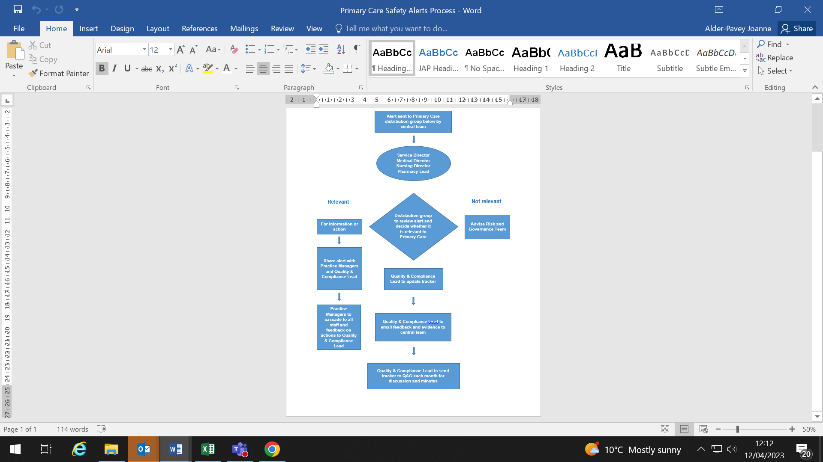

# Business Continuity, Disaster Recovery and Emergency Readiness

A table top exercise was carried out in June 2021 to review all business continuity plans. Each service should refer to its BCP for further details and should, for confidentiality, have one full version with all telephone numbers within locked away and one a version without personally identifiable information available at the surgery. BCPs will be reviewed twice a year, June and December. Updated BCPs will be reported to DMT in July and January.



# Working groups designed for peer networking, service transformation and support

In order to support shared learning, networking and discussions on key issues several opportunities have been created for representatives from practices to come together.

#### Operational practice managers peer network meetings

This are established to take place bi-weekly with practice managers from all sites, with a standard agenda of the following combined with any new items or areas practice managers would like to focus on:

**Estates**

**Patient engagement and communications**

* Surveys
* Materials for practices (posters / leaflets etc. needed)

**IT to include**

* Searches for audits
* Staff training needs around IT or clinical system
* Practice websites

**People and Culture**

* Staffing issues
* Development line management areas required
* Appraisals

**Performance**

* LES / DES / Flu / immunisations etc.
* KPIs

**Risks and issues**

**Sharing what each site is working on**

**What I need help with**

# ELFT Primary Care Directorate Nurse Forum

The aim of the nurse forum is to share information, link with each other and engage in shaping the future of Practice Nursing across the directorate. We meet once a month via Teams and support and share best practice. The forum aims to promote innovation and outstanding evidence based care for the populations we serve.

# People Participation

People Participation is all about helping our service users and their carers to have a say in how we run the Trust. It is also about working together so that we can improve local services and offer the best care and experience possible. Within Primary Care, we offer many opportunities to involve our patients and carers in developing and improving our services;

1. Joining their PPG
2. Sitting on interview panels
3. Completing surveys
4. Attending focus groups
5. Auditing and inspecting services
6. Sharing their story
7. Staff Training
8. Joining a QI project
9. Joining Trust Wide and strategic work streams

Patients and Carers involved in People Participation activities are offered reimbursement for their time and contributions. Each Directorate has their own dedicated People Participation Lead (PPL) who they can work with to develop People Participation activities within their services

For more information on People Participation, contact the People Participation Team at [elft.peopleparticipation@nhs.net](mailto:elft.peopleparticipation@nhs.net)

**Contact your PP Lead**

Sarah Needham [sarah.needham15@nhs.net](mailto:sarah.needham15@nhs.net)

**National General Practice Patient Survey**

Every January – March a national patient survey is externally administered with results published in July of that year. All practices are required to undertake a review of their results and engage with stakeholders to develop an improvement plan.

**What is Patient Experience?**

Patient experience is a regular collection of information about service user's experience at ELFT and the development of the action in the response to the feedback received. Our system also strengthens accountability through sharing of changes publicly and regular monitoring of patient views (e.g. You Said, We Did boards).

**Why do we measure Patient Experience?**

Feedback allows our services to improve on areas service users feel is important. Our process equally empowers patients to hold us to account by providing them with a platform to tell us about their experience and publicly sharing where we have taken action. The impact of this process can be measured in many ways – better patient outcomes, carers feeling listened to, staff having a better day at work, improvement efforts targeted in the right areas, and budgets spent where it matters most to patients.

**How do we collect Patient Experience?**

Quality Assurance team oversees and manages PREM (Patient Reported Experience Measures) surveys. Directorates and services have options how to best collect patient experience from the population they serve. PREMS can be collected through utilising online PREM survey link, QR Code, tablet stands in the reception areas (subject to infection control), and other options. For more information, please email QA team [elft.qa@nhs.net.](mailto:elft.qa@nhs.net)

PREM surveys for Primary Care went fully live in January 2021 and results are reported monthly to the Quality Assurance Group. All practices have access to view and download their own PREM data using the Envoy system. If you need a login for the Envoy system, please contact the QA team on [elft.qa@nhs.net.](mailto:elft.qa@nhs.net)

The local process chart:



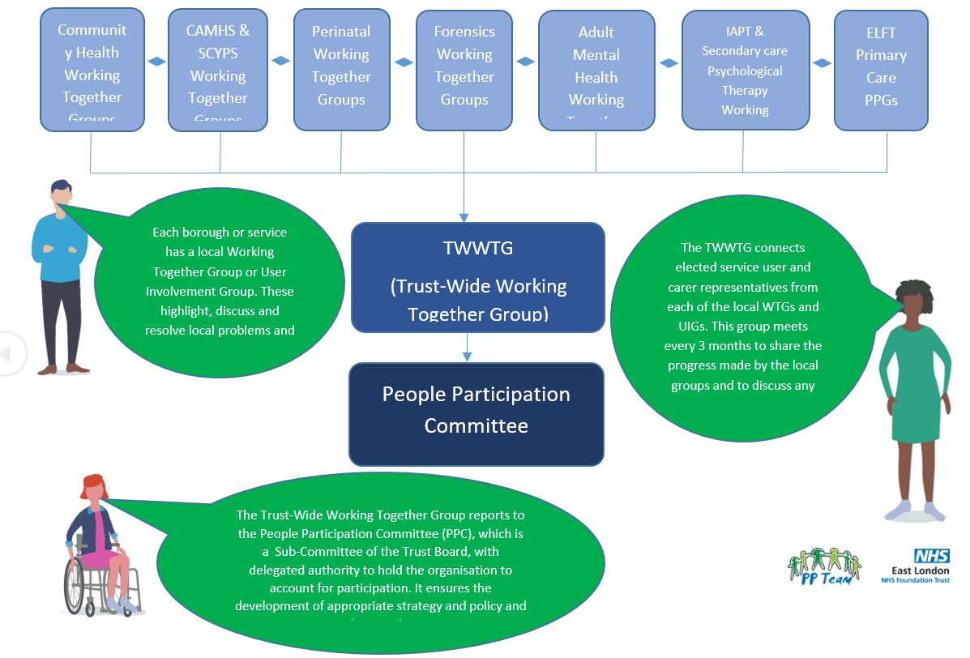

# Quality Assurance

ELFT’s quality assurance work streams help us understand whether our services are providing a level of quality that we would expect based on standards set by our service users and carers, by CQC, by NICE and by our clinicians. QA is an important mechanism that contributes to our aspiration about providing high quality, safe, effective and equitable care. QA at ELFT forms part of a wider quality system that also includes Quality Improvement and Quality Control.

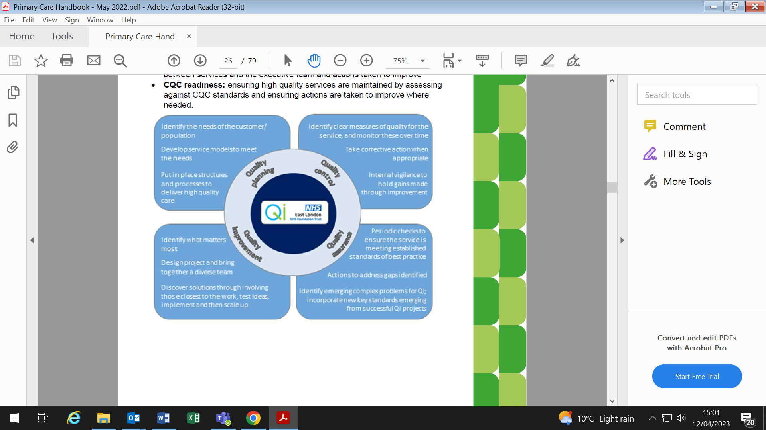

There is an expectation that teams participate in our internal quality assurance programmes, that good practice identified is recognised and shared, that any areas for improvement are acted upon, and that those actions are tracked by the Directorate Management Team.

This includes an annual CQC readiness process, 4-monthly clinical audit, ongoing collection of patient experience feedback and participation in service user led accreditation.

Your QA manager, Ella Webster (ella.webster3@nhs.net) is available to support teams to engage in our internal quality assurance processes and support the management team in its oversight.

How we can support primary care:

* + Regular communications, and regular point of contact
  + Work closely with local leads/champions
  + Development of ‘how to’ guides, process map and other reference documents
  + Access to real time data and training on the ‘Envoy’ system
  + Flexibility and regular process and standards review
  + Action tracking templates
  + Site visits

**Who can help you?**

|  |  |  |  |
| --- | --- | --- | --- |
| **Name** | **Role** | **Telephone** | **Email** |
| Ella Webster | PC Quality Assurance Lead | 07825900245 | [ella.webster3@nhs.net](mailto:ella.webster3@nhs.net) |

|  |  |  |  |  |  |  |  |  |  |  |  |  |  |  |
| --- | --- | --- | --- | --- | --- | --- | --- | --- | --- | --- | --- | --- | --- | --- |
| **Workstream** | **Action** |  | | | | | | | | | | | | |
| **Apr** | **May** | **Jun** | **Jul** | **Aug** | **Sep** | **Oct** | **Nov** | **Dec** | **Jan** | **Feb** | **Mar** | **Apr** |
| Directorate and Trust-wide Audits | Data collection |  |  | 5 -19 |  |  |  | 2-16 |  |  |  | 5-19 |  |  |
| Results published |  |  |  | 10 |  |  |  | 6 |  |  |  | 11 |  |
| Action plans communicated to QA manager |  |  |  |  | 21 |  |  |  | 18 |  |  |  | 22 |
| Quality & Safety Visits | Heath E1 Visit |  |  |  |  |  |  |  |  |  |  |  |  |  |
| Greenhouse Practice Visit |  |  |  |  |  |  |  |  |  |  |  |  |  |
| Newham Transitional Practice Visit |  |  |  |  |  |  |  |  |  |  |  |  |  |
| Health E1 Report |  |  |  |  |  |  |  |  |  |  |  |  |  |
| Greenhouse Practice Report & Action Planning |  |  |  |  |  |  |  |  |  |  |  |  |  |
| Newham Transitional Practice Report & Action Planning |  |  |  |  |  |  |  |  |  |  |  |  |  |
| SU-Led Accreditation | Teams Registration | *On-going* | | | | | | | | | | | | |
| Accreditation Panel |  |  | 23 |  | 2 |  | 18 |  |  | 22 |  |  |  |
| Staff Q&A sessions |  |  | x |  |  |  | x |  |  | x |  |  |  |
| Patient Experience | Care Opinion - Teams Registration | On-going | | | | | | | | | | | | |
| NICE | New/updated guidance is released *not an ask for teams | 3 | 2 | 1 | 3 | 1 | 1 | 2 | 1 | 1 | 2 | 1 | 1 | 1 |
| Executive Walkround | Takes place once a year (Executive Assistance will liaise with Team Leader to agree a date) |  |  |  |  |  |  |  |  |  |  |  |  |  |

**Trust Wide and Directorate Clinical Audit:** The trust’s internal mandatory audit programme involves teams completing mandatory audits every cycle (Feb, June and October). Locally, Directorate Management Teams define their own standards, which are important for them and help to ensure all services within their directorate are meeting key standards. The QA team distribute audit results to Directorate Management Teams, Audit leads, local Quality Assurance Leads and Lead Pharmacists. Local audit leads disseminate audit results after each quarter and teams discuss results, share good practice, agree priorities for improvement, and associated actions. Actions are documented in the below shared tracker saved in the PC Teams channel:

[Primary Care Quality Assurance Action Tracker.xlsx](https://nhs.sharepoint.com/:x:/r/sites/msteams_9b21e6/Shared%20Documents/Quality%20Assurance%20Action%20Tracker/Primary%20Care%20Quality%20Assurance%20Action%20Tracker.xlsx?d=w6da5e4a05b774ce788ecc0c4e9674a84&csf=1&web=1&e=8typ6s)

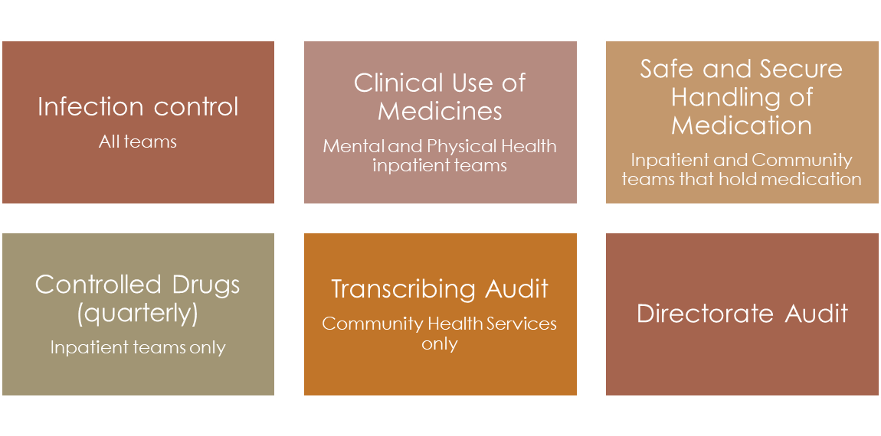

**Service User-Led Accreditation:** This programme was co-produced by services user and careers across the Trust. The teams can join the programme and be assessed by our trained service users against pre-defined standards that are most important to them. Teams can showcase all their incredible work and build on the recommendations, demonstrating a commitment to continuous improvement and excellence and, where relevant, work towards the next level of accreditation. In 2023, the programme incorporated new and updated standards and the addition of a platinum award, the latest and most ambitious award.

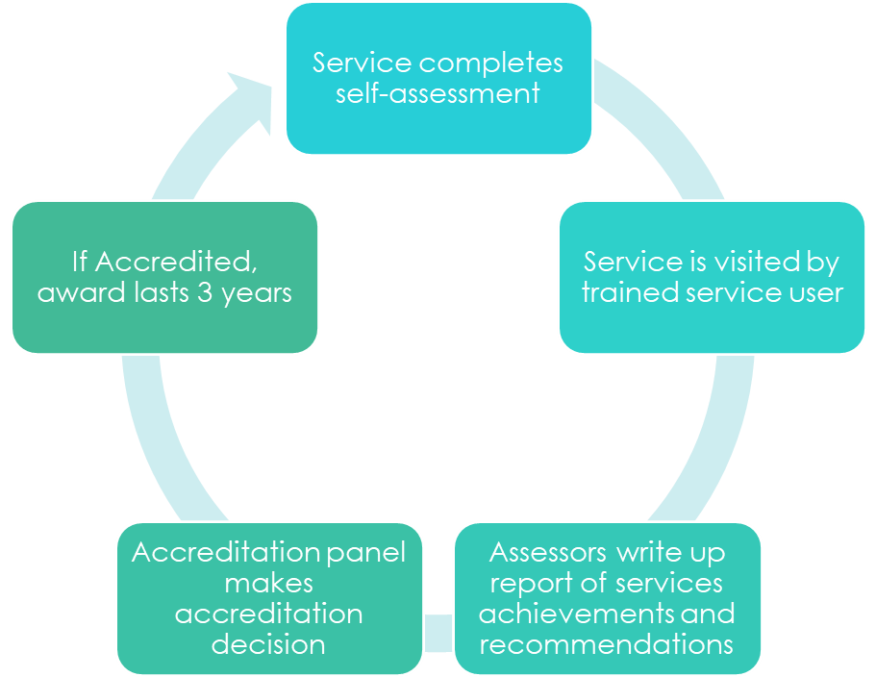

**Tracking NICE Guidelines:** Every month NICE releases new or updated guidelines to inform best practice in health care. Within ELFT, the guidelines are screened by Medical Directors to identify those relevant to the Directorate, and consequently allocated to a NICE Lead to review. In some cases, NICE Leads will produce a Baseline Assessment. Teams are expected to ensure that NICE Guidance is actively reviewed, recommendations are implemented and monitored.

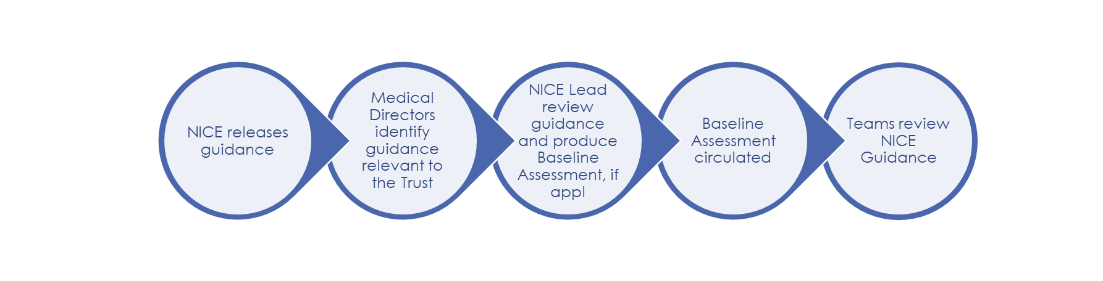

**Coordinating Executive Walkrounds:** These sessions give our teams a chance to speak directly to the executive team about what it feels like to work at ELFT – the good things, and the not-so-great things. One person from the executive team will be attending the walkround, which would usually take around 45-60 minutes. Teams receive a visit from the executive team at least once a year. As many team members as possible should be encouraged to attend. Key themes that come out of these meetings are reported on the Quality Committee. The visits are booked with plenty of notice. The Executive will contact the Team Leads and suggest some dates for the visit.

**CQC readiness:** The Care Quality Commission (CQC) are the regulators of all health and social care services in England. Within the directorate, Quality Assurance Visits are taking place, to support practices understand the quality of their services and stay on track with monitoring CQC standards, even when there is no inspection on the horizon. The aim of this process is to provide assurance and confidence to staff and those who use our services. In addition, allows us to share good practice and to act on learning identified during the visits.

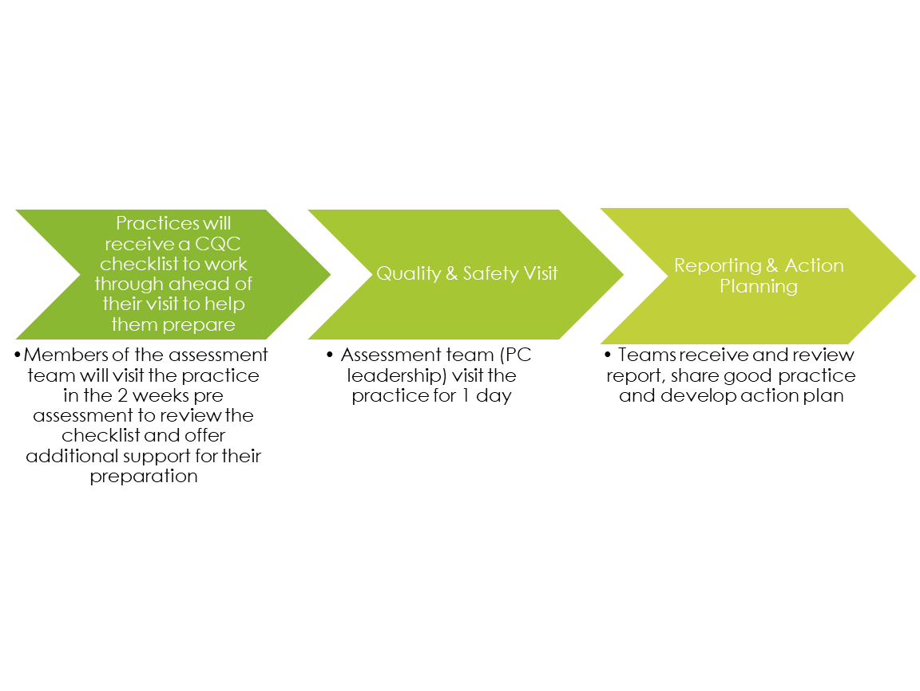

**Measuring patient experience:** It is vital that we understand the experience of people accessing our services. All our service users and their loved ones should be given the opportunity to leave feedback on their care and treatment. Patient experience needs to be collected regularly and actions developed in the response to the feedback received. Service user feedback will provide a better picture of the quality of the services we are providing. Feedback can be collected in different ways including text messaging, QR codes, verbal feedback, phone calls, and emails. The online providers of our patient experience surveys are Healthcare Communications and Care Opinion.

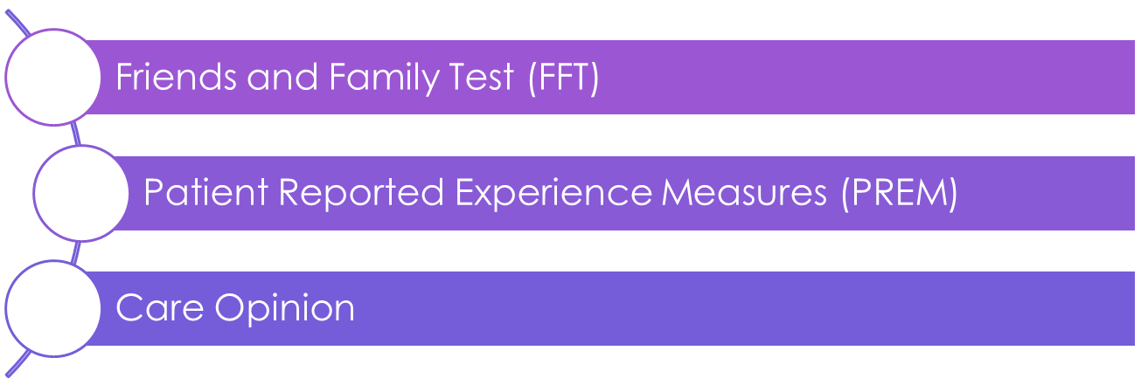

# Health, Safety and Security Team

The Trust has a duty to ensure that all persons using its premises are protected from all foreseeable hazards/risks as far as they may be affected by the activities of the Trust.

There is an Executive Lead - the Chief Operating Officer - who sits at board level, and who is responsible for H&S committee and security activity. The Health, Safety and Security team sits within the Governance and Risk department and consists of two staff members: the Trust Health, Safety, Security and Emergency Planning Manager and the Health, Safety and Security Advisor.

**Who can help you?**

|  |  |  |  |
| --- | --- | --- | --- |
| Vacant | Health, Safety & Security  Advisor |  |  |
| Richard  Harwin | Health, Safety, Security &  Emergency Planning Manager | 020 7655 4280  07870 683993 | [Richard.harwin@nhs.net](mailto:Richard.harwin@nhs.net) |

**Our Health, Safety and Security Manager leads** on all H&S issues across the Trust concerning advising and making recommendations on best practice. The H&S Manager will also advise and assist for non-clinical and clinical health & safety within the Trust, inclusive of:

* Support with H&S assessments of all areas/wards/ departments
* Facilitate H&S Induction and Risk Officer / Risk Facilitator Training, as per training needs analysis.
* Assist all staff to drive through the changes identified by risk management procedures, risk assessment or audit results to improve the quality of patient and staff safety.
* Direct the organisation on the relevant process for carrying out general risk assessments.
* To assist managers in delivering the risk assessment / risk control processes required by health & safety legislation and the status of risks via the risk register through provision of professional advice.
* Provide H&S advice giving, non-clinical risk, pregnant worker and Display Screen Equipment (DSE)
* Provide provisions and guidance on safe systems of work for lone workers

**The Health, Safety and Security Committee**

In addition, there is a Trust wide Health and Safety Committee, chaired by the Chief Nurse, and attended by staff side representatives, operational directors, estates and facilities and the Health and Safety Lead for the Trust. This group discusses and promotes trust wide health and safety issues that remain unresolved at directorate level. This group also promotes a culture of understanding and co-operation across the trust to ensure the health, safety and welfare of all staff, patients and visitors.

**Visitors to practices**

All visitors to site should be asked to sign into the signing in book and should be given a visitors’ badge. Visitors’ badges should be worn at all times.

**ID Badges**

All staff, contractors and volunteers must ensure that they display their ID Cards whilst on Trust property. These can be ordered by contact Enrique Nuesch - Resourcing Team [Enrique.nuesch1@nhs.net](mailto:Enrique.nuesch1@nhs.net)

# Quality Improvement (QI)

The ELFT QI programme has supported hundreds of QI projects since 2013, as the Trust main approach to solving and improving complex issues. Additionally, teams are encouraged to use QI tools in their Daily Improvement, using the Model for Improvement and quality improvement tools more broadly outside of quality improvement projects.

**Who can help you?**

|  |  |  |  |
| --- | --- | --- | --- |
| **Name** | **Role** | **Telephone** | **Email** |
| Carlos Santos | PC Improvement  advisor |  | [carlos.santos1@nhs.net](mailto:carlos.santos1@nhs.net) |

**Strategy for QI in ELFT Primary Care.**

The Directorate has a Quality Improvement strategy. Co- production of the strategy is at its core, listening to the directorate teams and focusing on their priorities, having Service User involvement as part of its ethos. The current version of the QI strategy for ELFT Primary Care covers the following domains and subtopics:

**Capability Building:**

1. “QI for All”:

* Every staff member in Primary Care to go through QI Training.
* Promote ‘QI literacy’, encouraging every member of the primary care teams to increase their understanding of QI and have a voice when devising solutions.

1. Developing Key QI Leaders:

* Fostering and making the most of individuals’ passion for QI, enabling them to lead and champion QI work.

1. Developing QI links and networks:

* Internal QI links reaching across directorates
* External ‘cross-system’, linking with QI work occurring elsewhere in the system
* Encouraging wider project team membership as appropriate

**Build Belief in QI:**

* + - Identify key opportunities for QI to make a positive difference across the directorate
    - Share learning and stories of the power and impact of QI across the directorate
    - Identify and engage key individuals (“super connectors”), creating space to
    - have their voice heard and to lead conversations around the value of QI
    - Make co-production business as usual, with wider participation of service users, carers, external organisations

**The QI meetings and Huddles**

The core strength of quality improvement lies in bringing people together and unleashing their potential around a common purpose. Under primary care, this occurs via meetings at local and directorate levels. Local teams have full discretion to decide the shape and frequency of their QI meetings and huddles.

Under Directorate level, the QI meetings occur every two weeks, intercalating between **QI Forum** and **QI coaching sessions**.

The QI Forum is a space:

* For current projects to be presented and discussed
* For new projects to be presented and potentially agreed (or recommendations)
* To discuss any other QI related topics such as training requirements and events in the QI calendar.

The QI Coaching session is a safe and positive space where coaches and project leads can:

* Discuss projects and develop ideas, as well as provide insights into the presented projects
* Become acquainted with QI projects occurring across the directorate, creating opportunities to learn from one another
* Learn about tools and techniques to enhance engagement and improvement skills
* Contribute to enhance the Improvement strategy of the Primary Care Directorate.

Both QI Forum and QI Coaching session share common objectives:

* Support colleagues to act as QI ambassadors across the directorate to encourage
* a shared vision of ‘QI for all’
* Provide support to Improvement Projects and Peer Support
* Develop further literacy on improvement tools
* Participation in the ‘story telling’ of successes and lessons learnt from QI projects.

**Capability Building: 3 levels of training**

Training on Quality Improvement for Primary Care delivered by the ELFT Quality Improvement Department. Additionally, bespoke sessions to meet particular needs from the directorate.

Three levels of training:

**Pocket QI**

Two half-day modules covering the basics of QI methods and tools. Available to ELFT staff, service users and carers involved in QI or wanting to learn core QI skills.

**Improvement Leaders’ Programme**

An 8-month programme involving 7.5 days of face-to-face learning, in addition to reading and online modules. For project leads, project team members and anyone in a management role. Improvement Coaching Programme

A 6-month leadership development programme, teaching more complex QI methods and tools. This helps QI coaches to develop skills to support teams in their improvement work.

**Protected time for QI:**

Capacity and Capability is at the forefront of all Improvement work carried out in Primary Care. Every individual involved in leading or coaching QI has protected time to focus on their assigned project and to attend the respective sessions for coaching and training.

# Datix and Risk Management

**Datix**

The Datix Team support the delivery of the Datix Risk Management system, we:

* Facilitate the Datix Risk Management System; the Trust uses a number of different modules including Incident Reporting, Complaints, PALS, Inquests, Claims and Access to Records
* Make changes to the system; add new users, sites and services.
* Make changes to deliver improvements and meet new reporting requirements.
* Provide Datix and incident training to staff including incident reporting and creating reports.

For further support in relation to Datix the team can be contacted via our dedicated support email address [elft.datixsupport@nhs.net](mailto:elft.datixsupport@nhs.net)

**Risk Management**

The Trust and Datix Manager is responsible for:

* Developing and reviewing the Trusts Risk Management Framework.
* Implementing the Trusts Risk Management Framework and supporting systems.
* Supporting the development of directorate risk registers
* Providing Risk Management Training

For further support, please contact Joanne Sims, Risk and Datix Manager,

📞0207 655 4006, 📱07824 561319, 📧[joanne.sims3@nhs.net](mailto:joanne.sims3@nhs.net)

**Policy Management**

The Trust and Datix Manager is responsible for:

* Develop and review the Trusts Policy and Procedure for the Development, Review and Control of Trust Approved Procedural Documents
* Facilitate the policy process
* Maintain the Trusts Policy Log and central store.

For further support, please contact Joanne Sims, Risk and Datix Manager,

📞0207 655 4006, 📱07824 561319, 📧[joanne.sims3@nhs.net](mailto:joanne.sims3@nhs.net)

**Who can help you?**

|  |  |  |  |
| --- | --- | --- | --- |
| **Name** | **Role** | **Telephone** | **Email** |
| Joanne Sims | Manager | 07824 561319 | [Joanne.sims3@nhs.net](mailto:Joanne.sims3@nhs.net) |
| Tribuven Sharma | Head of PALS & Complaints |  | [tribuven.sharma@nhs.net](mailto:tribuven.sharma@nhs.net) |

The Trust is committed to providing a safe environment for its staff, service users and visitors as well as delivering high standards of care. It acknowledges that sometimes, in the course of providing healthcare, incidents can occur, some of which may have serious consequences for a service user, their carers, families, staff and the public. In cases, even where human error is involved, incident investigation may reveal other related organisational failings, which need to be addressed.

The Trust positively encourages open and honest reporting of risks, hazards and incidents. Equally, it recognises that being involved in an adverse incident can be a difficult and stressful time for staff concerned. The Trust takes this responsibility seriously, and has developed further guidance focusing on learning and quality. It is not the policy of the Trust to use the reporting of an incident itself to attribute blame to any individual. When an incident occurs the most important thing is to deal with the incident to ensure service users, staff and the environment are safe.

As soon as possible after that, please take the time to report what happened using the Datix incident reporting system, however minor it might seem to you. This includes no harm and near miss events. This helps us identify when seemingly minor incidents keep on occurring. We can then learn from them and make improvements for the benefit of everyone.

**What is an incident?**

An incident is any event which ‘gives rise to, or has the potential to produce, unexpected or unwanted effects, involving the safety of service users, staff, families / carers, visitors to Trust premises or employed by the Trust, members of the public (where affected by the actions of service users), loss or damage to property, records or equipment which are on Trust premises or belong to the Trust. It includes accidents, clinical incidents, security breaches, violence, and any other event which does or could result in harm or damage’.

**Why report incidents**

Incident Reporting:

* Allows individuals, teams, Directorates and the Trust to learn from incidents and improve the quality and safety of the services. The Trust encourages staff to report every incident and near miss that takes place. Incident reporting has been increasing year on year, and the Trust is continuing to work hard to improve reporting.
* Helps ensure that everyone who needs to know that an incident, or near miss, has happened knows. This means appropriate remedial action is taken, and appropriate support is available to service users, staff, visitors and others who are involved. It also facilitates appropriate follow up, such as police involvement.
* Enables the appropriate level of investigation into incidents to take place, for the Trust to learn from adverse events, and improve the quality and safety of its services.

**Who reports incidents?**

Any Trust employee who can provide the necessary details of an incident can complete an incident form. It is recommended that new or inexperienced staff initially do so under the supervision of more experienced colleagues. An individual does not need to have been directly involved in an incident to report it; however, they must be able to give accurate and comprehensive information. It is the responsibility of the individual or the team/ward identifying the incident to ensure that it is reported on Datix.

**How to report an incident?**

* All incidents are reported on Datix
* Reporters do not need to log in or have a password
* Most of the form entails choosing from drop-down menus. Some choices may bring up some additional sections of the form. Guidance notes are featured throughout the form where necessary
* All mandatory sections are marked with a red asterisk. It is not possible to submit the form without completing mandatory sections
* Where appropriate, users will be asked to provide details of the individuals involved in the incident. Always choose the patient involved in the incident first, not the reporter or witnesses
* Where more than one person is involved, identify the main person. Where a service user attacks another identifies the perpetrator as the main person involved then the victim
* To avoid any potential breach of confidentiality, person identifiable information (names, phone numbers, addresses etc.) is only recorded where it is specifically requested, **not** in any free text boxes where initials should be used
* There are boxes to record the lead up to an incident, a description of the incident itself, and the actions taken to manage the incident (antecedent – behaviour - consequence)
* To ensure the appropriate response to an incident and so learning can be taken from it, it is vital that the incident is categorised accurately. Contact the Governance & Risk Management department if advice is required
* Once the report is completed click on submit

**Good incident reports aid improvement, and are:**

**F**actual – do not state opinions, stick to facts.

**A**ccurate – ensure that the incident type/category and directorate/site is accurate and include a clear description of what the actual incident is

**C**omprehensive – to allow decisions to be made quickly and alleviate any further information request

**T**imely – ensure that the reporting time limits are adhered to.

**When to report an incident?**

All incidents and near misses must be reported as soon as possible.

Immediate remedial action is often likely to take priority over completion of an incident report. In the event of a ‘serious incident’ (as defined by Trust Policy) it is expected that an incident report will be submitted within two **hours** of the incident taking place, although the incident is may be reported in person/by phone in the first instance.

All other incidents should be reported as soon as possible, always within **24 hours** of the incident taking place or 24 hours of becoming aware of the incident.

**What happens once an incident is reported?**

**Acknowledgement** – every incident form submitted generates an automated acknowledgement. Every report is read, and feeds into the Trust’s learning processes, as outlined below.

**Notification** - every incident report goes automatically to those who need to know about it. As a minimum, this will include:

* Team leader / Manager
* Consultant
* Matron and Borough Nurse (in-patient)
* Service manager
* Service Director
* Clinical Director
* Speciality Lead / Team
* Incident Team

It is vital that the correct information about people, ward/service, site, and consultant of the service user involved is included in the Datix report. In addition, some categories of incident will be forwarded to Trust Leads in that area, or those with particular responsibility for following up or supporting people involved in certain types of incident. For example, Health and Safety incidents are followed up by the Health, Safety and Security Manager, the Lead Nurse follows up Infection Control incidents. It is therefore vital that incidents are categorised accurately so that this follow up and support is delivered

**Manager’s sign off**

All incident reports require sign off by the manager of the service submitting the form. This sign off should take place within 48-hrs of the incident being reported.

The sign off process ensures the quality, accuracy and completeness of incident reports. It also provides additional information about the causes and management of incidents that can be used to learn, and to improve the quality and safety of services.

Sign off provides assurance that managers are aware of incidents that have taken place, and are in a position to ensure that the incident has been managed, those involved have been appropriately supported and appropriate action plans formulated. Managers should also use the incident reports to facilitate learning at local governance or reflective practice groups.

**Grading of severity**

After the manager has signed off an incident, all incidents are reviewed within the Governance & Risk Management Department and assigned a severity grading which equates to the level of review required.

**Grading Incidents**

The incident team assesses all incidents daily. When it is thought that an incident may meet the criteria of a ‘serious incident’, the Governance & Risk Management Department will liaise with the Medical Director who may request a 48-hour report.

All 48-hour reports are reviewed by a ‘Grading Panel’ of senior staff to reach a final decision. Quick and accurate grading facilitates the review process by which learning and improvement takes place.

**Incident Grading**

Level 1a Serious Incident panel investigation lead by an independent reviewer and a co-reviewer from a different Directorate to that where the incident took place

Level 1b Serious Incident – panel investigation lead by either a corporate SI reviewer or a Directorate reviewer plus a co-reviewer from the Directorate where the incident took place

**Governance**

Data and information collected from incident reports and subsequent reviews feed into the Trust’s Governance processes to help monitor and improve the quality and safety of our services. All staff are involved in the governance process, and learning from incidents takes place at all levels across the Trust. Individuals, teams and Directorates review and draw learning and actions for improvement from incidents that take place in their locality. Trust incident reporting data is analysed by the Governance & Risk Management Department and disseminated to key Trust Groups and Committees. Directorates should manage their own incident reporting data via dashboards. All Serious Incident Review reports will, where appropriate, identify areas of learning and have an associated action plan for addressing those issues. As well as feedback to individuals/teams involved in serious incidents, senior staff review all SI reviews across the Trust to ensure that issues are shared where appropriate. Issues arising from SI reviews are analysed by the Governance & Risk Management Department to identify key themes to help identify priorities and co-ordinate improvement work.

**Additional information**

For more incident reporting data, feedback and information around learning from incidents please speak to your local governance lead or go to the Governance & Risk Management pages of the intranet. The Governance & Risk Management Department is available to support all aspects of the incident process such as reporting, review and learning. Please do not hesitate to contact them by phone or email if you would like to discuss any part of the process, or need any practical support, help or guidance.

# Corporate Performance

**We provide Informatics**

* + - KPI & Reporting: request a new report or for any queries/problems with existing report/reporting services e.g. Traffic Light Report, Performance Report, reporting service issues.
    - We do not have access to the practices’ clinical systems to pull reports directly

**Who can help you?**

|  |  |
| --- | --- |
| **Name/Role** | **Contact Detail** |
| Dr Amar Shah – Chief Quality Officer | [Amarshah@nhs.net](mailto:Amarshah@nhs.net)  020 7655 4034 |
| Amrus Ali - Associate Director of Performance | [Amrus.ali1@nhs.net](mailto:Amrus.ali1@nhs.net)  07768866713 |
| Gopal Waddon - Trust wide Planning and Performance Manager | [Gopal.waddon@nhs.net](mailto:Gopal.waddon@nhs.net)  07506677778 |

**Role of the Team**

The Corporate Performance Department is responsible for ensuring that the Trust continues to be one of the leading mental health, community health and primary care providers and for ensuring that the Trust meets its long-term strategy as well as its national and local standards and targets set by the NHS England, Department for Health and local ICBs).

**Performance Measurement**

The team is responsible for supporting, agreeing and monitoring performance indicators and targets which relate to the following:

* Key performance indicators based on the four domains of quality such as safety, service/staff experience, value and population health
* Contract key performance indicators related to all operational services
* Key performance standards related to Care Quality Commission’s lines of inquire
* Commissioning of services
* Trust strategic objectives

**Performance Reporting and Planning**

The team is responsible for the production of timely performance reports and key business critical dashboards within the organisation, which highlight both variances in performance against agreed performance indicators and strategic objectives. The team is involved in shaping reporting expectations with internal and external stakeholders, and delivering a range of reports that provide meaningful insight and assurance:

* Reports for Board of Directors & Executives
* Dashboards for operational teams
* Individual services

The team also supports the Trust’s annual planning processes to help deliver its strategy by establishing reporting structures that allow Executives to monitor and review progress.

**Performance improvement and management**

The team is also responsible for supporting teams across Directorates to adopt improvement methodologies and techniques to deliver service improvement so that the Board have sufficient assurances on the delivery of its key external and internal performance objectives. This includes identifying key strategic areas of performance improvement and putting in place plans to resolve issues through working with multiple clinical and corporate departments. It also involves engaging with a range of different forums where performance is reported and discussed, and actions taken. The forums include:

* Monthly Executive Performance Meetings
* Directorate Management Team meetings
* Director of Operations Meetings
* Contracts and Performance Meetings
* Board of Directors Meetings

**Performance and Assurance process**

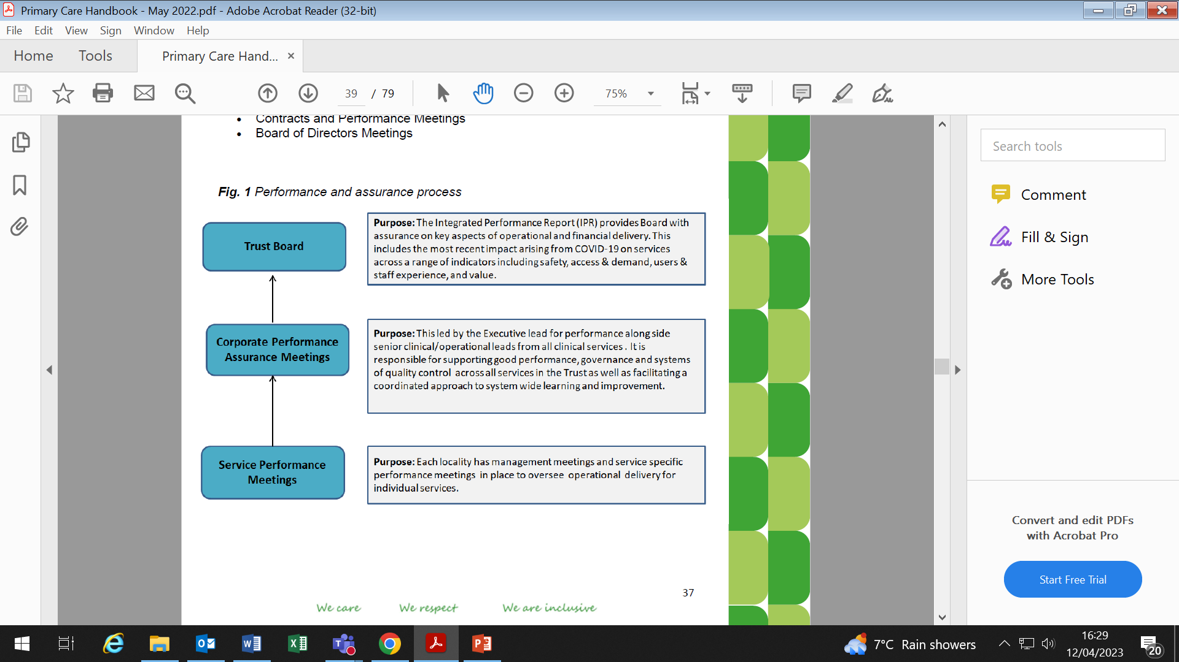

# IT and Digital

**Who can help you?**

|  |  |  |  |
| --- | --- | --- | --- |
| Mukhtar Omar | IT Service Desk Manager | 020 7655 4004 | [mukhtar.omar@nhs.net](mailto:mukhtar.omar@nhs.net) |
| Simon Fewer | Clinical Systems  Programme Manager | 02076554115  07506 673 662 | [Simon.fewer@nhs.net](mailto:Simon.fewer@nhs.net) |
| Report a problem, order new equipment, request IT services, access to systems, track outstanding queries and get help with all your technological issues via **IT Service Desk Portal.** | | The Helpdesk  0207 655 4004 | Portal on the desktop  <https://eastlondon.service-now.com/sp> |
| Smartcards | | 020 7655 4004 |  |
| IT orders | | 020 7655 4004 |  |
| Phone orders | | 020 7655 4004 |  |

SOP for escalating IT issues

|  |  |  |
| --- | --- | --- |
| **Cauldwell Medical Centre** | | |
| All computer issues: ITS Digital | 01234 581 850 | https://nhs.itsdigital.co.uk/ login |
| Smartcard Issues |  | HBLICT@service- now.com |
| Hospital issues re: IT  Tony Reynolds - IT Project Manager | 01234 355  122 |  |

|  |  |  |
| --- | --- | --- |
| **Kingsway Health Centre** | | |
| **HBLICT** |  |  |

|  |  |  |
| --- | --- | --- |
| **Bramingham Park Medical Centre** | | |
| **HBLICT** |  |  |

**EMIS Super User Training Information**

**What it is**

Advanced level training on EMIS modules. This enables the Super user to train the rest of the staff

**Who is doing it?**

Currently EMIS have stopped doing this.

NEL IT Facilitators can train the staff on advanced topics Training provided by **GP IT Facilitator NEL,** Clifton House, Basement, 75-77 Worship Street, London, EC2A 2DU, [**www.nelcsu.nhs.uk**](http://www.nelcsu.nhs.uk/) **This is free.**

If they cannot provide a particular topic, EMIS to be contacted. There may be a charge depending on the module and level of support needed.

**Any costs**

To be obtained from EMIS on need basis. NEL GP IT Facilitator is free

**What the programme of training is**

Custom need based on Training Needs Assessment

**What the outcomes will be**

* Staff will be able to use advanced features on EMIS Clinical system.
* For ex: Complex searches, building protocols, smartcards, Resource publisher, reporting & searches, configuration, workflows, system tools for audit trail, 2WW safety netting template/fast track template process, QOF templates (asthma, diabetes etc.)
* C&B - Referral and guidance reply and process.

**How we are then rolling out training across wider groups of staff re the train the trainer element.**

* All Practices should send one person on the free NEL training and share within their teams
* Peer support is one approach.
* If there is more support/training needed, access EMIS Support centre

**About EMIS Support Centre**

* Available to users via EMIS login
* There is lot of documentation on Product Knowledge
* Technical Support is available
* EMIS Communities is another domain where we can post a question. Community members and EMIS team would provide the response

# Communications and Engagement

The Trust's Communications Team handles all internal and external communications, including supporting Trust wide and Directorate specific communications.

**Media Enquiries**

All media enquiries should be directed to the press office on 020 7655 4066, 4038 or 4049.

**Filming and Photography on Trust Sites**

Filming or photography is prohibited on Trust sites. Please contact the Communications Team to discuss requests.

**Who can help you?**

|  |  |  |  |
| --- | --- | --- | --- |
| **Name** | **Role** | **Telephone** | **Email** |
| Steve Gladwin | Director of Communication & Engagement | 07584189390 | [Steve.gladwin1@nhs.net](mailto:Steve.gladwin1@nhs.net) |
| Glenn Mitchell | Deputy Head of Communications (Bedford & Luton) | 07940 467055 | [Glenn.mitchell2@nhs.net](mailto:Glenn.mitchell2@nhs.net) |
| Sara Marsili | Senior Primary Care Communications Manager | 07426 310086 | [sara.marsili@nhs.net](mailto:sara.marsili@nhs.net) |

**Primary care directorate monthly bulletin**

A directorate-led internal email bulletin issued monthly to all primary care colleagues. The bulletin provides news and updates comprising:

* Insights from the Trust’s Executive Lead for Primary Care on the strategic priorities for the directorate over the coming month
* Details of events and opportunities across the directorate for professional development and wellbeing
* Updated copies of the directorate handbook - a live document full of practical information relevant for all primary care colleagues.
* Directorate team and employee of the month details to promote recognition among peers and promote best practice

**Trust-wide weekly news bulletin**

A weekly email news bulletin issued to all ELFT colleagues, including primary care teams. The bulletin provides two-sentence summaries of all news and updates added to the Trust intranet over the preceding week and each item includes links for colleagues to access more detail.

The bulletin includes news highlights and achievements across all directorates, including primary care, along with strategic organisation-wide messaging. Strategic news and updates are also shared through one-off email messages when required and are supported by a regular blog issued by the Chief Executive.

**Executive Walkrounds**

A programme of executive visits is coordinated across the directorate and wider Trust.

The visits provide an opportunity for ELFT executive members to:

* discuss service achievements and challenges
* engage directly with teams
* share executive insights
* answer questions from services

**Director visits**

Each month, the Director of Primary Care, Medical Director for Primary Care, Director of Nursing or Head of Nursing will visit services. This is an opportunity to see the work of the teams on the ground, provide advice, guidance and support.

# Primary Care Skills Academy @ ELFT Purpose

* The Primary Care Directorate has developed its non-clinical key skills framework
* This is a framework to support the systematic training, learning and development of all staff across the Primary Care Directorate, which in turn will lead to improved outcomes for patients as a result of high quality training
* It also provides a platform for career development and succession planning across the directorate
* We believe it will inspire enthusiasm for learning and development across the directorate

We have appointed a Head of the Primary Care Skills Academy, NTP Practice Manager Louise Wilson who will:

* Lead the implementation of the skills academy across all our services (directorate wide)
* Form links with the trust’s Learning and Development (L&D) team, and other teams within trust departments, such as communications
* Oversee the work of the L&D officer in the Primary Care Directorate
* Provide inspiration, a “can do” attitude and build relationships

**What the role will involve / the academy will do:**

* + Develop course content and training manuals/materials
  + Commission training from external providers
  + Work with the trust LD teams and to refine trust training content, so it meets the needs staff working in Primary Care
  + Develop the directorate’s skills academy video content, and upload to our web space, which will create a repository of high-quality training materials, which can be accessed anywhere and at anytime
  + Develop primary care admin bank staff – so staff joining via the bank also receive the same high-quality training
  + Work with Hackney.gov to set up and pilot an apprenticeship scheme for those under 25 and homeless, with a combined offer of work in the primary care directorate, this will support reducing homelessness in our communities by action on inequalities and housing via hackney.gov
  + Support the directorate’s People Business Partner to develop our 5-year directorate People and Talent management plan.

**Outcomes:**

* + Issue the primary care skills academy offers for 22/23 to all “back-office” staff
  + Provide a full repository of content on the primary care extranet web space.
  + Develop a way of linking the KSF to the trusts statutory and mandatory compliance logs, so the skills are seen as part of everyday compliance in primary care and available for the CQC and others
  + Develop CPD linked to the above
  + Provide a structured way of evaluating content and learning outcomes so we can assess the value that the primary care skills academy generates.
  + Develop marketing/branding materials, including logo, for the primary care skills academy @ ELFT, so that this can be made as a future offer to wider systems should the skills offer be seen to add value through our own local testing and development.

**New practice leaflets and promotional materials for the on-boarding practice:**

Practice Leaflets are designed to provide practical information and signposting for patients and encourage active participation in shaping their primary care healthcare services. Information includes how to book appointments, how to register with a doctor and access test results, how to make a complaint or leave formal feedback and details of the Patient Participation Group and how to get involved.

# Freedom to Speak Up Guardian

Speaking up about any concern you have at work is important. In fact, it is vital because it will help us to keep improving our services for all patients as well as the working environment for our staff.

Concerns could include, but are not restricted to:

* unsafe patient care
* unsafe working environment
* inadequate induction or training for staff
* lack of or poor response to a reported patient safety issue
* a bullying culture across a team or organisation

If you are not comfortable speaking with your Line Manager about your concern, please contact one of the FTSU Ambassadors or the FTSU Guardian.

**Freedom to Speak Up Guardian**

Anita Hynes [elft.freedomtospeakup@nhs.net](mailto:elft.freedomtospeakup@nhs.net) 07436 027388

**Freedom to Speak Up Champions:**

Hortence Tchonang, Modern Matron for Bow Ward & Morrison Ward, John Howard Centre, Forensics

[Hortence.tchonang@nhs.net](mailto:Hortence.tchonang@nhs.net)

Temitope Adedewe, Modern Matron, The Coborn Centre for Adolescent Mental Health, Specialist Services East London.

[Temitope.adedewe@nhs.net](mailto:Temitope.adedewe@nhs.net)

Michelle Aldrich, Clinical Nurse Lead, Florence Ball House, Bedfordshire Mental Health.

[Michelle.aldrich@nhs.net](mailto:Michelle.aldrich@nhs.net)

Suzanne McCall, Adolescent Counsellor, Charter House, Specialist Services Luton.

[Suzanne.mccall1@nhs.net](mailto:Suzanne.mccall1@nhs.net)

Lena Pamphile, Administrator, Discharge Hub, Tower Hamlets CHS.

[Lena.pamphile@nhs.net](mailto:Lena.pamphile@nhs.net)

Claire Porter, Urgent Response Implementation Lead, Bedfordshire CHS.

[c.porter8@nhs.net](mailto:c.porter8@nhs.net)

Chouna Smith, Clinical Nurse Specialist, Wolfson House, Forensics.

[Chouna.smith@nhs.net](mailto:Chouna.smith@nhs.net)

# Contracts, Business Development and Procurement

The role of the Contracts team and Bids team within the CDD (formerly BDU) is to ensure the sustainable generation of income required to maintain, expand and improve the Trust’s services. This includes submitting contract tenders, developing business cases and negotiating contracts.

Procurement refers to the purchase of all goods and services on behalf of The Trust. Any member of staff responsible for the procurement of goods or services should ensure all actions align with government policy, legislation and The Trust's Standing Financial Instructions (SFI's).

**APMS / Enhanced Services and Primary Care Network Contracts**

* When the service is happy with what is being proposed by the Commissioner, once received from the commissioner, you are to send the documentation to Christian Hudson who will go through this and seek formal signatory before it is sent back to the commissioner on approval
* APMS contract reviews take place 1/4ly on commissioner request and availability of key stakeholders.

**Who can help you?**

|  |  |  |  |
| --- | --- | --- | --- |
| **Name** | **Position** | **Contact Number** | **Email** |
| Stephanie Tanner | Head of Business Development | 07388 714745 | Stephanie.tanner1@nhs. net |
| Michael Barron | Contract & Procurement OfficeeManager | 07984 845564 | [Michael.barron@nhs.net](mailto:Michael.barron@nhs.net) |
| Thomas Morgan | Associate Director – for Contracts & Procurement | 07596 831128 | [Thomas.morgan4@nhs.net](mailto:Thomas.morgan4@nhs.net) |

* You can contact the Operational Procurement Team (SBS) <http://sbs.nhs.uk/contact.html>(select provider "R12" and procurement support "operational")
* You can contact the on-site Procurement Team [elft.procurement@nhs.net](mailto:elft.procurement@nhs.net)
* You can follow the on-site Procurement Team on twitter: @ELFTProcurement
* Online Oracle/SBS Training Content - https://nww.sbs.nhs.uk/training- zone/home

# Finance

The Primary Care Directorate provides financial management support to three General Practices in the London area and two General Practices in the Bedfordshire area.

**Who can help you?**

|  |  |  |  |
| --- | --- | --- | --- |
| Naomi Scott | Management Accountant |  | [naomi.scott13@nhs.net](mailto:naomi.scott13@nhs.net) |
| Suganthy Kandiah | Finance  Business Partner | 07506 590616 | [suganthy.kandiah2@nhs.net](mailto:suganthy.kandiah2@nhs.net) |

**Budgets and responsibilities**

Budget statements for each area of responsibility are sent on the 10th working day of every month to Budget managers. Managers should ensure that they review their statement(s) each month and query any errors or omissions with your Finance Business Partner or Management Accountant. If you are a budget manager and are not set up to receive budget statements, please contact your Finance Business Partner or Management Accountant.

**Finance month end schedule**

Finance month end reporting period occurs from the 1st working day of each month to the 10th working day. As this is a busy period for the Finance department staff are encouraged to book meetings after this time.

**Finance Meetings**

Service/budget managers are encouraged to have monthly meetings with the Finance Business Partner or Management Accountant to review their statements. This ensures discrepancies are captured immediately and dealt with before the next reporting period.

**Authorisers / Oracle**

Budget managers should ensure they are set up in Oracle to enable them to access their budget statements, approve invoices, submit request to recruit forms and complete staff change forms amongst other things. The link for this can be found on the Trust Intranet. Form to be added to the Authorised Signatory database.

**Working group**

A Finance working group is set up each month to go through the budgets. These meetings will focus heavily around the income assumptions for each Practice and ensuring robust systems are in place to capture all income and expenditure.

**Standing Financial Instructions**

SFI’s are in place for the regulation of the conduct of its members and officers in relation to all financial matters with which they are concerned. They are designed to ensure that the Trust's financial transactions are carried out in accordance with the law and with NHSI guidance in order to achieve probity, accuracy, economy, efficiency and effectiveness.

**Responsibilities of a Budget holder / Manager**

* They remain within their budget allocation.
* Any likely overspend or reduction in income, which cannot be funded, is not incurred without the prior consent from the Service Director.
* The amount provided in the approved budget is used solely for the delivering of that service.
* No permanent employees are appointed without the approval of the Chief Executive, other than those provided for within the available resources and work force establishment as approved by the Board.
* They ensure completion of leaver forms, change forms and sickness forms for staff in a timely manner.

**Service Expenses - what can and cannot expense**

Service expenses must be ‘wholly, necessarily and exclusively’ incurred by staff whilst fulfilling the duties of their employment within the Trust.

**Petty Cash**

Under normal circumstances petty cash payments should only arise in the exceptional circumstances for low cost goods or services e.g. for minor urgent payments where purchasing via a Requisition / Purchase Order would compromise service delivery. Petty Cash should not be used as a substitute for normal ordering routes. Cannot expense:

* Alcohol and Tobacco
* Expenditure on staff parties and staff presents
* Staff flowers (the PA to the Chief Executive will arrange any flowers needed for presentations, funerals, births etc. on behalf of the Trust)
* Staff meals/accommodation whilst on courses – to be claimed when booking study leave
* Staff travel/parking/petrol: staff travel claim
* Petrol for lease cars: staff travel claim
* Reimbursement of company invoices

Guidance for petty cash is detailed in the Petty Cash Policy document on the intranet.

**Trust Credit Card - Approval process**

Approval must be sort from the Service Director/Assistant Director before credit cards are used.

Credit cards may only be used to purchase items that cannot be purchased through the normal procurement route, or where doing so would have a detrimental impact on service delivery.

Under no circumstances are credit cards to be:

* Used to withdraw cash
* Used to pay supplier invoices – paid via Oracle.
* Linked to a PayPal account
* Used to pay for travel or accommodation – use Travel Agent
* Used to purchase streaming services such as Amazon Prime (unless the service can demonstrate that it provides a financial benefit to the service) or Netflix.
* Used to purchase items listed as prohibited in the petty cash policy such as tobacco, alcohol, parking costs, petrol
* Used to pay for parking fines or other penalties incurred by employees whilst driving Trust pool cars.

Guidance for Credit card is detailed in the Purchase Card Policy document on the intranet.

# People and Culture

Our people are more important than ever. This is symbolic of our name change from HR (Human Resources) to People & Culture. Our aim is to continually develop a culture within ELFT where all people flourish and deliver high quality, continually improving, compassionate, inclusive and safe care.

We work alongside you and your teams helping to attract and retain our people that are essential to delivery of our services, improving leadership, team working, culture and change. This might be supporting you with a planned change project, a team away day, a leadership diagnostic or an investigation.

**We support with the following:**

* Recruitment
* Bank
* People Relations and advice
* People Development – Including learning and training,
* Apprenticeship Support
* Employment Policies
* Mediation
* Culture change
* Liaise with Occupational Health Services – Team Prevent
* Staff Engagement
* Staff Survey
* Staff Wellbeing
* Organisational Change
* Workforce Information
* Equality and Diversity
* Promote and embed the Trust Values into everything we do.

**Who can help you?**

|  |  |  |  |
| --- | --- | --- | --- |
| Jacqueline Awidi | Assistant People & Culture  Advisor | 07920244883 | [jacqueline.awidi@nhs.net](mailto:jacqueline.awidi@nhs.net) |
| Gemma Kendall | Associate People Business Partner | 07393 243312 | [gemmakendall@nhs.net](mailto:gemmakendall@nhs.net) |

|  |  |  |
| --- | --- | --- |
| **People and Culture** | | |
| Director of People and Culture | Tanya Carter  Email: [tanya.carter@nhs.net](mailto:tanya.carter@nhs.net) Tel:  07748553914 |
| Associate Director People and Culture | Barbara Britner  Email:  [Barbara.britner@nhs.net](mailto:Barbara.britner@nhs.net) |
| Associate Director of People  Development | Steve Palmer  Email:  [steve.palmer1@nhs.net](mailto:steve.palmer1@nhs.net)  Tel:    07387 258690 |
| Associate Director People and Culture | Dr Donna Willis  Email:  [donna.willis1@nhs.net](mailto:donna.willis1@nhs.net)  Tel:      07919 394687 |
| Head of Resourcing | Sonia Kaur  Email: [Sonia.kaur2@nhs.net](mailto:Sonia.kaur2@nhs.net)  Tel: |
| Head of People and Culture | Isabella Larkin  Email:  [Isabellalarkin@nhs.net](mailto:Isabellalarkin@nhs.net)  Tel:   07816972302 |
| Medical Staffing Business Partner | Neetu Klair  Email:  [neetu.klair@nhs.net](mailto:neetu.klair@nhs.net) |
| People Relations Manager | Wendy Johnson  Email: wendy.johnson22[@nhs.net](mailto:Corinne.cunningham@nhs.net)  Tel:  07341 789668 |
| People Development Business Partner | Princess Kabba  Email:  [princess.kabba@nhs.net](mailto:princess.kabba@nhs.net)  Tel:   07876847122 |
| Engagement and Wellbeing Business Partner | Jillian Dabbs  Email:  [jillian.dabbs@nhs.net](mailto:jillian.dabbs@nhs.net)  Tel:   07867179796 |
| People and Culture Manager | Olga Osokina  Email:  [olga.osokina@nhs.net](mailto:olga.osokina@nhs.net)  Tel:   07956720751 |
| People Information Manager | Joseph Duncan  Email:  [joseph.duncan@nhs.net](mailto:joseph.duncan@nhs.net) |

**Booking annual leave**

Annual leave requests must be made to your line manager with reasonable notice. Please ensure that any leave requested is authorised by your manager prior to commencing or booking holidays and before annual leave is taken; do not assume that leave requests will be automatically approved. The Trust is not responsible for any costs incurred by employees whose annual leave plans are not authorised. Requests for annual leave will be considered and approved only if they can be accommodated considering the need to run a safe service. Annual leave should be taken evenly throughout the year. A record must be kept of annual leave. For more information, please refer to the Trust Annual and Special Leave Policy or to your line manager.



**Managing absence**

Staff are expected to make every effort to attend work and fulfil the conditions of their contract of employment and your manager will support you to manage your attendance in accordance with the Trust Managing Sickness Absence Policy. If you are unable to attend work due to sickness, please inform your line manager as soon as possible before the start of your shift if you can, so arrangements can be made to cover your shift/work. Please keep your manager updated regarding any continued absence and fulfil your obligations as set out within the policy. If you are unable to attend work for other reasons, for example family emergency or bereavement please make contact with your manager to inform them.

**Payroll**

Staff experiencing any issues with pay should contact payroll on:

* Email address: [ELFTPayroll@uhb.nhs.uk](mailto:ELFTPayroll@uhb.nhs.uk)
* Telephone Number: 0121 371 7545
* Alternatively, contact head office on 0207 655 4000 and ask for ESR

**How to Claim for Additional Hours Worked**

Complete the top section of the Monthly Salary Return with your name, assignment number, Grade/Band, Month Ending Period. Indicate if you are a full time or part time worker and your contracted hours if part time. Complete the entries for Additional hours/Enhanced hours or Overtime hours worked. In the Remarks field please state if the hours claimed are in relation to COVID. Sign and Date the form

The form should be authorised by your line manager prior to submission to the Payroll Department to reach them by the 5th of the following month.

**Rates of payment**

Additional Hours are paid at the current basic pay hourly rate. Enhancements are paid at the rate of 1.33 for work done on a Saturday/Sunday/Bank Holiday.

Enhancements are paid at the rate of 1.25 for work done during Unsocial or Night hours (Unsocial is from 6.30pm to 8.30pm, thereafter it is Night).

Overtime hours are paid at the rate of 1.25 x the current basic hourly rate when worked on a Weekday

Overtime hours are paid at the rate of 1.33 x the current basic hourly rate when worked on a Saturday/Sunday/Bank Holiday.

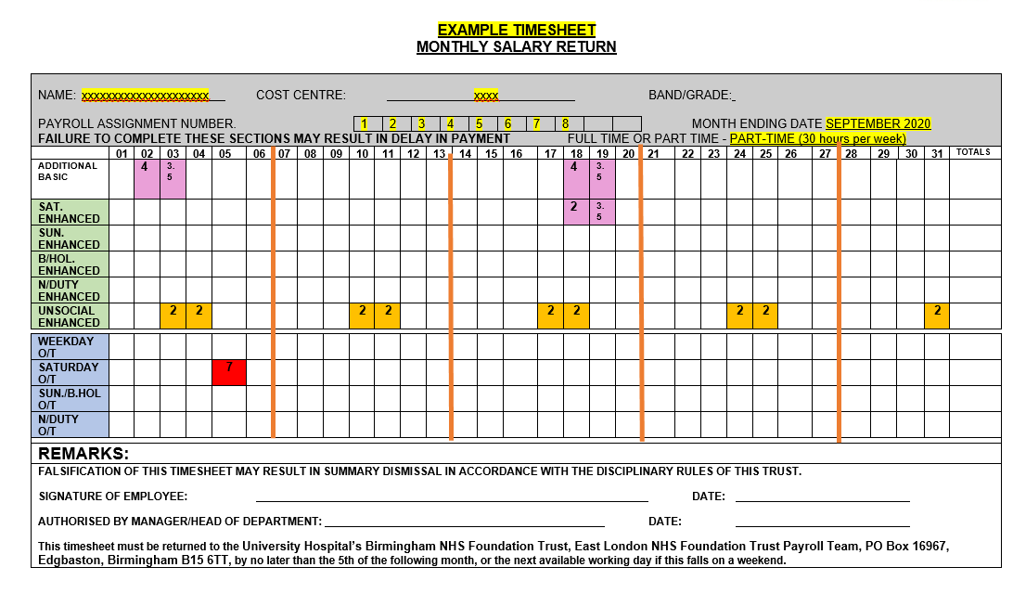

**Staff contracted to work F/T (37.5 hours per week)**

F/T staff who work extra hours (with prior agreement by the line manager) should claim in the appropriate

**Overtime** rows (shaded blue).

* Enter additional hours in the column for the relevant day of the month and against the appropriate overtime row, i.e. weekday/Saturday or Sunday.

**Example**: an additional 7 hours on Saturday 5th September are worked, = 7 hours should be entered in the column headed ‘5’ (5th Sep) and in the row for Saturday overtime. The example entry is shown highlighted in **Red**.

* F/T staff who within their regular 37.5 hours per week are required to work hours that attract the enhanced rate of pay then these hours should be claimed in the Enhanced rows (shaded green).

**Example**: normal working week is 37.5 hours, Monday to Friday. Weekly shift pattern is Monday to Wednesday

9.30am to 5.30pm and Thursday to Friday 12.30pm to 8.30pm. Hours worked between 6.30 and 8.30 are Unsocial and should be entered in the column for the date relating to Thursday and Friday and in the Unsocial Enhanced row. The example entries are highlighted in **Orange**.

**(Please note that claims for Enhancements are only allowed when actually worked; they are not claimable during any periods of absence such as sickness or annual leave.**

**Staff contracted to work P/T (less than 37.5 hours per week)**

P/T who work extra hours (with prior agreement by the line manager) should claim in the **Additional Basic,** first row on the timesheet up to full time weekly hours (37.5). Additional Basic hours are claimed for hours worked over the contracted hours, up to full time hours. Hours exceeding F/T can be claimed as Overtime.

**Example**: contracted weekly hours are 30 per week, meaning the first additional 7.5 hours worked each week are claimed as Additional Basic. 4 hours are worked on the 2nd Sep and 3.5 hours on the 3rd Sept, entries = 4 hours entered in column headed ‘2’ (2nd Sep) and in the row for Additional Basic and 3.5 hours entered in column headed ‘3’ (3rd Sep) and in the row for Additional Basic. The example entries are the first two **Pink** highlighted entries. Where some or all of the Additional Basic hours claimed attract an enhanced rate of pay, then these hours should, in addition to the Additional Basic hours row, also be entered in the appropriate Enhanced rows (shaded green).

**Examples:** if the additional hours are worked as 4 hours on Friday 18th Sep from 4.30pm to 8.30pm and 3.5 hours on Saturday 19th Sep entries = 4 hours should be entered in the column headed ‘18’ (18th Sep) row Additional Basic and in the same column 2 hours should be entered in the row for Unsocial Enhanced (hours worked between 6.30 and 8.30pm). 3.5 hours should be entered in the column headed ‘19’ (19th Sep) row Additional Basic and in the same column 3.5 hours should be entered in the row for Saturday Enhanced (total hours worked on Saturday). The example entries are the second two **Pink** highlighted entries.

**Appraisal**

Appraisals are undertaken annually and there are completed via the ELFT Learning Academy:

<https://learningacademy.elft.nhs.uk/totara/dashboard/index.php?id=6>

Dates for appraisals are published and communicated to all staff every year.

**ELFT** Employment Policies include:

* + - Annual and Special Leave Policy
    - Appraisal
    - Managing Sickness Absence
    - Staff Performance Improvement and Capability Policy
    - Grievance Policy and Procedure
    - Disciplinary Policy and Procedures
    - Supervision Policy
    - Equality Diversity and Human Rights Policy
    - Management of Staff Affected by Change Policy and Procedure
    - Maternity, Adoption and Shared Parental Leave Policy
    - Disclosure and Barring Service (DBS) Policy
    - Dignity at Work Policy and Procedure
    - Raising Concerns (Whistleblowing Policy)
    - The Secondment and Acting Up Policy
    - Additional Leave & Reward for Exceptional & Near Exceptional Work Attendance
    - Lease Car Policy
    - Dress Code Policy
    - Recruitment and Selection Policy
    - Alcohol & Substance Misuse Policy
    - Maintaining High Professional Standards in the Modern NHS (MHPS)
    - Managing Psychological Wellbeing at Work Policy
    - Learning and Development Policy
    - Statutory and Mandatory Policy 1.0
    - Apprenticeship Policy
    - Providing Employment Reference Policy
    - Checking Professional Registration and Revalidation Policy
    - Medical Appraisal and Revalidation Policy
    - Remediation & Rehabilitation of Doctor's Performance Policy

# Organisational Development

The **Organisational Development (OD) Team** are part of the People and Culture Directorate. We work with all teams and service across the Trust.

#### Our main areas of work are:

Personal development, Career Development, Coaching, Mentoring, Leadership Development, Talent Management, Health & Wellbeing, Service Improvement, Change and transformation, Team Development, Bespoke Interventions and Staff Engagement.

#### Please get in touch if we can help. Our current OD Business Partner is:

[mairead.heslin1@nhs.net](mailto:mairead.heslin1@nhs.net)

#### Wellbeing

We are also part of the People and Culture Directorate Wellbeing and are committed to improving the working lives of all our staff. The Trust has a number of policies and many sources of support to help staff achieve a balance between home and work. For more information, please see our intranet and Trust communications.

Tailored support available for staff includes:

* A safe space to chat or speak about your struggles and wellbeing needs with a trained wellbeing professional
* Exploring your wellbeing needs and providing access to services accordingly
* Support with the identification of common or serious mental health difficulties, to assess signpost and fast-track referrals into existing services
* Wellbeing workshops
* Personalised online therapy
* Online guided self-help resources
* Group therapy including cognitive behavioural therapy (CBT)
* A range of low and high intensity therapies according to your needs

**Staff Wellbeing Champions**

Kadijah Al Maajid Wellbeing Champion London [khadija.al-maajid@nhs.net](mailto:khadija.al-maajid@nhs.net)

For staff who are working within London please see:

https://keepingwellnel.nhs.uk/?dm_i=1TXQ%2C7G1TK%2C4JMD6U%2CU98DR%2 C1

For staff who are working within Bedfordshire and Luton please see:

https://[www.keepingwellblmk.nhs.uk/?dm_i=1TXQ,7G1TK,4JMD6U,U98DW,1](http://www.keepingwellblmk.nhs.uk/?dm_i=1TXQ%2C7G1TK%2C4JMD6U%2CU98DW%2C1)

In addition, please get in touch if we can help [elft.employee.engage@nhs.net](mailto:elft.employee.engage@nhs.net)



# Accessibility

Practices have been provided with an accessibility Toolkit Staff folder for your team – please save where appropriate on your shared drive and alert team that it is a resource that is there to support them around accessibility e.g. do’s and don’ts / posters for display for example:

* Info around what the PPG is and how to join
* Posters to display by all practices via an information board are:
  + Accessible Info Poster
  + People Participation Structure – to be on display where the PPG info is on display.
  + You should have a People Participation Notice Board – that houses all the PPG information
  + People Participation Poster Easy Read – this needs to be on display where the PPG info is
  + Accessing GP Services during Covid-19 poster
  + Interpreting/Translation Services available poster
  + Point to your language (this is to be printed and kept at Reception)

#### Who can help you?

|  |  |  |  |
| --- | --- | --- | --- |
| **Name** | **Role** | **Telephone** | **Email** |
| Sarah Needham | People Participation  Lead | 07776482337 | [sarah.needham15@nhs.net](mailto:sarah.needham15@nhs.net) |

**Other point or sources of information which may be useful:**

Website additions to consider:

An additional page or added to the Accessibility section already there:

* Links, audio track on NHS Accessible Information Standard: https://soundcloud.com/nhsengland/sets/accessible-information-standard- overview
* BSL friendly video on the NHS Accessible Information Standard:

https://youtu.be/WWrZlEu_KhQ

* Documents - Add these documents if you have ability to upload documents
* Summary of Accessible Information easy read
* Summary of Accessible Information standard
* Something added at the end of the PPG Registration form that gives patient the opportunity to disclose any accessibility needs before submitting
* Social Media - NHS England have launched an information pack for general practice on communications and we would like practices to develop the suggested info graphics for use in advertising that you are still open during the pandemic.
* **How information displays should look within your waiting area:**



**Accessibility Checklist for use by practices**

|  |  |  |  |
| --- | --- | --- | --- |
| **Statement** | **Yes** | **No** | **Unsure** |
| **Disabled access** |  |  |  |
| We have enough disabled parking |  |  |  |
| We have at least a 3 metre slope from entrance |  |  |  |
| There is a handrail either side of the slope |  |  |  |
| Our front door is at least 36 inches wide |  |  |  |
| There is a low threshold floor bar at the entrance |  |  |  |
| The signage for disabled toilet access is at eye level |  |  |  |
| The disabled toilet has a door at least 36 inches wide |  |  |  |
| There is a caution sign for very hot water in the disabled toilet |  |  |  |
| We have a Falls Procedure |  |  |  |
| The disabled toilet hygiene products are at a suitable height |  |  |  |
| The disabled toilet has at least a 1 metre turning circle |  |  |  |
| We have an alarm system in the disabled toilet |  |  |  |
| Our Fire Exits are accessible by wheelchair |  |  |  |
| We have seats appropriate for those with limited mobility |  |  |  |
| **Communication** |  |  |  |
| We can arrange for an interpreter when necessary for those where language is a barrier |  |  |  |
| We have a hearing loop |  |  |  |
| We can arrange for a BSL interpreter for those with hearing impairment |  |  |  |
| The counter at Reception is at a height accessible for wheelchair users to communicate easily with staff |  |  |  |
| We have a website that is user friendly for those with accessibility needs |  |  |  |
| We have a “Point to your language” table for non-English Speaking patients available at Reception |  |  |  |
| Patients can contact the surgery via; |  |  |  |
| * Email |  |  |  |
| * Text |  |  |  |
| * Phone |  |  |  |
| * Website |  |  |  |
| **Information** |  |  |  |
| We are displaying info in our Waiting area on The Accessibility Information Standard |  |  |  |
| We are displaying information in our Waiting area explaining that interpreting services are available |  |  |  |
| We let patients know that information is available in different formats e.g. Braille / Easy Read |  |  |  |
| We have information on our website explaining the Accessibility information standard |  |  |  |
| We have a toolkit for supporting staff to meet the needs of patients with accessibility issues |  |  |  |
| We have a member of staff who is our Accessibility Champion (People Participation Lead) |  |  |  |
| We are displaying information that encourages patients to let Reception know if they have accessibility needs that we are unaware of |  |  |  |
| We ask patients if they have accessibility needs upon registration |  |  |  |
| We record accessibility needs of all patients |  |  |  |

# Translation Services

**Bedfordshire practices under BLMK ICB for interpretation and translation services**

There are two translation services, one for spoken and one for non-spoken:

DA Languages for spoken languages - [Award Winning Translation Agency | DA Languages](https://gbr01.safelinks.protection.outlook.com/?url=https%3A%2F%2Fwww.dalanguages.co.uk%2F&data=05%7C01%7Cj.alder-pavey%40nhs.net%7C55fd7f259d3946ea24b008db78813592%7C37c354b285b047f5b22207b48d774ee3%7C0%7C0%7C638236268558138546%7CUnknown%7CTWFpbGZsb3d8eyJWIjoiMC4wLjAwMDAiLCJQIjoiV2luMzIiLCJBTiI6Ik1haWwiLCJXVCI6Mn0%3D%7C3000%7C%7C%7C&sdata=ackhT%2F4oR4Yn%2FvfOeb8j7UN5VOO6xkOAG1KCuxYrosc%3D&reserved=0)

Language Empire for non-spoken languages – [https://www.language-empire.net/](https://gbr01.safelinks.protection.outlook.com/?url=https%3A%2F%2Fwww.language-empire.net%2F&data=05%7C01%7Cj.alder-pavey%40nhs.net%7C55fd7f259d3946ea24b008db78813592%7C37c354b285b047f5b22207b48d774ee3%7C0%7C0%7C638236268558138546%7CUnknown%7CTWFpbGZsb3d8eyJWIjoiMC4wLjAwMDAiLCJQIjoiV2luMzIiLCJBTiI6Ik1haWwiLCJXVCI6Mn0%3D%7C3000%7C%7C%7C&sdata=RmArxXRapRBv9CCYoSH5ELRPZSinmhGs2uOXGX6YY3s%3D&reserved=0)

Video link: [https://vimeo.com/693451065/fc0f4524d5](https://gbr01.safelinks.protection.outlook.com/?url=https%3A%2F%2Fvimeo.com%2F693451065%2Ffc0f4524d5&data=05%7C01%7Cj.alder-pavey%40nhs.net%7C55fd7f259d3946ea24b008db78813592%7C37c354b285b047f5b22207b48d774ee3%7C0%7C0%7C638236268558138546%7CUnknown%7CTWFpbGZsb3d8eyJWIjoiMC4wLjAwMDAiLCJQIjoiV2luMzIiLCJBTiI6Ik1haWwiLCJXVCI6Mn0%3D%7C3000%7C%7C%7C&sdata=%2B52DCyb6NyU7vWulFMqYx4NoN%2Bdo8oG1HKljo%2FG0Efg%3D&reserved=0)

**Process for London Practices**

**Language Line Interpreting Services**

This service provides face-to-face interpreting, telephone interpreting, video interpreting and an online booking management system.

**Language Line’s Telephone Interpreting Service**

This is an established and proven 24/7/365 on-demand and flexible service. It is easy to access via any telephonic equipment and can facilitate communication in over 200 languages. With this service, you may:

* Hold a conversation with a limited English patient when they are with you
* Connect to an interpreter and call the patient (3rd party dial out)
* Take a call from the patient and connect to an interpreter (if your phone has a conference facility)
* Facilitate interpreting support for any Attend Anywhere appointments, by muting the audio through the laptop and using LanguageLine’s third party dial-out facility.

**Language Line Face to Face Interpreting Service**

This provision provides you with an interpreter for those appointments that require a physical presence (please refer to the trust guidelines). You will need to pre-book these sessions using the online booking portal. Please remember to cancel the interpreter if the clinical consultation itself is cancelled. There is a one-hour minimum charge for the face-to-face service irrespective of the actual interpreting usage.

**Language Line Video Interpreting Service (InSight).**

This is a secure, end-to-end encrypted, on-demand platform that facilitates video face-to-face communication in 40 of the most common languages within London including BSL. This award-winning service is designed for when the patient is with you. It also provides the option to access the telephone service - all through one-touch app-based access. The service needs a stable Wi-Fi or good roaming connection but can be accessed through smartphones, tablets, laptops, and desktops (with a camera facility).

**Website** https://[www.languageline.com/uk](http://www.languageline.com/uk)

<https://languageshop.org/>

# Equipment

Medical equipment is any device that is used in the rendering of patient care. Medical equipment is inventoried, tracked and maintained by Key Health Solutions clinical engineers. The accountability for ensuring this process happens is you the end user.

**Calibration**

All practices have access to a calibration. ELFT has the below company for Service and maintenance of medical equipment

https://[www.avensysmedical.co.uk/](http://www.avensysmedical.co.uk/)

Phone: 01562 745 858

**Medical devices**

Any issues related to medical devices contact ELFT team at [elft.medicaldevices@nhs.net](mailto:elft.medicaldevices@nhs.net)

**PAT testing**

A 2 yearly cycle facilitated by the estates team**.**

# Estates

Estates & Facilities look after Trust buildings.

The Helpdesk prioritises jobs according to urgency. Jobs logged for non-urgent maintenance will be passed to the contractors and attended to as part of the monthly community maintenance days. Ensure a record of logged jobs is kept locally to avoid duplication.

**Who can help you?**

|  |  |  |  |  |  |  |
| --- | --- | --- | --- | --- | --- | --- |
| **Leighton Road Surgery** | | | | | | |
| Rydons – Grovebury Road | | | 0845 269 5914 | | [erithhelpdesk@rydon.co.uk](mailto:erithhelpdesk@rydon.co.uk) | |
| **Cauldwell Medical Centre** | | | | | | |
| Other issues: (maintenance / cleaners etc.)  Emergency - | | | 01234 792 016  01234 355 122 | | https://bedfordhospital.mi cadhd.net/ | |
| Capital Project Officer - Mark Duffin Bedford Hospital | | | 01234 792  058 x2800 | |  | |
| Apcoa Parking UK (car park) Raj Singh | | | 01234 792 168 | | [raj.singh@apcoa.com](mailto:raj.singh@apcoa.com) | |
| **Bramingham Park Medical** **Centre** | | | | | | |
| **NHS PS**  Sarah Jerocritou | | |  | |  | |
| **Kingsway Health Centre** | | | | | | |
| **NHS PS**  Sarah Jerocritou | | |  | |  | |
| **Health E1** | | |  | |  | |
| Barts Health Helpdesk | | | 02082238697 | | Estates_helpdesk@barts health.nhs.uk | |
| **Newham Transitional Practice** | | | | | | |
| CHP (Community Health Partnership)  For big works, contact ELFT Estates Dep. | | | 0161 509 3350  01895 671 478 | | c.services@communityhe althpartnerships.co.uk | |
| **Greenhouse Practice** | | | | | | |
| **NHS PS**  For big works, contact ELFT Estates Dep. | | | 0800 085 3015  01895 671 478 | | https://[www.property.nhs.](http://www.property.nhs/) uk/contact-us/ | |
| **Main ELFT Estates & Facilities department** | | | | | | |
| ELFT Estates Helpdesk - OPTIMUM | | | 01895 671 478 | | [servicedesk@ogs.eu.com](mailto:servicedesk@ogs.eu.com) | |
| David Stevens | | Director of Estates &  Capital Development | 0207 655 4043 | |  | |
| Frank Riedel | | Associate Director of Capital Development & Property Management | 02081215629  07973 227902 | | [Frank.riedel@nhs.net](mailto:Frank.riedel@nhs.net) | |
| Adam | | Energy & Environmental | 02081215634 | | [Adam.toll@nhs.net](mailto:Adam.toll@nhs.net) | |
| Toll | | Manager | /07815956091 | |

**Estates policies and procedures of interest:**



# Flu Vaccination Ordering

The Practice Manager and Lead Clinician will review the usage of vaccines in the current season and estimate how much will be ordered for the year ahead. Orders should be placed by the end of January (end of the current flu season) for the next flu season. Flu clinics are booked after the first vaccines have been delivered.

**Health E1**, **The Greenhouse Practice** and **Newham Transitional Practice** adult flu vaccines are ordered from, and delivered by, ELFT Pharmacy. Newham Transitional Practice order children’s flu vaccines from ImmForm.

**Cauldwell Medical Centre** and **Leighton Road Surgery** order their adult vaccines from Seqirus. Children’s flu vaccines are ordered from ImmForm.

Seqirus also have an online platform and contact details as follows:

Login or signup easily at flu360.co.uk

Telephone: 0345 0093 804

Email: flu.salesuk@seqirus.com

# Primary Care Networks

PCNs were introduced in July 2019 based around populations of 30,000-50,000, an ideal size seen to be small enough for personalised care and population health management but large enough for the sharing of at-scale staffing and back-office functions to support resilience. PCNs in response to a funding deal higher than inflation, and the rest of the NHS, have been committed to delivering 7 of the NHS Long term plan aims, by the introduction of 7 nationally directed services over 3 years and support them in delivering this the funding comes in the way of part cash and mostly additional staffing.

We really want to ensure that every practice works as a strong partner within their local PCN. Being active refers into the shared additional staffing roles and supporting the delivery of integration and the 7 national DES specifications.

**Who can help you?**

|  |  |  |  |
| --- | --- | --- | --- |
| **Practice** | **PCN** | **Clinical Director** | **Manager** |
| Bramingham Park Medical Centre | Phoenix Sunrisers |  | Farkhanda Mehmood  [f.mehmood@nhs.net](mailto:f.mehmood@nhs.net) |
| Cauldwell Medical Centre | East Bedford PCN | Dr T J Gill  [tajvir.gill@nhs.net](mailto:tajvir.gill@nhs.net) | Carolyn Boyd  [carolyn.boyd1@nhs.net](mailto:carolyn.boyd1@nhs.net) |
| Greenhouse | Well Street Common, Hackney | Dr Simirit Degun  [s.degun@nhs.net](mailto:s.degun@nhs.net) | Christine Sanders |
| HealthE1 | Network 2 /East End Health  Network Tower Hamlets | Dr Spyros Symmiakou | Ashraf Ullah |
| Kingsway Health Centre | Phoenix Sunrisers |  | Farkhanda Mehmood  [f.mehmood@nhs.net](mailto:f.mehmood@nhs.net) |
| Newham Transitional Practice | Stratford PCN | Dr Subir Sen | Manuel Antony |
| Leighton Road Surgery | Leighton Buzzard PCN (Leighton-Linslade Connections) | Dr John Henderson and Dr Laura Lewis | Manager - Stephanie King Operations Manager |

**Key things PCNs are commissioned to do (this is not exhaustive):**

**Enhanced health and care in care homes** –

(Contractual delivery with Community Services). A PCN must work with community service providers ‘whose contracts will describe their responsibility in this respect’, and other relevant partners, to establish and coordinate a multidisciplinary team (“**MDT**”) to deliver these Enhanced Health in Care Homes service requirements. Includes, leading an MDT, lead accountable named clinician, weekly ward rounds, alignment to a single PCN of care homes and establish protocols between the care home and with system partners for information sharing, shared care plans.

**Structured Medications Scheme** - use appropriate tools to identify and prioritise the PCN’s patients who would benefit from a structured medication review, which must include patients in care homes, with complex and problematic polypharmacy, specifically those on 10 or more medications. On medicines commonly associated with medication errors. With severe frailty, those who are particularly isolated or housebound patients, or who have had recent hospital admissions and/or falls, and using potentially addictive pain management medication.

**Early diagnosis of cancer** – includes review the quality of the PCN’s Core Network Practices’ referrals for suspected cancer against the recommendations of NICE Guideline 1252 and make use of clinical decision support tools. Practice-level data to explore local patterns in presentation and diagnosis of cancer, and where available, the Rapid Diagnostic Centre pathway for people with serious but non-specific symptoms. Build on current practice to ensure a consistent approach to monitoring patients who have been referred urgently with suspected cancer or for further investigations to exclude the possibility of cancer (‘safety netting’), in line with NICE Guideline 12. Ensure that all patients are signposted to, or receive information on, their referral including why they are being referred, the importance of attending appointments and where they can access further support. Contribute to improving local uptake of National Cancer Screening Programmes.

* **Collaboration with the Community Trust***-* A PCN must agree with local community services providers how providers will work together, including agreed communication channels, agreed representatives, and how any joint decisions will be taken. A PCN must detail the arrangements with its local community services provider(s) in Schedule 7 of the Network Agreement
* **Additional Roles Workforce Intentions Submission**– Submit to NHSE which will feed HEE their 4-year additional roles recruitment plan – setting out which and how many of each role they will recruit over the years
* **Collaboration with the Mental Health Trust and Community Pharmacy***.* APCN must detail its arrangements with community mental health providers, and community pharmacy (via the community pharmacy nominated Pharmacy PCN Lead) in Schedule 7 of the Network Agreement.

**Impact and Innovation Fund***–* A population health improvement-based scheme, which encourages PCNs to meet high-level patient outcomes metrics. This scheme started small in 20/21 (worth around £25k per PCN rising to approx. £240k per PCN by 23/24 for full achievement).

To support the delivery of all the above and the future schemes to come – PCNs are resourced with some main funding streams in an additional roles scheme which is worth £12per weighted head of the PCNs registered population by 23/24. PCNs also receive £1.50 per head for administering the PCN (year on year) by way of leadership and a payment depending on PCN size for the clinical director. PCNs also receive this year a fair share of £43.7m in PCN development funding which nationally this year is focused on:

**To recruit, embed and retain new roles** to support the delivery of the workforce manifesto commitments (26,000 additional primary care professionals and 6,000 additional GPs) that reflect workload, activity and increase capacity across PCNs. Staff will be supported to have the skills and capability to operate effectively across networks and as part of integrated teams. Staff induction, clinical supervision and a focus on staff wellbeing and resilience, along with support to model demand and re-design ways of working should help embed the new workforce

**To enhance integration** by building on the work that’s already happened with care homes and community pharmacy in response to Covid-19 and strengthening this through multi-disciplinary team ways of working with community & mental health services, secondary care and other care and wellbeing providers. Working with patients, their carers’ and the wider community will be essential to create a joint model of proactive and personalised care.

**To continue to improve access** by embedding the use of total triage and remote consultation; cutting waiting times and supporting the interface between primary, community and secondary care.

**To reduce health inequalities**, enhancing population health management locally with a focus on prevention recognising the inequality in relation to COVID-19 and those groups who may have been disproportionally disadvantaged.

#### Additional roles (ARRS) and the £ available to PCNs

The ARRS is intended to deliver 26,000 extra staff by 2023/24. Recruitment through the scheme has been strong, and as of 31 December 2022 stands at 25,262 additional FTE. PCNs are on track to meet the 26k target for March 2024 over a year early.

Additional resources to those originally agreed in 2019/20 continue to be available for the ARRS as shown at row (B) of the table below to give total funding of £1,412 million in 2023/24.

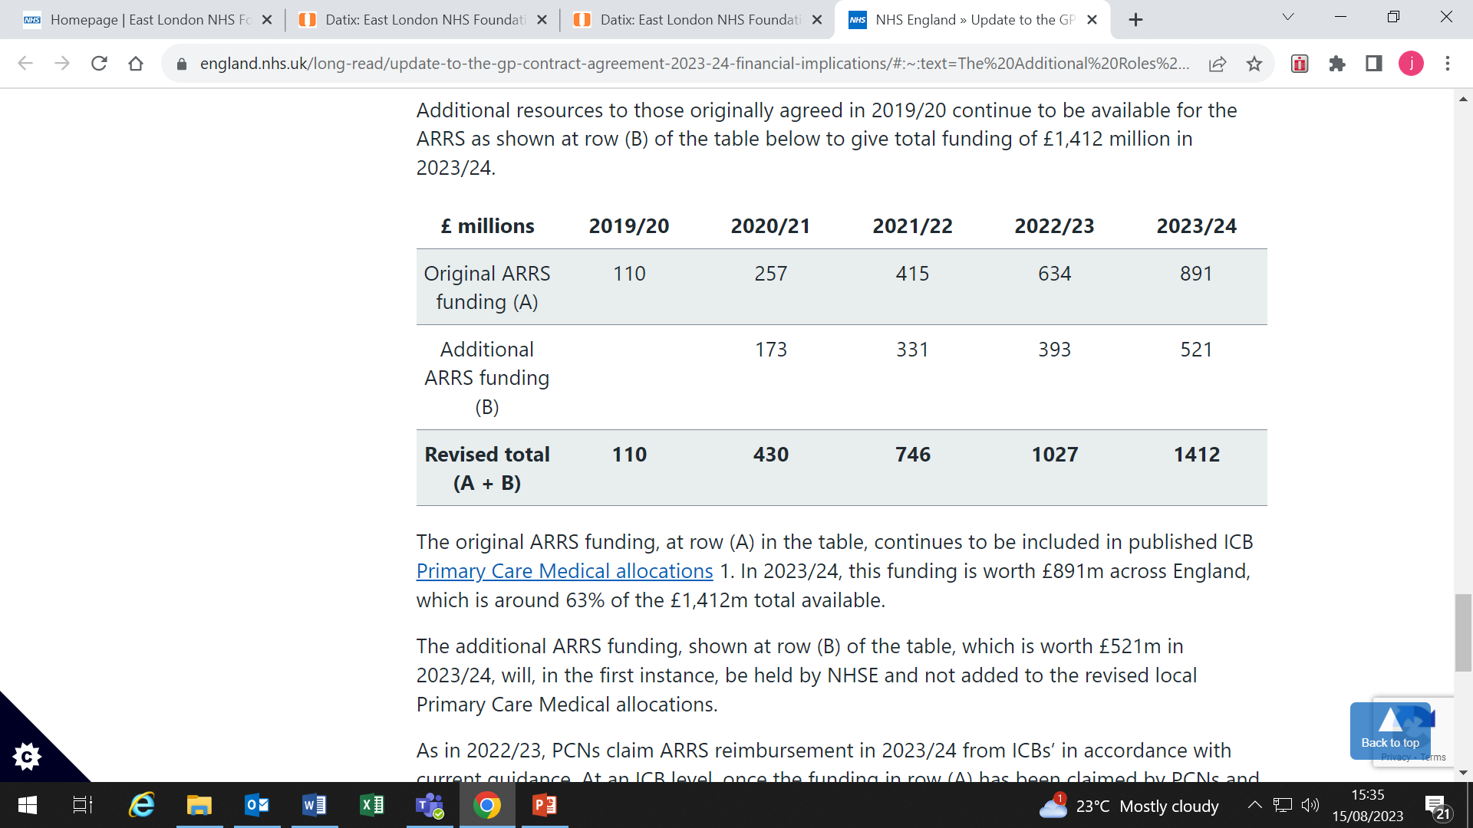

**The 14 Additional roles which can be funded via from 2020/21**

* Nursing Associates (Band 4)
* Trainee Nursing Associate (Band 3)
* Social Prescribing Link Worker (band 4 or 5)
* Care Coordinator role (band 4 or 5)
* Pharmacy Technician role (Band 5)
* Health and Wellbeing Coach role (Band 5)
* Occupational Therapist role (Band 7)
* Dietician role (Band 7)
* Podiatrist role (Band 7)
* Clinical Pharmacist role (band 7 or 8a)
* MSK Physiotherapist (band 8a)
* Physicians Associate (band 8a)

**Additional roles which can be funded from April 2021**

All the above and there will also be the introduction of two new roles (to make 14) to the additional roles scheme and they are:

* Mental Health Therapists (band 7) and
* Community Paramedic Practitioners (approx. band 6 or 7)

# Abbreviations sheet

|  |  |
| --- | --- |
| **Abbreviations** | **Meaning** |
| APMS | Alternative Provider Medical Services |
| ARRS | Additional Roles Reimbursement Scheme |
| BDU | Business Development Unit |
| CAS | Central Alert System |
| CMO | Chief Medical Officer |
| CQC | Care Quality Commissioning |
| DES | Directed Enhanced Service |
| DMT | Directorate Management Team |
| DSE | Display Screen Equipment |
| ELFT | East London Foundation Trust |
| FFT | Friend and Family Test |
| FGM | Female Genital Mutilation |
| FTSU | Freedom To Speak Up |
| GP | General Practitioner |
| H&S | Health and Safety |
| ICB | Integrated Care Board |
| JDs | Job Descriptions |
| KPIs | Key Performance Indicators |
| LES | Local Enhanced Services |
| MDT | Management Directorate Team |
| MHRA | Medicines and Healthcare products Regulatory Agency |
| NHSE | National Health Service England |
| NHSI | National Health Service Improvement |
| NICE | National Institute for Health and Clinical Excellence |
| PALS | Patient Advice Liaison Service |
| PBCGM | Practice Based Clinical Governance Meeting |
| PC | Primary Care |
| PCD | Primary Care Directorate |
| PCN | Primary Care Network |
| PPG | People Participation Group |
| PPL | People Participation Lead |
| PREM | Patient Reported Experience Measures |
| PSA | Patient Safety Alert |
| QA | Quality Assurance |
| QAC | Quality Assurance Commission |
| QAF | Quality Assurance Framework |
| QAG | Quality Assurance Group |
| QCL | Quality & Compliance Lead |
| QI | Quality Improvement |
| SBS | Shared Business Services |
| SFIs | Standing Financial Instructions |
| SIs | Serious Incidents |
| TOR | Terms of Reference |