Healthy Eating for a Healthy Weight
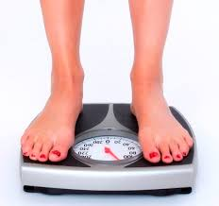 | What are Overweight and Obesity?  Raised body fat above the healthy range indicates overweight. In more severe cases, obesity is having lots of excess fat.  It is helpful to aim for a healthy body mass index (BMI) of less than 25 for the general population, and 23.5 for ethnic minority groups.
 | Being overweight or obese poses risk of respiratory problems, joint pain, diabetes, high blood pressure and low mood.
There are many causes of overweight and obesity, including:
- mental illness and medications
- eating high calorie (high fat or high sugar) foods and drinks
- sitting down for long periods of time
- boredom and lack of routine
- ready availability of high calorie foods
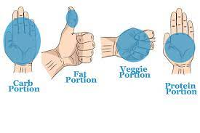 | Top Tips for a Healthy Diet  Follow the handsize portion guide which promotes a healthy balance of food groups.
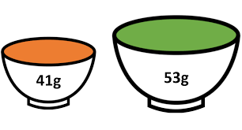 | Eat small portions by using small plates /bowls. Avoid second portions of starch (bread, potato, rice, dumpling, pasta).
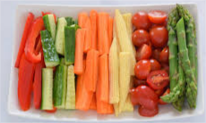 | Eat vegetables at every meal or snack. Vegetables are low in calories, high in fibre, and vitamins and minerals.
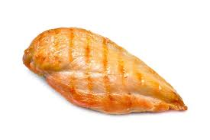 | Avoid fried / oily foods such as take-away, puddings, cream and butter. Try grilled chicken / fish without skin or batter, and low-fat dairy.
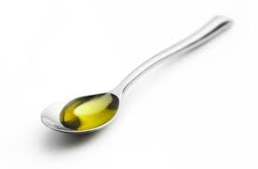 | Cook with maximum 1 tsp oil, spread butter thinly and drain oily foods with a paper towel, avoid salad dressing and mayonnaise.
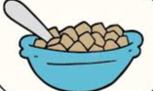 | Avoid sugary foods such as chocolate, cake, biscuits and puddings. Some cereals are high in sugar so choose plain varieties with fibre.
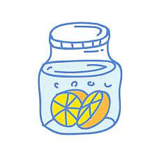 | Avoid sugary / fizzy drinks, they have up to 6 sugar cubes per can!  Choose water as much as possible – there are no calories in water.  Add sweetener to tea instead of sugar, and add fruit to water.
 | Aim for 30 minutes of activity every day such as walking or dancing.
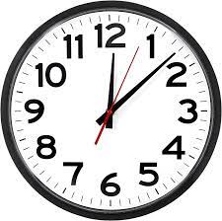 | Avoid snacks, and have a ‘protected mealtime’ without interruption which guarantees time to eat. Eat slowly and really enjoy the food.
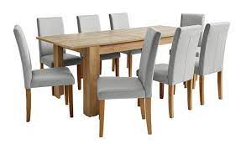 | Eat in an inviting space with preferred sound (music or silence), photos of relatives and friends, appropriate aroma (appetising food smells and away from toilets).
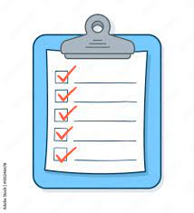 | Start a food diary, and monitor weight each week.

Food Record Chart for Service User Completion
