Healthy Eating to Prevent Constipation
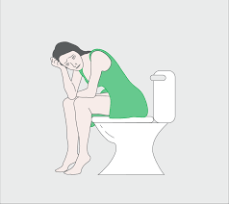 | What is Constipation?  Constipation is the uncomfortable and infrequent passage of stools with slow bowel movements. This can pose risks if chronic.
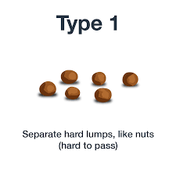 | Signs of constipation include:  - Bowels not opening for 3 days  - Bowels not opening 3 times per week  - Stools which are hard, dry, and difficult or painful to pass
Some of these ‘red flags’ can also indicate constipation:
- Bleeding when passing stool
- Unexplained weight loss
- Iron deficiency anaemia
- Bloating or abdomenal distention
- Hard palpable mass
- Vomit or reflux
- History of colon cancer or inflammatory bowel disease
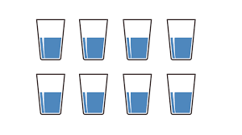 | Dietary Changes to prevent constipation  Drink plenty of water, at least 8 full glasses daily. This hydrates stool. Other decaffeinated drinks also help, like milk, herbal tea, and juice.
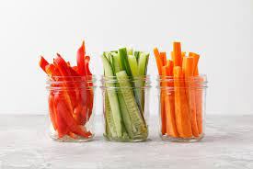 | Eat a variety of fruits and vegetables, and remove tough skins such as on squash or banana. Aim for at least 5-a-day to boost your fibre.
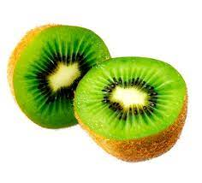 | Have at least 2 kiwis or a handful of dried prunes (80g per day) with plenty of water. These are a source of prebiotics.
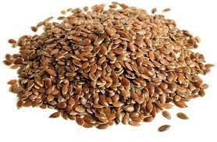 | Sprinkle 1-4tbsp of linseeds, flaxseeds or chia seeds daily onto food such as cereal, salad, soup or smoothies. These are also prebiotics.
 | Try live yoghurt, fermented foods, or probiotic drinks, powder or tablets for at least 2 weeks. Probiotics promote good gut health.
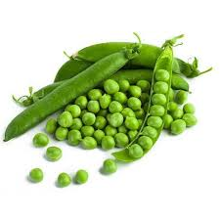 | Try wholegrain cereal, bread and pasta rather than white, and try beans and pulses like lentils and peas. These are a source of fibre.
Physical Changes to prevent constipation

Aim for at least 30minutes of physical activity per day, this will help to keep the bowel moving.
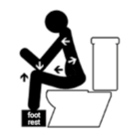 | Take regular toilet breaks, and ensure correct positioning:  - sit with knees higher than hips  - lean forwards  - bulge out abdomen  - straighten spine
 | Monitor stool output and frequency of bowel motions on a bowel chart using the Bristol Stool Chart.

Bristol Stool Chart
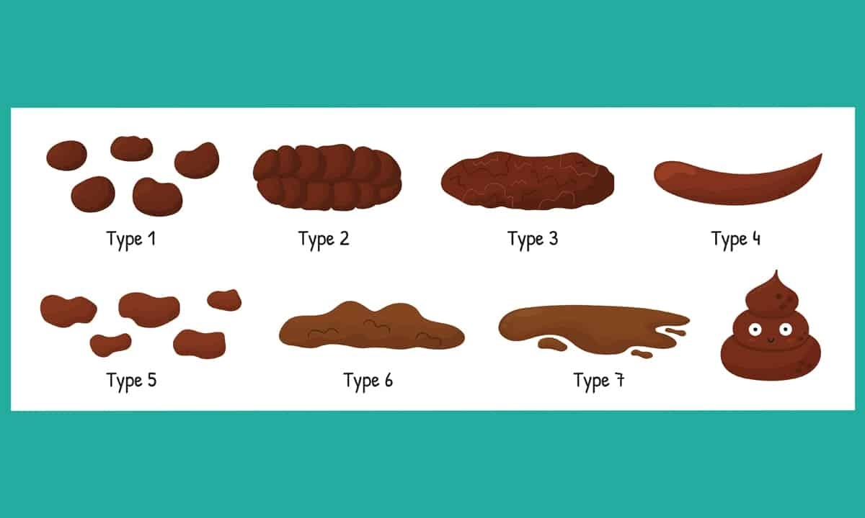

Bowel Chart

