Nutrition Support
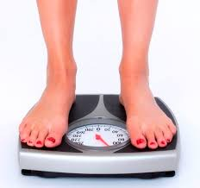 | What is Malnutrition?  Malnutrition is also known as underweight, and is caused by unintended weight loss.
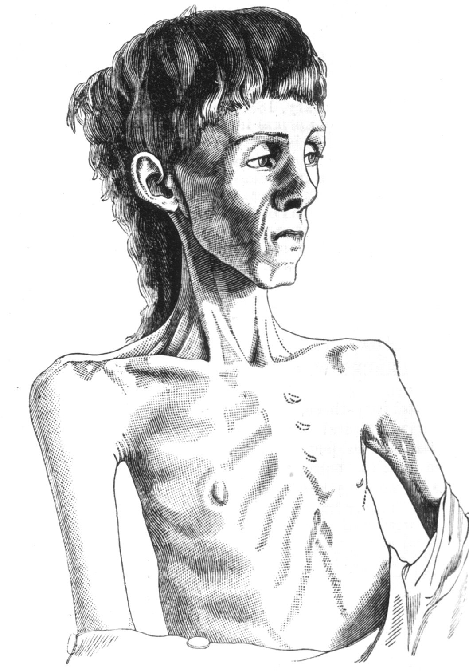 | Some signs of malnutrition include protruding bones, baggy clothes or jewellery, pale skin and fatigue.
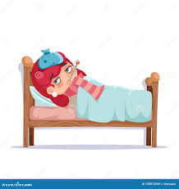 | Malnutrition can have serious negative impacts, including infection, admission to hospital, and longer stay in hospital.
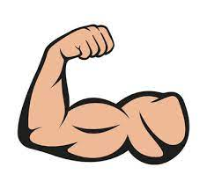 | What is Nutrition Support?  A diet high in energy (calories) and protein is called ‘Nutrition Support’ diet to help build strength and promote weight gain.  This diet is different to generic healthy eating advice.
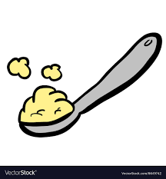 | If someone has a small appetite, we can fortify food with energy and protein to make sure that every mouthful counts.  Skimmed milk powder (UHT milk) is a source of protein which can be added to food without changing its flavour.
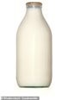 | Using full fat varieties of milk, yoghurt, cream, butter, oil and other foods is an easy way to add calories to food or drinks like tea, cereal or soup.
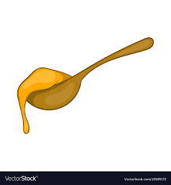 | Adding sugar, syrup, honey, jam, mayonnaise and other sauces can also add calories to food.
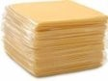 | Choosing meals or snacks made with eggs, beans, cheese, nuts, fish, chicken or meat adds protein to the diet.  Some examples include:  - sprinkling cheese onto main meals  - eating tuna, egg, cheese, chicken or meat sandwiches  - eatingomlettes  - dipping bread into hummus
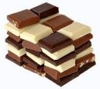 | High-energy snacks and puddings increase calories in the diet, such as custard, mousse or chocolate.
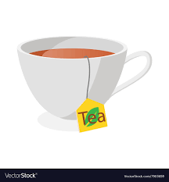 | Sugary and milky drinks are also a source of calories and protein.  Examples include:  - smoothies made with high-protein yoghurt and peanut butter  - tea made with skimmed powder, full fat milk and sugar  - juices and energy drinks
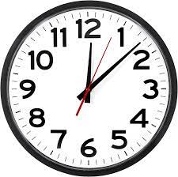 | Avoid skipping meals, and have snacks regularly during the day. Having a ‘protected mealtime’ without interruption guarantees time to eat.
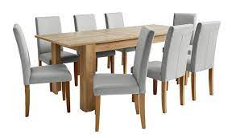 | Eat in an inviting space with preferred sound (music or silence), photos of relatives and friends, appropriate aroma (appetising food smells and away from toilets).
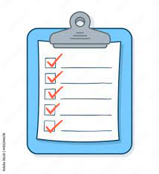 | Set reminders or ask for prompts and encouragement to eat, and monitor weight, food and drink on charts. Work with catering services to ask for high-calorie snacks and drinks as well.

Food Record Chart for Staff Completion
Name:  RiO #:  Date: | Food / fluid offered (add detail/comments) | Portion Consumed
Time: | Portion (R – refused, S – small, M – medium, L – large) | Nil | ¼ | ½ | ¾ | All

Guidance for completion of Food and fluid Record Charts

Record the date and time of food consumption

In column ‘Nil’, record food refusal with ‘R’

If food/drink was refused or missed please record a reason for this (eg felt sick after medications, or away at appointment)

Record additional independently sourced foods including take-away meals, shop-bought, gifted and vending machine foods and drinks

In column ‘All’ record ‘1’ if all of the food was eaten, or 2 or 3 to indicate multiple portions

Upload onto medical records

Example:
Name: Joe Bloggs  RiO #: 12345  Date: 23/03/24 | Food / fluid offered (add detail/comments) | Portion Consumed
Time: | Portion (R – refused, S – small, M – medium, L – large) | Nil | ¼ | ½ | ¾ | All
9.10.2023 / 8am | 2 slice toast, butter, 2 fried eggs |  |  |  | ü
9.10.2023 11am | 200ml – Oral nutritional supplement drink Aymes shake, chocolate flavor |  |  |  |  | ü
9.10.2023/ 11am | L - Shish kebab, chips, salad.  Note: Ate ¼ of a small portion of chips with one sachet of mayo; Did not eat salad or shish kebab. |  | ü
10.10/2023 / 10 am | Sachet Porridge, full-fat milk, cinnamon,  Refused as was feeling nauseous. | R

