Preventing Dehydration
What is Dehydration?

Dehydration is a harmful imbalance of fluid in the body, caused by not drinking enough, or excessive fluid losses.

Dehydration can be caused by difficulty swallowing, diarrhoea, vomit, feeling hot, not remembering to drink, diuretic medications
Some signs of dehydration include:
- dark urine
- dry mouth and cracked lips
- headache, dizziness and fatigue
- low blood pressure
- feeling thirsty and hungry
Dehydration can have serious negative impacts, including:
- delirium and reduced mental performance
- vomit
- risk of falls and injury
- urinary tract infection
- hospitalisation
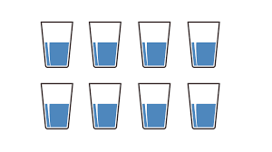 | Preventing Dehydration  Drinking at least 8 full glasses of fluid daily, and more on hot days or if feeling unwell, including water (sparkling), juice, tea and milk
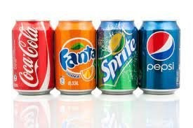 | Try decaffeinated tea, coffee and fizzy drinks instead of regular varieties.
 | Eat fluid-rich foods like fruits, vegetables, yoghurt, smoothies, custard, pudding, jelly, soups and stews.
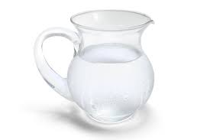 | Drink rehydration solution, made with 6 tbsp sugar, ½ tsp salt and 1L water. Sachets bought over the counter are also suitable.
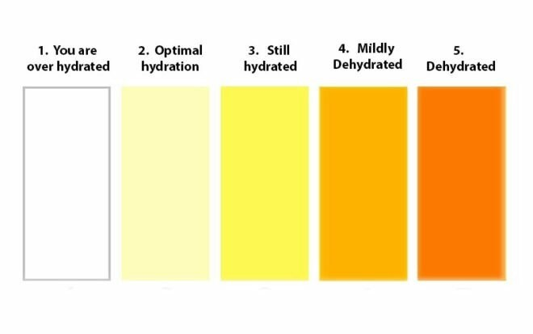 | Check urine colour, aiming for pale yellow, and monitor urine frequency. Set reminders to drink and ask for help.
Service User: Daily Fluid Chart for Staff Completion Date:
TIME | FLUID INTAKE (ml)  Oral/Enteral/Subcutaneous/IV | FLUID OUTPUT (ml): Urine/Vomit/Faeces/Saliva | BALANCE (ml) -ve/+ve
00.00-01.00
01.00-02.00
02.00-03.00
03.00-04.00
04.00-05.00
05.00-06.00
06.00-07.00
07.00-08.00
08.00-09.00
09.00-10.00
10.00-11.00
11.00-12.00
12.00-13.00
13.00-14.00
14.00-15.00
15.00-16.00
16.00-17.00
17.00-18.00
18.00-19.00
19.00-20.00
20.00-21.00
21.00-22.00
22.00-23.00
23.00-00.00
TOTAL

Estimating Fluid Intake
Use below table to estimate oral intake, and use syringe readings for enteral:
1 cup | 250ml | 1 teaspoon 5ml
1 soup bowl | 350ml | 1 tablespoon 15ml
1 mug | 335ml | 1 can fizzy drink 330ml

Signs of Dehydration
Does the service user have hard stools?  (type 1-2) Yes or No  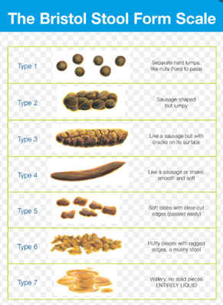 | Does the service user have dark urine?  (type 4 or more) Yes or No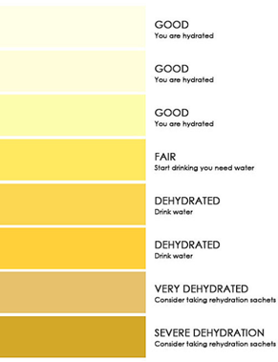
Does the service user have fluid losses? (sweating, diarrhoea, vomit) Yes or No | Does the service user have fluid losses?  (frequent urine output) Yes or No

If YES to any of the above, if no fluid restriction, add at least 200-500mls of water to the service user’s regimen, consider rehydration solution, and monitor signs regularly.

Comments:

