Treatment and Prophylaxis
Of influenza-like illness
Version number : | 1.1
Consultation Groups | Medicines Committee  Infection Prevention and Control  Antimicrobial Stewardship Group
Approved by (Sponsor Group) | Antimicrobial Stewardship Group  IPC Committee
Ratified by: | Medicines Committee
Date ratified: | 13th March 2024
Name of originator/author: | Lead Pharmacist Vaccinations and Antimicrobials
Executive Director lead : | Chief Medical Director
Implementation Date : | March 2024
Last Review Date | January 2024
Next Review date: | January 2027
ELFT Guideline (Adults patients)

Services | Applicable
Trust wide | X
Mental Health and LD

Community Health Services

Version Control Summary
Version | Date | Author | Status | Comment
1.0 | Jan 2024 | Roberta Contino | Draft
1.1 | Jan 2024 | Roberta Contino | Final | Amendments related to prophylactic treatment added by Lead IPC Nurse

CONTENTS

Pages
- INTRODUCTION  - OBJECTIVES  - SCOPE  - DEVELOPMENT AND CONSULTATION  - IMPLEMENTATION  - MONITORING AND COMPLAINCE  - DEFINITIONS  - COVID-19  - TESTING PATHWAYS  - TREATMENT OF INFLUENZA  - USE OF NEURAMINIDASE INHIBITORS in RENAL DISFUNCTIONS  - REFERENCES  APPENDIX A - TREATMENT OF PATIENTS WITH INFLUENZA-LIKE ILLNESS  APPENDIX B – POST EXPOSURE ANTIVIRAL PROPHYLAXYS | 4  4  4  4  5  5  5  6  6  8  9  10  11  13

- INTRODUCTION

ELFT Antimicrobial Guidelines are intended to provide clinicians with guidance on the management of common infections. This guideline provides evidence-based best practice on the management of patients with influenza-like illness. It covers the use of the viral neuraminidase inhibitor drugs Oseltamivir and Zanamivir in the treatment of influenza-like illness in adult patients, who become symptomatic during an existing admission in ELFT.
Drug resistant influenza viruses can emerge and spread within influenza outbreaks. Revised guidelines will be issued as appropriate.

- OBJECTIVES

• To maximise the clinical effectiveness of agents used
• To reduce drug-related toxicity
• To reduce development of antimicrobial resistance
• To ensure cost-effective use of antimicrobial agents

- SCOPE

This guideline applies to all healthcare professionals involved in the prescription, administration and monitoring of Oseltamivir for treatment and prophylaxis of influenza at all ELFT sites.

This guideline only applies to adult patients (≥ 18 years).

Prophylaxis may be offered to contacts of laboratory-confirmed cases. Such scenarios must receive expert advice from the duty Consultant Virologist.

- DEVELOPMENT AND CONSULTATION

This document is required to set standards of evidence-based best practice across ELFT sites and to allow the monitoring of prescription-based use of medicines. It covers the use of licensed medicines which are recommended for the treatment and prophylaxis of influenza.

It is based on the most up-to-date information from Public Health England^{1, 2} (formerly HPA), the Department of Health^{3, 4}, and the National Institute for Health and Care Excellence (NICE) ⁵.

The guideline has been produced in consultation with the UCLH Consultant in Medical Microbiology and Infectious Diseases – Infection Control Doctor, the ELFT Director of Infection Prevention and Control (DIPC), the ELFT IPC team and ELFT Pharmacy Lead for Antimicrobials and Vaccinations.

- IMPLEMENTATION

Approved guidelines will be housed on the ELFT intranet.

Implementation and adherence to the guidelines is the responsibility of the lead clinician and lead pharmacist for each division.
Clinical staff will be made aware of this guideline by a cascade email to relevant clinical divisions.

- MONITORING

Monitoring | Method | Lead | Frequency | Reporting | Acting on gaps
Compliance with treatment regimens | Point prevalence audits; root cause analysis | Lead Microbiology Consultant | Quarterly root cause analysis for each positive case | IPC  Antimicrobial Stewardship Group | IPC  Antimicrobial Stewardship Group

- DEFINITIONS

This guidance is referring also to some extent to COVID-19 as the two syndromes may overlap. Individuals with an influenza-like illness may have a COVID-19 infection, and conversely a patient with symptoms consistent with COVID-19 may have an influenza infection or another viral respiratory infection.
Influenza-like illness is defined as:

Fever ≥ 37.8°C or history of fever AND Two or more of:
• Cough
• Runny Nose
• Headache
• Limb or Muscle pain
• Sore throat
• Diarrhoea or vomiting

Influenza virus infection should also be considered as a differential diagnosis in patients with community or hospital acquired pneumonia, severe acute respiratory infection, exacerbation of chronic lung disease including asthma and COPD, sepsis, neurological presentations, myocarditis and rhabdomyolysis.

Risk groups for complicated illness include:
• Neurological, hepatic, renal, pulmonary and chronic cardiac disease
• Diabetes mellitus
• Severe immunosuppression (as explained below)
• Age over 65 years
• Pregnancy (including up to 2 weeks post-partum)
• Morbid obesity (BMI>40)

Complicated influenza: influenza requiring hospital admission and/or with symptoms and signs of lower respiratory tract infection (hypoxaemia, dyspnoea, lung infiltrate), central nervous system involvement and/or a significant exacerbation of an underlying medical condition

Severe Immunosuppression includes:
• Severe primary immunosuppression
• Chemotherapy or radiotherapy for malignancy, within last 6 months
• Solid organ transplant recipients on immunosuppressive therapy
• Bone marrow transplant recipients on immunosuppressive therapy, within last 12 months (longer if graft versus host disease)
• High dose systemic corticosteroids, within last 3 months:
- Adults: ≥40mg prednisolone per day for ≥1 week
- Children: ≥2mg/kg/day for ≥1week
• Other types of immunosuppressive therapy (e.g. biological treatment), within 6 months
• HIV infected patients:
- CD4 <200/μl or <15% of total lymphocytes in adults, or child over five
- CD4 <500/μl or <15% of total lymphocytes in a child aged one to five
- Expert advice required for those under 1 year

- COVID-19

Winter 2019-20 has seen the emergence of a novel coronavirus, SARS-CoV-2, the causal agent of COVID-19, resulting in an on-going major pandemic. All patients with an influenza-like illness should also be investigated for COVID-19. In addition, other criteria that should prompt investigation for COVID-19 are:

• New respiratory symptoms such as a new continuous cough
• An unexplained isolated fever
• Worsening pre-existing respiratory condition
• Either clinical or radiological evidence of pneumonia
• Acute respiratory distress syndrome
• A loss of, or change in, normal sense of taste or smell (anosmia) in isolation or in combination with any other symptoms

There is increasing evidence that COVID-19-Influenza A coinfection is associated with worse outcome.

- TESTING PATHWAYS

- Only patients who are showing symptoms of respiratory infection should be tested.
- Any patient with symptoms of respiratory infection must be promptly isolated in bedrooms.
- Ensure that all LFT (lateral flow tests) results are recorded in patients note on Rio.
- Staff are to wear FRSM or FFP3 mask (if FIT tested) (and other appropriate PPE based on risk assessment), when providing care to patient with respiratory symptoms.
- Inform the IPC team (elft.infectioncontrol@nhs.net) & Ward Manager/ service matron for support and to confirm next steps.
- Weekly PCR tests are no longer required for clinically vulnerable patients as per ELFT local guidance.
- LFT Testing is required 48 hours prior to discharge to care homes/hospices.

Positive LFT test result- If the patient tests positive for COVID-19:
- Monitor their physical health frequently (4x daily) and escalate any signs of deterioration.
- They can end their isolation early on day 7, if they have 2 consecutive negative LFT results taken on day 6 and day 7, 24 hours apart.
- If any of these tests return a positive result, the patient must continue and complete 10 days isolation.
- Updated Guidance on Patient testing can be found here
- Guidance on Management Pathway for Service User with COVID-19 Infection
- Guidance on Management of Patient contacts of COVID-19

For symptomatic patients who test negative for COVID-19:
- Continue to maintain isolation.
- Perform a respiratory viral screen following discussion with assessing Doctor.
- Pathology form should detail a request for a full respiratory panel including Influenza A&B and RSV.
- The patient should remain in isolation until the result is confirmed.

Immuno-compromised positive patients: The NHS is offering monoclonal antibody and antiviral treatments to people with COVID-19 who are at highest risk of becoming seriously ill.
- nMABS treatment protocol to be followed for eligible positive patients https://www.gov.uk/government/publications/covid-19-guidance-for-people-whose-immune-system-means-they-are-at-higher-risk/covid-19-guidance-for-people-whose-immune-system-means-they-are-at-higher-risk
- Negative but high-risk patients who are on a ward where a positive case/s are identified, must be encourage with protective isolation for their own protection from continuous exposure to the virus.

Positive Influenza result- For patients who test positive for Influenza, antiviral medicines should be considered for those in clinical risk groups as well as anyone at risk of severe illness or complications from influenza if not treated.
- For more information please refer to UKHSA Guidance on use of antiviral agents for the treatment and prophylaxis of seasonal influenza (publishing.service.gov.uk)
- Assessing doctors are to refer to local treatment protocols as appropriate.

For all positive patients (COVID-19 & Influenza):
- QDS observations [respirations, temperature, pulse] and consider sepsis screen and escalation as per NEWs score. Encourage patients to drink plenty of fluids.
- Those patients without en-suite facilities must be allocated a toilet for their sole use.
- Good respiratory hygiene must be encouraged, i.e. Use a disposable single use tissues to cover mouth and nose when coughing, sneezing, wiping or blowing noses; dispose of tissues promptly and then wash hands.
- All linen of symptomatic patients must be double bagged i.e placed in red bags and then placed directly into a white laundry bag.
- Ensure their rooms and allocated toilets are prioritised for enhanced frequent cleaning [at least three time a day], focussing on frequently touched surfaces.
- Patients who are struggling with isolation are to be encouraged to wear mask when leaving room.
- Frequent escorted fresh air breaks can be offered to patients who are in care in isolation.

- TREATMENT OF INFLUENZA

The use of antivirals and antibiotics within management pathway is given in Appendix A.

Whilst classically it was advised to start antivirals on clinical suspicion of influenza, given the availability at ELFT of rapid PCR, it should be possible to obtain a FluA/B testing and result urgently.

Following FluA/B diagnosis, it is recommended that antiviral treatment is given to all patients that are contacts of the index case. Prophylactic treatment should be given in time sensitive manner, within 48 hours of exposure regardless of patient’s underlying risk factors. If in doubt, consult the Infection Prevention & Control team at elft.infectioncontrol@nhs.net .

Outside of these circumstances, antivirals are usually not recommended especially if the onset of symptoms is over 48 hours, unless the clinician feels the patient is at risk.

Currently Oseltamivir is the treatment of choice for influenza A H3N2 and influenza B while Zanamivir is preferred for influenza A H1N1 given the respective barrier to resistance that both compounds have. At the time of writing, the first line antiviral should remain Oseltamivir even in the heavily immunocompromised host.

Heavily immunocompromised patients found to be infected with the H1N1 strain will be switched promptly to Zanamivir, under the Consultant Virologist approval.

If patients require a second course treatment, the Consultant Virologist should be contacted.

A longer course of treatment (10 days) for heavily immunocompromised patients (e.g. CarT patients, within 6 months of HSCT, GVHD, other haematology patients at high risk of complicated influenza) and ITU admissions with severe complicated influenza) should be considered on Virology approval.

Contact the Virology clinical staff if antiviral resistance is clinically suspected.

Choice of antiviral is dependent on possible route of administration.

Do not wait for a lab diagnosis if rapid not available, start antivirals immediately.

For the treatment of patients with influenza like-illness: go to Appendix A

For post-exposure antiviral prophylaxis: go to Appendix B

- USE OF NEURAMINIDASE INHIBITORS IN RENAL DYSFUNCTION

- The renal doses below are for treatment of suspected/proven infection
- For dosing of post exposure prophylaxis in renal dysfunction – see Appendix B
- For pregnant women, pre-pregnancy body weight should be used to calculate the creatinine clearance

RENAL DOSES FOR TREATMENT OF SUSPECTED / PROVEN INFECTION

OSELTAMIVIR PO

CrCl (ml/min) | >60 ml/min | 75mg PO BD
 | 31-60 ml/min | 30mg PO BD
 | 11-30 ml/min | 30mg PO OD
 | ≤10 ml/min | 30mg PO ONCE
Haemo-dialysis (HD) | 30mg PO ONCE, and then 30mg PO after every HD session
Continuous Ambulatory Peritoneal dialysis | 30mg PO ONCE
Patients on haemo(dia)filtration (CVVH) | 1 – 1.8 L/hr | 30mg PO OD
 | 1.9 – 3.6 L/hr | 30mg PO BD
 | > 3.6 L/hr | 75mg PO BD
ZANAMIVIR INH

Dose as normal renal function

- REFERENCES

1. UK Health Security Agency. Guidance on use of antiviral agents for the treatment and prophylaxis of seasonal influenza. November 2021.
https://assets.publishing.service.gov.uk/government/uploads/system/uploads/attachment_data/file/1037465/ukhsa-guidance-antivirals-influenza-11v4.pdf

2. Public Health England. Seasonal influenza: guidance for adult critical care units. Version 1, July 2017. https://www.gov.uk/government/publications/seasonal-influenza-managing-cases-in-critical-care-units (assessed 28th September 2017)

3. Department of Health. Use of Antivirals in an Influenza Pandemic: Scientific Evidence Base Reviewhttps://www.gov.uk/government/uploads/system/uploads/attachment_data/file/215668/dh_125328.pdf.

4. Department of Health Immunisation against Infectious Disease: the green book https://www.gov.uk/government/collections/immunisation-against-infectious-disease-the-green-book.

5. National Institute for Health and Care Excellence (NICE). Influenza - zanamivir, amantadine and oseltamivir (review) (TA168). Issued February 2009, updated 9th December 2010. http://guidance.nice.org.uk/TA168,

6. Department of Health and Social Care. Influenza season 2023/24: Use of antiviral medicines (14 Dec 2023)

7. The Renal Drug Database

8. Ariano et al Enteric absorption and pharmacokinetics of oseltamivir in critically ill patients with pandemic (H1N1) influenza. Canadian Medical Association Journal 2010; 182:357-363

9. Medicines Compendium. Zanamivir 10mg/ml solution. Available at: https://www.medicines.org.uk/emc/product/10193/smpc

10. Influenza co-infection associated with severity and mortality in COVID-19 patients. Published in Virol J. 2021 Jun 14. Bandar Alosaimi

11. https://www.ecdc.europa.eu/en/seasonal-influenza

APPENDIX A – TREATMENT OF PATIENTS WITH INFLUENZA-LIKE ILLNESS
TREATMENT

1st line: | OSELTAMIVIR (TAMIFLU®) 75mg BD (PO) for 5 days  If patients require a second course, Virology should be contacted
Alternative 2nd line: | ZANAMIVIR 10mg BD (INH) for 5 days  If patients require 2nd line, Virology should be contacted
*Oseltamivir and Zanamivir can be used in pregnancy. Mothers are recommended to continue breast-feeding on antiviral treatment. Follow up closely for symptoms.
**A longer course of treatment (10 days) may be considered in heavily immunocompromised patients (CarT patients, within 6 months of HSCT, GVHD, other haematology patients at high risk of complicated influenza and ITU admissions on Virology approval.
NOTE – All doses based on normal renal function. For dosing in renal impairment – see section 11
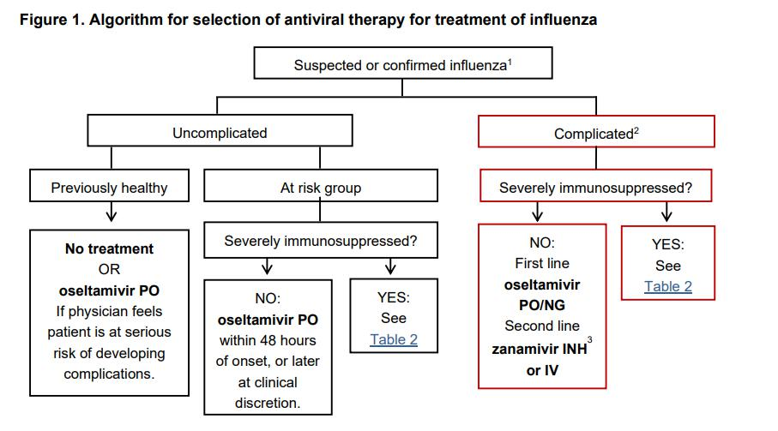

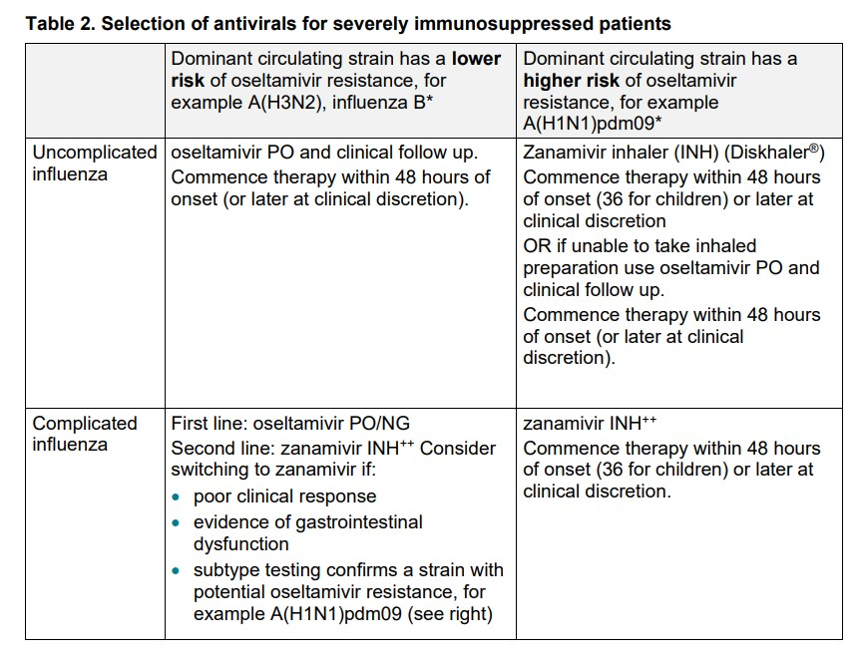
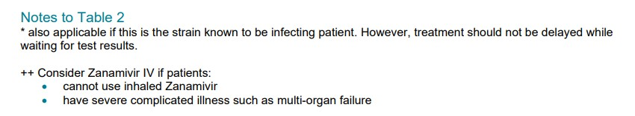
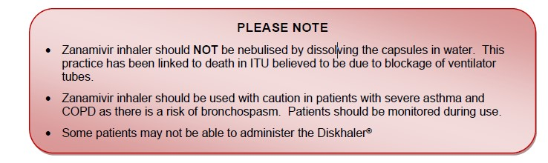

APPENDIX B – POST EXPOSURE ANTIVIRAL PROPHYLAXIS
Under all circumstances, prophylaxis for patients is sanctioned by the duty consultant Virologist.

POST EXPOSURE PROPHYLAXIS

1st line: | OSELTAMIVIR (TAMIFLU®) 75mg OD (PO) for 10 days
Alternative 2nd line: | ZANAMIVIR 10mg OD (INH) for 10 days
*Oseltamivir and Zanamivir can be used in pregnancy. Mothers are recommended to continue breast-feeding on antiviral treatment. Follow up closely for symptoms.

RENAL DOSES FOR POST EXPOSURE PROPHYLAXIS

OSELTAMIVIR PO

CrCl (ml/min) | >60 ml/min | 75mg PO OD
 | 31-60 ml/min | 30mg PO OD
 | 11-30 ml/min | 30mg PO every 48 hours
 | ≤10 ml/min | 30mg PO STAT, repeat after 7 days
Haemo-dialysis (HD) | 30mg PO ONCE, and then 30mg PO after every second HD session
Continuous Ambulatory Peritoneal dialysis | 30mg PO ONCE, repeat after 7 days
Patients on haemo(dia)filtration (CVVH) | 1 – 1.8 L/hr | 30mg PO every 48 hours
 | 1.9 – 3.6 L/hr | 30mg PO OD
 | > 3.6 L/hr | 75mg PO OD
ZANAMIVIR INH

Dose as normal renal function

