Title | Medicines Safety Report
Authors | Rajesh Jethwa/ Indreet Anand (Medicines Safety Officers)
Presented to | Medicines Committee
Date | 15th March 2024

Purpose of the Report:
This report provides a summary of medicines safety data that is collected in the Trust and is presented to the Medicines Committee for information. The committee is asked to consider the level of assurance provided by the report and decide whether further action is needed.

Strategic priorities this paper supports (Please check box including brief statement)
Improving service user satisfaction | ☒ | Improve service user-related outcomes by ensuring that they receive safe pharmaceutical care.
Improving staff satisfaction | ☒
Maintaining financial viability | ☐

Committees/Meetings where this item has been considered:
Date | Committee/Meeting
N/A | This report has not been considered in any other committees or meetings

Equality Analysis | This report has no direct impact on equalities
Contents
Section | Page | Source of information
Medication incident reporting | 1 | Inphase Dashboard
Key Medication Incidents | 2 – 5 | Inphase
Local Medicine Safety Updates | 6 | MSO’s
MHRA Drug Safety Update | 7-8 | MHRA
National Patient Safety Alerts | 9 | NPSA alerts

TRUSTWIDE INCIDENT REPORTING

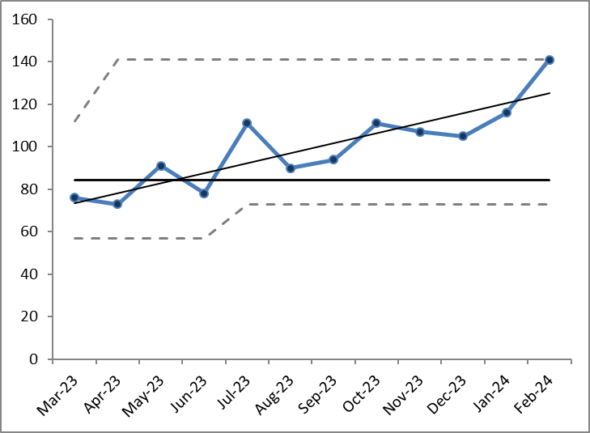
Figure 1 Total number of medication incidents reported per month (Mar 23 – February 24)
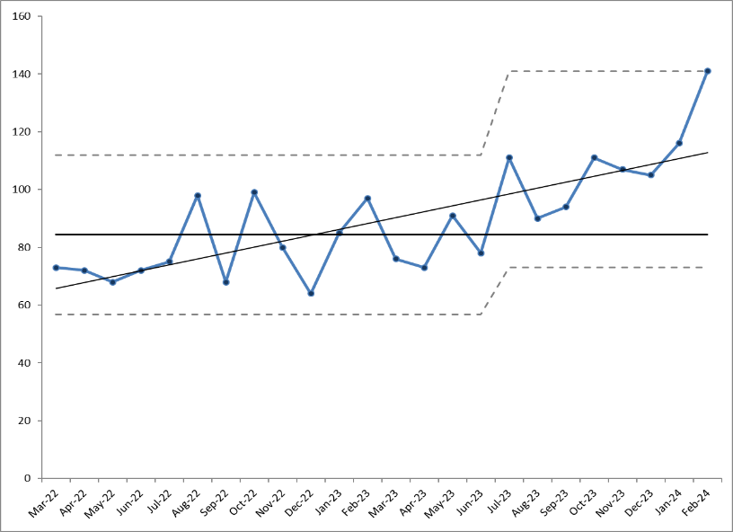
Medication incident reporting fluctuates within control limits. Inphase incident reporting system went live 1st November 23. Incident reporting has increased over the last 3 months. Feb 24 - 141 Medication Incidents were reported on Inphase. Historically medication incidents were being captured under ‘other’. Inphase medication incident template has additional categories which allows for reporters to better categorise the incident that has taken place. Nevertheless high reporting culture noted in BCHS, THCHS and C&H Mental Health services. As expected, incidents related to medicine administration is the most commonly reported.

Figure 2- Total number of medication incidents reported per month (Mar 21 – Feb 24)
Over the last 2 years there has been a increase in medication incident reporting trustwide (shown by data trendline); reflective of the increased awareness amongst staff to report and learn from incidents but also increase in the number of services provided where medicine is used.

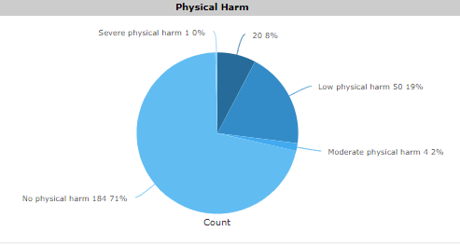
Figure 3 – Medication incidents broken down by type of harm (Jan 24 – Feb 24)
Assurance that incidents are being reviewed by the incident team and recategorised to reflect true level of physical harm. 71% of the medication incidents during this timeframe we reported to have caused no physical harm. There were 50 incidents reported that were thought to cause low levels of harm. 4 incidents reported as Moderate and 1 reported as severe physical harm.

HIGH RISK MEDICINES (Jan – Feb 24)
There was a high reporting of incidents related to the use of; Insulin, Controlled drugs and Clozapine.
ACTIONS
- 2x working groups looking at insulin errors within community health services
- Controlled Drug incidents – directly picked up by CDAO, MSO’s and Lead pharmacists. Discussions taking place with ward managers and director of nursing to strengthen process on the management of controlled drugs in inpatient setting. A new CD investigation tool to be presented at the may medicines committee.
- Clozapine – MSO’s will be presenting a learning seminar at the end of march in collaboration with the trust learning team to raise awareness of incidents related to the use of clozapine.
KEY MEDICATION INCIDENTS
Note: all incident descriptions have been directly extracted from INPHASE
MODERATE HARMS
LFPSE ID | Directorate | Incident description | Action
4487 | BCHS Complex care | ‘Patient has been under DN for syringe driver until 13/02/2023 when this was stopped. They were administering cyclizine 50mg in 1ml injection as a 150mg dose over 24 hours via the syringe driver.  When the syringe driver was stopped the GP documented that she was to take the cyclizine 50mg in 1ml by subcutaneous injection three times each day. This injection should only be given intravenous or intramuscular as stated on the BNF.  Due to the injection being administered by the wrong route, she now has burn marks on her legs with scabs and they are now infected. She has also not been informed to change sites on her body so is administering in one leg three times each day.  The GP never issued any syringes or needles so i believe she brought them from the internet.  The GP has been issuing 84 vials of cyclizine each month since the syringe driver has stopped’ | Cyclizine was not supposed to continue following discharge. GP continued to issue S/C cyclizine without there being any information on how to administer this. The cyclizine was no longer appropriate and the medication was stopped.
5099 | Newham MH – Ivory ward | ‘Patient was discharged from Ivory Ward in November 2023 following a crisis admission, then transferred to the care of the Home treatment Team (HTT).  Patient was then discharged from HTT on 16/12/23 (See discharge letter attached). The plans following discharge involved: discharge to CIMHS South, supplied with 7 days TTA and for GP to continue treatment regime as patient uses blister packs.  Patient was re-admitted to Ivory ward on 23/01/24 following a deterioration in her mental health, she became unwell and as a result also lost her job.  Medicines reconciliation carried out by the Pharmacist highlighted a discrepancy in the medication history as Quetiapine m/r tablets was not showing on the list of medicines on SCR or HIE.  Additionally the discharge letter from HTT listed Melatonin tablets which was newly started and this change was reflected in the GP Summary care Record, but for some reason unknown to us, the newly started Quetiapine tablets were omitted’. | Pharmacy followed up with community pharmacy and this was not being supplied. Discharge summary from December not picked up by GP. Quetiapine restarted on this admission. 72 hour report requested to better understand gap in transfer of care.
5579 | BCHS Twinwoods | ‘On 01/02/2024 Senior RN reported to myself concerns raised by Care Home Team Lead and Carers. An RN within the team had been allocated to administer an intramuscular B12,12 weekly injection on 2 occasions over 6 month period. Upon discussion with senior carer, she reported the RN had visited patient to administer B12 IM injection, patient has formal diagnosis of dementia and was agitated on RN's arrival. Carer had asked RN to come back a while later after patient had settled. RN informed carer they were 'too busy' and was unable to come back later or reschedule the visit for following day. Carer had asked RN to visit other patients in care home and come back after. RN agreed and visited other patients in home. Carer reported RN 'took the drawn up B12 medication in syringe with them'. RN came back to patient requiring injectable medication after seeing others patients in the care home. Carer reported RN then stated 'they were scared of patient and asked carer to administer the injection'. Carer stated she informed RN she had never given injection before and was not happy to administer. Carer reported RN 'reassured her and informed her the B12 Injection could be administered via the same route as insulin and that other care homes were doing this'. RN gave directions to carer to administer injection subcutaneously into patients abdomen. RN did not raise any concerns or issues to a Band 6, 7 or 8. Care Home Senior carer and Team Lead also reported the same incident occurred with the same RN, same patient but different senior carer on the next scheduled visit for administration of B12 intramuscular injection. Upon discussion with Senior Carer of care home, no concerns were raised in regards to patient harm. No discolouration of skin or new wounds present around injection site. | Injection should have been administered IM but RN refused to administer to patient and encouraged and directed carer to administer injection subcutaneously. Allocated visits to this RN have been reviewed. Manager met with senior carer and team lead to ascertain if any harm came to the patient.
5800 | Newham MH – Topaz ward | It was noted that one of the patients in Topaz ward was not improving in his mental state despite increasing his mental health medication. Routine blood tests revealed low levels of thyroid, which on further exploration showed that he was not receiving any thyroxine.  On probing why this happened, it came to light that since his admission in late November 2023, he has not been receiving any of his physical health medications including thyroxine, anti hypertensives and oral hypoglycaemic agents (2 months witout physical health medicines) | Previous HIE and GP records were checked immediately to determine SU’s regular medications and these were prescribed promptly. DOC was completed and an AAR has been requested

REPORTED AS A SEVERE PHYSICAL HARM
LFPSE 00005732
5732 | C&H – Joshua ward | Patient was transferred back to Joshua ward from HUH on 31/1/24 without a discharge summary. It was discussed in the morning huddle to chase up discharge summary. SU had a hypo on 05/02/24 and was admitted to HUH again. Upon investigation, ward team found out that during patient's time at HUH, there were changes to anti-diabetic medication and so gliclazide was stopped. However, since there was no discharge summary when patient returned to Joshua ward, gliclazide was prescribed and continually given | Ward team to ensure in future that patients should not return from acute hospital without a discharge summary and a handover. DOC requested and completed.

LOCAL MEDICINES SAFETY UPDATES
- TRUSTWIDE VALPROATE GROUP – Formation of new policy in line with national requirements with valproate. NEL ICB have sent over data on female patients prescribed valproate. Data is currently being analysed.

- SYSTEM WIDE WORKING
  - NEL MSQG: North East London Medicines Safety Quality Group
  - NEL High Risk Medicines Network
    - Valproate and Insulin subgroups
  - NEL Opioid Discharge Workstream
  - BLMK Medicines Safety Group

- DIGITAL
  - Internal Review and revision of EPMA reports and work being undertaken to transition some of these onto PowerBI. Pharmacy Dashboard has been agreed and is being constructed by performance team

- TRUST MEDICINES SAFETY GROUP – First meeting will be 10th April via Teams. Comms will be circulated shortly trustwide

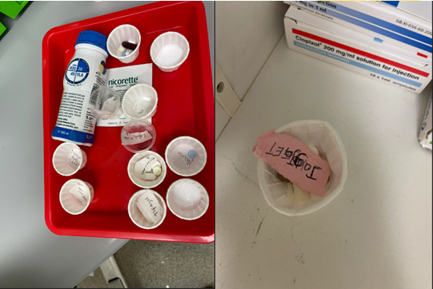
- SECONDARY DISPENSING – Incident reports and observations carried out by RJ in C&H directorate. Evidence that medicines being prepared in advance of drug round with initials/names of patients recorded on the bottom of dispensing pot. There is high risk involved with this form of medicine administration. If staff come across this practice on their wards to please report to ward manager and local pharmacy team. This must then be followed up with a INPHASE incident report.

MHRA DRUG SAFETY UPDATES
FEBRUARY 2023
- Codeine Linctus: reclassification to prescription only medicine (POM) owing to risk of dependence, addiction and overdose.
- Concerns the use of codeine linctus as an ingredient in the recreational drink known as ‘purple drank’ ‘Lean Sizzurp’ or ‘Dirty Sprite’. Serious risk such as loss of consciousness, respiratory depression and death
- MHRA has found evidence of purple drank being quite popular on social media platforms for YOUND ADULTS and there has been a increase in the number of reports for the sale of codeine linctus through non regulated and illicit websites.
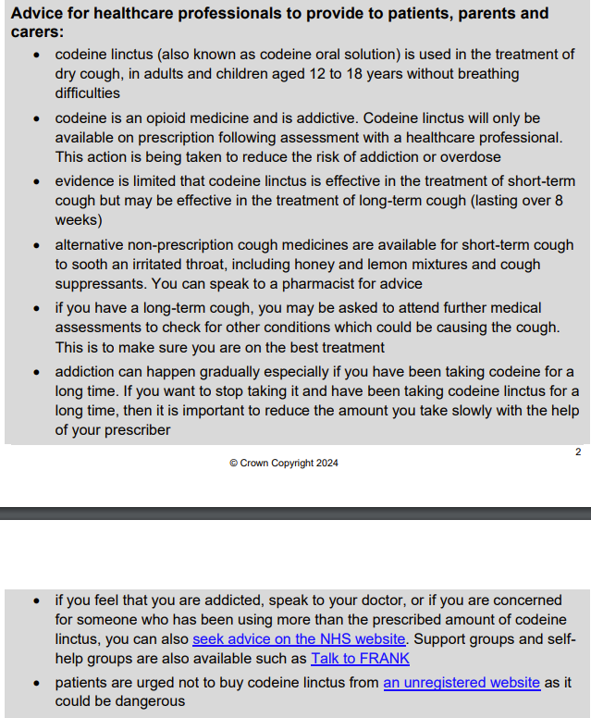

- Pseudoephedrine: very rare risk of posterior reversible encephalopathy syndrome (PRES) and reversible cerebral vasoconstriction syndrome
- PRES and RCVS present with following symptoms: sudden severe headache, sudden onset of nausea and vomiting, confusion, seizures and visual disturbances.
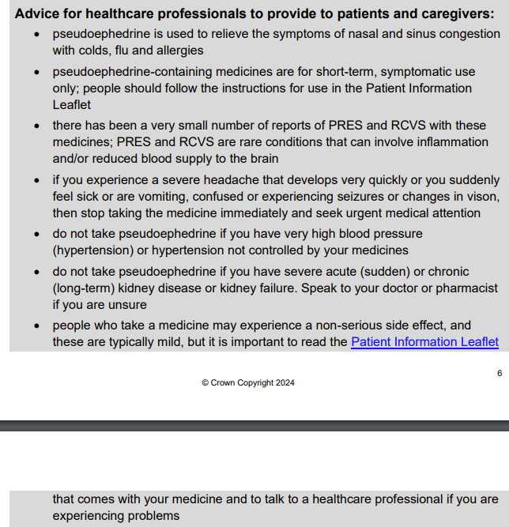
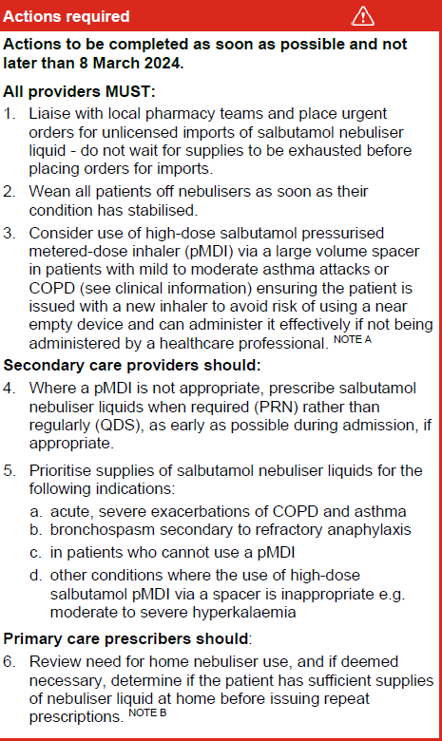
NATIONAL PATIENT SAFETY ALERTS
- Shortage of Salbutamol 2.5mg/2.5ml and 5mg/2.5ml nebuliser liquid unit dose vials
- Supply issues thought to be due to manufacturing issues
- Terbutaline, salbutamol and ipratropium remain available but may not be able to support demand
ELFT response
- Order has been placed for unlicensed imports but no confirmation as to when we will get these in.
- Patients on the wards have been identified via trace report and pharmacists have been asked to review treatment in these patients

