Job Evaluation Policy and Process

Version number : | 3.0
Consultation Groups | Directors, Line Managers, HR Staff, Trade Union Representatives
Approved by (Sponsor Group) | JSC Sub Policy Group
Ratified by: | Joint Staff Committee
Date ratified: | May 2024
Name of originator/author: | Associate Director of Business Partnering  People and Culture  Staff side
Executive Director lead : | Chief People Officer
Implementation Date : | May 2024
Last Review Date | May 2024
Next Review date: | May 2027

Services | Applicable
Trust wide | X
Mental Health and LD
Community Health Services

- Contents

Section | Title | Page
Section 1 | Contents | 2
Section 2 | Introduction | 3
Section 3 | Scope | 3
Section 4 | Definitions | 3
Section 5 | Appropriate Use of Job Evaluation | 4
Section 6 | Role and Responsibilities | 4
Section 7 | Creation of New Post | 5
Section 8 | Changed Post/Re-evaluation of Existing Post | 6
Section 9 | Documents for Submission | 9
Section 10 | Review & Appeals | 9
Section 11 | Job Evaluation (JE) Panels | 10
Section 12 | Monitoring | 11
Appendices
Appendix A | Process Map - New Post | 12
Appendix B | Process Map – Changed Post | 13
Appendix C | Effort and Environmental Factors Form | 14
Appendix D | Submission Form | 16
Appendix E | JD and PS Template and Guidance | 18
Appendix F | Review Process | 23
Appendix G | Best Practice and Additional Guidance on New and Changed Posts | 26
Appendix H | Standard Job Evaluation Approval, Approval with Caveats, and Decline Letters | 28

- Introduction

  - The NHS job evaluation scheme is used to determine the pay bands for all posts on Agenda for Change (AFC) contracts. It was introduced in 2004 and relies on consistent application within organisations and across the service. It is therefore essential that the job evaluation scheme continues to be used for determining the banding of posts and consequently staff pay rates.
  - The Trust uses the job evaluation scheme when determining the banding for newly created posts as well as for when existing posts are substantially changed or reviewed since they were last evaluated.
  - This policy document will set out the process to be followed for job evaluation in East London NHS Foundation Trust (ELFT) based on the current edition of the Job Evaluation handbook. It will also provide management and staff side with best practice guidance to ensure compliance and partnership participation in process, whilst minimising risk of equal pay claims.
  - The purpose of this guidance/policy is to ensure that there is a fair and equitable process to establish the pay banding for staff employed in the Trust.

- Scope

  - This policy applies to all posts on Agenda for Change terms and conditions of service
  - This policy does not apply to Very Senior Managers, or medical and dental posts.

- Definitions

  - Job matching - comparing and scoring jobs using national profiles
  - Job Evaluation - evaluation of jobs using the Intelligent Job Evaluation System (IJES)
  - National Profiles - a nationally agreed template against which jobs can be compared and scored.
  - Consistency checking - of evaluated jobs
  - New Post – a newly created post in the Trust for which a new job description and person specification has been written.
  - Changed Post/ Request for Re-evaluation– a post which has an existing job description and person specification, where the requirement of the role has changed meaning the job description is no longer fit for purpose or the banding needs reviewing in line with other roles in ELFT. This includes both vacant posts that are changed before recruitment and posts where a current staff member occupies and the work they are required to do has substantially changed or the banding needs reviewing

Standard guidance on how to distinguish a new role from a changed role is contained in chapter 3 of the Job Evaluation Handbook.

- Appropriate Use of Job Evaluation

  - It is important that the use of job evaluation is appropriate. Job descriptions and person specifications should be developed based on the post the service requires and the duties that need to be done. Job descriptions should never be written or amended to suit the individual in post.
  - It is important that managers ensure job descriptions are accurate and up to date and reflect the nature of the work that the service requires at each appraisal. If an individual takes on additional duties as a development opportunity, the manager should be clear that this is not expected to be a change to the job description and is done to support the member of staff in their development.
  - When creating a new post and new job description managers should be clear about what work the post will be expected to do and should never create a job description based around the desire to have a certain band. Managers should check what existing job descriptions are currently used in the Trust before beginning to write a new one. These are available on the Intranet
  - If an existing post has changed and is to be reviewed, managers should ensure a fair process is followed as detailed in Section 6.
  - It is expected that duties contained in a job description are not an exhaustive list and staff can be asked to carry out additional duties equivalent with their banding and level of responsibility, within reason.
  - Minor amendments to a job description can be made in discussion and agreement with the line manager and the job holder. Please refer to section 6.

- Role and Responsibilities

  - Job Evaluation Leads

The Trust recognises the importance of partnership and therefore will share the ownership for job evaluation processes with Staffside through the identification of two Job Evaluation Leads, one management and one Staffside. The Job Evaluation Leads should have knowledge of the Job Evaluation Scheme and will:
- Oversee the job evaluation process.
- Ensure that NHS Staff Council good practice guidelines are followed.
- Help resolve disputes or concerns that may arise between the initial evaluation undertaken by the job evaluation panel by providing expert knowledge.
- Facilitate training and development for all team members.

  - Managers responsibilities:
- To ensure employees in their team have an up to date and accurate job description and person specification.
- To write job descriptions and person specifications for any newly created posts in their team and ensure all job descriptions accurately reflect the role required by the Trust and never the band that is desired
- To support staff to understand their job description and duties.
- To review job descriptions yearly at appraisal with employees and send for job evaluation where appropriate, and when requested by the employee.

  - Employee responsibilities:
- To work within their job description.
- To raise any issues of inaccuracy with their line manager.
- To participate fully in any review of their job description that is undertaken.
- To acknowledge that the list of duties in their job description is not an exhaustive or prescriptive list, and agree to undertake other reasonable duties that are equivalent within banding.

  - Role of People and Culture Department:
- People Business Partners (PBP) to review job descriptions that are submitted for job evaluation and support and challenge managers through the process.
- PBP to ensure the relevant processes are followed and forms submitted.
- Job Evaluation Panel to evaluate job descriptions in line with the job evaluation scheme.
- To keep electronic copies of all job descriptions sent for evaluation.
- To ensure as part of the recruitment process that all job descriptions have been evaluated before advertising.
- Make a library of evaluated job descriptions available to all staff.
- Offer templates, forms and policy to all staff.

  - Role of Staff Side:
- To evaluate and consistency check all job descriptions sent for job evaluation.
- To support staff whose job descriptions are being reviewed.
- To participate in informal and formal consultation in relation to the review of job descriptions at panels and meetings in their protected time.
- Support staff through an appeals process

- Creation of a new post

  - A flowchart detailing the process for submitting a newly created job description for job evaluation can be found in Appendix A.
  - A new post may be created in circumstances of organisational change, both informal and formal, and when additional funding is secured to create a new type of post or team.
  - Before writing a job description and person specification for the new post managers should seek to establish if there are similar job descriptions currently used in the Trust. This can be done by speaking with Senior Managers within the Directorate, managers in other Directorates or the People and Culture Department, or by perusing the library of job descriptions on the intranet link.
  - If a similar job description already in use is identified as potentially suitable to be amended to suit the needs for the new role the line manager should follow the process in Section 8 and Appendix B.
  - If it is established that a new job description needs to be written managers should do so using the most up to date template which can be obtained from the Resourcing Team or on the Trust Intranet. The job description should be written to meet the service requirements, objectives and help achieve the Trust strategy.
  - Once the new job description and person specification has been written this should be sent to the locality People Business Partner via email along with the forms located in Appendix C and D.
  - The locality People Business Partner will review the documents and, if satisfied that job evaluation is appropriate and ready for submission, they will email the job description and the forms to the Trust job evaluation email.
  - The current process that the Trust follows is for the People & Culture Team responsible for managing the job evaluation email folder to pick up this email and enter the submission in the Job Evaluation Tracker document.
  - The Job Evaluation panel will then carry out an initial job evaluation of the new job description and record the outcome on the job evaluation system IJESnet. We will aim to review within 15 working days of the receipt of the email from the People Business Partner, beyond this we will keep Managers and People Business Partners up to date. The outcome of job evaluation will be emailed to the Manager and People Business Partner who sent the original request.
  - There are 3 possible outcomes: Matched, Matched with minor caveats that when completed will be matched by a Lead for Job Evaluation, or Not Matched with the reasons clearly stated along with guidance and support. Matched job descriptions will be saved and stored centrally and on the intranet in People and Culture folders for Managers to use as samples to support writing and reviewing job descriptions.
  - Consistency checking will be carried out monthly by one member each from management and Staffside.

- Changed Post or Re-evaluation of Existing Post

  - Changes may need to be made to posts over time to ensure the role is fit for purpose and requirements. Changes can range from minor (which may not need to be reviewed in line with the job evaluation process) to substantial which will result in the job description being submitted for evaluation again. Any changes, whether minor or substantial must be agreed with the staff members’ line manager.
  - A flowchart detailing the process for submitting an amended or reviewed job description for job evaluation can be found in Appendix B.
  - To note the person specification of a “changed post” should normally remain the same as the existing person specification and should not usually be changed unless significant requirements have changed.
  - Where a change in content affects staff currently in post, such staff should be provided with a copy of their original/unchanged job description prior to any submissions made.

  - Minor changes

    - There may be occasions where managers have to amend the content of a job description to incorporate minor changes. This may be, for example, to update duties in a job description in line with digital and technological advancements.
    - In these cases, the manager is required to informally consult with staff members currently working in that post, then amend the necessary information via tracked changes in a word document and forward this to the locality People Business Partner stating the reason for the change.
    - The locality People Business Partner will review the changes and assess whether they are classed as “minor” and will have no material impact on the banding or “substantial” where they may impact banding.
    - If the changes are classed as minor the People Business Partner will approve the job description to be used. If the changes could have an impact on the banding of the job description the People Business Partner will inform the manager that the Job description will need to be submitted for job evaluation and the manager will follow the relevant process in appendix A or B. Final job descriptions will be saved and stored centrally in People and Culture folders and the Trust Intranet.

  - Substantial Changes – Vacant Post

    - Once a post becomes vacant the line manager should review the job description to ensure it is fit for purpose before commencing recruitment.
    - If substantial changes to the job description need to be made the line manager should first check if there is another post which is similar in the Trust and look at the job description for this on the Trust Intranet. If this job description is fit for purpose, then it should be used for the vacant post going forward and does not need to be sent for job evaluation.
    - If no other job description in the Trust is fit for purpose, then the line manager should amend the old job description and send for job evaluation as per the process in Appendix B.
    - If only minor changes are made to the job description, then the process is per section 6.5.

  - Substantial Changes – Occupied Post

    - If a member of staff considers the demands of their role to have changed, they may request their line manager to review their job description to incorporate duties that they carry out not included in the original job description and required by the role and within ELFT strategy.
    - The manager and member of staff should meet to discuss the demands of the role and the day to day duties of the staff member and agree to review the job description based on this.
    - Changes to the job description should be made in agreement between both the staff member and manager. If a member of staff requests a change to be made which the line manager disputes, then this should be escalated to the next in line manager for further discussion, support and resolution.
    - The Effort and Environmental factors form (Appendix C) should also be reviewed and completed by the staff member and line manager and agreed amendments made.
    - Once the job description has been reviewed the line manager must complete the submission form (Appendix D) and send this, along with the amended job description and the effort and environmental factors form, to their locality People Business Partner.
    - The locality People Business Partner will review the documents and, if satisfied that job evaluation is appropriate, they will email the job description and the forms to the Trust job evaluation email.
    - The current process that the Trust follows is for the People Relations Advisor responsible for managing the job evaluation folder to pick up this email and enter the request in the Job Evaluation Tracker document.
8.7.8 The Job Evaluation panel will then carry out an initial job evaluation and consistency checking of the new job description and record the outcome on the job evaluation system IJESnet. This will be completed within 15 working days of the receipt of the email from the People Business Partner, beyond this we will keep Managers and Business Partners up to date. The outcome of job evaluation will be emailed to the Manager and Business Partner who sent the original request. Job descriptions will be saved and stored centrally in People and Culture folders for Managers to use as samples to support writing job descriptions.

8.7.9 Following a successful re-banding, pay arrears will be backdated to the date the issue was first raised by the employee and accepted by their manager. If there is some dispute as to when this occurred, the employee can submit evidence in support of their assertion.

  - Changed Post – Part of Formal Organisation Change Process

    - If, as part of a formal organisational transformation change process, job descriptions are to be amended then the manager will need to follow the process in appendix B.
    - Job descriptions should be fully evaluated prior to a formal consultation process being launched where possible.

    - Managers should refer to the Trusts Management of Staff Affected by Change policy and consult their People Business Partner for guidance and support.
    - Posts where staff believe the posts is wrongly graded or constitutes an equality dispute.

- Documents for Submission

9.1 All submissions for job evaluation should come via the locality People Business Partner and submissions directly from a line manager or staff member will be returned. The following documents, supplied on ELFT Intranet are required to be submitted electronically:

- Job description, person specification and structure chart with any changes to current version clearly detailed via “tracked changes.” The job description should be on the most recent template
- Effort and Environmental Factors Form (Appendix C)
- Submission Form (Appendix D)

  - Any requests that are not accompanied by the relevant documentation will be returned and not be submitted for evaluation until all the correct information has been received.
  - Employees should receive a copy of the panel letter in relation to their role on request.

- Review and Appeals

  - In the event that groups of staff, managers or individuals are dissatisfied with the result of matching or job evaluation they may request a review. This review should be conducted by a new panel with the majority of its members different from the original panel. Such a request must be made within 60 days of notification of the original panel’s decision. In order to trigger a review, the jobholder(s) must provide details in writing of where they disagree with the match or evaluation with evidence to support their case. The ‘request for review’ documentation (Appendix F) should be completed and sent to the locality People Business Partner who will forward it to the Lead responsible for job evaluation.
10.2 Panels will be scheduled on a needs basis to undertake reviews that are submitted for reconsideration. Further job information from the submitting manager and postholder (if exists) may be required by the panel prior to the day to enable them to complete the process. The evaluation of contentious or complex job descriptions sent through as part of the standard process can also be undertaken at panels if deemed appropriate.
10.3 The postholder has no right to appeal internally beyond the review panel if their complaint is about banding outcome.

  - The review/appeal panel can:

  - Confirm the same match or evaluation outcome
  - Confirm a match to a different profile or make a different evaluation
  - Or in the case of matching reviews only, refer the job for local evaluation

  - Since the NHS JE Scheme places paramount importance on the issue of accurate and up-to-date information, the review panel must only consider the facts before them. The jobholder will have provided evidence relating to the factor levels they disagree with. However, if the panel wishes to revisit other factors, they need to provide justification for doing this, for example because the new evidence provided is thought to alter other scores. They will then need to refer to the evidence they have been presented with, submit supplementary questions to the job advisors or representatives (two people representing management and staff in the area of work under review) where necessary and allow the job holder to provide additional information. Panels should only complete the review once they are satisfied that all relevant evidence has been examined.
  - All panel members will have been trained on the importance of matching or evaluating jobs using accurate information rather than making assumptions which are not evidenced. It is important that this process should equally apply to the review procedure; the risk in making assumptions about somebody’s job could lead to pay inequality and the scheme being brought into disrepute.
  - The review panel’s decision, whether it changes the banding outcome or not, must be subject to quality and consistency checking.
  - The jobholder should be provided with a detailed job report of the review of the match or evaluation.

- Job Evaluation Panels

  - The Trust acknowledges that job evaluation panels are best practice and the preferred process for job evaluation within national guidance. However, the Trust and staff side in partnership, seek to balance this with the move towards agile working and the need to have a timely and efficient process.
  - The Job Evaluation Panel consists of 1-2 Management side and 2 Staff side in each meeting, and for re-submissions 1-2 Management side and 1-2 Staff side with a minimum of 3 persons per panel with experienced members on the panel where there is only 1 to represent in all meetings.
  - At the time of publishing this guidance the JSC have agreed the process as described above and it may be necessary to convene a panel where a complex or contentious job evaluation request arises.
  - This will also be subject to yearly review in line with the number of trained job evaluators and their capacity. We will be working with staff side to increase training and monitor the effectiveness of 'virtual panels.' This guidance will be amended as and when the process changes in the future.

- Monitoring

Quarterly reports on numbers submitted and consistency-checked outcomes of job matches and evaluations will be presented to JSC. This information will be essential for the purposes of the Trust’s equal pay audit, which should be carried out periodically.
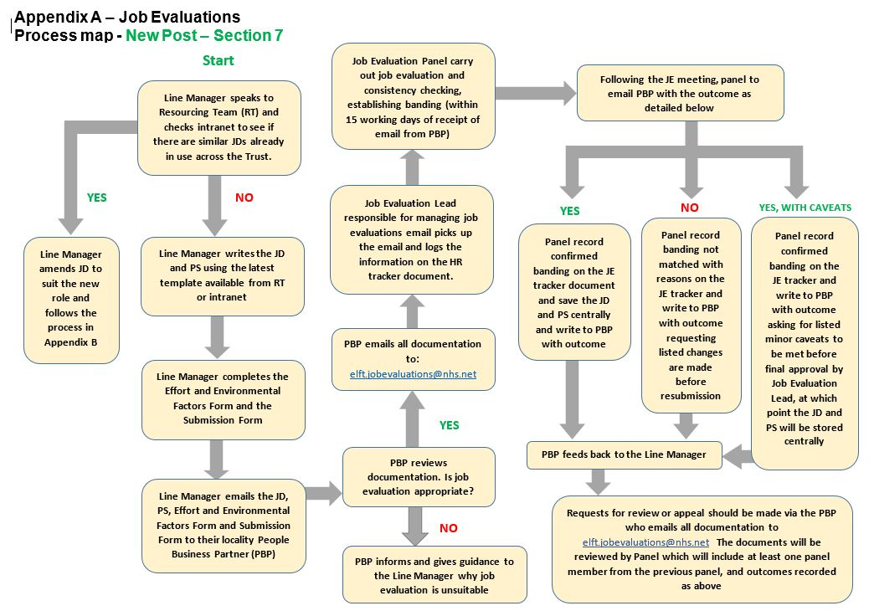
Page 12
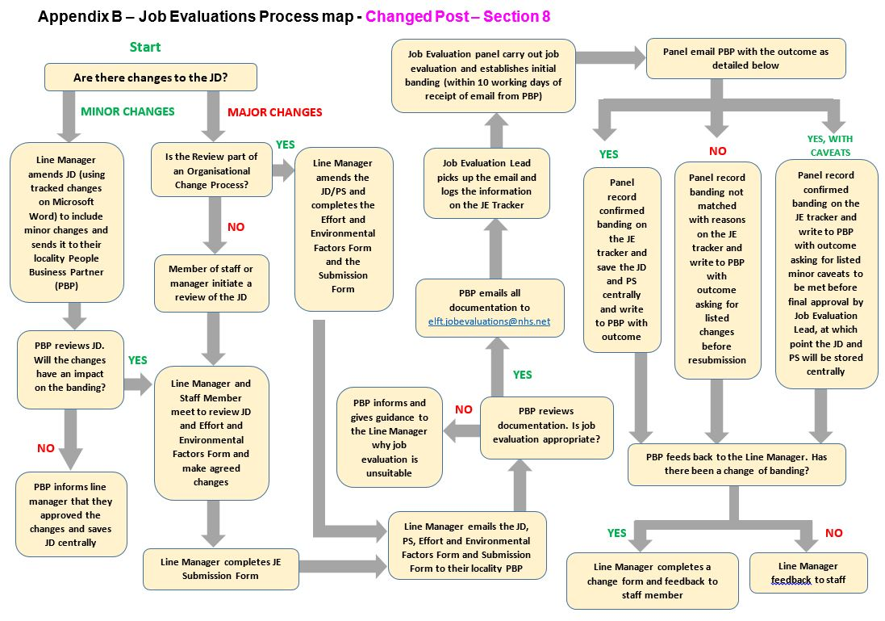
Page 13

Appendix C – Effort and Environmental Factors Form

QUESTIONS ABOUT RELEVANT JOB INFORMATION THAT MAY NOT BE COVERED BY JOB DESCRIPTIONS

Directorate: | Click here to enter text. | Department: | Click here to enter text.
Job Type:  (Staff Group) | Click here to enter text. | Current Band: | Click here to enter text.
Job Title: | Click here to enter text. | Vacant or Post Held: | Click here to enter text.

Effort and Environment Factors
- Will the post-holder use any equipment? If so please describe. | Click here to enter text.
- What physical movement is required in the job? E.g. standing, walking, sitting, kneeling, crouching, bending, climbing or crawling. | Click here to enter text.
- Is this for short or long periods of time and how often? | Click here to enter text.
- Will the post-holder be required to input at a keyboard, work at heights, push or pull trolleys - how often and for how long? Please state which. | Click here to enter text.
- Will the post-holder be required to lift equipment/weights with or without mechanical aids – how often and for how long? | Click here to enter text.
- What is the approximate weight – is it < 6 kilos, 6-15 kilos or over 15 kilos? | Click here to enter text.
- Will the post-holder have to move between different work areas, locations, etc.? Give examples. | Click here to enter text.
- Is the pattern of work predictable in nature? If no, please explain. | Click here to enter text.
- What is the level of concentration and how intense is the concentration required to do the job? Give examples. | Click here to enter text.
- Is this for short/long periods of time and how often? | Click here to enter text.
- Is there emotional involvement with patients and staff in difficult circumstances, either face to face or over the telephone, e.g. imparting bad news? | Click here to enter text.
- Will the post-holder be exposed either indirectly or directly to emotionally or distressing circumstances/situations? If so, for how long and how often? | Click here to enter text.
- Please describe briefly the working environment, e.g. lab, office, etc. | Click here to enter text.
- Will the post-holder be exposed to working conditions that are difficult to work in? E.g. extreme heat/cold, smells, noise, fumes, etc. | Click here to enter text.
- Will the post-holder be required to work in, directly with or exposed to: dangerous chemicals, unpleasant substances, infectious material, foul linen, bodily fluids, faeces, tissues, and others – please give examples, for how long and how often. | Click here to enter text.

Job Evaluation Submission Form
Appendix D – Submission Form

This form MUST be submitted with the Job Description and Person Specification and be signed
Failure to submit a fully completed form with the documents will result in the documentation not being logged or scheduled for job evaluation.

SECTION A
Directorate: | Click here to enter text.
Department: | Click here to enter text.
Post Title: | Click here to enter text.
Name of Manager responsible for the post: | Click here to enter text.

Reason for Job Evaluation Request (please tick applicable box):
☐ New Post (Vacant) – please complete sections B and F
☐ Changed Post (Post Held) – please complete sections C, E and F
☐ Changed Post (Vacant) – please complete section D, E and F

SECTION B – Creation of New Post
If the post is newly created, has the manager responsible done the following:
Checked for similar JDs already in use across the Trust: ☐ Yes ☐ No

If similar JDs are in use, why weren’t these used and amended as necessary? (State below)
………………………………………………………………………………………………………………………………………………………………………………………………………………………………………………………………………………………………………………………………………………………………………………………………………………………………………………………………
Has the line manager responsible agreed the following:
The Job Description: ☐ Yes ☐ No
The Person Specification: ☐ Yes ☐ No
Effort and Environmental Factor Form: ☐ Yes ☐ No

SECTION C – Changed Post (Post Held)
If the request is for a review of a current post and there is a member of staff in the role, have the post holder and manager agreed the following:
The Job Description: ☐ Yes ☐ No
The Person Specification: ☐ Yes ☐ No
Effort and Environmental Factor Form: ☐ Yes ☐ No

SECTION D – Changed Post (Vacant)
If the post is vacant, has the manager responsible agreed the following:

The Job Description: ☐ Yes ☐ No
The Person Specification: ☐ Yes ☐ No
The Effort and Environmental Factor Form: ☐ Yes ☐ No

SECTION E – Impact on Staff
- What impact will the review of this post have on existing staff within the team/department? | Click here to enter text.
- Are there similar posts in the Directorate? (please state the job titles) | Click here to enter text.
- Are there similar posts in other Directorates? (please state the job titles) | Click here to enter text.

SECTION F – Signatures
All signatures MUST be obtained before all documentation is forwarded to your locality People Business Partner.
Please Note: Employee signature is only required when Section C is completed.
Employee Name: | Click here to enter text.
Employee Signature: | Click here to enter text.
Date: | Click here to enter text.
Line Manager Name: | Click here to enter text.
Line Manager Signature: | Click here to enter text.
Date: | Click here to enter text.
Name of Borough Director/Service Director: | Click here to enter text.
Director Signature: | Click here to enter text.
Date: | Click here to enter text.
People Business Partner Name: | Click here to enter text.
People Business Partner Signature: | Click here to enter text.
Date: | Click here to enter text.

The completed form should be forwarded to your locality People Business Partner along with the Job Description, Person Specification and Effort and Environmental Factors Form
Appendix E – Job Description and Person Specification Template and Guidance

JOB DESCRIPTION
JOB TITLE:
BAND:
DEPARTMENT:
DIRECTORATE:
REPORTING TO:
ACCOUNTABLE TO:

JOB SUMMARY
*State the overall purpose of the post in a few brief sentences

Key Responsibilities
*List the key responsibilities that post holder will be responsible for in order to fulfil the purpose of the post

Main Duties and Responsibilities (DELETE IF NOT APPLICABLE)
*List the duties and responsibilities fully and accurately – this section doesn’t have to be fully exhaustive

Patient Care
Clinical
Administration
Management
Human Resources
Performance and Quality
Financial and Physical Resources

Knowledge and Skills
Knowledge, Training and Experience
Supervision
Communication and Relationships

Job Description Agreement
This job description is intended as a guide to the main duties of the post and is not intended to be a prescriptive document. Duties and base of work may change to meet the needs of the service or because of the introduction of new technology. This job description may be reviewed from time to time and changed, after consultation with the postholder.

Statement on Employment Policies
In addition to the requirement of all employees to co-operate in the implementation of Employment related policies, your attention is drawn to the following individual employee responsibilities:-
Health and Safety | Under the Health & Safety at Work Act 1974 it is the responsibility of individual employees at every level to take care of their own health and safety at work and that of others who may be affected by their acts at work, and to co-operate with management in complying with health and safety obligations, particularly by reporting promptly any defects, risks or potential hazards.
Equal Opportunities | ELFT is committed to equality of opportunity for all employees, job applicants and service users. We are committed to ensuring that no one will be discriminated against on the grounds of race, colour, creed, ethnic or national origin, disability, religion, age, sex, sexual orientation or marital status. The Trust commits itself to promote equal opportunities and value diversity and will keep under review its policies, procedures and practices to ensure that all employees, users and providers of its services are treated according to their needs.  For management posts, to ensure that within their service area fair employment practice and equality of opportunity are delivered.
Dealing With Harassment/ Bullying In The Workplace | The Trust believes employees have the right to be treated with respect and to work in a harmonious and supportive working environment free from any form of harassment and / or bullying.  The Trust has taken positive steps to ensure that bullying and harassment does not occur in the workplace and that procedures exist to resolve complaints as well as to provide support to staff. It is your responsibility as an employee to abide by and support these steps so all employees can work in a harmonious, friendly and supportive working environment free of any harassment or intimidation based on individual differences.  Disciplinary action will be taken against any member of staff found to be transgressing the Harassment and Bullying Policy.
No Smoking | To refrain from smoking in any of the organisations premises not designated as a smoking area. ‘East London Foundation Trust is a Smokefree Trust – this means that staff must be smokefree when on duty or otherwise in uniform, wearing a badge or identifiable as ELFT staff or undertaking trust business.’
Alcohol | To recognise that even small amounts of alcohol can impair work performance and affect ones ability to deal with patients and the public in a proper and acceptable manner. Consumption of alcohol during work hours in not permitted.
Confidentiality | As an employee of the Trust the post-holder may have access to confidential information. The postholder must safeguard at all times, the confidentiality of information relating to patients/clients and staff and under no circumstances should they disclose this information to an unauthorised person within or outside the Trust. The post-holder must ensure compliance with the requirements of the Data Protection Act 1998, Caldicott requirements and the Trust’s Information and IM&T Security Policy.  To safeguard at all times, the confidentiality of information relating to patients/clients and staff.
Data Protection Act  Data Protection – Your Data | To maintain the confidentiality of all electronically stored personal data in line with the provision of the Data Protection Act.  As part of your employment with East London Foundation Trust, we will need to maintain personal information relating to your work on your personal file. You have a right to request access to your personal file via the Human Resources Department.  To carry out as per Data Protection Act responsibilities with regard to the access and Health Records Act 1990.
Safeguarding | All employees must carry out their responsibilities in such a way as to minimise risk of harm to children, young people and adults and to safeguard and promote their welfare in accordance with current legislation, statutory guidance and Trust policies and procedures. Employees should undertake safeguarding training and receive safeguarding supervision appropriate to their role.
Service User and Carer Involvement | ELFT is committed to developing effective user and carer involvement at all stages in the delivery of care. All employees are required to make positive efforts to support and promote successful user and carer participation as part of their day to day work.
Personal Development | Each employee’s development will be assessed using the Trust’s Personal Development Review (PDR) process. You will have the opportunity to discuss your development needs with your Manager on an annual basis, with regular reviews.
Clinical Governance | As an employee of the trust you are expected to support the Trust's clinical governance framework for monitoring and improving standards of care. You must do this by:-  - taking part in activities for improving quality  - identifying and managing risks  - maintaining your continuous professional development
Professional Standards | To maintain standards as set by professional regulatory bodies as appropriate.
Conflict of Interests | You are not precluded from accepting employment outside your position with the Trust. However such other employment must not in any way hinder or conflict with the interests of your work for the Trust and must be with the knowledge of your line manager.
Risk Management | Risk Management involves the culture, processes and structures that are directed towards the effective management of potential opportunities and adverse effects. Every employee must co-operate with the Trust to enable all statutory duties to be applied and work to standards set out in the Risk Management Strategy.
Personal and Professional Development/Investors in People | The Trust is accredited as an Investor in People employer and is consequently committed to developing its staff. You will have access to appropriate development opportunities from the Trust’s training programme as identified within your knowledge and skills appraisal/personal development plan.
Infection Control | Infection Control is everyone's responsibility. All staff, both clinical and non-clinical, are required to adhere to the Trusts' Infection Prevention and Control Policies and make every effort to maintain high standards of infection control at all times thereby reducing the burden of all Healthcare Associated Infections including MRSA. In particular, all staff have the following key responsibilities:  Staff must observe stringent hand hygiene. Alcohol rub should be used on entry to and exit from all clinical areas. Hands should be washed before and after following all patient contact. Alcohol hand rub before and after patient contact may be used instead of hand washing in some clinical situations.  Staff members have a duty to attend infection control training provided for them by the Trust as set in the infection control policy.  Staff members who develop an infection that may be transmissible to patients have a duty to contact Occupational Health.

PERSON SPECIFICATION

JOB TITLE:
BAND:
DEPARTMENT:
DIRECTORATE:
REPORTING TO:
ACCOUNTABLE TO:

ATTRIBUTES | CRITERIA | ESSENTIAL/  DESIRABLE | SELECTON METHOD (S/I/T)
Education/  Qualification/  Training | *State the qualification and/or training requirements for the post e.g. does it require a post grad qualification or a doctorate
Experience | *State the previous experience that is required for the post – NB do not state this in years e.g. do not write “2 years experience in…” and instead use an appropriate adjective e.g. “significant experience in…”
Knowledge and Skills | *State the type and level of knowledge and skills required for the post
Other | *State any other requirements e.g. driving licence, physical requirements

S: Shortlisting I: Interview T: Test
Appendix F – Review Process
Outline of reasons for the request for a review.
Post holder |  |  | Senior Manager: I confirm that the information provided by the post holder is accurate.
Signed |  |  | Signed
Name |  |  | Name
Date |  |  | Date
People and Culture use only (delete as appropriate) when review is requested against banding for post:
Banding determined by matching  Banding determined by evaluation |  | Yes / N  Yes / No |  | National profile used:

APPENDIX F: Request for review of job evaluation
Where you have no disagreement with a particular factor, please mark as “NA”

JOB TITLE
JOB STATEMENT
FACTOR | Relevant job information – Area of disagreement
- Communication & relationship skills
- Knowledge, training & experience
- Analytical & judgement skills
- Planning & organisation skills
- Physical skills
- Responsibility for patient care
- Responsibility for policy/service development
- Responsibility for financial & physical resources
- Responsibility for human resources
- Responsibility for information resources
- Responsibility for research & development
- Freedom to act
- Physical effort
- Mental effort
- Emotional effort
- Working conditions

Appendix G – Best Practice and Additional Guidance on New and Changed Posts

It is accepted that most jobs will change over time, perhaps due to the introduction of new technology, new methods of patient care or perhaps simply as a result of operational or transformation change programmes. Although the job may have changed to some degree over time, most jobs will retain the requirements of its core job roles and responsibilities and therefore retain the same banding.

Although the Job Evaluation Handbook Section 3 [Mainstreaming Job Evaluation] subsections 3.3 and 3.4 provide the basis for new and changed roles, it does not define how employers will locally determine what is a new or changed role.

For New Posts:

New job roles will need to be created where none currently exist. The need for new job roles will be very rare as most NHS service provision has already been previously determined. However, there may be occasion where new roles will be required due to the changing nature of service delivery.

It is important to note that simply changing the Job Title, or adding or removing sentences within an existing job description does not make this a new job for evaluation purposes and the locality People Business Partner will conduct checks prior to submitting for job evaluation.

Job descriptions for new roles will only need to be written in the event that no other similar role exists within the organisation. New job roles should not display a pay band as this can be viewed as ‘bias’ when seeking a banding outcome.

If the role is deemed new, then a new job description, and person specification will need to be written. The new post should be added to the existing departmental structure chart to determine lines of accountability.

For Changed Posts:

If as a result of organisational change, there is a view that some current job roles will no longer fit within the new structure or proposed change, then the existing job description should be reviewed by the locality People Business Partner.

If changes are needed, the manager should discuss and agree with the affected staff what these changes will be, and how these may affect staff.

Annex X of the Agenda for Change Terms and Conditions and the manager’s guidelines outline that managers should provide the following:
- A risk assessment of the new structure should be undertaken at an early stage of the exercise.
- A check should be made of the relevant professional codes of conduct and ethics (including those for non-clinical job groups) in addition to agreed local policies or protocols, to ensure that removing a task and/or group of tasks from a role does not compromise good practice or pose risks to patient care.
- There is a requirement on employers to identify the precise differences between the jobs and make an explicit statement of what will no longer be done or done differently under the new structure.

The information in the re-written job description with tracked changes (or against a copy of the original job description) will be evaluated using all of the information available from the documents above. This may require the changing of some of the factor scores up or down. In any event, all changes made, must be provided with the evidence to support in the event of a challenge being made. The newly acquired job weighted score will be applied to this evaluated role, and subject to the ‘band range’ will either remain within the same pay band, or go down or up a pay band.

Providing all the above documentation and practice have been followed, then a transparent process has taken place, and staff can feel assured that their role has been properly assessed and evaluated.
Appendix H

Job Evaluation Approval Letter

Private & Confidential  <date> | Job Evaluation Panel  Trust Headquarters  Email: ELFT.Jobevaluations@nhs.net  Website: http://www.elft.nhs.uk

Dear (Manager Name & Business Partner Name here),
Reference number (from tracker IJES)
Thank you for submitting your (job title) job description for evaluation. We have evaluated this role at a (Band/Grade).
The job description was matched against the [name of national profile].
Yours sincerely,

[Name of Management Representative & Staffside Representative]
On behalf of Job Evaluation Panel
(Names here)

Job Evaluation Approval Letter - with caveats

Private & Confidential  <date> | Job Evaluation Panel  Trust Headquarters  Email: ELFT.Jobevaluations@nhs.net  Website: http://www.elft.nhs.uk

Dear (Manager name & Business Partner Name here),
Re: (Job Title) and (Reference number from tracker IJES)

Thank you for submitting the (job title) job description for evaluation. We have evaluated this role at a (Band/Grade here) with the following caveats:

a)
b)
c)

Once these caveats are addressed, please do send the completed job description to elft.jobevaluations@nhs.net and the job description will be placed in the completed job descriptions. We are available for support and guidance, do contact us.
Yours sincerely,

[Name of Management Representative & Staffside Representative]
On behalf of Job Evaluation Panel
(Names here)

Job Evaluation Declined Letter with Changes

Private & Confidential  <date> | Job Evaluation Panel  Trust Headquarters  Email: ELFT.Jobevaluations@nhs.net  Website: http://www.elft.nhs.uk

Dear (Manager name & Business Partner Name here),
Re: Job title and Reference number: (from tracker IJES),
Thank you for submitting (Job title) job description for evaluation. We have evaluated this role against the [name of national profile] and require the following improvements/changes before resubmission:
a)
b)
c)
Once these have been completed, please ensure that changes have been reviewed and forwarded to elft.jobevaluations@nhs.net. We look forward to evaluating your job description following these changes. We are available for support and guidance, do contact us.
Yours sincerely,

[Name of Management Representative & Staffside Representative]
On behalf of Job Evaluation Panel
(Names here)

