# Resuscitation Policy

|  |  |
| --- | --- |
| Version number : | 12 |
| Consultation Groups | Lead Nurses , CHS Policy Alignment Group, Medical Managers |
| Approved by (Sponsor Group) | Lead nurses |
| Ratified by: | Quality Committee |
| Date ratified: | December 2019 |
| Name of originator/author: | Physical Health Nurse |
| Executive Director lead : | Chief Nurse |
| Implementation Date : | December 2019 |
| Last Review Date | September 2019 |
| Next Review date: | Extended to July 2024 |

|  |  |
| --- | --- |
| Services | Applicable to |
| Trust Wide | × |
| Mental Health and LD |  |
| Community Health Services |  |

Version Control Summary

|  |  |  |  |  |
| --- | --- | --- | --- | --- |
| Version | Date | Author | Status | Comment |
| Version 12 | December 2019 | Lead Nurse for physical health and deputy director of Infection Control | Final | Review of policy including arrangements at Mile End Hospital implemented Nov 19 staff to call 9-999 previously 2222 |
| Version 11 | October 2014 | Lead Nurse Physical Health | Draft | Review of CPR policy  Governance responsibilities  Trust risk assessment  Inclusion of alternate methods of training as per resuscitation council quality standards 2014 |
| Version 10 | December 2012 | Lead Nurse Physical Health | Final | DNAR form reviewed for clarity  NHSLA audit compliance |
| Version 9 | April 2011 | Lead Nurse Physical Health | Final | 07.11.11 |
| Version 8 | November 2010 | Physical Health Group | Draft | Updated in line with Resuscitation Guidelines 2010 |
| Version 6 | 2008 | Duncan Gilbert |  |  |
| Version 5 | April 2007 | Sue Simister/Eirlys Evans |  |  |

|  |  |  |
| --- | --- | --- |
|  | **Table of Contents** | Page Number |
| 1 | Introduction | 4 |
| 2 | Definition | 4 |
| 3 | Purpose of Policy | 5 |
| 4 | Development of Policy | 5 |
| 5 | Roles and Responsibility | 5 |
| 6 | The Resuscitation Lead | 6 |
| 7 | The Quality Committee | 6 |
| 8 | Training and Development Department (T&D) | 6 |
| 9 | Pharmacy | 7 |
| 10 | Leadership within Directorates | 8 |
| 11 | Trust Directorates | 8 |
| 12 | The Response Team | 8 |
| 13 | Team Leaders/Ward Managers | 9 |
| 14 | All Registered Nursing Staff and Medical Staff | 9 |
| 15 | Non-Registered Nursing Staff and Therapists | 11 |
| 16 | Local Hospital Porters/Security and Ward Staff | 11 |
| 17 | In the event of death following resuscitation attempt | 13 |
| 18 | National Early Warning Scoring System | 14 |
| 19 | Reporting Incidents and Audit | 14 |
| 20 | In-patient and High-Risk Community Teams Resuscitation Equipment | 15 |
| 21 | Community Team Resuscitation Equipment | 15 |
| 22 | Resuscitation | 16 |
| 23 | Education and Training Requirements | 17 |
| 24 | Appendix 1 - NEWS 2 | 18 |
| 25 | Appendix 2 - Location of equipment - London | 22 |
| 26 | Appendix 3 - Assessing and treating the medically deteriorating patient Using the ABCDE approach | 24 |
| 27 | Appendix 4 - Use of Oxygen During a Medical Emergency | 33 |
| 28 | Appendix 5 – Defibrillation | 33 |
| 29 | References and Further Reading | 36 |
| 30 | Responsibilities of the Resuscitation Governance/committee | 37 |
| 31 | Resuscitation Audit Tool | 39 |

**1. Introduction**

ELFT (East London NHS Foundation Trust) has been providing mental health and community services for nearly 20 years, with our service users being central to everything we do.

We serve some of the most demographically diverse and in some cases highly deprived populations of the UK which includes people at different stages in their lives such as children, young people, working age adults, and older adults.

Everything we do is driven by our values of care, respect and inclusivity. Our patients’ needs matter most and we are constantly working to improve our support for all who use and have contact with our services.

ELFT recognises and accepts its responsibility to employees, patients, carers, visitors and families to ensure the requirements for resuscitation and management of the physically deteriorating patient are satisfied.

This policy is for all staff working in ELFT and details the Trust responsibilities in the event of a medical emergency in which the patient becomes physically unwell and/or stops breathing. All patients, staff and visitors who stop breathing will have cardiopulmonary resuscitation (CPR) performed except for those who have had a Do Not Attempt Cardiopulmonary Resuscitation (DNACPR) decision. For service users with a DNACPR or who require a DNACPR decision Trust employees must refer to the DNAR policy.

**2. Definition**

Cardiopulmonary resuscitation (CPR) is an emergency procedure for people in cardiac or respiratory arrest. It involves a physical intervention to create artificial circulation using chest compressions and rescue breathing to inflate the lungs and pass oxygen into the blood (artificial respiration). The main purpose of Basic Life Support (BLS) is to maintain a flow of oxygenated blood to the brain and the heart thereby delaying death and buying time. Immediate Life Support (ILS) involves airway management and the administration of an electric shock to the heart using a defibrillator. Automated External Defibrillators (AED) machines are used. This is usually required for the heart to restart e.g. for patients with ventricular fibrillation (VF). The use of AED is also taught and assessed on all resuscitation training.

CPR including ILS is continued until the patient shows signs of life or the attempt is unsuccessful. Please click on links as appropriate for more information.

<https://www.resus.org.uk/resuscitation-guidelines/adult-basic-life-support-and-automated-external-defibrillation/#blsaed>

If the clinical scenario is an unexpected emergency and no explicit decision about CPR has been considered and recorded in advance, staff should have an initial presumption in favour of CPR as part of their ‘duty of care’. Subsequent decisions about care and treatment might require doctors and ambulance crews to assess capacity (using the Mental Capacity Act) and make best interests decisions using the same legislation.

**3. Purpose of the Policy**

This policy sets down the guideline for resuscitation procedures in ELFT. The policy outlines the type of response required by staff on various sites and details the procedures that should be followed with regards to resuscitation attempts.

The purpose of this policy is to ensure that patients are monitored for signs of potential deterioration if they are an inpatient using the National Early Warning Scoring system (NEWS 2) and level of care escalated as necessary, therefore preventing any deterioration in the patient that may result in a cardiac arrest or that they stop breathing Appendix 1.

To ensure that patient, carers, staff at ELFT and the public will receive an appropriate response which will maximise their chances of survival when being seen by a member of Trust staff or when visiting any ELFT sites.

To ensure that all reasonable steps are taken to provide an initial first aid response for medical emergencies and that in all instances there is a referral for subsequent specialist treatment and care.

To ensure implementation and adherence of this policy to Resuscitation Council UK Guidelines (2015) and Quality Standards for mental health settings (May 2017), Medicines & Healthcare products Regulatory Agency (MHRA) regulations and standards; and National Audit Office Recommendations.

The policy is to be used in conjunction with the Management of Medical Devices Policy, Rapid Tranquilisation Policy, Physical Healthcare Policy, Mental Capacity Act Policy and Infection Control Policies.

Further work is underway to develop supporting polices including Do Not Attempt Resuscitation Policy (also known as DNACPR) and Anaphylaxis Policy.

**4. Development of the Policy**

This policy should be developed with the Medical Directors, Chief nurse, Directors of Nursing, Lead Nurses and the Physical Healthcare Committee. The Policy will consult with all ELFT Directorates and be ratified by the Quality Committee and Policy Working Group. Each Directorate will have a written specific protocol and local arrangements for summoning help in the event of an emergency.

**5.** **Roles and Responsibilities**

* The Trust will adhere to current recommendations made by the Resuscitation Council (UK) about matters concerning resuscitation, as part of its duty of care to patients, staff and visitors.
* Will use National Early Warning Score 2 (NEWS2 system relevant to the clinical area (Paediatric Early Warning Score (PEWS),
* Provide training for staff that performs physical observations to recognise and manage a deteriorating patient.
* Will provide a resuscitation service for patients, service users, visitors and staff on all Trust sites as defined by local clinical risk assessment.
* Will investigate all medical emergency incidents
* Will make recommendations to current systems and support the implementation of recommendations following the outcomes of incidents that arise from a medical emergency
* Will ensure that the Trusts emergency number (or alternative system where applicable) is operational at all times.

**6. The Resuscitation Lead**

* The Resuscitation Lead will advise on current Resuscitation Council (UK) procedures and clinical guidelines recommendations.
* Will have responsibility for advising the Physical Healthcare Committees on standardised emergency equipment and ensuring those standards are maintained
* Will advise the Education and Development Department regarding the training requirements for ELFT
* Will report twice a year on progress against this policy to the Trust Physical Healthcare Committee Will have a strategic overview for resuscitation within the Trust, developing systems and reviewing evidence in monitoring this policy.
* Will work with directorates to ensure staff receive yearly resuscitation training and competency assessment in the management of medical emergencies.
* This includes training needs analysis, content delivery and providing adequate training for staff including recognising and managing the deteriorating patient using an appropriate early warning scoring system and prevention of cardiac arrest.
* The Resuscitation Lead should make recommendations to clinical staff and directorates on the standardisation of emergency medical equipment
* Will monitor incidents relating to emergency medical devices and produce an annual summary of adverse incidents occurring with medical devices to the Trust's Physical Healthcare Committee
* Will collaborate with key individuals to review adverse incidents involving physical healthcare to ensure lessons are learnt in relation to medical emergencies and resuscitation events
* Will standardise resuscitation equipment across the Trust
* Will support the Operational Directorates to provide the emergency medical devices requirements
* Will make recommendations from local audits and national enquiries
* Will seek advice from the MHRA on any safety or quality aspects of emergency medical devices management

**7.** **The Quality Committee**

Will provide a strategic framework to demonstrate compliance with Care Quality Commissioning Standards and NHSLA

Will ratify and monitor the implementation of this policy in relation to managing the deteriorating patient and NICE CG50-Recognition of and response to acute illness in adult hospitals. London: NICE [www.nice.org.uk/CG50](http://www.nice.org.uk/CG50)

**8.** **Training and** **Development Department (T&D)**

* T&D will monitor and provide updates on Resuscitation courses. They will work with the Trust Resuscitation Lead and provide regular staff training updates.
* T&D are responsible for ensuring that staff receives regular training in resuscitation. This includes planning training needs analysis, content delivery and providing adequate training for staff in accordance with the National Core Skills Training Framework and Resuscitation Council (UK) guidelines 2015.
* Will provide training to staff as outlined in the training needs analysis and ensure its contents meet standards that have been approved by the Resuscitation Council (UK), Resuscitation Committee and other statutory bodies such as Care Quality Commission and Health and Safety Executive
* Will ensure trainers have sound working knowledge and understanding of this policy and are trained to a high standard, external providers will be required to evidence appropriate knowledge and skills. Will provide training resources and equipment to support current clinical practice guidelines
* Will ensure systems are in place to decontaminate equipment used in training in keeping with the Medical Devices and Infection Control Policies.
* Will ensure equipment used by trainers is stored appropriately and transported safely when used outside of the training centre.
* Will ensure that training equipment is updated as required
* Will collaborate with the operational Directorates to ensure training is relevant to service requirements

**9.** **Pharmacy**

* Will ensure that all emergency drugs, intravenous fluids are available in all designated areas as risk assessed and replaced when used or due to expire when informed by nursing staff.
* Will ensure that anaphylaxis packs are available in all clinical areas where medication is administered (Community nurses administering medication in a patient's home who suspect anaphylaxis must immediately call 999 stating 'anaphylactic reaction' and administer adrenaline as per resuscitation guidelines.
* Will liaise with the directorate, ward manager on matters relating to emergency drugs for resuscitation as required.
* Off-site wards may not have doctors around out of hours able to administer IV medication, however ambulance staff will bring their equipment.

**Red Non Cardiac Arrest Bag**

* *(this should be removed from this bag)* I.M Adrenaline 1:1000 ampoules 1mg/1ml x3.
* Aspirin 300mg soluble tablet x8.
* IM or IV Chlorpheniramine 10mg/ml ampoules x5.
* IM or IV Diazepam 10mg/2ml ampoules x5.
* Diazepam 5mg/2.5ml rectal solution tubes x5. (Adult dose is now 10-20mg-change preparation)
* GTN 400micrograms sublingual spray x1.
* IV Flumazenil 500micrograms/5ml ampoules x5.
* Glucagon Hypokit 1mg prefilled syringe x1.
* Glucogel tubes x3
* IM Naloxone 400micrograms ampoules x10.
* Salbutamol Nebules 5mg/2.5ml x2

**Blue Boxes (kept at City & Hackney only)- as have access to HUH crash team)**

* IV Adrenaline 1:10000 10mls x4.
* IV Sodium Chloride 0.9% 500mls x1.
* IV Glucose 10% w/v 500ml x1
* IV Glucose 20% w/v 500ml x1
* IV Calcium chloride 10% 10ml x1

**10.** **Leadership within Directorates**

* Will ensure that the policy and resuscitation guidelines are implemented within their clinical services.
* Will ensure that all staff employed within their Directorate has received the appropriate mandatory training and will audit centralised training records accessible accordingly
* Will ensure that there are resources to support the purchasing of medical emergency equipment in all clinical areas and especially in non-clinical areas e.g. reception areas and outpatient departments. Will work collaboratively to ensure that there are on site arrangements for standardised equipment in non-clinical areas to be checked weekly and that stocks are replenished when required
* Will ensure that there are site arrangements in place to respond to a medical emergency in both clinical and non-clinical areas
* Will ensure that there are response teams in place at in-patient sites to respond to a medical emergency
* Will ensure that all response teams are trained and have the knowledge and skills to respond appropriately to a medical emergency
* Will inform the next of kin of the incident, outcome and location of the person resuscitated if this is a member of staff or visitor
* Will ensure that NEWS 2 score audits are undertaken, reviewed and actions implemented where required

**11**. **Trust Directorates**

* The directorates will be responsible for development and implementation of this policy, ensuring the standards of the Resuscitation Council (UK) are implemented as appropriate
* Will support in-situ simulation training exercises using relevant scenarios
* Will audit all post resuscitation events on wards and complete relevant documentation to support any necessary recommendations
* Will support staff in providing up to date information on ordering of equipment.
* Will ensure that emergency medical equipment is audited annually and maintain a database of audit outcomes which will be reported to clinical area manager and Directorate leaders.

**12.** **The Response Team**

* Response team members must be available to respond immediately each time they are called, and can’t be constrained by competing responsibilities that prevent them from responding to an emergency call.
* Will be confident in the management of medical emergencies procedures as outlined in the Appendices.
* Will attend and update their Immediate Life Support (ILS) or Basic Life Support (BLS) training annually
* Will ensure they have had a site induction as part of local induction
* Will support the Duty Senior Nurse (DSN) to work as a team member and follow instructions to manage incidents safely
* Will report any deficiencies to the site manager and complete online incident reporting as required
* Will participate in in-situ simulation training of medical emergencies to include nontechnical skills such as team work, communication skills and human factors
* Will work as a team with both Trust and non-Trust staff to ensure the safety of service users, staff and the public are maintained
* Will be aware of local site arrangements for the response to emergency situations in non-clinical areas
* Will be aware of the local procedures for accessing and stocking medical emergency supplies for wards and non-clinical areas

**13. Team Leaders/Ward Managers**

* Will ensure that they and their staff are made aware of their responsibilities under this policy and other relevant policies.
* Will ensure that all staff has completed their mandatory resuscitation training requirements in keeping with the training needs analysis.
* Will ensure that all staff responsible for performing physical observations has completed the mandatory NEWS 2 Scores training for in-patient’s areas.
* Will ensure that the use of NEWS 2 Score is implemented in inpatient areas in keeping with Trust guidance
* Will ensure that response team members have had a site induction as part of a local induction and are aware of their responsibilities
* Will ensure that all resuscitation equipment is checked and recorded on the Trust standardised checklist
* Will ensure that core resuscitation equipment (oxygen cylinder, ligature cutters, suction machine and AED) are checked on each shift and recorded on the Trust standardised checklist
* Will lead and participate in audit of this activity to ensure checks are rigorous and items that are faulty or expired are replaced immediately
* Will respond immediately to recommendations made from resuscitation equipment or resuscitation events audits to ensure patient safety
* Will allocate registered nurses to carry out emergency bag checks so that staff become familiar with the equipment available
* Will ensure that all clinical staff including students, bank/agency staff are aware of the procedure to call (or alternative system where applicable) in the event of an emergency to access the response team and (9)999 to access emergency services and have access to the emergency equipment at all times.
* Will ensure for safety reasons, that all emergency equipment is stored safely in a room, to which all staff have access.
* Will ensure that all community clinical areas have a member of staff trained in Basic Life Support on duty at all times
* Will ensure that all inpatient clinical areas have a member of staff trained in ILS on duty at all times and that resuscitation training commensurate to their role.
* Will ensure that identified users of emergency equipment have the required level of competence to use this equipment
* Will ensure that changes to the equipment asset base are reported to the inventory/database keeper.
* Will ensure that contractual warrantees on specific items of equipment used for resuscitation are maintained.

**14. All Registered Nursing Staff and Medical Staff**

* Will be familiar with their responsibilities under this policy and related policies.
* Will know how to summon help by calling emergency services x (or alternative system where applicable) to access the response team and (9)999 to access the emergency services
* Will communicate effectively the type of emergency, the exact location of the emergency and brief details of the emergency.
* Will alert the porters and reception staff/ administrative staff if an ambulance has been called by giving details of where to send the emergency services.
* Will be familiar with the location of emergency equipment and ensure the resuscitation equipment is brought to the patient without delay.
* Will be aware of the resuscitation procedures as outlined in the Appendices Will take account of any "Do Not Attempt Cardiopulmonary Resuscitation" (DNACPR) orders as per DNAR Policy Do Not Attempt Cardiopulmonary Resuscitation (DNACPR).
* Use Personal Protective Equipment (PPE) when having to perform Basic Life Support (BLS) or Immediate Life Support (ILS) (link infection control policy).
* Will continue with the resuscitation attempt until the responding medical team or responding ambulance crew take over. Only Medical staff and staff who are trained to verify death can verify the person dead
* Will maintain respect for the privacy and dignity of the patient (Link EoLc policy), compassion for the relatives and support for other patients and staff.
* Will work as part of a team, collaborating and assisting the response team / ambulance crew, with the resuscitation attempt using the current Resuscitation Council (UK) guidelines according to level of ability.
* Will be aware of safer handling techniques during resuscitation events in keeping with guidance from the Resuscitation Council (UK).
* Will be sensitive to the ritual practices of the patient's faith in order to meet the spiritual needs of both the patient and their family.
* Will inform the next of kin of the incident, outcome and location of the person resuscitated
* Will in the event of a death, notify the person in charge of the ward/unit management team/modern matron as soon as is practicable.
* Will report any emergency/resuscitation events using Datix online reporting system and categorise either as an A, B or C category incident.
* Will participate and contribute towards the completion of the resuscitation event audit led by the Trust Resuscitation Lead.
* Will ensure that the event is recorded within the electronic patient record system
* Will ensure that all emergency equipment is checked weekly and recorded on the Trust standardised checklist.
* Will ensure that core resuscitation equipment (oxygen cylinder, ligature cutters, suction machine and AED) are checked daily and recorded on the Trust standardised checklist
* Will ensure that the expiry date of emergency equipment including drugs is included within the checking procedure.
* Will replace any faulty and disposable items that have not been used for 5 years or more or are due to expire in the following 2 weeks in accordance with Trust guidelines
* Will be competent (following training) in Early Warning Scoring system to identify the critically ill patient and thus enhance decision making and escalation of the seriously unwell patient
* Will ensure that high early warning scores are escalated appropriately in line with the early warning scores protocol
* Will attend ILS/BLS training in keeping with mandatory training for trained staff
* Will report any concerns regarding resuscitation to their ward/team manager and via the Datix system

**15. Non-registered nursing staff and therapists**

* Will be familiar with their responsibilities under this policy and related policies
* Will be familiar with how to summon help by calling emergency services (or alternative system where applicable) to access the response team and (9)999 to access the emergency services
* Will communicate effectively the type of emergency, the exact location of the emergency and brief details of the emergency
* Will alert the porters and receptionist/ admin if the ambulance service is called Will guide the ambulance crew on arrival such as opening doors to allow quick access.
* Will be familiar with the location of emergency equipment and ensure the resuscitation equipment is brought to the patient without delay.
* Will be aware of the resuscitation procedures as outlined in this policy in line with their level of resuscitation training attended.
* Will take account of any "Do Not Attempt Cardiopulmonary Resuscitation" orders as per policy DNACPR
* Use personal protective equipment (PPE) when having to perform Basic Life Support (BLS) or Immediate Life Support (ILS).
* Will support the resuscitation attempt as directed by the response team or responding ambulance crew.
* Medical staff and nurses trained and competent in verification of death only can verify the patient’s death. Will maintain respect for the privacy and dignity of the patient, compassion for the relatives and support for other patients and staff.
* Will work as part of a team, collaborating and assisting the response team/ ambulance crew with the resuscitation attempt using the current Resuscitation Council (UK) guidelines according to the responding staff's level of ability.
* Will support relatives, other patients, visitors and staff who are involved or witness a resuscitation attempt.
* Will be sensitive to the ritual practices of the patient's faith in order to meet the spiritual needs of both the patient and their family.
* Will receive the appropriate training as outlined in the training needs analysis matrix by the Training Department.
* Will attend BLS or ILS training as deemed appropriate by the team manager as part of the supervision and appraisal process.
* Will participate in simulation exercises of medical emergencies

**16. Local Hospital Security and Ward staff**

* Will be familiar with their responsibilities under this policy and related policies.
* Will on receiving an emergency call repeat back the type of incident to the caller confirming the exact location.
* Will ensure the response team is alerted by the alarm system and will be aware of the local site procedure.
* Will attend Basic Life Support training every year.
* Will be aware of where emergency equipment is available for use in non-clinical areas e.g. hospital grounds, canteen, community centre, reception areas.
* Will be aware of location of wheelchairs or evacuation chairs on local sites (might need to obtain from a ward).
* Will report any problems regarding lifts in the event of the ambulance service needed to transport a critically unwell patient.
* Will replace oxygen cylinders used during medical emergencies incidents immediately when request is received.
* Will ensure systems are in place to ensure the alarm system is functioning adequately and any faults are reported without delay and escalated if not dealt with immediately.
* Will assist the response team by ensuring the emergency services including air ambulances can reach the location as quickly as possible.
* Ward staff will telephone for an ambulance as they will be able to give clinical information. The ward staff will need to inform the porters immediately via emergency number or in line with local emergency procedures to make them aware of emergency services arriving on site and so that they can provide directions to the location if required. It is not the responsibility of the porters to give clinical information to the ambulance service. On finding an unresponsive patient
* Staff will follow the resuscitation algorithm at Appendix
* Call for help, activate panic alarms and call emergency number (or alternative system where applicable) to access the response team and emergency number to make an outside call to access the emergency services.
* Bring all the emergency equipment (resuscitation bag including ligature cutters and defibrillator, suction unit, emergency drug box to the scene without delay.
* Use the Danger Response Shout Airway Breathing Circulation (DRS ABC) approach to assess and treat the patient
* In the absence of a DNACPR order, staff who discovers the patient is expected to begin and continue CPR once a cardiac arrest is confirmed or suspected.
* If there are no signs of life (based on purposeful movement, normal breathing, coughing) high quality chest compressions should be commenced immediately, oxygen 15L/min administered via a bag-valve-mask and placing of defibrillation electrode pads on the patient’s bare chest, turning the defibrillator on and following voice prompts until the arrival of medical staff who may be able to obtain IV access for fluids and IV drugs in line with ‘The Chain of Survival’ steps.
* <https://www.resus.org.uk/resuscitation-guidelines/adult-basic-life-support-and-automated-external-defibrillation/#chain>
* During the treatment of persistent Asystole/Pulseless Electrical Activity, emphasis is placed on high quality chest compressions between defibrillation attempts, minimising interruptions to compressions, recognising and treating reversible causes and obtaining a secure airway and IV access
* For service users who survive a resuscitation event and are transferred to an acute hospital, proper handover must be ensured and close links with the Acute Trust must be maintained as appropriate.
* All patients returning to the Trust must have their medication reconciled by the pharmacist and medical team and care needs adjusted to minimize a reoccurrence.

17.

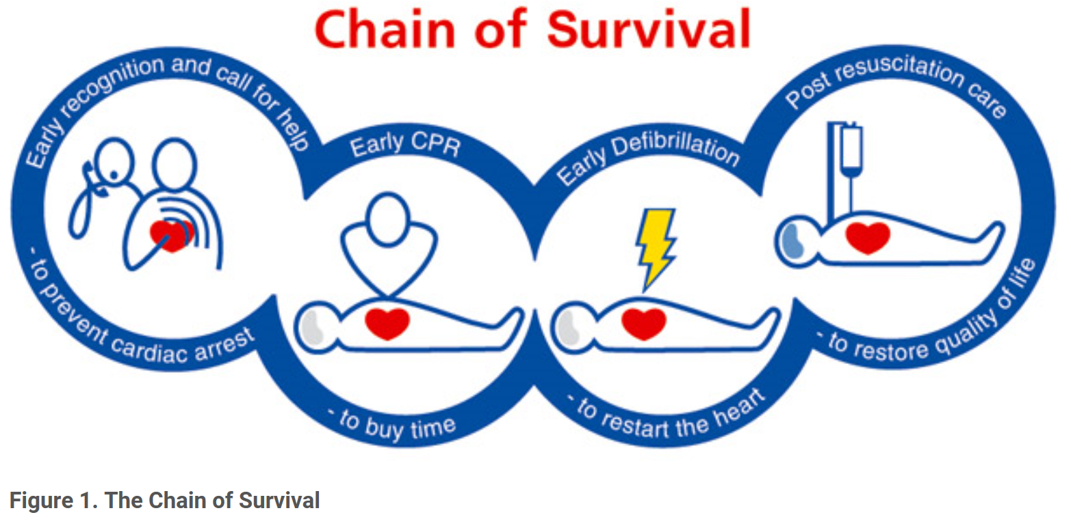

**17**. **In the event of death following resuscitation attempt**

* The nurse in charge must ensure the area is preserved as a potential ‘crime scene’ for in-patient wards.
* In the community, report the incident to your manager immediately and then ensure that the Police have been contacted.
* DEFIB/AED data may be requested as part of the enquiry. AED may need to be sent off for testing (Appendix 4). Staff need to preserve any evidence following a serious incident and replace any equipment taken out of circulation.
* The nurse in charge with the support of the DSN and duty doctor must ensure the police are contacted.
* Staff or patients should not enter the area until the police authorise use of the area or equipment used during the incident.
* Family members must be contacted, either by the ward team or arrangements made between the police service depending on the time and individual needs of carers and circumstances leading to the death.
* Local mortuary arrangements must be made with either the local acute hospital or funeral directors.
* Datix must be completed as soon as possible.
* Senior manager and consultant on call must be informed by DSN and duty doctor respectively.

**Post incident care:**

Resuscitation attempts are extremely demanding both physically and emotionally for patients, their relatives, carers and staff. Care should be taken;

* To ensure that those people who may be traumatised by the incident are identified. Every effort should be made to support those involved by listening and offering appropriate practical and emotional support immediately following the incident and at a later stage in accordance with the Trust Incident Policy and current NICE guidance.
* Debriefing following a cardiac/respiratory arrest must be handled with sensitivity. Team Leaders, Ward Managers, Duty Senior Nurses, Modern Matrons, Heads of Nursing, psychologists, night site managers, consultants and senior medical staff are identified to engage with patients, relatives, carers and staff who may have been affected following an incident.
* Many staff will have little experience of dealing with such a traumatic event as a cardiac arrest. The objective is to provide support for those involved and for staff to learn from the incident and allow those involved the opportunity to discuss the event in a constructive way without feeling blamed in any way.
* Debriefing by a person with facilitation experience should take place as soon as possible; as agreed by local arrangement
* This will allow sufficient time to gather all those involved in the incident for the debrief e.g. night staff, Duty Doctor, response team members, Duty Senior Nurse, manager on call, students, temporary staff i.e. bank and agency, other.
* If the incident happens in a ward or residential setting, a meeting with patients should be convened and the patients/residents/service users are to be offered support and appropriate aftercare as necessary.
* For patients who are under the Mental Health Act arrangements must be made between the ward and Mental Health Act Office to contact the Clinical Commissioning group.
* Should a patient die whilst in an inpatient setting, usual procedures should apply post serious incident with internal and external SI, police and coroner processes followed.
* In the case of an expected natural death, where no external investigations will be required, advice post bereavement should be given and the Death Certificate collected as per local arrangement.

**18. National Early Warning 2 Scoring System**. **Appendix** 1

* The Trust operates a National Early Warning 2 Scoring system that is designed to recognise the potentially physically deteriorating patient within an inpatient setting. All inpatient services are to use this system Appendix
* Each Directorate lead should have a system in place to audit the completion of NEWS 2 for in-patient wards. Directorate are responsible to ensure this is done and action plans are drawn up where required and addressed locally.
* It is important that the observations are recorded on patient electronic record. Staff undertaking the observations must respond accordingly on clinical presentation of patient and refer on to appropriate services as required.

**19. Reporting incidents and audit**

All resuscitation incidents must be recorded using online incident reporting system (Datix). A concise report must be completed for incidences.

A full account of the circumstances, NEWS 2 scores, actions, medication administered, equipment used and outcomes of treatment must be recorded on electronic patient record.

It is recommended that all ‘near miss’s events are audited by Directorate leaders to learn lessons and minimise further events.

Action plans are to be followed up on a Directorate basis by the Team Leader / Ward Manager and Modern Matron / Lead Nurses.

**20. In-patients and High-Risk Community Teams Resuscitation Equipment**

All in-patient areas and high-risk community teams e.g. The Spitalfields Practice, E1 will have standardised resuscitation/ emergency equipment which includes resuscitation bag, an AED, suction machine and a sealed emergency drug box.

The resuscitation bag should be stored in the clinical room and must be easily accessible by all staff and in a state of readiness.

Anaphylaxis packs must be available in all clinical areas where medication is administered. Anaphylactic packs should be stored in the Trust standard ' resuscitation bags' where these are available or in a secure location.

* Community nurses administering medication in a patient's home who suspect anaphylaxis must immediately call 999 stating 'anaphylactic reaction' and administer their adrenaline as per resuscitation guidelines.
* Items in the bags should be maintained in a tidy manner and checked every week including expiry dates as a minimum by 2 staff members, at least one of whom must be a registered nurse who is familiar with the emergency equipment. In addition, the oxygen, suction machine, ligature cutters and AED machine should be checked for presence and working condition on every shift. This must be documented on the Daily Emergency Resuscitation Equipment Checklist.
* The resuscitation bag should also be checked if the equipment has been used following a resuscitation event. The resuscitation bag should be stocked in accordance with the standardised list kept in the bag / trolley.
* Wards/ Directorates are expected to have a spare supply of disposable items available in the event of having to replace at short notice. Clinical areas should follow local procedures of how to restock items if used. The responsibilities for ensuring items are replenished remains with the Team Leader / Ward Manager.
* Disposable items should be replenished at the earliest opportunity. Non-disposable items should be de-contaminated / cleaned in accordance with both the manufacturers' policy and the infection control policy and re-instated to the resuscitation bag immediately insert how and where staff can replenish items if sites are different e.g. a centralised stock?
* The defibrillator, mechanical suction machine and pulse Oximeter and ECG must be serviced annually by the contracted provider.

**21. Community Team Resuscitation Equipment**

All community teams in Trust sites must have access to the following equipment:

Defibrillator (AED machine) in carry case. AED Defibrillator Pads (x 2 – one spare)

Tuff cut utility scissors, razor, gloves and alcohol wipes in AED carry case

AED to be stored in AED wall mounted cabinet, Pocket mask, First Aid Kit. Anaphylaxis packs must be available in all clinical areas where medication is administered. Anaphylactic packs should be stored in the trust standard ' resuscitation bags' where these are available or in a secure location.

Community nurses administering medication in a patient's home who suspect anaphylaxis must immediately call 999 stating 'anaphylactic reaction' and administer their adrenaline auto injector if available.

A weekly check of the above equipment must be carried out and documented on the community emergency equipment checklist by a BLS / ILS trained staff member.

Signs indicating the location of AED must be clearly on display in clinical and communal areas (appendix). Staff must be familiar with the steps to take in dealing with a medical emergency and calling for help i.e. 9/999 using a communication tool like SBARD.

High risk community teams e.g. specialist care areas will be expected to have the same equipment as in-patient areas.

**Resuscitation equipment in clinical areas List, please see locally.**

**Clinical services caring for children under 12 years’ old**

Where children less than 12 years old are cared for, clinical services must ensure that the right emergency equipment is available, and that staff are trained in Paediatric Life Support (PILS). PEWS must also be used for the recording of physiological observations. In the event of an emergency, the staff member trained in PILS should take the lead with the support of the response team and other staff.

The following additional emergency equipment must be available in the resuscitation bag:

* Paediatric CPR pocket mask
* Paediatric nebuliser mask
* Paediatric bag valve mask
* Oropharyngeal size 0 and 1
* Paediatric defibrillator pads and/or AED child key to adjust the voltage
* Paediatric resuscitation algorithm.
* Paediatric chocking algorithm

Paediatric Anaphylaxis packs must be available in all clinical areas where medication is administered. Anaphylactic packs should be stored in the trust standard 'resuscitation bags' where these are available or in a secure location.

Community nurses administering medication in a patient's home who suspect anaphylaxis must immediately call 999 stating 'anaphylactic reaction' and administer their adrenaline as per resuscitation guidelines.

**22. Resuscitation**

In the event of an incident occurring in the hospital grounds, canteen, gym, hospital corridor or reception areas, emergency equipment will be available for use in non-clinical areas located with the porters. The Duty Senior Nurse will be aware of the location of the nearest emergency bag and defibrillator. It is not advisable to remove emergency equipment from wards for these purposes as it may compromise care in these areas. The checking of this equipment will be completed by the Duty Senior Nurse and any items for ordering should be reported to the site manager

**23. Education and Training Requirements**

Trust staff should receive resuscitation training as per the ELFT Training Needs Analysis (TNA). Please see the ELFT Statutory and Mandatory Training Policy.

**All inpatient:** Nurses,*Band 5 and above* are now required to undertake Immediate Life Support including Anaphylaxis instead of the Basic Life Support training.

**Luton and Bedfordshire;** *All nursing staff Band 4* and above are required to undertake immediate life support training, including Anaphylaxis instead of the Basic Life Support training. This is partially due to the geographical separation of the wards.

**Doctors and junior doctors** will also be required to undertake Immediate Life Support training and Anaphylaxis instead of Basic Life Support**.** Inpatient Consultants and junior (as they do on call) require ILS.

**All Community sites;** require Community nurses that are BLS requirement and Anaphylaxis.Consultants and doctors who solely work in community need BLS and Anaphylaxis.

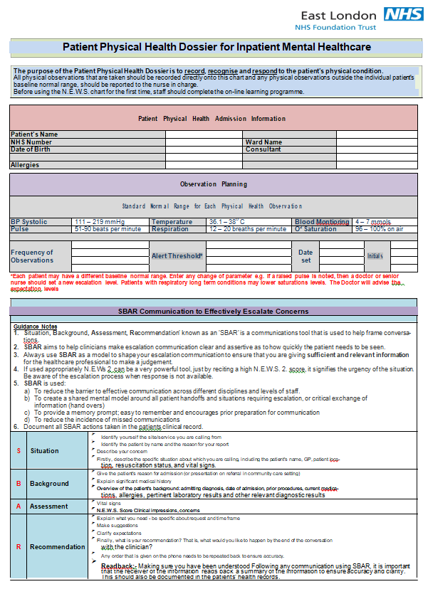**Appendix 1- NEWS 2**

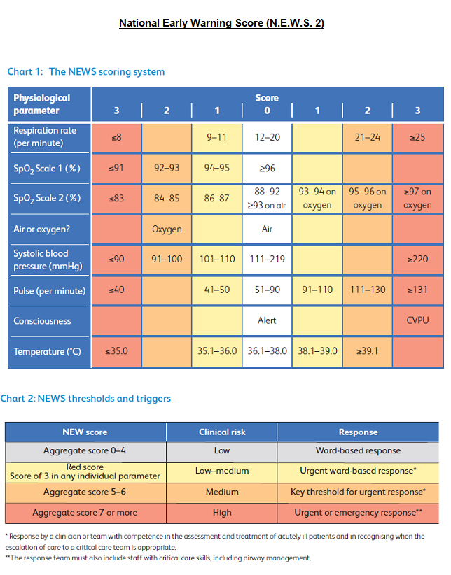

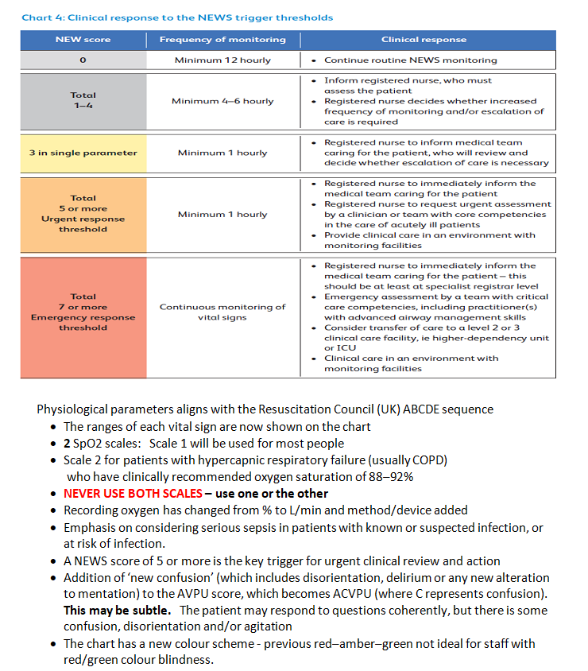



|  |  |  |  |  |  |  |
| --- | --- | --- | --- | --- | --- | --- |
| **Appendix 2** | | | | | | |
| **Location of Equipment – London**  Emergency equipment is usually located in the treatment room.  Staff should familiarise themselves with their equipment on arrival on the ward or community location.  In the Community Teams, the FRx defibrillator is in a wall cabinet close to the reception.  Staff carrying out community visits should request Laerdal masks from their Team Managers.    **All staff must know where their equipment is, must know how to summon help and must commence initial management – Basic Life Support until emergency response arrives.** | | | | | | |
| **Units** | **Calling for help** | | **Advance response** | **Other people to inform** | **Equipment** | **Responder** |
| Tower Hamlets Centre for Mental Health | Pull alarm | Use the radio to alert staff to the Cardiac Arrest and the location. | Call 9-999 | Inform reception  If appropriate, after all other measures taken and ambulance called, DSN to call duty doctor on mobile. | ILS emergency response bag | Response Team and DSN  Ambulance |
| Tower Hamlets CAMHS centres | Pull alarm or shout | Shout for staff to attend while waiting for ambulance | Dial 9-999 | Inform reception | AED  Emergency response bag | Ambulance |
| Mile End Hospital | Pull alarm or shout | Alert DSN to assess patient | **Call 9-999** | Reception coordinate calls | Crash trolley at reception | DSN, On site team  Ambulance |
| Newham Centre | Pull alarm | Use the radio to alert staff to the Cardiac Arrest and the location. | Dial 2222  and  Dial 9-999 | Inform reception | ILS emergency response bag | Rapid Response Team and DSN  Ambulance |
| John Howard Centre | Pull alarm | Use the radio to state and identify Cardiac Arrest or medical emergency and the location. | 9-999 | Call reception to request the duty doctor is called | ILS emergency response bag | Rapid Response Team and DSN  Ambulance |
| Wolfson House | Pull alarm | Use the radio to state and identify Cardiac Arrest and the location. | 9-999 | Inform reception | ILS emergency response bag | Rapid Response Team and DSN  Ambulance |
| **Units** | **Calling for help** | | **Advance response** | **Other people to inform** | **Equipment** | **Responder** |
| East Ham Care Centre | Shout for help |  | 9-999 | Inform reception | AED Oxygen  Bag valve mask Airway | Ward staff  Ambulance |
| Coborn Centre | Pull alarm | Use the radio to alert staff to the Cardiac Arrest and the location. | Dial 2222  To alert the rapid response team and the nearest doctor.  Dial 9-999 for ambulance | Inform reception  If appropriate, after all other measures taken and ambulance called, DSN to call duty doctor on mobile. | ILS emergency response bag | Rapid Response Team and DSN  Ambulance |
| City and Hackney Centre | Pull alarm | Use the radio to state and identify Cardiac Arrest and the location. | Dial 2222  For cardiac arrest team | Allocate staff to open both access doors for the Emergency Team | ALS emergency response trolley and drugs | ALS response by Cardiac Arrest Team.  Initial BLS / ILS response by MH staff. |
| **Community Staff** | | | | | | |
| **Units** | **Calling for help** | | **Advance response** | **Other people to inform** | **Equipment** | **Responder** |
| Community Teams at ELFT location | Shout for help |  | 9-999 |  | AED  Laerdal mask | Ambulance |
| Community staff in people’s homes | Shout for help |  | Dial 999 from your work mobile |  | Laerdal mask | Ambulance |

**Appendix 3**

**Assessing and treating the medically deteriorating patient using the ABCDE approach**

**Assessment using the ABCDE process for breathing patients**

With this process, you address issues as you find them.

**D - Danger**

Safety first, make sure you are safe to carry out your assessment.

**R – Response**

Use AVPU to assess conscious level

Alert

Voice – loud voice, tell them to open their eyes

Pain – Trapezius squeeze both shoulders

Unresponsive

It does not matter *HOW* they respond, it’s *WHAT* they respond to.

**A – Airway**

Assess the patency of the airway, clear obstructions before moving on.

**B - Breathing**

Assessment starts with RATE of breathing – should be between 12 and 20 breaths a minute.

Then quality of breathing – shallow, laboured, noisy

Then skin colour – pale, sweaty, cyanosed

Then SpO2 reading – between 94% and 98% is the target but always look at the clinical picture as well.

**C – Circulation**

Start with manual pulse – rate, regularity & volume. This will also give you skin temperature and sweatiness.

Blood pressure

Capillary Refill – press for 5 seconds and then release to see time for colour to return (should be 2 seconds) longer implies poor perfusion.

**D – Disability**

This is an assessment of brain function

Conscious level (AVPU)

Blood sugar (between 4 and 10)

Pupil reaction (equal and constricting with light)

**E – Expose, Environment, Everything Else**

Physical examination of patient for bleeding, fractures, rashes, distension of abdomen, blood loss from orifices.

Temperature

History from notes, bystanders, other professionals

Look for medic alert bracelets and drug charts

Intervene when you find something wrong, Oxygen therapy as soon as you identify the patient has a decreased level of consciousness, raised respiratory rate, difficulty breathing, cyanosis or any combination of the above.

**Call for response team and ambulance early. Any patient with an altered level of consciousness or breathing difficulties is a medical emergency.**

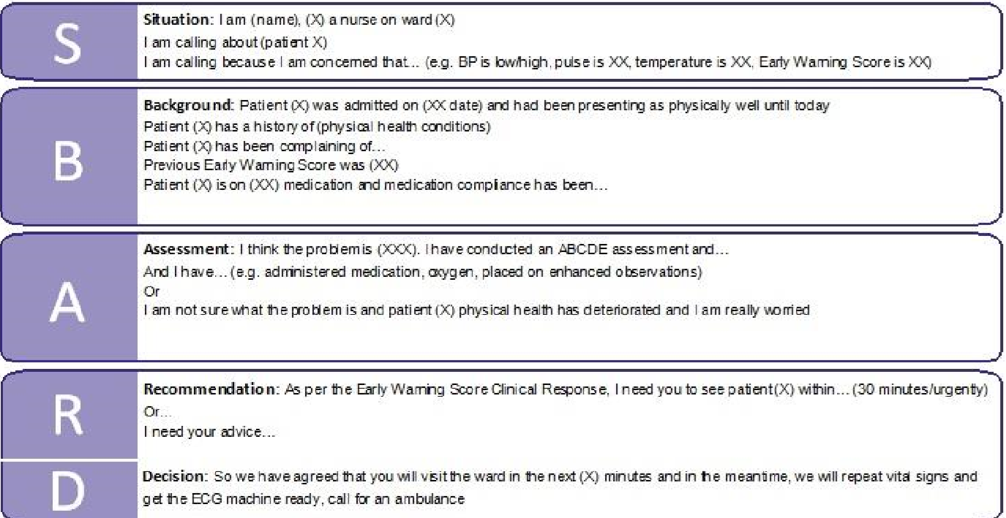

**Figure 1 SBARD Communication Tool**

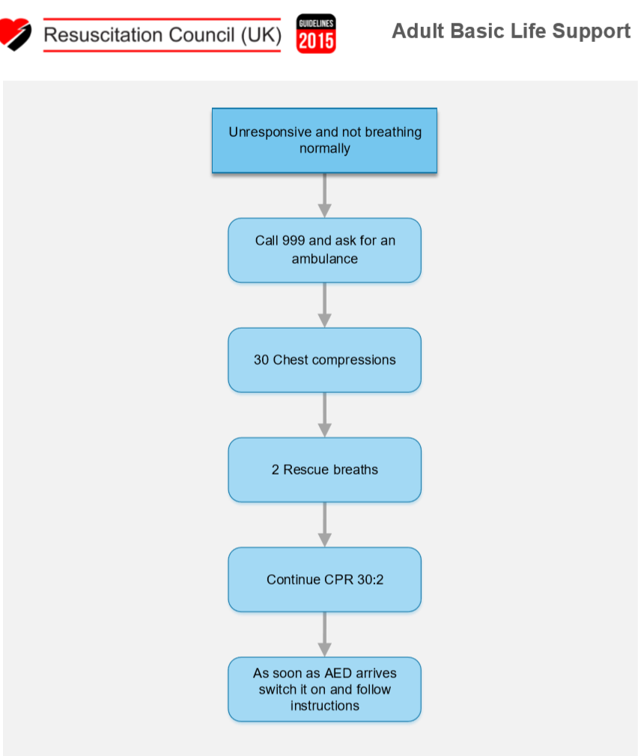

<https://www.resus.org.uk/resuscitation-guidelines/adult-basic-life-support-and-automated-external-defibrillation/#sequence>

**Figure 2**

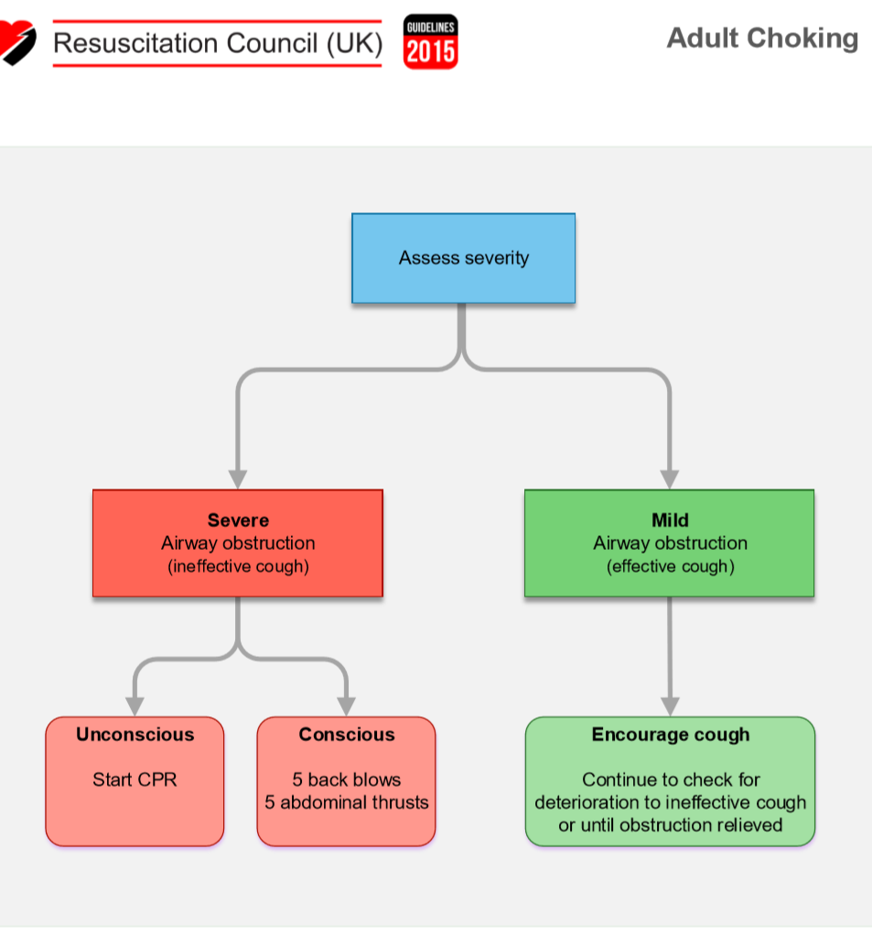

<https://www.resus.org.uk/resuscitation-guidelines/adult-basic-life-support-and-automated-external-defibrillation/#foreign>

**Figure 3**

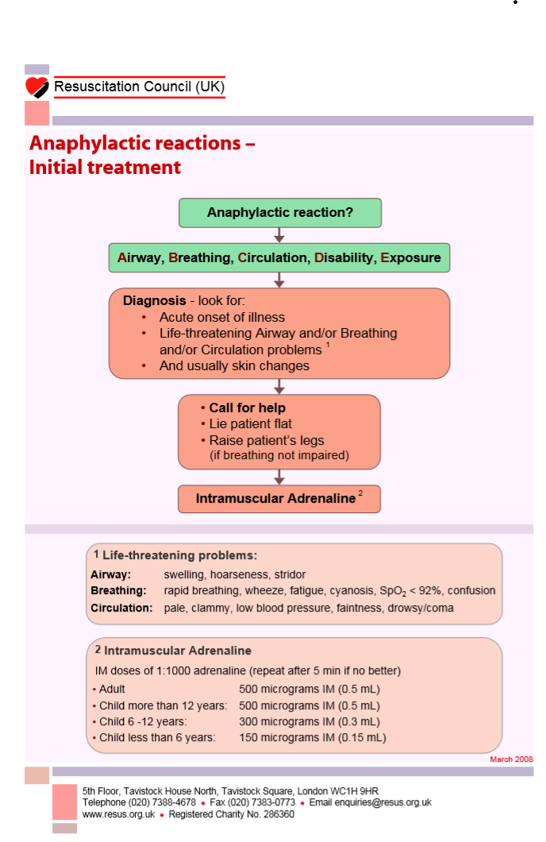**Figure 4** <file:///C:/Users/user/Downloads/EmergencyTreatmentOfAnaphylacticReactionsPPT.pdf>

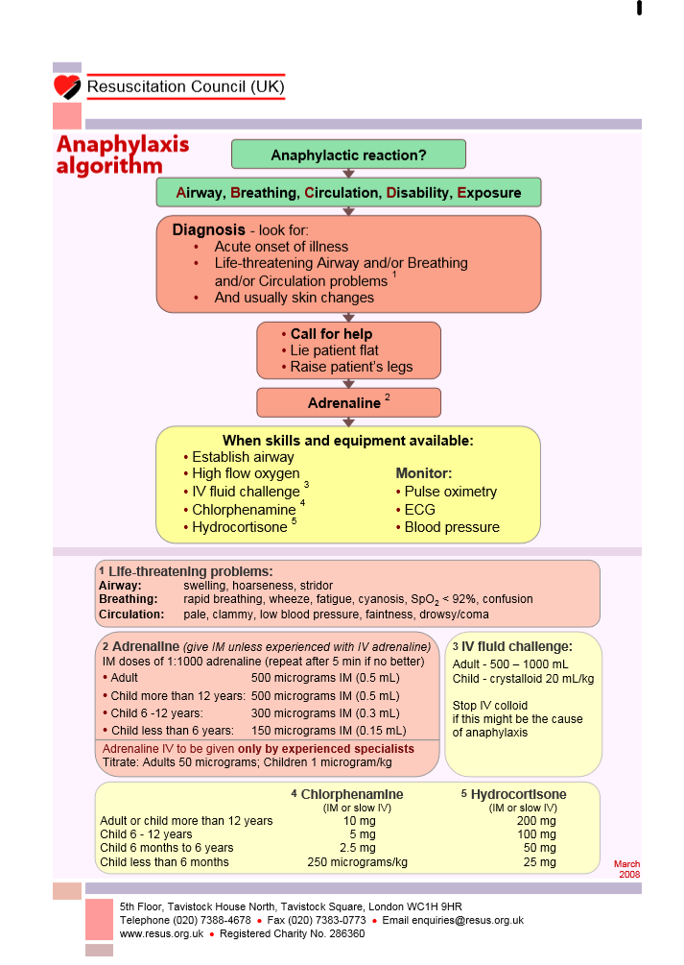**Figure 6** <file:///C:/Users/user/AppData/Local/Packages/Microsoft.MicrosoftEdge_8wekyb3d8bbwe/TempState/Downloads/EmergencyTreatmentOfAnaphylacticReactions%20(2).pdf>

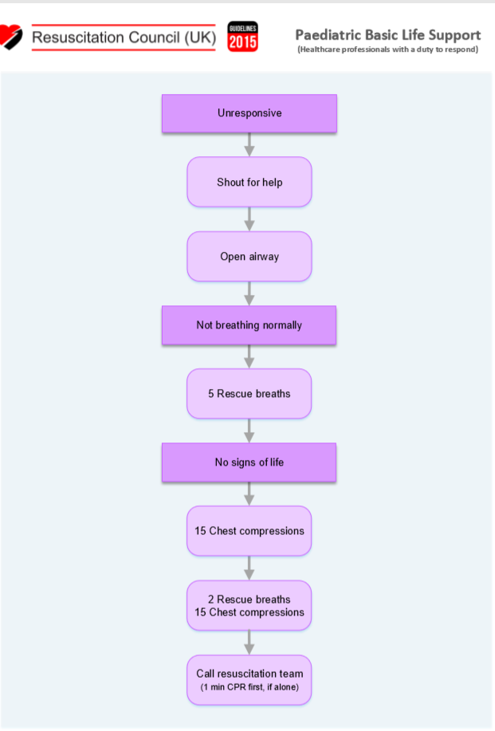

**Figure 7**

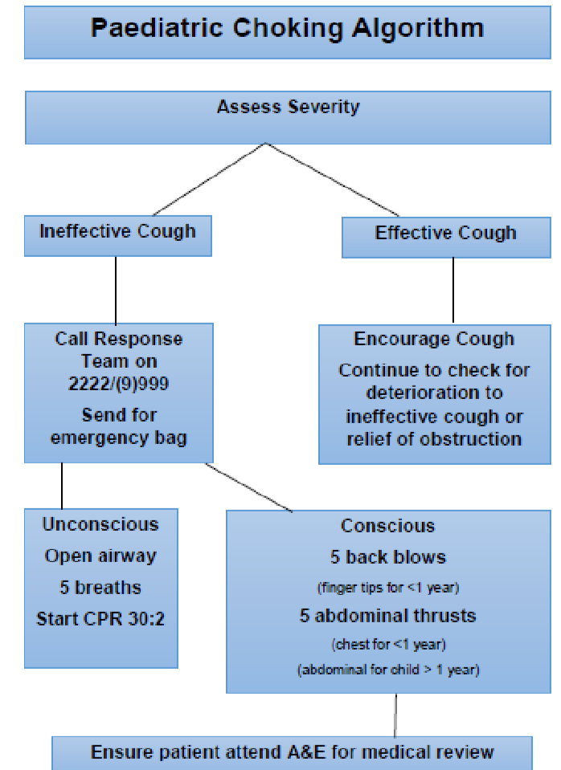

**Figure 8**

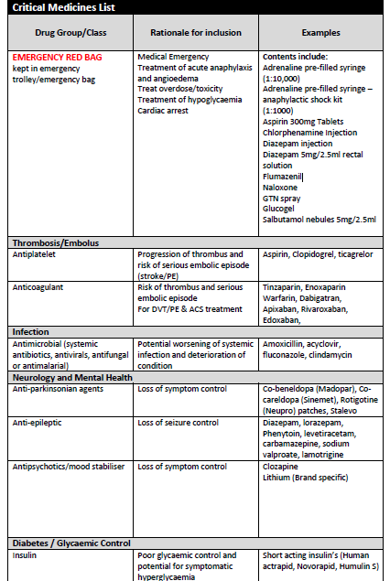 **Appendix 4**

**Use of Oxygen during a Medical Emergency**

The administration of supplementary oxygen is an essential element of appropriate management for a wide range of clinical conditions: however, oxygen is a drug and it therefore requires prescribing in all but emergency situations. Failure to administer oxygen appropriately can result in serious harm to the patient. The safe administration of oxygen therapy with appropriate monitoring is an integral part of the healthcare professional’s role. The aim of oxygen therapy is to achieve normal or near normal oxygen saturation for all acutely ill patients, apart from those at risk of respiratory failure. The usual saturation target is 94-98%.

In an emergency, oxygen prescription is not required. Oxygen should be given to ANY patient seen to be in respiratory distress, regardless of aetiology. It should be administered without delay and without a formal prescription but documented later on electronic patient’s record. All unwell, critically ill patients should be given 100% oxygen (15l/m reservoir mask) whilst waiting immediate medical review. Patients with Chronic Obstructive Airways disease (COPD) and other risk factors who develop critical illness should have the same initial target saturations as other critically ill patients. The target saturation levels should be in the range of 88-92%.

All patients who have a cardiac or respiratory arrest should have 100% oxygen provided along with resuscitation appropriate to the provider’s skills and equipment provision. Unwell patients with hypoxia should have emergency oxygen aimed at maintaining an oxygen target of 94-98%. If no reliable oxygen saturation probe is available: administer high flow oxygen initially until saturation can be measured, then adjust to meet appropriate oxygen target. Written records must be made along with what oxygen therapy has been given to the patient in addition to recording all other emergency treatment.

Nebulised therapy and oxygen Nebulisers are usually given via oxygen or a nebuliser machine. All patients requiring 35% or greater oxygen therapy should have their nebulised therapy by oxygen at a flow rate of >6 litres/minute. Patients with acute asthma symptoms should be managed as a medical emergency. In an emergency situation, nebuliser ampoules are available in the Emergency Drug Box

and the nebuliser mask is in the Resuscitation Bag.? Patients administering routine or prescribed nebulisers may use a nebuliser machine, as appropriate.

Pregnancy Pregnant women (20 weeks) should be managed in the left lateral position to improve cardiac function. The same target saturation should be sought as for any other seriously ill users (94-98%).

Monitoring Check, the patient's colour, respiratory rate and heart rate, degree of respiratory distress and pulse oximetry.

<http://www.brit-thoracic.org.uk/clinical-information/emergency-oxygen/emergency-oxygen-use-in-adultpatients.aspx>

**Appendix 5 - Defibrillation**

Defibrillation is one crucial stage in a sequence of events that need to occur for the resuscitation of a victim of sudden cardiac arrest (SCA). This sequence, or ‘chain of survival’, starts by summoning the emergency services as soon as possible. The second stage is providing basic cardiopulmonary resuscitation (chest compressions alternated with rescue breaths) to keep the victim alive until the third stage (defibrillation) can be performed. Defibrillation is the use of a high-energy electric shock that stops the chaotic rhythm of VF and allows the normal, organised, electrical rhythm of the heart to re-start. This can allow the pumping action of the heart to return.

The major factor limiting the number of people who survive SCA is the ability to provide defibrillation within a critical time. Conditions for defibrillation are optimal for only a very few minutes after the onset of VF, although this period can be extended if a bystander provides effective cardiopulmonary resuscitation (CPR), particularly chest compressions. The victim’s chance of survival falls by around 7 - 10% with every minute that defibrillation is delayed. AEDs are designed to deliver a shock only when required, they are therefore unlikely to do any harm to a person who has collapsed in suspected SCA. They are also safe and present minimal risk of a rescuer receiving a shock. <https://www.resus.org.uk/resuscitation-guidelines/adult-basic-life-support-and-automated-external-defibrillation/#summary>

**Location, Storage and Maintenance**

AEDs provided in the Trust should be accessible within three minutes of a confirmed cardiac arrest in keeping with the Resuscitation Council (UK) guidance. AEDs located in clinical areas should be stored in clinic rooms. AEDs located in non-clinical areas e.g. community centre, swimming pool, reception areas should be stored in a protective cabinet; the standard sign for an AED should be used to show where it is stored .

The AED should be stored in the emergency bag on in-patient units. It should be clean with no signs of damage. A flashing green light or X light (top right hand corner) showing alternating hour glass/square means it is ready for use. Defibrillator pads should be stored inside the carry case along with a spare set for each unit. Pads should be sealed, undamaged, within date and are compatible with available defibrillator model. A spare defibrillator battery with the “Install Before” date should be available and is compatible with defibrillator model in the unit. AEDs require hardly any routine maintenance or servicing; most perform daily self-checks and display a warning if they need attention.

The AED should be checked visually daily to ensure it is accessible and ready for use. An annual service by the contract engineers will ensure it is maintained in keeping with manufacture’s guidance. Site managers should ensure arrangements for replacement are in place if an AED is removed for any reason.

Clinical areas where children under 12 years old are cared for must have paediatric pads and/or defibrillator child key to allow the device to adjust the voltage.

All community teams will have an AED that is visible and easily accessible. A pocket mask should be available for use.

Clinical areas where children under 12 years old are cared for must have paediatric pads and/or defibrillator child key to allow the device to adjust the voltage.

All community teams will have an AED located in a cabinet that is visible and easily accessible. A pocket mask should be available for use.

**Automated External Defibrillators** (**AED) Flowchart**

1. [Incident Policy](http://elftintranet/sites/common/Private/Contentobject_View.aspx?id=28669),
2. [Information Governance and IMT Security Policy](http://elftintranet/sites/common/Private/Contentobject_View.aspx?id=58082)
3. [Medical Device Policy](http://elftintranet/sites/common/Private/Contentobject_View.aspx?id=28696)
4. [Cardio-Pulmonary Resuscitation Policy](http://elftintranet/sites/common/Private/Contentobject_View.aspx?id=28877)

**References and Further Reading**

1. Competencies for Recognising and Responding to Acutely Ill Patients in Hospital. Department of Health. 2009.   
   [http://webarchive.nationalarchives.gov.uk/20130107105354/http://www.dh.gov.uk/en/Publicationsandstatistics/Publications/PublicationsPolicyAndGuidance/DH_096989](http://webarchive.nationalarchives.gov.uk/20130107105354/http:/www.dh.gov.uk/en/Publicationsandstatistics/Publications/PublicationsPolicyAndGuidance/DH_096989)
2. The ECT Accreditation Service (ECTAS).   
   <http://www.rcpsych.ac.uk/workinpsychiatry/qualityimprovement/qualityandaccreditation/ectclinics/ectas/ectasstandards.aspx>
3. Establishing a standard crash call telephone number in hospitals. Patient Safety Alert 02. London: National Patient Safety Agency; 2004.
4. The Human Medicines Regulations 2012.   
   This legislation applies to non-prescribers and allows holders of a current Resuscitation Council (UK) ‘Advanced Life Support’ provider certificate to administer adrenaline and amiodarone without prescription to adults in cardiac arrest.<http://www.legislation.gov.uk/uksi/2012/1916/contents/made>
5. National Early Warning Score 2 (NEWS 2). Standardising the assessment of acute-illness severity in the NHS. Royal College of Physicians. Report of a working Party. July 2012.   
   <http://www.rcplondon.ac.uk/resources/national-early-warning-score-news>
6. National Institute for Health and Clinical Excellence. Acutely ill patients in hospital: recognition of and response to acute illness in adults in hospital 2007 (NICE Guideline 50).
7. National Institute for Health and Clinical Excellence.
8. Violence: The short-term management of disturbed/violent behaviour in in-patient psychiatric settings and emergency departments (Clinical Guideline 25).<http://publications.nice.org.uk/violence-cg25>
9. Rapid Response Report NPSA/2008/RRR010: Resuscitation in Mental Health and Learning Disability settings (November 2008).   
   [http://www.nrls.npsa.nhs.uk/resources/?EntryId45=59895](http://www.nrls.npsa.nhs.uk/resources/)
10. Resuscitation Guidelines 2015, Resuscitation Council (UK).   
    [http://www.resus.org.uk/resuscitation-guidelines/](https://www.resus.org.uk/resuscitation-guidelines/)
11. Resuscitation Council UK. (2017). *Quality standards for cardiopulmonary resuscitation practice and training.* Available: <https://www.resus.org.uk/quality-standards/mental-health-inpatient-care-quality-standards-for-cpr/https://www.resus.org.uk/quality-standards/mental-health-inpatient-care-quality-standards-for-cpr/>. Last accessed 29th June 2019.
12. Resuscitation Council UK. (2015). *The ABCDE Approach.* Available: <https://www.resus.org.uk/resuscitation-guidelines/abcde-approach/>. Last accessed 29th June 2019.
13. Advanced Life support <file:///C:/Users/user/Downloads/EmergencyTreatmentOfAnaphylacticReactionsPPT.pdf>

**Supporting Tools**

1. Lifesaver. An interactive film by Martin Percy. 2013.
2. Mobile apps:   
   [https://itunes.apple.com/gb/app/lifesaver-mobile/id633999639?ls=1&mt=8](https://itunes.apple.com/gb/app/lifesaver-mobile/id633999639)   
   [https://play.google.com/store/apps/details?id=air.com.unit9.lifesaver.android.mobile](https://play.google.com/store/apps/details)   
   Tablet apps:   
   [https://itunes.apple.com/gb/app/lifesaver-for-ipad/id633568035?ls=1&mt=8](https://itunes.apple.com/gb/app/lifesaver-for-ipad/id633568035)   
   [https://play.google.com/store/apps/details?id=air.com.unit9.lifesaver.android.tablet](https://play.google.com/store/apps/details)
3. Paediatric Early Warning Scoring (PEWS) charts are available for download at:<http://www.institute.nhs.uk/safer_care/paediatric_safer_care/pews_charts.html>

**Resuscitation group meetings - Terms of Reference**

The Trust has an obligation to provide a high-quality resuscitation service and to ensure staff are trained and updated regularly to a level of proficiency appropriate to each individual’s expected role as set by the Resuscitation Council (UK) Guidelines.

The Trust has to ensure quality standards for managing medical emergencies and cardiopulmonary resuscitation are maintained in keeping with the needs of patients in a mental health and community setting and there are clear lines of accountability for resuscitation services throughout the organisation. This also covers the physically deteriorating patient.

**Responsibilities of the resuscitation governance /committee include**:

1. Developing a strategy for communicating developments of the Resuscitation Policy decisions to the Physical healthcare and Quality committees.
2. Ensuring the resuscitation policy is updated to national resuscitation guidance and Medicines & Healthcare products Regulatory Agency (MHRA) regulations and standards and National Audit Office recommendations.
3. Ensuring implementation and adherence of the resuscitation policy
4. Ensuring staff receive regular training and competency in the management of medical emergencies. This includes planning training needs analysis, content delivery and providing adequate training provision for staff including recognising and managing the deteriorating patient using an early warning scoring system and prevention of cardiac arrest.
5. Ensuring training provided using Trust standard devices
6. Ensuring that emergency equipment is standardised and drugs are available for use for managing medical emergencies.
7. Ensuring systems are in place that confirms resuscitation equipment is available and ready for use.
8. Ensuring that systems of maintenance of all emergency equipment used within the Trust are robust, including contractual arrangements with Acute Trusts and Medical Physics and Bioengineering providers.
9. Evaluating and monitoring safety alerts and reporting with regard to medical emergency equipment
10. Defining the roles of the emergency response team.
11. Ensuring Quality improvement projects e.g. Audits of all serious medical emergencies and resuscitation events as reported on Datix online reporting system and audits on the use of DNACPR decisions.
12. Review resuscitation audits in which patients’ safety may have been at risk

**Chair:** Trust Resuscitation Lead

Contractor for Resuscitation, Representatives from ILS and BLS training providers from the Trust’s Education and Development Department, Representative from Mental Health Older Adults e.g. Do Not Attempt Resuscitation Policy, Representative from Education and Development, Junior doctor representative, Patient representative

Co-opted group for standardising equipment for the Trust and policy reviews, Pharmacy, Senior Nurses, Bio Medical Engineer, Health and Safety Advisers, Infection prevention and control.

Membership of this group should be the same person each time to achieve consistency except for the standardisation of equipment.

**Resuscitation Audit Tool**

**‘Most patients who have an in-hospital cardiac arrest have warning signs and symptoms before the arrest. Early recognition and treatment of the deteriorating patient will prevent some cardio-respiratory arrests’. *Resuscitation Council (UK) ILS Third Edition manual***

**Name of patient: Reported by:**

**Ward Reported to:**

**DOB: Date of incident:**

**Datix Incident number:**

**Ward**

**The purpose of this audit is to review the use of the early warning scoring system and the resuscitation event concerning this incident. The audit is used to support any investigations by the Trust and will suggest any immediate recommendations to be implemented.** The audit examines the following points:

* Implementation of the early warning scores
* Management decisions on high NEWS scores
* Safety checks and observations of the service user
* Response times and interventions used during the incident
* The use of Immediate life support ( ILS) and emergency equipment
* Post resuscitation incident
* ILS/BLS training for staff

|  |  |  |  |  |  |
| --- | --- | --- | --- | --- | --- |
|  | **Audit issues** | **Comments** | **Recommended Action** | **Who** | **R**  **A**  **G** |
| ***1***  ***2***  ***3***  **4**  **5**  **6** | ***Background to the incident-***  *State nature of incident**e.g. sudden death, attempted suicide, stroke, Cardiac arrest, fall, seizure, rapid tranquilisation,*  ***Overview of the Early Warning Scores (NEWS) physical observation chart*** *within the past 7 days of the incident (refer to NEWS audit). Was there evidence that high scores were escalated in keeping with action protocol? Was there a physical care plan in place to highlight risks?*  *Were the baseline observations performed on admission?*  ***Response times and interventions used during Resuscitation event***  *Was there a delay in starting basic life support/immediate life support? Was help called asap? E.g. alarms activated, 2222/999, did the emergency team respond appropriately?*  *On finding an unresponsive person, staff are expected to use the* ***A****irway* ***B****reathing* ***C****irculation* ***D****isability* ***E****xposure approach to assess and treat the patient. If there are no signs of life (based on purposeful movement, normal breathing, coughing) Chest Compressions should be commenced immediately, Oxygen 15L/min via a bag-valve-mask and placing of Defibrillation pads/electrodes on the chest until the arrival of Medical staff who may be able to obtain IV access for fluids and IV drugs.*  *During the treatment of persistent asystole/Pulseless electrical activity, emphasis is placed on good quality chest compressions between defibrillation attempts, recognising and treating reversible causes and obtaining a secure airway and IV access.*  *Staff that discovers the patient is expected to begin and continue CPR once a cardiac arrest is confirmed until told otherwise by someone with more experience or until death is confirmed by a doctor or paramedic.*  **Emergency Equipment used**  *Was the emergency equipment brought to the scene without delay? Was the equipment used in keeping with the standardised list of contents, were they in good working order and was there evidence of weekly checking to ensure all items were present and not expired? Was equipment stored safely and readily accessible during the incident? Were items used replenished asap (within the same shift)?*  ***Staff training in Basic Life Support (BLS) or Immediate Life Support (ILS)***  *Refer to training needs analysis for staff involved in the incident; include bank/agency staff records if available. Did an insitu simulation of medical emergency including familiarisation of emergency equipment take place in the past 6 months?*  **Observation of the patient prior to the incident occurring**  *Were the observations of the patient in keeping with the Engagement and Observation policy; were the staffing levels**appropriate for the shift? Did a visual handover take place at the beginning of the shift where the incident occurred? In the event of a sudden death at night were observations of the patient documented hourly? Was the body warm or cold to touch?*  **Post resuscitation incident**  *Was the room preserved as a crime scene in the event of a death on the ward? Was Last offices considered? How was privacy and dignity maintained during and following incident? Were the family and police informed immediately? Did a debrief occur within 72hours post incident? What support was offered to both staff and any patient involved?*  **Impressions**  *Was the response to this resuscitation event in keeping with trust policy? Areas of good practice, was there missed opportunities to avoid the incident from occurring in the first place?*  **Recommendations:** *What are the immediate recommendations for ensuring patient safety? e.g. risk assessment and risk management, review of staffing levels, ,investigation of staff performance, staff training.* |  |  |  |  |