Recruitment & Retention Premia Policy

Version number : | 1.0
Consultation Groups | JSC Policy Sub-Committee
Approved by (Sponsor Group) | JSC Policy Sub-Committee
Ratified by: | Joint Staff Committee
Date ratified: | 3rd July 2024
Name of originator/author: | People Business Partner  Staff side
Executive Director lead :
Implementation Date : | July 2024
Last Review Date | July 2024
Next Review date: | July 2025

Services | Applicable
Trust wide | X
Mental Health and LD
Community Health Services

Version Control Summary

Version | Date | Author | Status | Comment
1.0 | July 2024 | People Business Partner  Staff side

Contents

1. Policy Statement 4
2. Purpose 4
3. Scope 4
4. Definition 4
5. Equality and Diversity Statement 4
6. Roles and Responsibilities 5
7. Types of recruitment and retention premia 5
8. Critical Service Allowance 6
9. Determining the Need for Recruitment & Retention Premia 7
10. Consultation Process 7
11. Pan London Consultation (London based directorates) 8
12. Amount of RRP Payable 8
13. Reviewing RRP Arrangements 8
14. Training and Awareness 8
15. References 10
16. Contact Details 10
17. Monitoring, Audit and Review Procedures 10
Appendix 1 11
Application Form for Directorates out of London 11
Appendix 2 15
Market Sensitive Supplement (EXTENSION) – Application Form 15
Appendix 3 Pan London Policy 19
Appendix 4 22
Pan London Application for RRP 22

Policy Statement

1.1 The NHS pay system is predicated on the basis that employees will receive equal pay for work of equal value. However, it is accepted that market forces will apply to some jobs and some geographical areas. These market forces can be addressed by the payment of a Recruitment and Retention Premia (RRP).

The principles and rules in respect of the payment of a RRP are laid down in Section 5 of the NHS Terms & Conditions Handbook. Reference should also be made to Annexes 10 and 11 of the NHS Terms & Conditions Handbook.

Purpose

2.1 The aim of this policy is to set out the procedure and application of Recruitment and Retention Premia for applying local, short- or long-term premia and national premia requiring local agreement.

2.2 It is intended to give information, advice, and guidance on the process for determining RRP and the process for consulting on the proposed premia prior to implementation.

Scope

3.1 This policy applies to all staff employed by East London NHS Foundation Trust, together with those on a joint contract with the organisation and another employer. The policy is applicable to NHS Terms and Conditions of Service (AfC) posts where market pressures would otherwise prevent the organisation from being able to recruit and retain staff in sufficient numbers (for the posts concerned) at the normal salary for the job.

Definition

4.1 Recruitment and Retention premia are additions to the pay of a post or group of similar posts where market pressures would otherwise prevent the Trust from being able to recruit or retain staff in sufficient numbers at the normal salary for jobs of that weight.

Equality and Diversity Statement

5.1 The Trust is committed to preventing discrimination, valuing diversity, and achieving equality of opportunity. No person (staff, patient or public) will receive less favourable treatment on the grounds of the nine protected characteristics (as governed by the Equality Act 2010): sexual orientation; gender; age; gender re-assignment; pregnancy and maternity; disability; religion or belief; race; marriage and civil partnership. In addition to these nine, the Trust will not discriminate against the grounds of domestic circumstances, social- economic status, political affiliation, or trade union membership.

5.2 The Trust is committed to ensuring all services, policies, projects, and strategies undergo equality analysis.

Roles and Responsibilities

6.1 Responsibilities of the Manager (budget holder)

Once the need for a new RRP or continuation of an existing provision is identified, the manager will be responsible for:

- Completing the RRP application form (Appendix 1) or the extension application form (Appendix 2) with support of the People Information team, People Business Partner, Finance Business Partner and Divisional Director, or Corporate Director, as needed.
- Consultation with stakeholders, including Trust Staff Side and preparation for Pan London or East of England consultation.
- Gaining sign off from the Divisional/Corporate Management Team implementing the decision, including:
- approving all final adverts to ensure that they correctly list details of the approved market sensitive supplement.
- processing market sensitive supplements that are to be amended, withdrawn, extended and/or reclaimed.
- monitoring the impact of the RRP against predicted outcome.

6.2 Responsibilities of the People Business Partner

The PBP is responsible for:
Providing support to line managers in the development of a business case for the RRP advising managers on the implementation of the approved RRP in the division

6.3 Responsibilities of the People Information team

The People Information team is responsible for:

- Providing advice and support on the application of Market Sensitive Supplement policy
- Organising annual reviews of existing market sensitive supplements
- Assisting the Executive Committee with the information it needs to reach a decision on market sensitive supplements.
- Producing an annual report on the application of market sensitive supplements for the members of the Executive Committee.

6.4 Responsibilities of the Executive Committee

The Executive Committee will assess new applications and make sure existing market sensitive supplements are carefully reviewed with consideration given to whether predicted recruitment activity and financial savings are being achieved.

Types of recruitment and retention premia

7.1 There are two broad types of Recruitment and Retention Premia:

    - Locally agreed long-term RRP
    - Locally agreed short-term RRP

7.2 Short term RRP (including Golden Hello) will apply where the labour market conditions giving rise to recruitment and retention problems are expected to be short term and where the need for the premium is expected to disappear or reduce in the near future.

Short term RRP is an addition to pay spread over a fixed period.

Short term RRP:

- will be reviewed no less frequently than once every 12 months.
- may be withdrawn or have the value adjusted, subject to a notice period of six months.
- may be awarded to new staff at a different value to that which applies to existing staff.
- will not be pensionable, or count for purposes of overtime, unsocial hours payments or any other payments linked to basic pay excluding high-cost allowance. It will be paid as an allowance on ESR.
- It will no longer paid from the date of resignation and notice period begins.
- Those who move to restricted duties will have pay protected until the end of the HR process or return to work.

7.3 Long term RRP will apply where the relevant labour market conditions are deeper rooted and the need for the premium is not expected to vary significantly in the near future. It will be paid as a percentage of the whole pay.

Long Term RRP:

- will be reviewed no less frequently than once every 12 months.
- may be withdrawn or have the value adjusted, subject to a notice period of six months.
- may be awarded to new staff at a different value to that which applies to existing staff.
- will be pensionable, and will count for the purposes of overtime, unsocial hours payments and any other payments linked to basic pay.
- Will no longer be paid from the date a resignation period begins.
- Those who move to restricted duties will have pay protected until the end of the HR process or return to work.

Critical Service Allowance

8.1 Critical Service Allowance is paid to retain the employment of people who are critical to the delivery of a service in advance of and up to the date of a major change to the delivery of a function (e.g., outsourcing or merger) where there is a significant risk of service disruption as a result of resignations. Unless other arrangements are agreed, the whole of a Critical Service Allowance must be repaid if someone leaves before the change takes place.

  - The terms under which short- and long-term recruitment and retention premia can be allocated are defined in Part 2, Section 5 of the NHS Terms & Conditions of Service Handbook.

Determining the Need for Recruitment & Retention Premia

9.1 The case for payment of a RRP must be robust enough to resist the challenge of an equal pay/equal value claim.

9.2 The main factors that will indicate a prima-facie case for consideration of RRP are a repeated failure to recruit to a specific post(s) and/or an elevated level of staff turnover in a specific post(s). Thus, in determining whether a RRP is appropriate, the following evidence should be gathered:

    - Evidence that all the new vacancies have been advertised in relevant local, regional, national and/or professional media.
    - Evidence that recent adverts have produced insufficient suitable applications to fill all vacancies.
9.3 Where recent adverts have produced insufficient suitable applications. The following are examples of information that should be ascertained:

    - The range of media used to advertise the post(s).
    - Reasons why those who applied were not suitable.
    - The quality of the recruitment documentation (advert, Job Description, Person Specification etc.) should be scrutinized.
    - Where an applicant(s) was offered a position but rejected the offer, the reasons for not accepting the position.
    - Relevant national vacancy data.
    - Vacancy data for the service.
    - Local labour market information, where appropriate.
    - Any expected increase in the supply of staff suitable for the post (e.g., new trainees).
    - The turnover % rates for the staff group concerned in relation to the ELFT average.
    - The stability index for the staff group concerned (has turnover risen sharply recently after an extended period of stability? Is it only recently appointed staff who leave etc.?)
    - Where possible, local turnover rates should be compared with ELFT and national rates.
    - The position of neighbouring Trusts in relation to recruitment and/or retention of the staff group concerned.

9.4 Evidence should be provided against all the key bullet points above or if it is not possible to provide evidence an explanation as to why it is not possible to supply evidence should be documented (e.g., it is not possible to detail turnover rates because it is a newly developed post or role etc.).

9.5 Where an application for RRP is presented, the Chief People Director will establish an RRP Group constituted of Trade Union Representatives, People & Culture Representatives and Management Representative, to review the evidence gathered and determine whether RRP is appropriate and if so the type of RRP needed (short-term or long-term) together with the level of any such premia as defined in Section 5 of the Terms and Conditions of Service Handbook.

Consultation Process

10.1 Once the Trust has decided that a recruitment and/or retention problem can best be resolved through payment of a RRP, there is an expectation to consult with neighbouring employers (i.e., all the NHS organisations), staff side organisations, and other stakeholders such as the ICB, before implementing any long-term premium. This should be completed in 10 working days.

10.2 When the Trust considers payment of a RRP the pro-forma (Appendix 1) should be completed, outlining the case and evidence base for the premia.

10.3 At the end of the 10-day consultation period, the RRP Group constituted to consider the RRP will be re-convened to review the RRP considering the comments received. If any changes are made to the RRP, the Trust will inform those parties to the consultation of the final decision.

Pan London Consultation (London based directorates)

11.1. This is an external consultation process that seeks feedback from the wider NHS economy on the potential impact of the proposed market sensitive supplement on them. The process involves consulting with a group of representatives from the wider NHS economy in London (Appendix 3)

11.2 Pan London consultation will take place prior to the internal approval process and its feedback will be included in the internal application form for consideration. This will usually take around two – three weeks.

11.3 The manager responsible will consult with Trust Staff Side before proceeding with Pan London consultation.

11.4 To commence the consultation process, the manager responsible will complete and submit the application form (Appendix 1) to the People Information team who will liaise with the Pan London group for the consultation and notify the manager of the outcome. Responses to pan London comments or/and questions may be required by the division making the application.

Amount of RRP Payable

The combined value of any nationally awarded and any locally awarded RRP for a given post should not normally exceed 30% of basic salary with the recommended starting amount being 15%.

Reviewing RRP Arrangements

13.1 Recruitment and Retention premia should be reviewed every 12 months to determine whether the premia is still required. The review should consider the same evidence as described in section 8 and this information should be considered by the RRP Group to ensure an informed decision is reached.

13.2 The review should include engaging with neighbouring employers and other stakeholders to advise of the continuation or cessation of the RRP together with any changes (other than cost of living adjustments) to the level of the premia.

Training and Awareness

14.1 Advice and support will be provided by the People & Culture team to support staff and managers in adhering to this policy and their understanding of dealing with Recruitment & Retention Premia.

  - The People & Culture team will raise awareness of this policy through the publication of information on the Intranet and to advise staff of changes to the policy through the staff bulletin and ratification processes.

References

This policy should be read in conjunction with Part 2, Section 5 of the NHS Terms and Conditions of the Service Handbook.

Contact Details

Any queries regarding this policy should be directed to People & Culture.

Monitoring, Audit and Review Procedures

17.1 This policy will be monitored and audited on a regular basis. A full review will take place every two years by People & Culture unless legislative changes determine otherwise.

17.2 The NHS Organisation should monitor the awarding of any new RRPs to ensure compliance with the Equality Act 2010 by avoiding direct or indirect discrimination in respect of a protected characteristic as specified in that Act, in particular gender, and by meeting the public sector equality duty’.

Appendix 1

Application Form for Directorates out of London

Section 1 - TO BE COMPLETED BY THE DEPARTMENTAL MANAGER
Division / Corporate Directorate & Ward / Department
Describe the proposed Recruitment & Retention Payment you want to make:

1. Tick the requested option:
- Golden hello
- Short term RRP
- Long term RRP
- Critical Service Allowance

2. Level of payment (e.g., total payment per person or payment per annum per person if RRP and 15-30% allowance)

3. Frequency of payment and the value per payment
(e.g., Golden Hello - £xx upfront on commencing the job and £xxx after xxx months)

What is rationale for the Market Sensitive Supplement?
What are the implications if the application is not successful?
How much will the Market Sensitive Supplement cost the department per year?

Financial risks associated with the Market Sensitive Supplement?
How will financial risk be mitigated?
What internal committees/stakeholders, including staff side have been consulted with and what is the feedback?
What is the feedback from the Pan London consultation?
Proposed effective date
Proposed end date
Staff who are the subject of the Market Sensitive Supplement application: | Establishment |  |  |  | Current Headcount
 | Job Title | Band | Number  WTE |  | Job Title | Band | Number  WTE
Vacancy rate for affected group: |  |  | Annual turnover rate:
Is there a recruitment problem, a retention problem or both? |  |  | Number of resignations in past 12 months
If retention is an issue, what has the department already done to promote retention?
Posts advertised in previous 12 months
- Number of recruitment drives
- Media used
- Number of applicants
Reasons for shortage of suitable applicant / high turnover.

Please outline whether this is a local, London-wide, or national problem.
Vacancy / turnover rates for comparable London organisations.

If that is not possible, specify what has been tried to obtain the information.
Pay rates of competitor organisations, including Market Sensitive Supplements – NHS and non-NHS

If that is not possible, specify what has been tried to obtain the information.
Similar posts elsewhere in the Trust? If so, what are the views of the departmental managers?
Scope for developing non-pay benefits to make posts more attractive?
Scope for developing existing staff to take on the roles
Name: |  |  |  | Date:  Date received

Section 2 - TO BE COMPLETED BY THE HR BUSINESS PARTNER, FINANCE BUSINESS PARTNER AND DIVISIONAL DIRECTOR OR CORPORATE DIRECTOR

 | Finance Business Partner | HR Business Partner | Service Director
Do you support the application for the Market Sensitive Supplement? If so, please sign below.  If not, please pass feedback to the manager making this application.  Note: if you support the application in principle but require further evidence, please request this from the manager making this application. | I confirm that there is sufficient budget available to fund the level of MSS proposed  Name:  Signature:  Date: | I confirm that there is a justified need for this Market Sensitive Premium.  Name:  Signature:  Date: | I confirm that there is a justified need for this Market Sensitive Premium.  Name:  Signature:  Date:

Section 3 – TO BE COMPLETED BY Executive Committee

Is the application approved? Yes / No
If approved with variation, please give detail with effective and end date:

If application not approved, please give reason:

Name:

Signature:

Date:

Appendix 2

Market Sensitive Supplement (EXTENSION) – Application Form

Section 1 - TO BE COMPLETED BY THE DEPARTMENTAL MANAGER
Division / Corporate Directorate & Ward / Department
Details of the Market Sensitive Supplement
Describe the current Market Sensitive Payment you want to extend:

1. Tick the requested option:
- Golden hello
- Short term RRP
- Long term RRP
- Critical Service Allowance

2. Level of payment (e.g., total payment per person or payment per annum per person if RRP)

3. Frequency of payment and the value per payment
(e.g., Golden Hello - £xx upfront on commencing the job and £xxx after xxx months)

Any proposed changes to the current Market Sensitive Supplement along with the request for extension? | - Yes, the proposed changes are:  - No, same as the current Market Sensitive Supplement
Proposed period of extension and end date

Progress update
Staff who are the subject of the Market Sensitive Supplement application: | Establishment |  |  |  | Current Headcount
 | Job Title | Band | Number  WTE |  | Job Title | Band |  | Number  WTE
Vacancy and turnover rates before and after the introduction of the Market Sensitive Supplement
Costs and/or savings before and after the introduction of the Market Sensitive Supplement

The impact on vacancies of removing or reducing the Market Sensitive Supplement
Changes in the labour market

Actions taken to resolve the recruitment and retention issue, in addition to the Market Sensitive Supplement
Feedback from Staff side and external stakeholder if applicable
Manager’s Name: |  |  |  | Date:

Section 2 - TO BE COMPLETED BY THE HR BUSINESS PARTNER, FINANCE BUSINESS PARTNER AND DIVISIONAL DIRECTOR OR CORPORATE DIRECTOR

 | Finance Business Partner | HR Business Partner | Service Director
Do you support the application for the Market Sensitive Supplement? If so, please sign below.  If not, please pass feedback to the manager making this application.  Note: if you support the application in principle but require further evidence, please request this from the manager making this application. | I confirm that there is sufficient budget available to fund the level of MSS proposed  Name:  Signature:  Date: | I confirm that there is a justified need for this Market Sensitive Premium.  Name:  Signature:  Date: | I confirm that there is a justified need for this Market Sensitive Premium.  Name:  Signature:  Date:

Section 3 – TO BE COMPLETED BY Executive Committee

Is the application approved? Yes / No
If approved with variation, please give detail with effective and end date:

If application not approved, please give reason:

Name:

Signature:

Date:

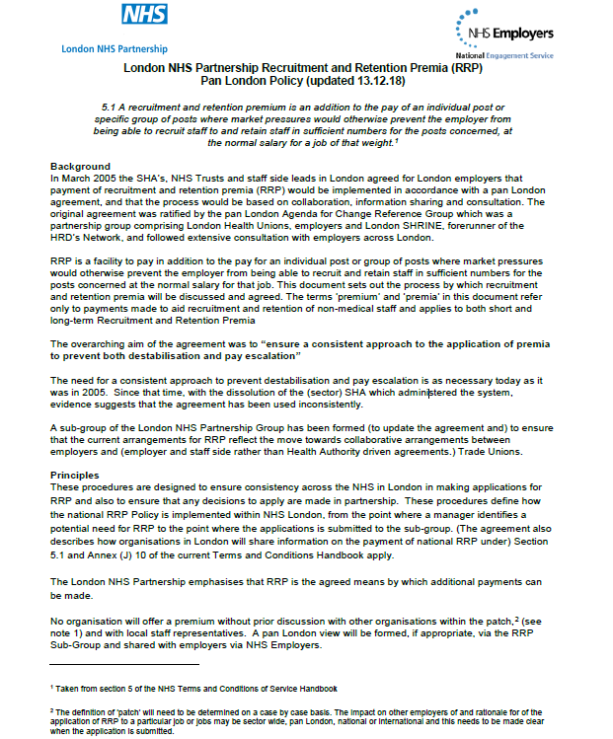
Appendix 3 Pan London Policy
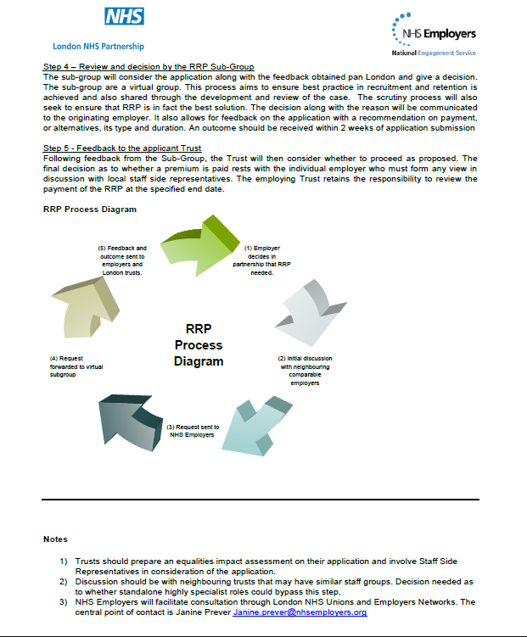

Appendix 4

Pan London Application for RRP

5.1 A recruitment and retention premium is an addition to the pay of an individual post or
specific group of posts where market pressures would otherwise prevent the employer from
being able to recruit staff to and retain staff in, sufficient numbers for the posts concerned, at
the normal salary for a job of that weight. ￼

Please forward this completed form to the Pan London RRP Review Group (Janine Prever, at janine.prever@nhsemployers.org) an outcome should be received within 2 weeks of application submission

Office use: Date Received: _______________ Application number: __________

Directorate (or equivalent terminology):

Service/Department:

Number of Posts in relevant group(s):

No. of Post(s) included in Proposal:

Pay Band(s) of Posts for proposed RRP:

Manager making application:

Date of application:

Is this application for problems with: Recruitment  Retention  Both 

Are you applying for: Short term RRP  Length of time ____________
Long term RRP 

Proposed effective date: _________________ (if different from date of application)

What is the proposed premium?
(Please express this as a cash sum and/or a percentage of basic pay)

Is there any other RRP currently applied: Yes  No 
If yes, please give details:

Internal Consultation:

Trust wide implications – Who else internally could be affected by this proposal, and which internal stakeholders have been consulted about it?

Have you sought input from your local staff side Chair / Secretary? If so, please ask them to add any comments here and sign at the bottom once agreement is obtained to submit the application.

External Consultation:

Who else externally (i.e., in your ‘patch’) could be affected by this proposal, and which external stakeholders have been consulted about it?

Please summarise the views of the other organisations in your ‘patch’ who have been consulted about your proposal:

Statement of Need (factors to include – recruitment information, response to adverts, results of exit interviews, information on market factors, national shortage specialty list, turnover, vacancy rates against establishment etc.)

Summary of other measures (and outcomes) already considered/carried out e.g., flexible working, training, and recruitment initiatives:

Total cost of proposals and any cost savings that could be achieved through this (e.g., reduction in agency costs):

Expected measurable benefits:

Sign off by Trust making Application:

Signature: _______________________________ Date:__________________

Print Name: ___________________________________

Job Title: _____________________________________

Tel: ______________________ Email:

Staff Side Chair / Secretary
Please sign to confirm application has been agreed in partnership

Signature: _______________________________ Date: __________________

Print Name: _____________________________

Tel: ______________________ Email:

