TRAC AUTHORISATION REQUEST GUIDE (To replace BAF or Budget Authorisation Form)
Implementation date -TBC
Step 1. Log into Trac jobs with your pre-existing username and password; link to TRAC jobs- https://admin.trac.jobs/admin/dashboard . This will take you to your TRAC dashboard.
Step 2. Click on ‘Recruitment’ and click on ‘Vacancy authorisation requests’ (see screen shot below)
Step 3. You will now reach the page below where you will need to select ‘New Vacancy Request’
Once you click the above this will take you to the screen below.
Step 4. Please select the appropriate Department i.e. for Non-medical roles select ‘1.0 General Staffing’ OR for Medical roles select 1.1 Medical Staffing by using the drop down buttons on the right. Next select the Grade or Band which you are recruiting for. Then select ‘Sector’, ‘Discipline’ and click on ‘Select’. If you have selected a wrong Sector and Discipline you can correct this by clicking ‘Deselect’ which will remove the previously selected item and allow you to select the correct one. Then click on continue which will take you to the next page.
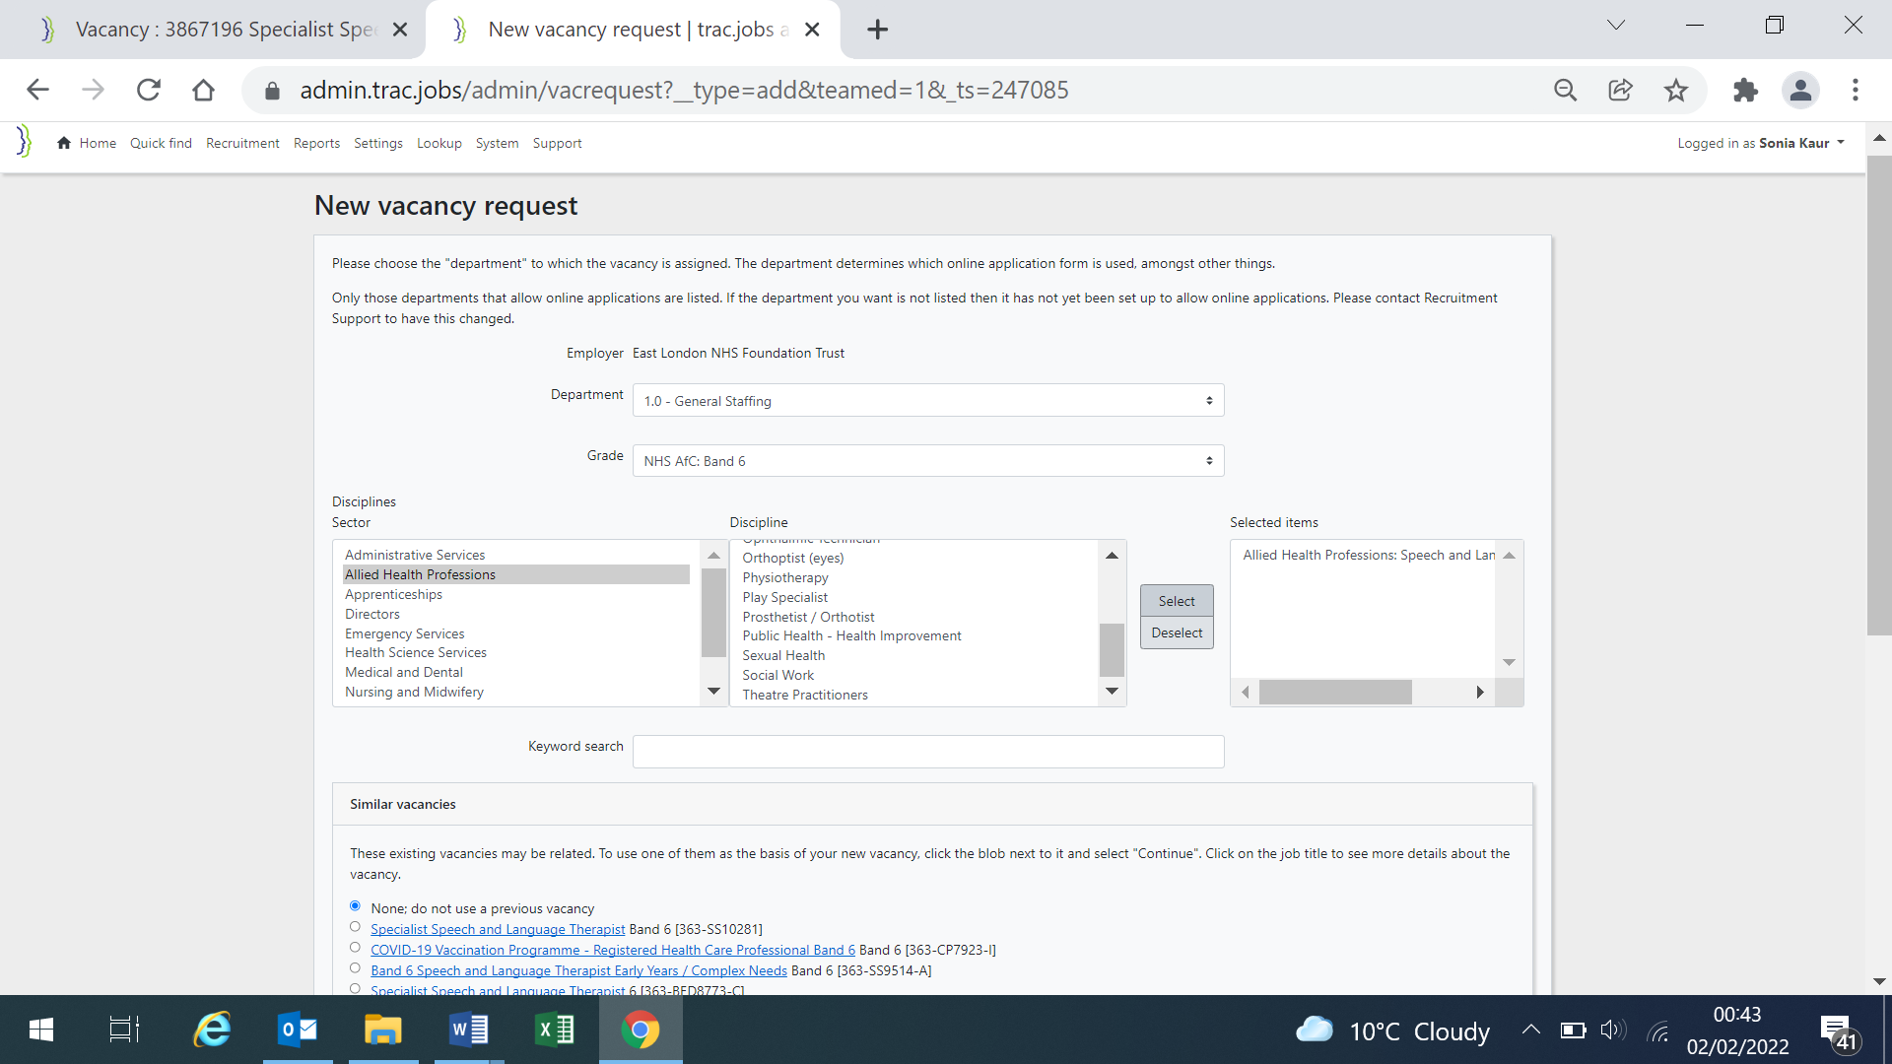

Scroll to bottom of page and click Continue, which will launch your Authorisation request form.

Step 5. You will now note that the form is launched and will be able to see the tabs that you need to complete namely- Authorisation, Vacancy Details, Advert Details, Documents, Shortlisters and Interviewers. You will require to input all items that are marked with an asterix or star against it

Tab1. Authorisation
‘Cost Code’-you will know your cost code or please request your finance business partner for this information
‘Position number’- you will only need to fill in the Full-tine equivalent value, but in decimal format i.e. 1.00 for 1 full time equivalent or 2.00 for two full time equivalent and so on.
Next you will need to provide a ‘Job Title’.
Next is ‘Reason for vacancy’ -you can choose from the drop down list of the various reasons
You will now need to provide the ‘Leavers name’ and ‘Leaving date’
‘Where is the funding for this post being generated’, you can type a text to explain – for example if this is in existing budget or a new funding source etc.
Tab 1 ‘Authoristaion’ Continued on next page
Tab 1 Authorisation Continued
Advertising Scope- Select ‘Public’ if you would like the job to be advertised on NHS Jobs externally and internally; if you would like the job to be advertised internally only please select ‘Internal’. If this request is only for additional authorisation, i.e. if you have already advertised a role previously and realise you have more than 1 role to offer but you have previously submitted an authorisation request, please select ‘Restricted’ and type in the reason (job reference and name of candidate) in the box below which states, ‘Add notes’.
‘Finance Authorisers’- please select Finance BP and Resourcing Team that covers your directorates.
Finance Team
Corporate, Estates, -FBP Michael Cziczkat
Tower Hamlets CHS, Newham CHS -FBP Peter Dempsey
Bedford CHS, Primary Care -FBP Suganthy Kandiah (Temp) cc’d
Luton & Bedford Adults –Senior FBP Alaa Alhamoud cc’d
Forensics -FBP Shewit Tefsai
Takmil Rahman – FBP Specialist
NEL London - Senior FBP Tina Smith
Resourcing Team Leads
Millie millie.ellenryan@nhs.net Bedford/Luton
Oluwatosin oluwatosin.ogunduyile@nhs.net City & Hackney, Forensic, Tower Hamlets, Newham
Enrique enrique.nuesch1@nhs.net Corporate/Primary Care
Imran imran.hussain10@nhs.net Medical
Lorraine lorraine.cousins3@nhs.net Specialist Services, Newham CHS, CTH

At this stage please click ‘Save draft’ before you click the next tab ‘Vacancy Details’ which is available at the top and bottom of the screen. DO NOT click the back button as this will not save the information you have entered. You may click between the tabs but it is advisable to save draft.

Tab 2. Vacancy Details
Please click on the drop down menu to select ‘Contract Type’ i.e. Permanent, Fixed-term, Secondment etc. Next choose the ‘Working Pattern’ i.e. Full-time, Part-time etc. Next enter the ‘Hours per week’ i.e. 37.5 or 20 etc. Select ‘Salary period’ as yearly and click either ‘Base Rate’, ‘Fringe HCAS’, ‘Outer London HCAS’, ‘Inner London HCAS’, then click ‘Update Salary values’.
Tab 2 ‘Vacancy details’ continued, see next page

Tab 2 ‘Vacancy details’ continued
After clicking the ‘Update Salary Values’ you will note that the ‘Salary Range’ has populated automatically. Next enter ‘Employment Checks’- ‘DBS Check required’, if it’s ‘Enhanced’ or ‘Standard’ and if it requires working with ‘Children’ and/ or ‘Adults’. Next select ‘UK Professional registration required-yes or no’ from drop down list. Next select ‘Occupational Health requirements’ from the drop down menu.
Next enter Key dates- Advertising Start date, closing date and Proposed interview date
Next enter Vacancy Location and address- Vacancy site, Vacancy Town, Vacancy postcode

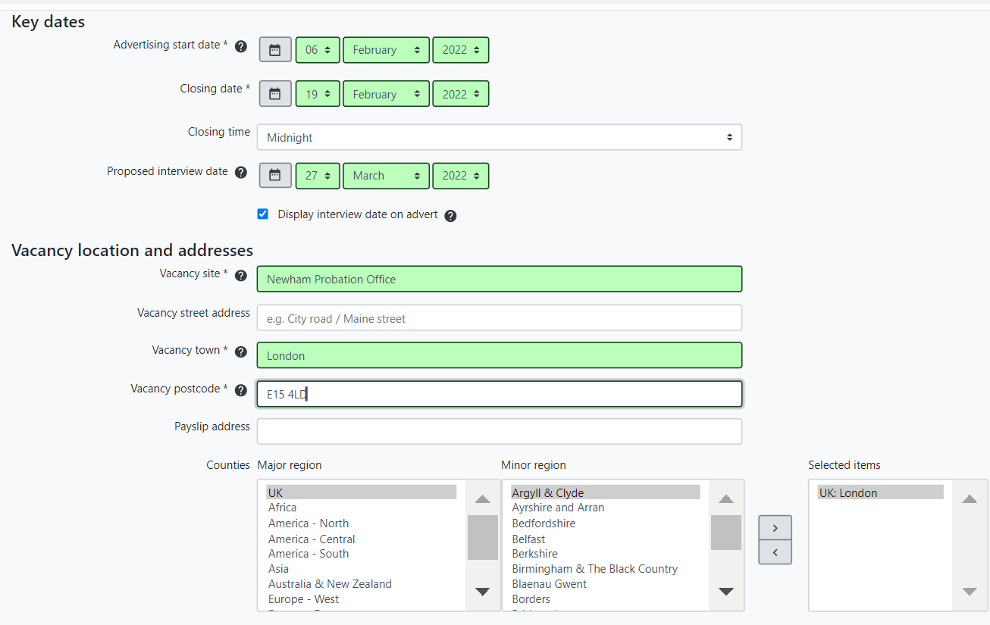
Tab 2 ‘Vacancy details’ continued
Lastly at bottom of the same screen you can’ Save draft’ and click on ‘Advert details’
Tab 3. Advert details
Please have your advert to hand, from which you can copy paste and populate ‘Job Overview’ (max 1500 characters including spaces, Main duties of the role 1500 characters including spaces, Working for your organisation- type-n/a and Job description- type n/a (for the latter 2, recruitment team will input the standard text).

Tab 3. Advert details continued
On the same screen continue to provide your ‘Contact information’ to include Contact Name, Job Title, email address, telephone number and any other Additional contact information if required.
Under ‘Sector and disciplines’ enter a text in Primary Specaility such as Allied health, Nursing or more specific such as Speech and Langue therapist, Community Nurse etc.
Next select ‘Staff group’ by clicking the drop down menu.
Next, the ‘Sector’ and Discipline will be auto populated, or you may select another by scrolling up and down in the boxes.
Next, please remember to Save Draft and click on Documents where you will be able to attach the Job Description and Person Specification.

Tab 4. Documents
Please attach the Job Description and Person specification in this section. Please ensure you have populated your Job Description and Person specification within the latest template, this is available on the Trust intranet or speak to your Recruitment officer who will also be able to provide this.
To attach the Job description and Person specification click the tab that says Job description, a pop-up box will appear (see bottom of page) asking you to add document. Then click on Upload Document. This will attach your JD to this authorisation request. Please save draft before you move to tab Shortlisters .
Pop-up box.

Tab 6 Shortlisters (skip tab 5 longlisting) - minimum of 2 shortlisters
Click on Shortlister tab. Please start typing the name and email address of the shortlisting panel in the tabs that appear below; the names and email addresses will auto-populate as you start to type the name, as most managers who are involved in recruitment have a Trac user account. If their details do not auto populate, please speak to your Recruitment Officer who will be able to add this user on TRAC. Please save draft before you click the final tab which is Interviewers.
Click save draft at this stage and click Interviewers (see next page).

Tab 7 Interviewers (Optional)
The final tab is Interviewers where you can add the names and email addresses of the panel, please remember to include a service user as one of the people on the interview panel. You may Click Copy Shortlisters if the interviewers are the same as shortlisters and add additional interviewers in the additional dialogue boxes.
Once you have done this, the form will now be complete and ready to submit for authorisation. You will now need to add a note in the dialogue box at the bottom of the screen where it is mentioned Add Note to say you are ‘submitting for authorisation’. Once the form is submitted this will instantly prompt and email to Finance and Recruitment prompting them to authorise your job and publish the advert.
Useful links:

TRAC Login- https://admin.trac.jobs/admin/dashboard
Trac Authorisation system user guide - https://admin.trac.jobs/userguide/
https://admin.trac.jobs/userguide/132677766.html
Generic recruitment inbox- elft.recruitment@nhs.net

