

Guidance for Prescribing and Administering

Influenza Vaccine to eligible In-Patients across East London NHS Foundation Trust (ELFT) during the 2024/25 Flu programme

|  |  |
| --- | --- |
| Version number: | 7.0 |
| Consultation Groups | ELFT Lead Pharmacists and Deputy Chiefs |
| Approved by (Sponsor Group) | Medicines Committee |
| Date approved | 11th September 2024 |
| Ratified by: | Medicines Committee |
| Date ratified: | 11th September 2024 |
| Name of originator/author: | Interim Trust Vaccinations Lead |
| Executive Director lead: | Chief Nurse |
| Implementation Date: | September 2024 |
| Last Review Date | September 2024 |
| Next Review date: | September 2025 |

|  |  |
| --- | --- |
| Services | Applicable |
| Trust wide | X |
| Mental Health and LD |  |
| Community Health Services |  |

Version Control Summary

|  |  |  |  |
| --- | --- | --- | --- |
| Version | Date | Author | Reason/description of changes |
| 1.0 | October 2018 | Jennifer Melville |  |
| 2.0 | October 2019 | Charity Okoli | Updated with new information from PHE/NHSE for 2019/20 flu season programme. |
| 3.0 | September 2020 | Charity Okoli | Added supporting information on flu vaccination for people with learning disability on page 5 |
| 4.0 | September 2021 | Charity Okoli | Section 8 changed, incorporating the information on how vaccination administered will be collated in 2021/22 programme. |
| 5.0 | June 2022 | Roberta Contino | Influenza guidance reviewed against DHSC/UKHSA/NHSE: The national flu immunisation programme 2022/23 letter dated 22nd April 2022.    Added supported information on how to prescribe the influenza vaccines on EPMA and how to record the influenza vaccine on NIVS |
| 6.0 | July 2023 | Roberta Contino | Influenza guidance reviewed against DHSC/UKHSA/NHSE: The annual national flu vaccination programme letter 2023/24 - dated 25th May 2023 and statement of amendment – dated 3rd July 2023. |
| 7.0 | August 2024 | Saema Arain and Charity Okoli | Influenza guidance reviewed against DHSC/UKHSA/NHSE: Statement of amendments to annual flu letter for 2024 to 2025, published 12 June 2024 . • The national flu immunisation programme 2024 to 2025 : Supporting Letter, published 12th March 2024 |

Contents

1. Introduction 4

2. Eligibility for vaccination: 4

3. Influenza vaccine products for 2024/25 7

4. Contraindications and precautions with the vaccine 9

5. Interactions with the vaccine 10

6. Prescribing and administering flu vaccines to patients 10

7. Infection prevention and control when administering vaccines 13

References and Further Information 14

Appendix 1: Groups included in the national influenza immunisation programme 16

Appendix 2: How to prescribe the influenza vaccine in EPMA 18

Appendix 3: How to record the influenza vaccine on NIVS 21

# Introduction

Seasonal influenza is an unpredictable but recurring issue we face every year, which tend to add pressure to NHS every winter.

Seasonal flu vaccination remains a critically important public health intervention and a key priority for 2024 to 2025 to reduce morbidity, mortality and hospitalisation associated with flu at a time when the NHS and social care will be managing winter pressures whilst continuing to recover from the impact of the coronavirus (COVID-19) pandemic. The delivery of the NHS flu immunisation programme over recent seasons has been both ambitious and challenging as we sought to offer protection to as many eligible people as possible, exceeding the World Health Organization (WHO) target for those aged 65 years and above for a third season running.

East London NHS Foundation Trust (ELFT) like other providers as expected by the government will focus on achieving high vaccine uptake levels in eligible groups, as they are most at risk of from flu.

# Eligibility for vaccination:

The programme provides direct protection to those at higher risk of flu associated morbidity and mortality, including older people, pregnant women, and those in clinical risk groups and is guided by advice from the Joint Committee on Vaccination and Immunisation (JCVI), an independent departmental expert committee. In addition, based on the [JCVI 2024 -25 recommendation](https://app.box.com/s/t5ockz9bb6xw6t2mrrzb144njplimfo0/file/1558177446261), a vaccination programme for children using live attenuated influenza vaccine (LAIV) provides individual protection to the children and reduces transmission to the wider population.

The below groups will be eligible for a flu vaccine from 1 September 2024:

* pregnant women
* all children aged 2 or 3 years on 31 August 2024
* primary school aged children (from Reception to Year 6)
* secondary school aged children (from Year 7 to Year 11)
* all children in clinical risk groups aged from 6 months to less than 18 years

From October 2024:

* those aged 65 years and over
* those aged 18 years to under 65 years in clinical risk groups (as defined by the Green Book, Influenza Chapter 19)
* those in long-stay residential care homes
* carers in receipt of carer’s allowance, or those who are the main carer of an elderly or disabled person
* close contacts of immunocompromised individuals
* frontline workers in a social care setting without an employer led occupational health scheme including those working for a registered residential care or nursing home, registered domiciliary care providers, voluntary managed hospice providers and those that are employed by those who receive direct payments (personal budgets) or Personal Health budgets, such as Personal Assistants
* All frontline health care workers, including both clinical and non-clinical staff who have contact with patients, should be offered flu vaccine from October (exact start date to be confirmed in due course) as a vital part of the organisations’ policy for the prevention of the transmission of flu. Social care workers directly working with people clinically vulnerable to flu should also have the flu vaccine provided by their employer.

The [influenza chapter](https://www.gov.uk/government/publications/influenza-the-green-book-chapter-19) in ‘Immunisation against infectious disease’ (the ‘Green Book’), which is updated periodically, gives detailed descriptions of the groups outlined above and in Appendix 1 Inpatients

All inpatients admitted to an inpatient ward in ELFT who have not had a flu vaccination at their GP or community pharmacy and where this has been confirmed via medicines reconciliation should be offered a flu vaccine if they fall into any of the categories outlined in the flu letter mentioned above. In particular, these groups:

* CAMHS inpatients - All children aged 2 to 3 years on 31 August 2024 and all primary school aged children (from reception to year 6)
* Older people’s mental health, forensics and CHS inpatients - People aged 65 years or over (including those becoming age 65 years by 31 March 2025)
* Adult mental health inpatients - Those aged less than 65 years of age, in a clinical risk group such as those with:
  + chronic (long-term) respiratory disease, such as severe asthma (requires continuous or repeated use of inhaled or systemic steroids or with previous exacerbations requiring hospital admission), chronic obstructive pulmonary disease (COPD) or bronchitis
  + chronic heart disease, such as heart failure o chronic kidney disease at stage 3, 4 or 5 o chronic liver disease
  + chronic neurological disease, such as Parkinson’s disease or motor neurone disease o learning disability o diabetes
  + splenic dysfunction or asplenia
  + a weakened immune system due to disease (such as HIV/AIDS) or treatment (such as cancer treatment)
  + morbidly obese (defined as BMI of 40kg/m2 and above)

* Mother and Baby Unit inpatients - All pregnant women (including those women who become pregnant during the influenza season)

The list above is not exhaustive, and the healthcare practitioner should apply clinical judgement to take into account the risk of flu exacerbating any underlying disease that a patient may have, as well as the risk of serious illness from flu itself. Flu vaccine should be offered in such cases even if the individual is not in the clinical risk groups specified above. Capacity assessments should be considered where appropriate.

Frontline health and social care workers will be provided with flu vaccination by their ELFT teams. ELFT flu vaccinators in directorates will be providing opportunities for staff to be vaccinated in order to protect staff and patients from flu. See information on the intranet about flu campaign and vaccination this season. A written instruction has also been authorised by ELFT organisation to be used for the peer-to-peer vaccination of staff during 2023/24 flu immunisation programme.

There is also a trust Flu PGD and patient specific directions agreed with GPs for vaccination of our service users in the community by trained nurses where agreement has been reached locally.

• Support for people with Learning Disability (LD) to enhance uptake

It has been observed that despite the fact that from 2014 people with learning disabilities were eligible to have a free flu vaccination there has not been an appreciable rise in the numbers receiving the flu vaccine. It is highly important that people with learning disability be supported by healthcare professionals by putting some reasonable adjustments in place, to ensure that people with LD have their flu immunisation. This is because many studies/reports such as the [CIPOLD](https://www.bristol.ac.uk/cipold/) report have shown that respiratory problems are a major cause of death of people with learning disabilities. Some of the adjustments that may be made for this group include:

* Consider the use of the nasal spray flu vaccine as an alternative adjustment that is less invasive when the LD patient is anxious about needles.
* The live intranasal influenza vaccine is given as a single spray squirted up each nostril. Note, this is not licensed for adults but can be used “off-label” for patients with LD who become seriously distressed with needles.
* The person seeing the patient may need to assess the patient’s capacity to decide to have the flu injection. If they do not have capacity for this decision, then this should not be a barrier to the flu injection being given; there would need to be a decision taken by the health professional that this is in their best interests.
* Healthcare professionals should inform people with learning disabilities, their family, carers and paid supporters that they are entitled to a free flu vaccination.
* Case coordinators, during the patient’s annual health check or CPA meetings should inform the patient and families/carers the reason it is important that they have a flu vaccination and provide information leaflets if possible.

Click the link below for more supporting information resources for Flu vaccinations for people with learning disability.

<https://www.gov.uk/government/publications/flu-vaccinations-for-people-with-learning-disabilities/flu-vaccinations-supporting-people-with-learning-disabilities>

Influenza vaccine products for 2024/25 programme <https://www.gov.uk/government/publications/influenza-vaccines-marketed-in-the-uk/all-influenza-vaccines-marketed-in-the-uk-for-the-2022-to-2023-season>

Influenza viruses change continuously and the World Health Organization (WHO) monitors the epidemiology of influenza viruses throughout the world, making recommendations about the strains to be included in vaccines, <https://www.who.int/news/item/23-02-2024-recommendations-announced-for-influenza-vaccine-composition-for-the-2024-2025-northern-hemisphere-influenza-seas>

All but one of the influenza vaccines available in the UK are inactivated and do not contain live viruses. One vaccine (Fluenz Tetra®) contains live viruses that have been attenuated (weakened) and adapted to cold so that they cannot replicate efficiently at body temperature. None of the influenza vaccines can therefore cause clinical influenza in those that can be vaccinated, although mild coryzal symptoms can occur with the live vaccine.

The live vaccine (Fluenz Tetra®) is administered by nasal spray, and the inactivated vaccines are all administered by intramuscular injection. There are very few individuals who cannot receive any influenza vaccine. When there is doubt, appropriate advice should be sought promptly from a specialist.

JCVI advice on influenza vaccines for the 2024 to 2025 season, updated 25 August 2023 <https://app.box.com/s/t5ockz9bb6xw6t2mrrzb144njplimfo0/file/1289995245447>

National Influenza Immunisation programme <https://www.gov.uk/government/publications/national-flu-immunisation-programme-plan-2024-to-2025/national-flu-immunisation-programme-2024-to-2025-letter>

A details of the influenza vaccines Marketed in UK <https://www.gov.uk/government/publications/influenza-vaccines-marketed-in-the-uk> (including details of ovalbumin content) is available on GOV.UK and summary table below: (Also refer to Influenza PGD)

|  |  |
| --- | --- |
| Eligible group | Type of Influenza vaccine |
| At risk children aged from 6 months to less  than 2 years | Offer QIVc (cell-based Quadrivalent Influenza Vaccine – offered off-label)    If QIVc is not available, give QIVe (The Quadrivalent Influenza Vaccine eggculture). |
| At risk children aged 2 to under 18 years | Offer LAIV nasal spray    If LAIV is contraindicated or otherwise unsuitable offer QIVc. (If QIVc is not available, give QIVe) |
| At risks adults, including pregnant women, aged 18 to  59 years | Offer QIVc    If QIVc not available offer QIVe |
| Those aged 65  years and over | Offer aQIV or QIV-HD    If aQIV or QIV-HD are not available, offer QIVc |



For up to date advice the Green Book

<https://www.gov.uk/government/publications/influenza-the-green-book-chapter-19>

ELFT have ordered the following vaccines;

1. SmPC QIVc vaccine (Cell based quadrivalent inactivated influenza vaccine – Seqirus) for routine vaccinations of inpatients under 65yrs old. Please see product SPC here: <https://www.medicines.org.uk/emc/product/12882/pil#gref>
2. SmPC aQIV vaccine (adjuvanted quadrivalent influenza vaccine – Seqirus ) for 65yrs and over, click link below: <https://www.medicines.org.uk/emc/product/12881/smpc#gref>

# Contraindications and precautions with the vaccine

None of the influenza vaccines should be given to those who have had:

• a confirmed anaphylactic reaction to a previous dose of the vaccine, or • a confirmed anaphylactic reaction to any component of the vaccine.

Anaphylaxis kits must be available in case of an allergic reaction.

4.1 Egg allergy - Adult patients can also be immunised in any setting using an inactivated influenza vaccine with an ovalbumin content less than 0.12 μg/ml (equivalent to 0.06 μg for 0.5 ml dose), except those with severe anaphylaxis to egg which has previously required intensive care who should be referred to specialists for immunisation in hospital.

4.2 Current illness or fever - Minor illnesses without fever or systemic upset are not valid reasons to postpone immunisation. If an individual is acutely unwell, immunisation may be postponed until they have fully recovered. This is to avoid confusing the differential diagnosis of any acute illness by wrongly attributing any signs or symptoms to the adverse effects of the vaccine.

4.3 IM administration - All seasonal influenza vaccines supplied by ELFT to the ward settings are licensed for Intramuscular administration. The preferred sites for intramuscular injection are the anterolateral aspect of the thigh (or the deltoid muscle if muscle mass is adequate) in children 6 months through 35 months of age, or the deltoid muscle in children from 36 months of age.

4.4 Injections and anticoagulants - It is important to closely monitor the patients taking coumarins and related anticoagulants closely. Caution is always advised when giving intramuscular injection to patients with bleeding disorders in order to reduce the risk of bleeding.

Individuals on stable anticoagulation therapy, including individuals on warfarin who are up to date with their scheduled INR testing and whose latest INR was below the upper threshold of their therapeutic range, can receive intramuscular vaccination. A fine needle (equal to 23 gauge or finer calibre such as 25 gauge) should be used for the vaccination, followed by firm pressure applied to the site (without rubbing) for at least 2 minutes. If in any doubt, consult with the clinician responsible for prescribing or monitoring the individual’s anticoagulant therapy.

Individuals with bleeding disorders may be vaccinated intramuscularly if, in the opinion of a doctor familiar with the individual's bleeding risk, vaccines or similar small volume intramuscular injections can be administered with reasonable safety by this route. If the individual receives medication/treatment to reduce bleeding, for example treatment for haemophilia, intramuscular vaccination can be scheduled shortly after such medication/treatment is administered. A fine needle (equal to 23 gauge or finer calibre such as 25 gauge) should be used for the vaccination, followed by firm pressure applied to the site (without rubbing) for at least 2 minutes. The individual/parent/carer should be informed about the risk of haematoma from the injection.

# Interactions with the vaccine

There are a number of medications including phenytoin, carbamazepine, phenobarbital and theophylline which have reported interactions with influenza vaccines leading to changes, mainly increases in plasma levels of these medications. However, the majority of these interactions are limited to isolated case reports, mainly without any observed clinical changes and therefore the interactions are not thought to be clinically significant. As the influenza vaccine is administered as a single vaccine any changes in plasma levels of these medicines is likely to be short lived and therefore the benefits of the vaccine in most cases will outweigh any risks. However, as changes in the plasma, levels of these medicines can lead to changes in effects or adverse effects it would be prudent to advise the patient to monitor for any increase in adverse effects or loss of symptom control and to consider plasma monitoring of these medicines should this occur.

For medicines, queries related to the vaccines, such as interactions, contact your local pharmacy team for advice.

# Prescribing and administering flu vaccines to patients

5.1 Medicines reconciliation at admission

Caution to avoid accidental double dosing of flu vaccination

It is also important to specifically check on admission whether the patient has already had the flu vaccination from another provider e.g. the GP, community chemist etc.

The process in place in order to avoid this risk comprise the following two steps:

1. Robust check on admission of patients to ELFT to see if vaccine had been given prior admission (as part of the medicines reconciliation process)
2. Proper communication to the Primary Care (GPs) on discharge of patients from ELFT to notify Flu vaccine had been administered while under the care of ELFT

On admission of patients to ELFT

* During working hours Monday to Friday 9am to 5pm: Pharmacists will as part of medicines reconciliation check for prior administration of flu vaccine at GP or community pharmacy, this may consist of the following actions: o Ask the patient where possible or check with family/carers o Check with the patient’s GP o Contact the patients named community pharmacist o Check on Summary Care Record (SCR) if up to date o Contact the PCN/GP practice-based Pharmacist
* Out of hours, this responsibility falls to the clerking prescriber.
* Document on patient’s electronic notes in RIO

1. Prescribing flu vaccine for inpatients

6.1 The prescribers and ELFT vaccinators must discuss the flu vaccines with eligible patients to ensure informed consent. Capacity assessments should be considered where appropriate. Where the patient lacks capacity to consent, staff could seek advice of the ELFT Mental Health office on what is appropriate.

Paper charts - the vaccine should be prescribed in the “once only” section of the inpatient administration chart as ‘Inactivated Quadrivalent Influenza Vaccine’ IM Injection.

EPMA - See Appendix 2 for EPMA influenza vaccine prescribing.

The vaccines will be provided by ELFT pharmacy for all inpatients who are eligible to be vaccinated during the 2023/24 flu vaccination programme; contact your local pharmacy staff for supplies.

* 1. Administration

Following vaccination of each patient, a record of the type of flu vaccine, batch number and expiry date of the vaccine as well as the route and site of administration must be documented in the patient’s electronic notes in RIO.

In order to adequately provide data for all ELFT service users vaccinated during the 2023/24 flu immunisation programme, arrangement have been made to capture the data using the National Immunisation & Vaccination System (NIVS).

The data will be uploaded on NIVS at point of administration of the vaccine by the allocated site flu lead vaccinator or deputy/designated administrator (see Appendix 3 for details)

This is because NIVS links information to GP system and NHS app for easy access, so it is important the data be shared promptly.

6.3 The details of information required for NIVS documentation are:

* Patient’s name
* Date of Birth
* NHS number
* EMIS/SystmOne or RIO number
* Type of Influenza (Flu) vaccine administered to patient
* Batch number of the flu vaccine administered
* Date administered

6.4 At discharge

Prescriber will add vaccine information to the notification of discharge (NODF) or other electronic records e.g. EMIS and SystmOne for the patients in community.

Ward pharmacist will check the NODF against the EPMA/CMM record for vaccine administration and ensure the vaccine information has been added prior to validation.

* Prescribers must add information on flu vaccination to the discharge notification letter.
* Pharmacists will check this information prior to validation of the Discharge Liaison Form (DLF or NODF).

Trained ELFT vaccinators are to deliver and administer the vaccine in line with the Green book.

Always use the latest updated online version of the Green book. See link below: <https://www.gov.uk/government/publications/influenza-the-green-book-chapter-19>

6.5 Useful Information leaflets and posters

1. Follow the link below for Information leaflets for patients on who should have the flu vaccine, which is available in different languages. <https://www.gov.uk/government/publications/flu-vaccination-who-should-have-it-this-winter-and-why/the-flu-vaccination-who-should-have-it-and-why-winter-2023-to-2024>

See link below for posters for visitors to hospitals and care homes: <https://www.gov.uk/government/publications/flu-poster-for-visitors-to-hospitals-and-care-homes>

1. For manufacturers written Patient Information Leaflet (PIL) for cell based quadrivalent inactivated influenza vaccine- Seqirus QIVc (for under 65yrs) click link below: <https://www.medicines.org.uk/emc/product/12882/pil#gref>
2. For manufacturers written Patient Information Leaflet (PIL) for adjuvanted quadrivalent influenza vaccine – Seqirus aQIV – (for 65yrs and over) click link below: <https://www.medicines.org.uk/emc/product/12881/smpc#gref>

# Infection prevention and control when administering vaccines

Premises that are administering the flu vaccine should follow the link below for recommended guidance <https://www.gov.uk/government/publications/infection-prevention-and-control-in-adult-social-care-settings/infection-prevention-and-control-resource-for-adult-social-care>

People who are displaying COVID-19 symptoms or are self-isolating because they are confirmed COVID-19 cases, or contacts of suspected or confirmed COVID-19 cases, should not attend until they have recovered and completed the required isolation period.

Further information on IPC measures is provided in which will be updated prior to and during the season as required. <https://www.england.nhs.uk/long-read/education-framework-for-the-infection-prevention-and-control-practitioner-ipc-workforce/>

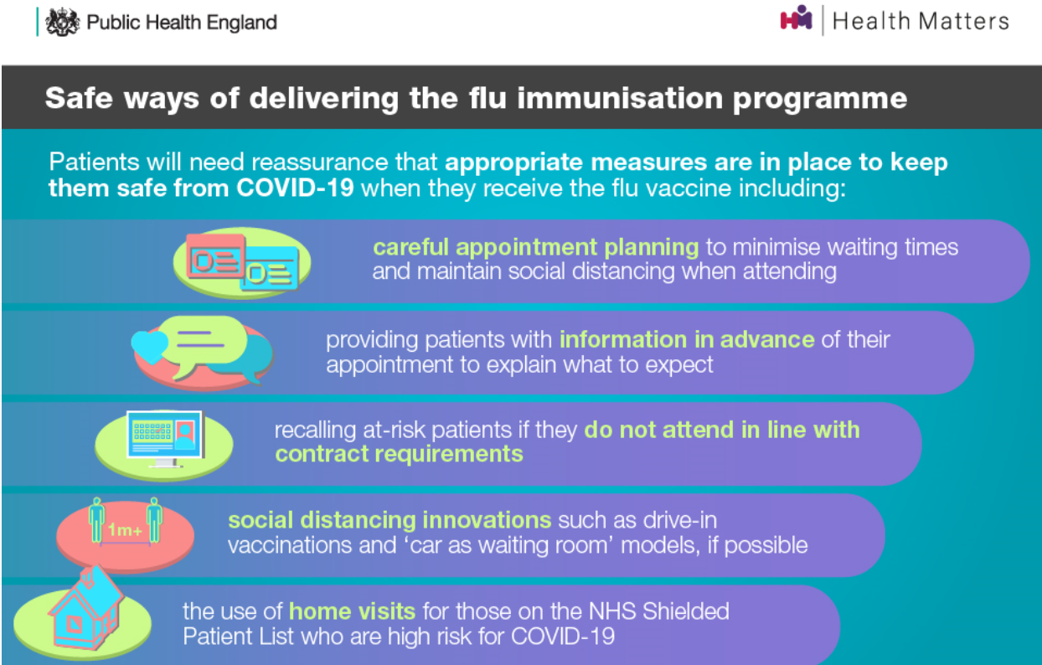

# 

# References and Further Information

1. The summary of product characteristics should be consulted to guide the prescribing and administration of the vaccine. Summary of Product Characteristics are available from:
   1. SmPC QIVc vaccine (Cell based quadrivalent inactivated influenza vaccine – Seqirus) for routine vaccinations of inpatients under 65yrs old. Please see product SPC here: <https://www.medicines.org.uk/emc/product/12882/pil#gref>
   2. SmPC aQIV vaccine (adjuvanted quadrivalent influenza vaccine – Seqirus ) for 65yrs and over) click link below: <https://www.medicines.org.uk/emc/product/12881/smpc#gref>
2. Chapter 19 of the ‘The Green Book’ provides detailed recommendations for the use of the vaccine <https://www.gov.uk/government/publications/influenza-the-green-book-chapter-19>
3. Premises that are administering the flu vaccine should follow the recommended <https://www.gov.uk/government/publications/infection-prevention-and-control-in-adult-social-care-settings/infection-prevention-and-control-resource-for-adult-social-care>
4. Further information on IPC measures <https://www.england.nhs.uk/long-read/education-framework-for-the-infection-prevention-and-control-practitioner-ipc-workforce/>
5. DHSC/UKHSA/NHSE: The national flu immunisation programme 2024 to 2025 : Supporting Letter, published 12th March 2024 <https://www.gov.uk/government/publications/national-flu-immunisation-programme-plan-2024-to-2025/national-flu-immunisation-programme-2024-to-2025-letter>
6. DHSC/UKHSA/NHSE: Statement of amendments to annual flu letter for 2024 to 2025 , published 12 June 2024 <https://www.gov.uk/government/publications/national-flu-immunisation-programme-plan-2024-to-2025/statement-of-amendment-to-the-annual-flu-letter-for-2024-to-2025-12-june-2024>
7. Immunisation Against Infectious Disease: The Green Book, Chapter 19. Updated 10th November 2023. <https://www.gov.uk/government/collections/immunisation-against-infectious-disease-the-green-book>
8. All influenza vaccines marketed in the UK for the 2024 to 2025 season, updated 21 March 2024. <https://www.gov.uk/government/publications/influenza-vaccines-marketed-in-the-uk>
9. JCVI advice on influenza vaccines for the 2024 to 2025 season, updated 25 August 2023
10. <https://app.box.com/s/t5ockz9bb6xw6t2mrrzb144njplimfo0/file/1289995245447>
11. Flu Vaccinations: Supporting people with learning disabilities, updated 25 September 2018
12. <https://www.gov.uk/government/publications/flu-vaccinations-for-people-with-learning-disabilities>
13. Flu immunisation training recommendations, updated 8 August 2023
14. <https://www.gov.uk/government/publications/flu-immunisation-training-recommendations>
15. Vaccine Incident Guidance <https://www.gov.uk/government/publications/vaccine-incident-guidance-responding-to-vaccine-errors>

Appendix 1 – Groups included in the national influenza immunisation programme

For the 2023 to 2024 influenza season, vaccinations will be offered under the NHS influenza immunisation programme to the following groups:

* all children aged 2 to 3 years on 31 August 2023
* all primary school aged children (from Reception to year 6)
* people aged 65 years or over (including those becoming age 65 years by 31 March 2024)
* those aged from 6 months to less than 65 years of age in a clinical risk group such as those with:
* chronic (long-term) respiratory disease, such as asthma (requires continuous or repeated use of inhaled or systemic steroids or with previous exacerbations requiring hospital admission), chronic obstructive pulmonary disease (COPD) or bronchitis
* chronic heart disease, such as heart failure
* chronic kidney disease at stage 3, 4 or 5
* chronic liver disease
* chronic neurological disease, such as Parkinson’s disease or motor neurone disease
* learning disability
* diabetes
* splenic dysfunction or asplenia
* a weakened immune system due to disease (such as HIV/AIDS) or treatment (such as cancer treatment)
* morbidly obese (defined as BMI of 40 and above)

* all pregnant women (including those women who become pregnant during the influenza season)
* household contacts of immunocompromised individuals, specifically individuals who expect to share living accommodation on most days over the winter and, therefore, for whom continuing close contact is unavoidable
* people living in long-stay residential care homes or other long-stay care facilities where rapid spread is likely to follow introduction of infection and cause high morbidity and mortality. This does not include, for instance, prisons, young offender institutions, university halls of residence, or boarding schools (except where children are of primary school age)
* those who are in receipt of a carer’s allowance, or who are the main carer of an older or disabled person whose welfare may be at risk if the carer falls ill
* frontline staff without employer led occupational health schemes, employed by a registered residential care or nursing home or registered domiciliary care provider, who are directly involved in the care of vulnerable patients or clients who are at increased risk from exposure to influenza
* frontline staff without employer led occupational health schemes, employed by a voluntary managed hospice provider, who are directly involved in the care of vulnerable patients or clients who are at increased risk from exposure to influenza
* frontline staff without employer led occupational health schemes employed through Direct Payments (personal budgets) and/or Personal Health Budgets, such as Personal Assistants, to deliver domiciliary care to patients and service users

Organisations should vaccinate all frontline health care workers and social care workers, in order to meet their responsibility to protect their staff and patients and ensure the overall safe running of services. There are limited circumstances where social care workers without access to an employer led occupational health scheme can access the vaccine on the NHS.

The list above is not exhaustive, and the healthcare professional should apply clinical judgement to take into account the risk of influenza exacerbating any underlying disease that a patient may have, as well as the risk of serious illness from influenza itself.

# Appendix 2: How to prescribe the influenza vaccine on EPMA (CMM)

Step 1: Prescriber searches for influenza vaccine like any other drug. It is important to note that there are 2 influenza vaccines available: one for patients aged under 65 and one for patients aged 65 and over. Ensure you select the correct one based on the patient’s age.

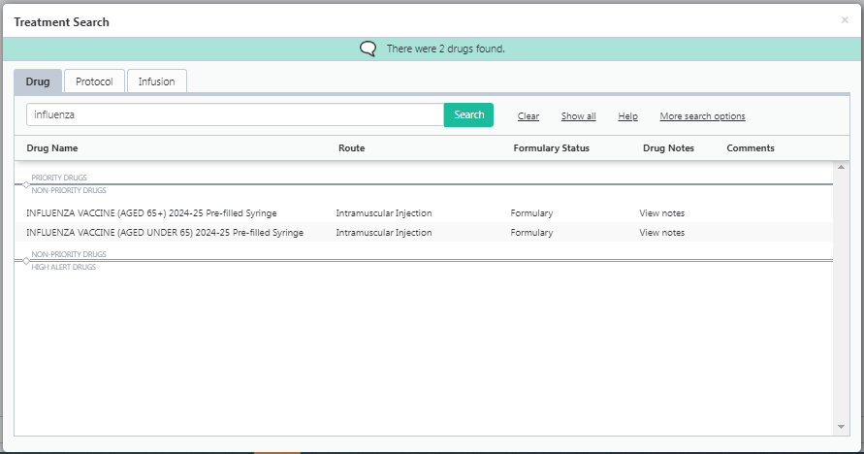

Step 2: Once the appropriate vaccine has been selected, a ‘drug note’ will appear with guidance. It is essential that this note is read thoroughly, and all guidance is followed. It is a mandatory requirement that the requested information is recorded as a progress note in RIO and the vaccination is also recorded in NIVS (see appendix 3 below for info on NIVS).

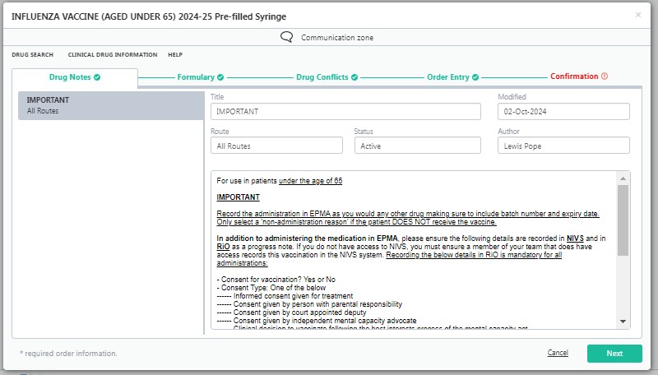

Step 3: The vaccine will default to be a 'STAT Order'. This STAT order will default to be given at the date and time of prescribing. This can be changed and set to a future date/time e.g. if the prescriber wants the vaccine given tomorrow or next week. It is important to take supply of the vaccine into account when prescribing.

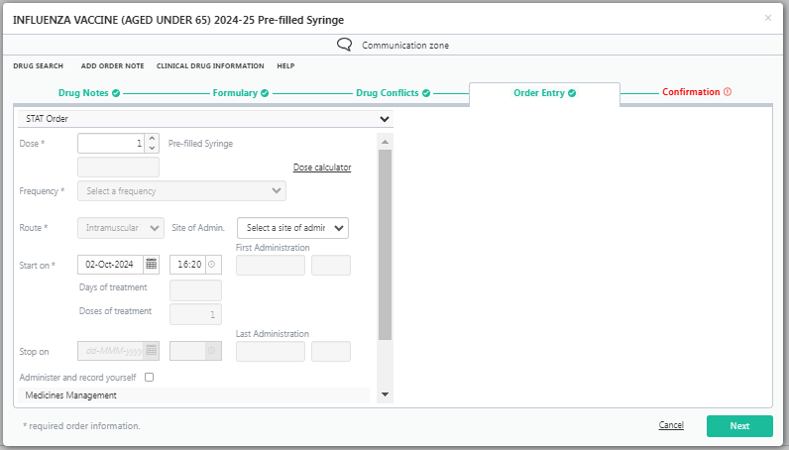

Important Information

The screenshot below shows the vaccine having been administered at 16:46 on 7th Nov 2019. It will remain in the 'Inpatient Rx' tab until the end of the day (i.e. 23:59) after which it will go to the 'Discontinued Rx' tab. If the prescriber tries to prescribe the influenza vaccine again on the same day, a warning alert will pop up saying the patient has already received this medication. The prescriber will not get a warning alert if the vaccine is prescribed on the following day after receiving the first dose and thereafter.

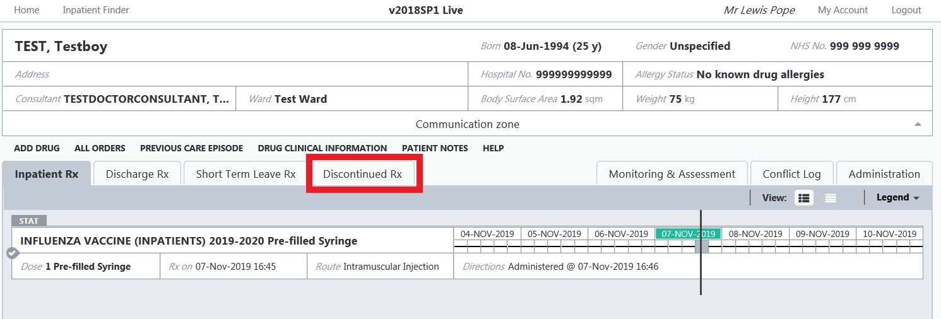

Therefore, it is strongly recommended that the prescriber checks the 'Discontinued Rx' tab in order to check whether the patient has already received the influenza vaccine before prescribing.

It is important that the supply of the vaccine to the ward is taken into account when prescribing i.e. if the vaccine needs to be ordered by pharmacy and will arrive on the ward the following day, ensure the dose is prescribed to be administered on that day or after.

# Appendix 3: How to record the influenza vaccine on NIVS

Step 1: Sign in with your NHS.net email and your password

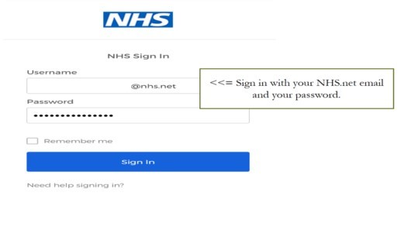

Step 2: Select the “Vaccinator location” icon

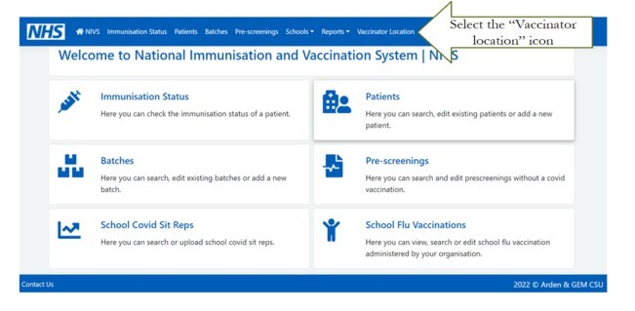

Step 3: Type in/select East London NHS Trust from the drop down

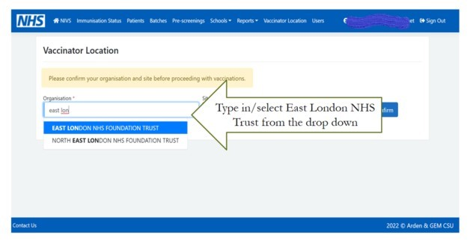

Step 4: Select your vaccination site. This is dependent on the selected organisation

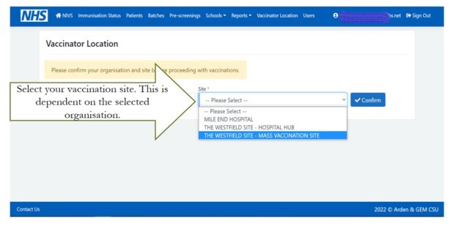

Step 5: Search Patients. Type NHS number and click “search” – circle in red. If no NHS number available, then fill with patient name, DOB, postcode and click “search” – circle in red.

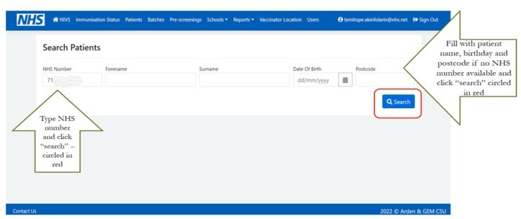

Step 6: If the search returns with no patient information, then select “New Patient”. Click the “Edit” option highlighted in blue

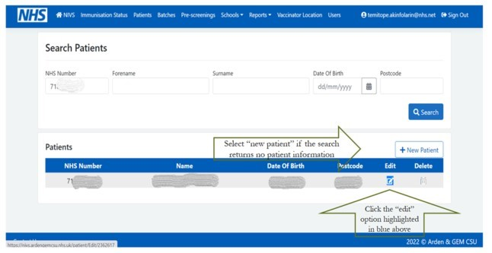

Step 7: If adding new patient with NHS numbers, type NHS number in the bar and click the “search” option circled in red. Confirm the information returned in your search or fill in the required information, scroll down and click “save”

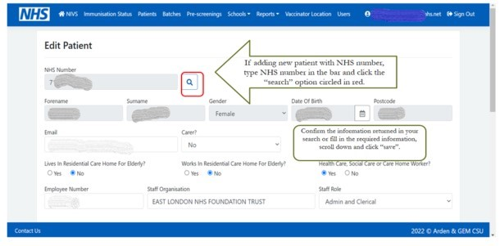

Step 8: Confirm the information returned in your search or fill in the required information, scroll down and click “save”. Then select the “New Flu Vaccination” tab

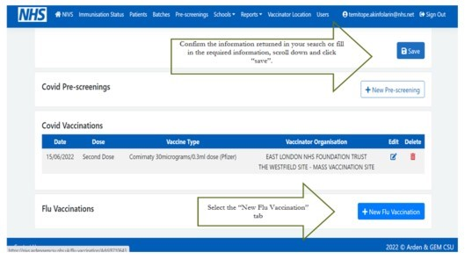

Step 9: Confirm patient’s consent and “consent type” and provide responses to the YES/NO questions. Fill in vaccinator name/surname – as required

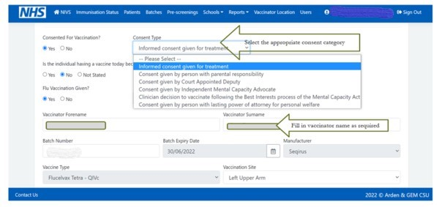

Step 10: Select the appropriate date and provide responses to the YES/NO questions.

Then select the correct batch number from the drop down menu. This will automatically populate the expiry date, manufacturer fields and vaccine type – as applicable.

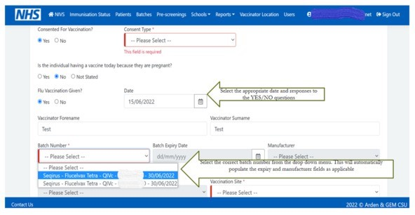

Step 11: Select the vaccination site

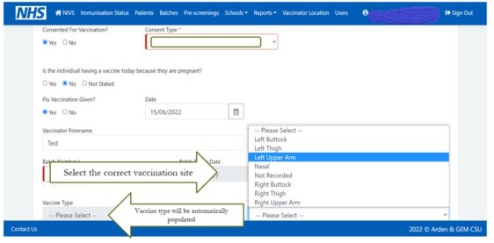

Step 12: Cross check the information and click “save”, if correct

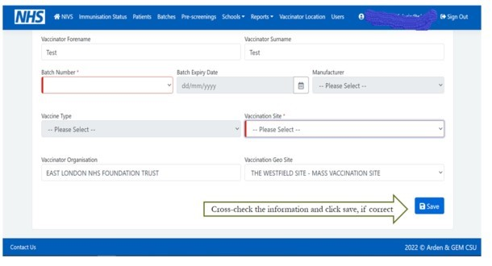

Step 13: Once you click “Save”, you should be returned to this page with the flu vaccination displaying as below

