

East London NHS Foundation Trust (ELFT)

Patient Safety Incident Response Plan (PSIRP)

Effective date: TBC

Estimated refresh date: TBC

|  |  |  |  |  |
| --- | --- | --- | --- | --- |
|  | **NAME** | **TITLE** | **SIGNATURE** | **DATE** |
| **Authors** | Charlotte Walton  Dr Deborah Dover | Deputy Head of Incidents / PSIRF Implementation Lead  Director of Safety & Consultant in Child & Adolescent Psychiatry |  |  |
| **Reviewer** |  |  |  |  |
| **Authoriser** |  |  |  |  |

Contents

1.0 Purpose, scope, aims and objectives 3

2.0 Our services 5

Figure 1.0- East London Services Patch 6

3.0 Situation analysis – national 6

4.0 Defining our patient safety incident & improvement profile 8

6. Our patient safety incident response plan: national requirements 12

7.0 Our patient safety incident response plan: local focus 13

8.0 Adoption of Patient Safety Incident Review Framework (PSIRF) 18

8.2 Learning Responses 18

9.0 Learning from incident responses 20

11. Staff training and competency 21

11.2 After Action Review (AAR) Training 21

12. Procedure to support staff affected by PSIs 22

13.0 Procedure to engage, involve and support patients, families and carers affected by PSIs 25

Current support for bereaved families, carers and staff involved in PSIs 25

Annex 1 – Glossary 27

Annex 2 – Training Plan 2023/24 29

# 1.0 Purpose, scope, aims and objectives

1.1 Purpose

1. This Patient Safety Incident Response Plan (PSIRP) sets out how East London NHS Foundation Trust (ELFT) will embed the Patient Safety Incident Framework by: compassionately engaging and involving those affected by patient safety incidents, applying a range of system-based approaches to patient safety learning, providing considered and proportionate responses, and providing supportive oversight, focused on strengthening response system functioning and improvement.
2. This plan will help us measurably improve the efficacy of our learning responses from After Action Review (AAR), Observations, Thematic and Cluster reviews and Care Review Tool (CRT) and Patient Safety Incident Investigation (PSII) by:
3. refocusing PSII towards a systems approach1 and the rigorous

identification of interconnected causal factors and systems issues

1. focusing on addressing causal factors and the use of improvement science2 to prevent or continuously and measurably reduce repeat patient safety risks and incidents
3. transferring the emphasis from the quantity to the quality of PSIIs such that it increases our stakeholders’ (notably patients, families, carers and staff) confidence in the improvement of patient safety through learning from incidents
4. demonstrating the added value from the above approaches

1**.2 Scope**

1.2.1 A PSIRP is a requirement of each provider or group/network of providers delivering NHS-funded care.

1.2.2 This document should be read alongside the introductory Patient Safety Incident Response Framework (PSIRF) 2020, which sets out the requirement for this plan to be developed.

1.2.3 We have developed the planning aspects of this PSIRP with the assistance and agreement of the organisation’s local commissioner(s).

1.2.4 The aim of this approach is to continually improve. As such this document will be reviewed annually to start with.

1 The approach is broken down into units to make it easier to understand the complexity, interactive nature and interdependence of the various external and internal factors.

2 “Improvement science is about finding out how to improve and make changes in the most effective way. It is about systematically examining the methods and factors that best work to facilitate quality improvement.” Health Foundation (2011) https://www.health.org.uk/publications/improvement-science.

**1.3 Strategic aims**

1.3.1 Improve the safety of the care we provide to our patients, and improve our patients’, their families’ and carers’ experience of it.

1.3.2 Further develop systems of care to continually improve their quality and efficiency.

1.3.3 Improve the experience for patients, their families and carers wherever a patient safety incident or the need for a PSII is identified.

1.3.4 Improve the use of valuable healthcare resources.

1.3.5 Improve the working environment for staff in relation to their experiences of patient safety incidents and investigations.

**1.4 Strategic objectives**

1.4.1 Act on feedback from patients, families, carers and staff about the current problems with patient safety incident response and PSIIs in the NHS.

1.4.2 Develop a climate that supports a just culture3 and an effective learning response to patient safety incidents.

1.4.3 Develop a local board-led and commissioner and integrated care system (ICS)/sustainability and transformation partnership (STP)-assured around PSII and alternative responses to patient safety incidents, which promotes ownership, rigour, expertise and efficacy.

1.4.4 Make more effective use of current resources by transferring the emphasis from the quantity of investigations to a higher quality, more proportionate response to patient safety incidents, as a whole. The aim is to:

* make PSIIs more rigorous and, with this, identify causal factors and system-based improvements
* engage patients, families, carers and staff in PSII and other responses to incidents, for better understanding of the issues and causal factors
* develop and implement improvements more effectively
* explore means of effective and sustainable spread of improvements, which have proved demonstrably effective locally.

3 A culture in which people are not punished for actions, omissions or decisions commensurate with their experience and training, but where gross negligence, wilful violations and destructive acts are not tolerated. Eurocontrol (2019) Just culture.

**1.5 ELFT Mission & Vision for Safety**

1.5.1 Our safety vision is:

To become an organisation which provides the safest possible care for all our people, with a positive and equitable safety culture and where safety is everyone’s primary concern, underpinned by strong leadership, people participation and proactive learning, monitoring and improvement.

1.5.2 Our working mission is:

To provide the safest possible care for our patients, safest conditions for our staff and safest lives for those communities we serve.

# 2.0 Our services

2.1.1 Originally formed in 2000, ELFT provides mental health care, community health care, primary care, and inpatient services to adults, young persons, older adults and forensics.

We serve a population of more than one million across three North East London boroughs, one million in Luton and Bedfordshire and two million Forensics. We are proud to serve one of the most culturally diverse parts of the UK.

We have 120 community and inpatient sites and over 900 specialist beds.

2.1.2 **Mental Health -** We provide a range of mental health services for children and young people, adults of working age and older adults including community mental health teams (CMHTs) crisis mental health teams and mental health inpatient care across East London, Luton and Bedfordshire.

2.1.3 **Community Health Services** - We are a healthcare provider of a wide range of community health services in Newham, Tower Hamlets and Bedfordshire. We provide additional specialist community health services in Newham (Diabetes care, continence, respiratory disease, and end of life care).

2.1.4 **Primary Care** - We have primary care services in Newham (Transitional GP Practice), Tower Hamlets (Health E1) and Hackney (The Greenhouse) - primary care practices specialising in support for homeless people. In 2020 Leighton Road GP Surgery in Leighton Buzzard and Cauldwell Practice in Bedford, joined ELFT.

2.1.5 **Improving Access to Talking Therapies** - The Newham Talking Therapies service was established in 2006 and was one of the pilot sites for this new approach to helping people gain access to therapies to support them in getting into employment, whilst addressing personal issues/barrier/obstacles.

In October 2018, the Trust added to its IAPT (Improving Access to Psychological Therapies) portfolio and now manages the Tower Hamlets Talking Therapies service in partnership with Mind in Tower Hamlets and Newham.

2.1.6 **Learning disabilities services** - The Trust provides Learning Disabilities services in all areas of the Trust. Two of the four services are integrated with the local authorities to meet the health and social needs of the individual and their families. The service aims to help service users reach their optimum health and develop independence.

2.1.7 **Other services** -

• Addiction services  
• Assertive outreach services   
• Forensic services (medium and low secure in East London)   
• Home treatment teams  
• Rehabilitation teams  
• Telehealth

# Figure 1.0- East London Services Patch

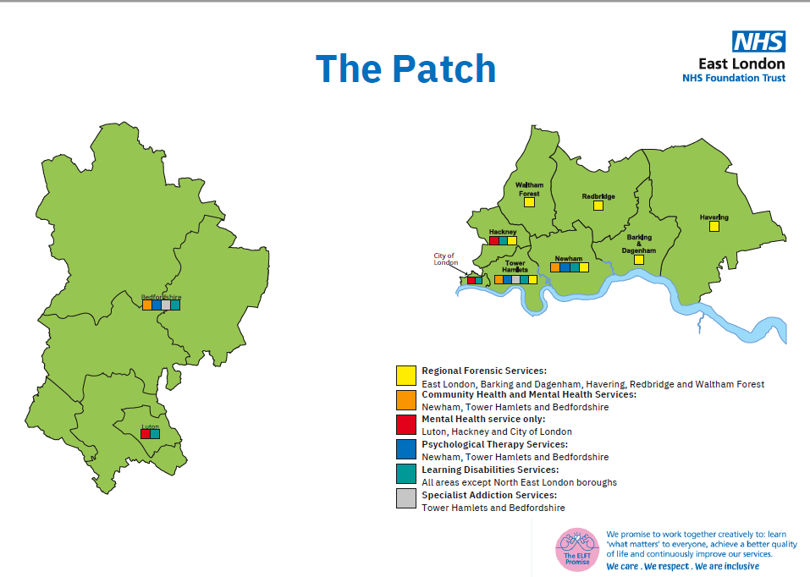

# 3.0 Situation analysis – national

3.1.1 Many millions of people are treated safely and successfully each year by the NHS in England, but evidence tells us that in complex healthcare systems things will and do go wrong, no matter how dedicated and professional the staff.

3.1.2 When things go wrong, patients are at risk of harm and many others may be affected. The emotional and physical consequences for patients and their families can be devastating. For the staff involved, incidents can be distressing and members of the clinical teams to which they belong can become demoralised and disaffected. Safety incidents also incur costs through lost time, additional treatment and litigation. Overwhelmingly these incidents are caused by system design issues, not mistakes by individuals.

3.1.3 Historically, the NHS has required organisations to investigate each incident report that meets a certain outcome threshold or ‘trigger list’. When this approach was developed it was not clear that:

a. Luck often determines whether an undesired circumstance translates into a

near miss or a severe harm incident.4 As a result, focusing most patient

safety investigation efforts on incidents with the most severe outcome does

not necessarily provide the most effective route to ‘organisational

learning’.5

b. There is no clear need to investigate every incident report to identify the common causes and improvement actions required to reduce the risk of similar incidents occurring. To emphasise this point, it has been highlighted that in-depth analysis of a small number of incidents brings greater dividends than a cursory examination of a large number.

3.1.4 An increased openness to report patient safety issues has also led to an ever-growing number of incidents being referred for investigation. NHS organisations are now struggling to meet the number of requests for investigation into similar types of incident with the level of rigour and quality required. Available resources have become inundated by the investigation process itself – leaving little capacity to carry out the very safety improvement work the NHS originally set out to achieve[1].

3.1.5 In addition, the remit for patient safety incident investigation (PSII) has become unhelpfully broad and mixed over time. This originates from an attempt to be more efficient by addressing the many and varied needs of different types of investigation in a single approach. Sadly, the very nature and needs of some types of investigation (e.g. professional conduct or fitness to practise; establishing liability or avoidability; or establishing cause of death) have frustrated the original patient safety aim and blocked the system learning the NHS set out to achieve.

3.1.6 Many other high-profile organisations now identify and describe their rationale for deciding which incidents to investigate from a learning and improvement perspective. While some industry leaders describe taking a risk-based approach to safety investigation (e.g. the Rail Accident Investigation Branch and Air Transport Safety Board), others list the parameters that help their decision-making processes (the police, Parliamentary Health Service Ombudsman and Healthcare Safety Investigation Branch).

3.1.7 We need to remove the barriers in healthcare that have frustrated the success of learning and improvement following a PSII (e.g. mixed investigation remits, lack of dedicated time, limited investigation skills). We also need to increase the opportunity for continuous improvement by:

* improving the quality of future PSIIs
* conducting PSIIs purely from a patient safety perspective
* reducing the number of PSIIs into the same type of incident
* aggregating and confirming the validity of learning and improvements by basing PSIIs on a small number of similar repeat incidents.

3.1.8 This approach will allow NHS organisations to consider the safety issues that are common to similar types of incident and, on the basis of the risk and learning opportunities they present, demonstrate that these are:

* being explored and addressed as a priority in current PSII work or
* the subject of current improvement work that can be shown to result in progress or
* listed for PSII work to be scheduled in the future.

3.1.9 *Sometimes a PSII is not indicated. To ensure every opportunity for learning occurs, other review techniques will be used. These include but are not limited to:*

* + Immediate safety action
  + “Being Open” conversation
  + Case record/note review (clinical review)
  + Incident Timeline
  + After-action review
  + LeDeR
  + Mortality Review
  + Safety Huddle
  + Audits (transaction, clinical, process, outcome)
  + Hot Debrief/ bed-head review
  + Risk Assessment

All information relating to PSIs and the insight generated from all responses must be recorded within local risk management systems and shared with the National Reporting and Learning System (NRLS) or its successor. PSIIs will also be recorded on the Strategic Executive Information System (StEIS) or its successor to allow organisation to monitor progress of PSIIs.

3.1.10 As part of this approach, incidents requiring other types of investigation and decision-making, which lie outside the scope of this work, will be appropriately referred as follows:

* professional conduct/competence – referred to human resource teams
* establishing liability/avoidability – referred to claims or legal teams
* cause of death – referred to the coroner’s office
* criminal – referred to the police.

# 4.0 Defining our patient safety incident & improvement profile

4.1 In order to understand our local safety profile and main safety issues, we have undertaken a three year analysis of our patient safety data, triangulating hard data with themes from safety and other reviews and “soft” intelligence, in terms of staff and service user opinions, led by our Director of Safety.  Sources of data analysis include:

* Incidents
* Complaints
* 48 hour reports
* Concise Reviews
* Serious Incident Reviews
* Whole Trust ELFT Staff Survey
* Freedom to Speak Up themes
* Service User Focus Groups
* Care Opinions Themes

4.2 We are in the process of incorporating the perspectives of our key stakeholders, such as the ICBs and Care Quality Commission (CQC).

4.3 This data has been triangulated according to frequency of the theme arising in the different data sources.  The top safety themes identified are listed in the matrix below, in order of the most frequently identified first.

**Table 1.0 Triangulated Safety Concerns and Themes**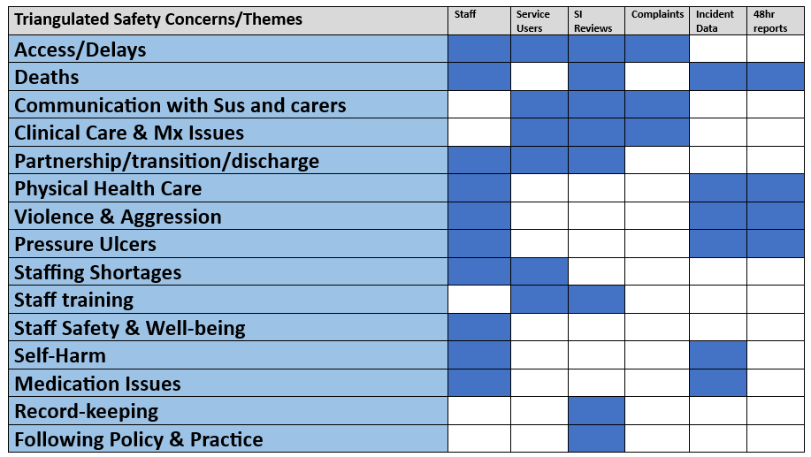

4.4 This list was then explored in depth with 30 of our clinical and safety leaders, along with our patient safety partners, and bearing in mind the range of learning methods available, in terms of four questions:

* Have we got these priorities right and have we missed any key priority areas?
* Is this a well understood area from a safety perspective?
* Do we have robust improvement work already taking place to address this area?
* What do we think is the most effective method for addressing this safety area?

4.5 We also undertook a ranking exercise to help us further co-create our core priorities. The results are shown below:

**Figure 2.0 List of Proposed Local Safety Priorities and Associated Methodologies for safety Learning -2023/2024**

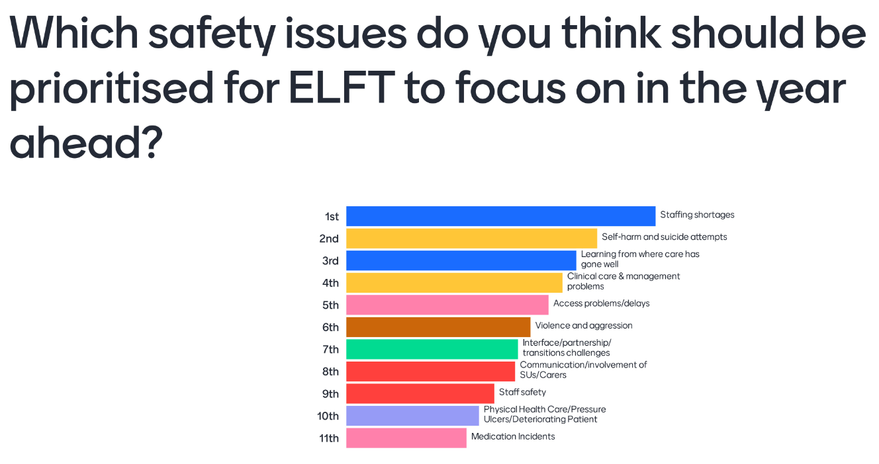

4.6 Based on this analysis work, we have identified the following (draft) list of proposed local Safety Priorities and associated proposed methodologies for safety learning and improvement, for the year 2023-2024.

4.7 It can be seen that “learning from where care has gone well” is highly ranked priority, which we have incorporated into our choice of methodology for each of our local priority areas.

4.8 We anticipate that this prioritisation exercise will be annually reviewed and revised to incorporate new emerging themes, understanding and issues and based on our learning from using new methods over the first year.

4.9 The figures for annual incidents reported and level of patient safety reviews undertaken are demonstrated below:

**Figure 3.0: Number of incident reported per annum and number of patient safety reviews completed per annum.**

# 6. Our patient safety incident response plan: national requirements

**Table 2.0 National priorities requiring PSII**

|  |  |  |
| --- | --- | --- |
| **Event** | **Action required** | **Lead body for the response** |
| Deaths thought more likely than not due to problems in care (incidents meeting the [learning from deaths criteria](https://www.england.nhs.uk/publication/national-guidance-on-learning-from-deaths/) for PSII) | PSII | ELFT |
| Deaths of patients detained under the Mental Health Act (1983) or where the Mental Capacity Act (2005) applies, where there is reason to think that the death may be linked to problems in care (incidents meeting the learning from deaths criteria) | PSII | ELFT |
| Incidents meeting the [Never Events criteria 2018](https://www.england.nhs.uk/publication/never-events/), or its replacement. | PSII | ELFT |
| Mental health-related homicides | Referred to the NHS England Regional Independent Investigation Team (RIIT) for consideration for an independent PSII Locally-led PSII may be required | As decided by the RIIT |
| Child deaths | Refer for Child Death Overview Panel review Locally-led PSII (or other response) may be required alongside the panel review – organisations should liaise with the panel | Child Death Overview Panel |
| Deaths of persons with learning disabilities | Refer for Learning Disability Mortality Review (LeDeR) Locally-led PSII (or other response) may be required alongside the LeDeR – organisations should liaise with this | LeDeR programme |
| Safeguarding incidents in which:  • babies, children, or young people are on a child protection plan; looked after plan or a victim of wilful neglect or domestic abuse/violence | Refer to local authority safeguarding lead Healthcare organisations must contribute towards domestic independent inquiries, joint targeted area inspections, child safeguarding practice reviews, domestic homicide reviews and any other safeguarding reviews (and inquiries) as required to do so by the local safeguarding partnership (for children) and local safeguarding adults boards | Refer to local designated professionals for child and adult safeguarding |

# 7.0 Our patient safety incident response plan: local focus

7.1 Over and above the national priorities, and based on our services and local priorities, the following types of incidents may be considered on a case by case basis for PSII at the weekly Decision Making Panel.

**Table 3.0: Types of incidents to be considered to be presented at the PSIRF Oversight Decision Making Panel**

|  |
| --- |
| * Unexpected Deaths of inpatients or those in the community where there is a high potential for learning (including from good practice) and/or need for restorative justice and/or where there are significant risks. |
| * Incidents which have a high potential for learning, irrespective of outcome, and especially where there is potential to learn from ‘good catches’, work as done and/or examples of safe care. |
| * Incidents which suggest a high level of current or future risk. |
| * New and emerging Safety Themes |

7.2 The below incident response plan was formulated following a collaborative ‘Away Day’ where the entire incident team, legal and affairs team, safeguarding representative, executive team and more, assessed the priority area and considered the QI work in place and how well understood it is to then identify the most suitable learning approach(es).

**Table 4.0 Priority Area and Quality Improvement Work in Place.**

|  |  |  |
| --- | --- | --- |
| **Priority Area** | **Quality improvement work in place.** | **Suggested learning/improvement approach(es)** |
| Staffing Shortages | Trustwide Safer Staffing Working Group in place.  Recruitment & Retention Working Group. | [Not well understood]  Incident learning from PSII’s, thematic reviews and frontline observations will feed back into the Trustwide Safer Staffing Working Group and Recruitment & Retention Working Group. |
| Self-Harm and suicide attempts | Ligature Risk Reduction Group in place, with thorough improvement programme underway, led by Director of Nursing. Suicide Prevention Working Group is established and Strategy in development.  Self-harm in young people improvement group established.  Safety planning working group established. | [Partially understood]  Thematic Review, After Action Reviews, PSII. Application of Royal College of Psychiatrists review tool (CRT) to learn from suicides.  . |
| Learning from Where Care has Gone Well | This is a key element of our five year safety plan.  Piloting of frontline observations is taking place. | [Not well understood]  Frontline Observations, After Action Reviews  Continue to incorporate notable practice into PSII’s and themed approaches. |
| Clinical Care & Management Issues | Broad area – improvement work completed for many key areas over recent years. | [Partially understood]  Specific areas of focus to be explored in depth via frontline observations, After Action Review, Thematic Review, PSII and round table reviews. |
| Access – waiting list/bed-finding/delayed care | Optimizing Flow programme in 2022-23 that ended in April 2023. The QI projects now continue as ‘business as usual’, supported by the local QI coaches and performance infrastructure. Five teams showed sustained improvement, with another twelve teams actively testing change ideas.  Under the Waiting Times and Recovery Backlog project, local and corporate performance are working with the 14 high-priority services to ensure that new change ideas are being tested to help reduce waiting lists.  All teams within the scope of the project Waiting Times and National Standards Project have developed a proposal for reporting against the new national waiting time standards. | [Partially understood]  Thematic Review, PSIIs, frontline observations, system reviews |
| Violence & Aggression | Inpatient Quality & Safety programme for 2023-24 is partly focusing on application of the safety bundle - Safety Cross, Community Meetings, Safety huddles, and the Brøset violence checklist, a predictive tool for violence.  Use of Force Working Group established with improvement plan. | [Well understood]  After action Reviews for low level incidents, plus PSIIs for those with strong potential for learning/restorative justice. |
| Interface/partnership/transition/discharge issues | Effective QI work on improving discharge pathway in CHS. Thorough transitions improvement work recently completed with ongoing tests of change.  Trustwide CAMHS to adult transition work undertaken and ongoing | [Partially understood]  System-level After Action Reviews, thematic reviews and PSIIs. System level improvement approach. |
| Communication with service users and carers | Improvement work underway led by complaints team. Carer strategy working group also focusing on improving interface between carers and services. | [Partially understood]  Inclusion of PSPs/SUs within PSII panels, AARs. 1-2 PSIIs chosen from incidents or complaints where this theme has been named by Sus or families. |
| Staff Safety; sexual safety, racism, bullying and harassment, other | Improvement work in place as part of People Plan. Trustwide Sexual safety and anti-racism QI work launched led by People and Culture.  Staff safety is a key focus of the safety plan. | [Partially understood]  PSIIs, AARs, Thematic Reviews |
| Physical Health Care/Pressure Ulcers/ deteriorating patient | Pressure Ulcer Cluster Review recently completed. Strong Trustwide learning focussed pathway in place, with in-depth reviews and thematic reviews plus ICB level improvement programme.  Physical Health Strategy? RB | [Well understood]  Continue existing approach, with change to systems approach e.g. replace RCAs with AAR and/or CRTs as standard methodology. PSII for up to 3 cases, where significant potential for learning exists. |
| Medication Incidents – Insulin or high risk medication incidents | Medicine Safety Group is in the process of being established that will coordinate Trustwide medicine safety improvement work. | After Action Reviews, Frontline Observations, Thematic review |
| Deaths | Thematic review of physical health deaths recently completed, robust Learning from Deaths panel with regular data review, significant focus via SI reviews. | CRTs and thematic reviews, under oversight of Learning from Deaths Panel.  PSIIs as listed above. |
| Emerging Safety Themes and/or risks | N/A | PSIIs, thematic reviews, AARs, round table (MDT) review |

**Figure 4.0 The Incident response pathway below illustrates the decision-making progress.**

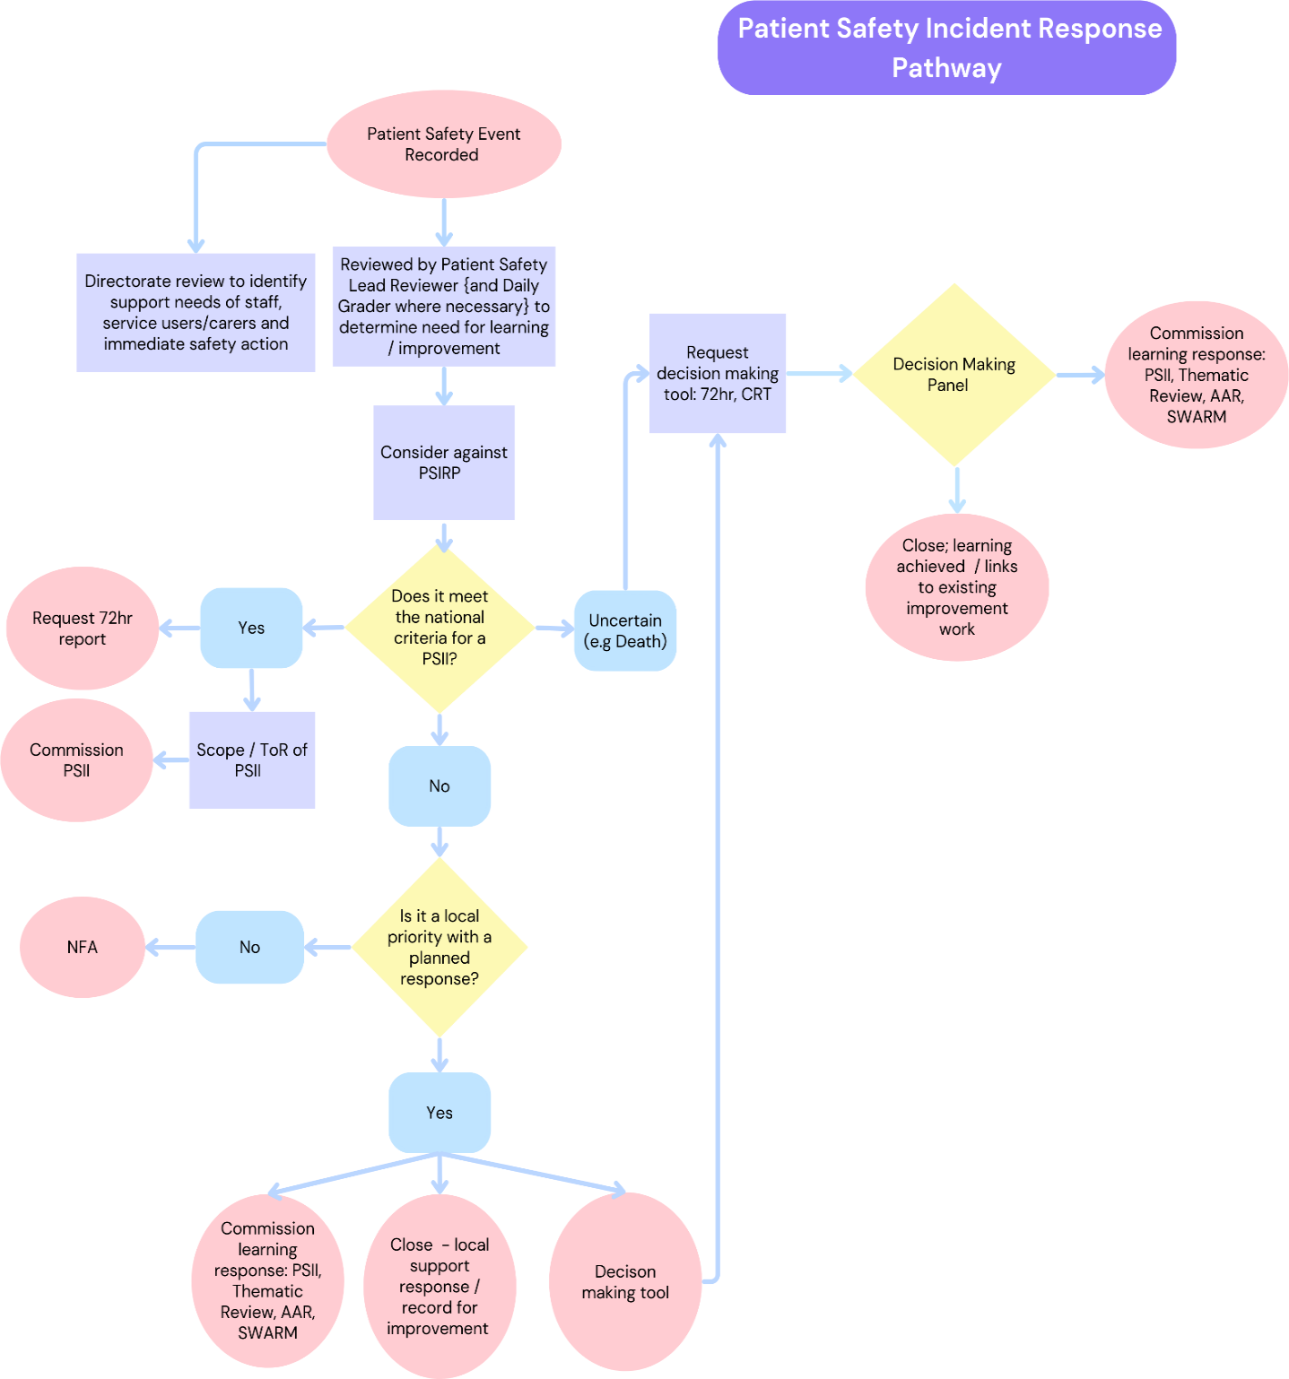

# 8.0 Adoption of Patient Safety Incident Review Framework (PSIRF)

8.1 In January 2024 we introduced the first phase of PSIRF implementation.

* The 48 hour report became a 72 hour report, providing an additional 24 hours to help services to focus on identifying support needs of those affected by incidents.
* We stopped declaring “Serious Incidents” and started declaring “Patient Safety Incident Investigations” (PSII) instead, for incidents meeting the [National Criteria for PSII](https://gbr01.safelinks.protection.outlook.com/?url=https%3A%2F%2Fwww.england.nhs.uk%2Fwp-content%2Fuploads%2F2022%2F08%2FB1465-3.-Guide-to-responding-proportionately-to-patient-safety-incidents-v1.1.pdf&data=05%7C01%7Ccharlotte.walton8%40nhs.net%7C3e64657d4c4c41f9569308dbf4b8cb48%7C37c354b285b047f5b22207b48d774ee3%7C0%7C0%7C638372846774793885%7CUnknown%7CTWFpbGZsb3d8eyJWIjoiMC4wLjAwMDAiLCJQIjoiV2luMzIiLCJBTiI6Ik1haWwiLCJXVCI6Mn0%3D%7C3000%7C%7C%7C&sdata=H7SpXRjeA45dVHRuZCTmbdJONCScl1HbgjOeCDSBnao%3D&reserved=0) or where we think there is significant risk and/or potential for learning.
* After Action Reviews have successfully been introduced as one of the new recommended learning responses for some incidents.
* The twice weekly PSIRF Oversight Panels have been replaced with a Daily Incident Review Panel, Decision Making Panel and a Sign-off Panel.
* In order to involve directorates more and strengthen decision-making, 72-hour report authors and a suitable senior directorate representative have been invited to join a the decision-making panel, where 72 hour reports are reviewed jointly to reach a decision on any next steps for learning and improvement.
* Started to embed a “People First approach” to prioritise support needs of those affected by incidents.
* Patient Safety Partners (PSPs) attend our Safety Learning Review Committee
* Obtaining feedback from those involved in incidents
* Reviewing and rationalising outstanding SI actions
* Adding safety to priorities to annual planning

# 8.2 Learning Responses

**8.2.1 Patient Safety Incident Investigations (PSIIs)**

PSIIs align with the Patient Safety Incident Response Framework (PSIRF), evolving from the former Serious Incident framework. Key changes include:

1. Adoption of SEIPS investigation methodology

2. Focus on system-wide issue identification

3. Collaborative approaches

4. Flexible timeframes

PSIIs are declared based on PSIRF recommendations, prioritising incidents with learning potential and systems review opportunities. They typically address national PSIRF priorities such as maternal deaths, never events, and incidents reportable to external bodies, as well as locally determined priorities.

These investigations aim to provide in-depth, systems-based reviews of patient safety incidents, usually completed within 3 months. This approach ensures comprehensive yet adaptable incident analysis, supporting ongoing organisational learning and patient safety improvements.

**8.2.2 Care Review Tools (CRTs)**

Care Review Tools (CRTs) are primarily desktop reviews designed for the rapid assessment of incidents, particularly a subset of unexpected deaths involving multiple services. They are preliminary review/assessment of incidents to determine whether a full Patient Safety Incident Investigation (PSII) is required or if other learning methods could enhance learning within the team. The scope of the CRT review should be within 3 to 6 months of the indexed incident/the patient's death.

CRTs must be completed within 10 working days by the Patient Safety Lead Reviewer to ensure rapid assessment and timely decision-making. The review should include all relevant documentation to identify significant gaps in care or missed opportunities that might necessitate a full Patient Safety Incident Investigation (PSII). If additional information or contact with services or families is required and cannot be obtained within the timeframe, the reviewer should proceed with the available information and present the findings to the sign-off panel. The sign-off panel, will make the final decision on whether the CRT findings warrant a PSII.

The Patient Safety Lead Reviewer may consult relevant directorates or services for additional information crucial to decision-making. Family involvement should be considered if it significantly aids incident understanding and learning. If neither services nor family are contacted, the reason must be documented. To avoid delays, the reviewer should complete the review with available information if timely contact is impossible.

Outcomes and Recommendations: After completing the patient safety review process, the following steps will be taken: The Patient Safety Lead Reviewer will assess any identified care omissions or learning opportunities. Based on their findings, they will recommend either further investigation through a Patient Safety Incident Investigation (PSII) or enhanced learning via an After Action Review (AAR). Subsequently, all CRT findings will be presented to the Sign-Off panel. The panel possesses the final discretion to determine and approve the appropriate learning process, if any, to be implemented.

**8.2.3 72-Hour Reports**

The 72-hour report is a tool for rapid information gathering following patient safety incidents, especially those potentially resulting in significant harm. This swift response mechanism serves to quickly assess the level of harm, identify immediate learning opportunities, and determine necessary next steps.

The initiation of a 72-hour report typically follows the PSIRF Oversight Daily Incident Review Panel, where Patient Safety Lead Reviewers and Director-Level Safety Graders collaboratively decide which incidents require this rapid assessment. Additionally, individual services can request a 72-hour report if they deem it necessary for their local review process.

Once initiated, the involved directorate or team compiles the report, gathering essential information about the incident. The completed report is then assessed to determine the severity of the incident and any immediate actions required.

The completed 72-hour report is discussed at the weekly PSIRF Oversight Decision Making Panel for next steps decisions.

# 9.0 Learning from incident responses

9.1 A large amount of work has taken place to improve oversight, safety culture and learning from safety, and the safety forum has supported a range of large-scale safety improvement work on priority areas.

9.2 Currently the Trust shares learning from incident response via the following:

* Monthly Trustwide Learning Lessons Seminars
* Local Learning Lessons forums
* Local and Trustwide safety newsletters
* Safety Briefings
* SI Committee
* Patient Safety Forum
  1. We have a new Learning from Patient Safety QI project that will develop over the next 12 months; Driver Diagram (version 1) below.

**Figure 4.0 Driver Diagram showing Learning from Patient Safety QI**

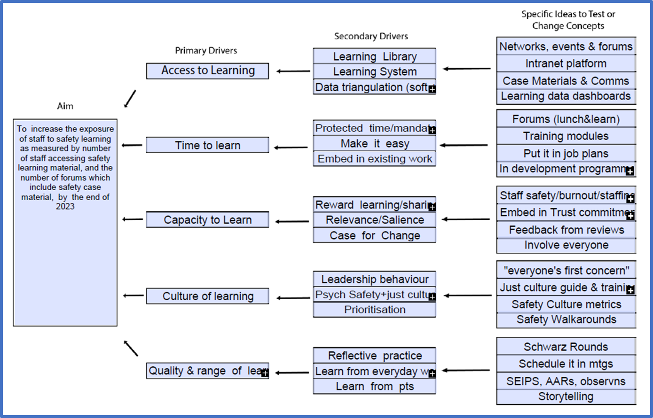

# 11. Staff training and competency

**11.1 Competency and capacity under PSIRF**

11.1.1 Learning response leads, those leading engagement and involvement and those in PSIRF oversight roles require specific knowledge and experience. Organisations may differ in how they approach engagement and involvement – this activity may be led by the person leading a learning response, or by a family/staff liaison officer or similar.

The patient safety incident response standards distinguish between the training requirements and competencies for these two roles but recognise they might be fulfilled by the same individual.

11.2.2 We have trained 40 members of our Quality Improvement (QI) team, Quality Assurance (QA) team and performance teams in systems approach in preparation for PSIRF.

11.2.3 The 2023/24 training plan is outlined in **Appendix 2.**

11.2.4 Future aspirations include development of and training for safety associates roles, and embedding systems training in QI and leadership development programmes.

# 11.2 After Action Review (AAR) Training

11.2.1 The AAR is a structured approach for reflecting on the work of a group and identifying strengths, weaknesses and areas for improvement. It is routinely used by project teams in corporations such as General Electric, British Petroleum and Motorola. An after action review (AAR) conducted after Hurricane Katrina led to new systems for communications during natural disasters.

11.2.2 An AAR method of evaluation usually takes the form of a facilitated discussion following an event or activity. It enables understanding of the expectations and perspectives of all those involved and it captures learning, which can then be shared more widely. AARs can be used after any activity or event that has been particularly successful or unsuccessful. It is also often used at the end of a project to help populate a lessons learnt log. It is important to disseminate learning widely so that good practice can be shared and others can learn from mistakes.

11.2.3 Three introductory AAR sessions were carried out Trustwide in autumn 2023 attended by 124 staff. Directorates are being supported to build a multidisciplinary cohort of AAR conductors, introduce a system to trigger and allocate AARs appropriately, and provide oversight of quality and share learning. At the time of this report, a cohort of approximately 80 senior clinical and operational staff have been trained as conductors across eight directorates with regular drop in support sessions available. Four training sessions are scheduled between March and May 2024; two in London and two in Luton and Bedfordshire.

# 12. Procedure to support staff affected by PSIs

**12.1 Current provisions in place to supporting staff after an incident**

12.1.1 At ELFT there is a culture and system of staff reflective practice and support, underpinned by established and recently introduced structures, such as:

* Time to talk forums
* Away Days
* Schwartz Rounds
* Supervision and appraisals
* Breathing Space
* Trauma Risk Management (TRiM)

12.1.2 Our Psychological Post-Incident Support Lead has produced a Post-Incident Psychological Support Review and Proposal.Whether psychological, relational, physical or professional Safety, the proposal is to privilege the severity of the risk to staff (in terms of wellbeing, sickness and attrition rates) and reflect the need for and motivate an obligatory, Trust-wide response across all levels of the system.

12.1.3 All staff affected by an incident should receive support and advice from their line manager. The line manager and service manager are responsible for arranging debrief following a serious incident. As part of the debriefing process the line manager must ensure that all staff are aware of how to seek additional support.

If the staff member is experiencing difficulties associated with the incident then a referral to Occupational Health services should be made by the line manager.

12.1.4 Where there is an inpatient death, the Associate Director of Governance & Risk Management provides guidance and/or additional support with debriefing meetings as well as providing support to individual staff who may need it, as part of the investigation process.

12.1.5 All staff that are required to attend for a formal interview as part of a serious incident review are sent an invitation letter containing the terms of reference of the review, an outline of the investigation process and details of how to access additional support from the Employee Assistance Programme.

12.1.6 The Trust has an ‘Employee Assistance Programme’ in place. The scheme is a 24hr, 7 days a week, free and confidential support service available to all Trust employees.

12.1.7 Feedback meetings following a serious incident review provide the opportunity to collaboratively discuss findings, recommendations and actions.

12.1.8 Monthly Learning Lessons Seminars are open to all staff and provide an informal and safe space to discuss and share learning from incidents.

12.1.9 The Legal Affairs Team provide expert advice and guidance in cases that follow the coronial process.

**12.2Planned improvements to how we support and involve our staff**

12.2.1 Under PSIRF we have implemented the following:

* Increase in use of After Action Reviews to provide meaningful immediate learning.
* Coroner’s training resource pack and bi-annual coroner’s training.
* Simulation training on difficult conversations with staff is planned to take place in the autumn for any trainee doctor or manager within the Trust.
* The membership of the twice weekly grading panel where reviews are presented for discussion and sign off has been expanded to include team leads and co-reviewers where their specialist knowledge, opinion and input is valued.

12.2.2 With Inphase an automated response will go to an incident reporter acknowledging that being involved in, or witnessing, a safety incident can lead to injury and can also be very distressing. It would encourage them to seek support from their team and/or line manager when needed, and if they feel comfortable doing so.

12.2.3 Colleagues will also be signposted to a range of wider resources available to support staff affected by incidents at work:

* Team Prevent is the Trust’s Occupational Health Service and can be contacted on 01327 810777, additionally a referral can be made via <https://managerzone.teamprevent.co.uk>
* Care first Lifestyle is The Trust’s Employee Assistance Programme provider.
* The Trust's Local Security Management Specialist (LSMS) who can provide support in relation to incidents of violence and aggression, and health and safety, and security.
* Specific support and guidance on the trust intranet for staff and to support service users/relatives.

12.2.4 Further ideas being developed are as follows:

* Staff support training for managers
* Restorative Just Culture is embedded
* Improved links between People and Culture and Patient Safety Team, possibly via the Patient Safety Forum or SI Committee (as it is currently known)
* Introduce feedback meetings following a concise review
* A trained pool of clinicians to offer peer support, groups or individually.

**12.3Staff support after an incident framework**

12.3.1 This proposed framework has a ‘people first’ approach and is designed to ensure that ELFT deliver a consistent offer and well-supported system making sure people and teams have a good experience.

**Figure 5.0 Pyramid showing staff support approach**

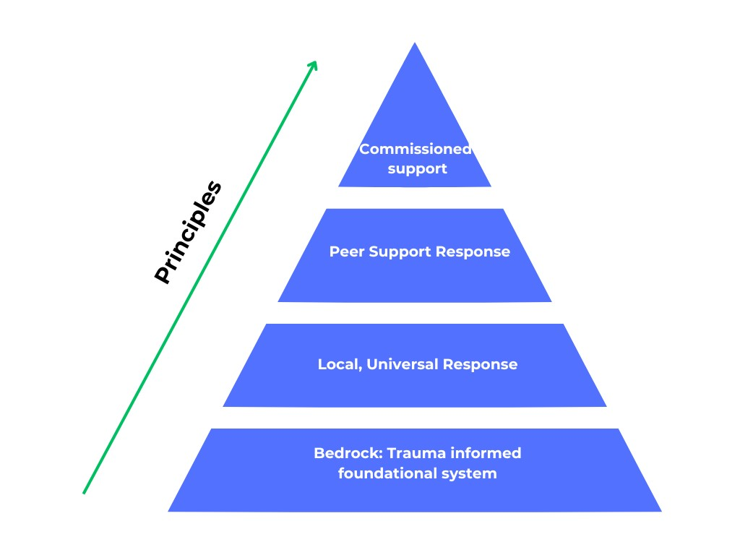

12.3.2 Bedrock: Trauma informed foundational system and local, universal response

* Directorate Management Team (DMT) triage system re support needs after incidents
* Team Level: Needs assessment (individual and Team) via Safety Huddle/Supervision
* Contact tracing
* Check-Ins/Team Debrief as needed/appropriate

Peer support response

* Occurs within the team
* Directorate level support co-ordination group (e.g. TRIM, PIP)
* Trust Peer Support Network
* Professional buddy System

Commissioned Support

* Employee assistant programme
* System for referring externally for professional help
* Signposting to specialist/ICB level/national support offers.

# 13.0 Procedure to engage, involve and support patients, families and carers affected by PSIs

13.1 The Patient Safety Incident Response Framework promotes systematic, compassionate, and proportionate responses to patient safety incidents, anchored in the principles of openness, fair accountability, learning and continuous improvement – and with the aim of learning how to reduce risk and associated harm.

13.2 The PSIRF supports development of a patient safety incident response system that prioritises compassionate engagement and involvement of those affected by patient safety incidents.

13.3 ‘Those affected’ include staff and families in the broadest sense; that is: the person or patient (the individual) to whom the incident occurred, their family and close relations. Family and close relations may include parents, partners, siblings, children, guardians, carers, and others who have a direct and close relationship with the individual to whom the incident occurred.

13.4 The Trust operates Being Open and Duty of Candour policies, which stipulate that families and carers must be notified when a related service user is involved or affected by a serious incident, within the context of confidentiality.

13.5 The care team will continue to maintain contact with the relative or family member as necessary and appropriate. In some circumstances, it will not be appropriate for the team to continue with this contact.

13.6 The Trust will make every effort to contact families of a victim who have been affected by the actions of a service user.

Current support for bereaved families, carers and staff involved in PSIs

13.1.1 On notification of a death immediate contact will be made by a senior manager of the service where the care took place, offering condolences, support and practical advice including how to obtain legal advice or the support of an advocate.

13.1.2 Contact will be maintained when appropriate according to the wishes of the family / carer.

13.1.3 In the case of an investigation, the Head of Incident Management will write to the family, explaining the review process and inviting them to make contact if they wish to be involved. In cases involving a patient death they will be signposted to support services.

13.1.4 This is followed up by the lead reviewer, offering support and asking how they wish to be involved. The lead reviewer will maintain contact with the family including making arrangements to feed back the findings of the review.

13.1.5 Where there is a death under City and Hackney Mental Health Service, we are offer signposting to bereavement services.

13.1.6 Translation services are available and used when appropriate at all points of communication during the review process.

13.1.7 The lead reviewer will signpost families to the Coroner’s Court in cases where there may be an inquest.

13.1.8 Feedback is being gathered from patients and families who have been involved in serious incidents on their experience of the process. This will help inform improvements that can be incorporated under PSIRF.

**13.2 Planned improvements to how we engage, involve and support patients, families and carers**

13.2.1 A working group has been established consisting of staff, patient safety partners (PSPs) and service users. It is in the final process of beginning to collect baseline data from those involved in SI/PSIIs to measure how engaged, involved and supported they were throughout the review process before implementing change ideas, some of which are in line with the expectations of the PSIRF supporting guidance ‘*Engaging and involving patients, families and staff following a patient safety incident’*:

* Recruitment of a Family Liaison Officer
* Identifying local engagement leads
* Direct involvement of the service user/family/carer in other learning methods e.g. Care Review Tool (CRT) process, attending an AAR etc.
* Sharing draft PSII report

# Annex 1 – Glossary

**AAR** **–** After Action Review

simple frontline approach to learning after an incident and focussed on asking 4 key questions as part of a 1-2hr facilitated group conversation in a psychologically safe forum, involving those involved in an event: What was meant to happen, what did happen, what accounts for the gap between what should have happened and what did happen, and what can we learn from this reflection?

**CQC –** Care Quality Commission

An executive non-departmental public body of the Department of Health and Social Care of the United Kingdom. It was established in 2009 to regulate and inspect health and social care providers in England.

**Frontline Observation**

Method to learn about a safety issue/area of care, by observation/shadowing/exploration of everyday work, using a systems approach.  For example, where a reviewer or team spend a day shadow a clinician whilst the administer insulin medication, or undertake vital signs monitoring, or ordinary work of some kind using either direct observation, video review, walk through talk through approaches.

**PHSO** - Parliamentary and Health Service Ombudsman (PHSO)

**PSI** – Patient Safety Incident

**PSII** - Patient Safety Incident Investigation

PSIIs are conducted to identify underlying system factors that contributed to an incident. These findings are then used to identify effective, sustainable improvements by combining learning across multiple patient safety incident investigations and other responses into a similar incident type. Recommendations and improvement plans are then designed to effectively and sustainably address those system factors and help deliver safer care for our patients.

**PSIRF** - Patient Safety Incident Response Framework

Building on evidence gathered and wider industry best-practice, the PSIRF is designed to enable a risk-based approach to responding to patient safety incidents, prioritising support for those affected, effectively analysing incidents, and sustainably reducing future risk.

**PSIRP** - Patient Safety Incident Response plan

Our local plan sets out how we will carry out the PSIRF locally including our list of local priorities. *These have been developed through a coproduction approach with the divisions and specialist risk leads supported by analysis of local data.*

**PSP** **–** Patient Safety Partner

Service users/lived experience experts who work collaboratively with our Safety team on improving Patient Safety.

**CRT**- Care Review Tool

Provides rapid assessment to ascertain the circumstances and care provided, with a higher level of independence than a 72-hour report, without necessitating a full Patient Safety Incident Investigation (PSII). It can be used as a decision making tool, a rapid learning response or used for purposed of thematic review.

**Schwartz Rounds**

Group reflective practice forums giving staff from all disciplines an opportunity to reflect on the emotional and social aspects of working in healthcare

**TRiM – Trauma Risk Management**

A trauma-focused peer support system designed to help people who have experienced a traumatic, or potentially traumatic, event.

**Thematic or Cluster Review**

Review of a group of incidents that have certain features in common, for purpose of identifying common system themes, and potential areas for learning and improvement.

# Annex 2 – Training Plan 2023/24

|  |  |  |  |  |  |  |  |  |  |
| --- | --- | --- | --- | --- | --- | --- | --- | --- | --- |
| Course | | | Staff Groups | | | | | | |
| National Training Requirements | **Duration & Format** | **Content** | **All Staff** | **Patient Safety Partners** | **Engagement Leads** | **Patient Safety Lead Reviewers** | **Co-reviewers** | **Patient Safety Specialists** | **Oversight Roles** |
| Systems approach to learning from patient safety Incidents | 2 days  Face to Face | * Introduction to complex systems, systems thinking and human factors * Learning response methods: including interviewing and asking questions, capturing work as done, data synthesis, report writing, debriefs and after-action reviews * Safety action development, measurement, and monitoring |  |  |  |  |  |  |  |
| Oversight of learning from patient safety incidents | 1 day  Face to Face | * NHS PSIRF and associated documents * Effective oversight and supporting processes * Maintaining an open, transparent and improvement focused culture * PSII commissioning and planning |  |  |  |  |  |  |  |
| Involving those affected by patient safety incidents in the learning process | 1 day  Online | * Duty of Candour * Just culture * Being open and apologising * Effective communication * Effective involvement * Sharing findings * Signposting and support |  |  |  |  |  |  |  |
| NHS Patient Safety Syllabus Level 1a - Essentials of Patient Safety for All Staff | 1 hour  eLearning | * Listening to patients and raising concerns * The systems approach to safety: improving the way we work, rather than the performance of individual members of staff * Avoiding inappropriate blame when things don’t go well * Creating a just culture that prioritises safety and is open to learning about risk and safety | *Available to all staff* |  |  |  |  |  |  |
| NHS Patient Safety Syllabus Level 1b - Essentials of Patient Safety for Boards and Senior Leadership Teams | 1 hour  eLearning | * The human, organisational and financial costs of patient safety * The benefits of a framework for governance in patient safety * Understanding the need for proactive safety management and a focus on risk in addition to past harm * Key factors in leadership for patient safety * The harmful effects of safety incidents on staff at all levels | *Available to all staff (aimed at boards and senior leadership team)* |  |  |  |  |  |  |
| NHS Patient Safety Syllabus Level 2 - Patient Safety - Access to Practice | 1 hour  eLearning | * Introduction to systems thinking and risk expertise * Human factors * Safety culture | *Available to all staff (aimed at all clinical staff)* |  |  |  |  |  |  |
| NHS Patient Safety Syllabus Level 3 | eLearning | * Still in development by NHS |  |  |  |  |  |  |  |
| NHS Patient Safety Syllabus Level 4 | eLearning | * Still in development by NHS |  |  |  |  |  |  |  |
| NHS Patient Safety Syllabus Level 5 | eLearning | * Still in development by NHS |  |  |  |  |  |  |  |
| Continuing professional development (CPD) |  | * To stay up to date with best practice (e.g. through conferences, webinars, etc.) * Contribute to a minimum of two learning responses |  |  |  |  |  |  |  |

|  |  |  |  |  |  |  |  |  |  |
| --- | --- | --- | --- | --- | --- | --- | --- | --- | --- |
| Course | | |  | | | Staff Group | | | |
| Local Training  Requirements | **Duration/Format** | **Content** | **All Staff** | **Patient Safety Partners** | **Engagement Leads** | **Corporate Reviewers** | **Co-reviewers** | **Patient Safety Specialists** | **Oversight Roles** |
| Co-reviewer Training    *[Supporting investigations as a subject matter expert facilitator]* | 1 day  {+ ongoing support} | * PSIRF Introduction * Understanding and building psychological safety with a just and learning culture * Safety I v Safety II * SEIPS explored * Observation Tool * Cognitive Interviewing * After Action Review * Swarm Huddles * MDT meetings |  |  |  |  | *Aimed at all co-reviewers (not currently mandated* |  |  |
| Introduction to After Action Review (AAR) | 1 hour | * Introduction to PSIRF * The origins and purpose of the AAR * Key elements and principles * Practicalities of running an AAR and the Four Questions * AAR summary write up | *Available to all staff* |  |  |  |  |  |  |
| After Action Review (AAR) Conductor | 3 hours  {+ ongoing support} | * Introduction to AAR Training *(as above)* * Practical group exercise x2 | *Available for all staff (aimed at those who have core facilitation skills and are in roles where they are supported to facilitate AARs)* |  |  |  |  |  |  |
| Care Review Tool (CRT) | 1 hour  {+ ongoing support} | * Background of the mortality review process * Development of the structured judgement review tool/ care review tool * Care review tool and how to complete * Support needed |  |  |  |  |  |  |  |
| Level 1 - Essentials of Digital Clinical Safety | eLearning | * What is digital clinical safety? * The legal framework * Digital clinical safety process * Why it matters to you | *Available to all staff* |  |  |  |  |  |  |
| Human Factors/  Ergonomics (Safety Science) for Patient Safety: Level 1 - Understanding | eLearning | * Human Factors/Ergonomics principles * Case studies | *Available to all staff* |  |  |  |  |  |  |
| PSIRF in Practice | 2-3 hours  Face to Face | * Under development * Essentials of Safety Culture & Systems approach * Learning and improvement * Support and involvement of those affected by incidents | *Available to all Teams* |  |  |  |  |  |  |
| Systems Engineering Initiative for Patient Safety (SEIPS) | 2 hours  Face to Face | * TBC |  |  |  |  |  |  |  |

|  |  |  |  |  |  |  |  |  |  |
| --- | --- | --- | --- | --- | --- | --- | --- | --- | --- |
| Course | | |  | | | Staff Group | | | |
| Health Services Safety Investigations Body (HSIB) Training | **Duration**  **/Format** | **Content** | **All Staff** | **Patient Safety Partners** | **Engagement Leads** | **Corporate Reviewers** | **Co-reviewers** | **Patient Safety Specialists** | **Oversight Roles** |
| A systems approach to investigating and learning from patient safety incidents | On-demand learning with bitesize modules  [20 CPD points] | * Complex systems, systems thinking and Human Factors. * Investigation practices such as interviewing, capturing work-as-done, using a systems framework (SEIPS), synthesising data and writing reports. * Developing effective safety actions and recommendations. * Engaging and involving those affected by patient safety incidents. |  |  |  |  |  |  |  |
| Involving those affected by patient safety incidents in the learning process | 1 day  [7 CPD points] | * Creating the right foundations. * Before and initial contact. * Continued and closing contact. * Additional considerations. |  |  |  |  |  |  |  |
| Patient Safety Incident Response Framework oversight | 2x 3.5 hour sessions  [7 CPD points] | * Introduces the principles of patient safety incident response oversight. It covers the mindset and the culture underpinning effective oversight, as well as the theory and practice of measurement and monitoring of patient safety. |  |  |  |  |  |  |  |
| Investigative interviewing | 3.5 hour  [3 CPD points] | * Overview of the principles that underpin a professional safety investigation interview with either a member of staff, a patient or a family |  |  |  |  |  |  |  |
| Demystifying thematic analysis | 3 hour  [3 CPD points] |  |  |  |  |  |  |  |  |
| Writing reports following investigations and other learning responses | 3.5 hour  [3 CPD points] |  |  |  |  |  |  |  |  |
| After Action Review | 3.5 hour  [3 CPD points] |  | *Available for all staff (aimed at those who have core facilitation skills and are in roles where they are supported to facilitate AARs)* |  |  |  |  |  |  |
| Safety investigation for strategic decision makers and senior leaders in healthcare | 2.5 hour  [2 CPD points] | * Provides strategic decision makers in healthcare an overview of the philosophical and methodological principles, which sit behind modern healthcare safety investigations. * This course is available as a team session for groups of executives at individual NHS trusts in England. * Please email [education@hssib.org.uk](mailto:education@hssib.org.uk) to register your interest. |  |  |  |  |  |  |  |

1. 4 Health and Safety Executive (2014) Investigating accidents and incidents: A workbook for employers, unions, safety representatives and safety professionals.

   5 Vincent C, Adams S, Chapman A et al (1999) *A protocol for the investigation and analysis of clinical incidents.*

   6 Public Administration Select Committee (2015) *Investigating clinical incidents in the NHS. Sixth report of session 2014–15*.

   7 Parliamentary and Health Service Ombudsman (2015) *A review into the quality of NHS complaints investigations where serious or avoidable harm has been alleged*.

   8 Care Quality Commission (2016) *Learning from serious incidents in NHS acute hospitals. A review of the quality of investigation reports*.

   9 NHS Improvement (2018) *The future of NHS patient safety investigation*.

   10 NHS Improvement (2018) *The future of NHS patient safety investigation: engagement feedback*.