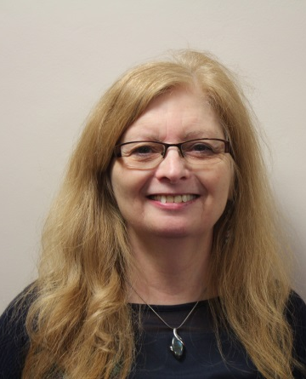
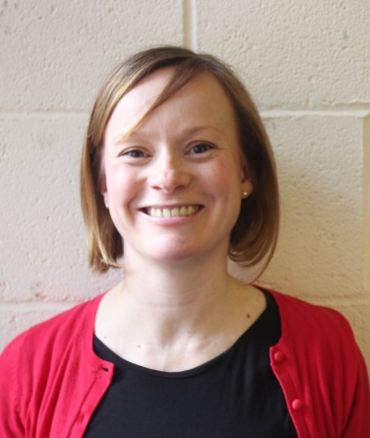
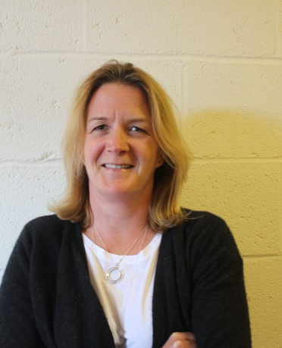
Bedford Emotional Behavioural Team

Roz Allen
Roz Allen Jenny Reeves Hazel Freeman
Clinical Team Lead Clinical Team Lead Art Psychotherapist
Child & Adolescent Clinical Psychologist
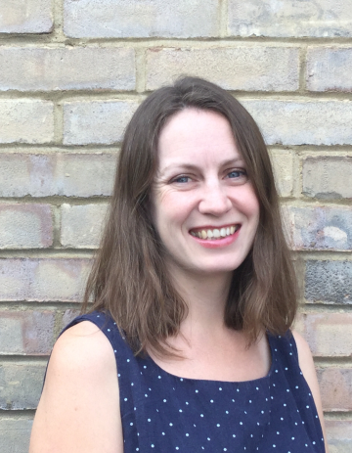
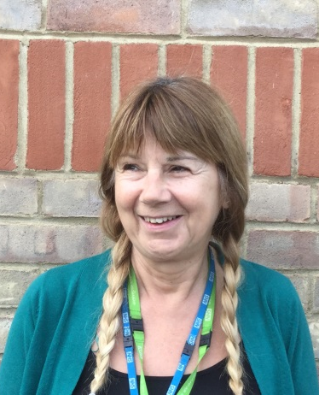
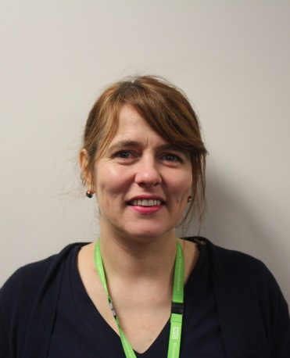
Psychiatrist

Kate Woollaston Karen Dathorne Leah Knight
Clinical Psychologist Lead Mental Health Nurse Mental Health Nurse
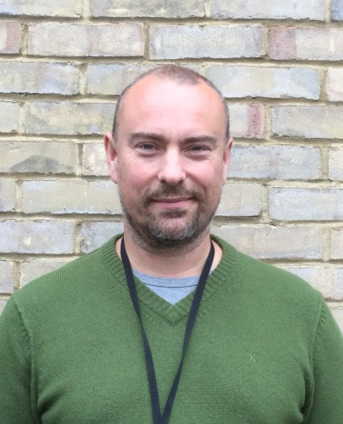
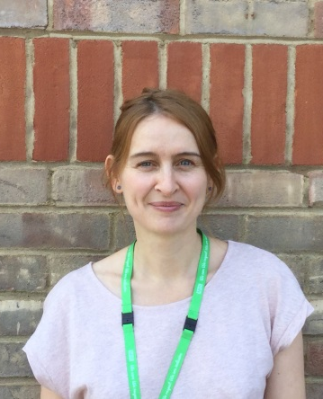
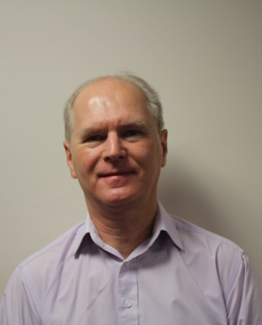

Phil Chadwick Susan Jacques Nick Sanderson
Systemic Psychotherapist Child & Adolescent Psychologist Snr Child Psychotherapist
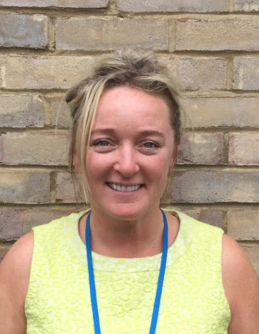
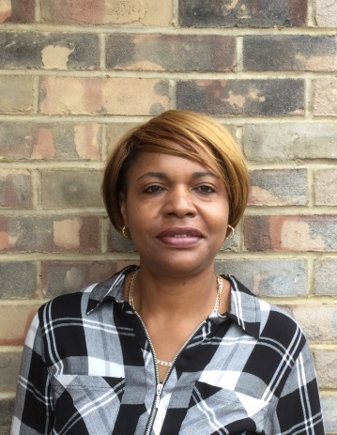
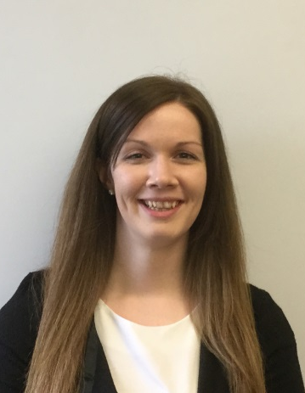

Claire Sullivan Norma Roberts Jo Meehan
Team Administrator Administrative Assistant CAMHS General Manager
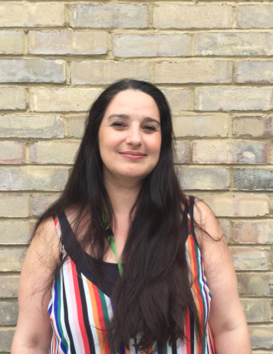
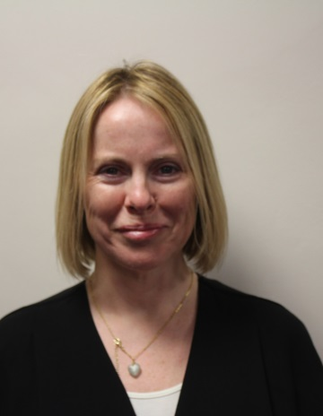
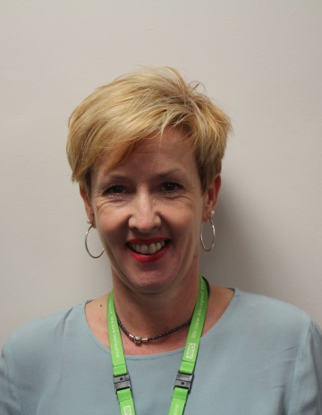

Niki Scott
Niki Scott Cathy Lavelle Elizabeth Joyce
Service User Participation Child & Adolescent Psychiatrist Community Support Worker
Lead Associate Clinical Director
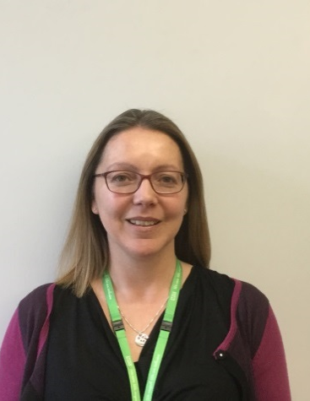
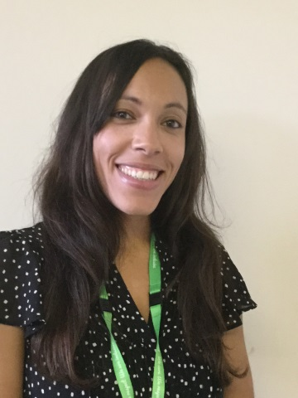
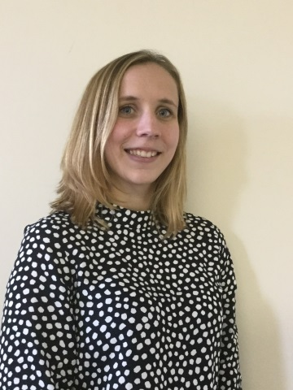

Emma Harbour Candice Williams Rosemary Herbert
CAMHS School Practitioner CAMHS School Practitioner Outcomes Administrator
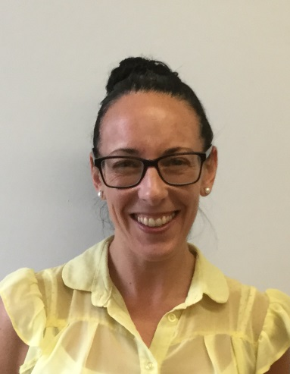
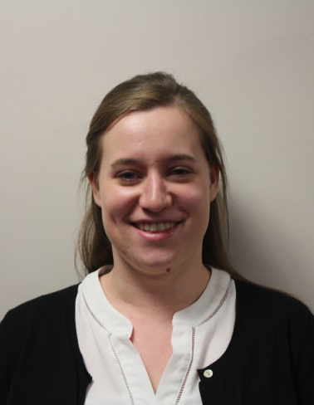
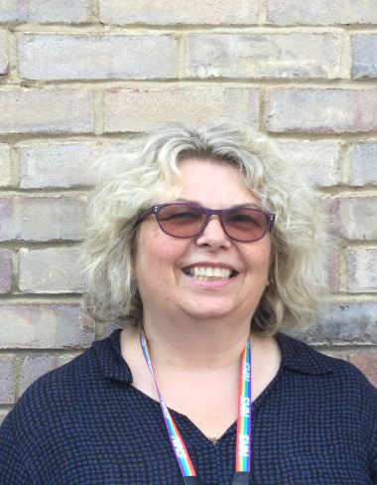

Kate Rothwell Heather Heseltine Caroline Athill
Trainee Psychotherapist Operations Manager Admin Team Lead

