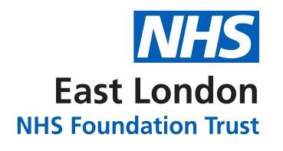

Annual Equalities Report 2019

Equal Opportunities

The Trust is an equal opportunities employer, accredited with the Two Ticks Disability Symbol and has achieved the 'Positive about Disabled People' status. The Trust has an Equality, Diversity and Human Rights Policy in place and a strategy for its effective implementation.

Awards

- ELFT‟s Black and Asian Minority Ethnic Staff Network Lead, Diana Okoukoni, was shortlisted for the first edition of the National BAME Health and Care Awards 2019 in the Inspiring Diversity & Inclusion Lead category

- The Bedfordshire and Luton Liaison and Diversion Service received a Howard League for Penal Reform in relation to their work with female offenders. The Trust team were recognised for their work diverting women from short-term custodial sentences and into therapeutic community sentences, providing psychological interventions to women under a court endorsed Mental Health Treatment Requirement.

Respect & Dignity at Work Campaign

In May 2019, we launched the Respect and Dignity Campaign following our 2018 national NHS staff survey results. The aim of the project was to reduce the numbers of staff who had experienced bullying and harassment from patients or their relatives, colleagues or their line manager. As part of the campaign, the Executive Directors made pledges. The Respect and Dignity project was in four parts.

A Mile in My Shoes Exhibition

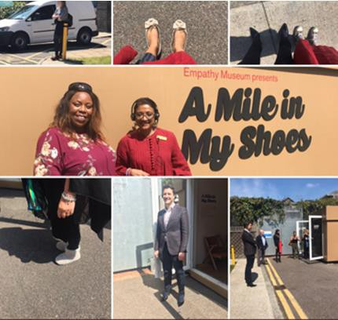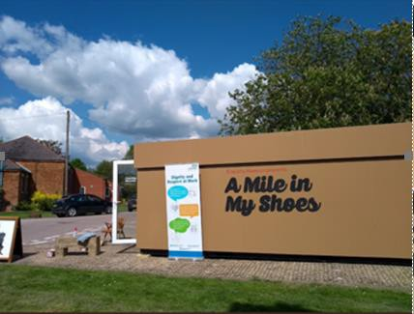

This was an installation called “A Mile in My Shoes‟, run by the Empathy Museum, and the installation came to the Trust in May 2019. The exhibition enabled staff to the shoe shop, put on a pair of shoes, listen to the individual’s stories on an I-pod, and then literally walk a mile in other people’s shoes whilst listening to their stories. Over 300 staff attended the exhibition across the Trust.

The exhibition featured in Bedfordshire and in London across two weeks. We had a successful Twitter campaign and pledges from Executive Directors. The exhibition was followed by focus groups for staff called “Through My Eyes‟, which enabled staff to share their stories and create illustrations. We collected around 45 stories and illustrations. We are working through the themes to progress to the next part of the project.
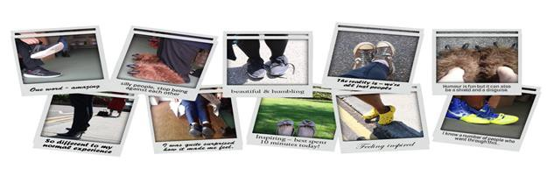
A series of big conversations have been run across the Trust called „Through Someone Else's Eyes‟, where we had targeted around 1300 managers to come together and hear the stories from staff and then to tell their own stories. The CEO Dr Navina Evans also shared her stories. The aim of the project is to develop leaders that are more compassionate.

In September 2019, we launched a survey tool called Go Engage, which enables the Trust to regularly take a “temperature check‟ of the organisation quarterly.

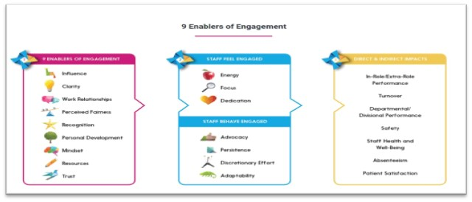

Knife Crime Workshops

As part of our staff wellbeing work around the wider determinants of health, we ran a series of Knife Crime workshops in response to the prevalence of knife crime, gangs and county lines in our boroughs. We know that around 25% our staff live and work in the boroughs within which we provide services. The sessions offered created a forum for staff to share their experiences with others in similar circumstances and to signpost them to support.

In terms of staff benefits and wellbeing, we have produced the second edition of our glossy Wellbeing and Benefits magazine highlighting the Trust’s offerings. The contract with Neyber was terminated prior to them going into administration and we are in discussions with possible alternative providers.

Recruitment, Selection and Retention

The Trust has maintained relatively static in terms of its vacancy rates to a level below comparator Trusts. Although, there are some areas in which recruitment remains a significant challenge our overall turnover remains low and we continue to develop our work to recognise staff.

We continue to undertake targeted recruitment and we are developing in terms of values- based recruitment. All applicants who declare a disability and meet relevant aspects of the person specification for the role are guaranteed to be shortlisted for interview.

To address the recruitment challenges, we have revised the bank rates for areas that are difficult to recruit to, to enable the Trust to be competitive and to reduce or reliance on agency workers. We have also launched a project to expand the Trust bank.

We are building maintaining a steady number of Apprentices across the Trust and there are plans to increase. We have successfully transferred apprentice levy funds to six small organisations. We are also beginning to work with schools for work experience and placements.

People Relations

The Fair Treatment Process implemented in 2019 has seen a significant and sustained reduction in the number of suspensions of staff and we continue to work closely with staff side to reduce the numbers of Black, Asian Minority Ethnic (BAME) staff who are in formal disciplinary processes.

Equality, Diversity and Inclusion
The Trust has one of the most diverse Boards in the NHS and international evidence shows that diversity leads to better decisions. Ensuring equality and valuing diversity is one of the Trust’s core values and is integral to our organisational culture.

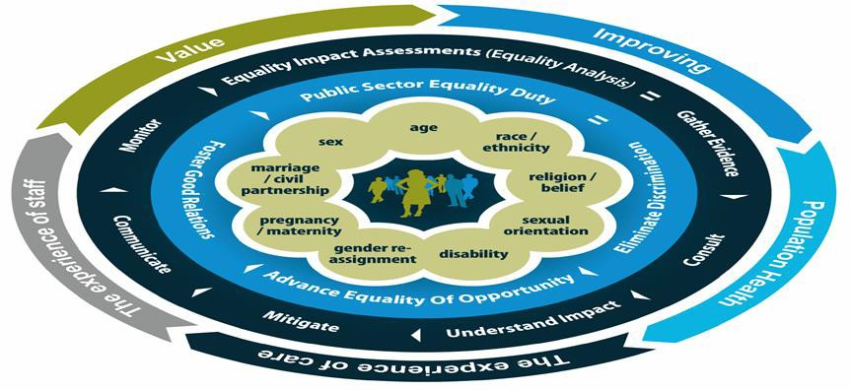

The work on the Trust’s Equality, Diversity and Human Rights (EDHR) priorities continued during 2019. Each directorate created equality plans that were aligned to the Trusts strategic aims. Each quarter there was a place based “Making Equality work” forum for each speciality to present on the achievement, challenges and plans related to equalities. This gave each service a space to learn from each other and share work that is happening in the borough. The discussion would be for staff, service users and wider populations.
The forums were chaired by Chief Nurse with discussions lead by Service/Clinical Directors. The remit was to ensure stronger links between Trust-wide work and that being undertaken in the Directorates.

In order to explore opportunities to share and collaborate the forums were held in the services and the remit was to:
- Discuss local work on equality, diversity and human rights
- Understand how the connections between all our locally-based help make this happen
- Understand how the equality, diversity and human rights needs of your local communities are met
- Explore the challenges and good practice to tackle them.

Below is a summary of activity in each directorate/forum
.

Newham
The forum related to Community Health Service, Adult Mental Health, Improving access to Psychological Therapies (IAPT), Specialist Children’s and Young People’s Team (SCYPs) and Child and Adolescent Mental Health Services (CAMHS).

Newham Community Health Services:
  - Focussed on older adults, staff understanding on mental capacity assessments and forums to discuss staff inequalities due to ethnicity.

Newham Adult Mental Health:
  - Focussed on psychological therapies worked with young people looking at how services can be culturally sensitive and reviewing barriers and solution; engaged diverse groups of services users.
  - Psychotherapy services looked at reasons why BAME communities engage less with psychotherapy with particular focus on stigma, European model, and different ways of seeking help.
  - Trainee psychologist in post focusing on BAME access. Also sought to understand staff competence in cultural knowledge and understanding.
  - Focus group with service users, QI project, staff training raising cultural awareness.
  - Adapted stepped care model to improve access for people from BAME community, which includes specific questions, BAME Tree of Life.

Newham Crisis Pathway re-design:
  - Event acknowledged contribution of service users who played a central role in redesign. Event was built around explaining the proposal and seeking views, discussing barriers.
  - Broad support for the Hub and many ideas offered to overcome barriers to access.

Newham Talking Therapies (IAPT):
  - Focus on flexible working for staff and training for managers having „difficult conversations‟, creating learning and development opportunities for staff.
  - Have a diverse workforce and service users match demographic profile in Newham, which is a considerable success, achieved through working in partnership with the community.
  - Have focused recently on increasing access by older people and men. o Service user forum in place and this coming year working with them to increase accessibility to all communities and reduce stigma, making interpreting available for group therapy.
  - Working in partnership with CHN to offer services to people with long-term health conditions, various QI projects and population health project on delivering therapy digital video calling.

Newham CAMHS:
  - Trust-wide CAMHS equality group, focussing on staff equality, all services self-evaluating against standards.
  - Focus on recruitment to increase diversity of staff. Access is an issue; now working with People Participation to address this via events.

Specialist children as young people services:
  - Work in progress around transition from children to adult services.
  - Bringing staff together across lots of sites, well-being events planned and meetings with managers.
  - Lots of involvement with service users, two parent groups running.

Tower Hamlets
Consisted of Community Health Services, Adult Mental Health and Learning Disability services, IAPT, CAMHS.

Tower Hamlets Community Health Services:
  - Redesigning the transition from children to adult services to ensure families receive the individual care they require.
  - People participation worked with service user groups in Foot Health, Continence and Continuing Healthcare to improve accessibility, enabling self-referrals where possible, Working Together Group oversees communication material.
  - Link to Carers‟ Centre.
  - Advocate Coaching for Health training to equip staff to help service users to make informed choices.
  - Develop education about conditions in the community to ensure all communities can access.
  - Building the confidence of staff to ask the right questions is vital as is working with other partners (public, private and voluntary and community sector as appropriate). Examples included the Muslim peer support worker in continence who goes to the mosques to raise awareness of the service and the newsletter for housebound patients delivered by the district nurses when they are providing care.

Tower Hamlets Talking Therapies (IAPT):
  - Therapists in every GP surgery.
  - 11 languages spoken across the service. Outreach in further education colleges and universities.
  - Co-production and QI projects – for example on waiting lists.
  - Depression and anxiety groups in Bengali.
  - Community engagement worker – in mosques, temples, etc., ESOL settings.
Referrals match the demographics of the community (as does the workforce).
  - Data audits to ensure there is fair access.

Workforce overview:
  - Diverse workforce.
  - Social and culturally specific events.
  - Training also includes cultural issues.

Service model:
  - Push to offer services close to home while recognising some people prefer that it is not (to prevent family, friends, neighbours and wider community knowing about conditions).
  - 1000+ referrals each month – 700 of these are self-referrals.
  - Digital packages are well used (for example, older people are the largest percentage of users and of recovery).
  - Therapy is under constant review and dialogue to adapt to the needs of service users.

Tower Hamlets CAMHS:
  - Interpreters and therapists work as “cultural advocates‟.
  - Evolving group therapies.
  - 70% of young people – 1st or 2nd generation Bangladeshi.
  - Inreach into schools. Lots of work with schools, example of mums and daughters‟ group in Mulberry School where discussions have included teenage relationships and sex.
  - Success in gaining funding for trailblazer work in schools.
  - CAMHS Trust-wide Equalities group Conversations re staff progression – equal opportunities – shortlisting and recruitment, unconscious bias.

Tower Hamlets Adult Mental Health Services:
  - Recovery model – start with the individual, understand needs and identify gaps.
  - Commitment to co-production – piloted in one CMHT with a plan to roll out.
  - Celebratory events related to diversity of cultures in the team.
  - Population health – focus on homelessness.
  - Not disclosing sexuality and faith – „prefer not to say‟ – how to tackle (as it may coincide with those who feel most dissatisfied).
  - Inpatient unit – staff feel more empowered than in the community to be creative, example of going to find a Mandarin speaker.

City and Hackney
Consisted of Adult mental health, forensic service and CAMHS.

City and Hackney Adults services:
  - Working with staff to reduce homophobia and increase support for patients who are LGBTQ.
  - Training co-produced with service users.
  - Training video resource created and available for all staff on the Intranet.
Include how to complete assessments.
  - Making role models via the internal vacancies and appointment bulletin.
  - Engaged with community in reviewing the experience of young black men and how they experience and access services in the boroughs.
  - EQUIP team quality improvement project on the experience of service users
  - Autism awareness training rolled out. Service working to enhance accessible information.
  - New service Health Based Place of Safety monitoring data of service users.

Forensic Service (Trust-wide but based in Hackney):
  - Considerable work in the service to reduce violence and specifically reduce sexual violence in the learning disability team.
  - Service also employs a sexual violence advisor to support staff who are subject to sexualised incidents.
  - Review of data highlighted over representation of BAME service users in restrictive practices and were analysing the referral to high secure services and discussing with teams about bias and impact of practice.

City and Hackney CAMHS:
  - CAMHS staff equality, which is Trust-wide review in the experience of staff in the directorate and the ability to develop and progress.
  - Review of the pathways for young people by demographics and what is available for each young person based on the pathways.
  - A programme called Non-Violent Resistance Parenting took place in alliance with the national organisation Non-Violent Resistance (NVR) and Hackney Community Voluntary Service (HCVS).
  - Non-Violent Resistance (NVR) is a psychological approach was originally developed to address serious behaviour problems in young people.
  - CAMHS Alliance having worked in partnership with third sector organisations to deliver parenting programmes in the Turkish and Jewish communities, and
after consultation with BAME community leaders if was felt this was an ideal opportunity to deliver NVR in order to engage with families who may struggle to engage with CAMHS Services.

Luton and Bedfordshire
Consisted of CAMHs, Pathway to recovery (addiction services), Adult Mental Health service and Community Health Services.

Luton and Bedfordshire CAMHS:
  - Challenges in recruitment and lack of diversity in senior posts.
  - Analysis of service users broadly representative of local populations, for example LGBTQ+. Nevertheless, there remain certain groups in the community who do not access services at all.
  - Team is focused on developing relationships with all communities, for example visiting faith and community organisations.
  - People Participation’s is engagement from a diverse range of service users, working specifically with young people in marking LGBT History month.

P2R Path to Recovery Luton and Bedfordshire:
  - There are Recovery Practitioners are diverse and representative of the local population but not reflective in the senior staff.
  - Work ongoing to attract, recruit and retain diverse senior staff.

Bedfordshire Community Health Services:
  - In recognition of the diverse local cultures, an Equity and Diversity group has been established to reflect on the Trust’s strategy, using disability as a starting point.
  - There are similar difficulties (in achieving a diverse workforce but some success in connecting with different communities, for example the Italian community in Bedford and recruitment of staff with the ability to speak different languages to the Single Point of Access, particularly in the south locality.
  - Service created audits of health centres to check hearing loops, wheelchair access and whether there is LGBTQ+ friendly information. The results of the audit are now be built into the development of the new Estates Strategy.

Luton and Bedfordshire People Participation:
  - Following concerns raised by two transgender service users about the response they were receiving from services, there is now a transgender policy for wards and gender-neutral toilets in place.

Interpreting and Translation
Compass took over the management of the provision of its interpreting and translation services, reviewing the provision and quality of interpreting across all services and working with service users to improve the experience.

There are sometimes difficulties in accessing interpreting and translation, particularly at short notice for services such as admissions and discharge, as well as for translators of some languages (not used by large numbers of patients). This emphasised the importance of continuing to recruit and retain a workforce that reflects the community although this is not necessarily easy or immediately achievable (at least in the short term). The importance of training interpreters was recognised, especially the ability to translate the technicalities and sensitivities of health issues accurately and fairly. Relying on family
members and other staff colleagues may sometimes work but is not always appropriate. Examples of technology helping at short notice for example use of „Google translate‟ when it may well be pragmatic to do so in certain situations.

Translation: particularly in relation to talking therapies, the different understanding of conditions and treatment between communities. Services have therefore aimed to develop local models appropriate to community needs although there can sometimes be tensions in matching these precisely with NICE guidelines. An example to address this is the preparation workshop for Bengali and Sylheti speaking patients which provides an explanation of therapy and what the treatment programme before it actually starts. There is also a „push and pull‟ aspect to the issue of translation both from different languages and from medical and technical to everyday terms. This involves recognising that there remains stigma associated with mental health conditions and some physical health conditions. It is therefore important to be sensitive about this but, at the same time, attempt to „de-stigmatise‟ by being more open.

Equality Plan Vision

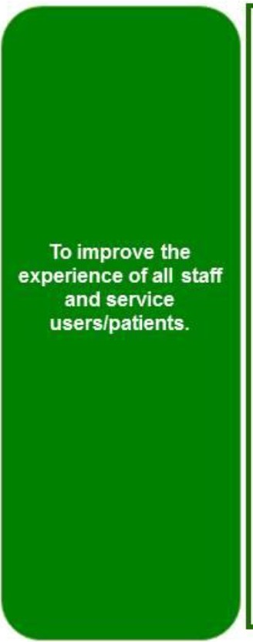
Trust Strategy

Equality Plan Vision Strategic outcomes

Trust-wide objectives

Success Measures

1_ Improved agreed health outcomes from selected populations within local teams_ 100% directorates to have equality objectives

2_ Reporting on PROMs and patient experience metrics to include analysis and response based on service user demographics .Identify five metrics to report on

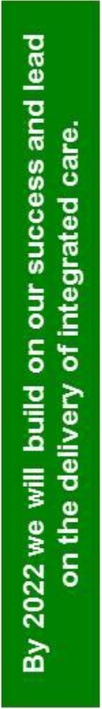
1_ _ 100% policies to equality impact accessed.

Improved experience of care
and
Improving population health outcomes

Capacity & capability

1_ Work with directorates to achieve their self­ identified objectives with partners using Quality Improvement to address health concerns in wider populations
2. To improve the capability of services to meet the needs of service users and carers by improving access to equalities information for teams.

Policies and standards
1. Include equality impact assessment in all clinical policies and procedures
2. Ensure all services are compliant with accessible information standards

Addressing specific areas of inequality
1_ Roll out safer service work in all directorates to ensure that vulnerable service users are provided with safe space on the wards (including women, LGBTQ, older adults and learning disabilities)
2. Roll out human rights training to all inpatient teams 3_ Reduce number of BME servicer restraints

Information and engagement
1_ Ensure accessible service information and provision people whose first language is not English
2. Develop and co-produced guidance and regarding working with Transgender Service Users

2_ 50% Increased recording of needs identified recorded, flagged, shared and needs met

  - 100% rollout of safer service framework to all inpatient services
2 _ All teams self-assessment of compliance with human rights practice with reduction in restrictive interventions
3. Reduce rate of restraint for BME servicers by 10% each year.

7. Increased reporting in language needs met
8 .Creation of guidance and addition to training programme_ Increased knowledge and
understanding of needs of service users who I
are Transgender measured via survey. J
l
we r |  | -'r.t:

Our values |  | we care |  |  |  |  |  | we aretvu;tudve
Organisational |  |  | SeMce user and |  | committed and | Quality | Clinically led | Inclusion and | Mental health and
treasures | carer involvement |  |  |  | canng staff | 1mprovemenl |  | d1vers1ty | recovery focus

96

Religion and Spirituality

In the last year we have extended our Spiritual Team in Bedfordshire, London and Luton, and joined the Quality Improvement (QI) project with a view to extend the reach of Spiritual Needs Assessments across the Trust. At present, we achieve an 80% engagement level in Newham. Our aim is to ensure that all service users have the opportunity of such an assessment as soon as possible after admission. This conversation places the user at the centre of the assessment. It is completely person centred and focusses on the spiritual needs of the person. The jointly agreed document is then incorporated within the care plan. In this way, the spiritual needs of the person are integrated and recognised by the whole multidisciplinary team.

In the last year, a member of the Spiritual Team has visited every in-patient facility at least weekly. All service users are made aware of our availability by our presence, posters and colleagues. In addition to the mainstream religious faiths, members of our team support those service users not represented by members of our team, e.g. Sikh, Jehovah Witness, etc. In such cases, we act as a bridge with their community. There are also many service users who do not align themselves with any particular faith tradition but see themselves on a journey of spiritual discovery often with no religious orientation but are deeply spiritual.

Referrals are by self-referral or from colleagues across all professions. In addition to individual support, members of our department deliver a range of different spiritual practices, which include Holy Communion, Friday Prayers, Prayer Groups, Meditation Groups, Spirituality Discussion Groups and worship sessions.

Our core underlying principle is to respect the diversity of the individual. This applies equally to the person’s gender, race and sexual orientation.

Since the team consists of a wide range of religious, spiritual and cultural traditions, we are able to respond in a unique way to the need of our service users. The traditions of the East

London community are now diverse and complex. We are able to understand that complexity and engage with it.

The Trust has initiatives in place to make psychological therapy services more accessible and relevant to the diverse needs of local communities. Both City & Hackney and Tower Hamlets Psychology Services have worked to improve access and cultural relevance of psychological therapies for BAME service users. Through partnership working with local faith and community groups, the Department of Spiritual, Religious and Cultural Care and the Recovery College we have continued staff training on jinn, black magic and evil eye and mental health, developed courses on religion, culture and mental health at East London Mosque and delivered culturally adapted therapies.

Workforce Equality Plan

The Workforce Equality Plan has been developed and underpins the 2018-2021 EDHR Plan as well as the Workforce Plan. Its objective is to improve the experience of all staff and service users/patients. It has a number of strategic objectives, which tie in with the objectives of Staff Equality Networks and the work of People & Culture Teams, as follows:

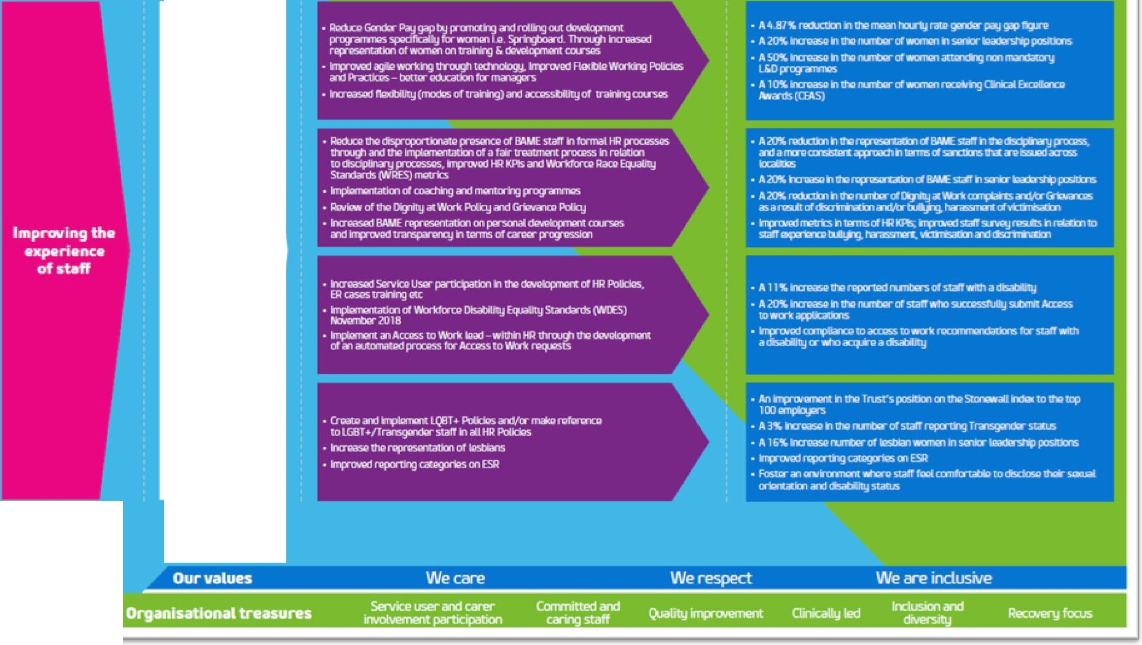

In 2019, we have been able to
- Achieve an increase of 9% in the number of Clinical Excellence Awards (CEAs) awarded to female consultants and reduce our gender pay gap from 12.45% in 2017 to 11.54% in 2018. 2019 reporting was suspended to the Covid 19 pandemic
- although ELFT will review internally
- Evened the likelihood of white staff compared to Black, Asian Minority Ethnic staff (BAME) in our 2019 Workforce Race Equality Standards (WRES) submission
- Reduced the number of suspensions and have reduced disproportionate effect of BAME staff in formal HR processes
- Implemented coaching and mentoring programmes and a coaching platform
- Increased service user participation in the development of HR Policies, ER cases and training
- Implementation of Workforce Disability Equality Standards (WDES) and action plan in conjunction with the ELFT ABILITY staff network
- Good progress against several equality targets
- Challenging success measures have been set for the plan to ensure we track and measure our progress against the strategic objectives annually.

Update on Progress

ELFT is dedicated to challenging prejudice and discrimination wherever this affects our service users or staff and making equality and diversity integral to our organisational culture. We have made a good progress on a number of areas below:
- Introduced new Equality, Diversity, and Human Rights Policy
- Achieved 185th rank overall and 21st rank in the sector on the Stonewall Workplace Equality Index
- Improved in a number of Workforce Race Equality Standard (WRES) areas
- Continued to deliver in-house mediation service
- Delivered three cohorts of Springboard Development Programme.

Staff Equality Networks

The Trust now has increased from four established staff networks to five (BAME, Disability, LGBTQ+, Women and Intergenerational) to offer support and a safe space to staff groups who might benefit from focussing on what they need to progress in their careers and personal development. The networks run events, conferences, workshops, training sessions, and celebration and social activities that all contribute to education, awareness, engagement, and reduction in variation of experience for staff with these protected characteristics.

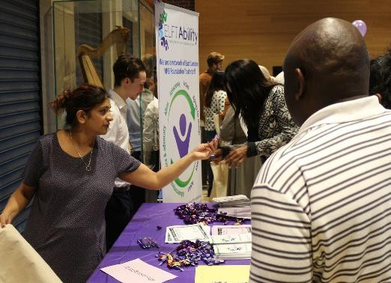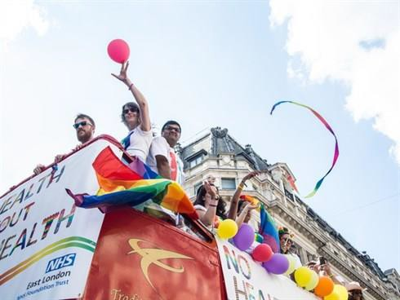

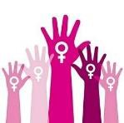
We also support LGBTQ+ and women charities and raise funds towards their activities via network events.

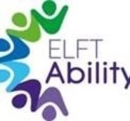
A summary of key annual highlights from each network can be seen below.

BAME | ELFT Ability
- Celebrated Black History Month  - Run regular network meetings and development workshops  - Facilitated annual conference  - Launched quality improvement project on improving  the experiences of BAME staff  - Facilitated a series of „BAME and COVID- 19‟ webinars | - Facilitated annual conference  - Run regular network meetings and peer support space  - Supported with submission of  WDES and development of WDES action plan  - Supported with production of Workplace Adjustments Guidance  - Launched „Disability Champions‟ monthly campaign  - Launched bi-monthly network newsletter  - Launched „See the Ability‟ campaign to profile staff with disabilities
LGBTQ+ | Women
- Run regular network meetings  - Celebrated LGBT History Month  - Facilitated annual conference  - Attended London Pride and London Black Pride  - Rolled-out LGBTQ+ awareness training in localities and in-patient services  - Improved on Stonewall Top 100 Index  - Launched „coffee connection‟ initiative  - Facilitated sector-wide webinar with Michael Brady, National Advisor for LGBT Health at NHS England | - Facilitated annual conference  - Run regular network meetings and development workshops  - Supported work on sexual violence in Forensics  - Run Trust-wide survey to help shape annual plan  - Set up virtual support channel on MS Teams
Intergenerational
- Launched the network
- Developed Twitter, intranet and email presence
- Run Trust-wide survey to help shape annual plan
- Run webinars and peer support space

CAMHS (Children and Adolescents Mental Health) Equality Group

On the back of our 2016 CQC visit, the CAMHS Equality Group was formed by the members of staff in all five localities.

The groups has commissioned an internal survey and ran a series of focus groups to identify the equality and diversity gaps within the CAMHS services. They have come up with the follow up plans to improve recruitment and retention practices; identify barriers to career progression; allow staff to talk openly and honestly about culture; and reduce the complains of inequalities within training commissioning.

.

Staff Profile

April 2018 – March 2019
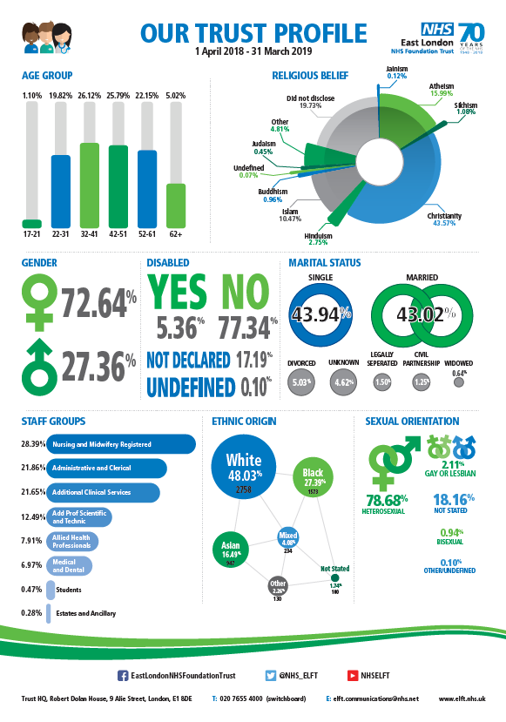

Staff Profile

April 2019 – March 2020

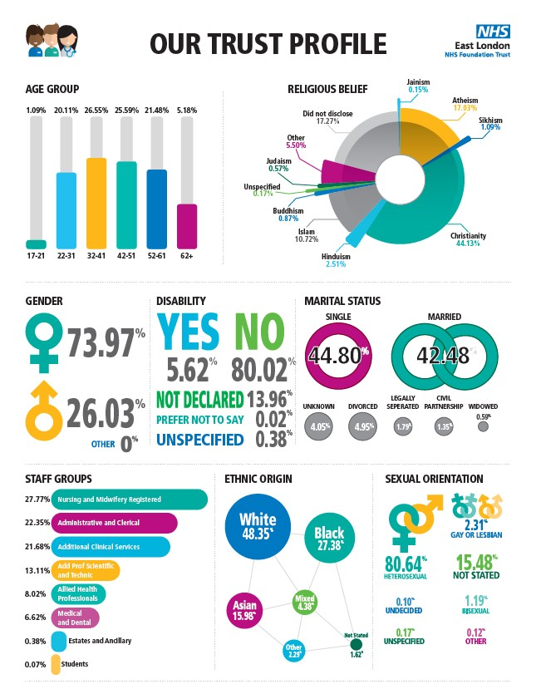

Gender Analysis

Staff Group | Total | Gender |  | Age
 |  | Female | Male | <25 | 26-45 | 46-65 | >65
Board of Directors | 20 | 7 | 13 | 0 | 6 | 14 | 0
Senior Managers | 4 | 1 | 3 | 0 | 0 | 4 | 0
Doctors and Dentists | 390 | 219 | 171 | 1 | 231 | 149 | 9
Nursing | 1672 | 1233 | 439 | 43 | 786 | 821 | 22
Other healthcare staff | 2741 | 2092 | 649 | 250 | 1544 | 923 | 24
Support staff | 1358 | 1021 | 337 | 101 | 632 | 592 | 33
All Employees | 6185 | 4573 | 1612 | 395 | 3199 | 2503 | 88
All Employees % | 100 | 73.94 | 26.06 | 6.39 | 51.72 | 40.47 | 1.42

Service User Demographics

