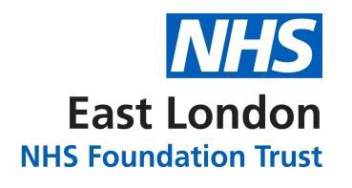

Annual Equalities Report 2018

The work on the Trust’s Equality, Diversity and Human Rights (EDHR) priorities continued during 2018-2019 following the review of the annual actions in the Trust’s Strategy 2014-2017 by the EDHR Strategy Steering Group. This review has also helped us to take stock of our 2014-2017 strategy as well as to develop ELFT’s new Equality, Diversity and Human Rights Plan 2018-2021 which would be in line with the Trust’s strategic objectives of the new strategy. It ultimately shapes our new Trust vision for equality, which is:
“By developing effective equality, diversity and human rights practice we want to be inclusive, enabling every member of staff, service user and carer to be their most authentic self and achieve their potential for development and recovery”.
Lorraine Sunduza

The Group’s analysis highlighted aspects of good practice but also recognised there is still much work to do.

Subsequently, the work to deliver our new plan and vision encompasses the following key areas:
- Use the demographic equality data from the breadth of our work
- Set external benchmarks to help assess performance
- Expand on the recruitment best practice
- Improve the quality of care, using the work on violence and restrictive practices
- Support the development of mature staff equality networks
- Work with our partners to address the stigma of mental health and help deliver integrated care that meets the diverse needs of local communities.

As well as reviewing our previous strategy, the Group has been refreshed with a new remit to help ensure our equality, diversity and human rights work makes a positive impact and focussing on place based forums across specialities in each borough called ‘Making Equality Work’.

The forums are lead by the Service/Clinical Directors with support from staff, the People Participation Lead, local representatives, service users and carers, and other partners. A clear part of its remit will be to ensure stronger links between Trust-wide work and that being undertaken in the Directorates. In order to explore opportunities to share and collaborate to, the Group will visit each locality over the coming year to:
- Discuss local work on equality, diversity and human rights
- Understand how the equality, diversity and human rights needs of the local communities are met
- Explore the challenges and good practice to tackle them
- Review if understanding of our patients and staff individually and collectively using the ‘protected characteristics’ of the Equality Act 2010 at its heart
- Review if we are meeting our statutory obligations by demonstrating ‘due regard’ to the Public Sector Equality Duty (and other requirements)
- Review if policy and service developments are being tested with the equality impact assessment tool
- Review if our practice is helping to deliver the strategic outcomes to achieve our mission.

The Group will also engage with each Directorate in turn to check progress and ensure this work adds up to deliver a strong and robust strategy across the whole organisation.
The Group is committed to making meetings a constructive dialogue, sharing what works and ways to address what does not right across the Trust. The proposed format is to open with a short presentation about what is happening locally but the focus of the discussion would be about how a stronger partnership across the Trust ensures excellence drives our work.

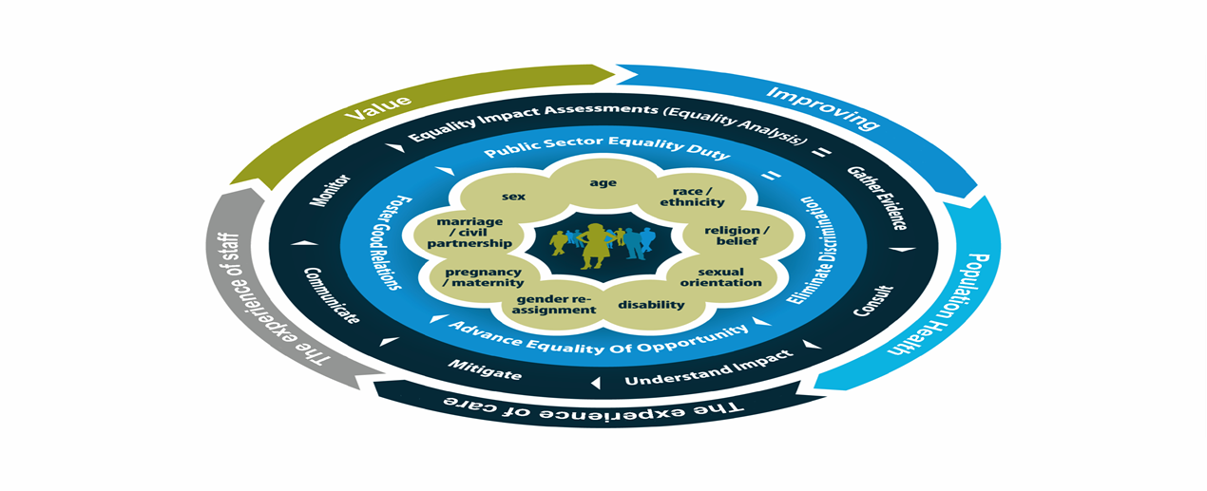

Equality Plan Vision

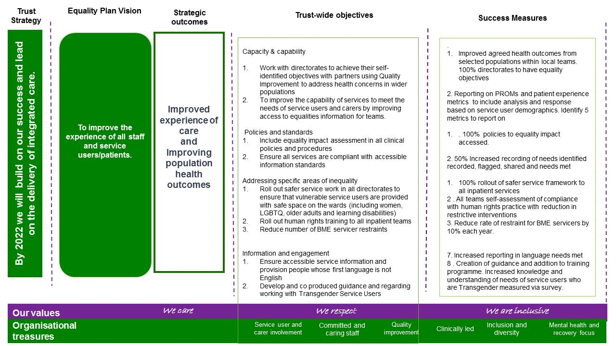

Safer Services

In response to an incident in the Newham Directorate, we started a safer services project to review the experience of female staff and service users on the wards. The review included interviews with staff, review of current policy in all directorates to ensure that vulnerable service users are provided with safe space on the wards (including women, LGBTQ, older adults and learning disabilities).

This work also complemented work in the Forensic Directorate looking at sexual incidents in the Learning Disability Services as part of the violence reduction work. There was also a review of the experiences of female staff who are not supported by a Sexual Violence Adviser.

For both projects, it is acknowledged that any gender can be a victim of sexualised incidents but an acknowledgement of the vulnerability of women.

The planned experiment of violence and aggression as a QI project was completed as the inpatient serviced moved to quality control. The project was renamed Time to Think and encompasses the Human Rights work which began in 2015 which included discrimination and restrictive practices and reviewing it via an equality lens. This has been expanded beyond Psychiatric Intensive Care Units (PICUs) and has included acute ward and CAMHS.

The three London Boroughs engage BAME members reflecting the population and review their understanding and engagement with mental health services. A series of focus groups were held to elicit views that can shape our response via a community engagement plan. The focus groups were drawn from the local communities, voluntary sector, NHS including CCGs and other stakeholder organisations. Participants came from a variety of BAME communities.

Religion and Spirituality

In the last year we have extended our Spiritual Team in Bedfordshire, London and Luton, and joined the QI project with a view to extend the reach of Spiritual Needs Assessments across the Trust. At present, we achieve an 80% engagement level in Newham. Our aim is to ensure that all service users have the opportunity of such an assessment as soon as possible after admission. This conversation places the user at the centre of the assessment. It is completely person centred and focusses upon the spiritual needs of the person. The jointly agreed document is then incorporated within the care plan. In this way the spiritual needs of the person are integrated and recognised by the whole multidisciplinary team.

In the last year every in-patient facility has been visited at least weekly by a member of the Spiritual Team. All service users are made aware of our availability by our presence, posters and colleagues. In addition to the mainstream religious faiths members of our team support those service users not represented by members of our team, e.g. Sikh, Jehovah Witness. In such cases we act as a bridge with their community. There are also many service users who do not align themselves with any particular faith tradition but see themselves on a journey of spiritual discovery often with no religious orientation but are deeply spiritual.

Referrals are by self-referral or from colleagues across all professions. In addition to individual support, members of our department deliver a range of different spiritual practices which include Holy Communion, Friday Prayers, Prayer Groups, Meditation Groups, Spirituality Discussion Groups and worship sessions.

Our core underlying principle is to respect the diversity of the individual. This applies equally to the person’s gender, race and sexual orientation. We do not make any judgement in any of these areas.

Since our team consists of a wide range of religious, spiritual and cultural traditions we are able to respond in a unique way to the need of our service users. The traditions of the East London community are now diverse and complex. We are able to understand that complexity and engage with it.

The Trust has initiatives in place to make psychological therapy services more accessible and relevant to the diverse needs of local communities. Both City & Hackney and Tower Hamlets Psychology Services have worked to improve access and cultural relevance of psychological therapies for BAME service users. Through partnership working with local faith and community groups, the Department of Spiritual, Religious and Cultural Care and the Recovery College we have continued staff training on jinn, black magic and evil eye and mental health, developed courses on religion, culture and mental health at East London Mosque and delivered culturally adapted therapies

Some exploratory work has been undertaken with Estates to train service users to inspect sites which could be developed further. At the Disability Conference in November 2017 staff have been trained to tackle homophobia and campaigns have promoted positive LGBT+ messages.
Workforce Equality Plan

The Workforce Equality Plan has been developed and underpins the 2018-2021 EDHR Plan as well as the Workforce Plan. Its objective is to improve the experience of all staff and service users/patients. It has a number of strategic objectives which tie in with the objectives of Staff Equality Networks and the work of HR and People and Culture Teams, as follows:

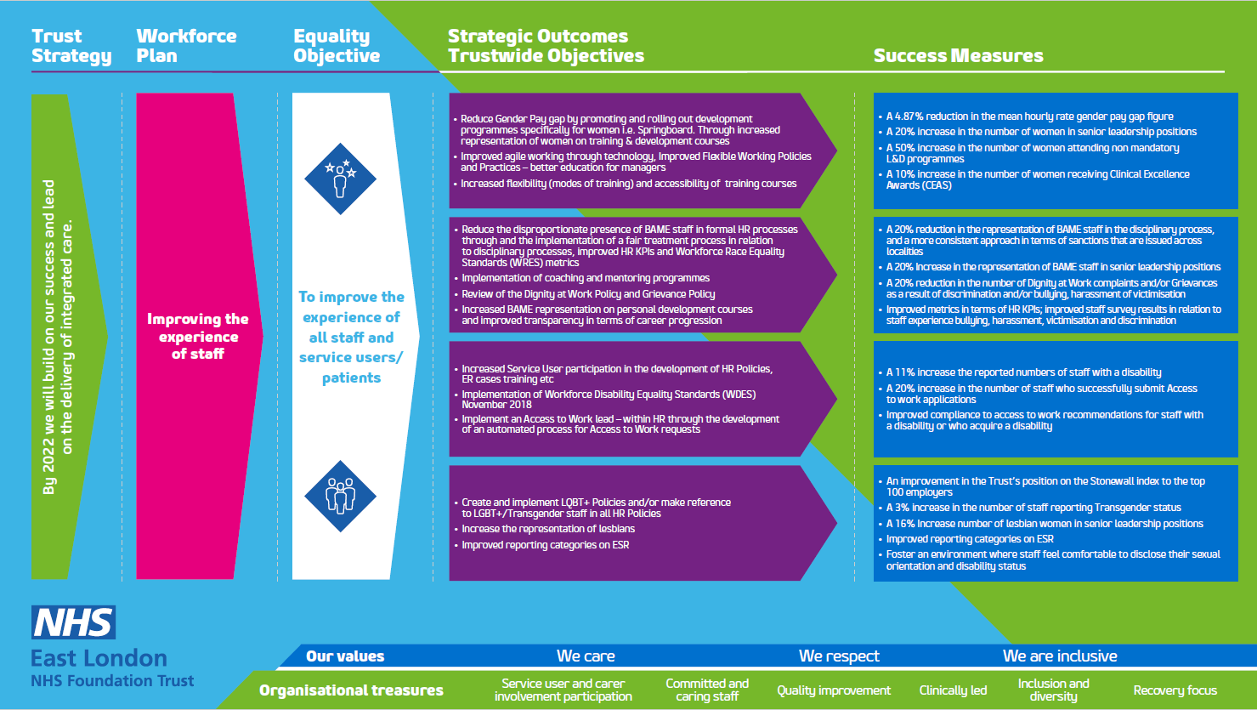

In summary, the Plan sets out to:
- Reduce gender pay gap
- Improved Agile working
- Increased flexibility and accessibility of training courses and increase BAME representation on personal development courses
- Reduce the disproportionate effect of BAME staff in formal HR processes
- Implementation of Coaching and Mentoring programmes
- Increased Service User participation in the development of HR Policies, ER cases and training
- Implementation of Workforce Disability Equality Standards
- Improve Access to Work process
- Create and Implement LQBT+ Policies
- Increase the representation of lesbians at Senior Management level
- Improved reporting categories on ESR.

Challenging success measures have been set for the Plan to ensure we track and measure our progress against the strategic objectives annually.

Update on Progress

ELFT is dedicated to challenging prejudice and discrimination wherever this affects our service users or staff and making equality and diversity integral to our organisational culture. We have made a good progress on a number of areas below:
- Introduced new Equality, Diversity, and Human Rights Policy
- Achieved 185th rank overall and 21st rank in the sector on the Stonewall Workplace Equality Index
- Improved on 8 out of 9 Workforce Race Equality Standard areas
- Improved the provision of adequate reasonable adjustments by 3%
- Retained Level 3 Disability Confident rating and are planning to qualify for Level 4 this year
- Improved by 1% on our mean and 0.61% on our median on the Gender Pay Gap submission
- Introduced in-house mediation service
- Delivered 3 cohorts of Springboard Development Programme.

Staff Equality Networks

 | The Trust now has four established staff networks (BAME, Disability, LGBTQ, and Women) to offer support and a safe space to staff groups who might benefit from focussing on what they need to progress in their careers and personal development. The networks run events, conferences, workshops, training sessions, and celebration and social activities which all contribute to education, awareness, engagement, and reduction in variation of experience for staff with these protected characteristics. |  | 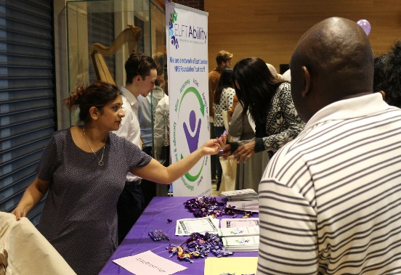
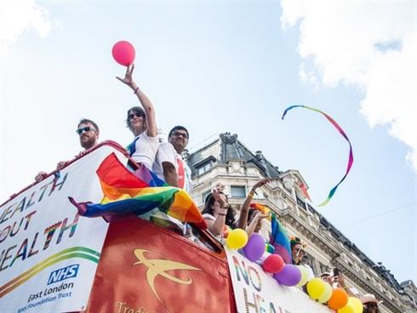 |  | 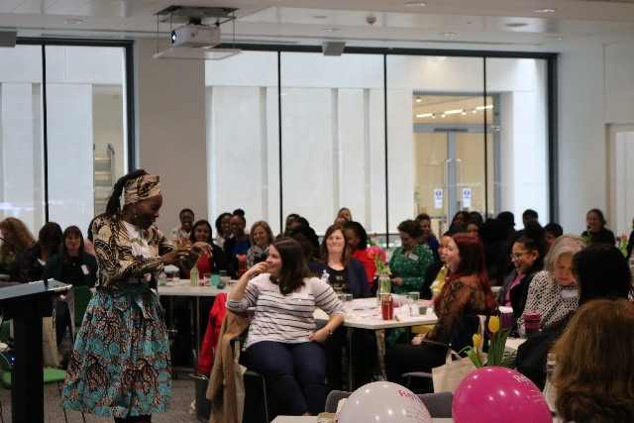

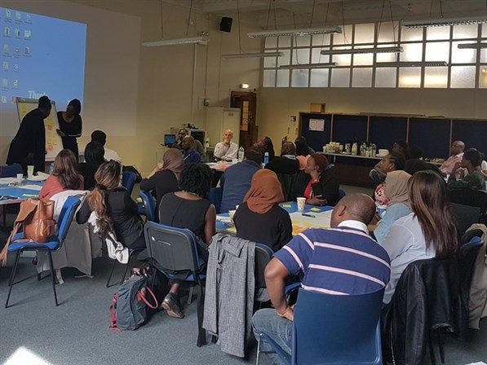 | We also support LGBTQ and women charities and raise funds towards their activities via network events.  We are in the process of implementing the Intergenerational Network for 2019-2020. A summary of key annual highlights from each network can be seen below.

CAMHS Equality Group

On the back of our 2016 CQC visit, the above group was formed by the members of staff in all five localities. The groups has commissioned an internal survey and has run a series of focus groups to identify the equality and diversity gaps within the CAMHS services and have come up with the follow up plans to improve recruitment and retention practices; identify barriers to career progression; allow staff to talk openly and honestly about culture; and reduce the complains of inequalities within training commissioning.

Freedom to Speak up

The Trust is committed to creating a culture where staff are empowered to speak up about any concerns they may have about patient care. We employ a Freedom To Speak Up Guardian, supported by a team of Freedom To Speak Up ambassadors, who provide support to staff across the organisation. The team provide an alternative way for staff to discuss and raise concerns, including concerns over equality and diversity (E&D) processes, discrimination, bullying, or harassment. They act as an independent and impartial source of advice to staff at any stage of raising a concern. They also ensure issues are raised at a senior level of the organisation.

Equality Networks

BAME | Disability
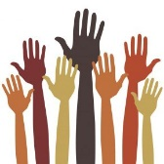  - Celebrated Black History Month  - Run regular network meetings  - Planning annual conference  - Set up Twitter page and comms distribution list  - Promoting and encouraging attendance at BAME development programmes and involvement in engagement events  - Interviewed CEO, Chair and Senior Managers in localities  - Run diversity campaign  - Meeting with Directorate management teams to explore challenges and offer support to progress | 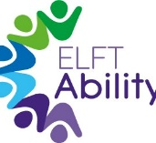  - Developed a brand and network identity  - Run re-launch and engagement event  - Set up Twitter page and comms distribution list  - Run regular network meetings  - Roadshows and stalls in localities to raise awareness  - Signed up for Purple Space membership and services  - Planning annual conference
LGBTQ | Women
- 130 network members have attended London Pride Parade  - Set up Twitter page and comms distribution list  - Launched trans and non-binary survey  - Delivered training and education sessions in localities  - Facilitated annual conference  - Support Albert Kennedy Trust charity  - Run regular network meetings  - Joined ELOP Practitioners Network  - Celebrated LGBT History Month  - In the process of launching ‘Straight Allies’ Programme | - 100 years of the vote walk through central London, with a banner made by Service Users  - Run “I weigh” campaign  - Delivered Confidence Events  - Set up Twitter page and comms distribution list  - Run regular network meetings  - Support Refuge charity  - Interviewed CEO, Chair, and female NEDs  - Facilitated annual conference

Staff Profile

