ELFT AnyConnect – Remote Access

The following document takes you through the basic steps of initial set-up and configuration of ELFT Remote Access (Section A), and then how to make a successful connection to ELFT Remote Access (Section B).
There are also some FAQ contained on the last page for troubleshooting.

Section A – Initial Set-up - Phone

Pre-requisite:
- RSA SecurID Token app installed on your Trust/personal mobile.
Note: The RSA icon may appear either as 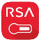 or 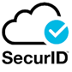 in the app store depending on your phone
operating system and is named - “RSA SECURID Software Token”
- Valid Token email and authentication password for the RSA SecurID app
- A stable Wi-Fi/broadband connection

  - Installing RSA-Token Mobile App
(all of the following steps in section 1 are done on your mobile)
  - On your mobile – open Google Play Store for Android or App Store for iPhone and search for RSA SecurID, and click install:

Note: When you first open the app and accept the EULA Policy, you will be presented with a welcome screen stating “To use this app, you must import a software token…..”
At this stage you will need to follow the steps below.

  - Open your NHS.net email on your mobile and open the email message regarding the RSA Token you received. If you did not receive this email – please contact elft.anyconnecthelp@nhs.net.

  - Copy the activation URL link in the email (by pressing your finger on the link), and selecting copy link address:
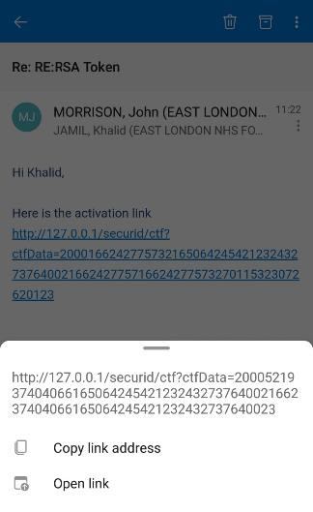

  - Now, go back to the RSA app you installed on your phone, and open the app by selecting the icon, which will be either of the two below:
or

  - On the main welcome screen, click on import token and select the import URL option.
Then paste the copied link into the box and select import:
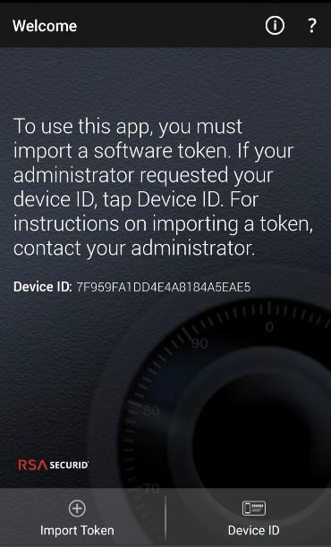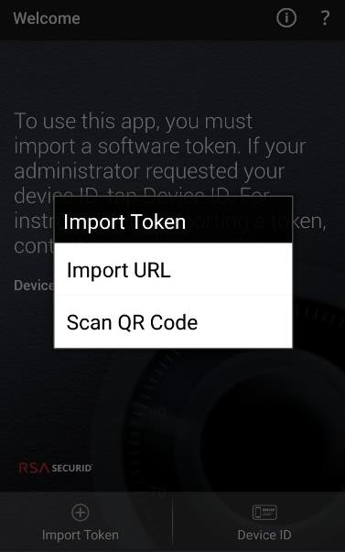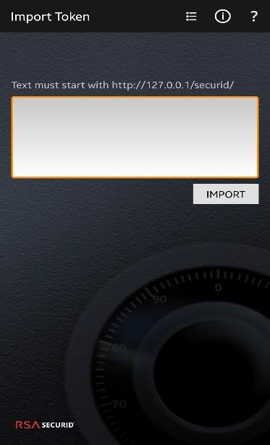

For iPhone: On the main welcome screen click on the bottom left of the screen and select the enter link option. Then paste the copied link into the box and select submit.

Note: If the token has been successfully imported – you will be asked for the RSA authentication password (if not please make sure that you are entering the correct URL link – as contained in the first email received from elft.anyconnect@nhs.net).

  - Your RSA authentication password would have been sent separately to your nhs.net email. Please enter the password to authenticate the link and your ID.

Once successful, you will be presented with the RSA-Token screen:

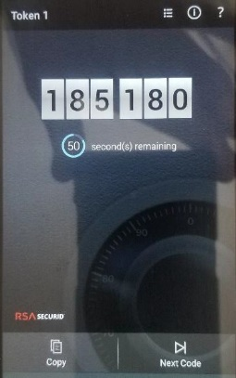

Hooray, at this stage you have completed the setup of the RSA app on your phone and can put your phone aside for now and proceed to the setup on your Trust laptop.

Setting up AnyConnect on your laptop/HP tablet for the first time

  - LOG OFF/RESTART YOUR LAPTOP/HP TABLET (This needs to take place every time you wish to connect remotely to AnyConnect. If this does not take place, you will not be able to access AnyConnect). Make sure that your laptop/HP tablet is connected to your local Wi-Fi (home broadband).
Note: These steps will not work when you are connected to the Trust Wi-Fi.
  - Please ensure you have a copy of this user guide open on your mobile phone for reference.
  - When the laptop/HP tablet starts up, do not attempt to login as you normally would.
On the main screen, you should see a successful Wi-Fi signal, and the AnyConnect icon at the bottom right (see below):

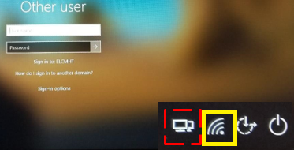
  - Click the AnyConnect icon:
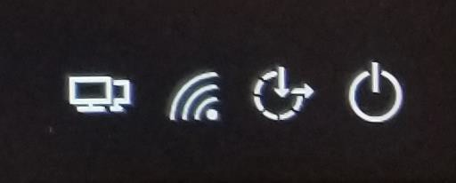

  - This will open the AnyConnect mobility client window (see below), click connect to start the set-up:
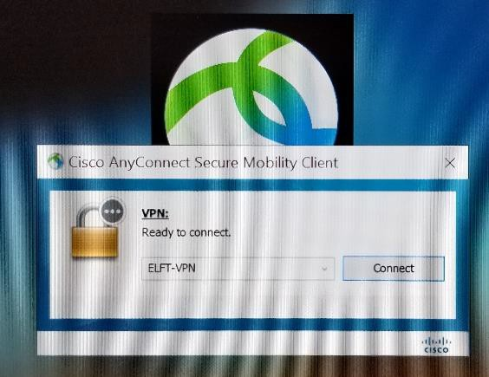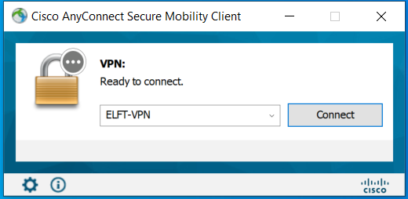

IMPORTANT: In the initial setup below, the username will be your ELFT Login-ID and the password will be the number generated by the RSA-SecurID app you have just installed on your phone.

  - After pressing connect you are presented with the screen below:

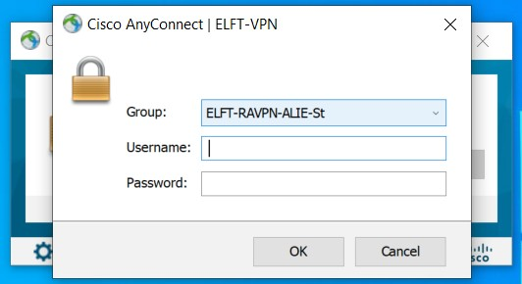

In the Username field, enter your ELFT logon-ID only:
!!!!!(Do not enter your ELFT login password here)!!!!!
The password required here is the RSA Token from the RSA Mobile app on your phone (as per Section 1).

Please DO NOT type your ELFT logon password !!!

  - Open the RSA-SecurID app on your mobile. Wait for the number to change, and then enter the six-digit number displayed – click OK.

IMPORTANT: Create Your Unique 4 - 8 alphanumeric PIN:

  - Once you click OK, you will be asked to create a secure PIN – this can be between 4 to 8 alphanumeric characters.
Then you need to confirm the PIN:

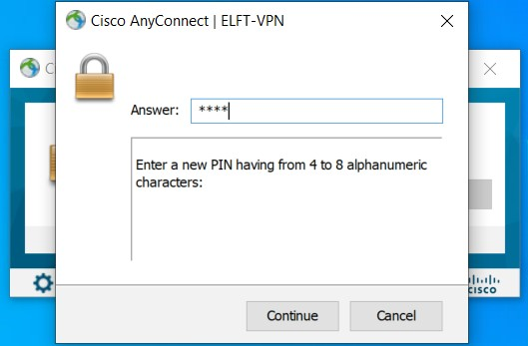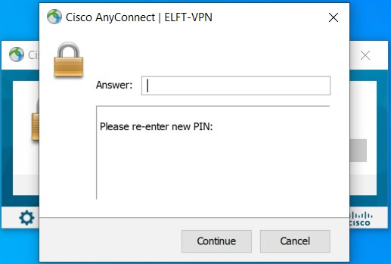

Please remember this PIN as it will be required when making a Remote connection.
And Do NOT write down or share this PIN with anyone.

  - Once your PIN has been accepted, you will next be asked to enter the new full passcode:
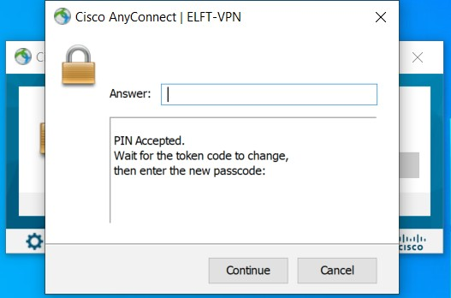

  - This passcode is made up of your newly created PIN and the RSA SecurID token on your phone (see example below). Open the RSA-SecurID app on your mobile and wait for the number displayed to change. Then enter the new passcode (made up of your PIN and Token – see example below):
PIN + RSA Token 2468235455

Passcode Example:

Let’s say you have set your PIN to 2468.
Then open the RSA SecurID app on your mobile, it would display a six-digit token (see image below). Wait for the numbers of the token to change:
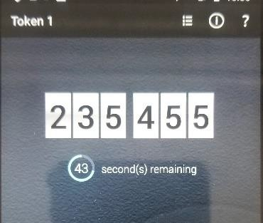

Your ELFT Remote Access password would then be:
PIN + RSA Token 2468235455

IMPORTANT: Please make sure that you have at least 15 seconds left on the timer below the token, otherwise the connection may error out:
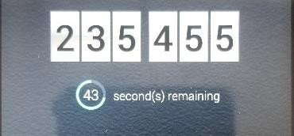

Remember that the RSA-Token changes every 60 seconds.

Section B:

Connecting to ELFT-Remote Access after initial setup

Before you start using ELFT Remote Access – and connect to ELFT services, please go through the following steps to make a successful connection:

  - Make sure your laptop/HP tablet is connected to Wi-Fi (or your home broadband). On the main logon screen, you should see a successful Wi-Fi signal (see image below). If not please wait for the laptop/HP tablet to connect to your Wi-Fi (the laptop will auto-connect if you have previously connected to the Wi-Fi successfully):

  - Do not attempt to login as you would normally. On the main logon screen, you should see a successful Wi-Fi signal (make sure that you have a working Wi-Fi connection), and the AnyConnect icon at the bottom right (see above):

Click on the AnyConnect Remote ELFT Remote Access icon.

This will display the Cisco AnyConnect Client Window:
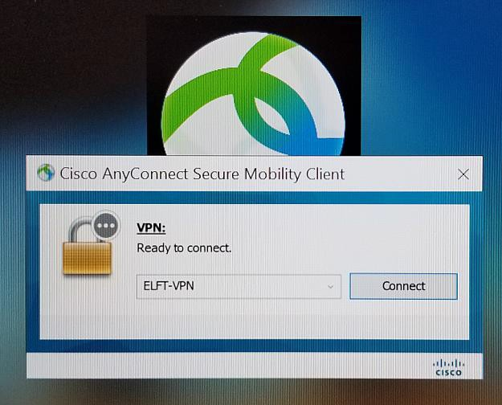

  - Click connect to start the Remote Access connection.
  - Once connected – the logon credential page will be displayed:

  - At the connection window (see above), enter your ELFT username – this is your ELFT- logon name

  - PLEASE NOTE that the password here is NOT your logon password, but the passcode (as explained in step 2.9). The password is made up of your PIN and the RSA Token as explained above. The PIN was created when you initially set-up the ELFT Remote Access connection (see step 2.7). And the RSA Token is retrieved from the RSA SecurID app that was installed on your mobile (see section 1.1).

PIN + RSA Token

Refer to Step 2.9 for Passcode example.

  - When you have entered the correct credentials, and the Remote Access connection has been successful, you will see the EULA agreement – click on accept
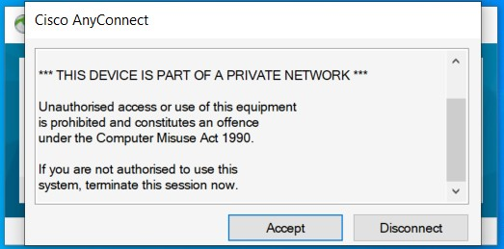

  - The standard logon screen will be displayed – and the icons in the bottom right of the screen should be as below:
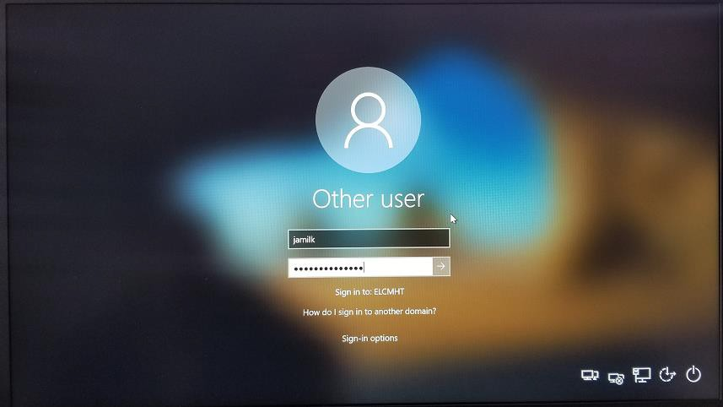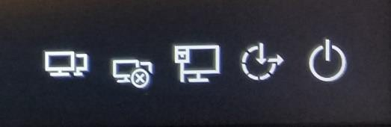

  - IMPORTANT: You can now login using your normal ELFT username and password – and you will be connected to the ELFT Network, with all your network shared-drives ( I:\ K:\ L:\ and N:\ ) and your H:\ drive available.

You can now use your laptop/HP tablet as if you were working on an ELFT site.

Please see the FAQ section for known issues and solutions.

If you have any technical issues please contact us via the email below:
elft.anyconnecthelp@nhs.net

Frequently Asked Questions:

I have forgotten my PIN, what should I do?
Please email us at elft.anyconnecthelp@nhs.net
Your PIN will be cleared, and you will need to go through the set-up again to set-up a new PIN. Please follow through Section 2 to complete the configuration again.

I cannot use my previous PIN
You will not be able to re-use your past 10 PINs – please select a different PIN between 4 – 8 alphanumeric characters.

When I enter my userID and Passcode, I get the access denied message
You have entered an incorrect token or PIN. Wait for the token to change in the RSA-SecurID app, and then re-enter the passcode (see example step 2.9).
NOTE: always wait for the token to change - and DO NOT use the same token twice.

AnyConnect is telling me my account is locked out – what do I do?
If you have entered an incorrect passcode too many times – your account will become locked as a security measure. Please contact us at elft.anyconnecthelp@nhs.net to get your account unlocked.

I do not have a Wi-Fi connection
Please check your home broadband connection. Contact your broadband supplier if there is a connection issue. Also, make sure that you have configured your Wi-Fi connection to “Connect automatically” in case the connection is lost:
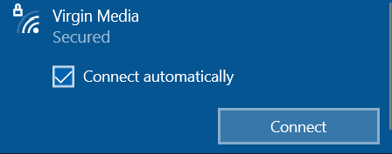

To configure auto-connect, make sure you are not connected to ELFT Remote Access.
- Click the Wi-Fi icon in the bottom right and disconnect your current connection.
- Re-open the Wi-Fi connection and click on your available home Wi-Fi.
- Before clicking on connect – make sure that the auto-connect option (as shown above) has a tick next to it.

I moved away from my laptop/HP tablet, and now the screen is locked?
If you leave your device idle for a period of time (i.e - you walk away to have your lunch or go for a walk) – the system will lock itself – and the screensaver will kick in. This will force the ELFT Remote Access to disconnect itself. When you come back to the laptop and unlock the screen (with your ELFT username/password) – the ELFT Remote Access connection will be automatically restored. This will be apparent by the status messages being displayed at the bottom right of the laptop screen:

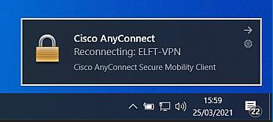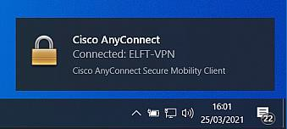

How can I log on onto ELFT Remote Access while I am at a clinic?
If you have a Trust smartphone, then your laptop can be tethered to your smartphone for remote connectivity. Please contact elft.anyconnecthelp@nhs.net for assistance with setting this up then follow instructions in Section B above.

